Aberdeen Grammar School
Faculty of Science

S2 Chemistry

Summary Notes

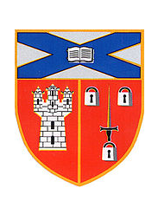

Topics 1: Chemical Reactions
Topics 2: Rates of Reaction
Topics 3: Atomic theory

Topic 1: Chemical Reactions – Success Criteria

By the end of this topic:
✓
1
2
3
4
5
6
7
8
9
10
11
12
13
14
15
16
17
18
19

- I can identify the occurrence of a chemical reaction by:
  - a change of colour;
  - an energy change;
  - a precipitate forming;
  - effervescence.

- I can state that in all chemical reactions new substances are produced.

- I can give examples of everyday chemical reactions: both fast and slow.

- I can listen to others and communicate ideas, summarise findings and draw conclusions.

- I can state that everything is made from approximately 100 elements.

- I can state that each element has a name and a symbol.

- I can state that mixtures occur when two or more substances come together without reacting.

- I can state that in a mixture the elements retain their physical and chemical identity.

- I can describe the processes used for separating mixtures of substances

- I can state that when two or more substances chemically react, new compounds are formed.

- I can state that a new compound has chemical bonds binding the elements together.

- I can state that a new compound has completely new chemical and physical properties.

- I can describe methods to break down chemical compounds by: heat alone; heating with carbon; and electrolysis.

- I am able to name the elements within a compound ending in –ide, -ate and –ite.

- I can state the composition of air.

- I can describe and carry out tests for some common gases.

- I can describe the processes involved in maintaining the balance of gases in the air.

- I can explain some of the processes that contribute to climate change and discuss the possible impact that atmospheric change could have on the survival of living things.

- I can make notes and organise these to develop thinking, help recall information and produce new texts
Elements

All materials of the Universe are many up from tiny invisible particles called ATOMS. Some atoms are more common in the Earth’s crust e.g. oxygen atoms account for 46.6% of the total. Some are not found in the Earth’s crust and are made in laboratories. At present there are over 110 elements.

A material that is made up of one kind of at is called an ELEMENT.

We do not find many pure element’s in the Earth’s crust

Each element/atom is listed on the PERIODIC TABLE. The Periodic Table provides a name, symbol, atomic number and mass number for each element.

Symbols for Elements

Scientists use special symbols for all the elements.

Some elements have symbols with a capital letter only, e.g.

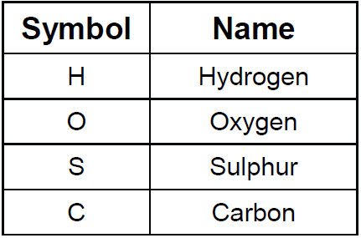

Some elements have symbols with a capital letter and a small letter, e.g.

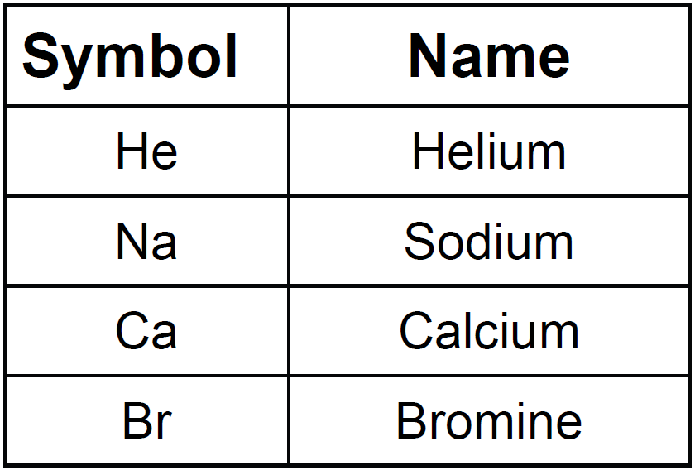
Compounds

A COMPOUND is a substance made up of two or more elements joined together chemically.

Rules for Naming compounds

1. Compounds ending in –ide usually contain only two elements, e.g.

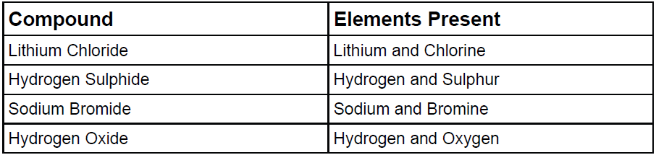

2. Exceptions to the “-IDE“ rule.

Compounds called HYDROXIDE, CYANIDE and AMMONIA contain more than two elements, e.g.

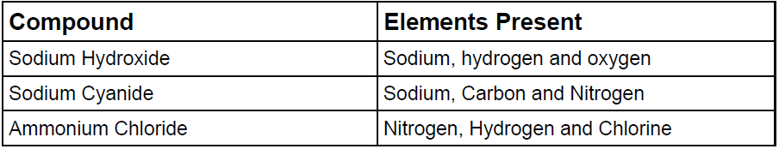

3. –ITES and –ATES

Compounds ending in –ATE or –ITE contain a third element called OXYGEN

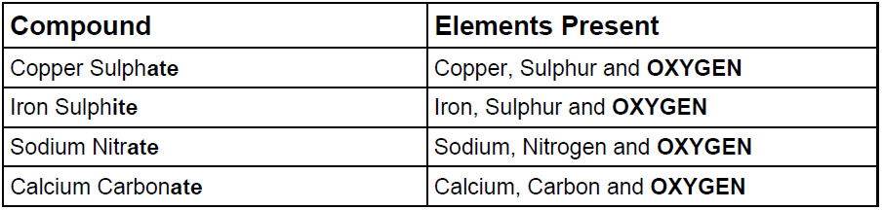

The metal name always comes first if present in a compound.

The appearance of a compound may be quite different from its original elements e.g. Sodium chloride is a white solid but sodium is a grey solid and chlorine is a green gas.
Mixtures

Mixtures are formed when two or more substances are mingled without reacting, examples are air and crude oil.

Separating substances in a mixture does not involve a chemical reaction, example iron and sulphur can be separated using a magnet.

The materials in the mixture still have the same properties.

Mixtures are very common in the Earth’s crust and we often prepare special mixtures for our own use. For example:

Road grit: Salt and sand
Alloy: Two or more metals
Fertilisers: Different salts for plant growth
Petrol: Different hydrocarbons
Air: Different gases including nitrogen and oxygen

Solvents, Solutes and Solutions

A solvent is a liquid in which a substance dissolves.

A solute is a substance that dissolves in a liquid.

A solution is a liquid with a substance dissolved in it, e.g.

Vinegar is made by dissolving ethanoic acid in water.
- Ethanoic Acid is the SOLUTE
- Water is the SOLVENT
- Vinegar is the SOLUTION

A dilute solution is one which contains a little solute in a lot of solvent.
A concentrated solution is one which contains a lot of solute to a little solvent.

Water is the most commonly use solvent.

A saturated solution is one in which no more solute will dissolve at that temperature.

An insoluble substance does not dissolve in the solvent.
Chemical Changes

In a chemical reaction at least one new substance is always formed.

Chemical reactions happen all around us. For example:
- Digesting food which you have eaten
- Gas burning in a fire
- A metal fence rusting
- Petrol burning in a car engine
- Skin forming over a cut.

There are other signs of a chemical reaction:

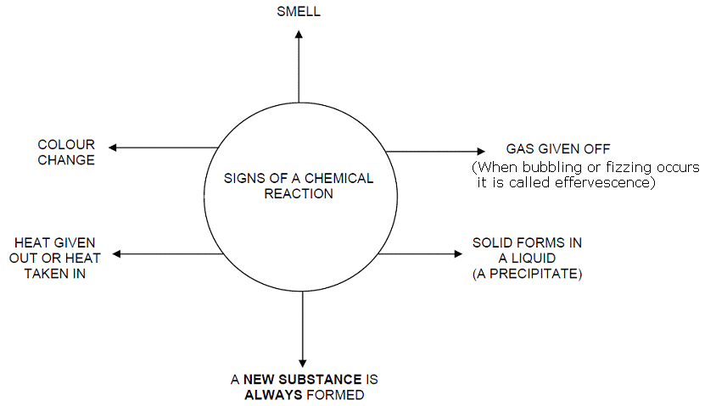

In all chemical reactions new substances are formed.

A new substance often looks different from the original substance.

Chemical reactions unlike physical reactions are difficult to reverse.

Energy changes take place in lots of chemical reactions

Reactions which take energy in are ENDOTHERMIC.

Reactions which give out energy are EXOTHERMIC.
Separating Substances

When two substances mix together but do not react, they form a mixture. It is usually quite easy to separate the substances in a mixture.

Filtration

If an insoluble solid is mixed with water, it is easy to separate the solid from the mixture. The method used to separate them is filtration.

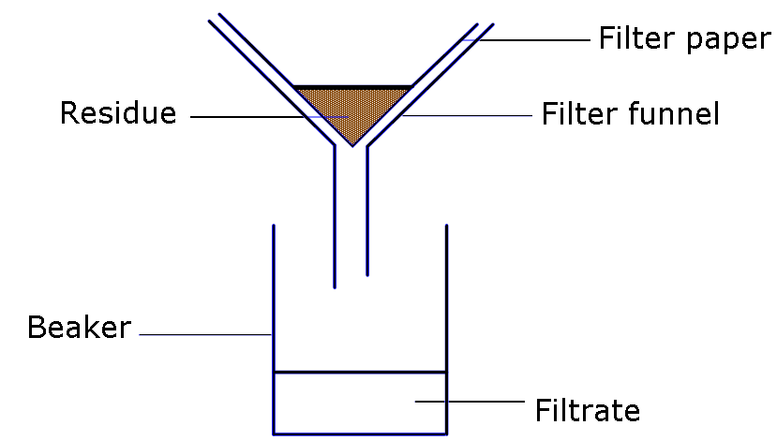

Filtration is the technique where solid particles in a liquid can be separated from the liquid using paper (filter paper).

The solid left in the filter paper is called the residue. The liquid collected is called the filtrate.

For substances such as salt solution the water in the filtrate can then be evaporated off leaving the solid salt.

Chromatography

Inks are a mixture of a liquid solvent, which is often water or alcohol, and a colouring substance.

This experiment is a way of finding out which substances are in a mixture.

Chromatography is the technique used to separate the dyes in an ink.

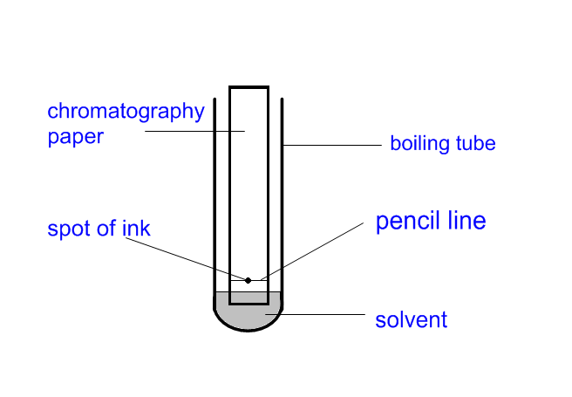

Distillation

Distillation is a method of separating a mixture of liquids by their differences in boiling point.

Distillation involves evaporation followed by condensation.

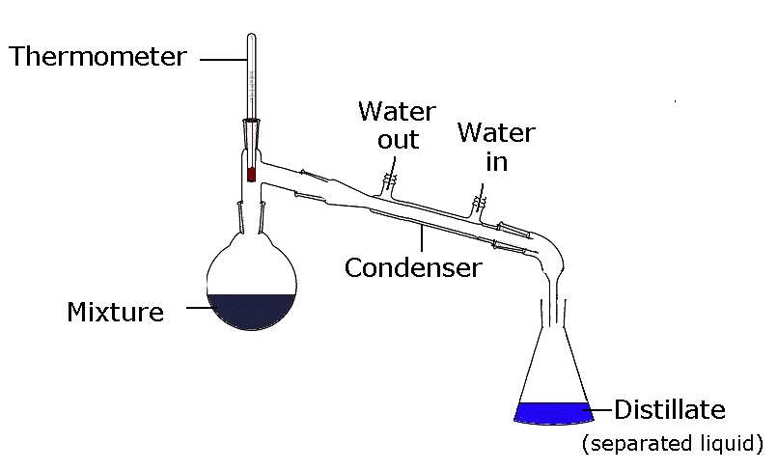
Can compounds ever be separated?

Mixtures can be separated using physical methods such as filtration, chromatography or magnets.

Compounds can only be separated into their elements using chemical methods such as electrolysis or heating with carbon.

Electrolysis

Electrolysis means to separate a compound into its elements using electricity.

A circuit like the one shown below using 6 volts direct current (DC) electricity can be used.

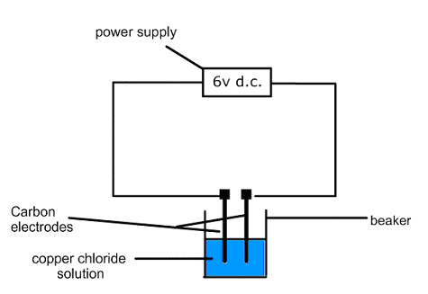

In this example chlorine gas would be produced at the positive electrode and copper metal at the negative electrode.

Using heat to break down compounds

Some metals can be obtained from metal oxides by heating strongly or heating with the element carbon.

For example:
If copper oxide is heated strongly with carbon powder it can be broken down into the elements copper and oxygen.
Word Equations

When chemicals react with each other, different chemicals are made. One of the best ways to describe what is happening is by writing a chemical equation.

A chemical equation tells you which chemicals reacted together (the reactants) and the new chemicals that were made in the reaction (the products).

The simplest equation is a word equation. For example:

sodium + chlorine → sodium chloride

magnesium + oxygen → magnesium oxide

Word equations will always be shown with reactants on the left side and products on the right side of the arrow:

Reactants → Products

Do not use an “equal to” symbol.
The Composition of Air

The air around us is made up of a mixture of different gases.

Gas | Percentage of the air (%)
Nitrogen | 78
Oxygen | 21
Carbon dioxide | 0.03
Argon | 0.9
Other gases | Tiny percentage of gases including hydrogen, methane and several others

Gas tests

Oxygen relights a glowing splint.

When a lit splint is placed in to a tube containing hydrogen the gas burns with a squeaky pop.

Carbon dioxide turns limewater from clear to cloudy
The Carbon Cycle and Climate Change

All living things contain carbon. Carbon is also a part of the ocean, air, and even rocks. In the atmosphere, carbon is attached to some oxygen in a gas called carbon dioxide.

Plants use carbon dioxide and sunlight to make their own food and grow. The carbon becomes part of the plant. Plants that die and are buried may turn into fossil fuels made of carbon like coal and oil over millions of years.

When humans burn fossil fuels, most of the carbon quickly enters the atmosphere as carbon dioxide. Increased levels of carbon dioxide can cause changes to the climate.

Increasing levels of carbon dioxide can act like a blanket to trap the Earth’s heat leading to an increase in the Earth’s temperature. This is known as the “Greenhouse Effect” and gases like carbon dioxide which produce this effect are called “Greenhouse Gases”.

This information can be put together to form the carbon cycle

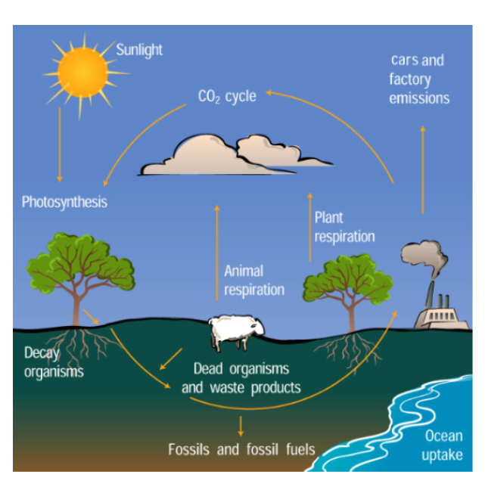

Changes in this cycle can alter the natural balance of the gases in our atmosphere and result in changes to the planet’s climate.

Topic 2: Rates of Reaction – Success Criteria

By the end of this topic:
✓
1
2
3
4
5
6
7
8
9

- I can give examples of different rates of everyday reactions.

- I understand the meaning of rate and have carried out experiments to demonstrate different rates.

- I understand that small particles react faster than large particles as they have a greater surface area.

- I understand that increasing the concentration of reactants speeds up the rate of a chemical reaction

- I understand that increasing the temperature of a reaction speeds up the rate of a chemical reaction

- I understand that a catalyst can speed up or slow down a chemical reaction and remain unchanged at the end of the reaction.

- I can give examples of the use of catalysts used in industry and everyday reactions.

- I understand that if one variable is to be investigated all other variables must remain constant.

- I can analyse and draw standard rate curves from given data and extract information from them.

Rates of Chemical Reactions

A chemical reaction occurs when two or more substances (reactants) undergo a change whereby new products are created.

Reactants Products

The reaction speed or rate can be measured as the 'rate of formation of product' or the 'rate of disappearance of reactant'.

Examples of some everyday chemical reactions are listed below
Chemical Change | Rate or Speed of Reaction
Burning of petrol in an engine | fast
Milk turning sour | slow
Making wine from grapes | slow

A chemical word equation will tell you about the reactants and products involved in a chemical reaction. But it will not tell you about the speed of the reaction, the reaction conditions or the energy changes involved.

Before a chemical reaction can happen, the molecules involved must collide and have enough energy to cause a reaction. The minimum energy required for a reaction to occur between molecules is called the activation energy.

You can increase the rate of a chemical reaction by:
- increasing the number of collisions, or
- reducing the energy needed for the reaction to take place

How Particle Size can Affect the Rate of a Reaction

The following methods are all ways of making the reaction surface area of a reactant larger. They also decrease the size of the reactant particles.
- Dissolving a material in water
- grinding the material into a fine powder
- cutting the material into small pieces
- spreading the material as a fine jet.

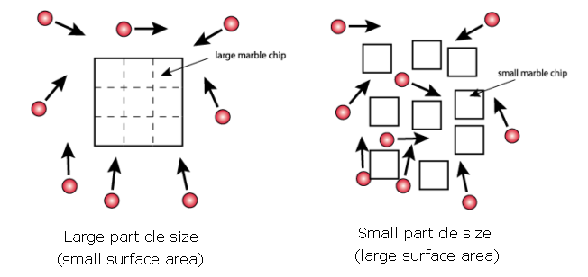

The reaction rate will increase when the effective reaction surface area is increased (particle size is small).

A marble chip reacts fast in acid when it is crushed into a powder. A similar marble chip will react slowly if it is left as a solid lump.

Increasing the surface area of a reactant will increase the rate of a reaction.

How Temperature can Affect the Rate of a Reaction

When a substance is heated its molecules have more energy and move faster.

The molecules of one reactant can collide more often with those of another reactant when the temperature is increased.

Increasing the temperature of reactants will increase the rate of reaction.

For example, iron filings will react faster in hot acid compared to cold acid.

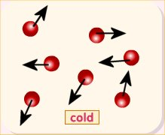 |  | 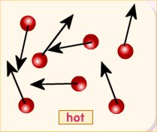

How Concentration can Affect the Rate of a Reaction

The greater the concentration, the more reactant molecules will be present per unit volume of the material.

There will be a greater chance for collisions to take place between reactant molecules so the reaction rate will increase.

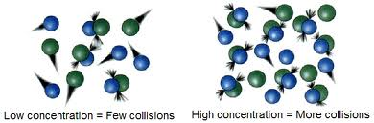

If a gas is compressed into a smaller volume its pressure will increase and this will have the effect of increasing the concentration of the reactant gas molecules. Therefore, increasing pressure will increase the reaction rate.

A lump of marble chip will react faster in concentrated acid compared with dilute acid.

Increasing the concentration of reactants will increase the rate of reaction.
The Use of a Catalyst in a Chemical Reaction

A catalyst is a chemical which makes a reaction go faster but remains unchanged after the reaction. Catalysts are very useful substances in everyday life.

Manganese dioxide added to hydrogen peroxide will cause the peroxide to decompose to water and oxygen. The manganese dioxide is the catalyst in this reaction.

A catalyst takes part in a chemical reaction, but does not get used up and can be reused with more reactants. It is chemically the same at the end of the reaction.

The following table shows some examples of common catalysts and their uses.

Catalyst | Use
Nickel | Making margarine from vegetable oils
Vanadium pentoxide | Manufacture of sulphuric acid
Enzymes | Various chemical changes in our bodies
Iron | Manufacture of ammonia
Platinum | Manufacture of nitric acid

Catalysts in Cars

Transition metals, for example platinum, are used as the catalysts in catalytic converters in a car exhaust.

They speed up the reaction which converts harmful gases such as nitrogen oxides and carbon monoxides into less harmful gases like nitrogen and carbon dioxide.
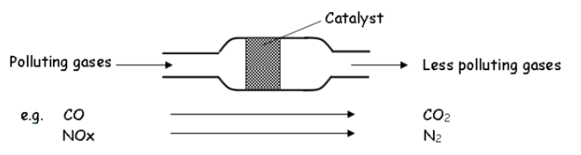

Changing variables in experiments

In any experiment investigating the effects of changing one variable, for example the concentration of reactants, all other variables in the investigation must be kept the same, for example temperature or the volume of reactants.

If you change two variables at the same time, you will not know which one is causing your results, so your conclusion may be invalid.

Reaction Rate Graphs

The rate of a chemical reaction may be measured by plotting a graph of the mass of a product produced with time.

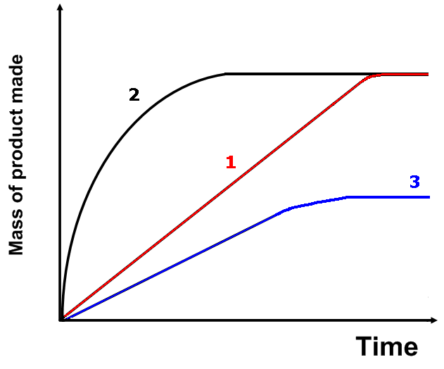

It can be seen that the reaction rate in graph 2 is larger than the other two graphs. A final mass of product occurs faster with graph 2.

Comparing graph 1 and graph 2, the greater rate of reaction in graph 2 could have been due to:
- a greater concentration of reactants in 2,
- a greater temperature of reactants in 2,
- a smaller particle size in the reactants in 2, or,
- the presence of a catalyst in 2.

Notice that the reaction rate decreases near the point where the final mass of product has been achieved. This happens because the concentration of reactants is very low. The final mass of products is the same in graph 1 and graph 2 because the same mass of reactants was used.

Comparing graphs 2 and 3, we can see that less product was produced in graph 3 because the mass of one of the reactants was less at the start of the reaction.
Topic 3: Atomic Theory

1
2
3
4
5
6
7
8
9
10
11
12
13
14
15
16
17
18
19
20
1. Classify the elements in the Periodic Table into: Solids, Liquids, Gases, Metal/Non-metal, man-made and natural.

2. Describe the structure of the Periodic Table using the terms: periods and groups accurately.

3. Identify the Group Numbers from left to right (1 to 8) and the Period Numbers 1 to 7 on the Periodic Table.

4. State that elements within the same group show similar chemical properties.

5. Correctly identify the following families of elements on a Periodic Table: halogens, alkali metals, alkaline earth metals, noble gases and transition metals
6. Describe the atom as containing: positive protons, negative electrons and neutral neutrons

7. State that the mass and charge of protons, electrons and neutrons as:
P: 1amu / positive
E: 0 amu / negative
N: 1amu / neutral

8. State that the atomic number of an element can used to identify it on the Periodic Table and is equal to the number of protons in an atom of that element.

9. State that all atoms are neutral because the number of Protons = the number of Electrons

10. State that the Mass Number of an atom is equal to the number of protons + number of neutrons.
11. Correctly describe an element in the format
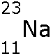

12. Calculate the no. of neutrons in an atom using the subtraction: mass number – atomic number

13. Recognise the electron arrangements of the first 20 elements.

14. Arrange the first twenty elements electrons into their specific energy levels.

15. Recognise the regularity of the Periodic Table.

16. Recognise that the elements with the same number of outer electrons are situated within the same group and have similar chemical properties.

17. Recognise that atoms of the same element can be different due to a slightly differing mass number.

18. State the meaning of positive ions and negative Ions in terms of the loss or gain of electrons.

19. State that atoms of the same element can be different due to a slightly differing Mass Number and that most elements are a mixture of isotopes

20. State what is meant by relative atomic mass (RAM) and understand how the RAM of an element can be calculated.

Classifying the elements

Everything in the world is made from about 100 elements.

Each element contains only one type of atom.

Atoms are the tiny particles from which everything is made.

All elements are arranged in the Periodic Table.

The Periodic Table was first arranged by the Russian Chemist Dmitri Mendeleev.

Elements on the Periodic Table can be classified (sorted) in a number of ways.

1) Metal and non-metals

The non-metals on the Periodic Table are found on the right side of the Table (shown below)

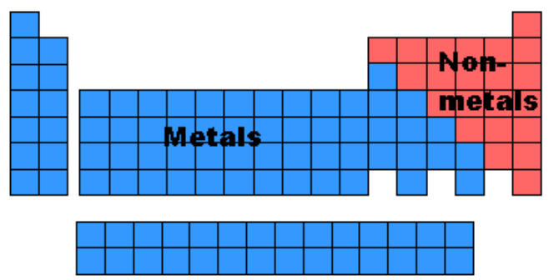

2) Solid, liquids or gases

Examples of three elements which are solids at room temperature are magnesium, aluminium and sulphur.

Three elements which are gases at room temperature are hydrogen, oxygen and chlorine.

The only two elements which are liquids at room temperature are bromine and mercury

3) Naturally occurring or man-made

The man-made elements have an asterisk beside their symbol on page 8 of the National 5 Chemistry Data Booklet.
The Periodic Table is arranged in columns known as Groups and rows known as Periods.

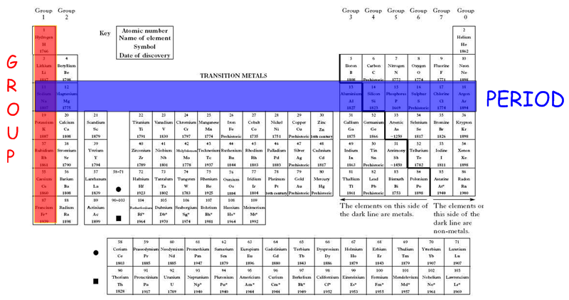

The structure of the atom

Atoms are actually made from even smaller particles. There are three types of particle in an atom:
- protons
- neutrons
- electrons

Protons, neutrons and electrons are not evenly distributed in an atom.

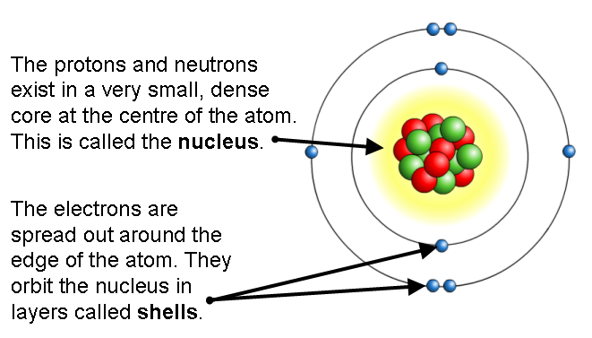

A short video describing the structure of an atom is available from the BBC Learning Zone web site at: http://www.bbc.co.uk/learningzone/clips/atomic-structure/10658.html

There are two properties of protons, neutrons and electrons that are especially important:
- Relative mass
- Electrical charge

The relative masses and electrical charges of the different particles are shown in the table below.

Particle | Mass | Charge
Proton | 1 | +1
Neutron | 1 | 0
Electron | Almost 0 | -1

The atoms of an element have no overall charge as the positive charge of the protons in the nucleus is equal to the sum of the negative charges of the electrons.

Atomic Number

The elements in the Periodic Table have a number called the atomic number which increases from left to right across the table.

This number tells us how many protons an atom has.

As all atoms are neutral (they have no overall electrical charge) the number of protons must equal the number of electrons.

The number of protons in an atom is called its atomic number.

For example:

Element | Symbol | Atomic Number | No. of protons
Hydrogen | H | 1 | 1
Calcium | Ca | 20 | 20
Chlorine | Cl | 17 | 17
Radon | Rn | 86 | 86
Lead | Pb | 82 | 82

Mass Number

The mass of an atom is due mostly to the total number of protons and neutrons it has in its nucleus.

This mass is given by the element's mass number.

Mass number = number of protons + number of neutrons

Therefore, as the atomic number is the number of protons in an atom:

Mass number = atomic number + number of neutrons

If we know the mass number and atomic number we can use this to work out how many neutrons are in an atom of the element:

Number of neutrons = Mass number - Atomic number

Nuclide notation

An atom's information is often written as:

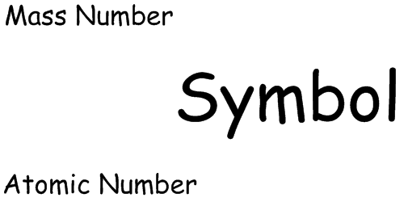

For example, the element Boron:

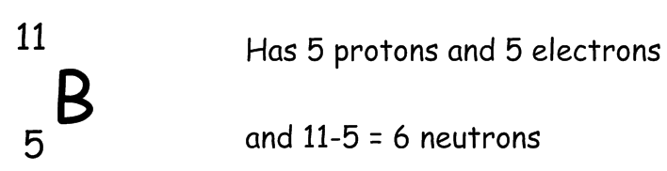

Electron arrangements

Electrons can have different energy levels and an electron occupies an area outside the nucleus called the electron shell or energy level depending on its energy.

Each shell can only hold a certain number of electrons.

The electrons in an atom occupy the lowest shell available (closest to the nucleus) and only go up a level when the lower one is full.

For example, sodium:

Atomic number = 11 (so it has 11 electrons)

They are arranged as 2,8,1

The first shell, closest to the nucleus can only hold two electrons. The second and third shells holds up to eight electrons each.*

(*You only need to be able to work out the electron arrangements for the first 20 elements at this stage and the rule above applies to the first 20 elements.)

The electron arrangement for sodium (2,8,1) can be drawn as follows:

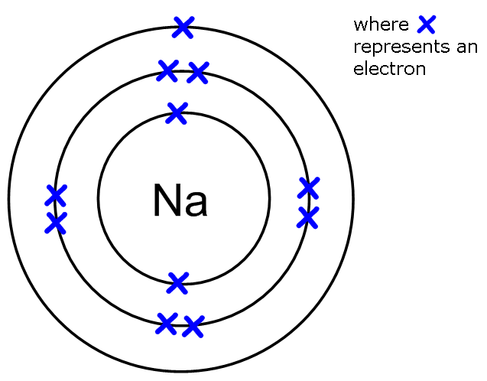

The electron arrangements of the first 20 elements are shown in the figure below:

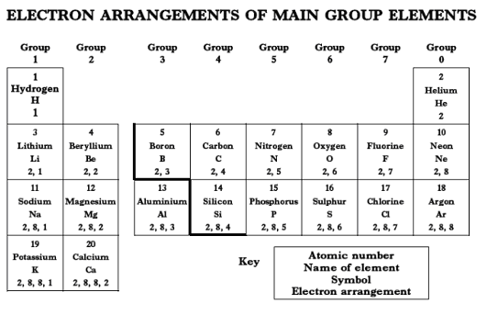

Ions

In some compounds, electrons have been transferred from one atom to another.

This means that it will be negatively charged if it has gained electrons, positively charged if it has lost electrons. These particles are called ions.

Metals lose electrons and become positive ions.

Non-metals usually gain electrons and become negative ions.

When an atom becomes an ion it has the same electron arrangement as one of the group 0 elements (for example neon).

Examples of Ions

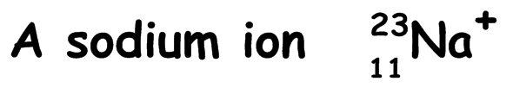

Has…

11 protons
10 electrons (arrangement 2, 8)
12 neutrons

In the ion there are 11 (positive) protons and 10 (negative) electrons, so the overall charge is 1+.

Isotopes

The number of neutrons in an atom can vary.

For example an atom of chlorine can have either 18 or 20 neutrons.

The symbols for these atoms are:

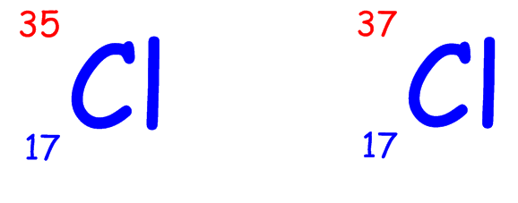
They are both chlorine atoms since they both have the same number of protons, they are called isotopes.

ISOTOPES are atoms with the same atomic number, but different mass numbers.

Most elements are made up of a mixture of isotopes which is why their (relative atomic) mass numbers you often see on a Periodic Table are not whole numbers.

Relative Atomic Mass

The relative atomic mass (RAM) of an atom is the average mass of the atoms of an element.

When we calculate the RAM of an element we take into account the proportions of each isotope present.

The RAM of an element is usually closest to the mass of the isotope with the higher proportion. For example the RAM of Cl = 35.5. Therefore we can conclude in a sample of chlorine

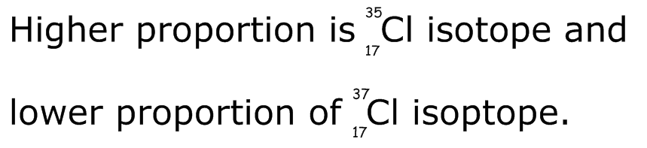

Some important groups in the Periodic Table

Group 1: The Alkali Metals

The elements in group 1 are known as the alkali metals.

They react rapidly (very fast) with water, producing an alkaline solution and hydrogen gas.

As you go down the group the elements become more reactive.

Examples include: Lithium, sodium and potassium

Group 2: The Alkali Earth Metals

These elements include magnesium, calcium and barium.

They burn brightly and react with oxygen to form oxides. The oxides form alkali solutions with water.

Magnesium + oxygen → magnesium oxide

Magnesium oxide + water → magnesium hydroxide

Group 7: The Halogens

The elements in group 7 are known as halogens.

Fluorine and chlorine are gases. Bromine is one of only two liquid elements. Iodine is solid.

As you go down the group the halogens become less reactive.

Group 0: The Noble Gases

The elements in group 0 are called the noble gases.

They are very unreactive and exist as individual atoms (monatomic).

Examples include: Helium, neon and argon.

The Transition Metals

The transition metals are elements which are found between groups 2 and 3.

They do not have their own group number.

Well known examples are iron, copper and gold.

They are generally quite dense (heavy) and many form brightly coloured compounds.

