NATIONAL 4 AND NATIONAL 5 CHEMISTRY

Unit 2: Nature’s Chemistry
Topic 1
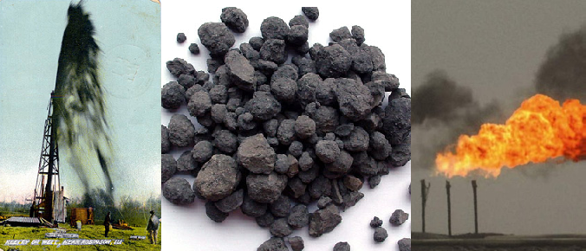
FUELS

Name __________________________________ Class _____

Unit 2: Nature’s Chemistry

Topic 1: Fuels

LEVEL  N4 N5 | AFTER COMPLETING THIS TOPIC YOU SHOULD BE ABLE TO: | NOTES  (Page) | How well I have understood (✓)
LEVEL  N4 N5 | AFTER COMPLETING THIS TOPIC YOU SHOULD BE ABLE TO: | NOTES  (Page) | ☺ | 😐 | ☹
N4 | State a fuel is a chemical, which burns giving out energy.
N4 | Name fuels and describe where they are used.
N4 | State what is meant by a fossil fuel, and name the fossil fuels.
N4 | Describe how the fossil fuels were formed.
N4 | Describe how the fossil fuels are extracted.
N4 | Name some of the alternative renewable energy technologies and give some advantages over fossil fuels.
N4 | Name some fuels produced from plants (biomass).
N4 | State combustion is another word for burning.
N4 | State when a substance burns it reacts with oxygen.
N4 | Describe an experiment to identify the products of combustion.
N4 | State hydrocarbons burn in a plentiful supply of air to produce water and carbon dioxide.
N4 | State if there is insufficient oxygen (air) during combustion incomplete combustion occurs.
N4 | Name the chemicals, which can be produced as the result of incomplete combustion of a hydrocarbon.
N4 | State crude oil is a mixture of molecules, which are mainly hydrocarbons.
N4 | State a hydrocarbon is a compound made from hydrogen and carbon atoms only.
N4 | State that refining crude oil separates the different hydrocarbons by distillation.
N4 | Describe how the distillation of crude oil is carried out in an oil refinery.
N4 | State the different components separated from crude oil are called fractions, and describe their properties vary with their boiling points.
N4 | Name the fractions obtained from crude oil and give some uses for each fraction.

N4 | FOSSIL FUELS | N4

WHAT IS A FUEL?
Fuels are important in our everyday lives.
Fuels provide energy to heat our homes, cook food, and power our transport.

DICTIONARY - FUEL
A FUEL is a chemical, which burns giving out energy.

DICTIONARY - COMBUSTION
COMBUSTION is another name for burning. It is a reaction of a substance with oxygen, giving our energy.

DICTIONARY - EXOTHERMIC
Any reaction, which gives out energy, is called an EXOTHERMIC REACTION.
Combustion is an exothermic reaction.

FOSSIL FUELS
Coal, oil and natural gas are FOSSIL FUELS.

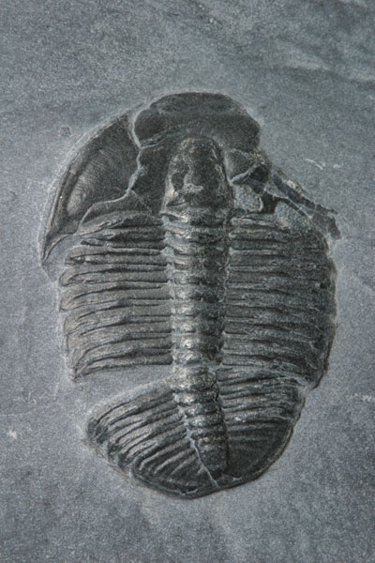 | Fossils are the remains of a plant or animal, which died millions of years ago and got, trapped in rock. | 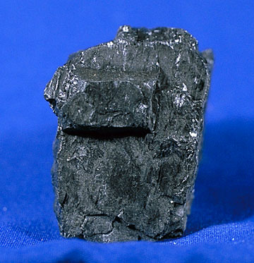  COAL
DICTIONARY - FOSSIL FUEL
A FOSSIL FUEL is a fuel, which has been made from the remains of dead plants, and animals, which died millions of years ago.
Coal, oil and natural gas are fossil fuels.
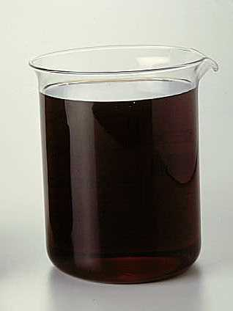  CRUDE OIL |  | 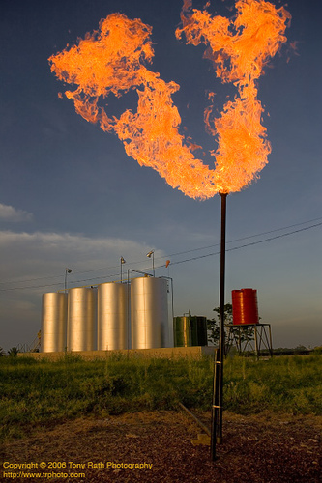  NATURAL GAS
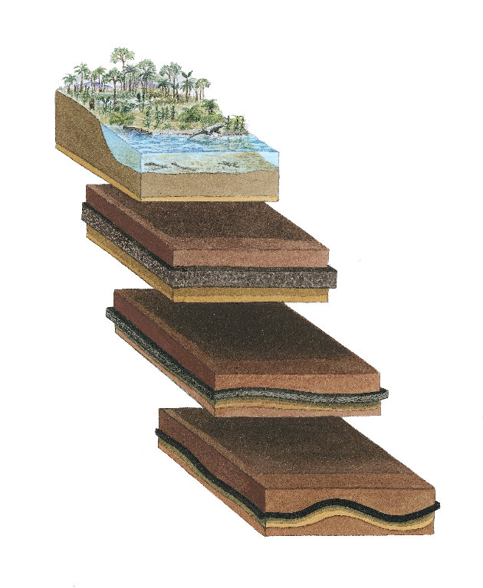
COAL FORMATION
Coal was formed from the dead remains of trees and plants that lived in forests and swamps about 300 million years ago, during a time called the CARBONIFEROUS AGE.

When the trees and plants died they formed layers. These layers became covered with mud, which protected them from the atmosphere, and this prevented them rotting away.
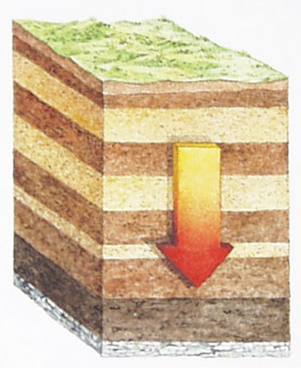

These layers became buried deep underground and with PRESSURE, HEAT and the action of bacteria, the layers of dead trees and plants changed into coal.

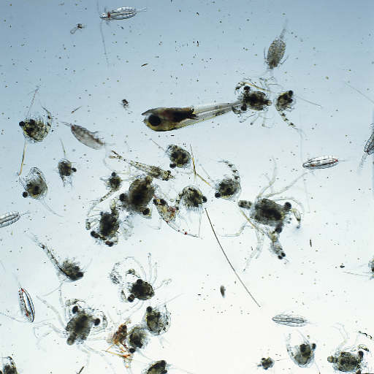
plankton

OIL & NATURAL GAS FORMATION

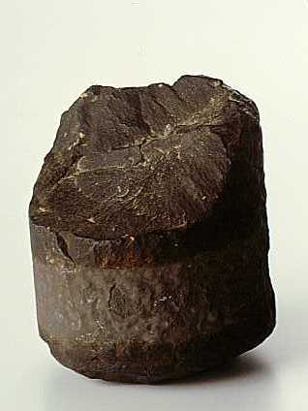
Oil and natural gas was formed from the dead remains of sea animals and plants called PLANKTON that lived about 300 – 400 million years ago.
Sandstone core from an oil well.

When the plankton died they fell to the sea floor and became buried amongst layers of sand.

With pressure, the sand was compressed into a porous rock called sandstone.

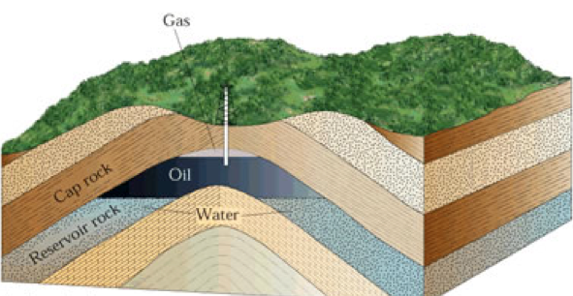
With PRESSURE, HEAT and the action of bacteria the plankton changed into oil and natural gas, which was trapped in the sandstone.

With movements in the Earth’s crust the layers of rock folded and a dome formed. This dome is an oil and gas well.

EXTRACTING FOSSIL FUELS

EXTRACTING COAL
Coal can be found in most countries. The first coal used by man was found on the surface or very close to it. Early coal extraction was small scale.

The industrial revolution demanded huge quantities of coal. The extraction of coal became a huge industry to supply the coal for industry.

There are a number of ways of extracting coal.

SURFACE MINING |  | DEEP MINING
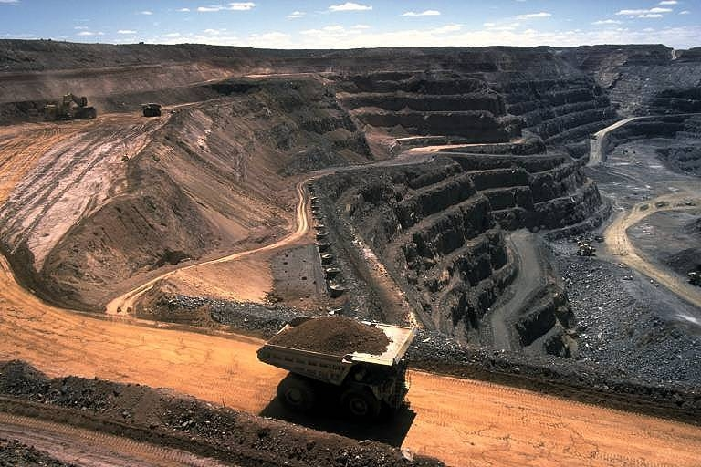  Surface mining is used when the layers of coal lie just below the surface of the earth. |  | 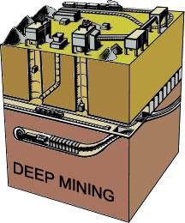  Deep mining is used when the layers of coal lie deep below the surface of the earth

EXTRACTING OIL & NATURAL GAS
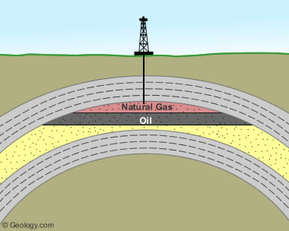
Oil and natural gas are trapped in layers of porous rock. The oil and natural gas are extracted by drilling down to the layers of rock, which contain the oil, and gas to create a well.
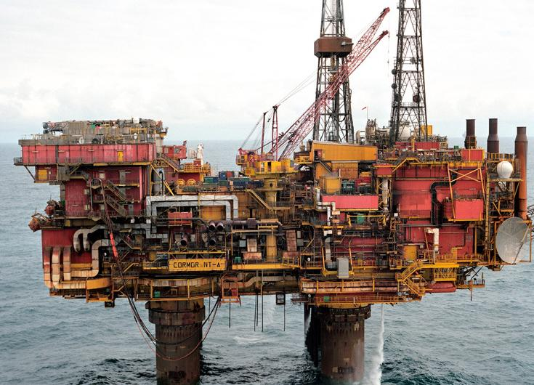

The oil and gas, which comes up from a well, can be transported to an oil refinery, by a pipeline or by tanker.

N4 | ALTERNATIVE SOURCES OF ENERGY | N4

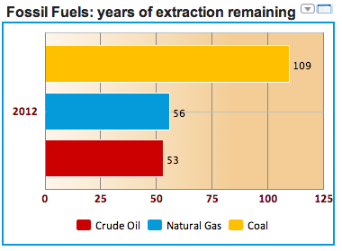
RENEWABLE ENERGY
The fossil fuels are a finite resource, which means they will eventually run out.

The graph shows the reserves of the fossil fuels in the earth.

To ensure our energy needs will continue to be met in the future requires a shift away from using fossil fuels to renewable sources of energy.

Reducing the quantity of carbon-based fuels used will reduce the emission of carbon dioxide, and therefore reduce global warming.

Examples of renewable sources of energy are:
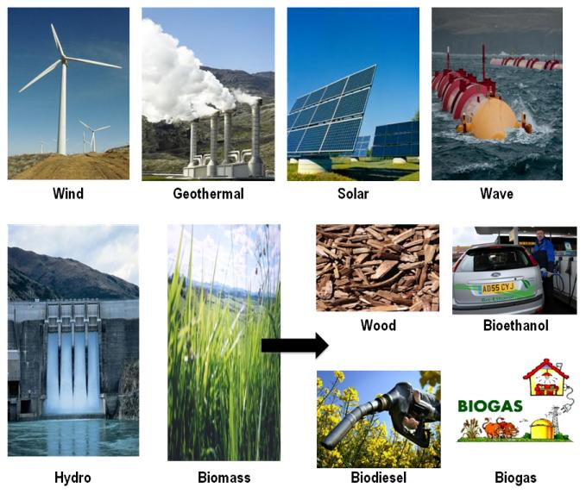
N4 | COMBUSTION OF FUELS |  |  |  | N4

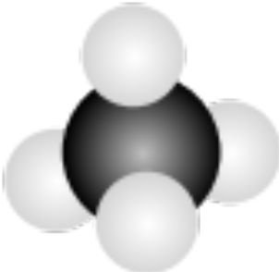
COMBUSTION REACTION
methane, CH₄
The most common fuel used to provide heat for cooking and heating in our homes is the gas called methane.

Methane is the simplest hydrocarbon.

COMBUSTION OF METHANE (CH₄)
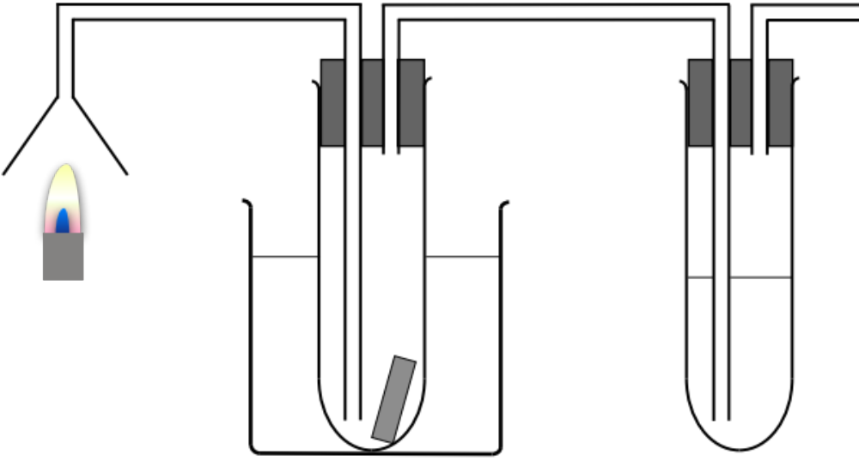
methane burning
TUBE A
TUBE B
dry test tube
cold water
cobalt chloride paper
lime water
suction pump

The products of combustion of methane are sucked into the apparatus.

RESULTS

TUBE A | Condensation and a colourless liquid forms.  The cobalt chloride paper changes colour from blue to pink. The colourless liquid is WATER.
TUBE B | The lime water turns cloudy. CARBON DIOXIDE has this effect on lime water.

CONCLUSION

This experiment shows that the products of combustion of methane are WATER and CARBON DIOXIDE.

To prove the colourless liquid, which forms in TUBE A is WATER you need to measure the melting point (freezing point) and the boiling point.

Pure water melts (freezes) at 0 ºC and boils
at 100 ºC.

COMBUSTION EQUATION

methane | + | oxygen |  | water | + | carbon dioxide
CH₄ | + | O₂ |  | H₂O | + | CO₂

During all reactions the atoms of the reactants rearrange to form the products.


During combustion of methane, the oxygen atoms bond with the hydrogen atoms to form water.

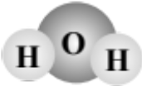

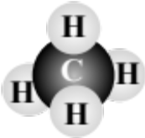
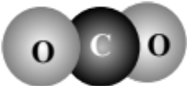
The carbon atom in methane bonds to oxygen atoms to form carbon dioxide.

ANOTHER HYDROCARBON – PARAFFIN WAX

Paraffin wax is another hydrocarbon.

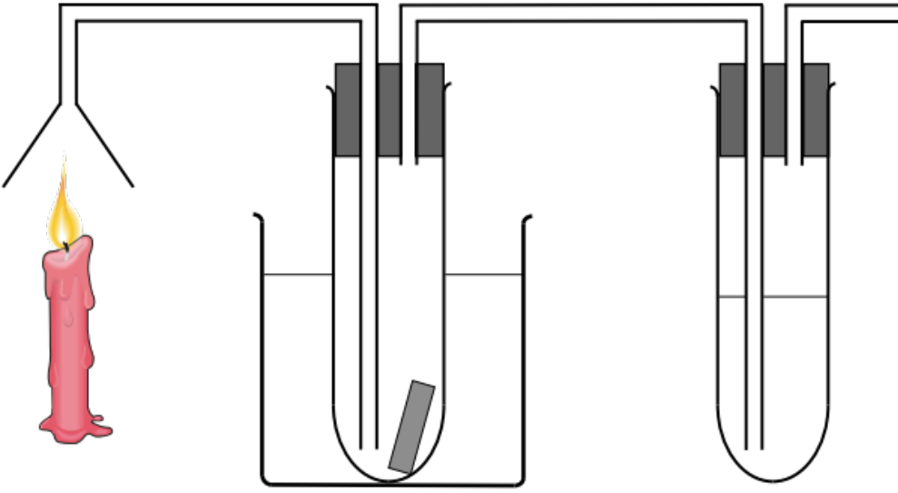
paraffin wax burning
TUBE A
TUBE B
dry test tube
cold water
cobalt chloride paper
lime water
suction pump

The products of combustion of paraffin wax are sucked into the apparatus.

RESULTS

TUBE A | Condensation and a colourless liquid forms.  The cobalt chloride paper changes colour from blue to pink. The colourless liquid is WATER. You can also test the boiling point (100ºC) and melting point (0ºC).
TUBE B | The lime water turns cloudy. CARBON DIOXIDE has this effect on lime water.

CONCLUSION

This experiment shows that the products of combustion of paraffin wax are WATER and CARBON DIOXIDE.

COMBUSTION EQUATION

paraffin wax | + | oxygen |  | water | + | carbon dioxide

Both methane and paraffin wax are HYDROCARBONS. Both produce water and carbon dioxide when they burn.

All hydrocarbons produce water and carbon dioxide when they burn.

hydrocarbon | + | oxygen |  | water | + | carbon dioxide

INCOMPLETE COMBUSTION

During the experiment the tubes of the apparatus became covered in black soot.

Soot is the element carbon. This means some of the carbon atoms in paraffin wax were not bonding to oxygen atoms during combustion, to form carbon dioxide.
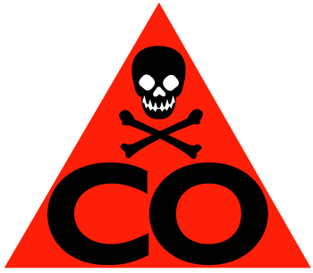
This happens when there is not enough oxygen to completely combine with the carbon atoms.

When there is insufficient oxygen for the fuel to burn COMPLETELY we say “INCOMPLETE COMBUSTION” occurs.

Incomplete combustion of a hydrocarbon also produces the poisonous gas called CARBON MONOXIDE (CO).

