NATIONAL 4 AND NATIONAL 5 CHEMISTRY

Unit 1: Chemical Changes and Structure

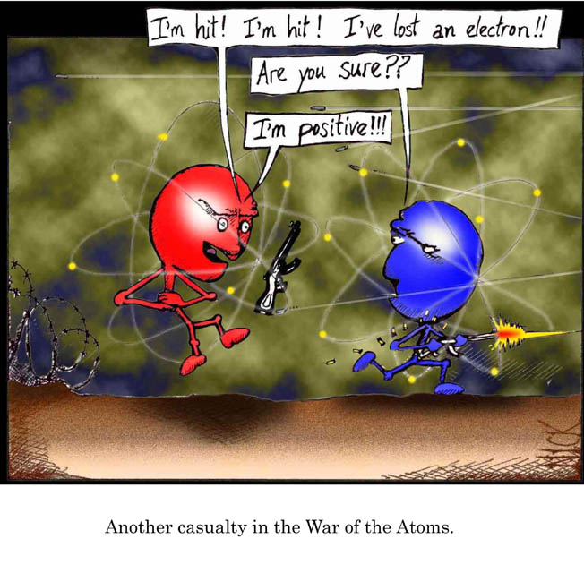
Topic 2
ATOMIC STRUCTURE

Name _____________________________________ Class _____

Unit 1: Chemical Changes and Structure

Topic 2: Atomic Structure

LEVEL  N4 N5 | AFTER COMPLETING THIS TOPIC YOU SHOULD BE ABLE TO: | NOTES  (Page) | How well I have understood (✓)
LEVEL  N4 N5 | AFTER COMPLETING THIS TOPIC YOU SHOULD BE ABLE TO: | NOTES  (Page) | ☺ | 😐 | ☹
N4 | State every element is made up of very small particles called atoms. | 2
N4 | Describe the structure of the atom as having a nucleus, which contains protons and neutrons, with electrons moving around outside the nucleus. | 3-5
N4 | State protons have a charge of one-positive, neutrons are neutral and electrons have a charge of one-negative. | 3-5
N4 | State an atom is neutral because the numbers of protons and electrons are equal. | 6
N4 | State that atoms of different elements have a different number of protons, called the atomic number. | 8
N4 | State electrons in an atom are arranged in energy levels. | 6-7
N4 | State the elements of the Periodic Table are arranged in terms of their atomic number and chemical properties. | 8-11
N4 | State those elements with the same number of outer electrons have similar chemical properties. | 8-11
N5 | State that protons and neutrons have an approximate mass of one atomic mass unit and electrons, in comparison, have virtually no mass. | 12-15
N5 | State an atom has a mass number which equals the number of protons plus neutrons. | 13
N5 | Write nuclide notation for an atom or an ion and calculate the number of protons, neutrons and electrons. | 14
N5 | State isotopes are atoms with the same atomic number but different mass numbers. | 15-16
N5 | State elements exist as a mixture of isotopes and the average mass of an atom is called the relative atomic mass and is rarely a whole number. | 16-17
N5 | Estimate the relative atomic mass of an element given the mass number and abundance of each isotope. | 16-17
N5 | State that the rows of the Periodic Table are called periods. | 18
N5 | Explain how the periods relate to the electron arrangement of an atom. | 18
N5 | State atoms can join by electrons transferring from one atom to another and forming ions. | 19-12

N4 | THE ATOM | N4

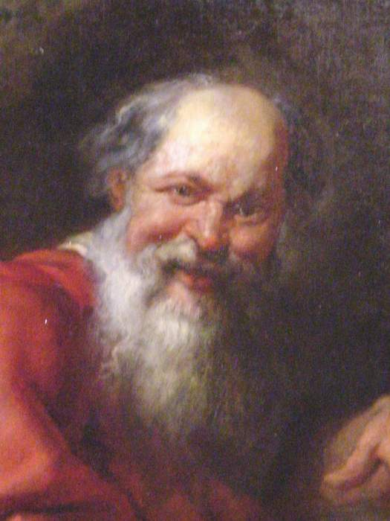
HISTORY OF THE ATOM
Democritus
(about 488 – 370 BC)

The term atom was first used by the Greek philosopher called Democritus.

Democritus thought that if a substance is broken up into smaller and smaller pieces, eventually a stage would be reached where a tiny particle of the substance would exist that could not be broken down.

He called this tiny particle an ATOM. From the Greek word “atomos,” this means indivisible.

All matter is made up of tiny particles called atoms.

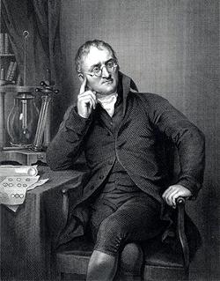
It took over 2000 years before the idea of matter and atoms was used again.
John Dalton
(1766 – 1844)
In 1803, a scientist called John Dalton put forward his ideas on elements and atoms.

John Dalton’s ideas:

  - All substances are made of tiny particles called ATOMS.
  - All atoms of one element are exactly the same.
  - Atoms of different elements join together to form compounds.
  - Atoms cannot be broken down into anything smaller.

John Dalton’s
model of the atom.
John Dalton thought an atom was like a tiny ball.

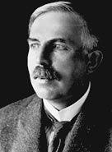
Ernest Rutherford
(1871 – 1937)
The discovery of radioactivity in the latter part of the 19th century showed that atoms were made of smaller particles.

In 1911, a new model of the atom was put forward by a scientist called Ernest Rutherford.
Ernest Rutherford
(1871 – 1937)
Ernest Rutherford’s model of the atom was:
  - The atom is mostly made of empty space.
+
Ernest Rutherford’s atom
  - At the centre of the atom is a tiny POSITIVELY charged particle called the NUCLEUS.
  - Moving round the nucleus are even smaller particles called ELECTRONS.
Negatively charged electron moving round the nucleus
  - Electrons carry a NEGATIVE charge.
Positively charged nucleus.

The positive charge of the nucleus comes from positively charged particles called protons.

ATOMIC NUMBER

All elements are arranged on the Periodic Table by their ATOMIC NUMBER.
The atomic number gives the following information about an atom.
  - The size of the positive charge (number of protons) in the nucleus.
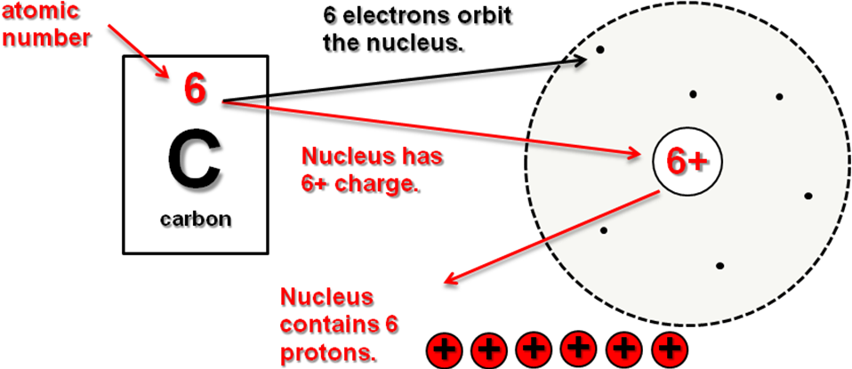
  - The number of negatively charged electrons orbiting the nucleus.

THE NEUTRON
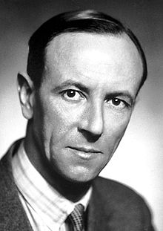
In 1932, James Chadwick discovered that atoms contained a third particle called the NEUTRON.
James Chadwick
(1891 – 1974)

The neutron is found in the nucleus of the atom and has zero charge, it is neutral.

The neutron has the same mass as a proton.

SUMMARY

The atom is made from three smaller particles.

+
Both particles have the same mass and are located in the nucleus of an atom.
Has a nearly zero mass and orbits the nucleus.

Proton
Neutron
Electron

STRUCTURE OF THE ATOM

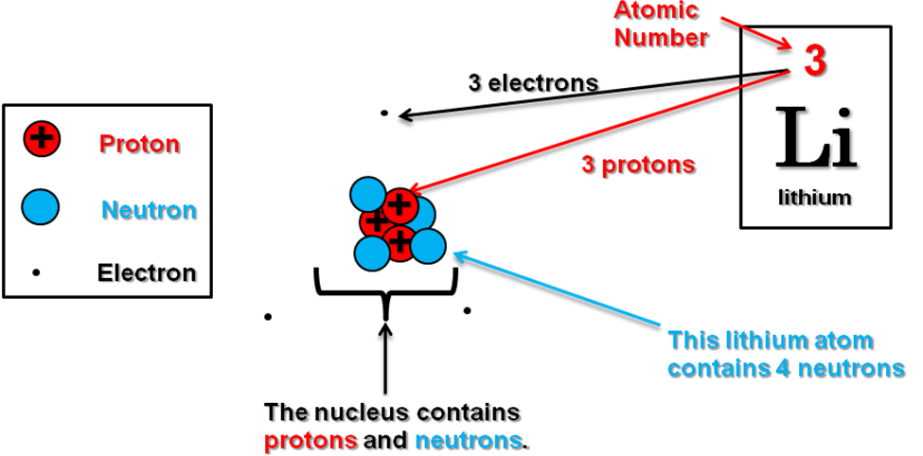
Lithium Atom

Though atoms are made of charged particles they have no overall charge. They are NEUTRAL.
The POSITIVE charge of the protons in the nucleus is CANCELLED OUT by the NEGATIVELY charged electrons.

DICTIONARY - ATOMIC NUMBER
ATOMIC NUMBER is the number of protons in the nucleus of an atom.
Since atoms are electrically neutral, the atomic number also tells you the number of electrons.

 | To practise working out the particles which make up an atom do the ATOMS AND ATOMIC NUMBER examples on page 2 of the Practice Examples Booklet.

N4 | ELECTRONS | N4

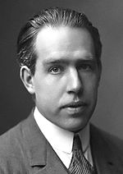
Niels Bohr
(1885 – 1962)
ENERGY LEVELS

The electrons in an atom orbit around the nucleus. This means electrons posses energy.
In 1913, Niels Bohr worked out that electrons only orbit the nucleus at certain distances called ENERGY LEVELS.

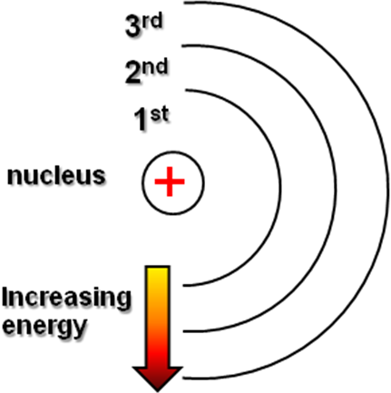

The first energy level can hold 2 electrons.
The second energy level can hold 8 electrons.
The third energy level can hold 8 electrons.

Electrons fill up the lowest energy levels first.

ELECTRON ARRANGEMENT

How the electrons fill up the energy levels in an atom is called the ELECTRON ARRANGEMENT.

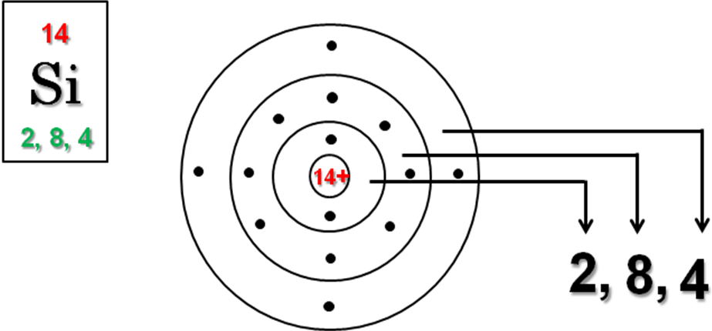

The electron arrangements of atoms can be found in the Chemistry Data Booklet.

ELECTRON ARRANGEMENTS OF SELECTED ELEMENTS

Group I | Group II |  | Group III | Group IV | Group V | Group VI | Group VII | Group 0
1  Hydrogen  H |  |  |  |  |  |  |  | 2  Helium  He
3  Lithium  Li | 4  Beryllium  Be |  | 5  Boron  B | 6  Carbon  C | 7  Nitrogen  N | 8  Oxygen  O | 9  Fluorine  F | 10  Neon  Ne
11  Sodium  Na | 12  Magnesium  Mg |  | 13  Aluminium  Al | 14  Silicon  Si  2, 8, 4 | 15  Phosphorus  P | 16  Sulphur  S | 17  Chlorine  Cl | 18  Argon  Ar
19  Potassium  K | 20  Calcium  Ca

 | Use the Chemistry Data Booklet to write the electron arrangement of each atom in the periodic table above.
CHEMICAL PROPERTIES

When atoms react and join they use their outer electrons on their atoms.
These electrons are the first particles the atoms meet when they approach each other to join.

The outer electrons on an atom are responsible for the CHEMICAL PROPERTIES.

GROUP I – ALKALI METALS

The elements in group I are called the ALKALI METALS.

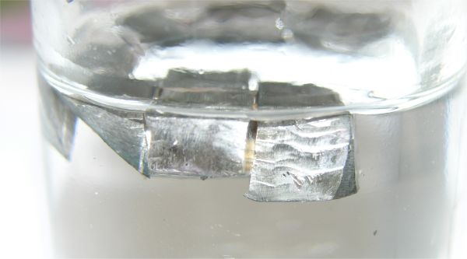
Lithium (Li)
Group I
3
Li
Lithium

11
Na
Sodium

19
K
Potassium

37
Rb
Rubidium

55
Cs
Caesium

87
Fr
Francium

All the alkali metals have 1 electron in the outer energy level of their atoms.

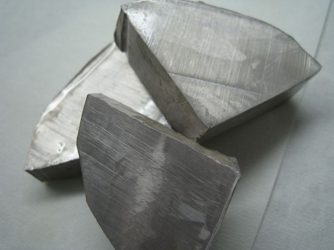
Li, Na and K are stored in oil to protect them from moisture and oxygen in the air.
Sodium (Na)

Li, Na and K react vigorously with water and produce an alkaline solution.

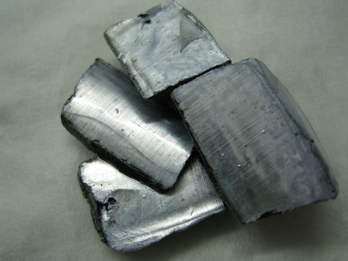
Potassium (K)

Going down group I, the reactivity of the metals increase.

All group I – alkali metal atoms have 1 electron in their outer energy level.

GROUP VII – THE HALOGENS

The non-metals in group VII are called the HALOGENS.
Group VII
9
F
Fluorine

17
Cl
Chlorine

35
Br
Bromine

53
I
Iodine

85
At
Astatine

Fluorine is a pale yellow gas.

Chlorine is a pale green gas.

Bromine is a brown liquid.

Iodine is a dark purple solid.

Astatine is man-made element which is radioactive.

All group VII – halogen atoms have 7 electrons in their outer energy level.

GROUP 0 – THE NOBLE GASES

The non-metals in group 0 are called the NOBLE GASES.
Group 0
2
He
Helium

10
Ne
Neon

18
Ar
Argon

36
Kr
Krypton

54
Xe
Xenon

86
Rn
Radon

Helium is used for filling balloons.

Neon is used in advertising lights.

Argon is used in lasers.

Krypton is used in special light bulbs.

Xenon is used in the bulbs in camera flashguns and stroboscopes.

Apart from helium, all group 0 - noble gas atoms have 8 electrons in their outer energy level. The helium atom only contains 2 electrons.

The chemical properties of an atom depend on the number of electrons in the outer energy level.

All the atoms in the same group have the same number of electrons in the outer energy level of their atoms which gives them similar chemical properties.
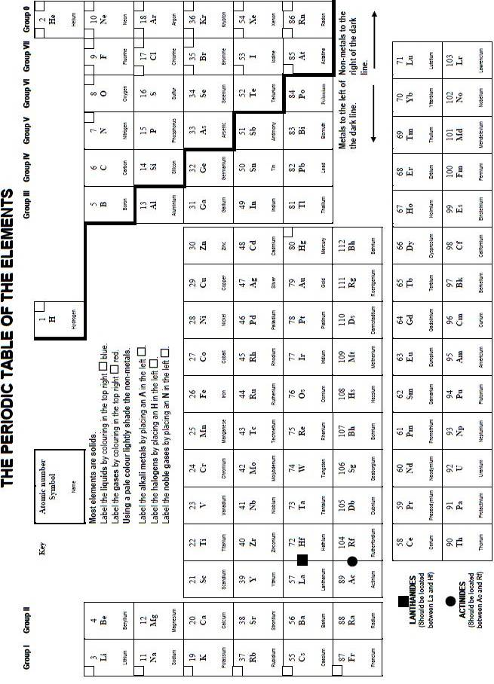

N5 | ATOMIC & MASS NUMBERS | N5

SUB – ATOMIC PARTICLES

Atoms are made of three smaller particles. These particles are called the sub – atomic particles as they are smaller than the atom.

Helium Atom 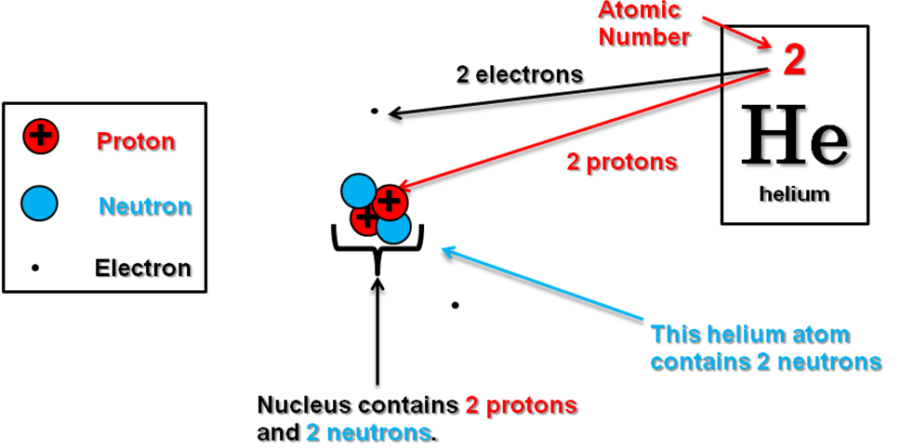

+
The proton has a positive charge.

Neutron has zero charge. It is NEUTRAL.

The proton and neutron have the same mass. Their mass is very small at 1.67 × 10^{‒27} kg.

This number is called 1 atomic mass unit (amu for short).

The electron has a negative charge. Its mass is about 1850 times smaller than a proton / neutron.
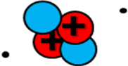
Helium nucleus has a mass of 4 amu.
The mass of an electron is so small it is taken to be 0 amu.
Proton
Neutron
Electron

This means the mass of an atom comes from the protons and neutrons in the nucleus of the atom.
SUMMARY

Particle | Mass  (amu) | Charge | Location
 | 1
 |  | 0
 |  |  | Moves around the nucleus

NUMBERS

DICTIONARY - ATOMIC NUMBER
ATOMIC NUMBER is the number of protons in the nucleus of an atom.
Since atoms are electrically neutral, the atomic number also tells you the number of electrons.

The mass number of this helium atom is 4 amu.
The mass of an atom comes from the protons and neutrons in the nucleus of the atom.
Since the proton and neutron have a mass of 1 amu the total is called the MASS NUMBER.

DICTIONARY - MASS NUMBER
MASS NUMBER is the total number of protons plus neutrons in the nucleus of an atom.
Mass number = No. of protons + No. of neutrons

Knowing the atomic number and the mass number of an atom, the number of neutrons in the nucleus can be calculated.

Neutron  number | = | Mass  number | - | Atomic  number

ELEMENT SYMBOLS

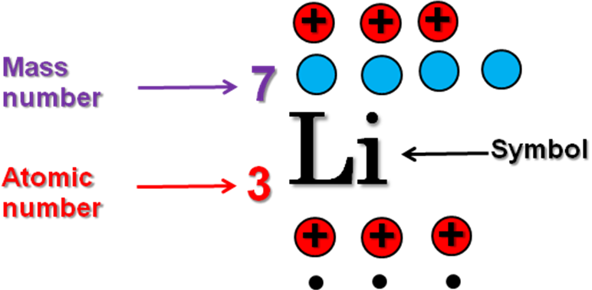
Lithium Atom

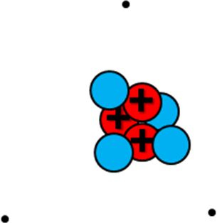
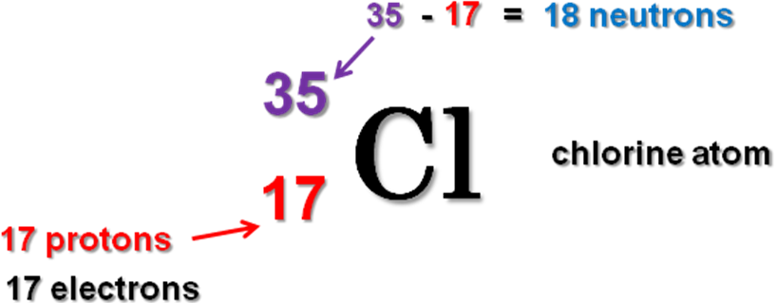

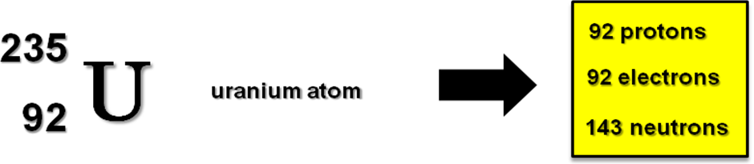

To practise working out the particles which make up an atom, and writing element symbols with mass and atomic numbers, do the ATOM NUMBERS 1 and 2 examples on pages 3 & 4 of the Practice Examples Booklet.

N5 | ISOTOPES | N5

SAME BUT DIFFERENT!!

The number of protons in the nucleus determines the type of atom.

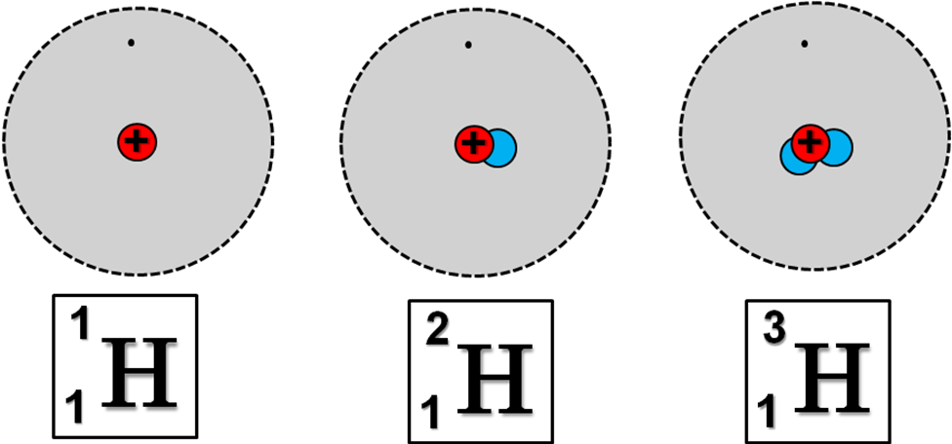
Here are 3 hydrogen atoms.

These are all hydrogen atoms as they have 1 proton in their nucleus.
The difference between the atoms is caused by different numbers of neutrons in the nuclei.
The different number of neutrons affects the MASS NUMBERS of the atoms.
These 3 different atoms of hydrogen are called ISOTOPES.

DICTIONARY - ISOTOPES
ISOTOPES are atoms with the same ATOMIC NUMBER but have DIFFERENT MASS NUMBERS.
i.e. Atoms of the same element with different numbers of neutrons in their nuclei.

Isotopes comes from two Greek words “isos” meaning “equal,” and “topos” meaning “place”.
Isotopes are atoms which come from the same place in the periodic table.
All elements have 2 or more isotopes.
ISOTOPES OF CARBON

 | 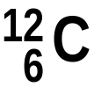 | 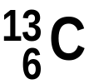 | 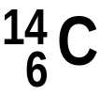
No. of protons
No. of electrons
No. of neutrons

A sample of carbon contains all 3 isotopes. However, the 3 isotopes are not present in equal quantities.

The average mass of a carbon atom is calculated.

RELATIVE ATOMIC MASS

Here are the 3 naturally occurring isotopes of carbon and their abundance.

Abundance | 98.93 % | 1.07 % | 0.0000000001 %

The average mass of a carbon atom is 12.011.

The average is just above 12 as the most abundant carbon isotope is mass number 12. No carbon atom has a mass of 12.011. Their masses will be 12 or 13 or 14.

The average mass of an atom is called the RELATIVE ATOMIC MASS.

The relative atomic mass of carbon is 12.011.

The mass of atoms is measured using an instrument called a MASS SPECTROMETER.
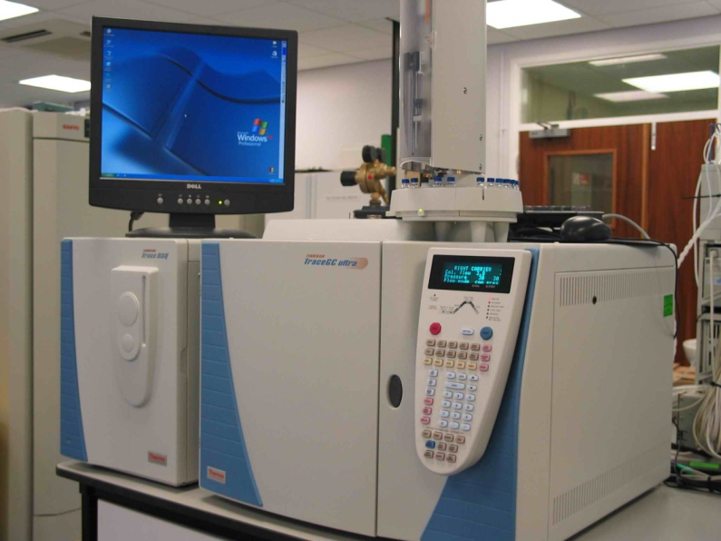
The mass spectrometer measures the masses of atoms and how much (abundance) of each isotope is present.

The scale of atomic mass of atoms is measured by using the isotope of carbon with mass number 12 (¹²C) as the standard.

The scale of atomic masses is said to be relative to the ¹²C standard.

DICTIONARY - RELATIVE ATOMIC MASS
RELATIVE ATOMIC MASS is the average mass of an atom. It is calculated from the mass numbers of the isotopes and their abundance.
The word “RELATIVE” is used because atoms have their mass compared to carbon atoms with a mass number 12 (¹²C).

Here are the isotopes of chlorine and their abundance.

 | 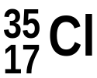 | 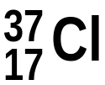
Abundance | 98.93 % | 1.07 %

The relative atomic mass of chlorine is 35.453. This average is close to 35 as ³⁵Cl is the most abundant isotope.

The relative atomic masses of selected atoms are listed in the Chemistry Data Booklet. Most values are rounded to whole numbers.

N5 | THE PERIODIC TABLE & IONS | N5

PERIODIC TABLE

The rows of the Periodic Table are called the PERIODS.

The periods relate to the filling up of the energy levels with electrons.

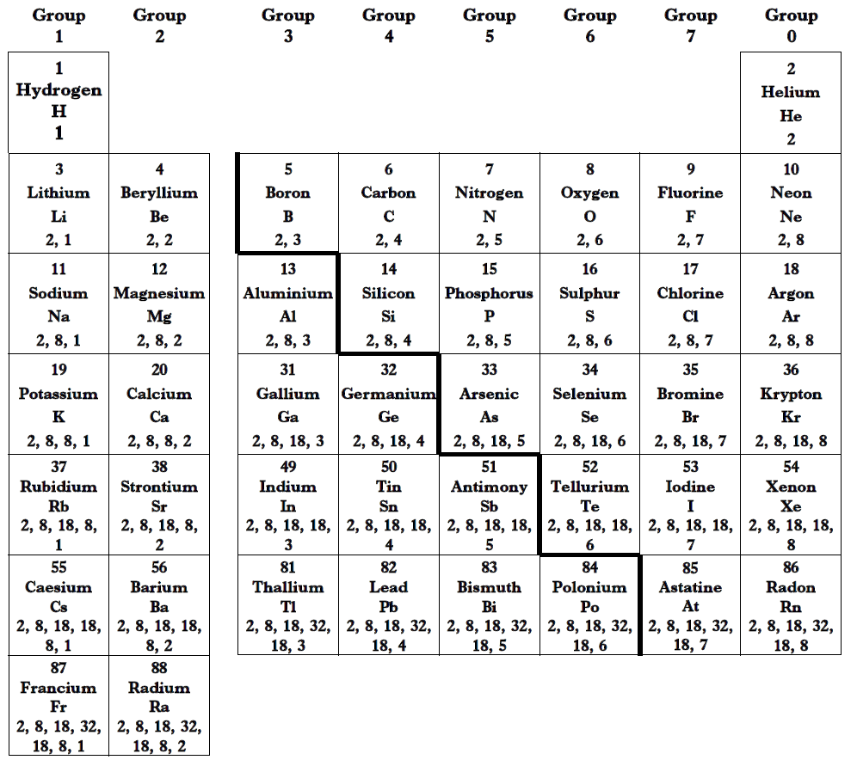
1st energy level holds 2 electrons.
1st energy level full.

2nd energy level holds 8 electrons.
There are 7 energy levels in an atom and there are 7 periods (rows). The energy levels further out from the nucleus can hold increasing numbers of electrons.

2nd energy level full.

The numbered columns are called GROUPS.
ATOMS JOINING
Atoms use their outer electrons to join. It is the outer electrons on an atom which gives the atom its chemical properties.

One way atoms can join is to TRANSFER one or more electron(s) from one atom to another.
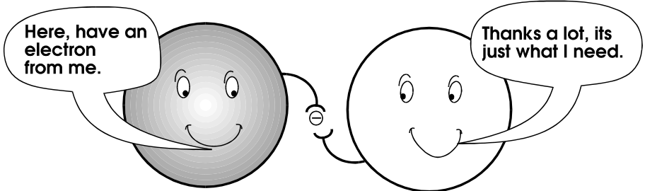

When an electron transfers from one atom to another the atoms will no longer be electrically neutral.

Charged atoms are called IONS.
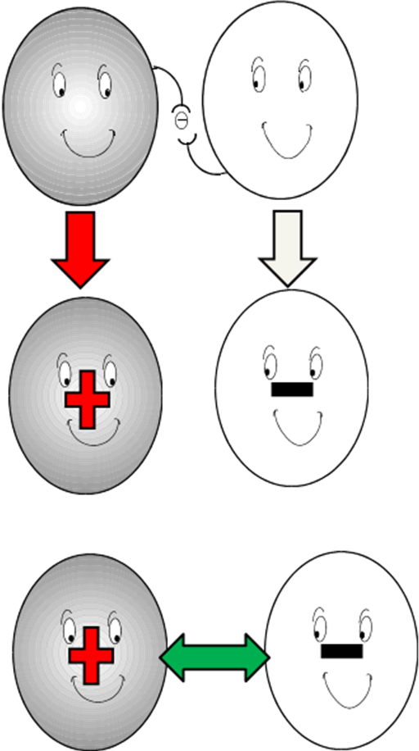
Atoms have equal numbers of positive charges (protons) in the nucleus and negative electrons.

Atoms are NEUTRAL.

When an atom loses an electron it becomes a positively charged ion.

When an atom gains an electron it becomes a negatively charged ion.

Opposite electrical charges attract.
The ions attract each other and stick together.
ION SYMBOLS

Lithium atom | Lithium ion
Li | Li⁺
 | Lithium ion has a 1 positive charge. Its atom lost 1 electron.

Oxygen atom | Oxide ion
O | O²⁻  Negative ions end their name in ide.
 | Oxide ion has a 2 negative charge. The oxygen atom gained 2 electrons.

Aluminium atom | Aluminium ion
Al | Al³⁺
 | Aluminium ion has a 3 positive charge. Its atom lost 3 electrons.

Chlorine atom | Chloride ion
Cl | Cl⁻  Negative ions end their name in ide.
 | Chloride ion has a 1 negative charge. The chlorine atom gained 1 electron.

IONS SYMBOL AGAIN!
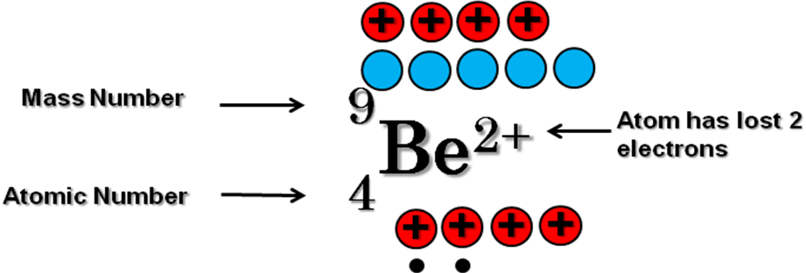
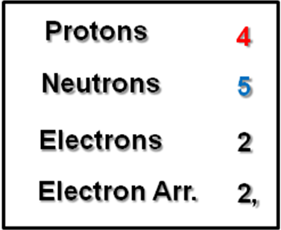

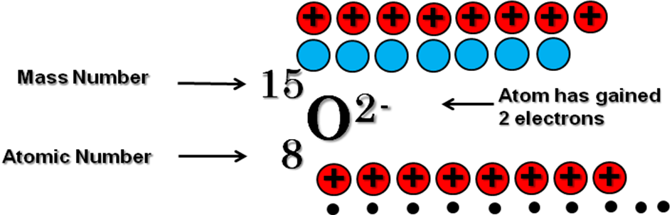

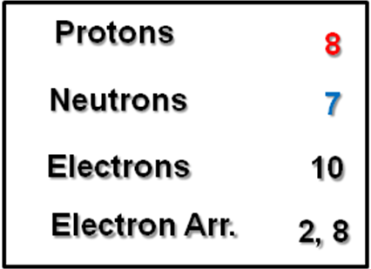

To practise working out the particles which make up an atom or ion, and writing element symbols with mass and atomic numbers, do the IONS, ATOMS AND NUMBERS Parts 1, 2 and 3 examples on pages 5 - 7 of the Practice Examples Booklet.

