 **NATIONAL 4 AND NATIONAL 5CHEMISTRY**

**Unit 2: Nature’s Chemistry**

**Topic 3**

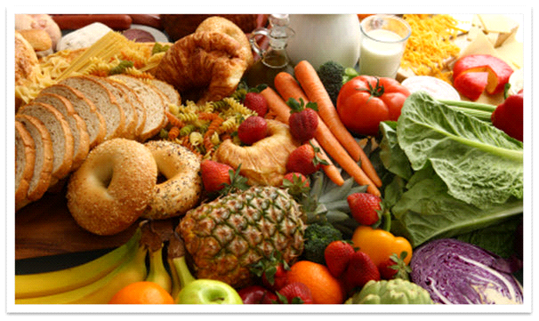**CARBOHYDRATES**

|  |
| --- |
| **Name __________________________________ Class _____** |

|  |  |  |  |  |  |
| --- | --- | --- | --- | --- | --- |
| Unit 2: Nature’s Chemistry | | | | | |
| Topic 3: Carbohydrates & Alcohols | | | | | |
| LEVEL N4 N5 | **AFTER COMPLETING THIS TOPIC YOU SHOULD BE ABLE TO:** | NOTES (Page) | **How well I have understood (✓)** | | |
| **☺** | **😐** | **☹** |
| N4 | Give examples of carbohydrates to include glucose, sucrose and starch. | 3 |  |  |  |
| N4 | State that carbohydrates contain the elements carbon, hydrogen and oxygen. | 3 |  |  |  |
| N4 | State that glucose is sweet and dissolves in water and that starch is not sweet and does not dissolve well in water. | 4 |  |  |  |
| N4 | Explain what is seen when a beam of light is passed through: glucose solution starch solution | 4 |  |  |  |
| N4 | State that it is possible to distinguish starch from other carbohydrates using iodine solution. | 5 |  |  |  |
| N4 | State that Benedict’s or Fehling’s Reagent is used to test for glucose but not for sucrose. | 5 |  |  |  |
| N4 | State that alcoholic drinks can be made from any fruit or vegetable, which is a source of starch or sugars. | 6 |  |  |  |
| N4 | State that fermentation is the breakdown of glucose to form alcohol and carbon dioxide. | 6 |  |  |  |
| N4 | State an enzyme in yeast acts as a catalyst for the reaction. | 7 |  |  |  |
| N4 | Explain why there is a limit to the ethanol concentration of fermentation products. | 7 |  |  |  |
| N4 | Explain why water and alcohol can be separated by distillation. | 7 |  |  |  |
| N4 | State that distillation is a method of increasing the alcohol concentration of fermentation products in the manufacture of ‘spirit’ drinks. | 7 |  |  |  |
| N4 | Give examples to show that the type of alcoholic drink varies with the plant source of the carbohydrate. | 8 |  |  |  |
| N4 | State alcoholic drinks, if taken in excess, can have damaging affects to health and mind. | 9 |  |  |  |
| N4 | Write the chemical equation for the combustion of ethanol. | 10 |  |  |  |
| N4 | State that ethanol, mixed with petrol, can be used as a fuel for cars. | 11 |  |  |  |
| N4 | The ethanol obtained from sugar cane, is a renewable source of energy. | 11 |  |  |  |
| N4 | Understand there are competing demands of growing crops for food and as a source of carbohydrate for fuel. | 11 |  |  |  |
| N5 | Write the balanced formula equation for the fermentation reaction. | 13 |  |  |  |
| N5 | State that ethanol is a member of a homologous series called the alkanols. | 13 - 16 |  |  |  |
| N5 | Identify an alkanol from the hydroxyl group and the ‘-ol’ name ending. | 13 |  |  |  |
| N5 | Name straight-chain alkanols, incorporating the position of the hydroxyl group, from shortened and full structural formulae (only C1 to C8). | 17 |  |  |  |
| N5 | State the chemical and physical properties of the alkanols and the general formula which show the alkanols are a homologous series. | 14 |  |  |  |
| N5 | Give examples of the uses of alcohols.the alkjanols ols | 18 |  |  |  |

|  |  |  |
| --- | --- | --- |
| **N4** | **CARBOHYDRATES** | **N4** |

**NAMES AND SOURCES**

Carbohydrates are naturally occurring molecules. Many carbohydrates are found in food.

Examples of carbohydrates are:

|  |  |  |  |  |
| --- | --- | --- | --- | --- |
| **GLUCOSE**  **C6H12O6** |  | **SUCROSE**  **C12H22O11** |  | **STARCH** |
|  |  | http://whatscookingamerica.net/Cookie/CookiePhotos/PowderedSugar2.jpg |  | http://img.alibaba.com/photo/10824062/Modified_Oxidized_Starch_T_20_Iii.jpg |
| **Used in many sweets and energy drinks.** |  | **Sugar in many sweet foods.** |  | **Found in flour, vegetables, bread and biscuits.** |

**WHAT ARE CARBOHYDRATES?**

Heating a carbohydrate (starch) can break it down into simpler substances, which gives evidence about its formula.

|  |  |
| --- | --- |
| **starch**  **water condenses**  **HEAT** | **RESULTS**  The starch turns black and water condenses on the cooler parts of the test tube.  The black substance is **CARBON**.  Water contains the elements **HYDROGEN** and **OXYGEN.** |

Carbohydrates are made from the elements **CARBON**, **HYDROGEN** and **OXYGEN**. The ratio of **hydrogen : oxygen** is always **2 : 1**.

|  |  |  |  |  |  |  |  |
| --- | --- | --- | --- | --- | --- | --- | --- |
| **Glucose:** | **C6H12O6** |  | **H : O** | **=** | **12 : 6** | **=** | **2 : 1** |

**TESTING CARBOHYDRATES**

The following properties of glucose, sucrose and starch were tested.

|  |  |  |  |
| --- | --- | --- | --- |
| **PROPERTIES OF CARBOHYDRATES** | | | |
| **PROPERTY TESTED** | **Glucose** | **Sucrose** | **Starch** |
| **Appearance (state / colour)** |  |  |  |
| **Taste** | **Sweet** | **Sweet** | **Not Sweet** |
| **Solubility in water** |  |  |  |
| **pH (acidic / neutral / alkaline)** |  |  |  |
| **Light beam through solution** |  |  |  |
| **Iodine test** |  |  |  |
| **Benedict’s test** |  |  |  |

**LIGHT BEAM TEST**

|  |  |
| --- | --- |
| The path of the light beam does not show up in the solutions of glucose and sucrose.  This shows their **molecules are too small to scatter light**.  Glucose and sucrose solutions are called **TRUE SOLUTIONS.** | **LIGHT BEAM**  **sucrose solution**  **glucose solution**  **starch solution** |

The light beam path shows up in starch solution showing its **molecules are large enough to scatter light**.

Starch forms a **COLLOIDAL SOLUTION** as its molecules are large enough to scatter light, but are small enough to remain in solution.

Starch is slightly soluble in cold water but dissolves in hot water.

|  |
| --- |
| **CONCLUSION**  **Glucose and sucrose have small molecules and starchmolecules are large.** |

**TESTING CARBOHYDRATES**

|  |  |
| --- | --- |
| **TEST FOR STARCH**  Starch is the only carbohydrate to change iodine solution from **ORANGE** to **BLACK**.  Iodine solution can be used to detect the presence of starch. |  |

|  |  |
| --- | --- |
| **BENEDICT’S (FEHLINGS) TEST**  When glucose solution is **WARMED** with **BENEDICT’S (FEHLINGS) SOLUTION** the colour changes from **BLUE to ORANGE.**  Benedict’s solution can be used to detect the presence of glucose. |  |

|  |
| --- |
| There is **no test for sucrose**, if **BOTH** the **iodine** and **Benedict’s** solutions do **not change colour** the carbohydrate is **sucrose**. |

|  |  |  |
| --- | --- | --- |
| **N4** | **ALCOHOL** | **N4** |

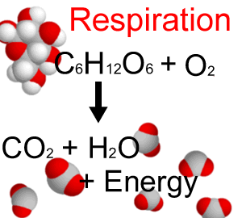**MAKING ALCOHOL - FERMENTATION**

All cells need energy to live. They get this by reacting **glucose** and **oxygen**, during a reaction called **respiration**.

Yeast is a living organism. It can carry out respiration without the need for oxygen. Without oxygen the products are not **carbon dioxide** and **water.**

|  |  |
| --- | --- |
| **The bubbles of gas turns the lime water cloudy showing carbon dioxide is produced.**  **glucose solution + yeast**  **lime water** | When yeast carries out respiration using **GLUCOSE** without oxygen the reaction is called **FERMENTATION.**  The products of fermentation are **ALCOHOL (ETHANOL)** and **CARBON DIOXIDE.** |

|  |
| --- |
| **DICTIONARY - FERMENTATION**  **FERMENTATION** is reaction where glucose is broken down to form **ethanol (alcohol)** and **carbon dioxide.** |

|  |  |  |  |  |
| --- | --- | --- | --- | --- |
| **glucose** |  | **ethanol (alcohol)** | **+** | **carbon dioxide** |
| **C6H12­O6** |  | **2 C2H5OH** | **+** | **2CO2** |

Fermentation is an **exothermic reaction** as energy is released. The energy released during fermentation, keeps the yeast alive.

**ENZYMES**

Enzymes are **protein molecules** present in living organisms, which assist reactions.

Enzymes are **biological catalysts**.

|  |
| --- |
| **DICTIONARY - ENZYMES**  **ENZYMES** are protein molecules, which act as biological catalysts. Many reactions, which take place in living organisms, use enzymes. |

Enzymes in yeast carry out fermentation. The particular enzyme, which converts glucose into ethanol, is called **ZYMASE.**

The ethanol is a waste product from the yeast producing energy. Eventually the **yeast is killed by the ethanol** and the fermentation stops.

**DISTILLATION**

To separate the alcohol (ethanol) from the fermentation mixture, distillation is used, as water and ethanol boil at different temperatures.

|  |  |
| --- | --- |
| **http://www.chemheritage.org/EducationalServices/pharm/antibiot/activity/distil/distil07.gif** | Water boiling point = 100 ºC  Ethanol boiling point = 78 ºC  As the temperature rises the ethanol boils off first. The temperature remains constant at 78 ºC.  When all the ethanol boils off the temperature rises to 100 ºC as the water in the mixture starts to boil. |

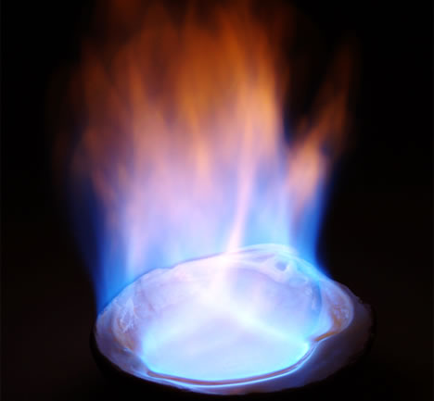

Ethanol is a colourless liquid, which is very flammable.

|  |  |  |
| --- | --- | --- |
| **N4** | **ALCOHOL - DRINKS & FUEL** | **N4** |

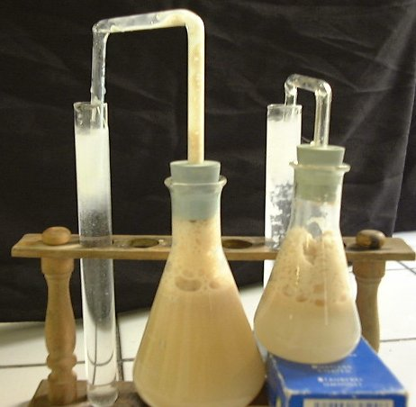**ALCOHOLIC DRINKS**

Ethanol is the alcohol, which is present in all alcoholic drinks. There are a huge variety of alcoholic drinks.

This is possible as there are many different sources of carbohydrate, which provides the sugars for fermentation.

Fermentation stops when the concentration of ethanol reaches approximately 12 %, when the **yeast is killed.**

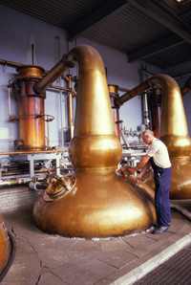

**whisky distillation**

To obtain a higher percentage of ethanol, **distillation** is used to separate the ethanol.

This gives drinks containing approximately 40 % ethanol.

These drinks are called **SPIRITS.**

**SOURCES OF ALCOHOLIC DRINKS**

|  |  |  |  |
| --- | --- | --- | --- |
| **ALCOHOLIC DRINKS** | | | |
| **Drink** | **Source of Carbohydrate** | **% of Alcohol** | **Distillation (yes / no)** |
|  |  |  |  |
|  |  |  |  |
|  |  |  |  |
|  |  |  |  |
|  |  |  |  |
|  |  |  |  |

**UNITS OF ALCOHOL**

Long-term consumption of high quantities alcohol leads to a number of medical problems.

Consumption of alcohol is normally measured in **units of alcohol**. Guidance on safe levels of drinking is given in terms of **units**.

**1 unit of alcohol = 10 cm3 of pure alcohol.**

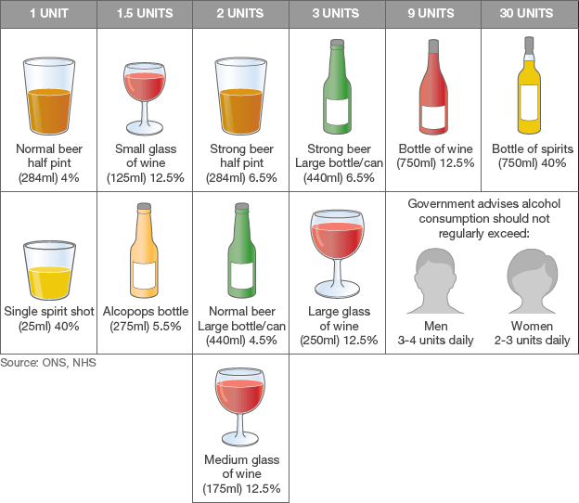

**Advice on the consumption of alcohol.**

**EFFECT OF ALCOHOL ON THE BODY**

Alcohol (ethanol) is a drug, as it affects the way the body works. Alcohol slows the central nervous system; the effect on the body depends on the quantity of alcohol drunk.

The following table shows the immediate effects of alcohol on the body.

|  |  |
| --- | --- |
| **Blood alcohol concentration (g / 100 cm3 of blood)** | **Effect on the person** |
| 0.01 - 0.05 | No effect. |
| 0.03 - 0.12 | More talkative, beginning of impairment of judgement and control. |
| 0.09 – 0.25 | Loss of critical judgement and impaired balance. |
| 0.18 – 0.30 | Disorientation, slurred speech and lethargy. |
| 0.25 – 0.40 | Vomiting, inability to stand and impaired consciousness. |
| 0.35 – 0.50 | Complete unconsciousness leading to possible death. |
| 0.45 + | Death from respiratory arrest. |

**ALCOHOL (ETHANOL) AS A FUEL**

Alcohol is a flammable liquid. The apparatus below can be used to identify the products of combustion of ethanol.



**ethanol burning**

**TUBE A**

**TUBE B**

**dry test tube**

**cold water**

**cobalt chloride paper**

**lime water**

**suction pump**

**RESULTS**

|  |  |
| --- | --- |
| **TUBE A** | Condensation and a colourless liquid forms.  The cobalt chloride paper changes colour from **blue** to **pink**. The colourless liquid is **WATER** (boiling point 100ºC and melting point 0ºC) |
| **TUBE B** | The lime water turns cloudy. **CARBON DIOXIDE** has this effect on lime water. |

**CONCLUSION**

This experiment shows that the products of combustion of **ethanol** are **WATER** and **CARBON DIOXIDE.**

|  |  |  |  |  |  |  |
| --- | --- | --- | --- | --- | --- | --- |
| **ethanol** | **+** | **oxygen** |  | **water** | **+** | **carbon dioxide** |
| **C2H5OH** | **+** | **3O2** |  | **3H2O** | **+** | **2CO2** |

Ethanol burns with a clean flame, which makes it an excellent fuel.

Ethanol is a **biofuel** as it can be made by fermenting carbohydrates obtained from plants.

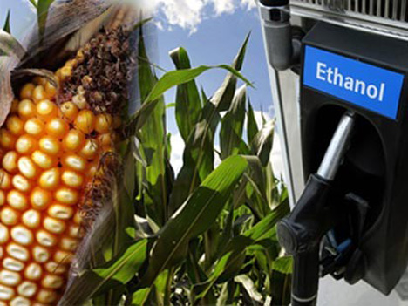**ETHANOL - A BIOFUEL**

Ethanol made from fermenting sugars (carbohydrates) from **sugar cane**, **potatoes** and **corn**, is a renewable source of energy.

Ethanol is currently being used as a fuel in Brazil and the USA. Some vehicles run on ethanol, and others use a mixture of ethanol and gasoline (petrol).

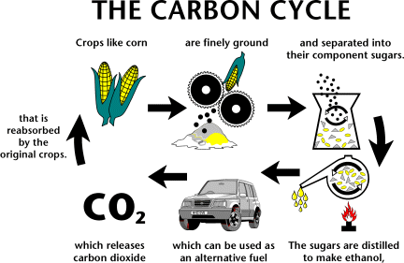

Despite ethanol releasing carbon dioxide when it is burned, plants would absorb it again **during photosynthesis**, which then would be used to produce more ethanol.

Ethanol appears to be environmentally an ideal fuel. However, if farmers are growing crops to produce fuels, they are not producing food to feed people.

There are large numbers of people in the world who experience hunger, so there are important decisions to be made regarding how crops are to be used.

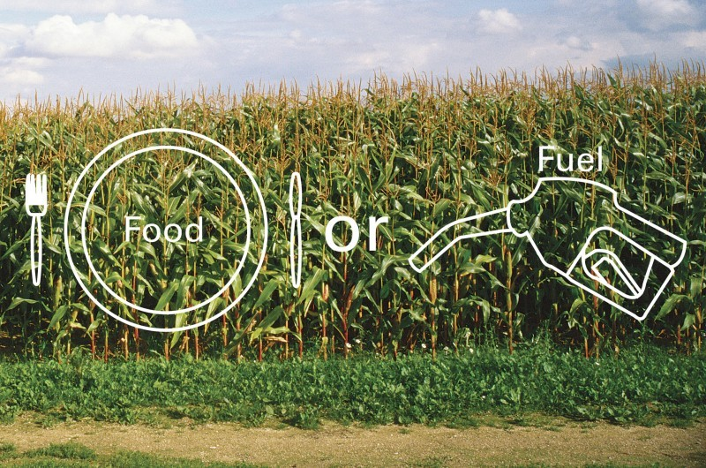

There are parts of plants, which are inedible. (e.g. the stalks of grain crops). These parts are made of a carbohydrate called **cellulose**. Cellulose can also be used to make ethanol.

Using cellulose to make ethanol could provide a solution to the food versus fuel problem.

|  |  |  |
| --- | --- | --- |
| **N5** | **ALCOHOL FAMILY (ALKANOLS)** | **N5** |

**COMMON ALCOHOL- ETHANOL**

Common alcohol is called ethanol.

**hydroxyl group**

|  |  |  |
| --- | --- | --- |
|  |  | **C2H5OH** |
| **CH3CH2OH** |  |  |

The **– O-H** group of atoms is called the **HYDROXYL GROUP**. This is called the **functional group** as it gives the molecule the chemical properties of an alcohol.

The name ethanol tells you the following information.

**ol – contains a hydroxyl group (-OH)**

**an – contains a single C – C bond**

**eth – contains 2 carbon atoms**

|  |  |
| --- | --- |
|  | **ethanol** |

Ethanol is a member of a family of alcohols called **ALKANOLS.**

**PROPERTIES OF ETHANOL**

Ethanol is a **flammable liquid**, which burns to produce **water** and **carbon dioxide**.

The table below shows further properties of ethanol.

|  |  |  |  |
| --- | --- | --- | --- |
| **PROPERTY TESTED** | **OBSERVATION** |  | **CONCLUSION** |
| Appearance (colour and state) |  |  | Ethanol is a covalent liquid.  It is neutral and soluble in water.  Ethanol is a good solvent. |
| Smell |  |  |
| Conductivity |  |  |
| Solubility in water |  |  | Ethanol has a structure similar to water. This is why it is soluble in water.  **H atom in H2O atom substituted with an ethyl group (C2H5-).** |
| pH (acidic / neutral / alkaline) |  |  |
| Solvent action: |  |  |
| ink |  |  |
| varnish |  |  |
| chlorophyll in leaves |  |  |

**MAKING ETHANOL**

Ethanol is made in the alcoholic drinks industry by **fermentation of sugars (glucose)** using enzymes in yeast.

|  |  |  |  |  |
| --- | --- | --- | --- | --- |
| **glucose** | **Enzymes in yeast**  **Enzymes in yeast** | **ethanol (alcohol)** | **+** | **carbon dioxide** |
| **C6H12­O6** |  | **2 C2H5OH** | **+** | **2CO2** |

Ethanol **(industrial alcohol)** is made in the petrochemical industry by **adding water (steam)** across the **C=C bond in ethene**. This reaction is called **HYDRATION**.

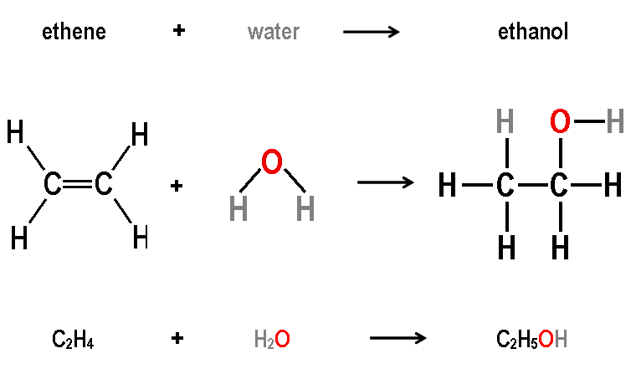

**ALKANOL FAMILY**

Ethanol is the second member of the **homologous series** of alcohols called **ALKANOLS**.

|  |  |  |
| --- | --- | --- |
| **methanol** | **ethanol** | **propanol** |
|  |  |  |
|  |  |  |
| **CH3OH** | **C2H5OH** | **C3H7OH** |

|  |  |
| --- | --- |
| **The general formula of the alkanol family is** | **CnH2n+ 1OH** |

**THE ALKANOLS CONTAINING 1 TO 6 CARBON ATOMS**

|  |  |  |  |
| --- | --- | --- | --- |
| **No. of C atoms** | **Alkanol Name** | **Molecular Formula** | **Full Structural Formula / Shortened Structural formula** |
| 1 | methanol | CH3OH |  |
|  |  |  | **CH3OH** |
| 2 |  |  |  |
|  |  |  | **CH3 CH2 OH** |
| 3 |  |  |  |
|  |  |  |  |
| 4 |  |  |  |
|  |  |  |  |
| 5 |  |  |  |
|  |  |  |  |
| 6 |  |  |  |
|  |  |  |  |

**PHYSICAL PROPERTIES – BOILING POINT**

The following graph shows the boiling point of alkanols versus number of carbon atoms.

**(Find the boiling points of methanol, ethanol, propan-1-ol and butan-1-ol in the data booklet and plot a spike chart on the graph paper below.)**

|  |  |
| --- | --- |
| 14 x 14 blank | **CONCLUSION**  As the number of carbon atoms in the alkanol molecule increases, the boiling point increases.  The alkanols have similar chemical properties and have a general formula showing they are a **HOMOLOGOUS SERIES**. |

**ALKANOL ISOMERS – SYSTEMATIC NAMING**

Alkanol molecules form isomers; therefore the name has to describe the structure. The naming rules learned for hydrocarbons apply except the molecule name ends in **– OL**.

|  |  |  |
| --- | --- | --- |
|  |  |  |
|  |  |  |
| **propan - 1 - ol** | **propan - 2 - ol** | **3 - methylbutan - 1 - ol** |

|  |  |
| --- | --- |
|  | To practise systematic naming of alkanols, do the **SYSTEMATIC NAMING – ALKANOLS** examples on **page 2** of the **Practice Examples Booklet**. |

**USES OF ALCOHOLS**

|  |  |  |
| --- | --- | --- |
| **Alcohol** | **Use** |  |
| **ethanol C2H5OH** | Alcoholic drinks |  |
| Fuel for vehicles. |
| Solvent for varnish, perfume, deodorant. |
| Feedstock for making chemicals. |
|  |  |  |
| **methanol CH3OH** | Mixed with ethanol to make methylated spirits. |  |
| Fuel |
| Feedstock for making chemicals |
|  |  |  |
| **propanol C3H7OH** | Medical – used in hand sanitizers and drug preparation. |  |
| Fuel |
| Feedstock for making chemicals. |

**MILD OXIDATION OF ETHANOL (ALKANOLS)**

Ethanol can undergo a reaction called **OXIDATION** where an oxygen atom is gained by the ethanol molecule.

The oxidation reaction can be carried out by passing ethanol vapour over hot copper(II) oxide. During the reaction oxygen transfers from the copper(II) oxide to the ethanol.

**RESULTS**

The pH or litmus paper turns **red** showing an acid has been produced.

The **black copper(II) oxide** changes to **orange / brown copper** due to loss of oxygen.

The oxidation reaction changes the ethanol to **ethanoic acid**.

|  |  |  |
| --- | --- | --- |
| **ethanol** |  | **ethanoic acid** |
|  |  |  |
|  |  |  |
| **C2H5OH** |  | **CH3COOH** |

Ethanoic acid belongs to a **homologous series** of molecules called the **ALKANOIC ACIDS**.

A dilute solution of ethanoic acid is **vinegar**.

Ethanol (common alcohol) can undergo **oxidation by the action of bacteria and oxygen from the air**. Oxidation of ethanol in alcoholic drinks (e.g. wine) turns the drinks sour due to the formation of ethanoic acid.