 **NATIONAL 4 AND NATIONAL 5 CHEMISTRY**

**Unit 3: Chemistry In Society**

**Topic 3**

**CORROSION**

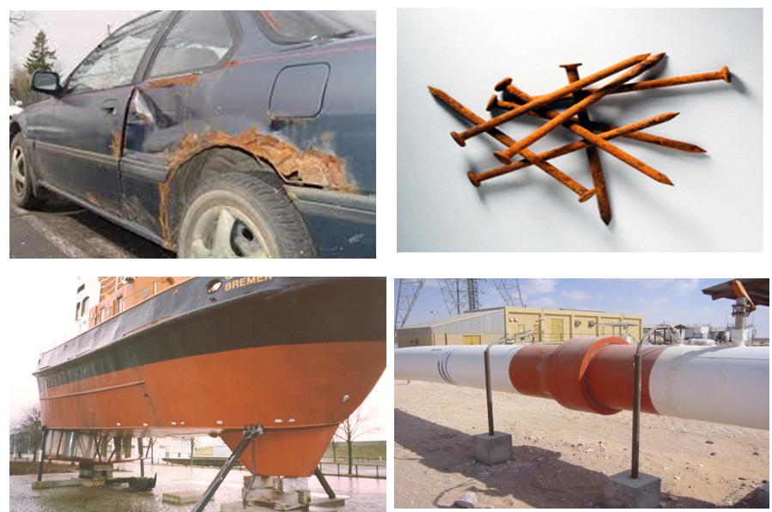

|  |
| --- |
| **Name __________________________________ Class _____** |

|  |
| --- |
| Unit 3: Chemistry In Society |
| Topic 3: Corrosion |

|  |  |  |  |  |  |
| --- | --- | --- | --- | --- | --- |
| LEVEL N4 N5 | **AFTER COMPLETING THIS TOPIC YOU SHOULD BE ABLE TO:** | NOTES (Page) | **How well I have understood (✓)** | | |
| **☺** | **😐** | **☹** |
| N4 | State corrosion is a chemical reaction, which involves the surface of a metal changing from an element to a compound | 3 |  |  |  |
| N4 | State different metals corrode at different rates and this relates to their reactivity. | 3 |  |  |  |
| N4 | State the term rusting is applied to the corrosion of iron. | 3 |  |  |  |
| N4 | State both water and oxygen, from the air, are required for rusting. | 4 |  |  |  |
| N4 | State acid rain increases the rate of corrosion. | 5 |  |  |  |
| N4 | State salt increases the rate of corrosion. | 5 |  |  |  |
| N4 | Use ferroxyl indicator to detect the corrosion of iron (rusting). | 6 |  |  |  |
| N4 | Ferroxyl indicator can be used to detect the presence of iron(II) ions and hydroxide ions. | 6 & 8 |  |  |  |
| N4 | Ferroxyl indicator turns blue in the presence of iron(II) ions and pink in the presence of hydroxide ions. | 6 & 8 |  |  |  |
| N5 | State that corrosion is an oxidation reaction. | 6 |  |  |  |
| N5 | Electrons lost by the iron during rusting are accepted by the water and oxygen to form hydroxide ions. | 7 |  |  |  |
| N4 | Give examples of anti-corrosion methods and how they are used in everyday situations. | 9-13 |  |  |  |
| N4 | Explain how painting, greasing, electroplating, galvanising, tin-plating and coating with plastic give a surface barrier to air and water which can provide physical protection against corrosion. | 9-13 |  |  |  |
| N4 | Describe how to electroplate a metal object. | 12 |  |  |  |
| N5 | Explain the chemistry of electroplating with appropriate ion-electron equations. | 12-13 |  |  |  |
| N4 | State when iron is attached to metals higher in the Electrochemical Series the iron is protected from corrosion and when attached to metals lower down in the series iron corrodes faster. | 13-14 |  |  |  |
| N4 | State galvanising (zinc) and the use of scrap magnesium are examples of sacrificial protection. | 14-15 |  |  |  |
| N4 | State galvanising (zinc) and the use of scrap magnesium are examples of sacrificial protection. | 15 |  |  |  |
| N4 | Explain why scratching tin plate increases the rate of rusting of iron. | 14 |  |  |  |
| N4 | State iron does not rust when attached to the negative terminal of a battery and give examples where this is used to protect. | 16 |  |  |  |
| N5 | State that electrons flowing to iron prevent rusting. | 16 |  |  |  |
| N5 | State that with metals higher in the electrochemical series, electrons flow to the iron, and with metals lower in the series, electrons flow from the iron. | 14-15 |  |  |  |
| N5 | Explain the effect of sacrificial protection in terms of electron flow (e.g. galvanising, scrap magnesium). | 14-15 |  |  |  |
| N5 | Explain why carbon atoms in steel help the steel corrode. | 17 |  |  |  |

|  |  |  |
| --- | --- | --- |
| **N4** | **CAUSES OF CORROSION** | **N4** |

**METALS AND CORROSION**

All metals react to form their ions. When a metal is exposed to the environment it changes into its ions. This reaction is called **CORROSION.**

|  |  |  |  |  |  |  |  |  |
| --- | --- | --- | --- | --- | --- | --- | --- | --- |
| The surface of a metal changes into a compound during corrosion. |  | **Screen Shot 2014-01-01 at 14.35.10.png**  **Mg** | **Zn** |  |  | **http://farm2.static.flickr.com/1027/537279063_7864b3980f.jpg?v=0**  **Fe** |  | **Ni** |
| The corrosion of iron / steel is often called **“RUSTING”**. |  | **Screen Shot 2014-01-01 at 14.43.28.png**  **Pb** |  | **Sn** |  | **Cu** |  | **Screen Shot 2014-01-01 at 14.56.03.png**  **Ag** |

|  |  |  |
| --- | --- | --- |
| **DICTIONARY - CORROSION**  **CORROSION** is a chemical reaction where the surface of a metal changes into a compound. |  | **DICTIONARY - RUSTING**  **RUSTING** is the special name given to the corrosion of iron. |

Steel is widely used, and therefore rusting is a major problem, which can weaken a structure.

Understanding the chemistry of the corrosion reaction helps with devising methods to prevent it**.**

**WHAT CAUSES CORROSION?**

The following experiment was set up to establish what causes the rusting of iron.

|  |  |  |
| --- | --- | --- |
| **WATER AND AIR** | **AIR / NO WATER** | **WATER / NO AIR** |
| **iron nail**  **air**  **water** | **boiled water (boiling removes dissolved air)**  **calcium chloride (removes water)**  **air** | **iron nail** |

**RESULTS**

**layer of oil**

The iron nail exposed to air and water had rusted badly. There was no rusting of the other nails

**CONCLUSION**

This experiment shows both **AIR** and **WATER** are needed for rusting.

**AIR**

The following experiment was set up, and left for a few days, to establish what gas in the air reacts with iron during rusting.

|  |  |
| --- | --- |
| **water**  **damp iron wool**  **air** | **RESULTS**  The water level moves up the test tube by 1/5th.  **CONCLUSION**  The **air** contains approximately 1/5th **oxygen** gas.  This experiment shows rusting uses **oxygen** from the **air**.  Corrosion (rusting) needs **OXYGEN** from the air and **WATER** for the reaction to occur. |

**SPEEDING UP RUSTING**

For rusting to occur both **oxygen** and **water** are required.

|  |  |  |
| --- | --- | --- |
|  | **AIR / SALT WATER** | **AIR / ACID RAIN** |
| The **rusting** of the nails was compared with the **air** and **water** experiment. | **iron nail**  **salt water**  **air** | **air**  **acid rain**  **iron nail** |

**RESULTS**

There was more **rusting** of the nails compared to the nail in **air** and **water**.

**CONCLUSION**

**Salt water** and **acids** are **electrolytes** as they contain ions. **Electrolytes** **speed up rusting** as they help with transfer of **electrons** from the **metal**.

|  |  |  |
| --- | --- | --- |
| **N4** | **DETECTING CORROSION** | **N5** |

**DETECTING RUST**

**Rusting** is a **slow reaction**. It can take many hours before the **orange / brown** colour can be seen. A quick way of detecting rust is required.

A few drops of **FERROXYL INDICATOR** was added to solutions containing corroded zinc (Zn2+(aq)), iron (Fe2+(aq)), magnesium (Mg2+(aq)) and tin (Sn2+(aq)).

|  |  |
| --- | --- |
| **ferroxyl indicator**  **Mg2+(aq)**  **Zn2+(aq)**  **Fe2+(aq)**  **Sn2+(aq)**  **Corroded metal solutions** | **RESULTS**  **Ferroxyl indicator** is **pale yellow**.  **Ferroxyl indicator** only changes from  **yellow** to blue with corroded iron solution.  **CONCLUSION**  **Ferroxyl indicator** detects the **corrosion of iron**. It detects **rusting of iron** and the formation of the **Fe2+(aq) ion**. |

**RUSTING EQUATIONS**

**Ferroxyl indicator** shows that when **iron** **rusts**, **iron(II) ions**, **Fe2+**form.

|  |  |  |  |  |
| --- | --- | --- | --- | --- |
| **iron atom** |  | **iron(II) ion** | **+** | **2 electrons** |
| **Fe(s)** |  | **Fe2+(aq)** | **+** | **2 e-** |
| **OXIDATION** | |  | **Electrons taken by water and oxygen**  **N5**  **CHEMISTRY** | |

The **iron** is **oxidised** when it **corrodes** (**rusts**).

**WATER** and **OXYGEN molecules**, present in the **air**, **gain the electrons** lost by   
the **iron atoms**. This changes them into **hydroxide ions** **(OH-(aq))**

**N5**

**CHEMISTRY**

|  |  |  |  |  |  |  |
| --- | --- | --- | --- | --- | --- | --- |
| **2 water molecules** | **+** | **oxygen molecule** | **+** | **4 electrons** |  | **4 hydroxide ions** |
| **2 H2O(*l*)** | **+** | **O2(g)** | **+** | **4 e-** |  | **4 OH-(aq)** |
| **REDUCTION** |  |  | **Electrons taken by water and oxygen** | |  |  |

This is a **REDUCTION REACTION**.

The equation for the reaction is listed in the **ELECTROCHEMICAL SERIES**.

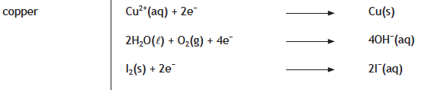

When **iron** **rusts**, **iron atoms** can lose **2 electrons** forming **iron(II) ions**.

**Iron atoms** can also lose **three** **electrons** to form the **iron(III) ion**.

|  |  |  |  |  |
| --- | --- | --- | --- | --- |
| **iron atom**  **Fe(s)** |  | **iron(III) ion** | **+** | **3 electrons** |
|  | **Fe3+(aq)** | **+** | **3 e-** |
| The **iron atom** undergoes **oxidation.** | |  | **Electrons taken by water and oxygen** | |

The equation is written in reverse to show **oxidation**.

The equation for the reaction is listed in the **ELECTROCHEMICAL SERIES**.

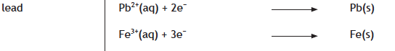

This means **rust** contains a mixture of **iron(II)** and **iron(III) ions**. The **iron(III) ion** is **orange / brown**. This ion gives **rust** its characteristic colour.

**FERROXYL AGAIN!**

**Ferroxyl indicator** turns **blue** in the presence of **iron(II) ions**, **Fe2+**.

**Ferroxyl indicator** can detect another **ion**.

The solutions below were tested with **ferroxyl indicator**.

|  |  |  |  |  |
| --- | --- | --- | --- | --- |
|  | **sodium sulfate (Na+)2SO42-** | **sodium chloride Na+Cl-** | **sodium nitrate Na+NO3-** | **sodium hydroxide Na+OH-** |
| **Ions present** | **SO42-**  **Na+**  **Na+** | **Cl-**  **Na+** | **NO3-**  **Na+** | **OH-**  **Na+** |

**RESULTS**

The sodium hydroxide changed the colour of **ferroxyl indicator** from **yellow** to **pink**.

**CONCLUSION**

Since all the solutions contain **sodium ions**, **Na+**, it is the **hydroxide io**n, **OH-** that produces the **pink** colour.

**Ferroxyl indicator** can detect the **water / oxygen** reaction taking place when any metal corrodes, by detecting the formation of the **hydroxide io**n, **OH-** .

**Ferroxyl indicator** can detect the **iron(II) ions**, **Fe2+**, when **iron** **rusts**. The **pink** colour produced by the **water / oxygen** reaction cannot be seen as the **blue** colour is so dark.

|  |  |  |
| --- | --- | --- |
| **N4** | **PHYSICAL PROTECTION** | **N5** |

**MAKING A BARRIER**

If **iron** is to **rust**, its surface must come in contact with both **WATER** and **OXYGEN.**

**iron (Fe)**

Placing a coating on the iron acts as a barrier by preventing **water** and **oxygen** coming in contact with the **iron.**

This type of corrosion protection is called **PHYSICAL PROTECTION.**

There are several methods of physical protection. These are:

1. Painting;
2. Plastic coating;
3. Coating with oil and grease;
4. Tin-plating – (This is used on “tin cans”);
5. Galvanising – (This is coating steel with zinc);
6. Electroplating.

**PAINTING**

Painting is the most common method used to put a coating on steel.

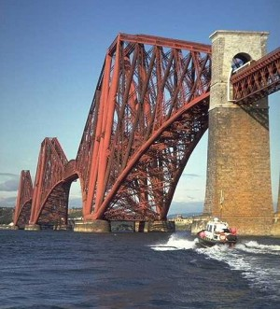

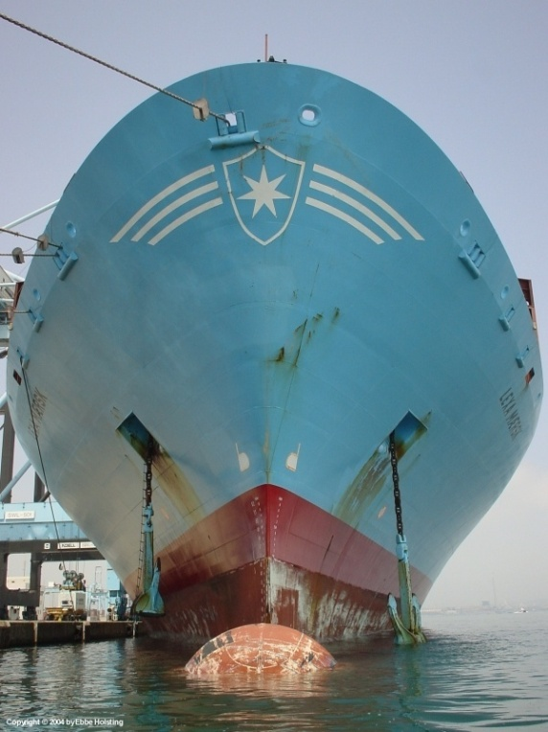**ADVANTAGES**

Paint is easy to apply and is cheap

**DISADVANTAGES**

Paint wears away and is easily damaged, which means it has to be regularly reapplied to maintain protection.

**PLASTIC COATING**

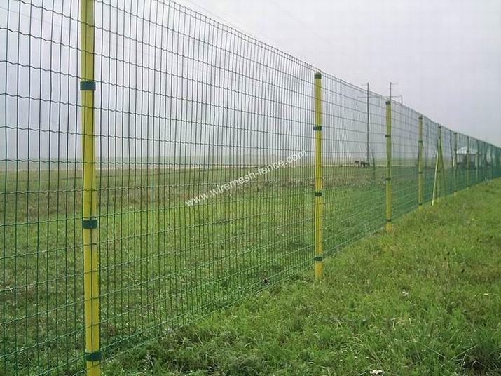Plastic coating is much harder than paint and lasts considerably longer.

The undersides of cars are plastic coated to protect the car from stones and grit thrown up by the wheels.

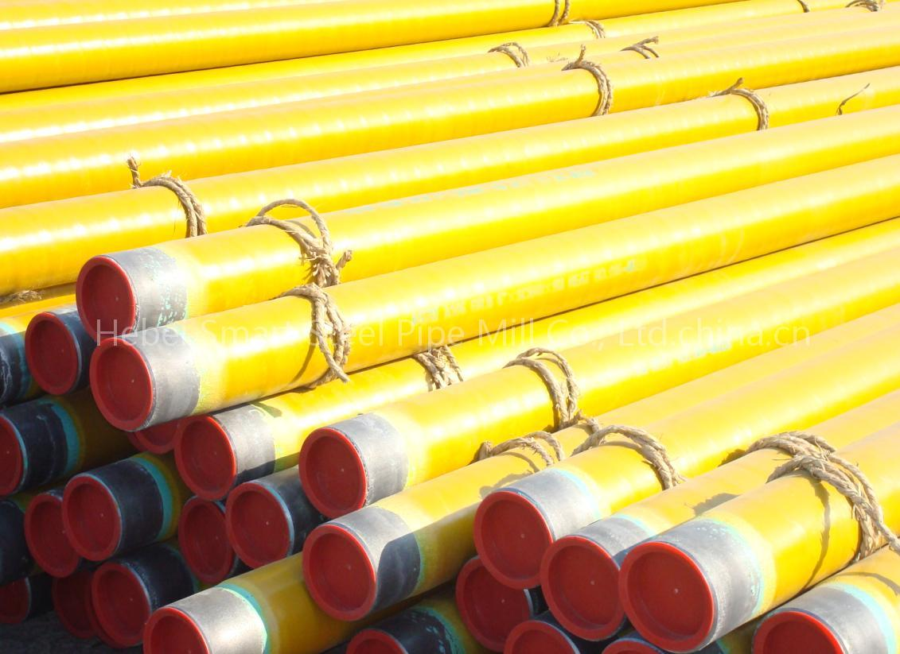Steel pipes are often plastic coated.

**ADVANTAGES**

Harder than paint and lasts considerably longer.

**DISADVANTAGES**

More expensive than painting and needs specialist application.

**OIL AND GREASE**

Painting and plastic coating cannot be used to protect moving parts in machinery. It would just flake off.

|  |  |  |
| --- | --- | --- |
| http://farm1.static.flickr.com/235/535548793_243190b90a_o.jpg | Screen Shot 2014-01-02 at 17.47.52.png |  |

Oil and grease is used to coat the metal.

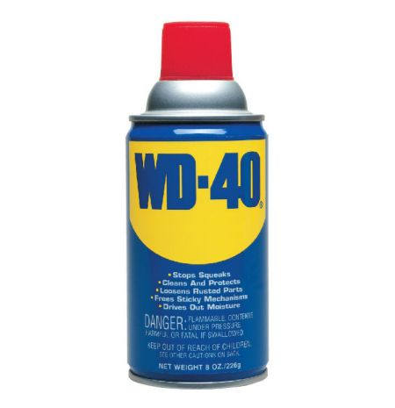Oil and grease forms a water and airtight layer on the metal, but to maintain the protection it must be re-applied regularly**.**

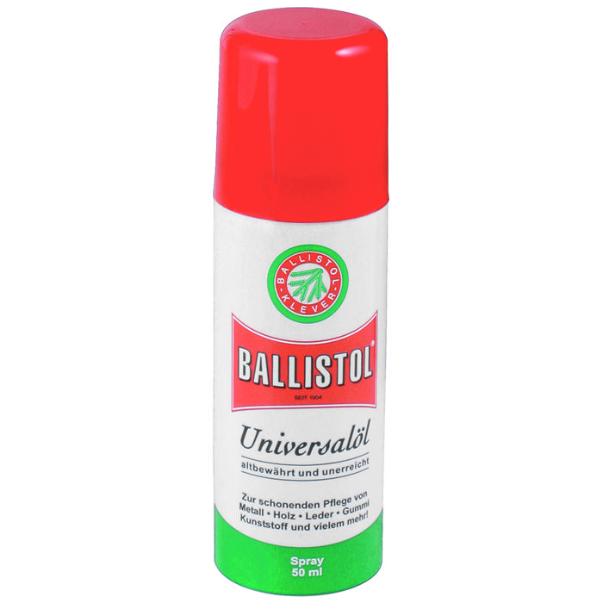

Garden tools and farming equipment can be protected by spraying them with oil.

**TIN-PLATING / GALVANISING / ELECTROPLATING**

**Tin-plating**, **galvanising** and **electroplating** all involve coating steel with another metal, which is less likely to corrode.

**TIN-PLATING**

**Tin-plating** steel involves coating steel with a thin layer of **tin**. The tin can be applied to the steel by dipping the steel in **molten tin**, or in a process called **ELECTROPLATING**.

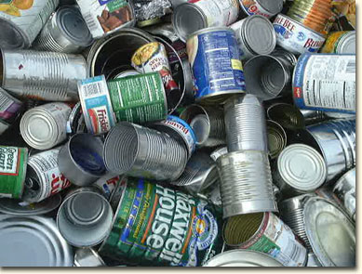

Many food cans, **“tin cans”** are actually made from **tin-plated** steel.

**GALVANISING**

|  |  |
| --- | --- |
| **http://www.dalekovod-cincaonica.com/slike/o-vrucem-cincanju/velike/01.jpg** | **GALVANISING** steel involves coating steel with a thin layer of **ZINC**.  The steel item to be **galvanised** is first cleaned of **rust** then it is placed in a bath of **molten zinc**.  The **zinc** coating binds to the surface of the steel. |

**Zinc** forms a very durable coating and needs little maintenance. **Galvanised steel** is used on cars, crash barriers, lampposts and nails.

|  |  |  |
| --- | --- | --- |
| http://www.motorcyclenews.com/upload/211692/images/barrier.jpg | http://www.tridenttrailers.com/Images%20-%20New%20trailers/new_gt26105_rtg.jpg | http://www.toolstation.com/images/library/stock/webbig/48247.jpg |

**ELECTROPLATING**

**ELECTROPLATING** uses electrolysis to coat a metal object with a thin layer of a second protective metal. This usually gives an attractive finish.

**EXAMPLES:** Gold and silver plated jewellery. Chromium plated cutlery and taps.

|  |  |
| --- | --- |
| http://www.lmsstores.com/users/11491/logos/Renaissance%20Gold%20Plating%2012-14-06%20Wrist%20Watch.jpg | http://www.etsingplating.com.cn/back/upload/20087171640480.gif  **N5**  **CHEMISTRY** |

**EXPERIMENT – Electroplating Copper with Nickel**

|  |  |  |  |  |
| --- | --- | --- | --- | --- |
| The **positive electrode** metal is made of **nickel**. This replaces the **nickel** **ions**, **Ni2+** in the solution, which are removed at the **negative electrode**.  **nickel electrode (positive)** | **Ni2+**  **Ni2+**  **-**  **+**  **Power Pack 4 V d.c.** | | | The object to be **electroplated** is connected to the **negative electrode** in the electrolysis of a solution containing **nickel ions**, **Ni2+(aq).**  **copper electrode (negative)**  The **Ni2+**ions are attracted to the **electrons** on the **negative electrode**. When the **Ni2+** ions touch the electrode they are changed into **Ni** atoms which forms a coating on the electrode. |
| **Ni(s) Ni2+(aq) + 2 e-**  **OXIDATION REACTION** | |  | **Ni2+(aq) + 2 e- Ni(s)**  **REDUCTION REACTION** | |

When an object is **electroplated**:

**ELECTROPLATING  
GOLD PLATING**

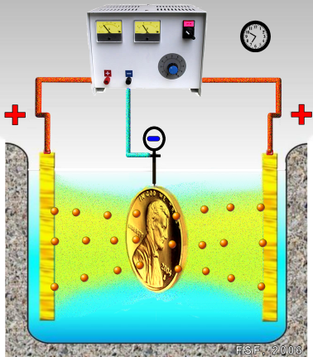

**Au**

**Au**

**Au+**

* + The object is connected to the **negative electrode**.
  + The **solution** contains **ions** of the **plating metal**.
  + The **positive electrode** is made of the **coating metal**.

|  |  |  |
| --- | --- | --- |
| **N4** | **ELECTROCHEMICAL PROTECTION** | **N5** |

**METALS IN CONTACT**

When different metals are joined and placed in an electrolyte, electrons flow between the metals.

The following experiment shows the effect joining different metals to iron, has on the rate of corrosion of iron. **Ferroxyl indicator** is used to follow the progress of the corrosion reaction.

|  |  |  |  |  |  |  |  |  |  |
| --- | --- | --- | --- | --- | --- | --- | --- | --- | --- |
|  | **Fe nail** |  | **Fe + Mg** |  | **Fe + Zn** |  | **Fe + Sn** |  | **Fe + Cu** |
| **Ferroxyl indicator** in gelatin. |  |  |  |  |  |  |  |  |  |

**RESULTS**

Comparing the iron nail with the other tubes, magnesium and zinc slows down the corrosion of iron, and tin and copper speeds up the corrosion.

**EXPLANATION**

**Fe**

**N5**

**CHEMISTRY**

|  |  |
| --- | --- |
| **Magnesium** and **zinc** are **above** **iron** in the **Electrochemical Series.** Both metals give **electrons** to the **iron** **preventing** **iron** atoms **losing** **electrons**, and therefore **preventing** **iron** corroding. | **e-**  **e-**  **e-**  **e-**  **e-**  **e-**  **e-**  **e-**  **Zn**  **Mg** |

**Fe**

|  |  |
| --- | --- |
| **Tin** and **copper** are **below** **iron** on the **Electrochemical Series**. **Electrons** flow from the **iron** to the **tin** and **copper**. This protects the **tin** and **copper** from corroding but **speeds up the corrosion** of **iron**. | **e-**  **e-**  **e-**  **e-**  **e-**  **e-**  **e-**  **e-**  **Cu**  **Sn** |

**SCRATCHED COATINGS**

Both tin and zinc protect steel well as long as the coating is not scratched.

|  |  |  |
| --- | --- | --- |
| **scratched zinc** |  | **scratched tin** |
| **ferroxyl indicator  and salt solution** |  |  |

**Zinc** is **above** **iron** in the **Electrochemical Series**. **Electrons** flow from the **zinc** to the **iron**, **preventing** **iron** **losing electrons** and corroding.

**Iron** is **above tin** in the **Electrochemical Series**. **Electrons** flow from the **iron** to the **tin**. **Iron corrodes faster than normal**.

**SACRIFICIAL PROTECTION**

Connecting a metal that is **above iron** in the **Electrochemical Series** will slow down the corrosion of **iron**.

**Magnesium**, **aluminium** and **zinc** are commonly used metals for this purpose.

These metals corrode faster than normal when connected to iron as they **transfer electrons** to the **iron**.

The **magnesium**, **aluminium** and **zin**c are **“SACRIFICED**” to protect the **iron**.

This method of protection is called **SACRIFICIAL PROTECTION**.

|  |
| --- |
| **Examples of the use of cathodic protection:**   1. The hulls of ships and the legs of oil platforms have huge blocks of zinc bolted to them. 2. The protection of galvanised steel after the coating of zinc is scratched. 3. Bags of magnesium are attached to pipelines at regular intervals along the pipe. |

To maintain the protection of the **iron**, the **aluminium**, **zinc** and **magnesium** have to be replaced at regular intervals.

|  |  |
| --- | --- |
| http://www.anodesystems.com/Cathodic_Protection/Underground_Pipe_and_Propane_Tank_Cathodic_Protection_files/protank.jpg | http://www.tis-gdv.de/tis_e/misc/elektro.jpg |

**CATHODIC PROTECTION**

Giving **iron electrons** prevents it from corroding. The **negative electrode** of a direct current electrical supply can provide **electrons**.

**N5**

**CHEMISTRY**

|  |  |  |
| --- | --- | --- |
| The **positive electrode** speeds up the corrosion of **iron**. The **positive electrode** takes away **electrons**, which helps the change from an **iron** **atom** to an **iron ion**.  iron nails | **e-**  **e-**  **e-**  **e-**  **e-**  **e-**  **e-**  **e-**  **e-**  **e-**  **e-**  **e-**  **+**  **-**  **Power Pack 4 V d.c.** | The **negative electrode** protects the **iron** by providing **electrons**. This makes it **hard for the nail to lose** **electrons** and corrode.  ferroxyl indicator and salt solution |

The **negative electrode** is called a **CATHODE**, so connecting **iron** to the **negative terminal of a d.c. supply to protect it from corroding**,is called **CATHODIC PROTECTION**.

|  |
| --- |
| **Examples of the use of cathodic protection:**   1. Steel piers and oil rigs are connected to the negative terminal of a d.c. supply. 2. The body of a car is connected to the negative terminal of a car battery. |

|  |  |
| --- | --- |
| http://buyanodes.com/untitled_2.jpg | Macintosh HD:Users:IanSmith:Desktop:Screen Shot 2014-02-13 at 23.27.05.png |

**WHY STEEL CORRODES**

**N5**

**CHEMISTRY**

The following experiment shows why steel rusts so easily.

|  |  |
| --- | --- |
| **ferroxyl indicator  and salt solution**  **Carbon rod**  **A**  **Iron nail**  **e-**  **e-**  **e-**  **e-** | The ammeter shows that **electrons** flow from the **iron nail** to the **carbon rod**.  The **blue colour** shows the **iron atoms** are **losing electrons** forming **iron(II) ions, Fe2+.**  The **pink colour** shows the **electrons** flowing onto the carbon rod are being taken by **water** and **oxygen** forming **hydroxide ions, OH-.**  Steel is an alloy containing **iron** and **carbon.** When **water and oxygen come in contact with steel, electrons flow from the iron atoms to the carbon atoms.** |

Carbon dioxide in the air makes rainwater slightly acidic creating the electrolyte which helps the **transfer of electrons** **between the iron and carbon atoms.**

Steel has an inbuilt **electrochemical cell.**