**NATIONAL 4 AND NATIONAL 5CHEMISTRY**



**Unit 2: Nature’s Chemistry**

**Topic 4**

**ALCOHOLS, CARBOXYLIC ACIDS & ESTERS**

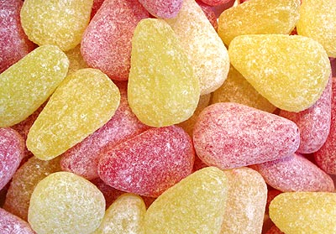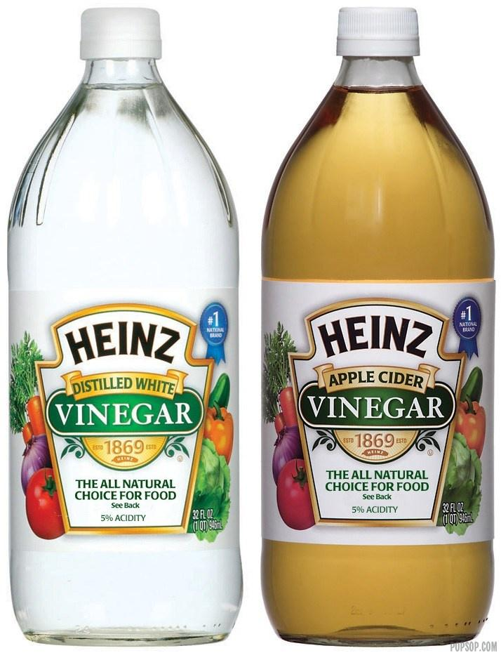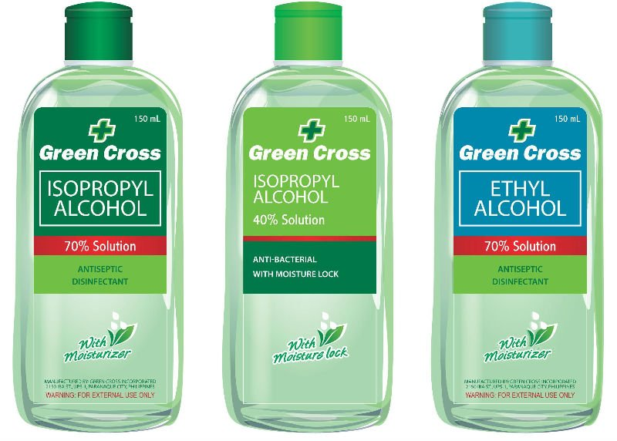

|  |
| --- |
| **Name __________________________________ Class _____** |

|  |
| --- |
| Unit 2: Nature’s Chemistry |
| Topic 4: Alcohols, Carboxylic Acids & Esters |

|  |  |  |  |  |  |
| --- | --- | --- | --- | --- | --- |
| LEVEL N4 N5 | **AFTER COMPLETING THIS TOPIC YOU SHOULD BE ABLE TO:** | NOTES (Page) | **How well I have understood (✓)** | | |
| **☺** | **😐** | **☹** |
| N5 | Identify an alkanoic acid from the carboxyl group and the ‘-oic’ name ending. | 3 |  |  |  |
| N5 | Name straight-chain alkanoic acids from shortened and full structural formulae (only C1 to C8 ). | 5 - 6 |  |  |  |
| N5 | Write molecular formula, shortened and full structural formula, given the name of a straight-chain alkanoic acids (only C1 to C8). | 5 - 6 |  |  |  |
| N5 | State carboxylic acids are made when an alcohol with its hydroxyl group on the end of a carbon chain undergoes mild oxidation. | 5 |  |  |  |
| N5 | State the chemical and physical properties of the alkanoic acids and the general formula, which show the alkanoic acids, are a homologous series. | 2 & 7 |  |  |  |
| N5 | Give examples of the uses of alkanoic acids.the alkjanols ols | 8 |  |  |  |
| N5 | Identify an ester from the ester group and the ‘-oate’ ending. | 9 - 10 |  |  |  |
| N5 | Name an ester given the names of the parent alkanol and alkanoic acid or from shortened and full structural formulae. | 9 - 10 |  |  |  |
| N5 | Can draw shortened and full structural formulae for esters given the names of the parent alkanol and alkanoic acid or the names of esters. | 11 - 12 |  |  |  |
| N5 | State esters are formed by the condensation reaction between an alkanoic acid and an alcohol. | 9 - 11 |  |  |  |
| N5 | Explain in the condensation reaction, the molecules join together by the reaction of the functional groups to make water. | 9 - 11 |  |  |  |
| N5 | State the ester link is formed by the reaction of a hydroxyl group with a carboxyl group. | 9 |  |  |  |
| N5 | Describe an experiment where an ester is produced. | 13 |  |  |  |
| N5 | Give examples of the uses of esters. | 14 |  |  |  |
|  |  |  |  |  |  |

|  |  |  |
| --- | --- | --- |
| **N5** | **CARBOXYLIC ACIDS (ALKANOIC ACIDS)** | **N5** |

**VINEGAR**

Vinegar is a dilute solution of **ETHANOIC ACID**. Its old name is **ACETIC ACID**.

|  |  |  |
| --- | --- | --- |
| **ethanoic acid** |  |  |
|  |  | **CH3COOH** |

**carboxyl group**

The – **COOH** group of atoms is called the **CARBOXYL GROUP**. This is called the **functional group** as it gives the molecule the chemical properties of a **CARBOXYLIC ACID**.

The carboxylic acids with a structure based on an alkane structure are called **ALKANOIC ACIDS**.

The name **ethanoic acid** tells you the following information.

**eth – contains 2 carbon atoms**

|  |  |
| --- | --- |
|  | **ethanoic acid** |

**oic – contains a carboxyl group (-COOH)**

**The carboxyl group gives the molecule acidic properties.**

**an – contains a single C – C bond**

Ethanoic acid is a member of a family of carboxylic acids called the **ALKANOIC ACIDS**.

**PROPERTIES OF ETHANOIC ACID**

Ethanoic acid is soluble in water. The table below shows further properties of a solution of ethanoic acid.

|  |  |  |  |
| --- | --- | --- | --- |
| **PROPERTY TESTED** | **OBSERVATION** |  | **CONCLUSION** |
| Appearance (colour and state) |  |  | A solution of ethanoic acid contains ions.  With a **pH less than 7**, the solution contains the **hydrogen ion (H+)**.  A solution of ethanoic acid reacts with magnesium and calcium carbonate showing it is a typical acid. |
| Smell |  |  |
| Conductivity of solution |  |  |
| pH (acidic / neutral / alkaline) |  |  |
| Reaction with: |  |  |
| magnesium |  |  |
| marble (calcium carbonate) |  |  |

**WHY IS IT CALLED VINEGAR?**

Ethanoic acid is formed when ethanol undergoes mild oxidation. This reaction can happen in alcoholic drinks (e.g. wine or cider) when the ethanol reacts with oxygen from the air.

The name vinegar comes from combining two French words.

|  |  |  |
| --- | --- | --- |
|  | **vinaigre** |  |
| **vin means wine** |  | **aigre means sour** |
|  | **vinegar** |  |
| **Acids have a sour taste. Vinegar means sour wine.** | |

**MAKING ALKANOIC ACIDS**

Alkanoic acids are made when alcohols undergo a mild oxidation reaction.

The **hydroxyl group (-OH)** on the alcohol molecule has to be on the end of a carbon chain to produce a **carboxyl group (-COOH)** during mild oxidation.

|  |  |  |
| --- | --- | --- |
| **propan-1-ol** |  | **propanoic acid** |
|  | **The hydroxyl group (-OH) is on the end of the carbon chain.** |  |
|  |

|  |  |
| --- | --- |
|  | **The hydroxyl group (-OH) is not on the end of a carbon chain.**  **This will not form a carboxyl group during mild oxidation.** |
|

**ALKANOIC ACID FAMILY**

Ethanoic acid is the second member of the **homologous series** of carboxylic acids called **ALKANOIC ACIDS**.

|  |  |  |
| --- | --- | --- |
| **methanoic acid** | **ethanoic acid** | **propanoic acid** |
|  |  |  |
|  |  |  |
| **HCOOH** | **CH3COOH** | **C2H5COOH** |

**THE ALKANOIC ACIDS CONTAINING 1 TO 6 CARBON ATOMS**

|  |  |  |  |
| --- | --- | --- | --- |
| **No. of C atoms** | **Alkanoic Acid Name** | **Molecular Formula** | **Full Structural Formula / Shortened Structural formula** |
| 1 | methanoic | HCOOH |  |
|  |  |  | **HCOOH** |
| 2 |  |  |  |
|  |  |  | **CH3COOH** |
| 3 |  |  |  |
|  |  |  |  |
| 4 |  |  |  |
|  |  |  |  |
| 5 |  |  |  |
|  |  |  |  |
| 6 |  |  |  |
|  |  |  |  |

**GENERAL FORMULA OF ALKANOIC ACIDS**

The general formula for the alkanoic acids is based on the alkane general formula.

|  |  |  |  |  |  |  |
| --- | --- | --- | --- | --- | --- | --- |
| **methanoic acid** |  | **ethanoic acid** |  | **propanoic acid** |  | **butanoic acid** |
| **HCOOH** |  | **CH3COOH** |  | **C2H5COOH** |  | **C3H7COOH** |

|  |
| --- |
| **GENERAL FORMULA OF ALKANOIC ACIDS** |
| **CnH2n + 1COOH** |
| **CAUTION**  the **n** in the formula **is not related to the carbon atoms indicated by the name**,as there is a carbon atom in the carboxyl group. |

**PHYSICAL PROPERTIES – BOILING POINT**

The following graph shows the boiling point of alkanoic acids versus number of carbon atoms.

**(Find the boiling points of methanoic acid, ethanoic acid, propanoic acid and butanoic acid in the data booklet and plot a spike chart on the graph paper below.)**

|  |  |
| --- | --- |
|  | **CONCLUSION**  As the number of carbon atoms in the alkanoic acid molecule increases, the boiling point increases.  The alkanoic acids have similar chemical properties and have a general formula showing they are a **HOMOLOGOUS SERIES**. |

**OCCURRENCE OF CARBOXYLIC ACIDS**

|  |  |  |  |  |
| --- | --- | --- | --- | --- |
| **methanoic acid (formic acid)**  **HCOOH** |  | **ethanoic acid (acetic acid)**  **CH3COOH** |  | **butanoic acid (butyric acid)**  **C3H7COOH** |
| In ant stings.  A preservative and antibacterial agent in livestock feed. |  | Food flavouring - vinegar.  A food preservative – pickling. |  | In butter, milk and cheese. Has a cheesy smell. |
|  |  |  |  |  |
|  |  |  |  |  |
| **lactic acid CH3CHOHCOOH** | | |  | |
| In sour milk, yogurt and cheese. Forms in our muscles during exercise. | | |

|  |  |  |
| --- | --- | --- |
| **N5** | **ESTERS** | **N5** |

**WHAT IS AN ESTER?**

When a **CARBOXYLIC (ALKANOIC) ACID** molecule reacts with an **ALCOHOL (ALKANOL)** molecule a molecule called an **ESTER** forms.

The **hydroxyl group of the alcohol** reacts with the **carboxyl group of the acid**.

|  |  |  |  |  |  |  |
| --- | --- | --- | --- | --- | --- | --- |
| **molecules join** | **+** |  |  |  | **+** |  |
| **hydroxyl group** |  | **carboxyl group** |  | **water molecule** |  | **ester link (carboxylate group)** |

During the reaction the **H atom of the hydroxyl group** and the **OH of the carboxyl group** break off and join to form a **water molecule**.

The **alcohol** and **acid** molecules join to form an **ester link (carboxylate group)**.

A reaction where a molecule of water is eliminated as two molecules join is called a **CONDENSATION REACTION**. **Making an ester** is a **CONDENSATION REACTION**.

**NAMING AN ESTER**

The name of an ester comes from the **alcohol** and **carboxylic acid** from which it is made.

|  |  |  |  |
| --- | --- | --- | --- |
| **The alcohol molecule gives the ester its first name.**  **The alcohol name changes to ALKYL.** | **methanol** |  | **methyl** |
| **ethanol** |  | **ethyl** |
| **propanol** |  | **propyl** |
| **butanol** |  | **butyl** |

|  |  |  |  |
| --- | --- | --- | --- |
| **The carboxylic acid molecule gives the ester its second name.**  **The acid name changes to ALKANOATE.** | **methanoic acid** |  | **methanoate** |
| **ethanoic acid** |  | **ethanoate** |
| **propanoic acid** |  | **propanoate** |
| **butanoic acid** |  | **butanoate** |

**Example**

|  |  |  |  |  |  |  |
| --- | --- | --- | --- | --- | --- | --- |
| **propan-1-ol** | **+** | **ethanoic acid** |  | **propyl ethanoate** | **+** | **water** |

**ESTERIFICATION**

Making an **ester** is a **condensation** reaction.

The reaction is called **ESTERIFICATION** as the reaction produces an **ester**.

|  |  |  |  |  |  |  |
| --- | --- | --- | --- | --- | --- | --- |
| **alcohol** | **+** | **carboxylic acid** |  | **ester** | **+** | **water** |
| **propan-1-ol** | **+** | **ethanoic acid** |  | **propyl ethanoate** | **+** | **water** |
|  | **+** |  |  |  | **+** |  |
| **water molecule eliminated** | | |  | **ester link (carboxylate group)** |  |  |
|  | **+** |  |  |  | **+** |  |
| **CH3CH2CH2OH** | **+** | **HOOCCH3** |  | **CH3CH2CH2OOCCH3** | **+** | **H2­O** |

|  |  |  |  |  |  |  |
| --- | --- | --- | --- | --- | --- | --- |
| **ethanol** | **+** | **methanoic acid** |  | **ethyl methanoate** | **+** | **water** |
|  | **+** |  |  |  | **+** |  |
| **CH3CH2OH** | **+** | **HOOCH** |  | **CH3CH2OOCH** | **+** | **H2­O** |

|  |
| --- |
| **DICTIONARY - CONDENSATION REACTION**  A **CONDENSATION REACTION** is a reaction where molecules join with the elimination of a small molecule (often water). Making anester by reacting an alcohol with a carboxylic acid is a condensation reaction.  Making an ester is also called **ESTERIFICATION.** |

|  |  |
| --- | --- |
|  | To practise writing esterification reactions do the **ESTERIFICATION** examples on **page 3** of the **Practice Examples Booklet**. |

**DRAWING AND RECOGNISING ESTER FORMULAE**

Esters can be recognised by the two oxygen atoms from the **CARBOXYLATE GROUP** (**COO** or **OOC**) in the middle of the formula.

The formula / structure of an ester can be written with the alcohol part followed by the acid part or vice-versa.

|  |  |  |  |  |
| --- | --- | --- | --- | --- |
|  | | **OR** |  | |
|  | |  |  | |
| **alcohol part** | **acid part** |  | **acid part** | **alcohol part** |
| **2 carbons** | **4 carbons** |  | **4 carbons** | **2 carbons** |
| **ethyl** | **butanoate** |  | **butanoate** | **ethyl** |

**ethylbutanoate**

The following examples show how to name an ester from its **shortened structural formula** or **molecular formula**.

The formula / structure of an ester can be written with the alcohol part followed by the acid part or vice-versa.

|  |  |  |  |  |
| --- | --- | --- | --- | --- |
| **SHORTENED STRUCTURAL FORMULA** | |  | **MOLECULAR FORMULA** | |
| **CH3CH2OOCCH2CH2CH3** | |  | **C2H5OOCC3H7** | |
| **2 carbons** | **4 carbons** |  | **2 carbons** | **4 carbons** |
| **ethyl** | **butanoate** |  | **ethyl** | **butanoate** |
|  |  | **OR** |  |  |
|  |  |  |  |
| **CH3CH2CH2CO OCH2CH3** | |  | **C3H7CO OC2H5** | |
| **4 carbons** | **2 carbons** |  | **4 carbons** | **2 carbons** |
| **butanoate** | **ethyl** |  | **butanoate** | **ethyl** |

**ethylbutanoate**

|  |  |
| --- | --- |
|  | To practise naming esters from their formula and writing the formulae of esters, do the **ESTER FORMULAE** examples on **page 4** of the **Practice Examples Booklet**. |

**MAKING AN ESTER – ETHYL PROPANOATE**

To prepare an ester an **alcohol (ethanol)** has to be reacted with a **carboxylic acid (propanoic acid)**.

The rate of the reaction is slow at room temperature and the yield of ester is low. The rate of the reaction can be increased by **heating the reaction mixture** and by using **concentrated sulphuric acid as a catalyst**.

The presence of the **concentrated sulphuric acid increases the yield of ester**.

The cold surface reduces evaporation of the contents of the test tube by condensing the vapours.



paper towel soaked in cold water

**Alcohol (ethanol)** and **carboxylic acid (propanoic acid)** + a few drops of **concentrated sulphuric acid**

hot water

**The mixture is heated for a short time (10 mins).**

**After heating the contents of the test tube is poured into a solution of sodium hydrogencarbonate. This reacts with any unused acid**

**The ester can be carefully smelled.**

sodium hydrogencarbonate solution



ester floats as an oily layer on top of the solution

Esters have a pleasant fruity smell. Esters are found in fragrances giving flowers, fruit, perfumes their characteristic smell. Esters are also used in flavourings.

**OCCURRENCE OF ESTERS**

Many esters have pleasant smells and flavours. They are found in nature in common fruit flavours. They are found in coffee, tea, wine and beer.

|  |  |  |  |
| --- | --- | --- | --- |
| **Ester** | **Parent Alcohol** | **Parent Carboxylic Acid** | **Flavouring / Fragrance** |
| propyl pentanoate | propan-1-ol | pentatonic acid | pineapple |
| ethyl butanoate | ethanol | butanoic acid | apple |
| octyl butanoate | octan-1-ol | butanoic acid | orange |
| pentyl ethanoate | pentan-1-ol | ethanoic acid | banana |

**Esters are good solvents** for varnishes, paints and adhesives. For example, **butyl ethanoate** and **ethyl ethanoate**. These esters have a low boiling point and evaporate easily i.e. they are volatile liquids.

**Esters are found in medicines**. They are used in local anaesthetics. For example, **benzocaine**, **cocaine**, **novocaine**.

**Aspirin**, a common pain killer.