NATIONAL 4 AND NATIONAL 5 CHEMISTRY

Unit 1: Chemical Changes and Structure

Topic 4
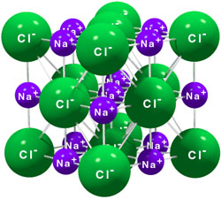
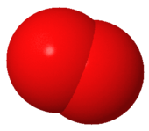
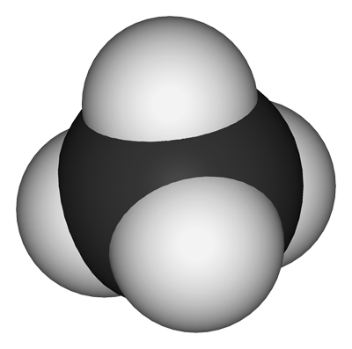
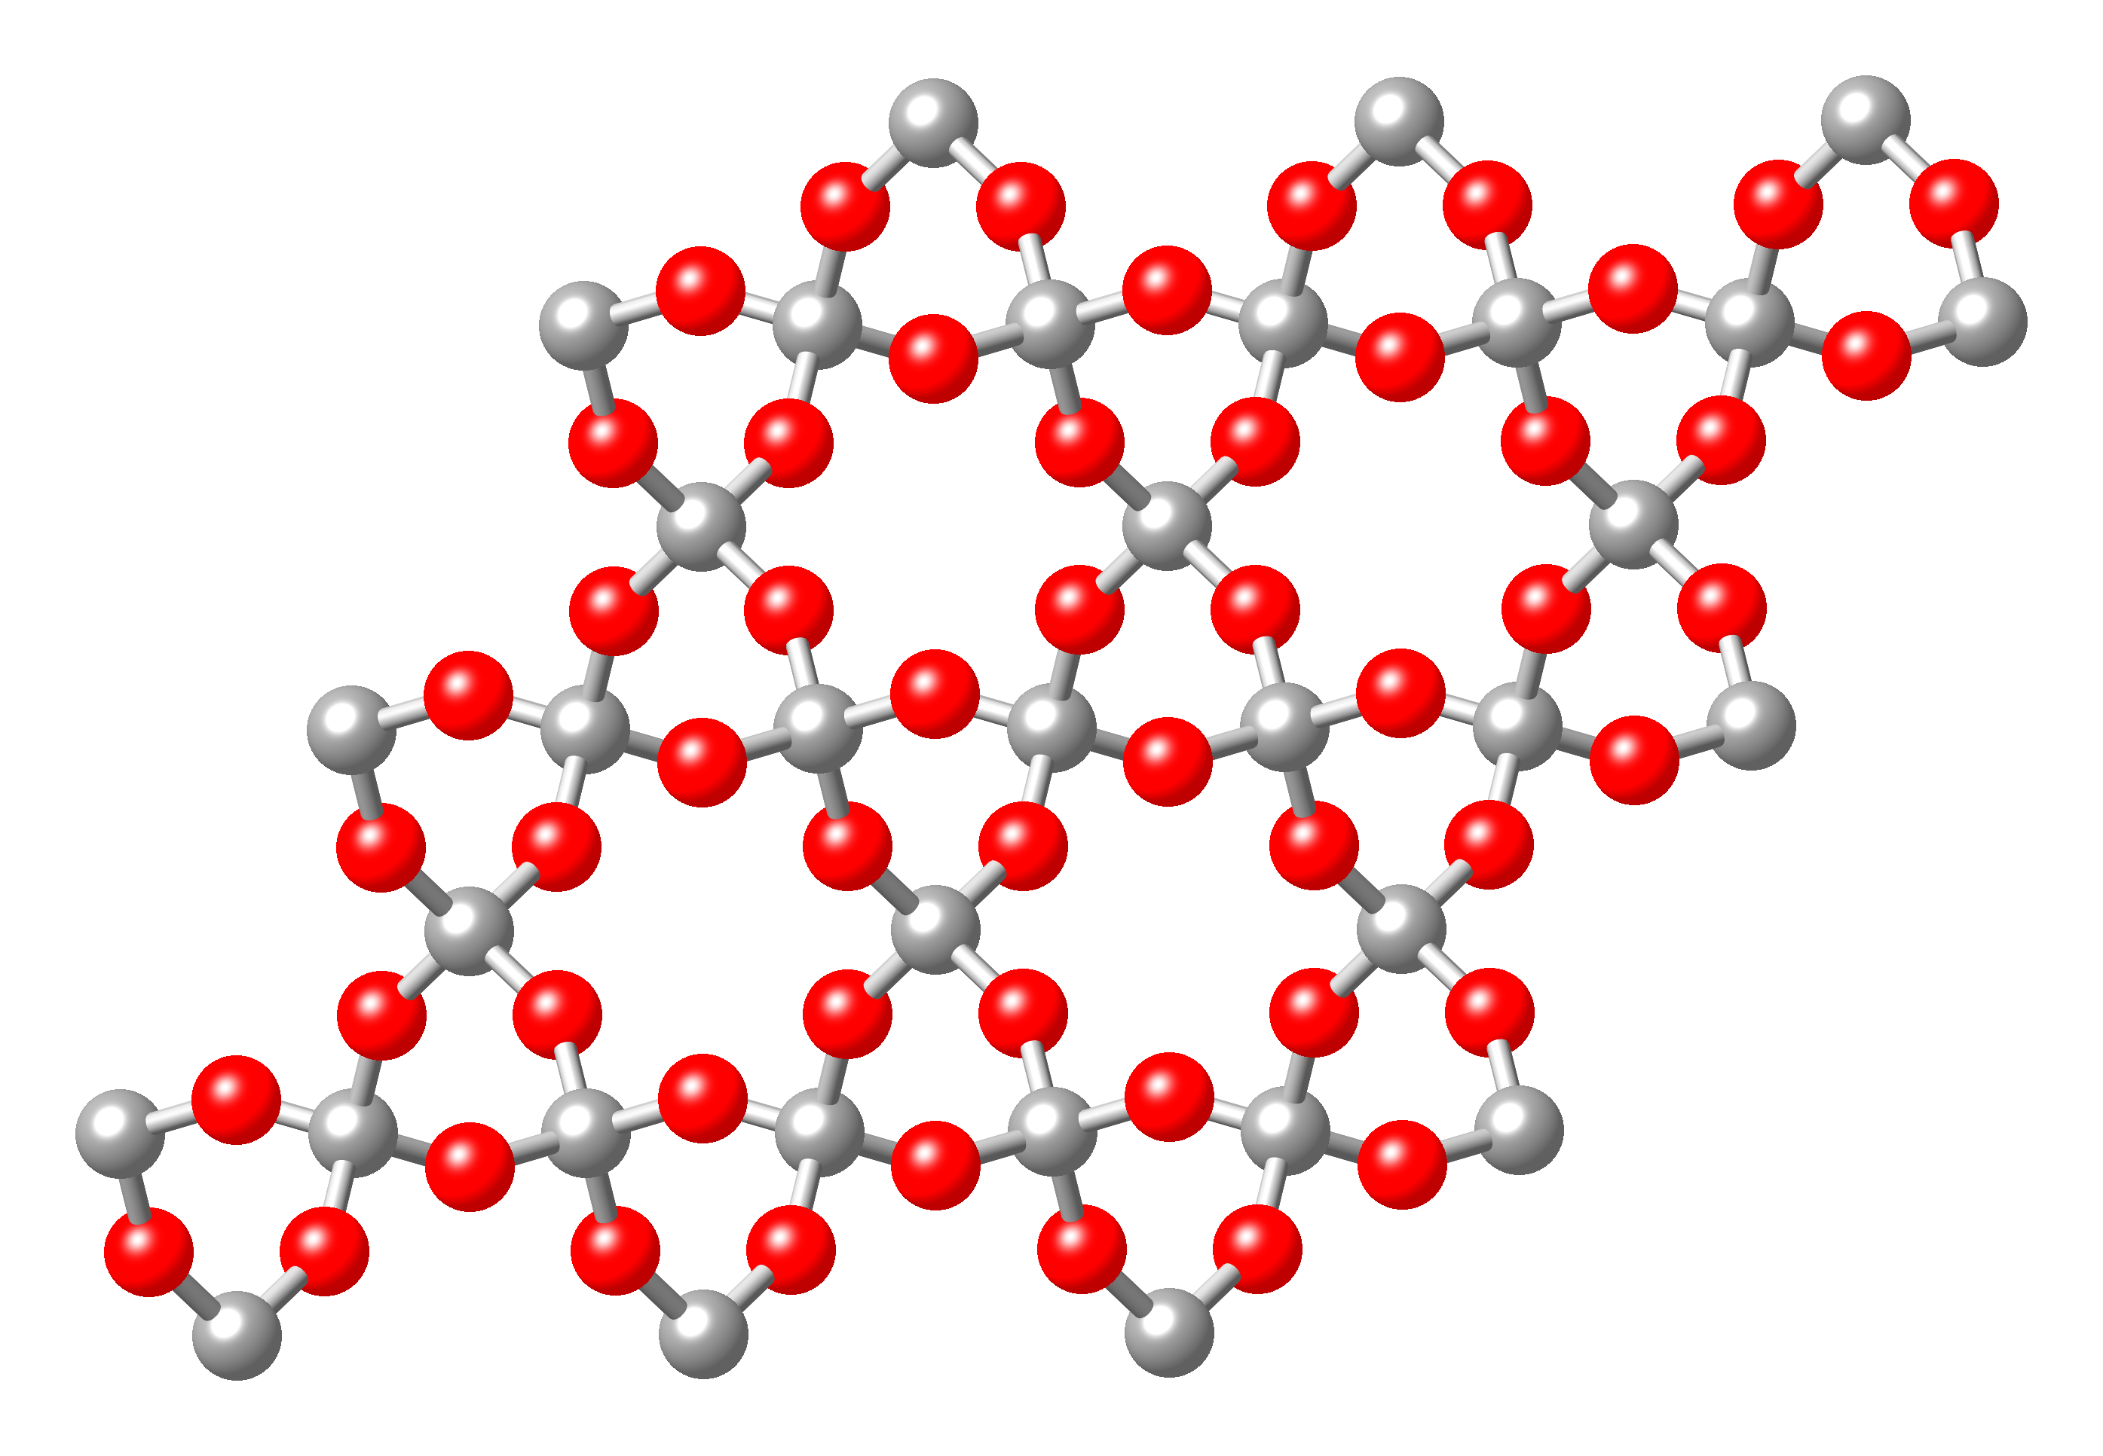
BONDING, STRUCTURES & PROPERTIES

Name ____________________________________ Class _____

Unit 1: Chemical Changes and Structure

Topic 4: Bonding, Structure and Properties

LEVEL  N4 N5 | AFTER COMPLETING THIS TOPIC YOU SHOULD BE ABLE TO: | NOTES  (Page) | How well I have understood (✓)
LEVEL  N4 N5 | AFTER COMPLETING THIS TOPIC YOU SHOULD BE ABLE TO: | NOTES  (Page) | ☺ | 😐 | ☹
N4 | State atoms can be held together by bonds and there are types of bonding called metallic, ionic and covalent. | 4-5
N4 | Ionic compounds are usually formed when metals combine with non-metals. | 5
N4 | State covalent bonding usually occurs when non-metal atoms bond. | 5
N4 | State in a covalent bond atoms share pairs of electrons. | 13
N4 | State a molecule is a group of atoms held together by covalent bonds. | 25
N4 | A diatomic molecule is made up of two atoms. | 25
N4 | Positive ions are formed by metal atoms losing electrons, and negative ions are formed by non-metal atoms gaining electrons, during a transfer of electrons from the metal atom to the non-metal atom. | 11-12
N4 | Covalent substances (solids, liquids, solutions) do not conduct electricity. | 7-8
N4 | Many covalent substances have low melting and boiling points and are insoluble in water but are soluble in other covalent liquids. | 18
N4 | Many covalent substances are insoluble in water but are soluble in other covalent liquids. | 17
N4 | Ionic compounds do not conduct electricity in the solid, but these compounds do conduct electricity when dissolved in water or when molten. | 7-8
N5 | State in forming bonds, atoms can achieve a stable electron arrangement. | 19-23
N5 | State the covalent bond is a result of two positive nuclei being held together by their common attraction for the shared pair of electrons. | 23
N5 | Draw diagrams show how the outer electrons are shared to form the covalent bond(s) in a molecule. | 13-15
N5 | State ionic bonding is the electrostatic force of attraction between oppositely charged ions. | 24
N5 | Explain why discrete covalent substances have low melting and boiling points due to the weak forces of attraction that need to be overcome. | 25
N5 | Explain why ionic compounds and covalent network substances have high melting and boiling points due to the strong forces of attraction which need to be overcome. | 24
N5 | State the formula for a discrete covalent substance gives the actual number of atoms in each molecule but in a covalent network substance gives the simplest ratio of atoms of each element. | 26-27
N5 | The formula for an ionic compound gives the simplest ratio of positive ions to negative ions. | 24

Unit 1: Chemical Changes and Structure

Topic 4: Bonding, Structure and Properties

LEVEL  N4 N5 | AFTER COMPLETING THIS TOPIC YOU SHOULD BE ABLE TO: | NOTES  (Page) | How well I have understood (✓)
LEVEL  N4 N5 | AFTER COMPLETING THIS TOPIC YOU SHOULD BE ABLE TO: | NOTES  (Page) | ☺ | 😐 | ☹
N5 | Name the shapes of molecules | 28-29
N5 | Predict the shape of a molecule form its covalent bonding. | 28-29
N5 | Explain the conduction of ionic compounds in terms of movement of ions and the non-conduction of covalent substances in terms of molecules, which are uncharged. | 10 & 35
N5 | Explain that an ionic compound breaks down into its elements during conduction and this reaction is called electrolysis. | 9, 10, &35
N5 | State a dc supply must be used if the products of electrolysis are to be identified. | 35
N5 | Explain the formation of atoms/molecules at each electrode during electrolysis in terms of positive ions gaining electrons and negative ions losing electrons. | 32
N5 | Write the ion-electron equations for the reactions, which take place on the electrodes during electrolysis. | 33-34

N4 | CLASSIFICATION | N4

ELEMENT OR COMPOUND?

In chemistry substances that have similar properties are grouped together. This is called CLASSIFYING them.

ELEMENT and COMPOUND are common classifications.

Elements can also be classified as METAL and NON-METAL.

 | To practise classifying substances as element or compound, and classifying elements as metal or non - metal do the CLASSIFICATION 1 examples on page 2 of the Practice Examples Booklet.

METALLIC, IONIC or COVALENT?

Another way chemists classify substances is by the type of bonding which holds the atoms of the substance together.

There are three types of bonding called:

- METALLIC BONDING |  | This is only found in METALS.

Examples:

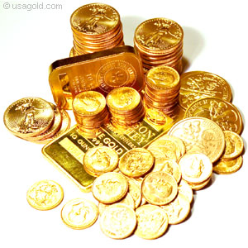
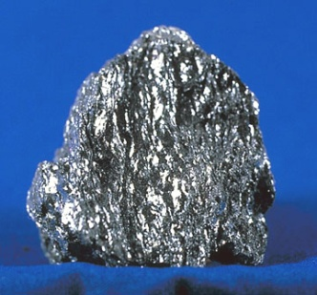
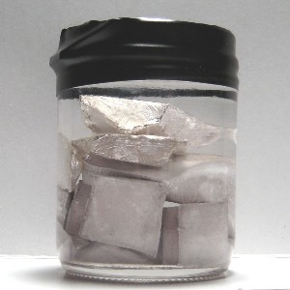

Gold (Au)
Iron (Fe)
Sodium (Na)

- IONIC BONDING |  | This is found in compounds made from METALS and NON-METALS.

Examples:

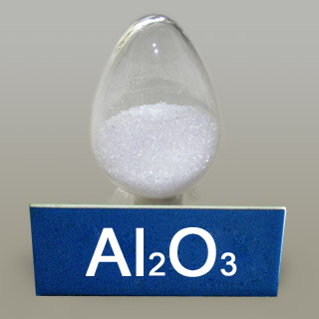 | Aluminium oxide  Al₂O₃  metal  non-metal |  | 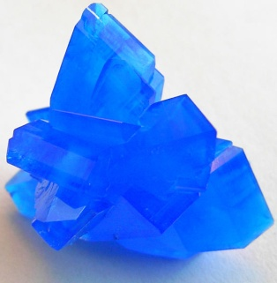 | Copper(II) sulphate  CuSO₄  metal  non-metal

- COVALENT BONDING |  | This is found in substances made only from NON-METALS

Examples:

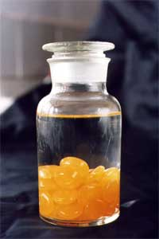 |  | 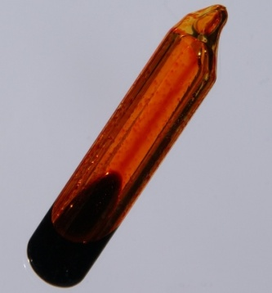 |  |  |  | 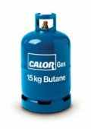
Phosphorus  (P) |  | Bromine  (Br₂) |  | Water  (H₂O) |  | Butane  (C₄H₁₀)
ELEMENTS |  |  |  | COMPOUNDS

Covalent bonding is found in both elements and compounds.

NOTE:
The only non-metallic elements which don't have covalent bonding are the Noble Gases. These elements cannot form bonds and exist as single atoms. They are described as MONATOMIC.

 | To practise classifying substances as metallic, ionic or covalent do the CLASSIFICATION 2 examples on page 3 of the Practice Examples Booklet.

N4 | CONDUCTION | N4

CONDUCTIVITY

Testing if a substance conducts electricity provides useful information about the type of bonding in a substance.
Whether a substance is a solid, liquid or dissolved in water to form a solution can affect the substance’s conductivity.

STATE SYMBOLS

When writing a formula you can indicate the state of a substance by writing a state symbol.

SOLID |  | (s) |  | H₂O(s) |  | 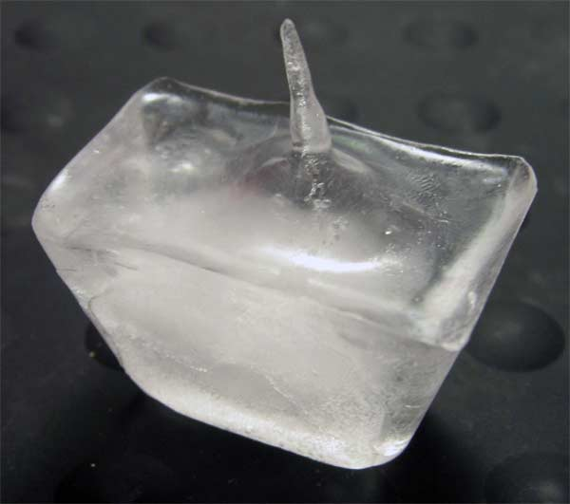

LIQUID |  | (l) |  | H₂O(l) |  | 

GAS |  | (g) |  | H₂O(g) |  | 

SOLUTION |  | (aq) |  | 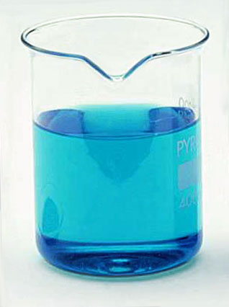
 |  |  |  | CuSO₄(aq)

The Latin word for water is AQUA. This is where the symbol (aq) comes from.

The (aq) means aqueous.

Solutions made using water as the solvent are called AQUEOUS SOLUTIONS.

To practise writing formula including a state symbol, do the FORMULAE WITH STATE SYMBOLS examples on page 4 of the Practice Examples Booklet.
CONDUCTION AND SOLIDS (s)
The conductivity of a substance can be tested using the following apparatus.
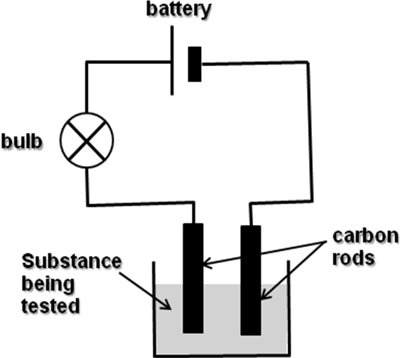

A selection of different solids had their conductivity tested.

CONCLUSION

The only solids which conduct electricity are metals and carbon in the form of graphite.

The solids which conduct all have metallic bonding EXCEPT carbon (graphite) which has covalent bonding.

CONDUCTION AND LIQUIDS (l)

A selection of different liquids had their conductivity tested. Some solids were also heated to melt them and the conductivity of the liquid was tested.

CONCLUSION

The only liquid at room temperature which conducted electricity was mercury.

Mercury has metallic bonding.

Apart from mercury, all the liquids at room temperature have covalent bonding.

The only melted solid which conducted was lead(II) bromide.

Lead(II) bromide has ionic bonding.

CONDUCTION AND SOLUTIONS (aq)
A selection of different solutions had their conductivity tested.

CONCLUSION

The only solutions, which conducted electricity, contained an ionic compound.

CONDUCTION SUMMARY

Type of Bonding | Conductivity  (conductor or insulator?)
Type of Bonding | Solid (s) | Liquid (l) | Solution (aq)
Metallic
Ionic
Covalent

Complete the table above to summarise what you have learned about conduction and the type of bonding in a substance.

Solid conductors have metallic bonding. Carbon in the form of graphite is an EXCEPTION, as it has covalent bonding.

Liquid conductors have metallic and ionic bonding.

Solutions which conduct contain compounds which have ionic bonding.

Covalent substances NEVER conduct electricity EXCEPT carbon (graphite).

N4 | CONDUCTION | N4

Conductivity experiments show that metals conduct when solid and liquid. Ionic compounds conduct when liquid and in solution.

What happens when a metal and ionic compound conducts electricity?

IONIC COMPOUNDS

This experiment looks at what happens when copper(II) chloride solution conducts electricity.

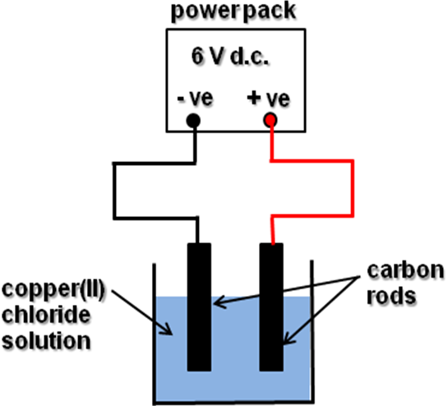
RESULTS

During conduction:
- Copper metal forms on the negative electrode.
- Chlorine gas forms on the positive electrode.

CONCLUSION

For COPPER to form on the negative electrode it has to have a POSITIVE charge. | Cu²⁺  copper ion

For CHLORINE to form on the positive electrode it has to have a NEGATIVE charge. | Cl ‒  chloride ion

This shows that copper(II) chloride is made from IONS and not NEUTRAL ATOMS.

IONIC compounds are made from IONS. This is why they are classified as IONIC.
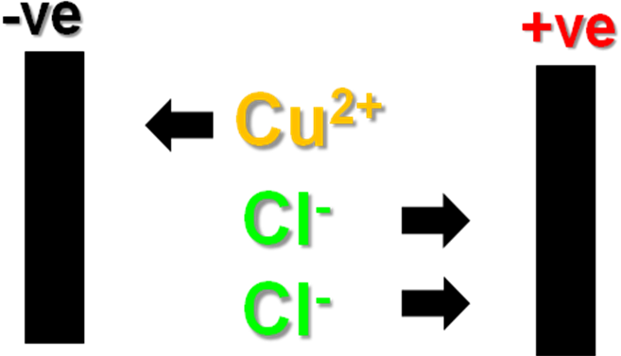
During conduction:

The ions move to the electrodes of opposite charge.
When the ions touch the electrodes they get changed back to atoms.

This reaction is called ELECTROLYSIS.

DICTIONARY - ELECTROLYSIS
ELECTROLYSIS is the break down of an IONIC COMPOUND using electricity.

Ionic compounds only conduct when molten (liquid), and in solution as their ions are FREE TO MOVE ABOUT. When solid the ions cannot move.

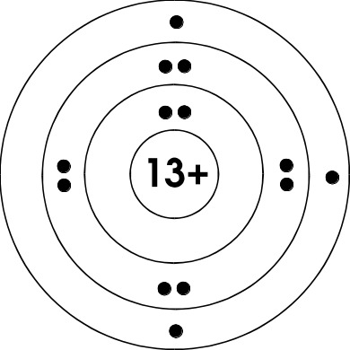
Al atom
Aluminium atom 2, 8, 3.
The 3 outer electrons are free to move between the aluminium atoms.

METALS

Metals are not affected by conducting electricity. The atoms in a metal are held together by METALLIC BONDING.

The atoms in a metal are packed very close to each other. This allows the electrons on the outer energy level of each atom to move between the atoms
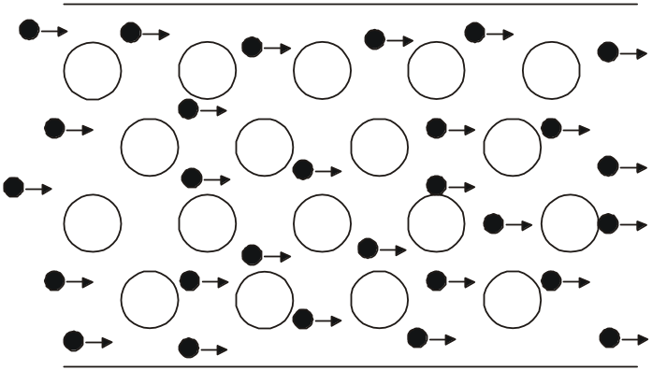
During conduction electrons are pushed in from the negative terminal of a battery or power supply.

Electrons move towards the positive terminal.

CONDUCTION SUMMARY

Conduction involves the movement of charged particles.

When a METAL conducts the charged particles which move as the current are ELECTRONS.

When an IONIC COMPOUND conducts the charged particles which move as the current are IONS.

IONIC COMPOUNDS can only conduct when molten (liquid) or in solution as their ions are free to move. When solid the ions are not able to move and therefore cannot conduct.
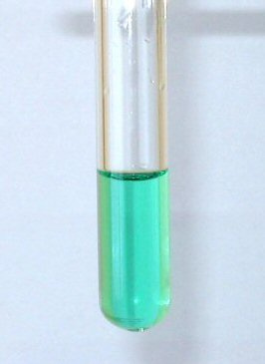

copper(II) chloride

Insulator

Conductor

Ions cannot move.

Ions free to move.

N4 | IONIC BONDING | N4

Compounds classified as IONIC are made from IONS not neutral atoms.
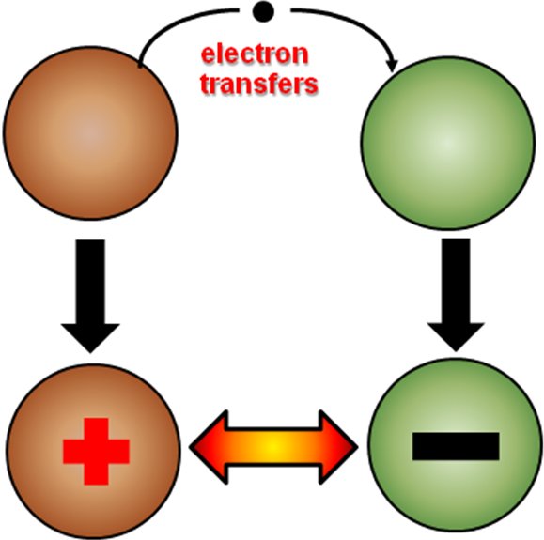

Ions are formed when one or more electron(s) transfers from one atom to another.

The atom which loses electron(s) forms a positive ion.

The atom which gains electron(s) forms a negative ion.

The attraction between the oppositely charged ions is the IONIC BOND.

FORMING IONS

The valency of an atom = the size of the charge of its ion.
valency

ion charge

Metal atoms always form positive ions.  Their atoms lose electron(s). | Mg² |  | Mg²⁺
 | Magnesium atom loses 2 electrons to form its ion.

valency

ion charge

Non-metal atoms always form negative ions. Their atoms gain electron(s). | Cl ¹ |  | Cl⁻
 | Chlorine atom gains 1 electron to form its ion.

IONS OF THE ELEMENTS

Group  I | Group  II |  |  |  |  |  |  |  |  |  |  |  |  | Group  III | Group  IV | Group  V | Group  VI | Group  VII
Li | Be |  | Valency |  |  |  |  |  |  |  |  |  |  | B | C | N | O | F
Na | Mg |  | 2 | 3 | 3 | 3 | 2 | 3 | 2 | 2 | 2 | 2 |  | Al | Si | P | S | Cl
K | Ca |  | Sc | Ti | V | Cr | Mn | Fe | Co | Ni | Cu | Zn |  | Ga | Ge | As | Se | Br

Write in the charges of the ions of the elements in the Periodic Table above.
To practise writing formula of ions do the ION FORMULAE examples on page 5 of the Practice Examples Booklet.

N4 | COVALENT BONDING | N4

Transferring electrons between atoms to form ions is one way atoms can join. This results in IONIC BONDING.

Atoms can join by SHARING ELECTRONS. This is called COVALENT BONDING.

Covalent bonding occurs when non-metal atoms join.
Its atomic number is 1 which means its atom has 1 electron.

The electron can be represented by ● or a X in a diagram.


The hydrogen atom is the simplest atom.

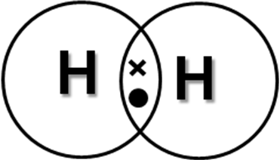
Hydrogen atoms join by overlapping their outer energy level and sharing their electron.

When drawing diagrams to represent covalent bonding only the electrons in the outer energy level of an atom are important, as it is only the outer electrons which are involved in bonding.
This is a covalent bond. It contains 2 electrons.

The valency of an atom tells you the number of electrons available for sharing.

Complete the following diagrams of non-metal atoms showing the arrangement of their electrons in the outer energy level of their atoms.

COVALENT BONDING – NON-METAL ATOM PICTURES

 | Group I |  | Group IV | Group V | Group VI | Group VII
Valency
 | H
 | hydrogen |  | carbon | nitrogen | oxygen | fluorine
Electron Arr.

 |  |  | Group IV | Group V | Group VI | Group VII
 | Valency
 |  |  | silicon | phosphorus | sulfur | chlorine
Electron
Arr.

The valency of an atom tells you the number of unpaired electrons in the outer energy level.

COVALENT BONDING IN ELEMENTS

Only the unpaired electrons are used for making covalent bonds.

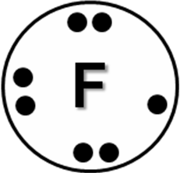
Fluorine atom has 1 unpaired electron in its outer energy level.

This is shared with another fluorine atoms’ unpaired electron.

Fluorine, F₂


FULL STRUCTURAL FORMULA

The line represents a covalent bond.
i.e. A shared pair of electrons.

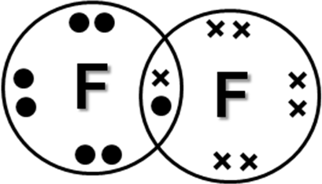


The oxygen atom has 2 unpaired electrons in its outer energy level.

These are shared with other oxygen atoms’ unpaired electrons.

Oxygen, O₂

FULL STRUCTURAL FORMULA

The 2 lines represent a double covalent bond.
i.e. 2 pairs of shared electrons.

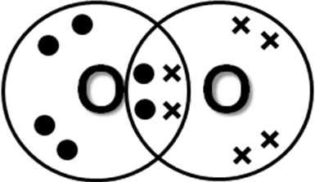

COVALENT BONDING IN COMPOUNDS

Hydrogen chloride, HCl
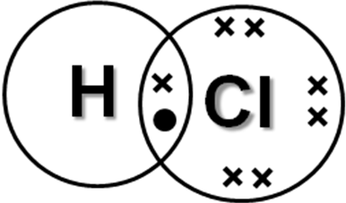


Hydrogen oxide (water), H₂O

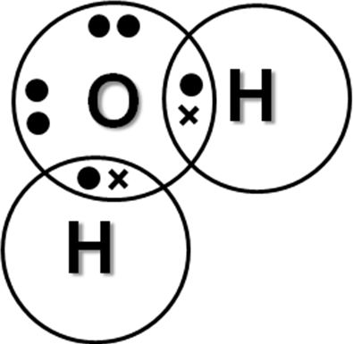
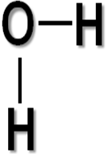

Silicon hydride, SiH₄
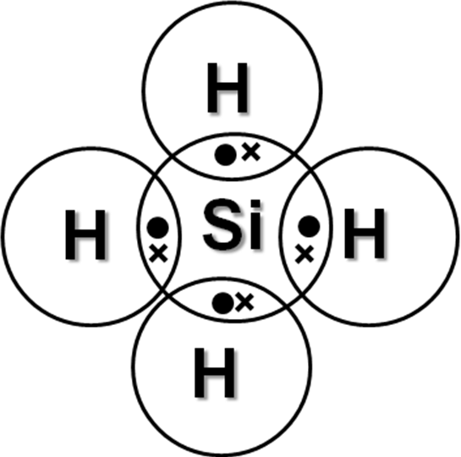
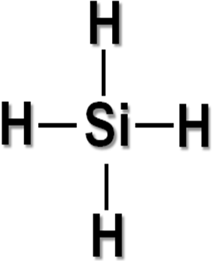

To practise drawing diagrams to represent the covalent bonding in a substance, do the COVALENT BONDING DIAGRAMS examples on page 6 of the Practice Examples Booklet.

N4 | PROPERTIES | N4

Conduction of electricity is the only property that has been studied.

SOLUBILITY, MELTING POINT and BOILING POINT are other properties which depend on the type of bonding in a substance.

SOLUBILITY OF IONIC and COVALENT SUBSTANCES

All metals are insoluble in water and other liquids.

SOLUBILITY OF IONIC AND COVALENT SUBSTANCES RESULTS TABLE
Compound |  |  | Soluble in?
Name | Formula | Bonding | Water | Ethanol | Propanone
A Sodium chloride
B Potassium sulphate
C Phenyl salicylate | C₁₃H₁₀O₃
D Stearic acid | C₁₈H₃₆O₂

Complete the table above with the results from the Solubility of Ionic and Covalent Substances experiment.

CONCLUSION

Ionic substances are soluble in water but are insoluble in other covalent liquids (hexane and white spirit).

Ionic substances are soluble in water but are insoluble in other covalent liquids (hexane and white spirit).

Water, hexane and white spirit all have covalent bonding.

Water is an unusual covalent liquid as it is a good solvent for ionic substances. Most covalent liquids are good solvents for covalent substances.

 | Homework: Using the information obtained from this experiment complete the “Solubility Of Ionic And Covalent Substances Results” Table.
MELTING AND BOILING POINTS

MELTING / BOILING POINTS AND BONDING TYPE
Compound | Formula | Bonding type | High or Low melting point
Potassium sulphate
Sodium chloride
Silicon dioxide
Stearic acid | C₁₈H₃₆O₂
Phenyl salicylate | C₁₃H₁₀O₃
Salicylic acid | C₇H₆O₃

Complete the experiment on melting points of compounds and use your results to fill in the table above.

Homework: Complete the “Melting / Boiling Points And Bonding Type” table provided using melting and boiling point data from the chemistry data booklet.

CONCLUSION

Metals have high melting and boiling points and are solids at room temperature. Mercury is the only exception.

Ionic substances have high melting and boiling points and are all solids at room temperature.

Covalent substances have low melting and boiling points and can be solids, liquids or gases at room temperature.

If a substance is a liquid or gas at room temperature, it will probably have covalent bonding.

The Noble Gases and mercury are exceptions to this general statement.

BONDING AND PROPERTIES SUMMARY

Type of Bonding | Conductivity  (c = conductor, i = insulator) |  |  | Solubility in: |  | Melting Point | Boiling  Point
Type of Bonding | ( s ) | ( l ) | (aq) | Water | Other covalent liquids | Melting Point | Boiling  Point
Metallic |  |  | Do not form solutions | Insoluble | insoluble | high | high
Ionic
Covalent

Complete the Bonding and Properties Summary table above.

N5 | BONDING EXPLAINED | N5

Atoms can bond by:
(a) | Transferring electrons |  | ionic bonding
(b) | Sharing electrons |  | covalent bonding

To gain an understanding why atoms bond we have to look at the electron arrangements of the atoms which do not bond – the Noble Gases.
He | Ne | Ar | Kr | Xe
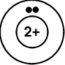 | 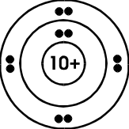 | 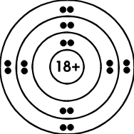 | 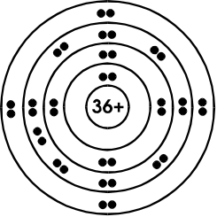 | 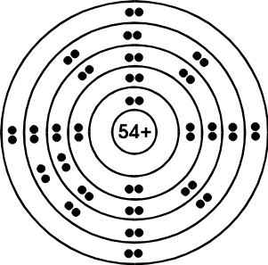
2 | 2, 8 | 2, 8, 8 | 2, 8, 18, 8 | 2, 8, 18, 18, 8
Apart from helium, all Noble Gas atoms have 8 electrons in their outer energy level. This electron arrangement makes the atoms stable and therefore unreactive.

Atoms bond to get an electron arrangement like a Noble Gas atom.

For most atoms this will mean getting 8 electrons in their outer energy level.

IONIC BONDING

In ionic bonding, electrons transfer from the metal atom to the non-metal atom.

Sodium reacting with chlorine to form sodium chloride, NaCl.

sodium atom
chlorine atom
sodium ion
chloride ion

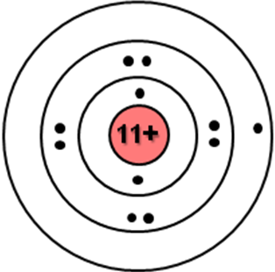
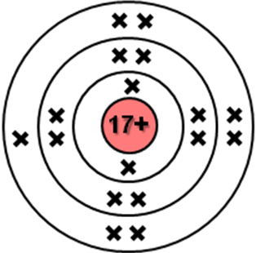
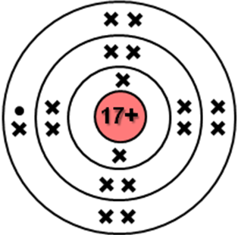
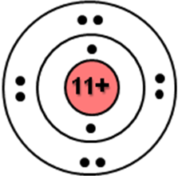

Ions form

Outer electron transfers.
Na
2, 8, 1
Cl
2, 8, 7
Na⁺
2, 8
Cl⁻
2, 8, 8

Both ions have 8 outer electrons.

Both ions have an electron arrangement like a Noble Gas atom, which makes each ion stable.

Lithium reacting with oxygen to form lithium oxide, Li₂O.
O²⁻
2, 8
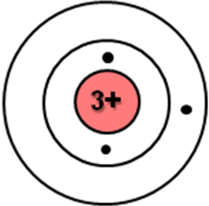
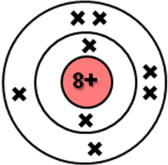
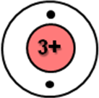
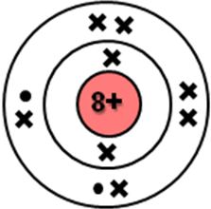
Outer electron transfers.
Li
2, 1
Li
2, 1
O
2, 6
Li⁺
2
Li⁺
2

Ions form

For the Li atom to achieve a stable electron arrangement the Li atom has to lose 1 electron and become a Li⁺ ion.

For the O atom to achieve a stable electron arrangement the atom has to gain 2 electrons and become an O²⁻ ion.

Two Li atoms are required to transfer an electron each to the oxygen atom.

Aluminium reacting with oxygen to form aluminium oxide, Al₂O₃.
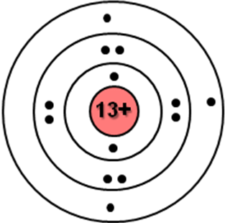
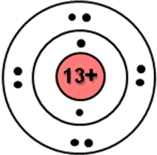
Al
2, 8, 3
Al
2, 8, 3
The 3 outer electrons on each Al atom transfer to the oxygen atoms.
Ions form
O²⁻
2, 8
O²⁻
2, 8
O²⁻
2, 8
O
2, 6
O
2, 6
O
2, 6
Al³⁺
2, 8
Al³⁺
2, 8

The Al³⁺ ion and the O²⁻ ion have an electron arrangement similar to a Ne atom. Both ions are stable.

To practise working out the electron arrangement of an atom and the ion it forms, do the ELECTRON ARRANGEMENTS OF ATOMS AND IONS examples on page 7 of the Practice Examples Booklet.

COVALENT BONDING

In covalent bonding non-metal atoms share electrons. This gives each atom access to the other atom’s outer electrons to fill their outer energy level.

Hydrogen, H₂

Hydrogen atom

By sharing electrons, each H atom gets access to a second electron.
Each H atom now has an electron arrangement similar to a He atom.

Hydrogen molecule, H₂

H
1

Carbon hydride, CH₄

Hydrogen atom

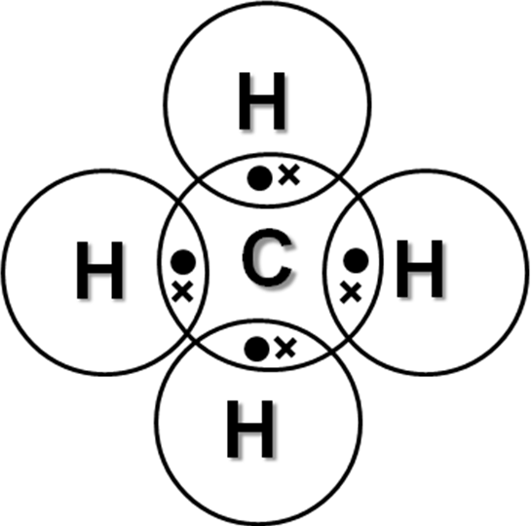
Carbon atom



H
1
C
2, 4

Each H atom gets access to a second electron from the C atom.

Each C atom gets access to 4 additional electrons by sharing with 4 H atoms.

Both C and H atoms now have stable electron arrangements.

BONDING SUMMARY

Atoms bond in order to get a stable electron arrangement – an electron arrangement similar to a Noble Gas atom.

- Metal atoms achieve stability by losing their outer electrons and forming positive ions.
- Non-metal atoms achieve stability by:
gaining electrons forming negative ions;
OR
sharing electrons with other non-metal atoms and forming covalent bonds.

COVALENT BONDING – HOW IT WORKS

In ionic bonding the bond is the attraction between the oppositely charged ions.

How does sharing electrons – covalent bonding hold non-metal atoms together?

Shared pair
of electrons.

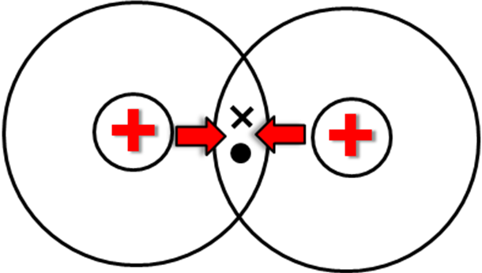

The positive nuclei are attracted to the negative shared pair of electrons. This attraction holds the atoms together. This is the covalent bond.

N5 | STRUCTURES | N5

Covalent and ionic substances have different structures which explains why they have different properties.

IONIC STRUCTURE

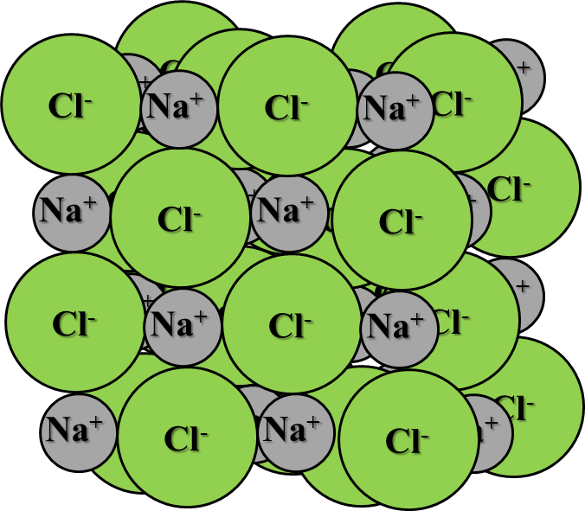
Ionic substances are made from IONS. The ionic bond is the attraction between the oppositely charged ions.

The ions in a solid are arranged so the ions of the same charge are not near each other.

Here is the structure of sodium chloride.

This regular repeating pattern of ions is called an IONIC LATTICE.

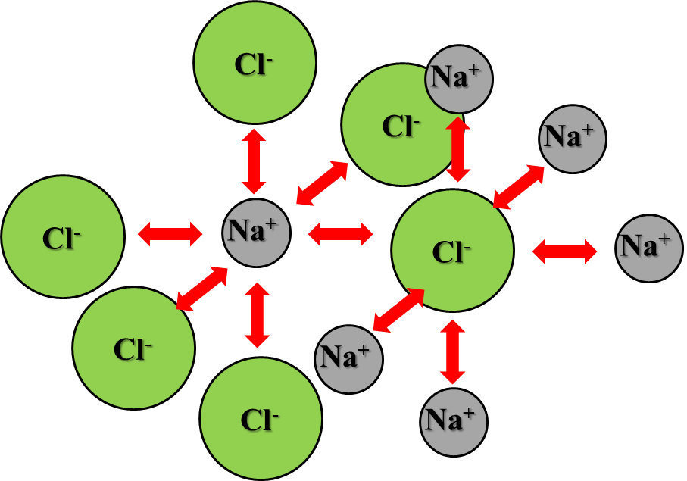

Each sodium ion, Na⁺ is surrounded by 6 chloride ions Cl⁻ and vice versa.

There are equal numbers of sodium and chloride ions in the ionic lattice.
The ratio of Na⁺ : Cl⁻ is 1 : 1.
This is why the formula is Na⁺Cl⁻.

The formula of an ionic compound gives the ratio of the ions in the lattice.

The strong attraction between the ions takes a lot of energy to break. This is why all ionic compounds have high melting and boiling points and are solids at room temperature.
COVALENT STRUCTURE - MOLECULES

Many covalent substances have low melting and boiling points.


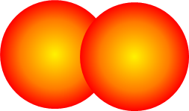
Covalent substances, which have low melting and boiling points, are made from MOLECULES.
Oxygen molecule, O₂
(element)
Methane molecule, CH₄
(compound)

The formula of a molecular substance actually tells you the type of atoms and how many of each atom is in the molecule.

DICTIONARY - MOLECULE
A MOLECULE is a group of non – metal atoms joined together by covalent bonds.
The smallest molecule is made from two non - metal atoms. The largest are made from thousands of non – metal atoms.
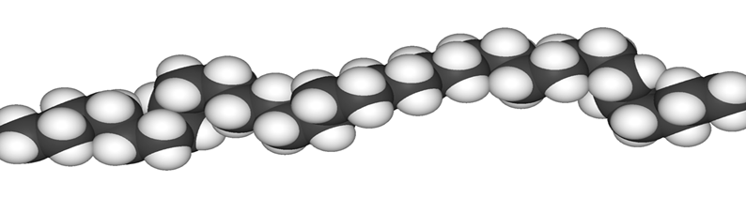

Polythene is a huge molecule made from thousands of carbon and hydrogen atoms.

The atoms in a molecule are held together by strong covalent bonds.
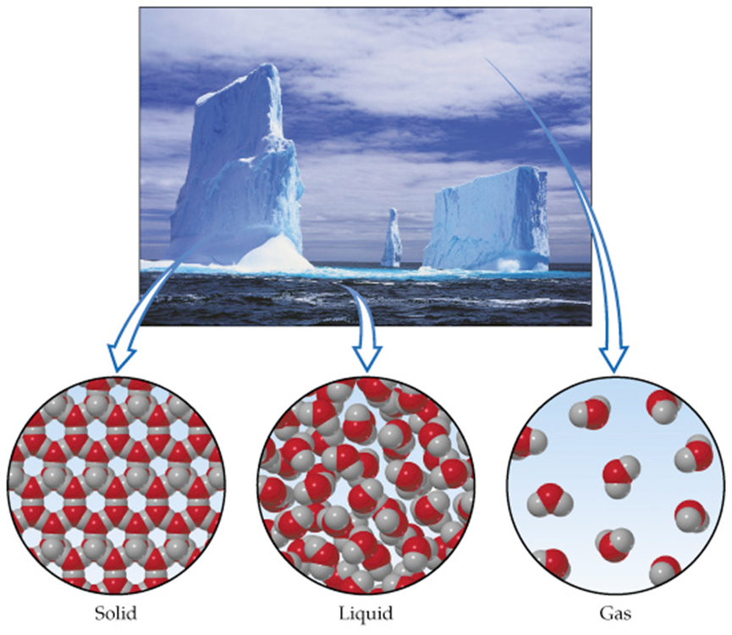
Here is water as a solid, liquid and a gas. The three states of matter.
There are only weak forces of attraction BETWEEN MOLECULES.
This means little energy is needed to make the water molecules move away from each other.
This is why the melting and boiling points are low.
The covalent bonds holding the H and O atoms together in each molecule are NOT BROKEN in changing state.
COVALENT STRUCTURE – NETWORK STRUCTURE

Some covalent substances have very high melting and boiling points and are very hard solids.

These covalent substances are not made from molecules.
They have a structure called a COVALENT NETWORK.
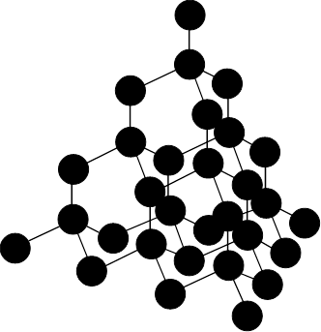
Structure of carbon as diamond.
Diamond is made of carbon atoms and has a covalent network structure.
Every carbon atom is bonded to 4 other carbons which build up a huge network of atoms.
To melt the network requires the strong covalent bonds to be broken.
This means a huge amount of energy is required and the melting point is very high.

COVALENT STRUCTURE AND MELTING AND BOILING POINT

Complete the Covalent Structure and Melting and Boiling Point table below using the Chemistry Data Booklet to find the melting and boiling points of the covalent substances. Decide if the substances have a molecular or network structure.

COVALENT SUBSTANCE | MELTING POINT(ºC) | BOILING POINT (ºC) | STRUCTURE  (molecular or network)
nitrogen (N₂)
silicon dioxide (SiO₂)
butane (C₄H₁₀)
boron (B)
silicon (Si)
sulphur dioxide (SO₂)
phosphorus (P)
Silicon dioxide, SiO₂ has a covalent network structure.
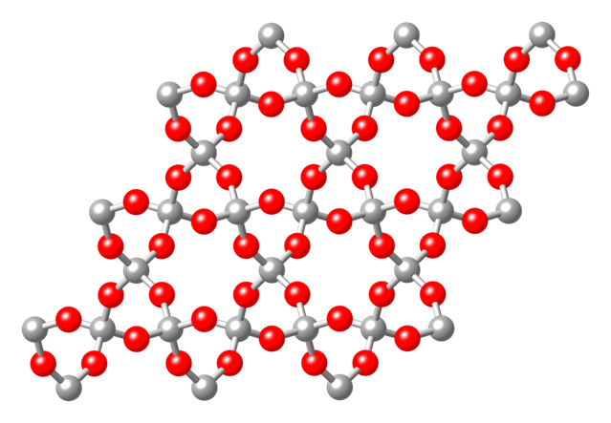

Its formula shows the ratio of Si : O in the network is 1 : 2.
Granite is largely silicon dioxide.

Structure of silicon dioxide, SiO₂.



Marischal College – Aberdeen City Council Headquarters is made of granite, i.e. silicon dioxide, SiO₂.

N5 | SHAPES OF MOLECULES | N5

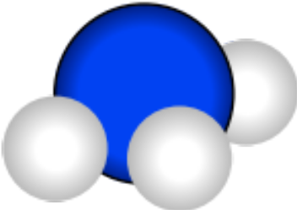
Many molecules are not flat, but have a three dimensional shape. There are times when you need to draw the shape of a molecule.

The shape of a molecule depends on the valencies of the atoms in the molecule.

VALENCY 4 ATOM

Group 4 atoms have a valency = 4. These atoms can form 4 covalent bonds.
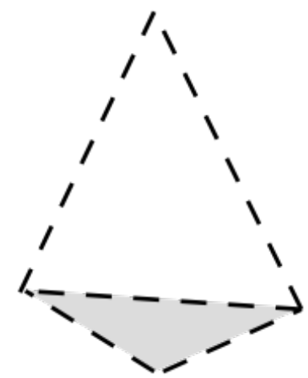



The pairs of electrons in the bonds repel each other.

The bonds point out from the atom towards the corners of a shape called a TETRAHEDRON.
(A triangular based pyramid.)

Dotted line for bond which projects behind the plane of the paper.
EXAMPLE: carbon hydride (methane) CH₄
C
H
H
H
H
C
H
H
H
H
Solid line for bonds that lie on the plane of the paper.
Draw the bonds as …

Carbon hydride (methane) has a tetrahedral shape.
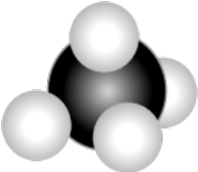
Triangle for bond which come out of the plane of the paper.

All molecules made with a valency 4 atom can make a molecule with a tetrahedral shape, when the atom bonds to an atom with valency one.
VALENCY 3 ATOM

An atom with valency 3 will make a molecule with a similar shape to a valency 4 atom, except with one bond less.
EXAMPLE: nitrogen iodide NI₃
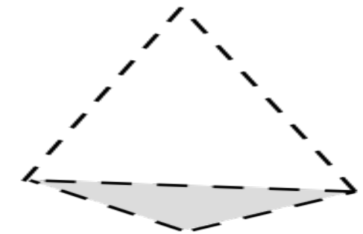

N
I
I
I
All the atoms sit on the corners of a pyramid.

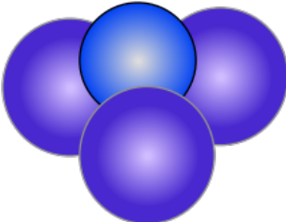

Nitrogen iodide has a pyramidal shape.

All molecules made with a valency 3 atom can make a molecule with a pyramidal shape, when the atom bonds to an atom with valency one.

VALENCY 2 ATOM

An atom with valency 2 will make a molecule with a similar shape to a valency 3 atom, except with one bond less.
EXAMPLE: sulfur chloride SCl₂

S
Cl
Cl
The molecule is flat, and all atoms sit on the same plane. This shape is called planer.

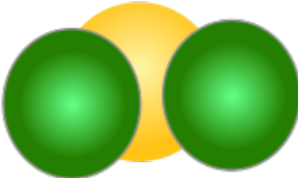
Sulfur chloride has a planer shape.
As the atoms form a bent shape, the shape can be called bent planer.

All molecules made with a valency 2 atom can make a molecule with a planer shape, when the atom bonds to an atom with valency one.

SHAPES OF MOLECULE - SUMMARY
C  H  H  H  H  valency 4 atom | N  I  I  I  valency 3 atom | S  Cl  Cl  valency 2 atom
TETRAHEDRAL | PYRAMIDAL | PLANER

N5 | ELECTROLYSIS | N5

Electrolysis is the break down of an ionic compound using electricity. The reaction occurs on the electrodes during conduction.

ELECTROLYSIS OF SOLUTIONS

Electrolysis of copper(II) bromide and zinc iodide solutions.

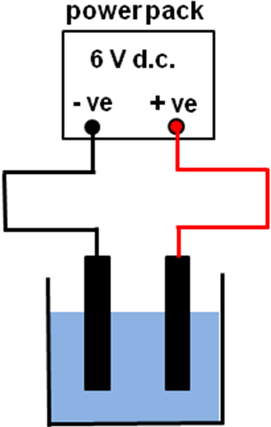
RESULTS

Compound | Product at:
Compound | +ve electrode | -ve electrode
copper(II) bromide | bromine | copper
zinc iodide | zinc | iodine

copper(II) bromide solution or zinc iodide solution
carbon
rods

ELECTROLYSIS OF A LIQUID

For electrolysis to take place the ions in an ionic compound have to be free to move. The ions are free to move when the ionic compound is dissolved in water and when it’s molten (liquid.)

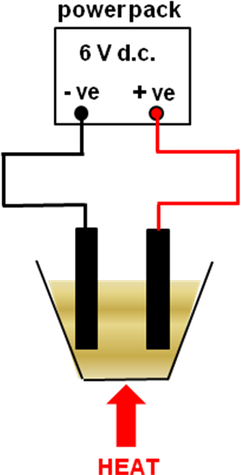  molten lead(II) bromide  carbon  rods | RESULTS  Lead forms at the negative electrode and bromine forms at the positive electrode.
CONCLUSION

During electrolysis:

A metal forms at the negative electrode as metal ions are positively charged and are attracted to the negative electrode.

A non - metal forms at the positive electrode as non - metal ions are negatively charged and are attracted to the positive electrode.

During electrolysis the ions get changed into atoms when the ions touch the electrodes.
molten lead(II)
iodide
A liquid, which contains ions, is called an ELECTROLYTE.

Electrolytes conduct electricity.

All ionic compounds make electrolytes when melted or in solution.

ELECTROLYSIS EXPLAINED

Using the electrolysis of copper(II) chloride solution to explain the process of electrolysis.

In electrolysis the positive electrode is called the ANODE and the negative electrode is called the CATHODE.
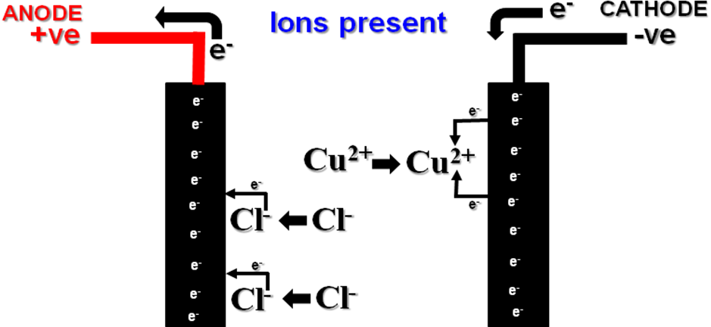
The chloride ion, Cl ‒, is attracted to the positive electrode.
When 2 Cl‒ ions touch the electrode, 1 electron each transfers to the electrode changing them into Cl atoms, which then join to form a Cl₂ molecule.

The copper(II) ion, Cu²⁺, is attracted to the negative electrode.
When the Cu²⁺ touches the electrode, 2 electrons transfer onto the ion, changing it into a copper atom.
Cu²⁺(aq)+2e‒Cu(s)
2Cl‒ (aq)Cl₂(g)+2e‒

ELECTROCHEMICAL SERIES

The equations showing the ions being discharged are called “ion-electron equations.”

These are listed in the ELECTROCHEMICAL SERIES.

In the electrolysis of molten lead(II) bromide, lead formed at the negative electrode and bromine formed at the positive electrode.

Here is the ion-electron equation for the discharge of the lead(II) ions:

- ve  electrode | Pb²⁺( l ) + 2e⁻ → Pb( l )

This equation is just copied from the Electrochemical Series table with a change to the state symbols.

In the Electrochemical series the listed equations for chlorine, bromine and iodine have to be reversed to show the discharge of their ions.

Here is the bromine equation from the Electrochemical Series.

Br₂( l ) + 2e⁻ → 2Br‒(aq)

Writing the equation in reverse shows the discharge of bromide ions to form bromine. For this to happen a total 2 electrons have to be lost.

+ ve  electrode | 2Br ⁻ ( l ) → Br₂(g) + 2e⁻

Bromine (Br₂) is a gas because the molten lead(II) bromide is so hot it boils the bromine.

Complete the Electrolysis Reactions table below using the Electrochemical Series in the Chemistry Data Booklet.

The first example has been done to show you how to complete the table. Note the state symbols have been missed out.

ELECTROLYSIS REACTIONS
Compound | Ions Present | Product at:
Compound | Ions Present | Negative electrode | Positive electrode
Copper(II) chloride | Cu²⁺ , Cl⁻ | copper | chlorine
Copper(II) chloride | Cu²⁺ , Cl⁻ | Cu²⁺ + 2e⁻ → Cu | 2Cl⁻ → Cl₂ + 2e⁻
Lead(II) bromide
Zinc(II) iodide
Tin(II) chloride
Nickel(II) bromide

COVALENT SUBSTANCES

Covalent substances do not conduct electricity (except carbon as graphite).

Covalent bonding involves sharing electrons between the bonding non - metal atoms to form molecules. The atoms in a molecule do not become charged. They do not form ions.
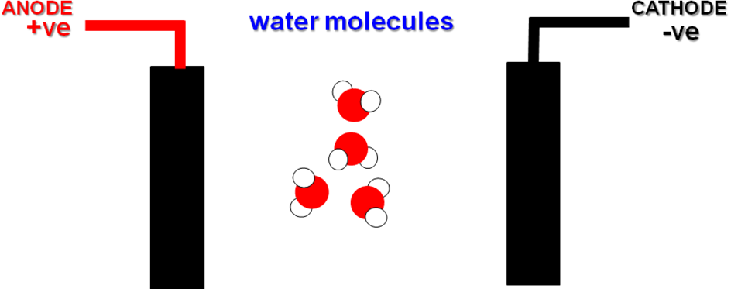
The neutral molecules do not get attracted to the electrodes.

Covalent substances do not conduct as molecules are not charged, and therefore do not get attracted to the electrodes.

DIRECT CURRENT

Electrolysis will only take place when a DIRECT CURRENT (d.c.) is passed into an ELECTROLYTE.

A direct current ensures that there is a POSITIVE and NEGATIVE electrode. [ANODE and CATHODE.]

There is another connection on the power pack - ALTERNATING CURRENT (a.c.).

In a.c. the current changes direction 50 times per second, so there is not a permanent positive and negative electrode. As a result, electrolysis does not occur when a.c. is used.

