 **NATIONAL 4 AND NATIONAL 5 CHEMISTRY**

**Unit 2: Nature’s Chemistry**

**Topic 6**

**MEASURING ENERGY FROM FUELS**

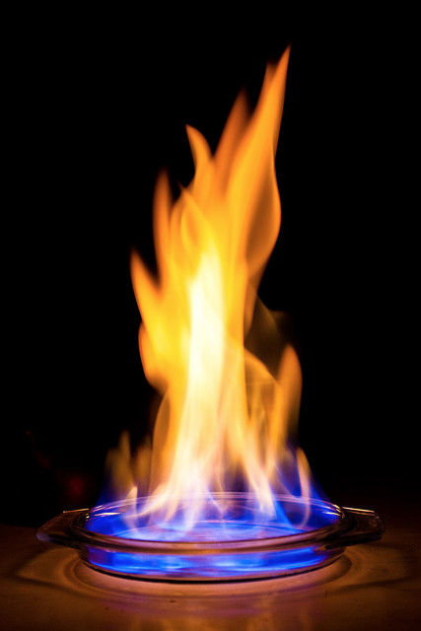

|  |
| --- |
| **Name __________________________________ Class _____** |

|  |
| --- |
| Unit 2: Nature’s Chemistry |
| Topic 6: Measuring Energy From Fuels |

|  |  |  |  |  |  |
| --- | --- | --- | --- | --- | --- |
| LEVEL N4 N5 | **AFTER COMPLETING THIS TOPIC YOU SHOULD BE ABLE TO:** | NOTES (Page) | **How well I have understood (✓)** | | |
| **☺** | **😐** | **☹** |
| N5 | Calculate the quantity of heat energy used to heat a given mass of water using the relationship *Eh = cmΔT.* | 3 - 4 |  |  |  |
| N5 | Carry out an experiment to determine the heat energy E*h* released from burning a fuel. | 5 - 6 |  |  |  |
| N5 | State the measurements which have to be made during the determination of the heat energy released from fuel experiment. | 5 - 6 |  |  |  |
| N5 | I.5.4etermination of the heat energy released from fuel experiment.burning a fuel. relationship Calculate E*h* per gram of a fuel from experimental data. | 5 - 6 |  |  |  |
| N5 | Use a balanced chemical equation to calculate the number of moles of a product made by a reaction from a given number of moles of a reactant. | See note below * |  |  |  |
| N5 | Use a balanced chemical equation to calculate the number of moles of a reactant required by a reaction to produce a given number of moles of a product. | See note below * |  |  |  |
| N5 | Use a balanced chemical equation to calculate the mass of a product made by a reaction from a given mass of a reactant. | See note below * |  |  |  |
| N5 | Use a balanced chemical equation to calculate the mass of a reactant required by a reaction from a given mass of a product. | See note below * |  |  |  |
|  | **\* These outcomes are covered in the Unit 1 Topic 5 - Chemical Formulae & Reaction Quantities note, Pages 15 – 20 – THE MOLE & REACTION QUANTITIES.** |  |  |  |  |

|  |  |  |
| --- | --- | --- |
| **N5** | **MEASURING ENERGY FROM FUELS** | **N5** |

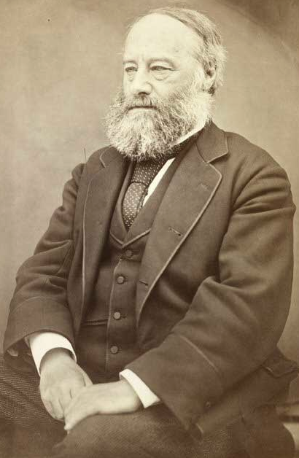

**James Prescott Joule**

**(1818 – 1889)**

**ENERGY RELEASED FROM FUELS**

Combustion of a fuel releases energy, i.e. it is an **EXOTHERMIC REACTION**.

The unit for measuring energy is the **JOULE (J)**. The unit is named after **James Prescott Joule**, the physicist who did a lot research on energy.

A joule is a small quantity of energy. Often measurements of energy are given in **kilojoules (kJ)**.

To compare the quantity of energy released by different fuels the same mass of fuel must be burned in each experiment.

The table shows the energy released when **1 gram** of each fuel is burned.

|  |  |  |  |
| --- | --- | --- | --- |
| **Fuel** | **Energy released per gram (kJ g-1)** |  |  |
| methane | 55.7 |  |  |
| butane | 49.6 |  | **How do chemists measure the energy released when 1 g of these fuels are burned?** |
| gasoline | 48.3 |  |
| methanol | 22.7 |  |  |

**MEASURING ENERGY RELEASED FROM A FUEL**

The energy released when a fuel burns can be used to heat water.

|  |  |  |
| --- | --- | --- |
| **Facts about water:**  It requires **4.18 kJ of energy to raise 1 kilogram of water by 1 ºC**.  This measurement is called the **specific heat capacity of water**.  The symbol for this is the letter ‘**c**’.  **1 cm3 of water has a mass = 1 g**.  Therefore,  **1 kg of water has a volume = 1000 cm3 (1 litre).** |  |  |

|  |  |
| --- | --- |
| The energy required to heat a mass of water can be calculated using the following relationship: | |
| **Eh = c × m × ΔT** | **Eh** = energy required to heat water.  **c** = specific heat capacity of water = 4.18 kJ kg-1 ºC-1.  **m** = mass of water heated in kg.  **ΔT** = temperature change of the water. |

|  |  |  |  |  |  |  |  |
| --- | --- | --- | --- | --- | --- | --- | --- |
| **EXAMPLE**  Calculate the energy required to raise the temperature of 500 cm3 of water by 16 ºC. | | | | | | | |
| **c = 4.18 kJ kg-1 ºC-1** | **Eh** | **=** | **c** | **×** | **m** | **×** | **ΔT** |
| **m = 0.5 kg (500 cm3 = 500 g = 0.5 kg)** |  | **=** | **4.18** | **×** | **0.5** | **×** | **16** |
| **ΔT = 16 ºC** | **Eh** | **=** | **33.44 kJ** | | |  |  |

|  |  |
| --- | --- |
|  | To practise calculating the energy transferred to water when it is heated, do the **HEATING WATER** examples on **page 2** of the **Practice Examples Booklet**. |

**EXPERIMENT: COMPARING FUELS**

**AIM:** To compare the energy released when 1 g of different alcohols is burned.

|  |  |
| --- | --- |
| fuel (alcohol)  spirit burner  draught shield  100 cm3  of water (0.1 kg)  copper can  thermometer | **ALCOHOLS:**  methanol, ethanol and propan-1-ol. |
|  |
| **MEASUREMENTS TO BE MADE**  Mass of water in kg.  Temperature of water before heating.  Temperature of water after heating.  Mass of burner at start.  Mass of burner after heating water. |

**100 cm3 of cold water** is placed in the copper can and the temperature measured.

**The spirit burner is weighed before lighting**. After lighting the burner, it is immediately placed under the can to heat the water. The water is stirred with the thermometer during heating.

When the temperature of the water has risen by about 20 ºC, the flame is extinguished, and the spirit burner weighed.

|  |  |  |  |
| --- | --- | --- | --- |
| **RESULTS** | **ALCOHOL** | | |
| **methanol** | **ethanol** | **propan-1-ol** |
| Mass of water / kg |  |  |  |
|  |  |  |  |
| Initial temperature of water / ºC |  |  |  |
| Final temperature of water / ºC |  |  |  |
| **T** / ºC |  |  |  |
|  |  |  |  |
| **Eh = c × m × ΔT**  (Energy transferred to the water) / kJ |  |  |  |
|  |  |  |  |
| Initial Mass of burner / g |  |  |  |
| Final Mass of burner / g |  |  |  |
| Mass of alcohol burned / g |  |  |  |
|  |  |  |  |
| **Energy released per gram of alcohol / kJ g-1** |  |  |  |

**CONCLUSION**

Look at the results of the experiment. Is there a pattern to the energy released when 1 g of **methanol (CH3OH)**, **ethanol (C2H5OH)** and **propan-1-ol (C3H7OH)** is burned?

**EVALUATION**

Do you think your results are accurate? Do you think **all the heat released** from the burning fuels was transferred to the water? What are the limitations of the equipment? Can you suggest improvements you could make to the experimental procedure?

|  |  |
| --- | --- |
|  | To practise calculating the energy released when fuels burn do the **MEASURING ENERGY FROM FUELS** examples on **page 3** of the **Practice Examples Booklet**. |