**NATIONAL 4 AND NATIONAL 5 CHEMISTRY**



**Unit 3: Chemistry In Society**

**Topic 6**

**NUCLEAR CHEMISTRY**

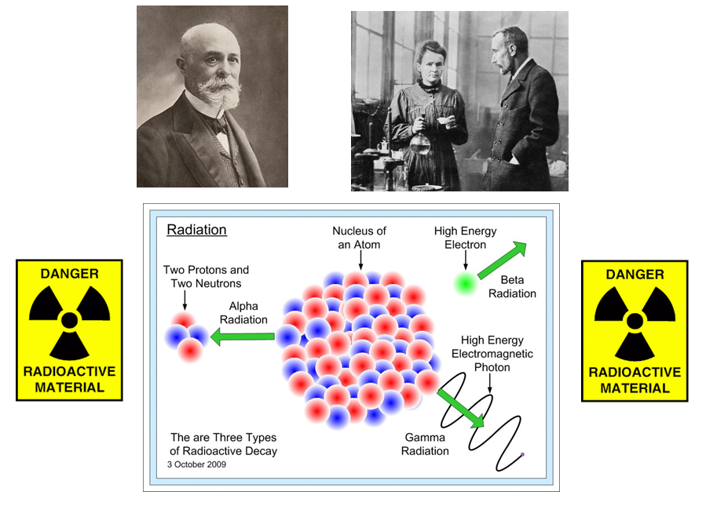

|  |
| --- |
| **Name __________________________________ Class _____** |

|  |
| --- |
| Unit 3: Chemistry In Society |
| Topic 6 : Nuclear Chemistry |

|  |  |  |  |  |  |
| --- | --- | --- | --- | --- | --- |
| LEVEL N4 N5 | **AFTER COMPLETING THIS TOPIC YOU SHOULD BE ABLE TO:** | NOTES (Page) | **How well I have understood (✓)** | | |
| **☺** | **😐** | **☹** |
| N4 | State elements are created in the stars from simple elements by nuclear fusion. | 3 |  |  |  |
| N4 | All naturally occurring elements, including those found in our bodies, originated in stars. | 4 |  |  |  |
| N4 | Describe what happens what during nuclear fusion. | 3 |  |  |  |
| N4 | State radioactivity results from the nuclei of some atoms, which are described as unstable. | 4 |  |  |  |
| N4 | State radioactive elements are found in nature and the radiation produced is called background radiation. | 5 |  |  |  |
| N4 | Describe how background radiation can be measured using a Geiger counter. | 5 |  |  |  |
| N5 | State radioactive decay involves changes in the nuclei of atoms. | 8 |  |  |  |
| N5 | Described the natures and properties of alpha, beta and gamma radiation. | 7-9 |  |  |  |
| N5 | State the stability of nuclei depends on the neutron : proton ratio. | 10 |  |  |  |
| N5 | State unstable nuclei (radioisotopes) are transformed into more stable nuclei by releasing energy. | 11 |  |  |  |
| N5 | Write balanced nuclear equations, involving neutrons, protons, alpha particles and beta particles | 11-12 |  |  |  |
| N5 | State the half-life is the time taken for the activity or mass of a radioisotope to halve. | 13-14 |  |  |  |
| N5 | State the decay of individual nuclei within a sample is random and is independent of chemical or physical state. | 14 |  |  |  |
| N5 | Calculate the quantity of radioisotope, half-life or time elapsed given the value of the values of two of the variables. | 14-15 |  |  |  |
| N5 | Describe how radiocarbon dating is used to date archaeological remains. | 15-16 |  |  |  |
| N5 | Describe how rocks and the age of the Earth can be dated using radioisotopes. | 17 |  |  |  |
| N5 | Describe how radioisotopes can be used in medicine, industry and in a smoke detector. | 17-20 |  |  |  |
|  |  |  |  |  |  |

|  |  |  |
| --- | --- | --- |
| **N4** | **ELEMENT FORMATION & RADIOACTIVITY** | **N4** |

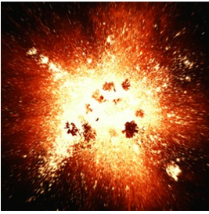**MAKING ELEMENTS**

Atoms came into existence during a massive explosive event **nearly 13.7 billion years ago**, called the **BIG BANG**.

After the explosion, the universe was extremely hot and compact. Soon after, the universe cooled enough to allow the smallest atoms to form. These were **hydrogen atoms**.

With the high temperatures that still existed the **nuclei** of the **hydrogen atoms** joined to form **heavier nuclei** and therefore more elements. This process is called **NUCLEAR FUSION**.

|  |  |  |  |  |
| --- | --- | --- | --- | --- |
| **hydrogen-1** | **+** | **hydrogen-2** |  | **helium-3** |
|  | **+** |  |  |  |
|  | **+** |  |  |  |

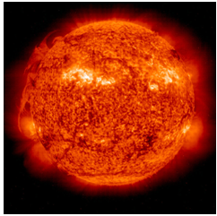**NUCLEAR FUSION** releases huge amounts of energy. **Nuclear fusion** continues today in stars. This produces the energy that comes from our own star, the **SUN**. It also continues to make new elements.

**Hydrogen** **atoms** were the first atoms to form from the **BIG BANG**. **Over 95 %** **of all atoms in the universe today are hydrogen** **atoms**. These **hydrogen** **atoms** are mostly found in stars.

In small stars, such as the **Sun**, elements such as **carbon**, **oxygen** and **silicon** are formed by **nuclear fusion** of small nuclei.

|  |  |  |  |  |  |  |
| --- | --- | --- | --- | --- | --- | --- |
| **carbon-13** | **+** | **helium-4** |  | **oxygen-16** | **+** | **neutron** |
|  | **+** |  |  |  | **+** |  |
|  | **+** |  |  |  | **+** |  |

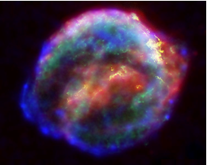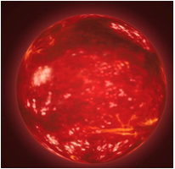In more gigantic stars (**red giants**) the **nuclei** of even heavier elements are built up.

When a **red giant** reaches a certain stage in its lifetime it explodes apart in what astronomers call a **super nova**. This blasts all the elements formed into space as gas and dust.

New stars and planets may form from this mixture.

**This means that all atoms apart from hydrogen atoms on Earth were originally formed by nuclear fusion in stars.**

**RADIOACTIVE ATOMS**

The **nuclei** of some atoms are **RADIOACTIVE** this is due to their **nuclei** being **UNSTABLE**. In the **nuclei** **of radioactive atoms** the repulsive forces between the positively charged protons are so large that the nucleus gives off radiation to become stable.

All atoms with atomic numbers **above 92 (i.e. more than 92 protons in each nucleus)** are all unstable. With so many protons in the nucleus the repulsive forces are too great for the nucleus to be stable.

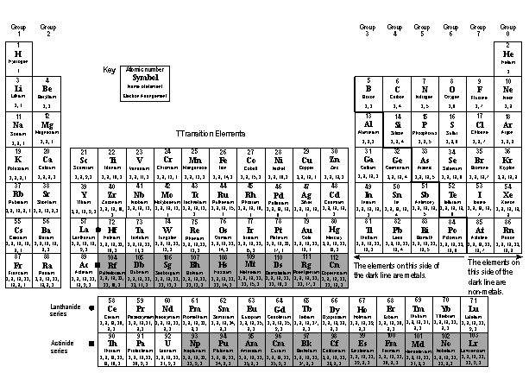

**RADIOACTIVITY IN THE ENVIRONMENT**

The Earth contains radioactive atoms, which formed when the planet formed after the **BIG BANG**. Over billions of years many of these atoms have given off their radioactivity and changed into stable atoms. However, there are still tiny quantities of radioactive atoms in almost every substance. These radioactive atoms are called **Naturally-Occurring Radioactive Materials (NORM)**.

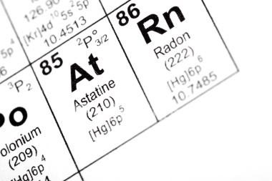

Granite contains radioactive elements like **radium**, **uranium** and **thorium**. When **uranium- 238** atoms give off radiation it changes into radioactive **radon-222** gas.

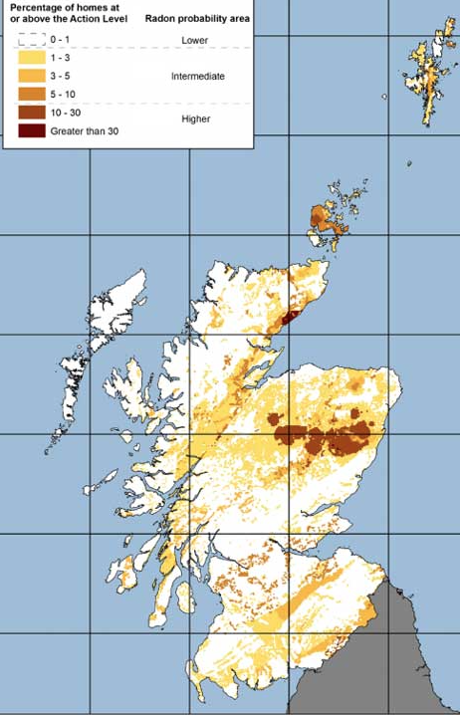

This radioactive radon escapes from the ground into the air. However, if houses are built on ground where **radon-222** is escaping, the concentration of the **radon-222** gas in the house can build up to a level that is dangerous to health, if the house is not well ventilated.

The map of Scotland shows the level of **radon-222** escaping from the ground in different parts of the country.

**BACKGROUND RADIATION**

The tiny amount of radioactive atoms in the environment **(NORM)** means that people are exposed a tiny level of radiation. This natural level of radiation is called the **BACKGROUND RADIATION**.

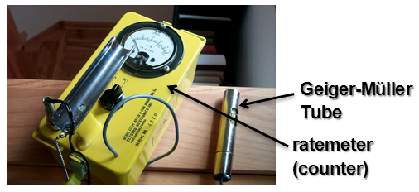

Radioactivity is measured using a **Geiger-Müller Tube** connected to a **ratemeter (counter)**.

When the equipment is switched on there is always a reading on the ratemeter. This radiation comes from the **background radiation**.



The background radiation not only comes from **NORM**, some radiation comes in from outer space. This is called **COSMIC RADIATION**.

In the 20th century there has been radioactive materials released into the environment due to nuclear accidents, and the use of nuclear weapons. These radioactive materials have all increased the **background radiation**.

|  |  |  |
| --- | --- | --- |
|  |  | Fukushima power station disaster, Japan on 11th March. 2011. A meltdown of three nuclear reactors occurred due to the plant being hit by a tsunami after an earthquake. |
| The mushroom cloud of the atomic bombing of Nagasaki, Japan on 9th Aug. 1945. | Chernobyl power station disaster, Ukraine on 26th April 1986. |

|  |  |  |
| --- | --- | --- |
| **N5** | **RADIOACTIVE RADIATION** | **N5** |

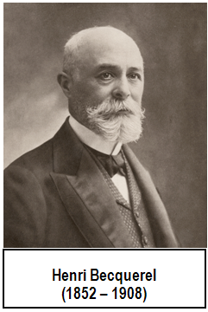**DISCOVERY OF RADIOACTIVITY**

The French physicist Henri Becquerel discovered radioactivity **in 1896** while doing experiments with uranium salts.

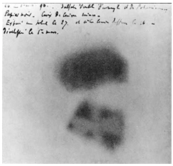He found uranium salts blackened a photographic plate, which was surrounded with light protecting paper.

He concluded the uranium salts were giving off invisible rays, which could pass through the paper. These radiations were called **“Becquerel Rays”**.

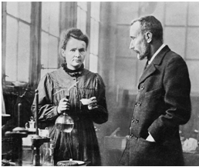

**Pierre and Marie Curie** researched this discovery further. They came up with the term **RADIOACIVITY**.

Their work led to the discovery of two radioactive elements, which they named **polonium** and **radium**.

**TYPES OF RADIATION**

There are three types of radiation. Until the exact nature of these radiations was fully investigated they were simply known as **alpha (α)**, **beta (β)** and **gamma (γ) radiations**, from the first three letters of the Greek alphabet. These names are still used today.

**EXPERIMENT – RADIOACTIVITY AND CHARGE**

The following experiment investigates the electrical charge of **alpha (α)**, **beta (β)** and **gamma (γ) radiations**.

**radioactive source**

**lead shield producing a beam**

**charged plates**

**Alpha ()** is deflected towards the **negative plate** showing it has a **positive charge**.

**Beta ()** is deflected towards the **positive plate** showing it has a **negative charge**.

****

****

****



**Gamma ()** is not deflected showing it does not have an electrical charge.

**Beta ()** is deflected more than **alpha (α)** showing **beta ()** has a **lighter mass** than **alpha (α)**.

**Beta ()** is deflected more than **alpha ()** showing **beta ()** has a **lighter mass** than **alpha ()**.

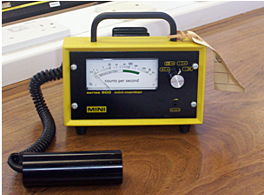**EXPERIMENT – PENETRATING POWER**

The different radiations can be detected using a **Geiger-Müller Tube** connected to a **counter**.

The following experiment shows the different penetrating powers **alpha (α)**, **beta (β)** and **gamma (γ) radiations.**



**radioactive source**

**ratemeter**

**Geiger-Müller Tube**

**thin sheet of paper**

**aluminium  
6 mm**

**lead  
20 mm**

****

****

****



A thin sheet of paper absorbs **alpha (α**), but not **beta (β)** and **gamma (γ) radiations.**

Aluminium absorbs both **alpha (α**) and **beta (β) radiations**, but not **gamma (γ).**

A block of lead absorbs all three types of radiation.

**NATURE OF THE RADIATIONS**

The nature of each of the three types of radioactive radiation have been studied by scientists, and it is now known exactly what each type of radiation is made of.

**Radioactivity comes from the nucleus of an atom. When the nucleus of an atom gives off radioactivity, the nucleus is described as unstable**.

**(a) ALPHA () RADIATION**



** – particles have a relative mass = 4.**

**Alpha () radiation** is **positively charged particles** emitted from unstable nuclei of some radioactive atoms. They are usually referred to as **alpha particles ( – particles)**.

Each ** – particle** is made of **two protons** and **two neutrons**, exactly the same as the **nucleus of a helium atom**.

**Alpha particles** are **relatively heavy** and **slow moving**. They do not travel far in air, due to them colliding with molecules in the air.

**(b) BETA () RADIATION**

**Beta () radiation is negatively charged particles, with a charge of -1, emitted from unstable nuclei of some radioactive atoms.**

**They are usually referred to as beta particles ( – particles).**

A ** – particle** is a **fast-moving electron**. The ** – particle** comes from a **neutron** when it **splits ejecting a high-energy electron**, leaving a **proton** in the nucleus.

|  |  |  |  |  |
| --- | --- | --- | --- | --- |
| **neutron** |  | **proton** | **+** | **electron** |
|  |  |  | **+** |  |
|  |  |  |  | ** – particle** |

**(c) GAMMA () RADIATION**

**Gamma () radiation** consists of **high energy electromagnetic waves** emitted from **unstable nuclei** of some radioactive atoms.

They are not particles, have **no mass or charge**, and **travel at the speed of light** (as do all electromagnetic waves).

**They are usually referred to as gamma rays ( – rays).**

|  |  |  |  |  |  |
| --- | --- | --- | --- | --- | --- |
| **RADIOACTIVE RADIATION SUMMARY** | | | | | |
| **TYPE** | **NATURE** | | **CHARGE** | **RELATIVE MASS** | **SPEED** |
| ** particle** | helium nucleus |  | +2 | 4 | slow |
| ** particle** | high-energy electron |  | -1 | almost 0 | fast |
| ** ray** | high-energy electromagnetic waves | | 0 | 0 | speed of light |

**RADIOISOTOPES – BAND OF STABILITY**

Scientists do not fully understand what makes one isotope stable and another unstable. However, **it is known that, for nuclei containing more than one proton, neutrons are essential for holding the positive protons together**.



**0**

**100**

**Number of neutrons**

**Number of protons**

**0**

**20**

**40**

**60**

**80**

**100**

**25**

**50**

**75**

**125**

**150**

**Band of stability**

**No. of neutrons = No. of protons**

The graph shows that for low atomic numbers the **number of neutrons equals the number of protons to give stable nuclei.  
  
(Carbon-12** has **6 neutrons** and **6 protons.)**

For higher atomic numbers, an even greater **proportion of neutrons** are required to **give stable nuclei.  
  
(Lead-207 has 125 neutrons and 82 protons.)**

|  |
| --- |
| The stability of an isotope depends on:  **neutron : proton ratio** |

A **RADIOISOTOPE** is an atom with an unstable nucleus that emits radioactive radiation.

**RADIOACTIVE DECAY**

A radioactive isotope emits an **alpha** or a **beta particle** from the nucleus to become stable. During the loss of the **alpha** or **beta particle**, energy is also released. This type of nuclear change is called **RADIOACTIVE DECAY**.

**Alpha decay** occurs when a **radioisotope** **emits an alpha particle**.

|  |  |  |
| --- | --- | --- |
| An **alpha particle** contains **2 protons** and **2 neutrons**. Loss of an **alpha particle** from the nucleus of a radioisotope changes the nucleus. | **When an alpha particle is lost from a nucleus**. | |
| ${}_{\text{2}}^{\text{4}}{\text{He}}$ | The mass number drops by 4.  The atomic number drops by 2.  Symbol for an -particle in a nuclear equation. |

|  |
| --- |
| The new isotope that forms after nuclear decay is called the **DAUGHTER PRODUCT** or **ISOTOPE**. |

|  |  |  |  |  |
| --- | --- | --- | --- | --- |
| **EXAMPLE: thorium-230 decays by -emission.** | | | | |
|  |  |  | **+** |  |
|  |  |  |  |  |
|  |  |  |  | ** – particle** |

**-decay** takes place when a radioisotope emits a **beta particle**.

A **-particle** is an **electron**, which is emitted from the nucleus when a neutron changes into a proton, and an **electron**.

|  |  |  |  |  |  |  |
| --- | --- | --- | --- | --- | --- | --- |
| **neutron** |  | **proton** | **+** | **electron** |  | **When a beta particle is lost from a nucleus**. |
|  |  |  | **+** |  |  | The mass number remains unchanged.  The atomic number increases by 1. |
| $${}_{\text{0}}^{\text{1}}{\text{n}}$$ |  | $${}_{\text{1}}^{\text{1}}{\text{p}}$$ | **+** | ${}_{\text{-1}}^{\text{0}}{\text{e}}$ |  | Symbol for a -particle in a nuclear equation. |
|  |  |  |  | ** – particle** |  |  |

|  |  |  |  |  |
| --- | --- | --- | --- | --- |
| **EXAMPLE: phosphorus-32 decays by -emission.** | | | | |
|  |  |  | **+** |  |
|  |  |  |  |  |
|  |  |  |  | ** – particle** |

|  |  |
| --- | --- |
|  | To practise **WRITING NUCLEAR EQUATIONS**, do the **NUCLEAR EQUATIONS** examples on **page 2** of the **Practice Examples Booklet**. |

|  |  |  |
| --- | --- | --- |
| **N5** | **RADIOACTIVE RADIATION** | **N5** |

**PATTERN OF DECAY**

When a radioactive substance gives out radiation its level of radioactive activity decreases as it decays away.

The activity of a radioactive source can be measured using a Geiger-Müller Tube connected to a ratemeter. The Geiger-Müller tube detects each time an individual nucleus decays. The activity is displayed on the ratemeter as the **number of counts per minute or per second**. The **number of counts per second** is a unit called the **becquerel, Bq**.

**EXPERIMENT – MEASURING HALF-LIFE**

A sample of **iodine-131** had its activity measured every 5 days, using the apparatus below. Measurements were taken for a total of 40 days.

**ratemeter**

**Geiger-Müller Tube**

**iodine-131**



**RESULTS** Using the data from the experiment plot a line graph and work out the time for the activity to drop from 8000 counts min-1 to 4000 counts min-1.

|  |  |  |  |
| --- | --- | --- | --- |
| **Time (days)** | **Activity (counts min-1)** |  | **0**  **0**  **2000**  **4000**  **6000**  **8000**  **Activity / counts min-1**  **10**  **20**  **30**  **40**  **Time / days**  **Activity vs. Time for iodine-131** |
| 0 | 8000 |  |
| 5 | 5100 |  |
| 10 | 3350 |  |
| 15 | 2200 |  |
| 20 | 1400 |  |
| 25 | 950 |  |
| 30 | 580 |  |
| 35 | 370 |  |
| 40 | 250 |  |
|  |  |  |

The **time taken for the activity of a radioactive source to decrease by half** is always the same. This length of time is called the **HALF-LIFE**.

The time taken for the activity of the iodine-131 to drop from 8000 counts min-1 to 4000 counts min-1 is **8 days**. **The half-life of iodine-131 is 8 days**.

**HALF-LIFE (t1/2)**

For any radioactive source the **time taken for the activity to decrease by half is always the same**. It is impossible to say when a particular radioactive nucleus in a sample will decay, but you can measure the time period where half of the radioactive nuclei will have decayed.

|  |  |  |  |
| --- | --- | --- | --- |
| **DICTIONARY – HALF-LIFE (t1/2)**  The **HALF-LIFE (t1/2)** of a radioisotope is the time taken for half of the nuclei in the sample to decay.  **OR**  The time taken for the activity of a radioisotope to halve. |  | **RADIOISOTOPE** | **HALF-LIFE** |
|  | Polonium-215 | 0.0018 s |
|  | Bismuth-212 | 60.5 s |
|  | Sodium-24 | 15 hours |
| **Radioactive decay is a nuclear change**, the rate of decay is unaffected by anything outside the nucleus. It is **not affected by factors, which affect the rate of a chemical change**, such as **temperature**, **pressure**, **concentration**, **or a catalyst**. |  | Iodine-131 | 8.07 days |
|  | Cobalt-60 | 5.26 years |
|  | Radium-226 | 1600 years |
|  | Uranium-238 | 4.5 billion years |

**Half-life is not affected** if the radioisotope is present as a **solid**, **liquid** or **gas**, or whether it is **present as atoms or ions**, in an **element or compound**.

**HALF-LIFE CALCULATIONS**

The half-life of any radioisotope is a constant, which means it can be used in calculations to solve problems involving radioactive decay and time.

|  |  |  |  |  |  |  |  |  |  |
| --- | --- | --- | --- | --- | --- | --- | --- | --- | --- |
| **EXAMPLE:** 16 g of a radioisotope has a half-life of 20 days. What mass of the original isotope will still be left after 60 days?  **60 days is 3 half-lives (since 3 × 20 = 60).** | | | | | | | | | |
| **16 g** | ÷ 2 | 8 g | ÷ 2 | 4 g | ÷ 2 | **2 g** |  |  |  |
|  |  |  |  |  |  |
| 20 days | 20 days | 20 days |  |  |  |
| **start** |  |  |  |  |  | **answer** |  |  |  |

|  |  |  |  |  |  |  |  |  |  |
| --- | --- | --- | --- | --- | --- | --- | --- | --- | --- |
| **EXAMPLE:** A radioactive sample has a half-life of 10 days. If a sample has an activity of 4800 Bq, what will its activity be 40 days later. **40 days is 4 half-lives (since 4 × 10 = 40).** | | | | | | | | | |
| **4800 Bq** | ÷ 2 | 2400 Bq | ÷ 2 | 1200 Bq | ÷ 2 | 600 Bq | ÷ 2 | **300 Bq** |  |
|  |  |  |  |  |
| 10 days | 10 days | 10 days | 10 days |  |
| **start** |  |  |  |  |  |  |  | **answer** |  |

|  |  |  |  |  |  |  |  |  |  |  |  |  |
| --- | --- | --- | --- | --- | --- | --- | --- | --- | --- | --- | --- | --- |
| **EXAMPLE:** The activity of a radioactive sample is 1728 Bq. After 24 hours, the activity had fallen to 27 Bq. Calculate the half-life of the sample. | | | | | | | | | | | | |
|  |  |  |  |  |  |  |  |  |  |  |  |  |
| **1728 Bq** | ÷ 2 | 864 Bq | ÷ 2 | 432 Bq | ÷ 2 | 216 Bq | ÷ 2 | 108 Bq | ÷ 2 | 54 Bq | ÷ 2 | **27 Bq** |
| **start** |  |  |  |  |  |  |  |  |  |  |  |  |
| 6 half-lives have elapsed in 24 hours. | | | | | | | | | | | | |
| **Half-life = $\frac{\text{time}}{\text{number of half-lives}}$** **= $\frac{\text{24}}{\text{6}}$ =** **4 hours answer** | | | | | | | | | | | | |

|  |  |
| --- | --- |
|  | To practise doing **HALF-LIFE CALCULATIONS**, do the **HALF-LIFE** examples on **page 3** of the **Practice Examples Booklet**. |

|  |  |  |
| --- | --- | --- |
| **N5** | **USES OF RADIOACTIVITY** | **N5** |

**CARBON DATING**

The rate of radioactive decay of a radioisotope is unaffected by differences in conditions such as temperature or pressure. Therefore, it can be assumed that radioactive decay has proceeded unaffected by other changes throughout history. The half-life of a radioisotope can be used as a clock for dating the past.

Things that were once alive (e.g. wood, bones, cotton) can be dated using a radioisotope of carbon, carbon-14.

|  |  |
| --- | --- |
| $${}_{\text{6}}^{\text{14}}{\text{C}}$$ | **Carbon-14 has a half-life of 5730 years**. It can be used to date remains up to about 60 000 years old. It is assumed that the number of carbon-14 atoms in a living thing today, is the same in living things in ancient times.  About 1 × 10-10 % of carbon atoms in living things is radioactive carbon-14. |

**Carbon-14** is continually being made in the upper atmosphere when **neutrons** from cosmic rays collide with the nucleus of **nitrogen-14** atoms. This causes the **nitrogen-14** atom to eject a **proton** resulting in a **carbon-14** being made.

|  |  |  |  |  |  |  |
| --- | --- | --- | --- | --- | --- | --- |
| **neutron** | **+** | **nitrogen-14** |  | **carbon-14** | **+** | **proton** |
|  | + |  |  |  | + |  |
|  | **+** |  |  |  | **+** |  |

|  |  |
| --- | --- |
| The **carbon-14** reacts with **oxygen** to form **carbon dioxide**. | **14CO2** |

Plants take in the **radioactive carbon dioxide** during photosynthesis. When animals eat plants for food, the radioactive **carbon** passes onto the animals.

**Carbon-14** then decays by **-decay**.

|  |  |  |  |  |
| --- | --- | --- | --- | --- |
|  |  |  | **+** |  |

While the plant or animal is alive the proportion of **carbon-14** in the living organism remains constant. When the organism dies the amount of **carbon-14** in the organism begins to decrease.

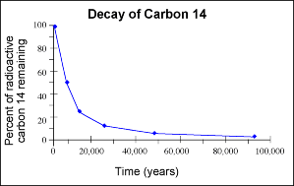

To date ancient remains, a sample of **carbon-14** is extracted and the activity measured.

Using a half-life graph for **carbon-14** it is possible to work out the age of the item.

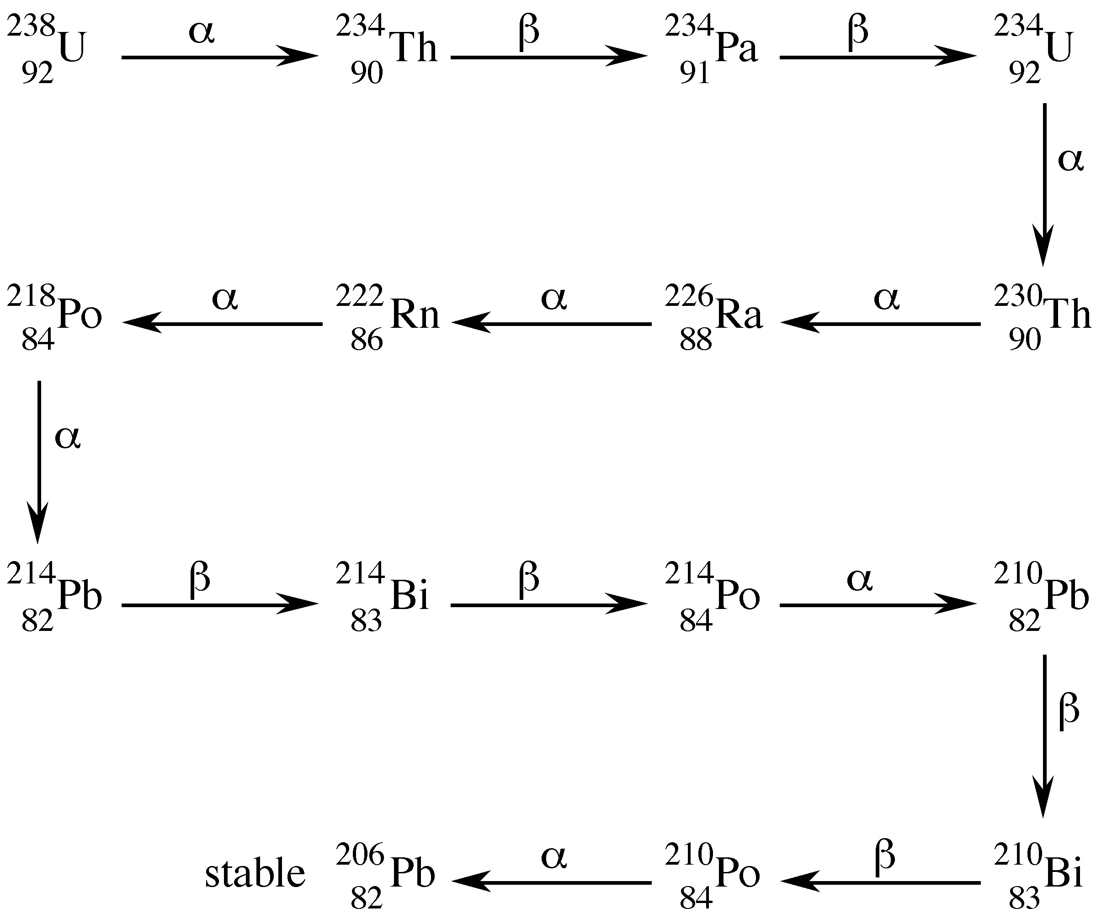**GEOLOGICAL DATING**

Geologists have calculated the Earth was formed 5.56 billion years ago.

This was calculated using the radioisotope **uranium-238**, which is present in some rocks. **Uranium-238** decays by a series of **alpha** and **beta decays** until the stable isotope **lead-206** is formed.

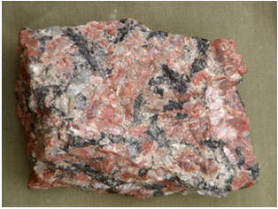

By measuring the quantity of **lead-206** in a rock, and knowing the half-lives of each radioisotope in the decay series, the age of the Earth was calculated.

The first step in the decay series is **alpha decay**.

|  |  |  |  |  |
| --- | --- | --- | --- | --- |
| $${}_{\text{92}}^{\text{238}}{\text{U}}$$ |  | $${}_{\text{90}}^{\text{234}}{\text{Th}}$$ | **+** | $${}_{\text{2}}^{\text{4}}{\text{He}}$$ |

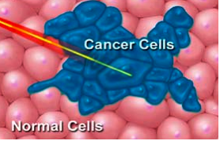**MEDICAL USES**

**(a) RADIOTHERAPY**

This uses **gamma radiation** to kill cancer cells inside the body. The rays have to be very penetrating to reach cancer cells deep inside the body.

**Cobalt-60** is a source of **-rays**. It has a half-life of 5.27 years.

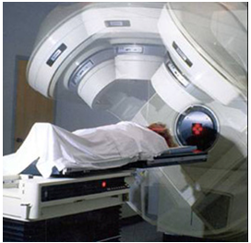

Moving the beam of gamma rays maximises the exposure of the cancer cells, but minimises the exposure of the healthy cells.

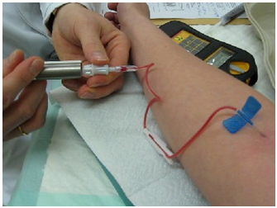**(b) TRACING INSIDE THE BODY**

Radioisotopes can be injected into the bloodstream and measuring the radioactivity can follow their movement around the body.

The movement of the radioactivity can be used to identify blockages in blood vessels, and the uptake of an isotope by a particular organ allowing an image of the organ to be made.

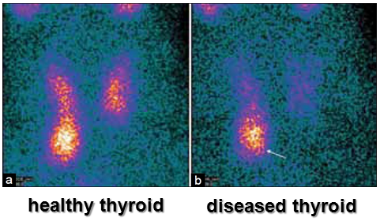**Technetium-99m** is a **gamma emitter** with a **half-life of 6 hours**, is widely used in medicine.

It is used for imaging and investigating the function of the heart, lungs, kidneys thyroid, and liver.

**The picture shows the uptake of technetium-99m by the thyroid gland.**

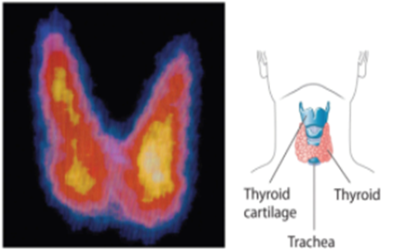

**Iodine-131** is a **beta emitter** with a **half-life of 8 days**, is used to investigate the function of the thyroid gland and the treatment of cancer of the thyroid.

|  |  |  |  |  |
| --- | --- | --- | --- | --- |
| $${}_{\text{53}}^{\text{131}}{\text{I}}$$ |  | $${}_{\text{54}}^{\text{131}}{\text{Xe}}$$ | **+** | $${}_{\text{-1}}^{\text{0}}{\text{e}}$$ |

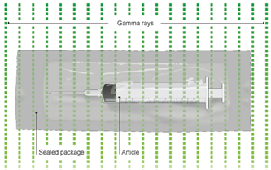**(c) STERILISATION OF MEDICAL EQUIPMENT**

This uses **gamma** **radiation** to kill bacteria and germs that may be on medical instruments.

The instrument is first sealed inside plastic and then irradiated with **-rays**.

The instrument remains sterile while the packaging is not opened.

**INDUSTRIAL USES**

**(a) CONTROLLING THICKNESS**

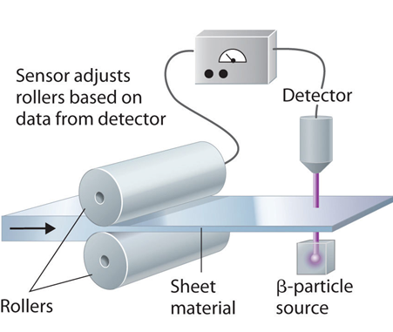

The thickness of paper, plastic sheeting, and metals can be monitored by **beta** or **gamma** **radiation**.

While the thickness of the sheet of material remains constant the detector records a constant reading.

If the thickness increases more radiation is absorbed, the detector senses a drop in the activity, and this in turn is used to adjust the pressure of the rollers.

**(b) LOCATING LEAKS**

**Sodium-24** is a **beta emitter** with a **half-life of 15 hours**. It is used to locate leaks in buried pipes.

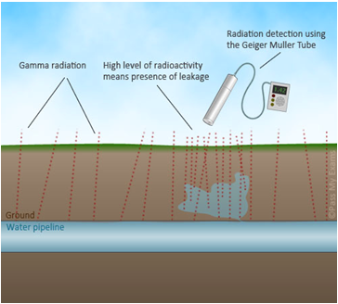

|  |  |  |  |  |
| --- | --- | --- | --- | --- |
| $${}_{\text{11}}^{\text{24}}{\text{Na}}$$ |  | $${}_{\text{12}}^{\text{24}}{\text{Mg}}$$ | **+** | $${}_{\text{-1}}^{\text{0}}{\text{e}}$$ |

The **sodium-24** is added to the liquid passing along the pipe.

The leak can be detected by moving along the path of the pipeline with a radiation detector.

Where the leak has occurred a high level of radiation will be detected.

**(c) NON-DESTRUCTIVE TESTING**

Engineers us **gamma radiography** to check for cracks / defects in welds or metal structures. This is similar to making an X-ray of the structure.

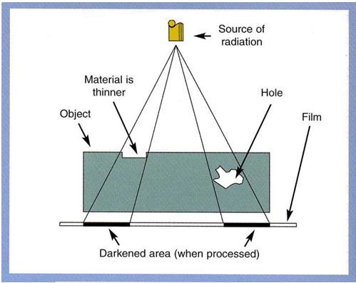

The gamma radiation exposes photographic film. Where there is a defect, the film has a greater level of exposure.

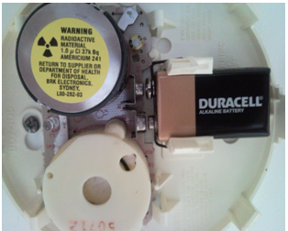**RADIOISOTOPES IN THE HOME**

**Americium-241** is used in smoke alarms. It is an **alpha emitter** with a **half-life of 432.2 years**.

|  |  |  |  |  |
| --- | --- | --- | --- | --- |
| $${}_{\text{95}}^{\text{241}}{\text{Am}}$$ |  | $${}_{\text{93}}^{\text{237}}{\text{Np}}$$ | **+** | $${}_{\text{2}}^{\text{4}}{\text{He}}$$ |

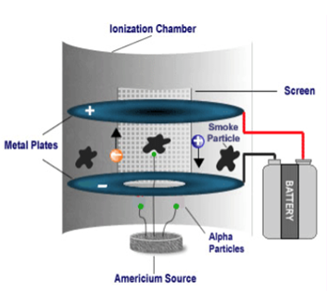The smoke alarms contain a tiny quantity of **241Am** (0.005 g). The **-particles** emitted by the **241Am** inside the ionisation chamber, ionises the air between two charged metal plates resulting in a small current flowing.

If smoke particles enter the alarm they neutralise the ions and absorb some of the **-particles**.

The number of ions in the ionisation chamber drops, which reduces the current.

An electronic circuit detects the change in current and triggers the alarm.