**NATIONAL 4 AND NATIONAL 5 CHEMISTRY**



**Unit 3: Chemistry In Society**

**Topic 7**

**CHEMICAL ANALYSIS**

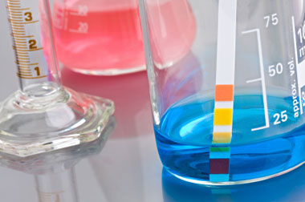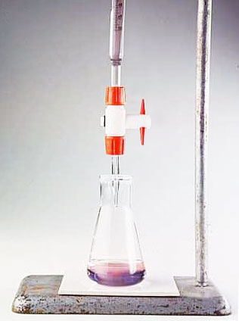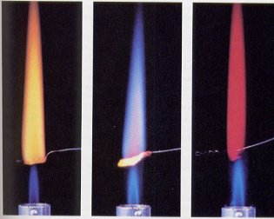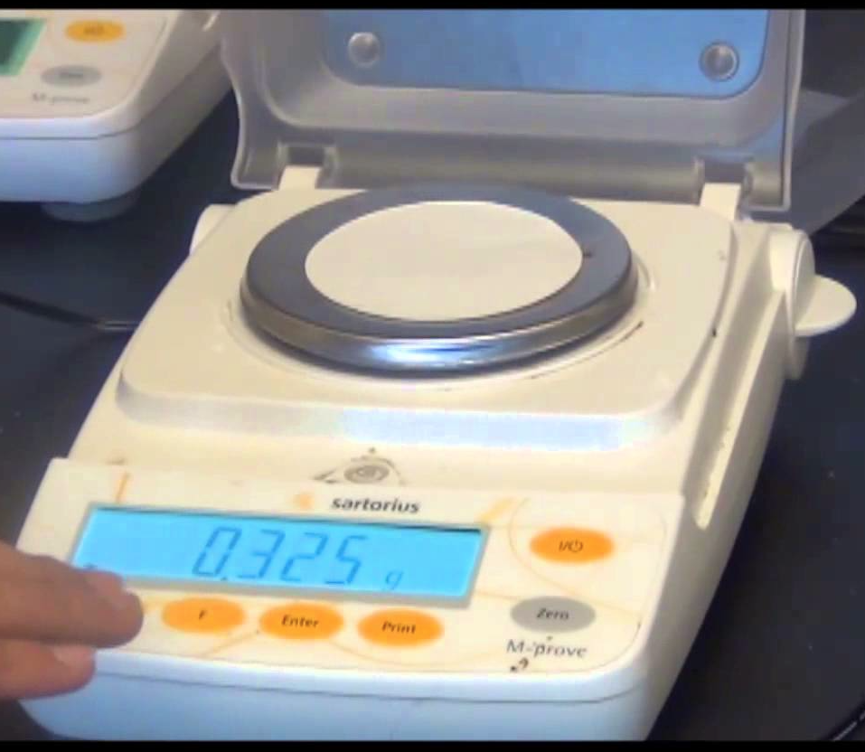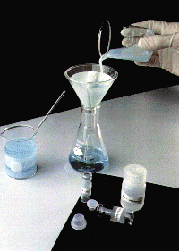

|  |
| --- |
| **Name __________________________________ Class _____** |

|  |
| --- |
| Unit 3: Chemistry In Society |
| Topic 7: Chemical Analysis |

|  |  |  |  |  |  |
| --- | --- | --- | --- | --- | --- |
| LEVEL N4 N5 | **AFTER COMPLETING THIS TOPIC YOU SHOULD BE ABLE TO:** | NOTES (Page) | **How well I have understood (✓)** | | |
| **☺** | **😐** | **☹** |
| N4 | State a chemical test to identify the following gases: oxygen (O2), hydrogen (H2), carbon dioxide (CO2), nitrogen (N2) and ammonia (NH3). | 3 |  |  |  |
| N4 | Measure the pH of a substance and classify the substance as acidic, alkaline or neutral. | 4 |  |  |  |
| N4 | Use the reaction of an acid with a carbonate compound to detect the presence of the carbonate ion, CO32-. | 5 |  |  |  |
| N4 | Use the reaction of an alkali with an ammonium compound to detect the presence of the ammonium ion, NH4+. | 5 |  |  |  |
| N4 | Use flame testing to identify a metal in a compound. | 6 |  |  |  |
| N5 | State that flame testing detects the presence of metal ions. | 6 |  |  |  |
| N5 | Use silver nitrate to test for halide ions (Cl-, Br-, I-). | 7 |  |  |  |
| N4 | Use chromatography to identify substances in a mixture. | 7 - 8 |  |  |  |
| N4 | Carry out an investigation involving a number of techniques to analyse a substance. | 9 |  |  |  |
| N4 | Use filtration and evaporation to separate substances. | 9 |  |  |  |
| N5 | Carry out a titration to determine the concentration of a compound in a solution. | 10 |  |  |  |
| N5 | Calculate the concentration of a substance using a volumetric calculation from the results of a titration. | 10 |  |  |  |
|  |  |  |  |  |  |

|  |  |  |
| --- | --- | --- |
| **N4** | **QUALITATIVE ANALYSIS** | **N5** |

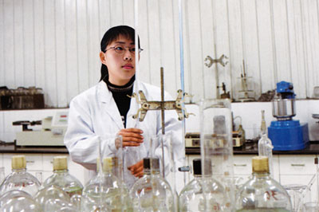

**TYPES OF ANALYSIS**

Chemists use their knowledge of the chemical properties of substances to identify unknown substances and measure the quantity of these substances. This is called **CHEMICAL ANALYSIS**.

**Chemical analysis** is used in medicine, forensic science, the food and chemical industry.

There two types of analysis.

* **QUALITATIVE ANALYSIS** – this identifies the presence of a chemical, but does not measure the quantity of the chemical.
* **QUANTITATIVE ANALYSIS** – having identified the presence of a chemical, this type of analysis measures the quantity of a chemical.

**QUALITATIVE ANALYSIS – TESTING GASES**

The table shows how to identify some common gases.

|  |  |
| --- | --- |
| **GAS** | **TEST PROCEDURE & RESULT** |
| Oxygen **(O2)** | Relights a glowing splint. |
| Hydrogen **(H2)** | Use a burning splint - it burns with a pop. |
| Carbon dioxide **(CO2)** | Turns limewater cloudy. |
| Nitrogen **(N2)** | No test – all the three test above tests fail. |
| Ammonia **(NH3)** | Strong horrible smell which dissolves in water to form an alkali. |

**QUALITATIVE ANALYSIS – TESTING GASES**

**Ionic compounds** can be **identified by testing conductivity**. Ionic compounds conduct when molten (liquid) or when dissolved in water to form a solution.

The following sections shows how to test for specific ions.

**(a) HYDROGEN (H+) & HYDROXIDE (OH-) IONS**

**Hydrogen ions (H+(aq))** in a solution makes it **ACIDIC**. **Hydroxide ions (OH-(aq))** in a solution makes it **ALKALINE**.

**Testing the pH of a solution** with **pH paper or universal indicator** can identify if the **hydrogen ion** or **hydroxide ion** is present in a solution.

**NEUTRAL substances have a pH of EXACTLY 7.**

**ACIDIC substances (H+) have a pH BELOW 7.**

**ALKALINE substances (OH-) have a pH ABOVE 7.**

**1**

**2**

**3**

**4**

**5**

**6**

**7**

**8**

**9**

**10**

**11**

**12**

**13**

**14**

**(b) CARBONATE ION (CO32-)**

All **carbonate** compounds react with **acids** to produce a **salt + water + carbon dioxide gas**.   
**[Unit 1 –Topic 8 Neutralisation notes].**

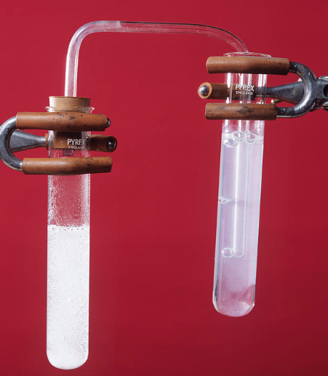

**carbonate + acid**

**limewater**

To test for the **carbonate ion** (CO32-), add an **acid (hydrochloric acid)** and test the gas coming off with limewater.

**If the limewater turns cloudy** it shows the **carbon dioxide** is being produced by the reaction, and therefore the **substance under test contains the** **carbonate ion (CO32-).**

**(c) AMMONIUM ION (NH4+)**

All **ammonium compounds** react with **alkalis** to produce a **salt + water + ammonia gas**.  
**[Unit 3 –Topic 5 Plant Nutrients & Fertilisers notes].**



ammonium chloride + sodium hydroxide

wet pH paper

**HEAT**

To test for the **ammonium ion** in a compound, **heat** the compound with an **alkali** **(sodium hydroxide)** and **test the gas coming off with wet pH paper.**

The **ammonia gas** produced by the reaction turns the **pH paper dark blue / purple**.

When **ammonium** **chloride** is heated with **sodium hydroxide** the products are **sodium** **chloride**, **water** and **ammonia** gas.

|  |  |  |  |  |  |  |  |  |
| --- | --- | --- | --- | --- | --- | --- | --- | --- |
| **ammonium chloride** | **+** | **sodium** **hydroxide** |  | **sodium chloride** | **+** | **water** | **+** | **ammonia** |
|  |  |  |  |  |  |  |  |  |
| **NH4Cl** | **+** | **NaOH** |  | **NaCl** | **+** | **H2O** | **+** | **NH3** |

**(d) METAL IONS**

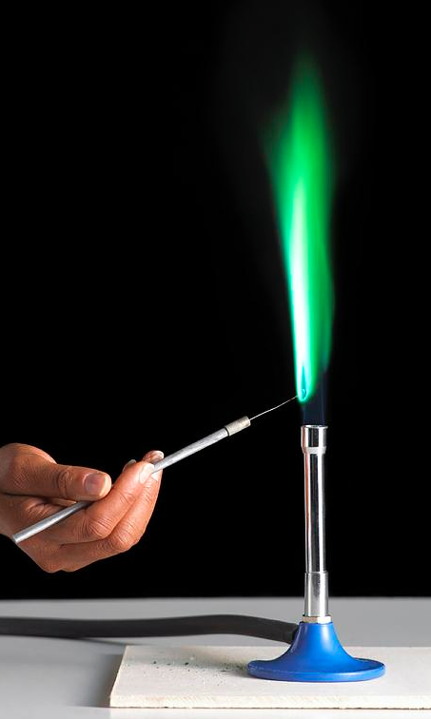Many **metals ions** produce a **COLOURED FLAME** when placed in a bunsen flame. The colour produced by a compound can be used to identify a metal ion.

This analytical method is called **FLAME TESTING**.

A few crystals of a metal compound is placed on a **flame test rod / wire**. The wire is placed in a bunsen flame at the side just outside the blue cone.

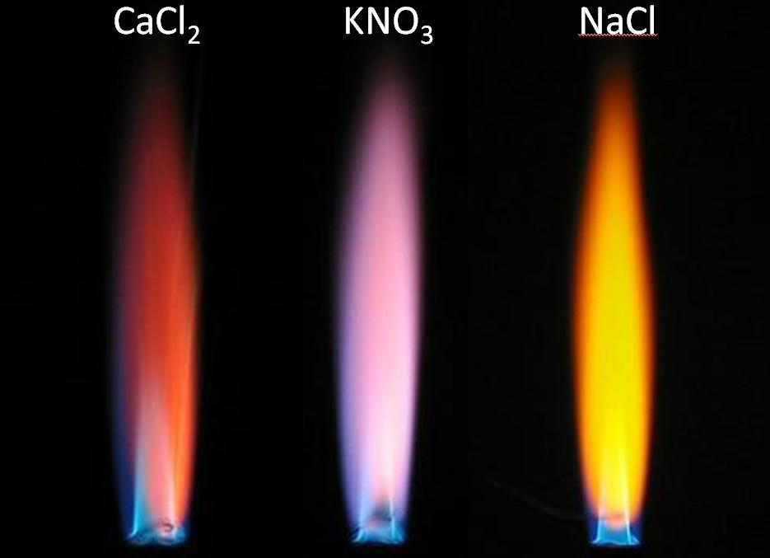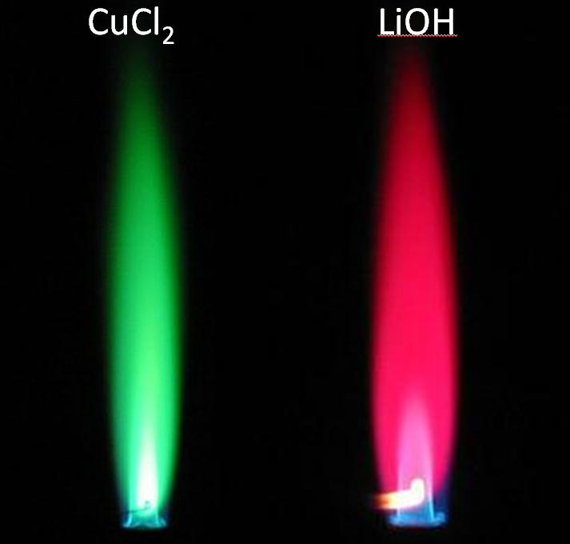

**Ca2+**

**K+**

**Na+**

**Cu2+**

**Li+**

**METAL ION FLAME COLOURS**

**N5**

**CHEMISTRY**

A table of **FLAME COLOURS** produced by **metal ions** is given in the **chemistry data booklet**.

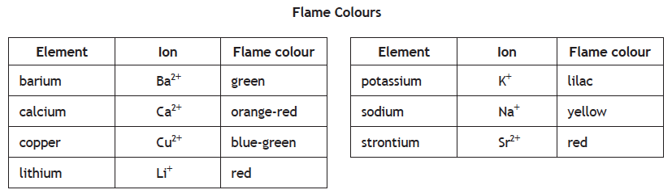

**(e) HALIDE IONS (Cl-, Br-, I-)**

**N5**

**CHEMISTRY**

The ions of the **HALOGENS (Group VII elements)** arecalled the **HALIDE IONS**.

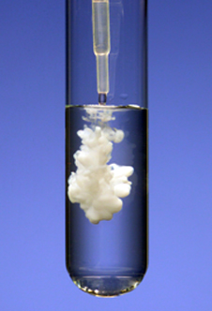To test for the **chloride ion (Cl-)**, **bromide ion (Br-)** and iodide ion (I-), **silver nitrate solution** is added to a solution containing a **halide ion**.

**Silver nitrate solution** produces a precipitate with **chloride ion (Cl-)**, **bromide ion (Br-)** and **iodide ion (I-)** ions, as **silver** **chloride**, **silver** **bromide** and **silver** iodideare **insoluble**.

The different **halide ions** produce different colours of precipitate.

**Silver** **chloride** is **white**, **silver** **bromide** is **off white / cream** and **silver** **iodide** is **pale yellow**.

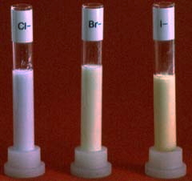

|  |  |  |  |  |
| --- | --- | --- | --- | --- |
|  | **+** | **Cl-(aq)** |  | **Ag+Cl- (s) white** |
| **Ag+(aq)** | **+** | **Br-(aq)** |  | **Ag+Br- (s) off white / cream** |
|  | **+** | **I-(aq)** |  | **Ag+I-(s) pale yellow** |

**QUALITATIVE ANALYSIS – CHROMATOGRAPHY**

**Chromatography** is a separation technique. **Chromatography** can be used to separate the dyes found in ink.

The name **chromatography** comes from the **Greek words, chroma** which means **“colour”**, and **graphien** which means **“ to write.”**

A spot of ink is placed on the base line drawn on the chromatography paper in pencil.

**water  
(solvent)**

**chromatography paper**

**base  
line**

**spot of ink**

The **chromatography** paper is placed in a small volume of solvent.

As the solvent move up the **chromatography** paper the dyes in the ink dissolve. Each dye has a different solubility, and therefore each dye moves up the paper at a different speed

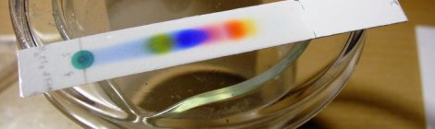The dyes in the ink separate out and can be identified.

**Chromatography** can be used to identify the chemicals which make up food dyes. Some people are allergic to certain food colouring / dye and have to avoid foods containing these chemicals.

A chromatography paper is prepared where a spot of food colouring is placed on the base line of the chromatography paper. Next to this spot, spots of known food colourings are also placed on the base line.

**Food dye from food.**

**Samples of known food dyes.**

**solvent**

The chromatography paper is placed in an appropriate solvent. The paper is removed from the solvent when the solvent has travelled close to the top of the paper.

Comparing the position of food dye spot or spots with spots of known food dyes allows the dyes in the food to be identified.

This example shows the orange food dye is a mixture of the red and yellow dyes.

|  |  |  |
| --- | --- | --- |
| **N4** | **QUANTITATIVE ANALYSIS** | **N5** |



**TYPES OF QUANTITAVE ANALYSIS**

There two types of quantitative analysis.

* **GRAVIMETRIC ANALYSIS** – the quantity of a chemical is determined by measuring the mass of chemicals.



* **VOLUMETRIC ANALYSIS** – the concentration of a chemical is determined by carrying out a titration.

**GRAVIMETRIC ANALYSIS**

**Gravimetric analysis** involves **measuring masses** to work out the quantity of a chemical in a substance.

**Gravimetric analysis** is used to determine the percentage of salt in a sample of rock salt.

Salt obtained from a salt mine is called rock salt.

Rock salt is a mixture of salt, stones and sand.

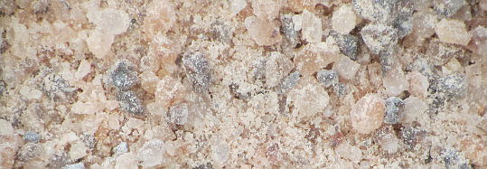

To separate the salt from the rock salt involves:

**Dissolving** the salt from the rock salt using water.

**Filtering** the salt solution / gravel mixture to separate salt solution.

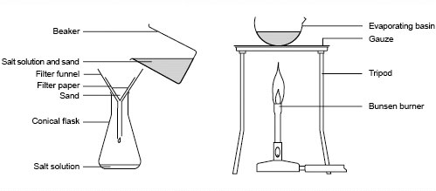

**Evaporating** the water from the salt solution to give crystals of salt.

**RESULTS**

|  |  |  |
| --- | --- | --- |
| Mass of rock salt used | = | **20.0 g** |
|  |  |  |
| Mass of dry evaporating basin | = | 30.3 g |
| Mass of evaporating basin + salt | = | 43.5 g |
|  |  |  |
| Mass of salt obtained from the rock salt | = | 43.5 - 30.3 = **13.3 g** |

|  |  |  |
| --- | --- | --- |
| Percentage of salt in rock salt calculation. | | |
| **% of salt** | **=** | $\frac{\text{mass of salt in rock salt}}{\text{mass of rock salt}}$**✕ 100** |
|  |  | $\frac{\text{13.3}}{\text{20.0}}$**✕ 100** |
| **% of salt** | **=** | **66.5 %**  **N5**  **CHEMISTRY** |

**VOLUMETRIC ANALYSIS**

**Volumetric analysis** involves carrying out a **titration** to provide the data required to calculate the concentration of a solution.

|  |  |  |
| --- | --- | --- |
|  | **Carrying out a titration** has been covered in **Unit 1 Topic 8 – Neutralisation notes.** |  |
| **Screen Shot 2014-03-16 at 21.49.42.png** |
| **Carrying out a volumetric calculation** has been covered in **Unit 1 Topic 5 – Chemical Formulae & Reaction Quantities notes.** |