**Curriculum for Excellence**

**Advanced Higher Chemistry**



**Unit 1a: Inorganic and Physical Chemistry**

**Electromagnetic radiation and atomic spectra**

**Atomic orbitals, electron configurations and the Periodic Table**

**Transition metals**

**Unit 1: Inorganic and Physical Chemistry**

**Unit 1a**

**Contents**

**Section 1: Electromagnetic radiation and atomic spectra**

* Electromagnetic waves
* The relationship c=fλ
* Dual nature of electromagnetic radiation — waves and particles
* The relationships E=hf and E=Lhf
* Atomic emission
* Evaluation of evidence for energy levels in atoms of elements
* Atomic emission spectroscopy and atomic absorption spectroscopy and how they are used to identify and quantify the elements present in a sample

**Section 2: Atomic orbitals, electron configurations and the Periodic Table**

* The four quantum numbers used to describe any electron within an atom.
* The shapes of s, p and d orbitals
* Electron configuration including:
  + aufbau principle
  + Hund’s rule
  + Pauli exclusion principle
* The Periodic Table including electron configurations and Ionisation energies.
* The relative values of first, second and subsequent ionisation energies in terms of the stabilities of different subshell electron configurations.
* Apply VSEPR rules to determine shapes of molecules and polyatomic ions.

**Section 3: Transition metals**

* Electronic configuration of transition metal atoms and ions and the anomalies of the model explained.
* Oxidation states of transition metals.
* Oxidation numbers of transition metal ions.
* Using changes in oxidation number of transition metal ions to determine whether oxidation or reduction has occurred.
* Classification of ligands, co-ordination number.
* Bonding of ligands in transition metal complexes.
* Naming complex ions according to IUPAC rules.
* Explanation of colour in transition metal complexes.
* UV and visible absorption of transition metal complexes.
* Catalysis by transition metals.
* Transition metals and their compounds as catalysts

**Section 1: Electromagnetic radiation and atomic spectra**

**Electromagnetic waves**

The work of Rutherford and others in the early part of the twentieth century resulted in the model of the atom in which negative electrons are arranged around a positive central nucleus.

It is the electrons, rather than the nucleus, which take part in chemical reactions and so it is necessary to understand the electronic structure of an atom to explain its chemical properties. The key to understanding electronic structure and how electrons behave in an atom comes from the study of electromagnetic radiation.

In 1864 James Maxwell developed a theory describing all forms of radiation in terms of oscillating or wave-like electric and magnetic fields in space. Hence radiation such as light, microwaves, X-rays, television and radio signals is collectively called electromagnetic radiation.

Electromagnetic radiation may be described in terms of waves of varying length between 10–14 m and 104 m that travel in a vacuum at a constant velocity of approximately 3 x 108 m s–1. Two simple waveforms are shown in Figure 1.

The wavelength of a wave is the distance between adjacent wave crests or high points (or successive troughs or low points). This distance is measured in metres (m) or an appropriate sub-multiple such as nanometres (nm). A nanometre is 10–9 metres. The symbol for wavelength is the Greek letter λ (lambda).

Waves can also be specified by their frequency, symbol f. For a wave travelling through some point in space the frequency is the rate of advance of any one wave crest or the number of complete waves passing the point per unit time. The unit of measurement of frequency is the reciprocal of time in seconds (s–1) and this unit is called the hertz (Hz).

Another unit of frequency often used by spectroscopists is the wavenumber, which is the reciprocal of the wavelength (1/ λ). The wavenumber is the number of waves in one unit length of radiation, i.e. the number of waves per metre, and is measured in m–1.

**Figure 1**

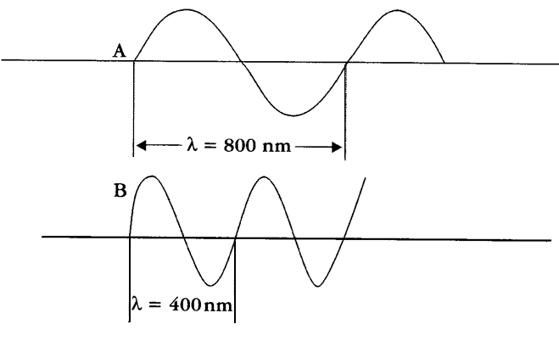

In Figure 1 the wavelength of wave A is twice that of wave B. Since both waves are travelling at the same speed, wave B completes two vibrations in the time wave A completes one. Thus the frequency of wave A is half that of wave B.

**The relationship c=fλ**

The relationship between wavelength, frequency and velocity is:

velocity = frequency x wavelength

(m s–1) (s–1) (m)

c = f λ

The above relationships are summarised in Table 1.

**Table 1**

|  |  |  |  |
| --- | --- | --- | --- |
| **Quantity** | **Symbol** | **Units** | **Description** |
| Wavelength | λ | Metres (m) | Distance between adjacent wave crests |
| Velocity | c | m s–1 | Rate of advance of any one wave crest |
| Frequency | f | Hertz (Hz) | The number of wavelengths or cycles passing a point in 1 second |
| Wavenumber |  | Waves per metre (m-1) or more commonly cm-1 | Number of waves in one metre or one centimetre of radiation. Often used in place of frequency |

**Figure 2**

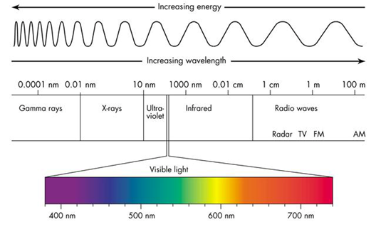

Image source: [www.cyberphysics.co.uk/topics/light/emspect.htm](http://www.cyberphysics.co.uk/topics/light/emspect.htm)

1nm (1 nanometre) = 1 x 10-9 m

From Figure 2 it can be seen that visible light, which is that part of the electromagnetic spectrum that excites the nerve cells of the human eye, constitutes only a very small part of the total spectrum. When electromagnetic radiation interacts with matter, there is a transfer of energy from the radiation to the receiving body. Sitting out in the sun to get a suntan or cooking with microwave ovens are good examples of this.

**Dual nature of electromagnetic radiation — waves and particles**

Energy can only be transferred in small bundles or packets, which are called quanta. These quanta of energy are of a definite size and therefore the transfer of energy can only occur in definite amounts. Because of this, it is necessary to consider that electromagnetic radiation is not only made up of waves, but can also be regarded as a stream of very small particles. These small particles are known as photons.

Electromagnetic radiation is said to exhibit wave-particle duality, i.e. it may be considered to be a stream of photons with wave properties, the energy of the radiation being related to the wavelength or frequency of the radiation by the equation:

for a photon,

**E = hf**  (where h is Planck’s constant = 6.63 x 10–34 J s)

The relationship between the energy transferred by the emission or absorption of one mole of photons and the frequency of the radiation can be calculated as follows:

The relationship between the energy transferred by the emission or absorption of **one mole of photons** and the **frequency** of the radiation can be calculated as follows:

for **one mole** of photons,

*E = Lhf* or *E* = *Lhc*

λ

where *L* is the Avogadro constant.

Using these relationships, the energy of radiation is calculated in J mol–1.

Multiplying by 10–3 gives the energy in the more common unit kJ mol–1.

**Questions**

1. Calculate the energy, in kJ mol–1, corresponding to

(a) a wavenumber of 1000 cm–1

(b) a wavelength of 620 nm.

2. The bond enthalpy of a Cl–Cl bond is 243 kJ mol–1.

Calculate the maximum wavelength of light that would break one mole of these bonds to form individual chlorine atoms.

**Atomic emission**

If light from a tungsten filament lamp is passed through a glass prism, the light is split into the colours of the rainbow. This is known as a continuous spectrum as it consists of a continuous range of wavelengths. In contrast, if sufficient electrical energy is passed into a tube of gas at low pressure, the gas atoms or molecules are said to become excited and can emit electromagnetic radiation, e.g. light.

When this is passed through a glass prism a line spectrum is obtained. A line spectrum shows up a characteristic number of discrete wavelengths. Glowing neon, for example, appears red to our eyes but when this red light is passed through a prism the light is shown to be composed of a few different colours and the spectrum consists of lines corresponding to the wavelengths of these different colours (see Figure 3).

Spectra like this are known as emission spectra since light emitted by the gases is analysed by passing it through a prism.

In modern spectrometers the light is separated into its different wavelengths using a diffraction grating instead of a prism. The light firstly passes through a series of narrow slits producing a fine beam or line of light before passing through the diffraction grating, and the emitted light is observed as a line spectrum, as shown in Figure 3.

**Figure 3:** The emission spectrum of neon

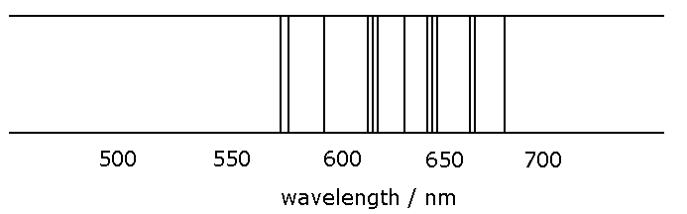

Figure 3 shows that the red light seen from glowing neon is actually made up of light of different wavelengths mainly from the red end of the visible spectrum. Examination of the emission spectrum of hydrogen shows that this consists of a number of lines of precise frequency, corresponding to precise emissions of energy (Figure 4).

**Figure 4:** The emission spectrum of hydrogen in the visible range (Balmer series)

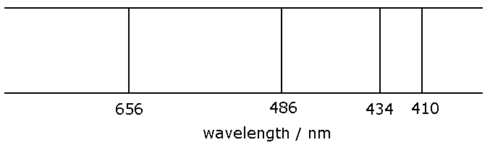

These lines correspond to well-defined energy changes and by using the relationship

E = Lhf the magnitude of these energy changes can be calculated.

Atoms are said to become excited when they absorb energy and emission spectra arise from the movement of electrons from a higher to a lower energy when the excited atom returns to its ‘ground state’.

The frequency of the line in the emission spectrum corresponds to the difference in energy between the two electronic energy levels. This is shown in Figure 5.

**Figure 5**

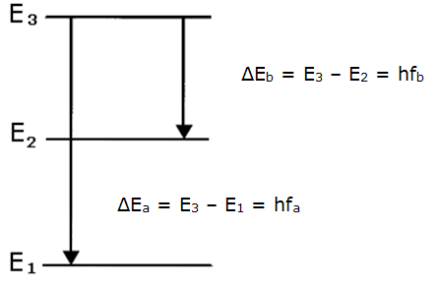

It follows that since the differences in energy between the levels are fixed, the energy levels themselves must be fixed. Thus, since the electrons must occupy these energy levels, the electrons themselves must have fixed energies.

In other words the energies of electrons are **quantised** and an atom can be considered to be emitting a photon of light energy when an electron ‘falls back’ from a higher energy level to a lower energy level.

Each line in the emission spectrum represents radiation of a specific wavelength or frequency from which these differences in energy can be calculated.

**Evaluation of evidence for energy levels in atoms of elements**

Although a hydrogen atom has only one electron, the emission spectrum of hydrogen has different series of lines in different parts of the electromagnetic spectrum. The differences in energy and hence the part of the electromagnetic spectrum in which the lines show up depend on the energy level to which the ‘excited’ electron falls back.

The full emission spectrum of hydrogen consists of one series of lines in the ultra-violet region, one series of lines in the visible region and several in the infra-red region. These series of lines are named after the scientists who discovered them (Table 2).

**Table 2**

|  |  |  |
| --- | --- | --- |
| **Name of series** | **Energy level to which excited electron falls** | **Part of the electromagnetic spectrum** |
| Lyman | n = 1 | Ultraviolet |
| **Balmer** | **n = 2** | **Visible** |
| Paschen | n = 3 | Infrared |
| Brackett | n = 4 | Infrared |
| Pfund | n = 5 | Infrared |

The electronic transitions that give rise to the Lyman, Balmer and Paschen series are shown in Figure 6.

**Figure 6**

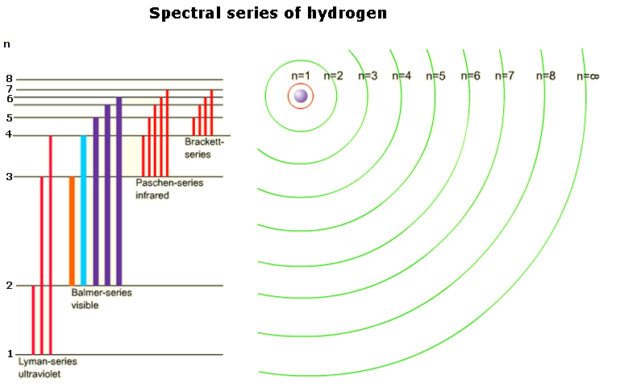

The lines of the Lyman series correspond to changes in electronic energy levels from higher energy levels down to the *n* = 1 ground state.

**Figure 7:** The Lyman series in the emission spectrum of hydrogen.

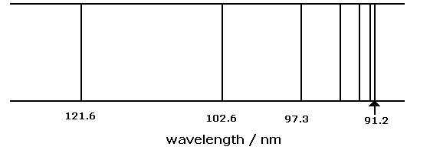

It can be seen that as the energy increases, the energy levels become closer together until they converge.

The difference in energy between the ground state and the convergence limit (indicated by an arrow in Figure 7) corresponds to the energy required for the electron to break away from the atom. This is its **ionisation energy**.

**Question**

Calculate the ionisation energy for hydrogen if the wavelength of the line at the convergence limit is 91.2 nm.

## **Spectroscopy**

Just as specific lines in the emission spectra of elements give information about the electronic structure of these elements, the technique of **atomic emission spectroscopy** (AES) can be used to detect the presence of these elements. Each individual element provides a characteristic spectrum that can be used to identify that particular element.

Both AES and **atomic absorption spectroscopy** (AAS) involve transitions between electronic energy levels in atoms. Individual spectral lines correspond to definite electronic transitions. In general the energy difference corresponds to the visible region of the electromagnetic spectrum (approximate wavelength 400–700 nm) but in some applications the ultra-violet region (approximate wavelength 200–400 nm) is used.

In AES a gaseous sample is excited with thermal or electrical energy, causing electrons to be promoted to higher energy levels. The wavelength of the radiation emitted as the electrons fall back to lower energy levels is recorded.

This technique can be used to detect metal elements in, for example, foodstuffs or effluent water since each element has a known characteristic spectrum. The element present can also be determined quantitatively by measuring the intensity of the emitted radiation. The greater the amount of that element present in the sample, the greater will be the intensity of its characteristic radiation.

In AAS electromagnetic radiation is directed through a gaseous sample of the substance. Radiation corresponding to certain wavelengths is absorbed as electrons are promoted to higher energy levels. The wavelength of the absorbed radiation is measured and used to identify each element, as each element has a characteristic absorption spectrum.

The amount of the species present in the sample can also be determined by quantitative measurement of the amount of light absorbed by the atomised element. The measured absorbance is proportional to the concentration of the element in the sample.

For example, AAS can be used to measure the concentration of lead in water, down to levels of 0.2 mg l-1, or in other words 0.2 parts per million (ppm). The sample is firstly atomised using a flame or by electrical heating. Some of the radiation emitted from a special lamp is absorbed by the lead in the sample. The more radiation that is absorbed, the greater is the amount of lead present in the sample.

In order to determine the exact quantity of lead present, a calibration curve needs to be plotted by measuring quantitatively the absorbances of aqueous solutions containing lead of known concentrations (Figure 15). Using the absorbance reading of the sample being analysed the concentration of the lead can be determined from the calibration curve.

**Figure 15**

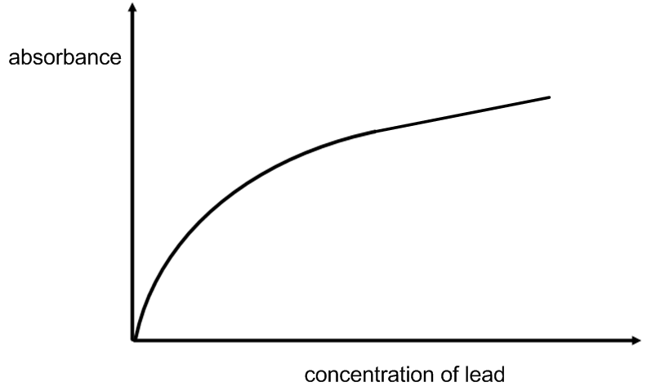

A more sensitive form of AAS uses electricity to heat a graphite furnace to approximately 2600ºC instead of using a flame to vaporise the sample.

As before, identification of the element is possible because each element has its own well-defined characteristic absorption spectrum at known wavelengths. In addition, the amount of absorbance is proportional to the concentration of the element in the sample.

**Section 2: Atomic orbitals, electron configurations and the Periodic Table**

**Quantum numbers and electron shells**

Much of the work required to interpret and explain emission spectra was done by the Danish scientist **Niels Bohr**, who developed a model for the electronic structure of atoms.

The equations derived from Bohr’s model were used successfully to calculate values for the radius of the hydrogen atom and its energy levels, including its ionisation energy.

The main points of Bohr’s theory can be summarised as follows:

* the electron in a hydrogen atom exists only in certain definite energy levels
* a photon of light is emitted or absorbed when the electron changes from one energy level to another
* the energy of the photon is equal to the difference between the two energy levels (E), which is related to the frequency by the equation DE = hf.

These definite quantities of energy possessed by electrons are known as **quanta**.

An electron can only possess certain fixed amounts of energy known as quanta. The energy of the electron can be defined in terms of **quantum numbers**.

Electrons in atoms are arranged in a series of shells. Each shell is described by a number, known as the **principal quantum number, n**.

The shells are numbered starting with the shell nearest the nucleus and working outwards. For the first shell n = 1, for the second shell n = 2 and so on.

The higher the value of n, the higher the potential energy associated with the shell and the further from the nucleus the electron is likely to be found. The hydrogen atom has only one electron and its spectrum is fairly simple to interpret.

Other elements are more complex and close examination of their spectra under high resolution shows that the lines are often not single lines but are split into doublets or triplets, etc. This suggests that the electron shells are further subdivided into **subshells**. These subshells are described by the letters **s, p, d and f.**

Calculations using quantum mechanics show that all shells have an s subshell and all the shells except the first have a p subshell. Likewise all the shells except the first and second have a d subshell and so on, as shown in Table 3. The subshells within a shell have different energies, increasing s 🡪 p 🡪 d 🡪 f.

**Table 3**

|  |  |
| --- | --- |
| **Shell** | **Subshells** |
| 1 | 1s |
| 2 | 2s, 2p |
| 3 | 3s, 3p, 3d |
| 4 | 4s, 4p, 4d , 4f |

Each type of subshell (s, p, d and f) contains one or more energy levels or orbitals. These are defined by another quantum number, **the angular momentum quantum number l**. This is related to the shape of the orbital and is given the values 0, 1, 2, …, (n – 1) as shown in Table 4.

**Table 4**

|  |  |  |
| --- | --- | --- |
| **Value of n** | **Value of l** | **Energy level** |
| 1 | 0 | 1s |
| 2 | 0  1 | 2s  2p |
| 3 | 0  1  2 | 3s  3p  3d |
| 4 | 0  1  2  3 | 4s  4p  4d  4f |

Electrons, like photons, display the properties of particles and waves. Treating bound electrons in atoms as waves leads to regions of high probability of finding the electrons. These regions of high probability are called **atomic orbitals.**

An atomic orbital is generally considered to be the volume in space where the probability of finding an electron is greater than 90%. The overall size of each orbital is governed by the value of n, the principal quantum number, while the actual shape of the orbital is given by the value of l, the angular momentum quantum number. **All s orbitals (l = 0) are spherical in shape**, the diameter of the sphere increasing as n increases (Figure 8).

**Figure 8**

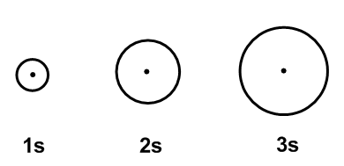

The probability of finding the s electron outwith the orbital is relatively low but not zero. For p, d and f orbitals, it is necessary to define a further quantum number, *m* known as the magnetic quantum number, and this gives the multiplicity and spatial orientation of the orbital. Table 5 shows how *m*can have any integral value between –*l* and +*l*.

**Table 5**

|  |  |  |  |
| --- | --- | --- | --- |
| **Value of n** | **Value of l** | **Value of m** | **Type of orbital** |
| 1 | 0 | 0 | 1s |
| 2 | 0  1 | 0  -1, 0, +1 | 2s  2p |
| 3 | 0  1  2 | 0  -1, 0, +1  -2, -1, 0, +1, +2 | 3s  3p  3d |

The p orbitals, unlike the s orbitals, are not spherical in shape but have two lobes and are usually described as being dumb-bell in shape, as shown in Figure 9.

**Figure 9**



Since for the p orbitals l = 1 there are three possible values of m, namely –1, 0 and +1, there will be three p orbitals of equal energy.

Orbitals of equal energy are said to be **degenerate**. Because they have different values for m, they will have different orientations in space – in fact, they are arranged along the three mutually perpendicular principal axes x, y and z, as in Figure 10.

**Figure 10**

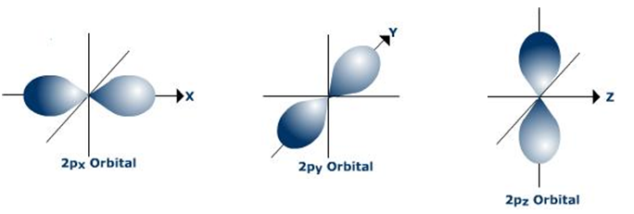

Likewise with the d orbitals (l = 2), there are five possible values of m

(–2, –1, 0, +1, +2) and so when n ≥ 3, there are five degenerate d orbitals. These have the individual names and shapes shown in Figure 11.

**Figure 11**

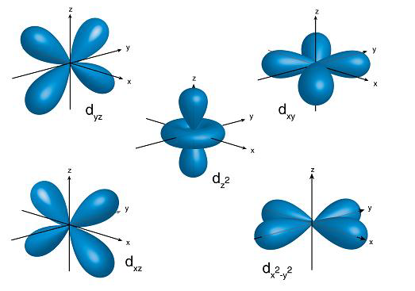

Each type of subshell contains one or more orbitals and the number of orbitals in a subshell is summarised in Table 6.

**Table 6**

|  |  |
| --- | --- |
| **Subshell** | **Number of orbitals** |
| s | 1 |
| p | 3 |
| d | 5 |
| f | 7 |

The three quantum numbers also allow us to define the orbital for an electron, as shown in Table 7.

**Table 7**

|  |  |  |  |
| --- | --- | --- | --- |
| **Type of quantum number** | **Symbol** | **Value** | **Property described** |
| Principle | n | 1,2,3… | Orbital size/energy |
| Angular momentum | l | 0,1,2… (n-1) | Orbital shape |
| Magnetic | m | -l…. 0 …. +l | Multiplicity and orientation |

In about 1920 it was realised that an electron behaves as if it has a spin, just as the planet earth has a spin. To describe an electron in a many-electron atom completely a fourth quantum number is therefore needed, namely the spin quantum number, **s**.

The spin quantum number can have one of only two values, +½ and –½. Thus, given values of the **four quantum numbers**, n, l, m and s, it is possible to define any single electron in an atom in terms of its energy and likely location.

In 1925, Wolfgang Pauli proposed what is now known as the **Pauli exclusion principle**:

**‘no two electrons in any one atom can have the same set of four quantum numbers’.**

This leads to two important conclusions:

* the maximum number of electrons in any atomic orbital is two
* if there are two electrons in an orbital, then they must have opposite spins (rather than parallel spins).

The number of orbitals and electrons in each subshell is given in Table 8.

**Table 8**

|  |  |  |
| --- | --- | --- |
| **Type of subshell** | **Number of orbitals** | **Number of electrons** |
| s | One s orbital | 2 |
| P | Three p orbitals | 6 |
| d | Five d orbitals | 10 |
| f | Seven f orbitals | 14 |

In an isolated atom the orbitals within each subshell are degenerate.

For example, the three different 2p orbitals (2px, 2py and 2pz) in an atom have equal energy.

**Summary of quantum numbers:**

n - the principal quantum number

l - the angular momentum quantum number

m - the magnetic quantum number

s - the spin magnetic quantum number

**Electronic configuration**

There are two main ways in which the electronic configurations of atoms can be expressed.

Consider a hydrogen atom. It has one electron, which will occupy the orbital of lowest energy which is, of course, the 1s orbital. This can be expressed as 1s1, i.e. one electron in the 1s orbital.

Helium will have both its electrons in the 1s orbital and this can be written as 1s2. This is called **spectroscopic notation.**

The other way in which the electronic configuration can be expressed is by using a notation in which an orbital is represented by a box and each electron by an arrow. Using this notation the electronic configuration of hydrogen can be represented as

H      and helium can be represented as He 

1s 1s

This is called **orbital box notation**.

One arrow pointing upwards and the other pointing downwards shows that the two electrons in the orbital have opposing spins, in keeping with the Pauli exclusion principle (Table 9).

**Table 9 - Correct**

|  |  |
| --- | --- |
| 1st electron | 2nd electron |
| n = 1 | n = 1 |
| l = 0 | l = 0 |
| m = 0 | m = 0 |
| s = +½ | s = -½ |

If the electronic configuration of helium were to be represented with both arrows pointing in the same direction, i.e. parallel spins, this would be incorrect since it would not conform to the Pauli exclusion principle because the two electrons would have the same values for all four quantum numbers (Table 10).

**Table 10 - Incorrect**

|  |  |
| --- | --- |
| 1st electron | 2nd electron |
| n = 1 | n = 1 |
| l = 0 | l = 0 |
| m = 0 | m = 0 |
| s = +½ | s = +½ |

Before we can write the electronic configuration for multi-electron atoms, it is necessary to know the order in which the various orbitals are filled.

The **Aufbau** **principle** states that the **orbitals of the lowest energy levels are always filled first.**

Thus, provided the relative energies of the orbitals are known, the electronic configuration can be deduced.

Spectroscopic data give the following arrangement of the energies of the orbitals:

**1s 2s 2p 3s 3p 4s 3d 4p 5s** 4d 5p 6s 4f 5d 6p 7s 5f 6d 7p

increasing energy

This may seem very complicated and another method of working out the increasing relative energies is given in Figure 12.

**Figure 12**

[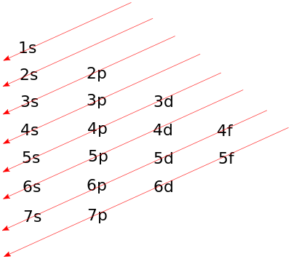](http://en.wikibooks.org/wiki/File:Atomic_orbital_diagonal_rule.svg)

In order to use Figure 12, you must follow the arrows from tail-to-tip, starting with the first arrow in the upper left-hand corner, and working your way down through the arrows to the lower right-hand corner of the diagram.

When the situation is reached where more than one degenerate orbital is available for the electrons, it is necessary to use **Hund’s rule of maximum multiplicit**y, which states that

‘when electrons occupy degenerate orbitals, the electrons fill each orbital singly, keeping their spins parallel before spin pairing occurs’.

For example, the electronic configuration of a nitrogen atom (listed as 2, 5 in the Data booklet) is written as follows using **spectroscopic notation**:

1s2 2s2 2p3

and using **orbital box notation** to show electron spins:

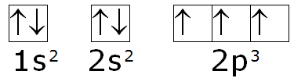

**Question**

Using both spectroscopic and orbital box notations write down the

electronic configurations for:

(a) lithium

(b) oxygen

(c) sodium

(d) aluminium

(e) phosphorus

(f) argon

(g) calcium

(h) Li+

(i) F–

(j) Mg2+

(k) S2–

(l) K+

Remember that the electronic configuration should have the same number of electrons in each shell as the corresponding electron arrangement in the Data Booklet.

The electronic configuration for neon, Ne, is 1s2 2s2 2p6 and that of argon, Ar, is 1s2 2s2 2p6 3s2 3p6.

It is often acceptable to write the electronic configurations of other species in a shortened version, taking account of the electronic configuration of the preceding noble gas.

For example:

* The electronic configuration for sodium can be written as [Ne] 3s1, where [Ne] represents 1s2 2s2 2p6,
* and that of calcium can be written as [Ar] 4s2 where [Ar] represents 1s2 2s2 2p6 3s2 3p6.

The Periodic Table can be subdivided into four blocks (s, p, d and f) corresponding to the outer electronic configurations of the elements within these blocks.

All the Group 1 elements (the alkali metals) have electronic configurations that end in s1. All the Group 2 elements (the alkaline-earth metals) have electronic configurations that end in s2.

Because the elements in **Groups 1 and 2** have their outermost electrons in s orbitals, these elements are known as **s-block elements**.

The elements in **Groups 3, 4, 5, 6, 7 and 0** are known as the **p-block elements** as their outermost electrons are in p subshells.

The elements where d orbitals are being filled are known as the d-block elements and those in which f orbitals are being filled are the f-block elements. This is shown in Figure 13.

**Figure 13**

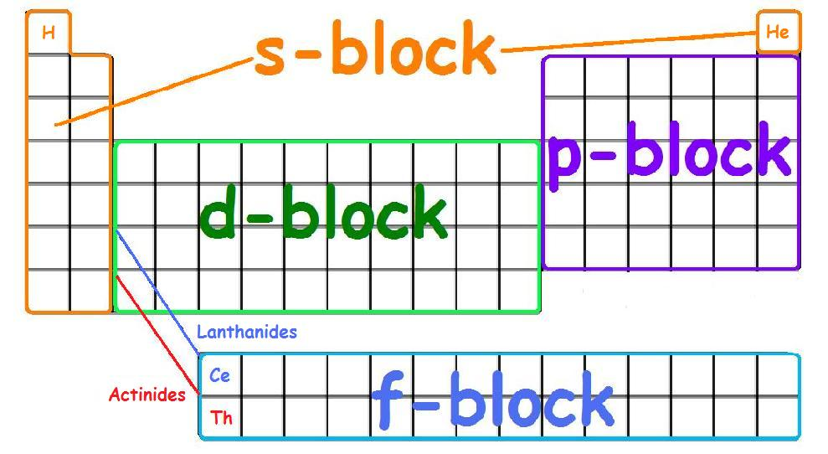

Image source: <http://chemwiki.ucdavis.edu/>

**Ionisation energy**

Figure 14 shows how the first ionisation energy varies with atomic number for elements 1 to 36.

**Figure 14**

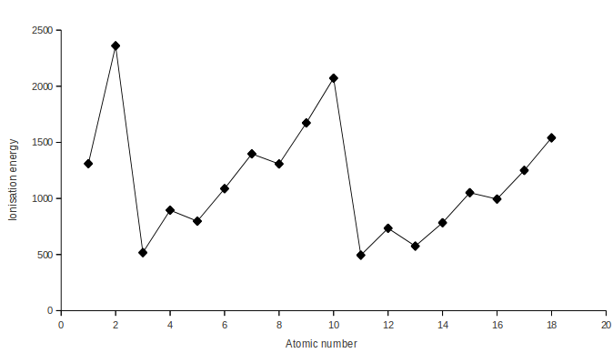

The highest points are the noble gases (Group 0) and the lowest points are those of the alkali metals (Group 1).

The first ionisation energy for an element E is the energy required to remove one mole of electrons from one mole of atoms in the gas state, as depicted in the equation

E(g) 🡪 E+(g) + e–

There are three main factors that affect the ionisation energies of an element:

* the atomic size – the greater the atomic radius, the further the outermost electron is from the attraction of the positive nucleus and therefore the lower will be the ionisation energy

• the nuclear charge – the more protons in the nucleus, the harder it will be to remove an electron and consequently the greater will be the ionisation energy

• the screening effect – the inner electrons shield the outermost electrons from the attraction of the positively charged nucleus and so the more electron shells between the outer electron and the nucleus, the lower will be the ionisation energy.

Looking at Figure 14 there are two obvious patterns. In general,

• the ionisation energy increases across a period

• the ionisation energy decreases down a group.

However, looking more closely, it can be seen that the first ionisation energies do not increase smoothly across a period. This irregularity is evidence for the existence of subshells within each shell. For example, the reason that the first ionisation energy of boron is lower than that of beryllium can be explained by considering their electronic configurations:

Be 1s2 2s2

B 1s2 2s2 2p1

Accordingly, removal of the outer electron from a boron atom involves taking one electron from the 2p subshell, but with a beryllium atom this electron comes from the full 2s subshell. Since full subshells are relatively stable, it follows that the first ionisation energy of beryllium is greater than that of boron.

A similar argument can be used to explain the higher first ionisation energy of magnesium (1s2 2s2 2p6 3s2) compared to aluminium (1s2 2s2 2p6 3s2 3p1).

The higher first ionisation energy of nitrogen compared to oxygen can also be explained by considering their electronic configurations:

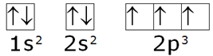

N 1s2 2s2 2p3 or



O 1s2 2s2 2p4 or

Since half-full subshells are relatively stable and because nitrogen has a half-full subshell it has a higher ionisation energy than oxygen. A similar argument can be used to explain the higher first ionisation energy of phosphorus compared to sulphur. There will also be electron–electron repulsions between two electrons in the same orbital.

Likewise the relative values of first, second and subsequent ionisation energies can be explained in terms of the stabilities of the electronic configurations from which the electrons are removed.

For example, the sodium atom, Na, has electronic configuration 1s2 2s2 2p6 3s1 and the first ionisation energy of sodium is small (502 kJ mol–1). The sodium ion, Na+, has the electronic configuration of the noble gas neon, 1s2 2s2 2p6, and because this is a more stable electronic configuration, the second ionisation energy of sodium is significantly greater (4560 kJ mol–1). This second electron to be removed from the sodium is in a shell much closer to the attraction of the nucleus and therefore much more energy is required to overcome this attraction.

**Shapes of molecules and polyatomic ions**

The shapes of molecules or polyatomic ions (e.g. NH4+) can be predicted from the number of bonding electron pairs and the number of non-bonding electron pairs (lone pairs).

This is because the direction which covalent bonds take up in space is determined by the number of orbitals occupied by electron pairs and the repulsion between these orbitals. The repulsive effect of a non-bonded pair or lone pair of electrons is greater than that of a bonded pair and so the trend in repulsive effect is:

**bonded pair:bonded pair < bonded pair:lone pair < lone pair:lone pair**

The shape adopted by the molecule or polyatomic ion is the one in which the electron pairs in the outer shell get as far apart as possible. In other words, the shape in which there is the minimum repulsion between the electron pairs.

The arrangement of the electrons in covalently bonded molecules can be shown in electron dot diagrams. For example in hydrogen:



If we wish to show that each of the bonding electrons is from a different hydrogen atom the dot-and-cross variation can be used:



Similar diagrams for fluorine and nitrogen are:

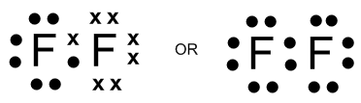

and

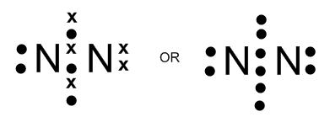

**Question**

Draw dot-and-cross diagrams for

(a) chlorine (b) hydrogen fluoride (c) carbon dioxide

(d) ammonia (e) hydrogen cyanide, HCN (f) water

Some of these molecules contain pairs of electrons that are not involved in bonding. Such non-bonding pairs of electrons are often known as lone pairs.

For example, in water:

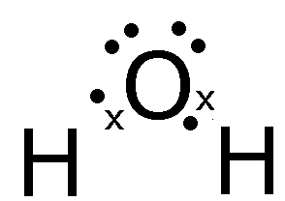

there are two bonding pairs of electrons  and two non-bonding pairs of electrons .

The total number of bonding and non-bonding pairs of electrons becomes important in determining the shapes of molecules.

Sometimes both the electrons making up a covalent bond come from the same atom. This type of covalent bond is known as a **dative** covalent bond (or co-ordinate covalent bond). An example of the formation of a dative covalent bond is when ammonia gas is passed into a solution containing hydrogen ions to form the ammonium ion, NH4+.

NH3(g) + H+(aq) 🡪 NH4+(aq)

The dot-and-cross diagram for this reaction is:

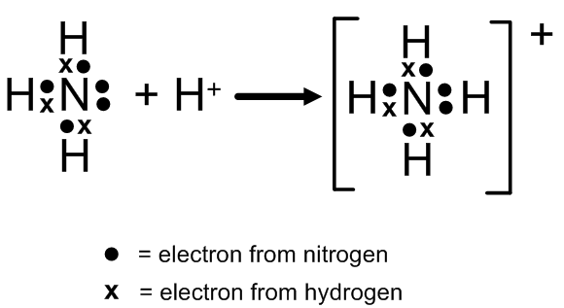

**The valence shell electron pair repulsion (VSEPR) Model**

The VSEPR model can predict the structure of nearly any molecule or polyatomic ion in which the central atom is a non-metal, as well as the structures of many molecules and polyatomic ions with a central metal atom. The VSEPR model is not a theory; it does not attempt to explain observations. Instead, it is a counting procedure that accurately predicts the three-dimensional structures of a large number of compounds.

We can use the VSEPR model to predict the geometry of most polyatomic molecules and ions by focusing on only the number of electron pairs around the central atom, ignoring all other valence electrons present. Because electrons repel each other electrostatically, the most stable arrangement of electron groups (i.e., the one with the lowest energy) is the one that minimizes repulsions.

Groups are positioned around the central atom in a way that produces the molecular structure with the lowest energy, as illustrated in Figure 16 "Common Structures for Molecules and Polyatomic Ions That Consist of a Central Atom Bonded to Two or Three Other Atoms" and Figure 17 "Geometries for Species with Two to Six Electron Groups".

**Figure 16** Common Structures for Molecules and Polyatomic Ions That Consist of a Central Atom Bonded to Two or Three Other Atoms

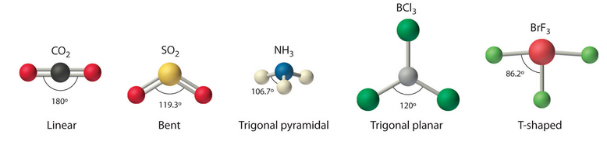

The VSEPR model explains these differences in molecular geometry.

Reproduced from Averill, B.A. and Eldredge, P. (2012) *Principles of General Chemistry* under Creative Commons licensing agreement.

**Figure 17** Geometries for Species with Two to Six Electron Groups

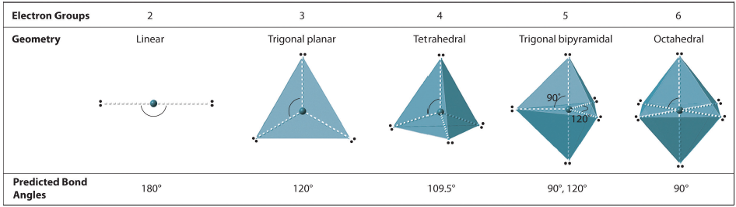

Groups are placed around the central atom in a way that produces a molecular structure with the lowest energy. That is, the one that minimizes repulsions.

Consider some examples:

**Two filled orbitals, both bonding pairs**, e.g. beryllium chloride, BeCl2(g)

In the beryllium chloride molecule beryllium has two outer electrons and each chlorine atom contributes one electron and so there is a total of four electrons, i.e. two electron pairs, involved in bonding. These two bonding pairs will be as far apart as possible at 180º and so the beryllium chloride molecule is linear:

Cl-Be-Cl

**Three filled orbitals, all bonding pairs**, e.g. boron trifluoride, BF3

In the boron trifluoride molecule boron has three outer electrons and each fluoride atom contributes one electron to the structure. In total there are six electrons involved in bonding, resulting in three bonding pairs. Repulsions are minimised between these three bonding pairs when the molecule is flat and the bond angles are 120º. The name given to this shape of molecule is trigonal planar (or simply trigonal):

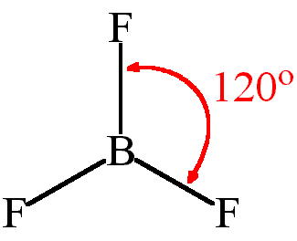

**Four filled orbitals, all bonding pairs**, e.g. methane, CH4

In methane, the central carbon atom has four outer electrons and each hydrogen atom contributes one electron to the structure and so there is a total of eight electrons involved in bonding, resulting in four electron pairs. The methane molecule is **tetrahedral** because this is the shape in which there is minimum repulsion between these electron pairs. The exact bond angles in methane are found using X-ray diffraction to be 109.5º, which is the true tetrahedral value:

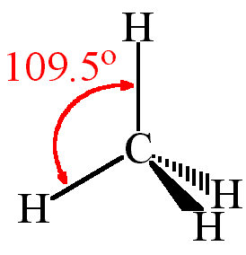

**Four filled orbitals, three bonding pairs and one lone pair**, e.g. ammonia, NH3

In ammonia, the central nitrogen atom has five outer electrons and each hydrogen atom contributes one electron. There is a total of four electron pairs, but only three are bonding pairs, i.e. there are three N–H bonds while one pair of electrons is a non-bonding or lone pair. The arrangement of the electron pairs is tetrahedral but since there are only three bonds the shape is said to be **pyramidal**.

There is greater repulsion between the lone pair and the three bonding pairs than there is between the three different bonding pairs with the result that the bonds are pushed closer together by the lone pair. Instead of a bond angle of 109.5º, the three bonds are angled at **107º** to each other:

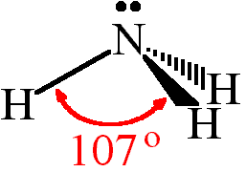

**Four filled orbitals, two bonding pairs and two lone pairs**, e.g. water, H2O

In water, the central oxygen atom has six outer electrons and each hydrogen atom contributes one electron. There is a total of four electron pairs, but only two are bonding pairs. In other words, there are two O–H bonds and two non-bonding or lone pairs. The arrangement of the electron pairs is tetrahedral but since there is greater repulsion between the two lone pairs than between the lone pairs and the two bonding pairs the outcome is that the bonds are pushed even closer together in water than in ammonia. In water the bond angle is approximately 105º and the shape of the water molecule is **bent**:

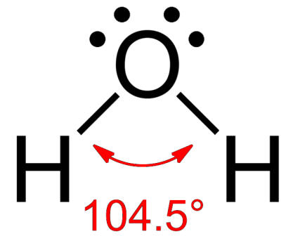

It is worth noting that if the lone pair on the nitrogen in ammonia was to form a dative covalent bond with a hydrogen ion to form the ammonium ion, there would be four equivalent bonding pairs and no non-bonding pairs. (A dative bond is a covalent bond - a shared pair of electrons - in which both electrons come from the same atom).

The shape of the ammonium ion would therefore be tetrahedral and all the bond angles would be 109.5º, as in methane:

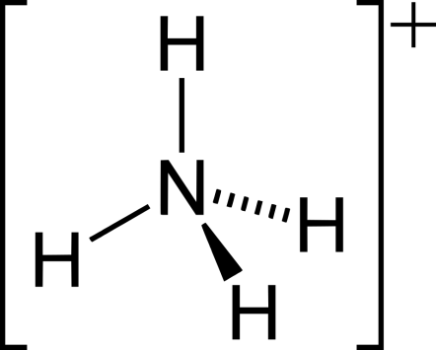

**Five filled orbitals, all bonding pairs,** e.g. gaseous phosphorus(V) chloride, PCl5(g)

In gaseous phosphorus(V) chloride the central phosphorus atom has five outer electrons and each chlorine atom contributes one electron to make five electron pairs. There will be no lone pairs as there will be five P–Cl bonds. The shape of the molecule is **trigonal bipyramidal**:

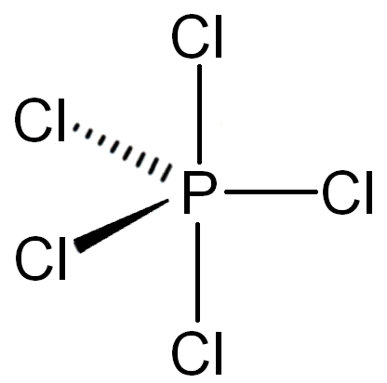

With no lone pairs on the central phosphorus atom, the bond angles between the three central chlorine atoms are 120º. The upper chlorine atom has bond angles of 90º to the three central chlorine atoms as does the lower chlorine atom. The bond angle between the upper and lower chlorine atom is 180º.

**Five filled orbitals, three bonding pairs and two lone pairs**, e.g. chlorine(III) fluoride, ClF3

In chlorine(III) fluoride the central chlorine atom has seven outer electrons and each fluorine atom contributes one electron to make five electron pairs in total. Three of these will be bonding pairs and two will be lone pairs. The five electron pairs will be in a trigonal bipyramidal arrangement but the actual shape of the molecule depends on the arrangement of the bonds.

Considering all the repulsive forces between the electron pairs and taking into account that there is greatest repulsion at 90º and least at 180º, and also remembering that the trend in repulsive effect is bonded pair:bonded pair < bonded pair:lone pair < lone pair:lone pair, the most stable option for this molecule is:

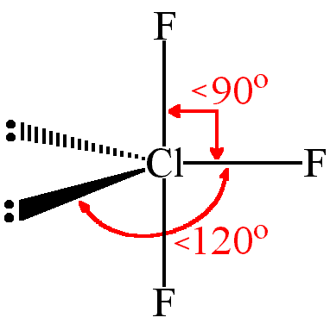

The ClF3 molecule is said to be **‘T-shaped’.**

**Six filled orbitals, all bonding pairs, e.g. sulphur hexafluoride, SF6**

In sulphur hexafluoride, the central sulphur atom has six outer electrons and each fluorine atom contributes one electron, resulting in six electron pairs, all of which are bonding pairs. The shape of the molecule is:

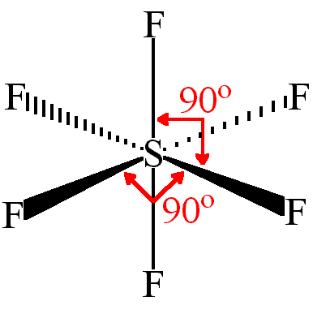

If this molecule were constructed in a solid shape it would be a regular octahedron and therefore the SF6 molecule is **octahedral** in shape.

Bearing in mind that the number of electron pairs decides the shape of molecules, Table 11 provides a useful summary of molecular shapes.

**Table 11**

|  |  |
| --- | --- |
| **Total number of electron pairs** | **Arrangement of electron pairs** |
| 2 | Linear |
| 3 | Trigonal |
| 4 | Tetrahedral |
| 5 | Trigonal Bipyramidal |
| 6 | Octahedral |

**Question**

Draw molecules of the following species showing their shapes:

(a) PCl3 (d) PF5 (g) NF3

(b) SnCl4 (e) BeF2 (h) BH4–

(c) BrF4- (f) H2S

|  |  |  |  |  |  |  |
| --- | --- | --- | --- | --- | --- | --- |
| **Total No.**  **of**  **Filled orbitals** | **No. of**  **Bonding**  **Pairs** | **No. of**  **Lone Pairs** | **Geometrical Name** | **Approximate**  **Bond Angle** | **Shape** | **Examples** |
| 2 | 2 | 0 | linear | 180º |  | BeCl2 |
| 3 | 3 | 0 | trigonal planar | 120º |  | BF3, NO3– |
| 2 | 1 | bent |  |  | SO2 |
| 4 | 4 | 0 | tetrahedral | 109.5º |  | CH4, NH4+ |
| 3 | 1 | trigonal pyramidal | 107.5º |  | NH3 |
| 2 | 2 | bent | 105º |  | H2O |
| 5 | 5 | 0 | trigonal bipyramidal | 120o (in plane) & 90o (above & below) |  | PCl5 |
| 3 | 2 | T-shaped |  |  | ClF3 |
| 6 | 6 | 0 | octahedral | 90º |  | SF6 |
| 4 | 2 | square planar |  |  | XeF4 |

**Molecular Shapes Summary**

**Section 3: Transition metals**

**Electronic configuration of transition metal atoms and ions**

The d-block transition metals are defined as metals with an incomplete d subshell in at least one of their ions. When a transition metal atom loses electrons to form a positive ion the 4s electrons are lost before the electrons occupying the 3d orbitals.

Consider the electronic configurations of the transition elements using [Ar] to represent that of argon [1s2 2s2 2p6 3s2 3p6] (Table 12).

**Table 12**

|  |  |  |
| --- | --- | --- |
|  | **Electronic configuration** | |
| **Element** | **Spectroscopic notation** | **Orbital box notation**  **(d electrons only)** |
| Scandium | Ar 3d1 4s2 |  |
| Titanium | Ar 3d2 4s2 |  |
| Vanadium | Ar 3d3 4s2 |  |
| Chromium | Ar 3d5 4s**1** |  |
| Manganese | Ar 3d5 4s2 |  |
| Iron | Ar 3d6 4s2 |  |
| Cobalt | Ar 3d7 4s2 |  |
| Nickel | Ar 3d8 4s2 |  |
| Copper | Ar 3d10 4s**1** |  |
| Zinc | Ar 3d10 4s2 |  |

As can be seen from Table 12, the filling of the d orbitals follows the aufbau principle, with the exception of chromium and copper atoms.

These exceptions are due to a **special stability** associated with **all the d orbitals being half filled**, as in the case of chromium, **or completely filled**, as in the case of copper. This is better seen using the orbital box notation.

When transition metals form positive ions it is the **s electrons that are lost first** rather than the d electrons, e.g. the electronic configuration for an iron atom is [Ar] 3d6 4s2 and so the electronic configuration for the iron(II) ion will be [Ar] 3d6.

**Questions**

1. Write down the electronic configurations in both spectroscopic and orbital box notation for the following atoms and ions.

(a) Cu

(b) Mn2+

(c) Ti3+

(d) Co

(e) Co2+

(f) Co3+

(g) Ni2+

(h) Cu+

(i) Fe3+

2. Zinc invariably forms the 2+ ion and the only ion of scandium is the 3+ ion. Using spectroscopic notation, write down the electronic configurations for both these ions and use them to explain why zinc and scandium are often regarded as not being transition metals.

**Oxidation states**

In ionic compounds the oxidation number is equal to the charge on the ion in a compound.

For example, in iron(II) chloride, Fe2+(Cl–)2, iron is in oxidation state +2 and in iron(III) chloride, Fe3+(Cl–)3, iron is in oxidation state +3.

The two terms, oxidation state and oxidation number, are usually interchangeable so an element is said to be in a particular oxidation state when it has a specific oxidation number.

There are certain **rules for assigning and using oxidation numbers**.

1. The oxidation number in a free or uncombined element is zero. Thus, metallic magnesium has an oxidation number of zero as does Cl in chlorine gas, Cl2.
2. For ions consisting of single atoms the oxidation number is the same as the charge on the ion. For example, the oxidation number of chlorine in Cl- is –1, for oxygen in O2- it is –2 and for aluminium in Al3+ it is +3.
3. In most compounds the oxidation number for hydrogen is +1 and for oxygen it is –2. Notable exceptions are metallic hydrides (–1 for hydrogen) and peroxides (–1 for oxygen).
4. In its compounds fluorine always has oxidation number –1.
5. The algebraic sum of all the oxidation numbers in a molecule must be equal to zero.
6. The algebraic sum of all the oxidation numbers in a polyatomic ion must be equal to the charge on the ion. For example, in SO42– the sum of the oxidation numbers of the one sulphur and four oxygen atoms must equal –2.

**Questions**

Use the rules above to find the oxidation numbers of:

(a) Mn in MnF2

(b) S in SO2

(c) S in SO3

(d) C in CO32–

(e) Mn in MnO2

(f) S in SO42–

(g) Mn in MnO42–

(h) Mn in MnO4–

(i) Cu in CuCl42–

Oxidation numbers can be used to determine whether an oxidation–reduction reaction has taken place. An increase in oxidation number means that oxidation of the species has occurred, whereas a decrease in oxidation number means that reduction has occurred.

For example, consider the oxidation number of manganese as it changes from MnO4– to Mn2+. The oxidation number of manganese in MnO4– is +7, but in Mn2+ manganese is in oxidation state +2. This means that when MnO4– is changed to Mn2+ a reduction reaction has taken place. This fits in with the more familiar definition that reduction is a gain of electrons, as shown in the ion–electron equation:

MnO4– + 8H+ + 5e– 🡪 Mn2+ + 4H2O

It can be seen that manganese in oxidation state +7 has been reduced and so MnO4– is acting as an oxidising agent when it reacts in such a manner. It is generally true that compounds containing metals in high oxidation states tend to be oxidising agents whereas compounds with metals in low oxidation states are often reducing agents.

**Questions**

1. Write an ion-electron equation for Fe2+ acting as: (i) an oxidising agent

(ii) a reducing agent.

2. Work out the oxidation number of Cr in Cr2O72– and decide whether the conversion of Cr2O72– to Cr3+ is oxidation or reduction. Is the Cr2O72– acting as an oxidising agent or a reducing agent in this reaction? Confirm your answer by writing the appropriate ion–electron equation.

3. Work out the oxidation number of chromium in Cr2O72- and in CrO42– and decide whether the conversion of Cr2O72– to CrO42– is oxidation or reduction.

4. The most common oxidation states of iron are +2 and +3. Using orbital box notation, draw out their respective electronic configurations and suggest which of the two ions is the more stable.

Transition metals exhibit variable oxidation states of differing stability. A common oxidation state of most of these elements is +2 when the atom has lost its 4s electrons.

However, because the 3d subshells have energy levels very close to that of the 4s subshell, it is fairly easy for the 3d electrons to be also lost to form other oxidation states. The different ions in different oxidation states have different stabilities, as in the case of Fe2+ and Fe3+.

Changing from one oxidation state to another is an important aspect of transition metal chemistry, often characterised by a distinct colour change, as shown in Table 13.

**Table 13**

|  |  |  |
| --- | --- | --- |
| **Ion** | **Oxidation state of transition metal** | **Colour** |
| VO3- | +5 | Yellow |
| VO2+ | +4 | Blue |
| V3+ | +3 | Green |
| V2+ | +2 | Violet |

The multiplicity of different oxidation states shown by some transition metals is given in Table 14. The most stable oxidation states are shown in bold.

**Table 14**

|  |  |  |
| --- | --- | --- |
| **Element** | **Different oxidation states** | **Examples of compounds** |
| Ti | +2, **+3**, **+4** | Ti2O3, TiO2 |
| V | +1, +2, **+3**, **+4**, **+5** | VCl3, V2O5 |
| Cr | +1, +2, **+3**, +4, +5, **+6** | Cr2O3, CrO3 |
| Mn | +1, +2, +3, **+4**, +5, +6, **+7** | MnCl2, MnO2 |
| Fe | +1, **+2**, **+3**, +4, +6 | FeCl2, Fe2O3 |
| Co | +1, **+2**, **+3**, +4, +5 | CoO, CoCl3 |
| Ni | +1, **+2**, +3, +4 | NiO, NiCl2 |
| Cu | **+1**, **+2**, +3 | Cu2O, CuCl2 |

**Question:** Suggest why scandium and zinc are not included in Table 14.

**Transition metal complexes**

A complex consists of a central metal ion surrounded by ligands. A ligand is a molecule or negative ion which bonds to the metal ion by the donation of one or more electron pairs into unfilled metal orbitals i.e. they form a dative (or co-ordinate) bond.

The most common neutral compound to act as a ligand is water, which bonds to the central metal ion through one of the lone pairs on the oxygen atom. Ammonia, NH3, is also a neutral ligand, bonding through the lone pair on the nitrogen atom.

Common ligands that are negative ions include:

* cyanide ion, CN–
* halides, F–, Cl–, Br– and I–
* nitrite ion, NO2–
* hydroxide ion, OH–.

Ligands such as CN–, H2O, NH3 and other molecules or negative ions donating one electron pair to the metal ion are said to be monodentate. Those that donate more than one electron pair are polydentate. The term ‘dentate’ is derived from the Latin word for tooth and so monodentate ligands can be considered as one-toothed ligands.

Ligands are also said to be chelating, from the Greek word meaning a claw. If the ligand has **two lone pairs**, it is called a **bidentate** chelate.

Common bidentate ligands are the ethanedioate (oxalate) ion and 1,2-diaminoethane (ethylenediamine), both of which are shown in Figure 18.

**Figure 18**

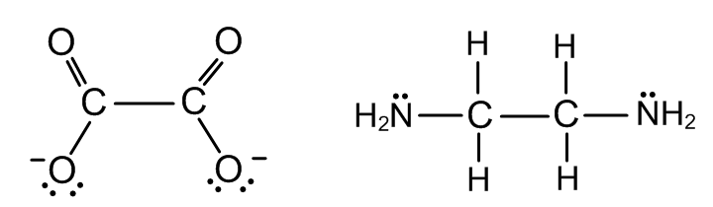

A common reagent in volumetric analysis is EDTA, ethylenediaminetetraacetic acid. It is a hexadentate ligand which complexes with many metals in a 1:1 ratio (Figure 19).

**Figure 19 (a) Structure of EDTA; (b) complex of EDTA with nickel**

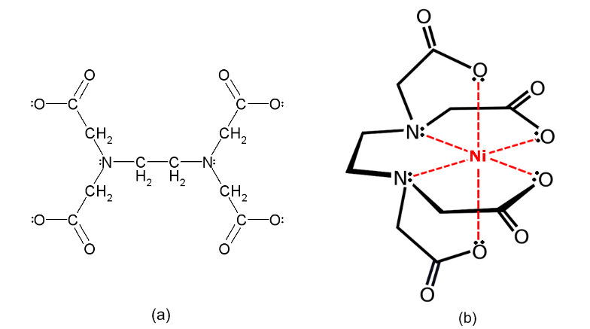

The number of ligands in a complex ion varies depending on the particular ligand. For example, in [Cu(H2O)6]2+ the copper(II) ion is surrounded by six water molecules and in [CuCl4]2– there are four chloride ions acting as ligands around the copper(II) ion.

The number of bonds from the ligand to the central metal ion is known as the **co-ordination number** of the central ion and in the two examples given above the copper(II) ion has co-ordination numbers 6 and 4 respectively.

**Naming complex ions**

Complex ions and complexes are written and named according to IUPAC rules.

The formula of a complex ion should be enclosed within square brackets, although common complexes such as MnO4– are often written without brackets. The metal symbol is written first, then the negative ligands followed by the neutral ligands, e.g. [Fe(OH)2(H2O)4]+.

When naming the complex ion or molecule the **ligands should be named first**, in **alphabetical order**, **followed by the name of the metal**.

If the ligand is a **negative ion** the name of which ends in **-ide, the ending changes to ‘o’**, e.g. chloride, Cl–, becomes chloro, cyanide, CN–, becomes cyano.

If the ligand is a **negative ion** the name of which ends in **-ite, the final ‘e’ changes to ‘o’**, e.g. nitrite, NO2–, changes to nitrito.

If the ligand is water it is named aqua, ammonia is named a**mm**ine and carbon monoxide is carbonyl.

If there is more than one particular ligand it is prefixed by di, tri, tetra, penta, or hexa, etc. as appropriate.

If the complex ion is an **anion** (**negative** ion) **the suffix -ate is added** to the name of the metal. Sometimes the Latin name for the metal is used in this context, e.g. ferrate not ironate and cuprate rather than copperate.

The oxidation state of the metal is given in Roman numerals after its name.

For example,

* the complex ion [Ni(NH3)6]2+ is named hexaamminenickel(II)
* the negative complex ion [Fe(CN)6]3– is named hexacyanoferrate(III).

**Questions**

Name the following complexes:

(a) [CoCl4]2–

(b) [Ni(H2O)6]2+

(c) [Fe(CN)6]4–

(d) [Ti(NH3)6]3+

(e) [Ni(CN)6]4–

(f) MnO4–

(g) [PtCl6]2–

(h) Ni(CO)4

(i) [Cu(NH3)4]2+

**Colour in transition metal complexes**

Simple ions and complex ions of the transition metals are often coloured. This is because they absorb light in certain parts of the visible spectrum.

The colour seen is the complementary colour to that absorbed, i.e. it is a combination of the colours not absorbed. To understand this outcome, it has to be appreciated that white light is a combination of the three primary colours red, blue and green.

If red light is absorbed, the colours transmitted are blue and green, which is seen as green/blue or cyan.

If blue light is absorbed, the colours transmitted are red and green, which is seen as yellow.

If green light is absorbed the colours transmitted are blue and red, which is seen as magenta.

These colour changes are summarised in Figure 20.

**Figure 20**

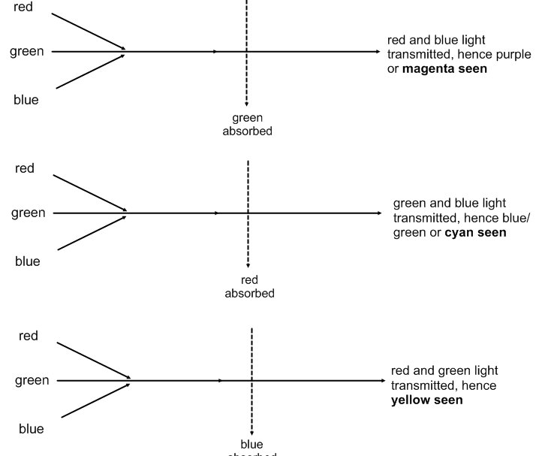

The reason that compounds of transition metals absorb white light is the loss of degeneracy of the d orbitals in these compounds. In the free ion, the five different 3d orbitals (dxy, dyz, dxz, dx2—y2 and dz2) are degenerate, i.e. of equal energy. However, in a complex such as [Ti(H2O)6]3+ the metal ion is no longer isolated but is surrounded by the six water molecules serving as ligands. The complex has an octahedral shape and the water molecules can be considered to approach the central Ti3+ along the x-, y- and z-axes.

Due to electrostatic repulsion, the orbitals that lie on these axes will be raised to higher energy than those orbitals that lie between the axes.

The dxy, dyz and dxz orbitals lie between the axes. For example, the dxy orbital lies between the x- and y-axes and so on. The dx2—y2 orbital has a double dumb-bell shape with the lobes lying along the x- and y-axes. The dz2 orbital has both its large lobes lying along the z-axis.

This results in the dx2—y2 and dz2 orbitals being of higher energy than the dxy, dyz and dxz orbitals in the octahedral complex. This is shown diagrammatically in Figure 21.

**Figure 21**

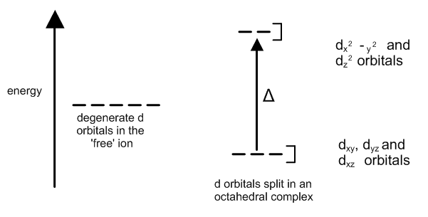

The d orbitals are split differently in complexes of different shapes.

The amount of splitting, , of the d orbitals depends on the ligand. The ability of ligands to cause the splitting of the d orbitals is given by the spectrochemical series.

For the most common ligands this is:

I– < Br– < Cl–  < F–  < H2O < NH3 < CN–

small orbital splitting large orbital splitting

‘weak’ field ligands ‘strong’ field ligands

Transition metal complexes can absorb light because photons of the appropriate energy can excite electrons from the d orbitals of lower energy (ground state) to d orbitals of higher energy (excited state). This energy is dissipated as heat and is not re-emitted as light.

For example, consider the Cu2+(aq) ion. It has electronic configuration [Ar] 3d9 and this is shown diagrammatically in Figure 22 in which an electron is represented by an arrow.

**Figure 22**

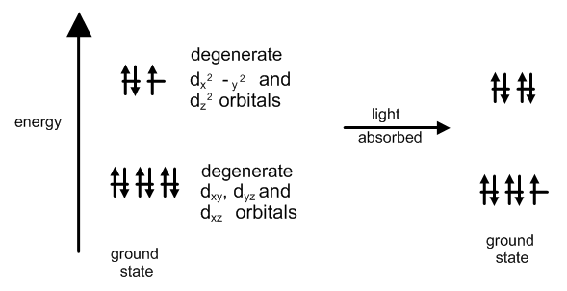

Figure 22 shows an electron from one of the lower energy orbitals being promoted to a higher energy orbital. This transition is known as a d–d transition. If the energy absorbed corresponds to the visible part of the electromagnetic spectrum, then the colour observed will be the complementary colour to that absorbed.

In the case of Cu2+, red light is absorbed, giving the familiar blue-green colour of copper(II) ions in aqueous solution. Changing the ligand can change this colour. For example, replacing the water molecules by chloride ions (by adding concentrated HCl) produces a green colour, and a dark blue or violet colour is observed when the water molecules are replaced by ammonia molecules as ligands.

**Ultra-violet and visible absorption spectroscopy**

The effects of d–d transitions can be studied using ultra-violet and visible absorption spectroscopy. The absorption of ultra-violet or visible radiation corresponds to outer electrons becoming excited. When an atom, molecule or ion absorbs energy, electrons are promoted from their ground state to an excited state. The energy difference between these states corresponds to the ultra-violet and visible regions of the electromagnetic spectrum. For ultra-violet radiation the wavelength range is approximately 200–400 nm and for visible radiation the wavelength radiation is approximately 400–700 nm. Since ultra-violet radiation has shorter wavelengths it is of higher energy than visible radiation.

Most transition metal compounds are coloured because they absorb visible radiation. Solutions that absorb ultra-violet but not visible radiation appear colourless, as our eyes are unable to detect that ultra-violet radiation has been removed from the transmitted light.

An ultra-violet/visible absorption spectrophotometer contains a source and a detector of ultra-violet and/or visible radiation. The radiation from the source is focused into a beam and passes through a diffraction grating, which splits it into its constituent wavelengths. In some instruments the radiation is also split into two separate beams, one beam passing through a solution of the sample being investigated and the other passing through a reference cell, which usually contains the solvent only. As the radiation passes through the sample, photons of a specific frequency, corresponding to the energy difference between the ground state and the excited state to which the electron is promoted, are absorbed.

The radiation of this particular frequency is absorbed so the transmitted radiation emerges from the sample with a decreased intensity. If photons of a given frequency are not absorbed then radiation corresponding to this frequency is unchanged as it passes through the sample. The spectrometer measures the intensity of the radiation transmitted through the sample and compares this value with the intensity of the incident radiation. The instrument usually plots the intensity of light absorbed at a particular frequency or wavelength against the frequency or wavelength of the radiation.

The outcome is known as the absorption spectrum of that sample. When there is absorption of radiation in a certain frequency range, the spectrum shows an absorption band. In the case of visible light being absorbed, the colour transmitted is white light minus the absorbed light and the complementary colour is observed.

For example, the blue [Cu(H2O)6]2+ ion, which is present in aqueous solutions of copper(II) sulphate, copper(II) chloride, etc., has an absorption band in the red part of the visible spectrum, as shown in Figure 23. Since red light is absorbed, blue and green light are transmitted and aqueous copper(II) salts appear blue-green (cyan) to our eyes.

**Figure 23**

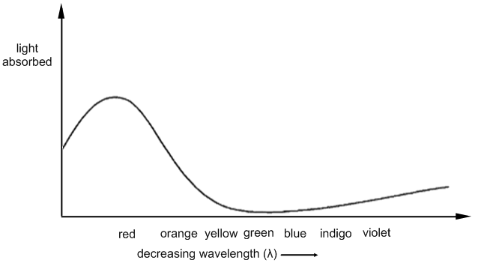

For the complex [Cu(NH3)4(H2O)2]2+ the absorption band is moved slightly more towards green so that both red and green light are absorbed and solutions containing this ion are darker blue in colour.

**Catalysis by transition metals**

Transition metals and their compounds act as catalysts in many important industrial chemical reactions, some of which are summarised in Table 15.

**Table 15**

|  |  |
| --- | --- |
| **Process** | **Catalyst used** |
| Haber | Iron granules |
| Contact | Vanadium(V) oxide |
| Ostwald | Platinum gauze |
| Catalytic converter in cars | Platinum, palladium, rhodium |
| Preparation of methanol | Copper |
| Preparation of margarine | Nickel |
| Polymerisation of alkenes | Titanium compounds |

Catalysts speed up chemical reactions by providing an alternative reaction pathway of lower activation energy. Transition metals can form a variable number of bonds because of the availability of unoccupied or partially occupied d orbitals. It is believed that the presence of unpaired electrons or unfilled d orbitals allows intermediate complexes to form, providing reaction pathways of lower energy compared to the uncatalysed reaction.

Transition metals usually have co-ordination numbers of 4, 5 or 6 in their complexes and this allows reactant species to attach themselves to the transition metal in a compound in which the co-ordination number of the transition metal is 4. The catalysed reaction can then take place without disturbing the other ligands although the size and shape of these can direct the course of the reaction. The product formed leaves the catalyst, and the catalyst is left unchanged at the end of the reaction. For example, passing ethene into a solution containing TiCl4 and (C2H5)3Al causes its polymerisation into poly(ethene).

Many transition metals act as catalysts because of their ability to exist in a variety of different oxidation states. This also allows the transition metal to provide an alternative reaction pathway with lower activation energy and so speed up the reaction. The transition metal reverts to its original oxidation state once the reaction is complete.

A good example occurs on adding pink cobalt(II) chloride solution to a solution of hydrogen peroxide and Rochelle salt (potassium sodium tartrate) at about 50ºC. Before the cobalt(II) ions are added the reaction progresses very slowly with only a few bubbles of gas being released. Almost immediately on adding the CoCl2(aq) there is a colour change from pink to green and vigorous effervescence. When the reaction is over the pink colour returns. In terms of oxidation states the cobalt has changed from +2 (pink) to +3 (green) and then back to +2 at the end:

Co2+(aq) 🡪 Co3+(aq) 🡪 Co2+(aq)

pink green pink

**To be inserted here**

Homogeneous and heterogeneous catalysts should be explained in terms of changing oxidation states with the formation of intermediate complexes and the adsorption of reactive molecules onto active sites respectively.