Curriculum for Excellence

Advanced Higher Chemistry

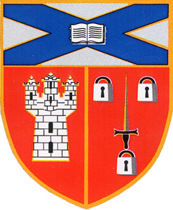
Unit 2: Organic Chemistry and Instrumental Analysis

Molecular Orbitals
Molecular Structure
Stereochemistry
Synthesis
Experimental Determination of Structure
Pharmaceutical Chemistry

contents

Introduction

Section 1: Molecular Orbitals

Section 2: Molecular Structure

Section 3: Stereochemistry

Section 4: Synthesis

Section 5: Experimental Determination of Structure

Section 6: Pharmaceutical Chemistry
Introduction

Organic chemistry is generally considered to be the chemistry of the compounds of carbon with the exceptions of the carbonates and the simple oxides of carbon.

Around the beginning of the nineteenth century, those substances that were derived from plant and animal sources were described as organic and those from non-living sources were described as inorganic. It was believed that organic substances were special and could be created only in the presence of the ‘vital force’ found in living organisms. They could not be created from inorganic compounds.

However, in 1828 Friedrich Wohler inadvertently changed the inorganic compound ammonium cyanate into urea, a component of urine and therefore a product of a living organism:

NH₄⁺ NCO– NH₂CONH₂
ammonium cyanate urea

Further organic compounds were synthesised in the next few years and even though the vital force theory was eventually disproved, the classification of chemical substances as organic or inorganic has continued up to the present day.

It has become clear that the ability of living organisms to feed, move, grow and reproduce is dependent on the individual properties of a huge variety of compounds of carbon. It is the element carbon that is special.

Currently, at least five million compounds have been identified and of these more than 95% are compounds of carbon. Yet carbon makes up only 0.2% of the earth’s crust. The ability of carbon to form such a huge variety of compounds is due to important properties of the carbon atom itself:

• carbon atoms can form four strong covalent bonds with a wide variety of other elements, e.g. hydrogen, nitrogen, oxygen, sulfur, phosphorus, halogens and some metals
• carbon atoms can form strong bonds with other carbon atoms, giving rise to molecules containing chains of carbon atoms, which can be straight or branched
• carbon atoms can form molecules containing carbon atoms (and sometimes other atoms) arranged in rings
• carbon atoms can form multiple bonds with other carbon atoms and with oxygen and nitrogen atoms.

The importance of organic chemistry in modern-day technology cannot be overstressed. It is the chemistry of life and so is fundamental to biology and medicine. It is involved in the production and processing of food, the treatment of disease, the manufacture of clothing (synthetic fibres and dyes) and of fuels and detergents, and in many other facets of modern life. Potential solutions to many of the world’s major problems may lie in organic chemistry.

In this unit, we build on your knowledge of organic chemistry gained from Higher Chemistry and provide you with a deeper understanding of the substances and their reactions.

Before starting the unit, you should be quite sure of the meanings of the following terms: homologous series, hydrocarbon, physical properties, chemical properties, functional group, saturated, unsaturated.

Section 1: Molecular Orbitals

The study of the vast number of organic compounds is simplified by classification into smaller groups according to similarities and differences in the structures of their individual molecules.

Specific groupings of atoms within a molecule give that molecule particular characteristic properties. These specific groupings of atoms are known as functional groups. You will already have encountered some of these, e.g. hydroxyl, carbonyl, carboxyl and ester groupings. Organic compounds can be classified systematically by considering the functional groups present in the molecules.

Hydrocarbons

Hydrocarbons are compounds containing the elements carbon and hydrogen only. This broad grouping contains a number of further sub-divisions including the familiar homologous series of alkanes, alkenes, alkynes and cycloalkanes met previously.

Figure 1

Bonding in alkanes
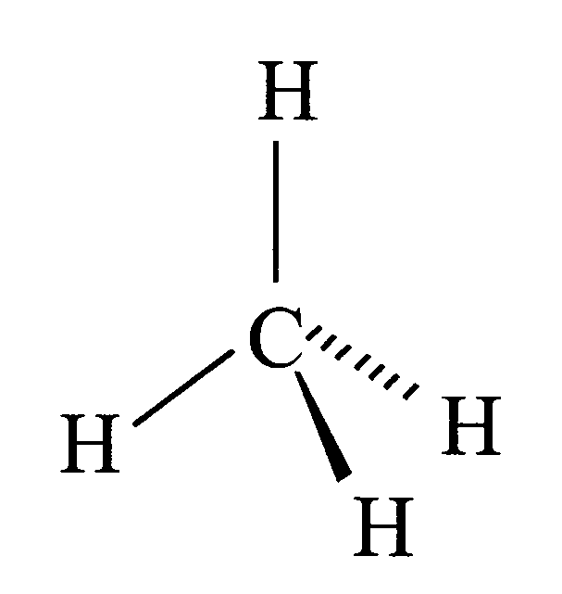
Alkanes are a saturated series of hydrocarbons fitting the general formula CnH2n+2. This means that every carbon atom in any alkane molecule forms four covalent single bonds, i.e. in each carbon atom there are four bonding pairs of electrons. We can predict that these four bonding pairs will mutually repel and take up a tetrahedral arrangement, as seen in the tetrahedral methane molecule (Figure 1).

One way to consider the formation of a covalent bond is as the overlap of a half-filled atomic orbital on one atom with a half-filled atomic orbital on another atom. The two electrons in the bond are now attracted by two nuclei. Thus the overlap of the two atomic orbitals gives rise to a molecular orbital in which the two bonding electrons, now paired up, move under the influence of both nuclei.

The electron arrangement of an isolated carbon atom in the ground state is 1s² 2s² 2p². The two electrons in the 2p sublevel will occupy individually two of the three p orbitals according to Hund’s rule (see Unit 1a). So, there are
therefore only two unpaired electrons and one might expect that only two covalent bonds would be formed. Clearly, this is not the case. Methane, the simplest alkane, has the formula CH₄ and obviously contains carbon atoms forming four bonds.

This can be explained by the concept of hybrid orbitals. These are considered to result from the ‘mixing’ of atomic orbitals to generate a new set of orbitals. There is a solid mathematical basis for doing this based on the Schrödinger wave equations. Thankfully, you do not need to know anything about the complex calculations involved, only about the end result! The calculations predict the shapes of the hybrid orbitals as sketched in Figure 3.

In each carbon atom in methane and other alkanes, the 2s orbital and all three 2p orbitals mix to generate four equivalent hybrid orbitals. The 2s and 2p sublevels are close in energy. One of the 2s electrons has to be promoted to the third 2p orbital. This results in a carbon atom containing four singly occupied orbitals, which can be mixed to produce four hybrid orbitals of equal energy (Figure 2).

Figure 2: sp³ hybridisation

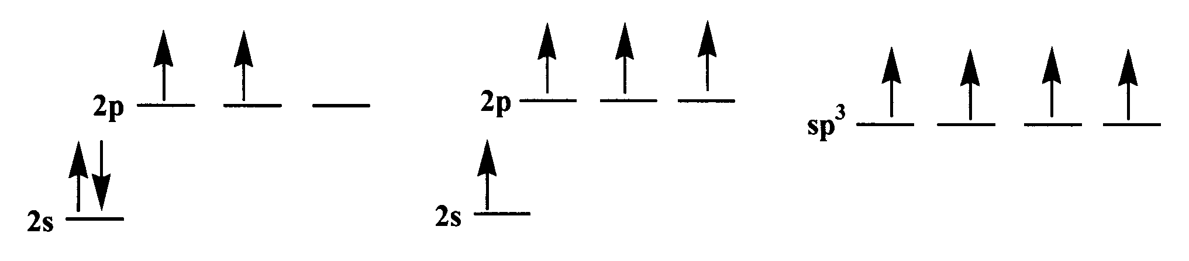
carbon atom before carbon atom after carbon atom after
promotion promotion hybridisation

The energy required to promote the electron is more than compensated for when the hybrid orbitals form bonds with other atoms since there is much more effective overlap using the hybrid orbitals. The hybrid orbitals are much more directional in shape than the unhybridised orbitals and consequently provide better overlap when forming bonds with other atoms. Since there are four hybrid orbitals, four bonds can now be formed.

Figure 3: Orbital shapes
One p orbital one sp³ hybrid orbital

For simplicity, the small lobe of the sp³ hybrid orbital is omitted from subsequent diagrams. The four hybrid orbitals are arranged tetrahedrally around the nucleus, giving exactly the overall geometry that minimises electron repulsion. Since these hybrid orbitals are formed from one s orbital and three p orbitals, this process is known as sp³ hybridisation and the hybrid orbitals are called sp³ orbitals.

The formation of methane can be illustrated as shown in Figure 4. A similar process can be used to explain the formation of an ethane molecule (Figure 5).

Figure 4: Molecular orbitals in methane

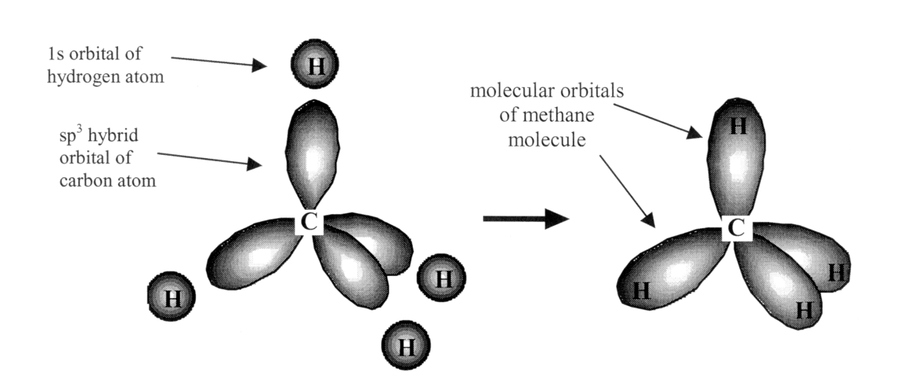

Figure 5: Molecular orbitals in ethane

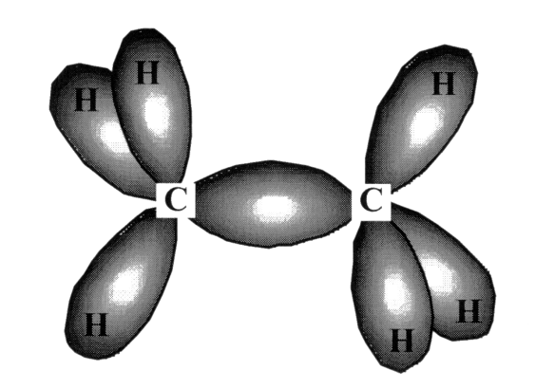

All the covalent bonds in these molecules – indeed for all alkanes – are formed by end-on overlap of atomic orbitals lying along the axis of the covalent bond. Such covalent bonds are known as sigma (σ) bonds.

Bonding in alkenes

The alkenes are an unsaturated homologous series of hydrocarbons fitting the general formula, C_{n}H_{2n}. Each alkene molecule contains one carbon-to-carbon double bond.

In trying to describe the formation of a double bond between two carbon atoms a variety of models can be used. For any model to be acceptable, it must be able to explain the observed facts and measurements. For example, spectroscopic measurements confirm that the bond angles in methane and ethane are 109.5º. Our sp³ hybridisation bonding model for methane and ethane is consistent with this observation.

What are the key facts about the ethene molecule?
(a) Electron diffraction shows that the ethene molecule is planar, with bond angles of 120º.
(b) The carbon-to-carbon double bond is shorter than the carbon-to-carbon single bond.
(c) Bond enthalpies (Table 1) show that the carbon-to-carbon double bond is stronger than the carbon-to-carbon single bond but not twice as strong.

Table 1

 | C–C | C=C | CC
Bond enthalpy (kJ mol⁻¹) | 337 | 607 | 828

(d) There is restricted rotation around the carbon-to-carbon double bond. For example, but-2-ene has the structural formula CH₃CH=CHCH₃. However, it exists as two different geometric isomers (see Stereoisomers, page 14):

trans-but-2-ene cis-but-2-ene

In the trans-isomer, the hydrogen atoms are on opposite sides of the double bond. In the cis-isomer, the hydrogen atoms are on the same side. Clearly rotation about the carbon-to-carbon double bond is difficult, unlike the situation with a single bond where there is comparatively free rotation. For example, 1,2-dibromoethane does not exhibit similar isomerism.

Once again, these facts can be explained by a bonding model involving hybridisation. In this case, sp² hybridisation takes place. Each carbon atom uses the 2s orbital and only two of the 2p orbitals. Promotion and mixing as before give three identical sp² hybrid orbitals (Figure 6).

Figure 6: sp² hybridisation

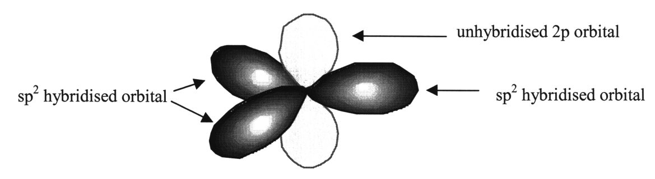

The three hybrid orbitals lie at 120º to each other in a plane perpendicular to the unhybridised 2p orbital. In ethene (Figure 7), the hybrid orbitals are used to form sigma (σ) bonds to hydrogen atoms and also to link the two carbon atoms (as shown).

Figure 7

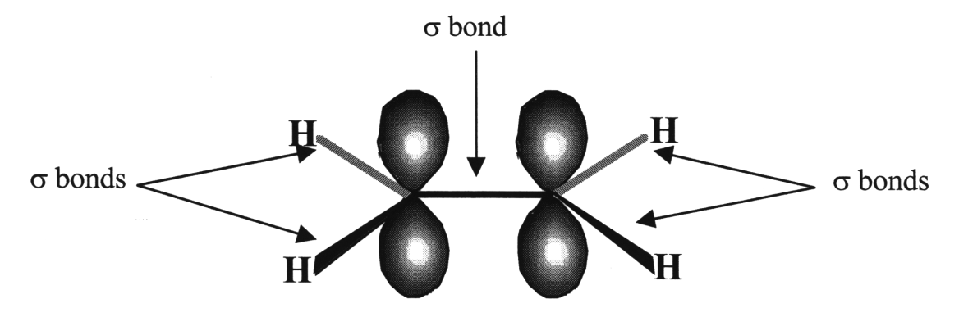

Remember that sigma bonds are formed by end-on overlap of atomic orbitals lying along the axis of the bond. In ethene, each carbon atom also has an unhybridised 2p orbital perpendicular to the plane of the molecule. These orbitals are parallel to each other and close enough to each other to overlap above and below the plane of the sp² bonds. This overlap produces a new molecular orbital between the two carbon atoms, with lobes above and below the molecular plane (Figure 8).

Figure 8: Π bond in ethene

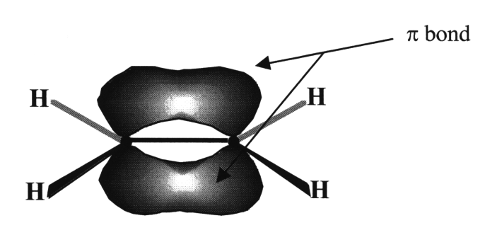

Such a bond formed by sideways overlap of p orbitals is known as a pi (Π) bond. This extra bond pulls the carbon atoms closer together, shortening the bond length. Sideways overlap is less effective than end-on overlap, with the result that Π bonds are not as strong as σ bonds. Thus, the carbon-to-carbon double bond is stronger than the carbon-to-carbon single bond but not twice as strong. Π overlap between the two p orbitals is most effective when the p orbitals are parallel. If one end of the molecule is twisted relative to the other, then the amount of overlap is reduced and eventually the Π bond will be broken. This will require a lot of energy and so our model also explains the restricted rotation about the carbon-to-carbon double bond.

The Bonding Continuum

So, the overlapping of orbitals to create bonds, as in valence bond theory, is limited in its use because it does not explain the molecular geometry of molecules very well. This is where hybridisation and the molecular orbital theory provides a better explanation. When atomic orbitals combine they form new molecular orbitals: these can be bonding or antibonding orbitals.

In a non-polar covalent bond, the bonding molecular orbital is symmetrical about the midpoint between two atoms. Polar covalent bonds result from bonding molecular orbitals that are asymmetric around the midpoint between two atoms. Ionic compounds represent an extreme case of asymmetry with the bonding molecular orbitals being almost entirely located around just one atom.

- Absorption of light and chromophores

Molecular orbitals arise from the linear combination of atomic orbitals to form bonding and antibonding (marked with *) orbitals. The bonding orbitals are at a lower energy than the antibonding orbitals. Electrons will fill these orbitals according to their energy levels: the lower energy orbitals first, and then the higher energy orbitals. Figure 9 shows these orbitals and their relative energy levels.

Figure 9

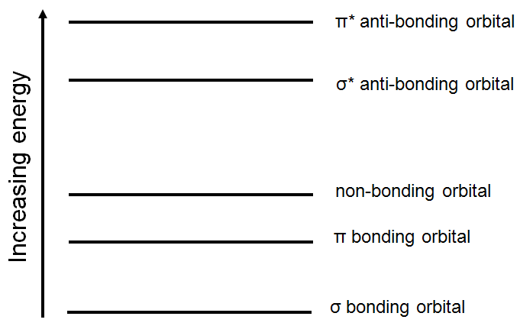

The σ and π bonding orbitals contain normal bonding pairs of electrons.
The σ* and π* anti-bonding orbitals are normally empty. The non-bonding orbital contains lone pairs of electrons.

Energy from photons can promote electrons from bonding or non-bonding orbitals into the higher energy anti-bonding orbitals. Several transitions are possible, each with an electron being excited from a full orbital into an empty one (Figure 10).

Figure 10
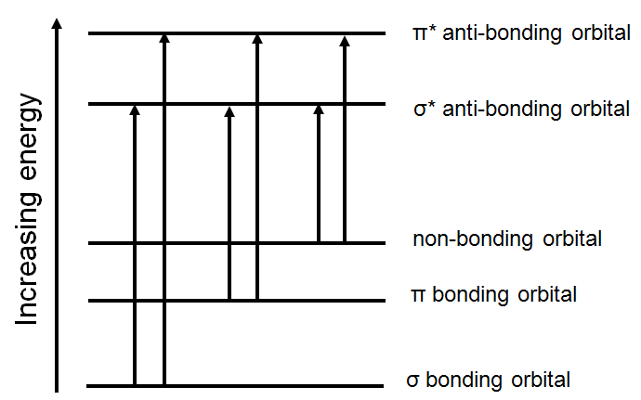

While many chemical compounds are coloured because they absorb visible light, most organic molecules appear colourless.

Organic compounds that contain only σ bonds are colourless. When only σ bonds are present, the σ bonding orbital is the highest occupied molecular orbital (HOMO), and the lowest unoccupied molecular orbital (LUMO) is the σ* anti-bonding orbital.

While these organic compounds do absorb light, the energy transitions involved in promoting an electron from σ to σ* (HOMO to LUMO) are very large. These absorptions correspond to the UV part of the spectrum, and so the compound is colourless.

Excitations of electrons in compounds containing simple π bonds still involve a large transition to promote an electron from HOMO (Π bonding orbital) to LUMO (σ* anti-bonding orbital), and thus these compounds also absorb in the UV region of the spectrum and are also colourless.

Conjugated systems

Organic molecules that are coloured contain delocalised electrons spread over a number of atoms. These molecules are known as conjugated systems.
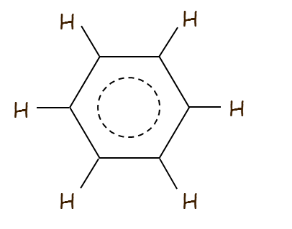
Benzene has a structure of C₆H₆ where all 6 six carbons are sp² hybridised which means that they each have a p orbital. The adjacent p orbitals overlap resulting in delocalised electrons stabilising the structure (Figure 11). Benzene can be described as a conjugated small molecule.

Figure 11

For bonds to be conjugated in long carbon chains, alternating double and single bonds must be present.

For example Vitamin A (Figure 12):

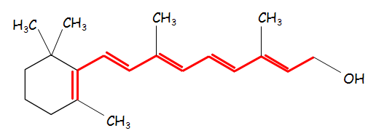Figure 12

Vitamin A contains a long chain of alternating σ and Π bonds.

The molecular orbital contains delocalised electrons which stretch along the length of the conjugated system.

The greater the number of atoms spanned by the delocalised electrons, the smaller the energy gap will be between the delocalised orbital and the next unoccupied orbital.

Exciting the delocalised electrons will therefore require less energy. If this falls within the visible part of the electromagnetic spectrum this will result in the compounds appearing coloured.

Chromophores

A chromophore is a group of atoms within a molecule that is responsible for its colour. Coloured compounds arise because visible light is absorbed by the electrons in the chromophore, which are then promoted to a higher energy molecular orbital. By comparing chromophores, we can find out about the energy of light that is being absorbed.

Vitamin A (Figure 12) has a conjugated system that spreads over five carbon-to-carbon double bonds. It appears yellow.

β-carotene
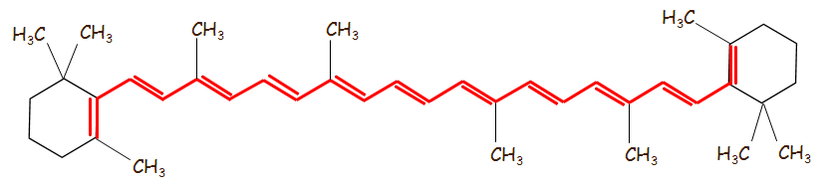
Figure 13

β-carotene (Figure 13) is found in carrots, sweet potatoes and apricots. It has a conjugated system that spreads over eleven carbon-to-carbon double bonds. It appears orange.

Lycopene

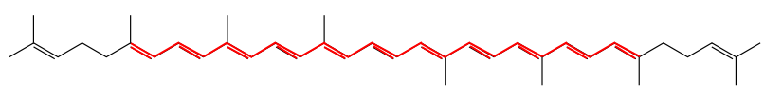
Figure 14

Lycopene (Figure 14) is found in watermelon, pink grapefruit and tomatoes. It has a conjugated system that spreads over eleven carbon-to-carbon double bonds. It appears red.

The colours we observe are not absorbed by the molecule. If the chromophore absorbs light of one colour, then the complementary colour is observed (See Table 2).

Table 2

Compound | Number of C=C in conjugated system | Main colour absorbed | Colour compound appears
Vitamin A | 5 | Violet | Yellow
β-carotene | 11 | Blue | Orange
Lycopene | 11 | Green | Red

If a compound absorbs any portion of the spectrum in the visible light region, it will be coloured. Since violet light has higher energy than blue or green, when it is absorbed we observe the yellow light that is transmitted.

As molecules with greater conjugation absorb lower energy light, the greater the degree of conjugation, the more likely the compound is to have a red colour.

Similarly, less conjugation results in compounds appearing yellow.

Section 2: Molecular Structure
Skeletal formulae (www.chemguide.co.uk)
In a skeletal formula, all the hydrogen atoms are removed from carbon chains, leaving just a carbon skeleton with functional groups attached to it.
For example, in Figure 15, butan-2-ol is represented by both the normal structural formula and the skeletal formula:

Figure 15
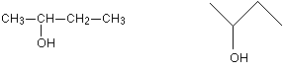

In a skeletal diagram of this sort
- there is a carbon atom at each junction between bonds in a chain and at the end of each bond (unless there is something else there already - like the -OH group in the example);
- there are enough hydrogen atoms attached to each carbon to make the total number of bonds on that carbon up to 4. There are, however, some very common cases where they are frequently used. These cases involve rings of carbon atoms which are surprisingly awkward to draw tidily in a normal structural formula.
Cyclohexane (Figure 16), C₆H₁₂, is a ring of carbon atoms each with two hydrogens attached. This is what it looks like in both a structural formula and a skeletal formula.
Figure 16 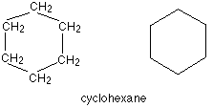
Figure 17 is cyclohexene, which is similar but contains a double bond:
Figure 17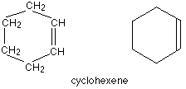
Now complete the questions on Drawing Organic Structures
Section 3: Stereochemistry

Stereoisomerism

Isomerism is an interesting and important feature of organic chemistry. It occurs whenever there is more than one way to organise a given number of atoms into a molecule. Isomers have been defined as ‘compounds with the same molecular formula but different structural formulae’.

In structural isomerism, the molecules differ in terms of the order in which the atoms are joined together. For example, there are two possible isomers with the molecular formula, C₂H₆O (Figure 18).

Figure 18

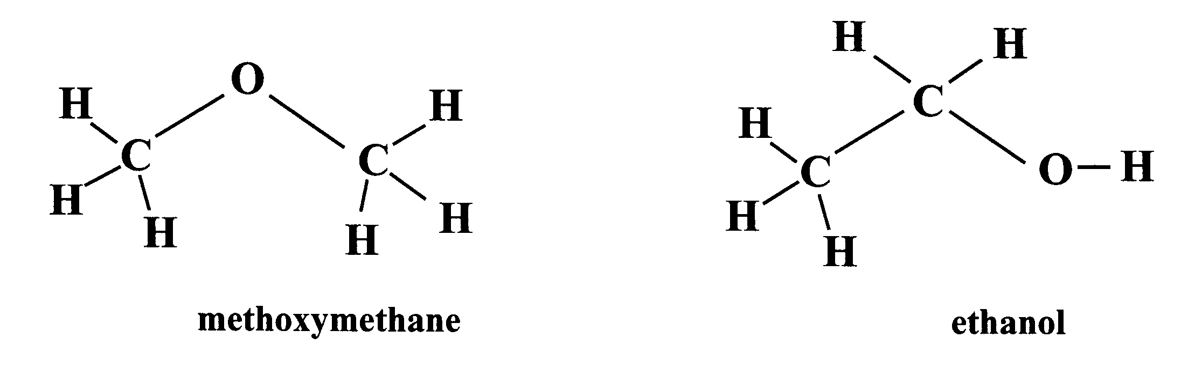

In methoxymethane, the oxygen atom lies between the two carbon atoms whereas in ethanol the two carbon atoms are bonded together with the oxygen at the end. Clearly, the two substances belong to different homologous series and will have very different chemical and physical properties.

In stereoisomerism, the molecules differ only in the orientation of the atoms in space. They have identical molecular formulae and the atoms are bonded together in the same order. However, because the arrangement of the atoms in space is different, the molecules are non-superimposable. This means that no matter how hard you try it is impossible to superimpose the image of one molecule on top of the other. We will consider the following types of stereoisomers: geometric and optical. Students are strongly encouraged to use molecular models to show exact molecular shapes in all aspects of isomerism.

Geometric isomerism

Geometric isomerism is one type of stereoisomerism and generally arises because of the lack of free rotation around a bond, especially a carbon-to-carbon double bond. As was seen earlier (see page 7), rotation around the double bond is restricted because it would involve breaking the π bond. Consequently, if both carbon atoms of the double bond each carry a single substituent, then two isomers will exist, one with the substituents on the same side of the double bond, the other with the substituents on the opposite sides, e.g. but-2-ene (Figure 19).

Figure 19

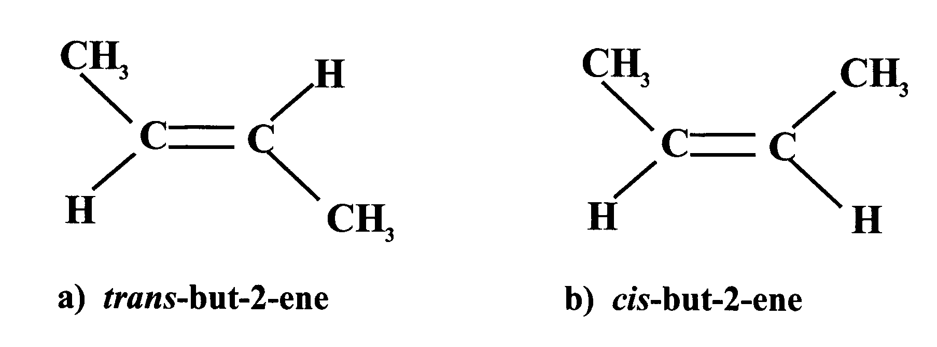
(a) trans-but-2-ene (b) cis-but-2-ene

If the substituents are on opposite sides, the isomer is called the trans-isomer whereas if the substituents are on the same side it is called the cis-isomer. Structure (a) in Figure 19 is the trans-isomer since both methyl groups are on opposite sides (as are the two hydrogen atoms) whilst structure (b) is the cis-isomer since the methyl groups are on the same side.

This situation can also occur with di-substituted cycloalkanes (Figure 20).

Figure 20

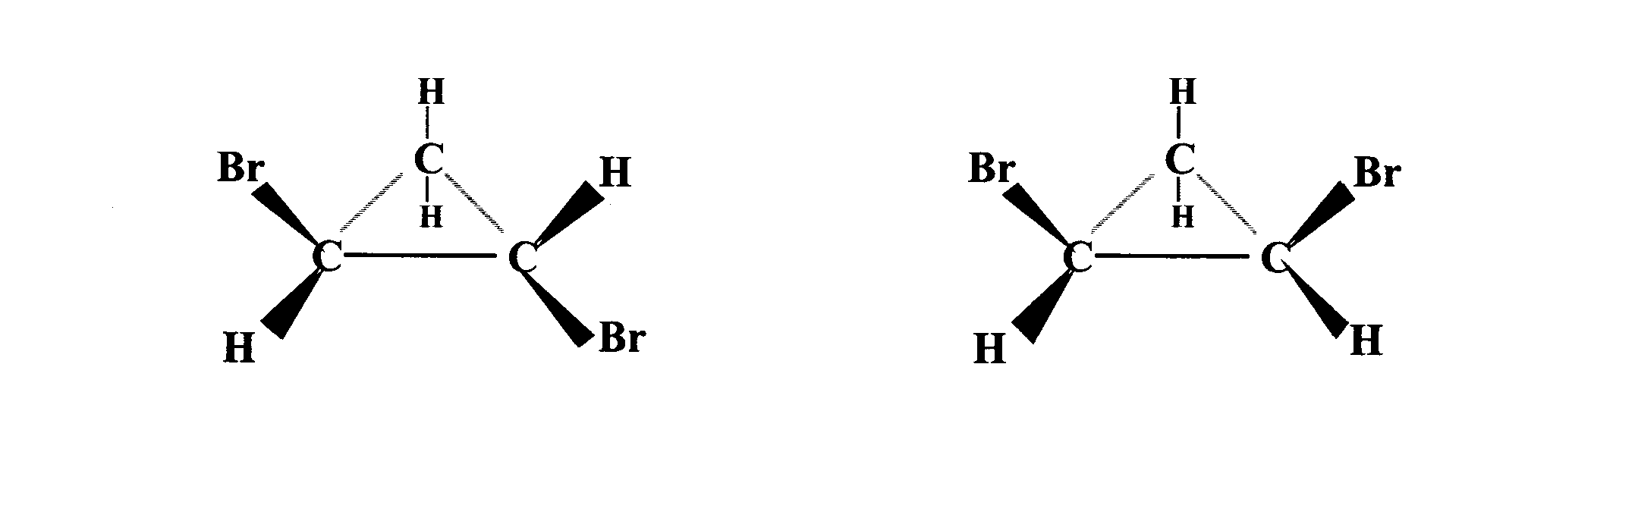
(a) trans-1,2-dibromocyclopropane (b) cis-1,2-dibromocyclopropane
Geometric isomers generally display differences in physical properties, as shown in Table 3.

Table 3

Isomer | Melting Point °C | Boiling Point °C
cis-But-2-ene | -139 | +4
trans-But-2-ene | -106 | +1
cis-Dichlorethene | -80 | +60
trans-Dichloroethene | -50 | +49

The differences in the melting points can be explained in terms of the differences in the shapes of the molecules. It appears likely that molecules of the trans-isomers are able to pack more closely together in the solid state than the cis-isomers. This close packing increases the van der Waals’ forces between the molecules and hence increases the melting point. On the other hand, differences in boiling point seem to be due to slight differences in polarity between the cis- and trans-isomers.
In both geometric isomers of 1,2-dichloroethene the C–Cl bonds are polar (Figure 21). In the cis-isomer, both bonds lie on the same side of the double bond and so the molecule itself will be polar. However, because of the symmetry of the trans-isomer, the polarities of the bonds cancel each other out and so the molecule itself is non-polar. As a result of these extra polar–polar attractions between the molecules of the cis-isomer, the cis-isomer has a higher boiling point than the trans-isomer.

Figure 21

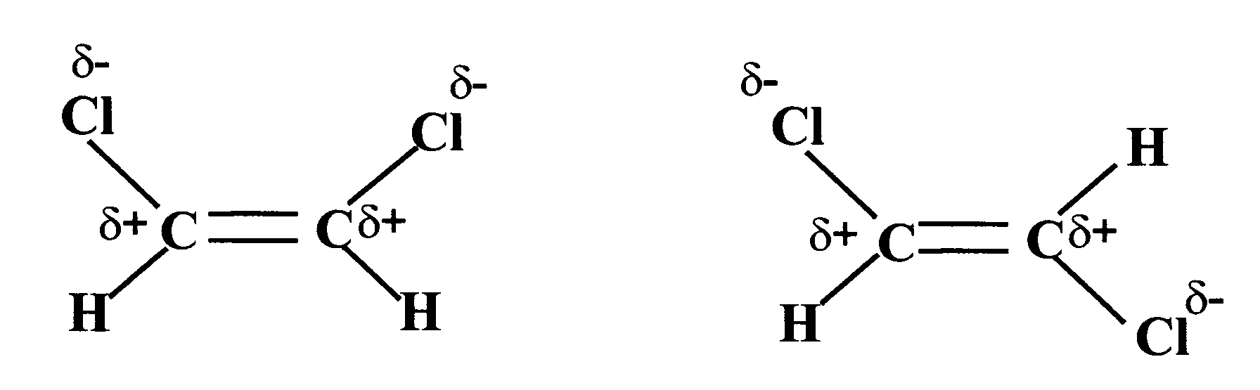

In certain cases, geometric isomers can also display different chemical properties. An example is the relative ease of dehydration of the two isomers of but-2-enedicarboxylic acid (Figure 22).

Figure 22

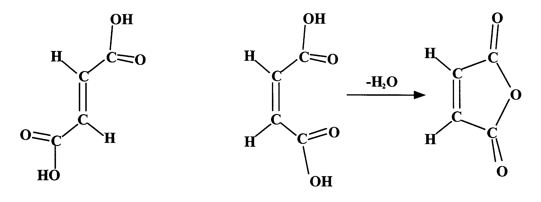
(b)
(a)

The condensation, with elimination of water, of two carboxyl groups produces an acid anhydride, e.g. two molecules of ethanoic acid can condense to give ethanoic anhydride (Figure 23).

Figure 23
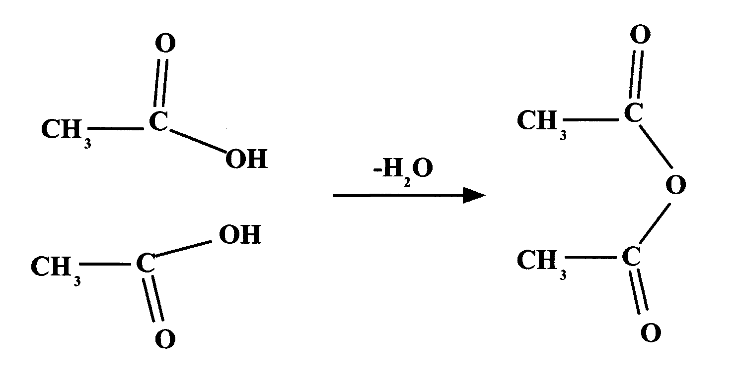
When the cis-isomer of but-2-enedicarboxylic acid, which has two carboxyl groups on the same side of the double bond, is heated an internal condensation reaction takes place to produce but-2-enedioic anhydride (see Figure 22b). This is clearly not possible for the trans-isomer (Figure 22a) since the carboxyl groups are on opposite sides and there is restricted rotation about the carbon-to-carbon double bond.

Fats and edible oils are naturally occurring esters of glycerol (propane-1,2,3-triol) and long-chain carboxylic acids called fatty acids. Edible oils are simply liquid fats. The fatty acids are almost exclusively straight-chain molecules, with an even number of carbon atoms usually ranging from about 10 to 20. The chains may be saturated, monounsaturated or polyunsaturated (more than one carbon-to-carbon double bond per molecule). Animal fats tend to have a higher proportion of saturated fatty acids whereas vegetable oils have a higher proportion of unsaturated fatty acids.

Recent medical research has linked a diet that is high in saturated fats with high levels of cholesterol in the blood. This leads to a build-up of fatty deposits in arteries and an increase in the incidence of heart disease. Unsaturated fats have not been similarly implicated and so health authorities have been advising people to cut down on the total amount of fat in their diet and also to replace sources of saturated fat with unsaturated fats wherever possible. Most of the important unsaturated fatty acids have a cis-arrangement around their carbon-to-carbon double bonds (Figure 24).

Figure 24

oleic acid

(octadec-cis-9-enoic acid)

linoleic acid

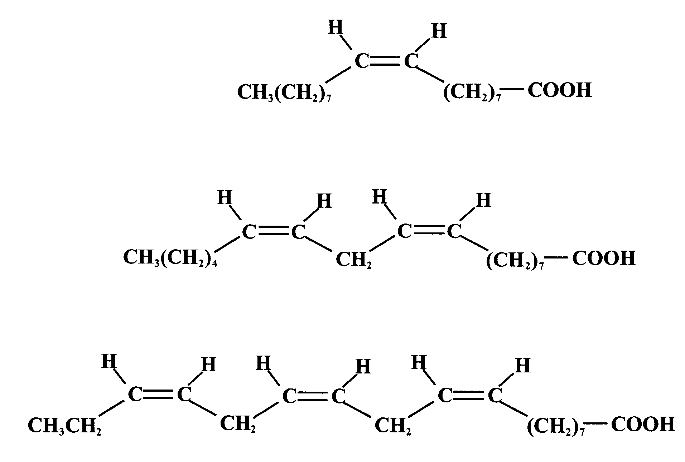
(octadec-cis-9,cis-12-dienoic acid)

linolenic acid

(octadec-cis-9,cis-12,cis-15-trienoic acid)

A few trans-fatty acids are found naturally, mainly in meat products and dairy foods. Current scientific evidence suggests that they behave in a similar way to saturated fatty acids in raising blood cholesterol levels.

Optical isomerism

This type of stereoisomerism arises whenever a molecule contains a tetrahedral carbon atom that has four different groups attached to it (Figure 25).
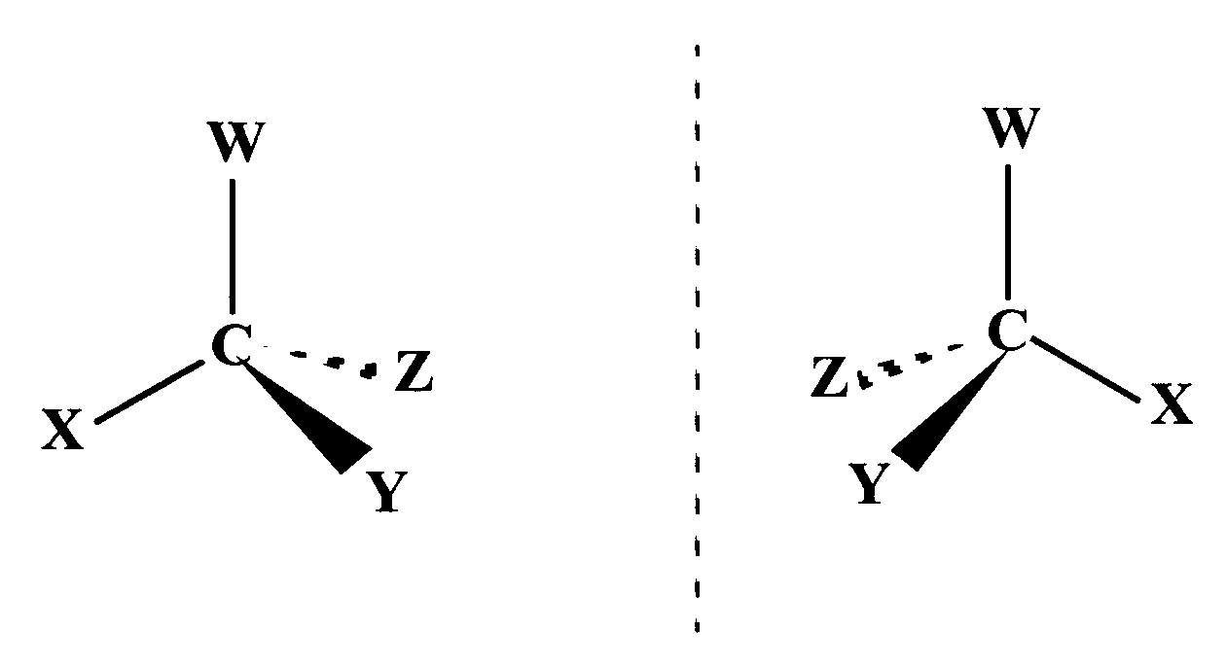
Figure 25

There are two possible arrangements for such a molecule, as shown in Figure 25. These differ only in that one is a mirror image of the other. Such isomers are known as enantiomers (from the Greek enantio meaning ‘opposite’). It is impossible to exactly superimpose the structure of one enantiomer on top of the other. (Students are again encouraged to use molecular models to show this). The two molecules are said to be asymmetric, i.e. they have no centre of symmetry, plane of symmetry or axis of symmetry. The molecules are described as chiral. The relationship between the two molecules is a bit like the relationship between your two hands, which are also mirror images and cannot be superimposed on each other. A right-handed glove does not fit a left hand and is said to be chiral (from the Greek word for hand).

Unlike geometric isomers, optical isomers (enantiomers) have identical physical properties except that they have an opposite effect on plane polarised light. For this reason, they are said to be optically active. They also have identical chemical properties except when the reactions are carried out in a chiral (asymmetric) environment.

Light is a form of electromagnetic radiation that is most simply understood as a wave phenomenon. Light travels as a transverse wave, which means that the magnetic and electrical fields oscillate at right angles to the direction of travel of the light. A normal ray of light consists of waves vibrating in many directions at right angles to the direction of travel (see Figure 26a).

Figure 26
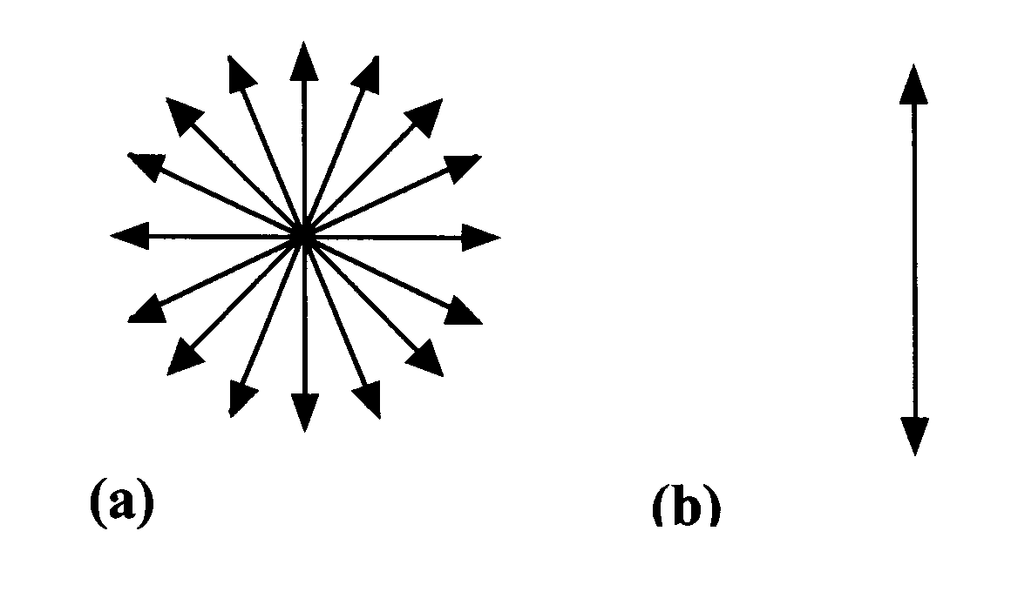
Certain substances only allow the transmission of light vibrating in a single plane. Passing light through such a substance produces plane polarised light (see Figure 26b). ‘Polaroid’ sunglasses make use of such substances to reduce glare and reflections off water.

Substances that are able to rotate the plane of polarised light are said to be optically active. This phenomenon was discovered as early as 1815. In 1848, Louis Pasteur was working with an optically inactive salt of tartaric acid when he noticed that there were two different kinds of crystal which were mirror images of each other. He painstakingly separated the two crystal forms using a hand lens and tweezers into two piles.

He then discovered that solutions of each type were optically active and indeed that one kind rotated the plane of the polarised light in a clockwise direction while a solution of the other rotated the plane by exactly the same amount in the opposite direction. Pasteur proposed that this happened because the molecules themselves must be mirror images. It was a further hundred years before the exact configurations of the two optically active isomers of tartaric acid were finally confirmed (Figure 27).

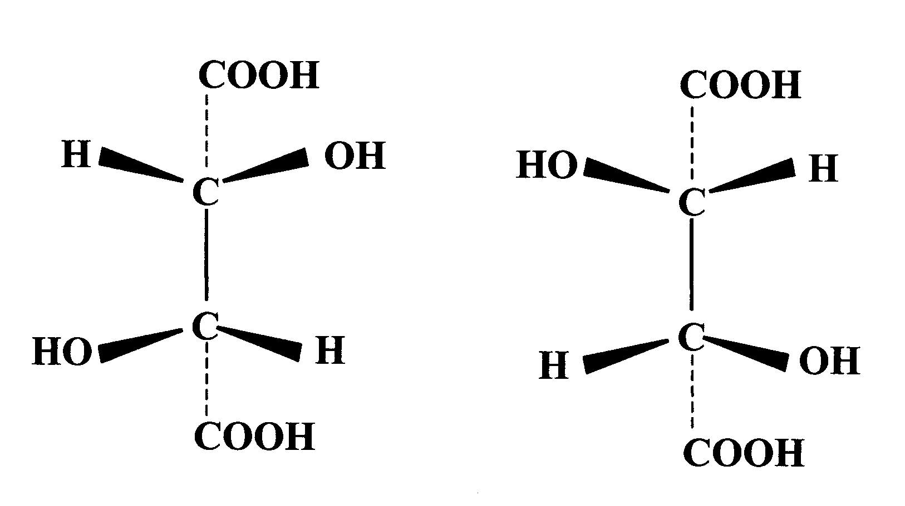
Figure 27

It should be noted that tartaric acid molecules contain two asymmetric carbon atoms (chiral centres). A mixture containing equal amounts of the two optical isomers is known as a racemic mixture and is optically inactive. The salt of tartaric acid with which Pasteur was working was a racemic mixture, which explains why it was optically inactive.

Chirality is extremely important in biological systems. Enzymes are complex proteins that are condensation polymers built up from monomers known as 2-amino acids or α-amino acids (general formula NH₂–CH(R)–COOH).

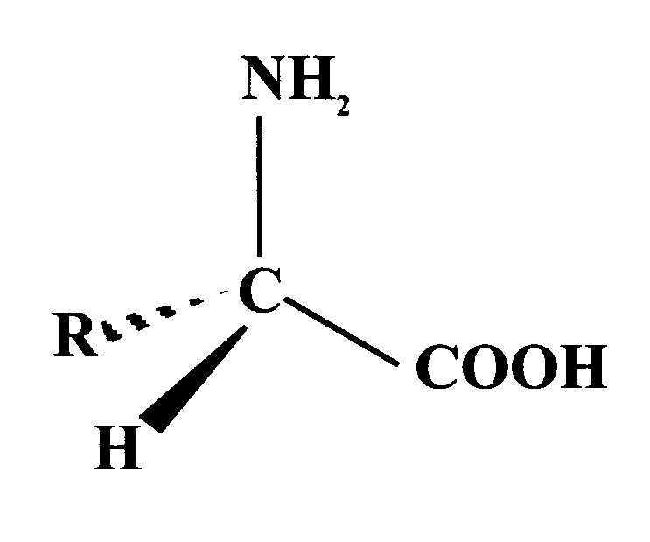
From Figure 28 it is clear that the 2-amino acid molecule is chiral and so there are two optical isomers for every amino acid found in proteins, except for glycine (2-aminoethanoic acid) where R = H. Only the optical isomer shown in Figure 28 occurs naturally in higher order living organisms such as humans. Since the monomer units are chiral, it follows that the enzymes themselves will be chiral. If the substrate molecule on which a particular enzyme operates is chiral, then only one of the optical isomers of the substrate will fit the enzyme’s active site. Consequently, the other isomer will not be biologically active. In general, if a naturally occurring molecule can exhibit optical isomerism, only one of the optical isomers is usually present in the biological system. In this context, it is worth speculating that there is a good chance that somewhere in the universe a world exists that is entirely of the opposite handedness. If one met intelligent beings from such a world, we might be able to communicate and share ideas but we certainly could not share their food!

Figure 28

Questions

1. (a) Draw structures for all possible isomers (structural and geometric) with molecular formula, C₄H₈.
(b) If that was too easy, try to draw structures for the 12 isomers with formula C₅H₁₀.

2. Draw the full structural formula for the Figure 29
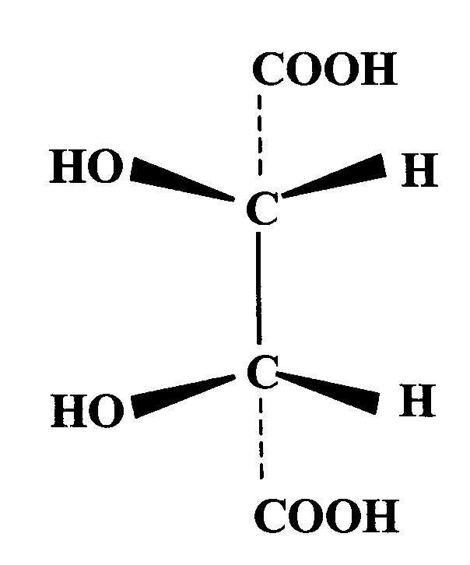
first alkane to show optical isomerism and name the compound.

3. Would you expect the isomer of tartaric acid shown in Figure 29 to be optically active? Explain your answer.

4. Thalidomide is a notorious drug. In the 1960s it was prescribed to pregnant women to treat morning sickness. There are two optical isomers. One of the isomers provided an effective treatment for the morning sickness but unfortunately the other caused serious malformation of the foetus.

Figure 30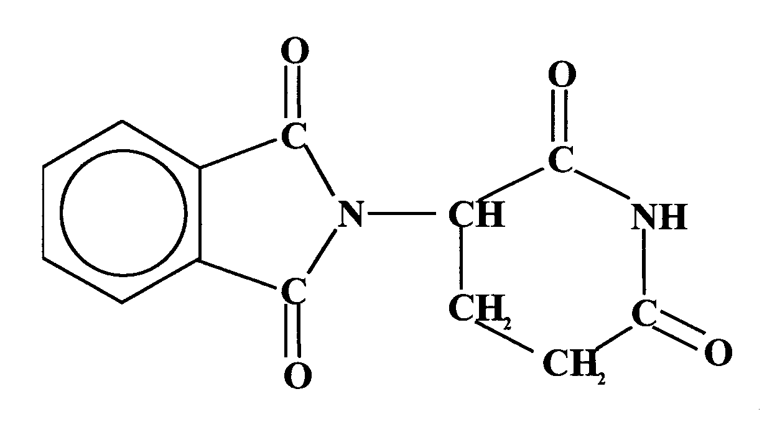

From Figure 30, explain why thalidomide exhibits optical isomerism.

Section 4: Synthesis

Any study of organic chemistry involves the consideration and explanation of the physical and chemical properties of the various homologous series. Physical properties such as melting and boiling points and miscibility with water are explained here in terms of the intermolecular forces involved.

Throughout the unit you will encounter and be expected to identify a variety of different types of reaction, some of which will be new to you. These will include:

addition condensation hydrolysis oxidation
reduction substitution elimination acid/base

Throughout this section you will learn how to:
- devise synthetic routes, with up to three steps to show how a final product can be obtained from a given reactant
  - For example the synthesis of carboxylic acid by oxidation of primary alcohols made by the hydration of alkenes, and
- deduce possible reactions from molecular structures.

All chemical reactions involve the breaking and making of bonds. The way in which bonds break has an important bearing on the direction a reaction will take and on the mechanism of that reaction. Breaking bonds is sometimes called bond fission.

In covalent bonding, electrons are shared in pairs between two atoms, e.g. in the HBr molecule:

H:Br

When the bond breaks, these electrons are redistributed between the two atoms. There are two ways in which this redistribution can happen.

Homolytic fission

In this type of bond fission, the two shared electrons separate equally, one going to each atom:

H:Cl H• + Cl•

The dot• beside each atom represents the unpaired electron that the atom has retained from the shared pair in the bond. The atoms are electrically neutral because each has equal numbers of protons and electrons. However, the atoms are highly reactive because the unpaired electron has a strong tendency to pair up with another electron from another atom or molecule.

Such highly reactive atoms or groups of atoms containing unpaired electrons are called free radicals.

Free radicals are most likely to be formed when the bond being broken has electrons that are more or less equally shared.

Heterolytic fission

When the bond breaks, both of the shared electrons go to just one of the atoms, e.g.

H:Br H+ + :Br–

Heterolytic fission is more likely when a bond is already polar. For example, bromomethane contains a polar carbon to bromine bond and under certain conditions this can break heterolytically (Figure 31).

Figure 31

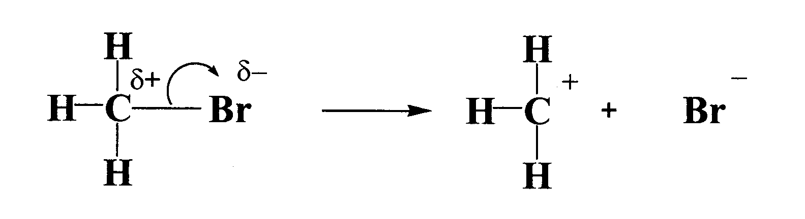

It should be noted that the CH₃⁺ ion contains a positively charged carbon atom. The CH₃⁺ ion is an example of a carbocation (also called a carbonium ion). Sometimes heterolytic fission can lead to the formation of ions containing a negatively charged carbon atom. These ions are called carbanions. Generally speaking, both these types of ions tend to be unstable and highly reactive. Consequently, they only exist as short-lived reaction intermediates.

In understanding the nature of organic reactions, two other terms are extremely useful, namely electrophiles and nucleophiles.

The word ‘electrophile’ means literally ‘electron lover’ or ‘electron seeker’. In other words, electrophiles are atoms or groups of atoms that are deficient in electrons and are attracted to groups that can donate electron pairs. Carbocations (carbonium ions) contain a positively charged carbon atom and so are electrophilic.

The word ‘nucleophile’ means literally ‘nucleus lover’ or ‘nucleus seeker’. In other words, nucleophiles are atoms or groups of atoms that are rich in electrons and are attracted to positively charged centres. Carbanions contain a negatively charged carbon atom and so are nucleophilic.

The terms ‘electrophile’ and ‘nucleophile’ do not apply only to ions. Many organic compounds are polar. They carry partial charges, although not full positive and negative charges. These partial charges can also act as electrophilic or nucleophilic centres (Figure 32).

Figure 32 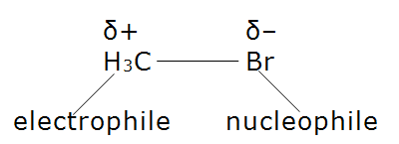

Examples of electrophiles | Examples of nucleophiles
carbocations, R⁺ | carbanions, R⁻
other cations, e.g. H⁺ ion | other anions, e.g. OH⁻, CN⁻
electron-deficient centres | molecules with lone pairs of electrons, e.g. :NH₃
positively polarised centres in | negatively polarised centres in molecules, e.g. O in H₂O

Table 4

Curly Arrow Notation (adapted from www.chemguide.co.uk)
Curly arrows (as shown in Figure 31) are used in mechanisms to show the various electron pairs moving around.
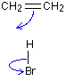
The arrow tail is where the electron pair starts from. That's always fairly obvious, but you must show the electron pair either as a bond or, if it is a lone pair, as a pair of dots. Remember that a lone pair is a pair of electrons at the bonding level which is not currently being used to join onto anything else.
The arrow head is where you want the electron pair to end up.
Figure 33
For example, in the reaction between ethene and hydrogen bromide (Figure 33), one of the two bonds between the two carbon atoms breaks. That bond is simply a pair of electrons.
Those electrons move to form a new bond with the hydrogen from the HBr. At the same time the pair of electrons in the hydrogen-bromine bond moves down on to the bromine atom.
There's no need to draw the pairs of electrons in the bonds as two dots. Drawing the bond as a line is enough, but you could put two dots in as well if you wanted to.
Notice that the arrow head points between the C and H because that's where the electron pair ends up. Notice also that the electron movement between the H and Br is shown as a curly arrow even though the electron pair moves straight down. You have to show electron pair movements as curly arrows - not as straight ones.
The second stage of this reaction nicely illustrates how you use a curly arrow if a lone pair of electrons is involved.
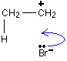
The first stage leaves you with a positive charge on the right hand carbon atom and a negative bromide ion. You can think of the electrons shown on the bromide ion as being the ones which originally made up the hydrogen-bromine bond.

Figure 34

Note: There are another three lone pairs around the outside of the bromide ion - making four in all. These aren't normally shown because they don't actually do anything new and interesting! However, it is essential that you show the lone pair you are interested in as a pair of dots. If you don't, you risk losing marks in an exam.
The lone pair on the bromide ion moves to form a new bond between the bromine and the right hand carbon atom (Figure 34). That movement is again shown by a curly arrow. Notice again, that the curly arrow points between the carbon and the bromine because that's where the electron pair ends up.
That leaves you with the product of this reaction, bromoethane (Figure 35):

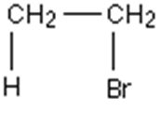 | Figure 35
Using curly arrows to show the movement of single electrons
The most common use of "curly arrows" is to show the movement of pairs of electrons. You can also use similar arrows to show the movement of single electrons - except that the heads of these arrows only have a single line (or barb) rather than two lines.
Two lines in arrowhead - shows the movement of an electron pair
One line in arrowhead - shows the movement of a single electron
An example of the latter case is shown in Figure 36. The homolytic fission of a chlorine molecule into two free radicals, can be shown as:
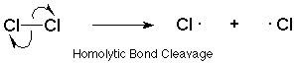
Figure 36
The two electrons in the covalent bond have split between the two chlorine atoms, with one electron going to each. Each curly arrow, therefore, has only one line in its arrowhead.

Reactions of alkanes

The alkanes are relatively unreactive compared with other organic compounds. They do not react with acids or alkalis. Liquid paraffin, a mixture of alkanes, is used as an inert liquid in the storage of sodium and other alkali metals to prevent their reaction with air and moisture. As you already know, alkanes are widely used as fuels because of their ease of combustion. The only other reaction of importance at ordinary temperatures is their reaction with chlorine or bromine.

(Covered in Curriculum for Excellence Higher Chemistry)

Reaction with bromine is relatively slow and only takes place in the presence of sunlight. Reactions with chlorine are generally faster but still require light. In both cases, the corresponding hydrogen halide is formed. These observations are best explained by a reaction mechanism involving a free radical chain reaction. Remember that a free radical is an atom or molecule containing an unpaired electron.

Consider the reaction of an alkane (R–H) with bromine. R represents the rest of the molecule, e.g. in methane, H₃C–H, R is a methyl group.
The first stage in the reaction is the initiation step. Light (hf) supplies the correct amount of energy to break the Br–Br bond. Breakage of the bond forms two bromine atoms each with an unpaired electron:

initiation Br₂ Br• + •Br

Unpaired electrons

The Br–Br bond has split so that one electron of the pair has gone to each atom. This type of bond breaking is known as homolytic fission (see
page 21).

The second stage in the reaction is the propagation step. Since free radicals are very reactive intermediates, there is a strong tendency for unpaired electrons to pair up. A bromine atom can do this by removing a hydrogen atom from an alkane molecule to form a hydrogen bromide molecule:

propagation 1 R–H + •Br R• + H–Br

This also produces another free radical, R•, which in turn reacts with a bromine molecule to form the bromoalkane and another bromine atom:

propagation 2 R• + Br–Br R–Br + •Br

This bromine atom can attack another alkane molecule and in doing this the chain reaction is propagated. These two propagation steps will continue in turn until one of the reactants is used up. The chain will be terminated whenever any remaining free radicals meet and combine:

termination R• + R• R–R
Br• + Br• Br–Br
R• + Br• R–Br

This mechanism is consistent with the observed facts. Light is necessary to start the reaction but once started the reaction will continue in darkness. The products of the reaction are the bromoalkane and hydrogen bromide. However, depending on the relative proportions of the reactants, multiple substitution of the alkane can take place and in order to ensure that monosubstitution predominates, a large excess of the alkane is used. The boiling point of the bromoalkane is significantly higher than that of the alkane and so the excess alkane can be easily removed by distillation. However, the reaction is not specific and any hydrogen atom in the alkane may be substituted. The more complex the alkane, the more complex will be the mixture that is obtained.

A useful memory aid for the reaction of bromine with alkanes is to remember the ‘S’s:

Saturated hydrocarbon (Single bonds)

Slow, Substitution reaction, which takes place in Sunlight

Haloalkanes

Organic compounds containing halogen substituents are comparatively rare in the natural world. Consequently, most have to be synthesised in laboratories. They are widely used in the modern world. For example, they are important in medicine, agriculture and in the manufacture of plastics. In medicine, one of the first examples of their use was in 1847 by James Young Simpson of Bathgate, who was the first to use chloroform (trichloromethane) as a general anaesthetic. More recently, safer haloalkanes have been devised for use as anaesthetics. Unfortunately, there are also serious problems associated with halogen-containing compounds. They are implicated in much environmental damage to the planet, notably in the overuse of pesticides and in damage to the ozone layer.

Nomenclature of haloalkanes

The haloalkanes (also known as halogenoalkanes or alkyl halides) are substances consisting of molecules in which one or more of the hydrogen atoms of an alkane molecule have been replaced by a halogen atom. The more complicated the molecule, the more possibility there is for structural isomerism. Care is therefore required in correctly naming and drawing structures. The correct name is derived by using the IUPAC system to which you were introduced at National 5 and Higher.

• the presence of a halogen atom is shown by the appropriate prefix: fluoro-, chloro-, bromo- or iodo-
• if a molecule contains more than one halogen atom of the same type, this is shown by using the prefixes di-, tri-, tetra-, etc.
• the basic name of the compound comes from the longest unbranched chain
• the position of the substituent(s) is shown by a number in front of the prefix.

For example:

(a) 2,3-dichloropentane
The longest chain contains five carbon atoms. There are two chlorine atoms. The chain is numbered from the end that keeps the numbers as low as possible. Thus the name begins 2,3- and not 3,4-.
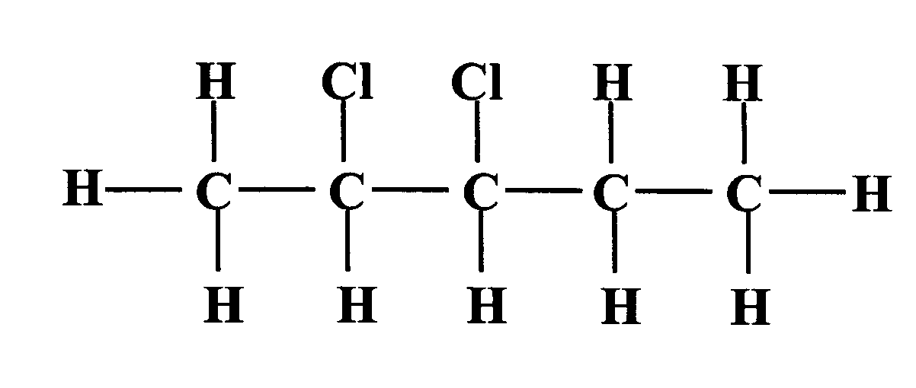
- 3-bromobut-1-ene
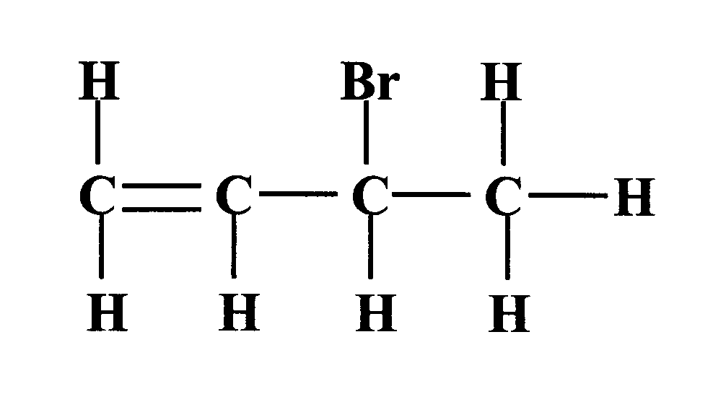
The double bond is numbered first and then the bromine atom is assigned its number.

- 2,3-dibromo-1-chloro-2-methylbutane
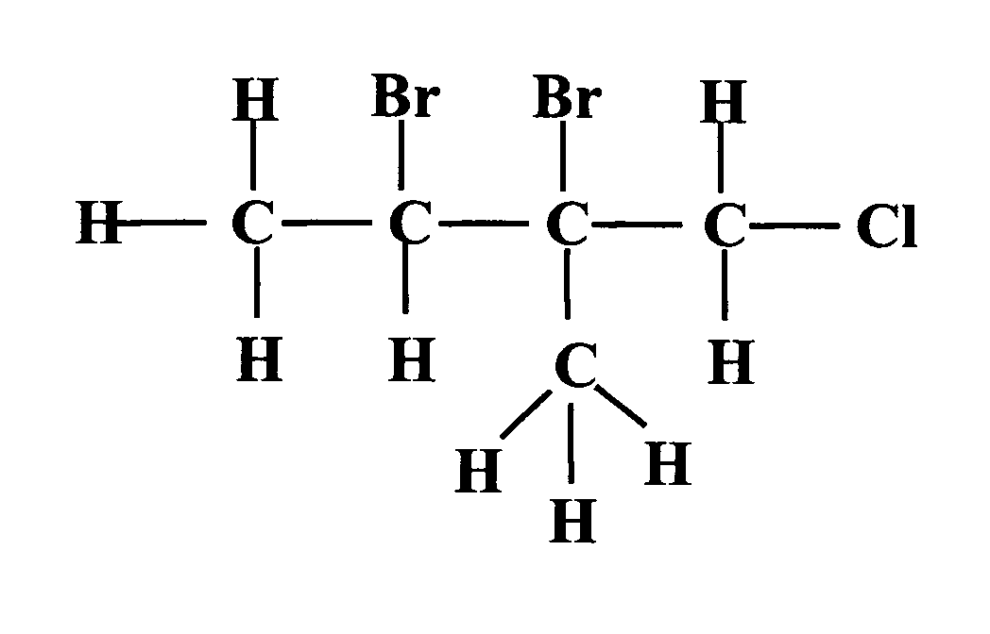
The longest chain contains four carbon atoms and the chain is numbered from the end that has the first substituent, in this case, chlorine. The substituents are listed in alphabetical order according to the prefix. Note that dibromo comes before chloro because ‘b’ comes before ‘c’. Prefixes such as di- and tri- are ignored.
Questions
1. Draw full structural formulae for the following:
(a) 1-bromo-2,3-dimethylbut-2-ene
(b) 4-chloro-3,3-dimethylcyclohexene
(c) 4-bromo-1-chloro-2,3,5-trimethylhex-1-ene.

2. Name the following compounds:
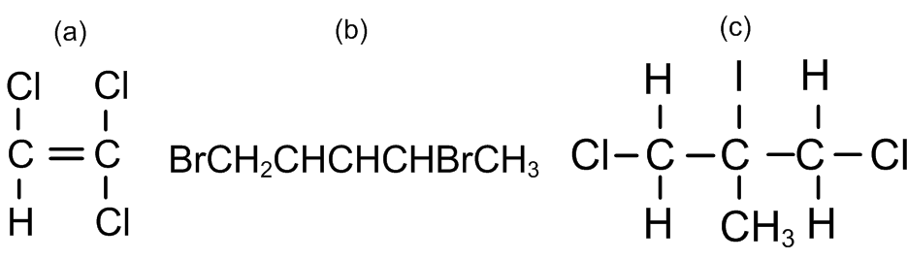

Monohaloalkanes can be classified as primary (1º), secondary (2º) or tertiary (3o) depending on the environment of the halogen substituent X, e.g.

primary: the substituent is attached to a terminal carbon atom of a chain.

The carbon atom carrying the substituent has only one alkyl group attached to it.
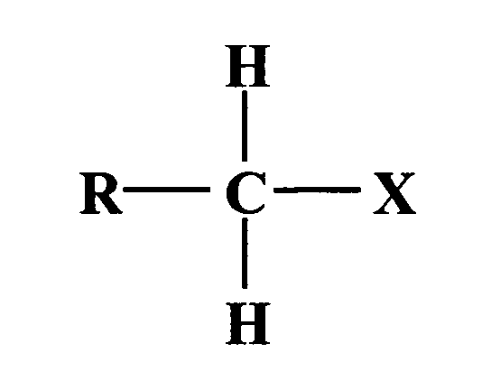

secondary: the substituent is attached to a chain carbon atom. The carbon atom carrying the substituent has two alkyl groups attached to it.

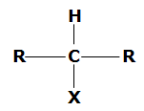

tertiary: the substituent is attached to a branch point in a chain. The carbon atom carrying the substituent has three alkyl groups attached to it.

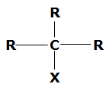

Reactions of haloalkanes

The reactions of haloalkanes are largely dependent on two main factors:

• which halogen is present, e.g. fluoro- compounds are very unreactive because of the strength of the C–F bond. The reactivity of the other haloalkanes also seems to be related to the bond strength since the order of reactivity is generally

R–I > R–Br > R–Cl > R–F

(weakest bond) (strongest bond)

• the position of the carbon to halogen bond within the molecule.

There are two main reactions that are important in the chemistry of the haloalkanes: nucleophilic substitution reactions and elimination reactions.

Nucleophilic substitution reactions (S_{N}1 and S_{N}2 reactions)

Halogen atoms generally have a higher electronegativity than carbon and so it is reasonable to expect that the C–X bond in the haloalkane will be polarised, with the carbon atom carrying a partial positive charge. This means that this carbon atom will be susceptible to attack by nucleophiles. If the C–X bond breaks heterolytically, an X⁻ ion will be formed. Chloride, bromide and iodide ions are all stable ions and are regarded as good leaving groups. This means that the presence of these atoms in a molecule will facilitate the heterolytic cleavage of the bond. In general, a nucleophilic substitution reaction can be represented as shown in Figure 37, where Y⁻ represents the attacking nucleophile and X⁻ is the leaving group.

Figure 37

In fact, nucleophilic substitution can occur by either of two distinctly different mechanisms.

(a) Consider the hydrolysis of the primary haloalkane bromoethane, using an aqueous alkali.

C₂H₅Br(l) + OH- (aq) C₂H₅OH (aq) + Br-(aq)

Experimental investigation into the kinetics of this reaction shows that the reaction is first order with respect to hydroxide ions and first order with respect to the bromoethane, i.e.

rate = k[C₂H₅Br][OH-] (see Unit 1(b), Kinetics)

We can deduce from this evidence that the rate-determining step (RDS) in the reaction mechanism involves one molecule of bromoethane and one hydroxide ion. The nucleophilic hydroxide ion approaches the partially positive carbon atom from the side opposite to the departing bromide ion (as in Figure 37). As it gets closer, a bond begins to form between the oxygen atom and the carbon atom. At the same time, the bond between the carbon and the bromine begins to weaken. If there is sufficient energy in the collision, a transition state forms in which the C–O bond is half formed and the C–Br bond is half broken (Figure 38). As the oxygen atom gets even closer, the C–Br bond rapidly breaks and the C–O bond forms. If the reactant molecule is chiral (see page 19) this causes an inversion of chirality.
Figure 38

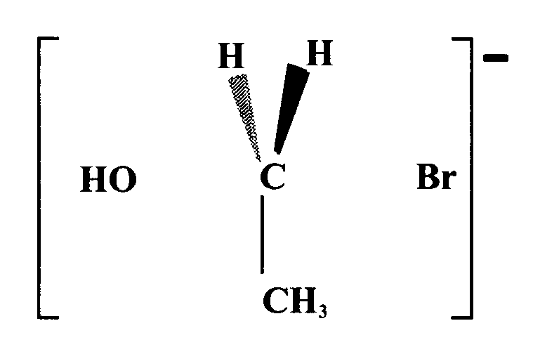

This type of reaction is known as an SN2 reaction.

S = substitution N = nucleophilic 2 = the RDS involves a
collision between two
particles

(b) Consider the hydrolysis of 2-bromo-2-methylpropane, a tertiary haloalkane, using water:

(CH₃)₃CBr(l) + H₂O(l) (CH₃)₃COH(aq) + HBr(aq)

Experimental investigation in this case shows that the rate of reaction is first order with respect to the haloalkane but is independent of the concentration of water, i.e. it is zero order with respect to water. Thus the rate equation is as follows:

rate = k[(CH₃)₃CBr]

The RDS (the slowest) must only involve the bromoalkane and it seems likely that this step involves the slow heterolytic cleavage of the C–Br bond to form a planar carbocation and a bromide ion (Figure 39).

Figure 39

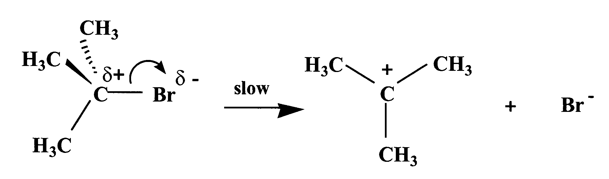

The intermediate carbocation then reacts very quickly with a water molecule (Figure 40).

Figure 40
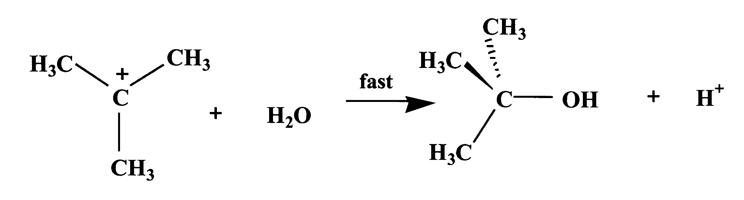

Since this is very fast, the overall rate of reaction is determined only by the rate at which the carbocation is formed, i.e. by the rate of dissociation of the haloalkane, a step involving only one molecule. If the reactant molecule is chiral, the product is a racemic mixture since the planar carbocation can be attacked from either side (see pages 18-19).

This type of reaction is known as an SN1 reaction because it is a Substitution, Nucleophilic and only one molecule is involved in the RDS.

Nucleophilic Substitutions in Monohaloalkanes

For any nucleophilic substitution, the mechanism that takes place will depend, amongst other things, on the nature of the haloalkane. In general, primary and secondary haloalkanes tend to be hydrolysed by SN2 reactions whereas with tertiary haloalkanes the SN1 mechanism dominates (or elimination takes over instead of substitution, see page 34). This outcome is in part related to the stability of the carbocation intermediate involved. The order of stability has been shown to be:

1o < 2o < 3o
(primary) (secondary) (tertiary)

Alkyl groups have a tendency to push electrons towards a neighbouring carbon atom. This means that in the tertiary carbocation the electron-donating effect of the three alkyl groups helps to stabilise the positive charge on the tertiary carbon atom. A primary carbocation with only one alkyl group will therefore be much less stable than a tertiary carbocation.

Substitution reactions of haloalkanes have proved extremely useful for the synthesis of a wide variety of organic compounds.

(a) Reaction with alkalis to form alcohols

Using water or aqueous alkali produces specific alcohols, which in turn can be converted to aldehydes or ketones. Aldehydes can then be oxidised to alkanoic acids:

R–X R–OH

e.g. CH₃CH₂CH₂CH₂Cl CH₃CH₂CH₂CH₂OH

(b) Reaction with alcoholic alkoxides to form ethers

When metallic sodium is reacted with a dry alcohol, such as ethanol, hydrogen is evolved and a solution of the corresponding sodium alkoxide is produced, e.g.

Na(s) + C₂H₅OH(l) H₂ (g) + C₂H₅O⁻ Na⁺

The alkoxide ion is a powerful base but also a powerful nucleophile. Reaction of a suitable haloalkane with a sodium alkoxide solution produces an ether (see page 37). This is an important synthetic route, particularly for unsymmetrical ethers. For example, sodium ethoxide will react with bromomethane to form methoxyethane:

C₂H₅O⁻ Na⁺ + BrCH₃ C₂H₅OCH₃ + Na⁺Br⁻

At this point it is worth noting that all nucleophiles are bases and vice versa. Since the alkoxide is a base, it is possible for an elimination reaction to take place instead of the substitution, either as a minor side reaction or as the dominant process (see page 34). The substitution is favoured at lower temperatures.

(c) Reaction with ethanolic cyanide to form nitriles

Another useful nucleophile is the cyanide ion, CN⁻. If a haloalkane is mixed with a solution of potassium cyanide in ethanol and heated under reflux, the product is a nitrile, e.g.

CH₃CH₂CH₂I + CN⁻ CH₃CH₂CH₂CN + I⁻
1-iodopropane butanenitrile

The main advantage of this reaction is that the carbon chain has been increased by one carbon atom. In all the previous substitutions, the number of carbon atoms in the molecule remained the same. Nitriles are derivatives of carboxylic acids and are easily converted into the corresponding acid by acid hydrolysis, or into an amine by reduction using lithium aluminium hydride (LiAlH₄), which is a source of the hydride ion, H⁻ (Figure 41).

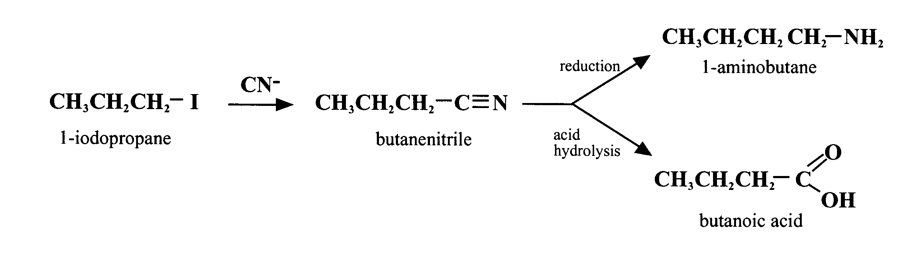
Figure 41

Elimination reactions of monohaloalkanes

Haloalkanes can also react in the presence of strong bases by eliminating a hydrogen halide molecule to form alkenes. Since good nucleophiles are often good bases, substitution and elimination reactions can occur at the same time and the reaction conditions largely determine which process dominates. Generally speaking, in water, a polar solvent, substitution predominates but in ethanol solution elimination takes over (Figure 42).

Figure 42

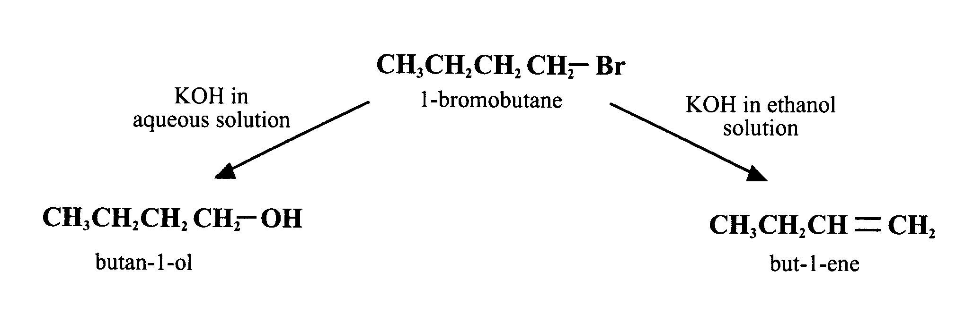

As with the nucleophilic substitution, there are two possible mechanisms for the elimination reactions. The first mechanism is a one-step process in which removal of the hydrogen ion occurs simultaneously with loss of the halide ion (Figure 43).

Figure 43
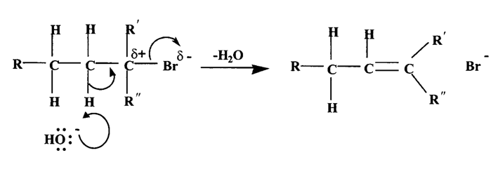

Question

What are the possible products when 2-chloro-2-methylbutane is reacted with:
(a) aqueous potassium hydroxide
(b) a solution of potassium hydroxide in ethanol
(c) a solution of sodium ethoxide in ethanol?

Alcohols

Properties

Previously, the homologous series called the alkanols (general formula C_{n}H_{2n+1}OH) was introduced as a subset of the bigger family of compounds known as the alcohols. Alcohols are compounds of the general formula R–OH. The OH group is the hydroxyl group and the R group is generally derived from a hydrocarbon or a substituted hydrocarbon. The presence of a hydroxyl group is shown in the name of the compound by the name ending –ol. As with the haloalkanes, alcohols can be classified as primary, secondary or tertiary depending on the environment of the hydroxyl group.

Study of the alcohols at Higher showed that both the physical and chemical properties were determined by the presence of the hydroxyl group in the molecules. The O–H bond is particularly polar because of the powerful attraction of the oxygen atom for the bonded electrons. This polarisation leads to hydrogen bonding between one molecule and the next (Figure 44).

Figure 44
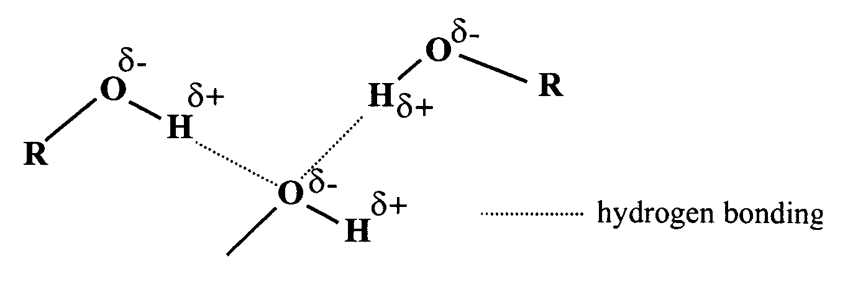

More energy is required to overcome these extra intermolecular forces and so alcohols have higher melting and boiling points than other organic compounds of similar molecular mass and shape (Figure 45).

Figure 45
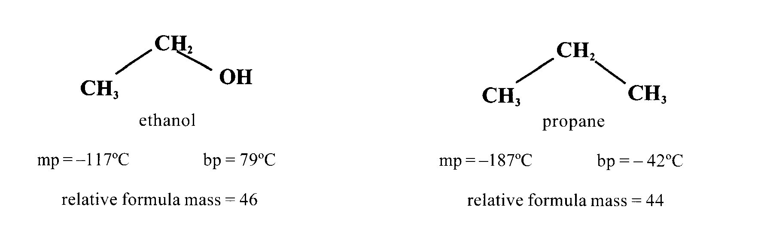
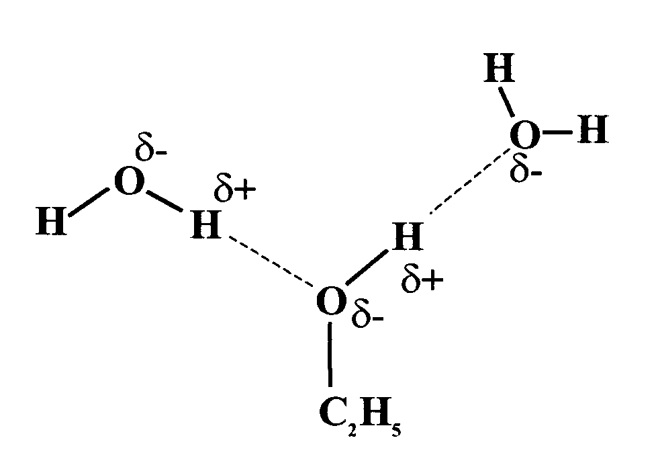
Hydrogen bonding is also responsible for the miscibility with water of the lower alcohols, e.g. ethanol (Figure 46).
Figure 46

However, as the chain length increases, the solubility in water decreases. The alkyl group is non-polar and cannot form hydrogen bonds with water. As the alkyl group gets bigger, the effect of the polar hydroxyl group becomes less significant and the larger molecules are effectively non-polar and so immiscible with water.

Table 5

Alcohol | Solubility (g/100 g of H₂O)
Methanol | ∞
Ethanol | ∞
Propan-1-ol | ∞
Butan-1-ol | 7.9
Pentan-1-ol | 2.3
Hexan-1-ol | 0.6
Heptan-1-ol | 0.2
Decan-1-ol | 0

( = the alcohol is completely miscible with water)

Preparation of alcohols

As we have already seen, alcohols can be made using a variety of different methods:
- Fermentation of sugars produces ethanol (National 5)
- Hydrolysis of haloalkanes
- Hydration of alkenes
- Reduction of carbonyl compounds using lithium aluminium hydride

Fermentation is carried out on a vast scale to produce a large variety of alcoholic drinks but is rarely used to manufacture ethanol. Hydrolysis of haloalkanes is extremely useful in the laboratory to synthesise specific alcohols.

Hydrolysis of haloalkanes

Using water or aqueous alkali produces specific alcohols, which in turn can be converted to aldehydes or ketones. Aldehydes can then be oxidised to alkanoic acids:

R–X R–OH

e.g. CH₃CH₂CH₂CH₂Cl CH₃CH₂CH₂CH₂OH

Hydration of alkenes

However, in industry by far the most important method for the large-scale production of alcohols, except methanol, is the acid-catalysed hydration of alkenes (you should be able to explain why this is not possible for methanol). This is carried out under pressure using a solid-supported phosphoric acid catalyst in the presence of water.

Figure 47

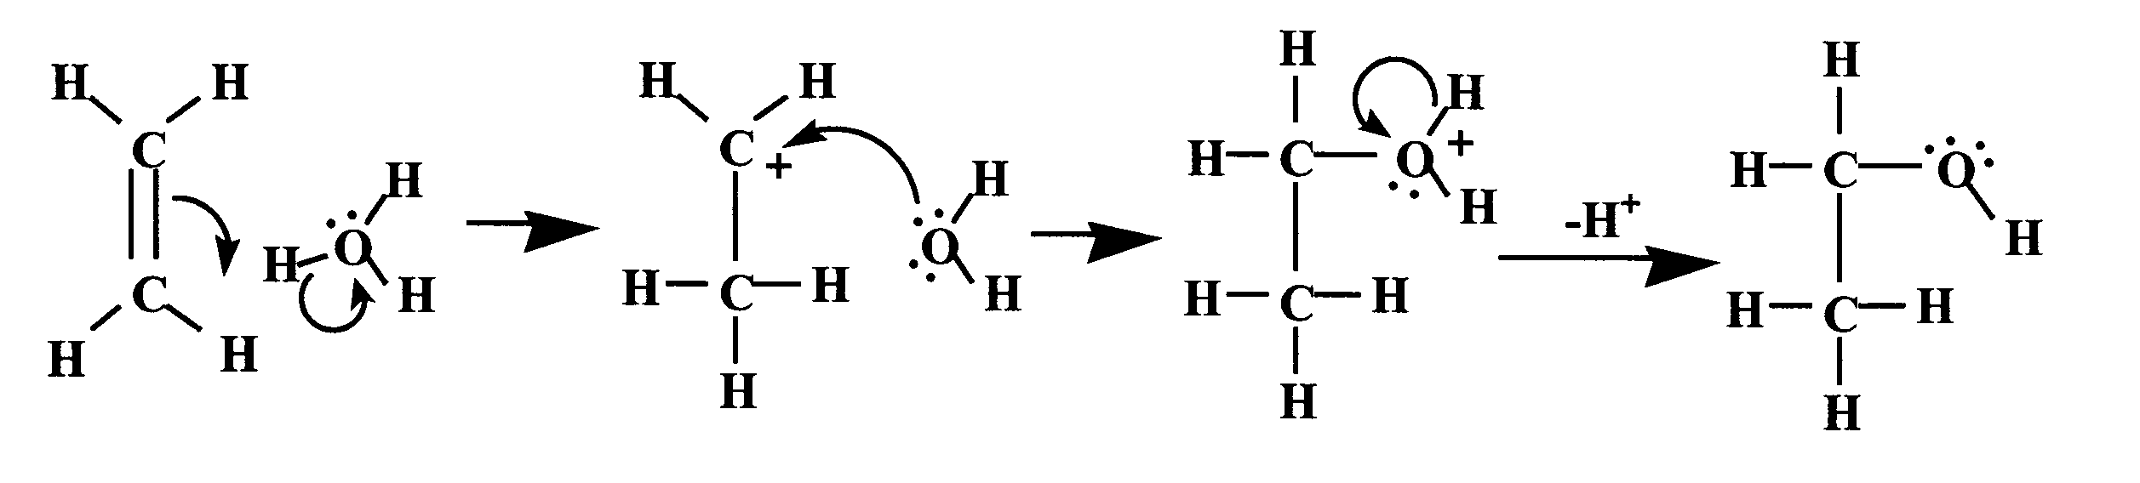

Methanol is produced industrially from synthesis gas (a mixture of carbon monoxide and hydrogen), which is in turn produced by the steam reforming of natural gas. Nowadays, the synthesis gas is reacted at high temperature and relatively low pressure over a copper-based catalyst to produce methanol.

CO + 2H₂ CH₃OH ∆H = –92 kJ mol⁻¹

Reduction of carbonyl compounds using lithium aluminium hydride

Both aldehydes and ketones can be reduced to the corresponding alcohols using reducing agents such as lithium aluminium hydride, LiAlH₄. Lithium aluminum hydride contains the AlH₄⁻ ion, which is able to transfer a hydride ion (H⁻) to the partially positive carbon atom of the carbonyl group of an aldehyde (or ketone) (Figure 48). Because lithium aluminium hydride reacts violently with water, it is essential to carry out the reaction under anhydrous conditions.

Figure 48

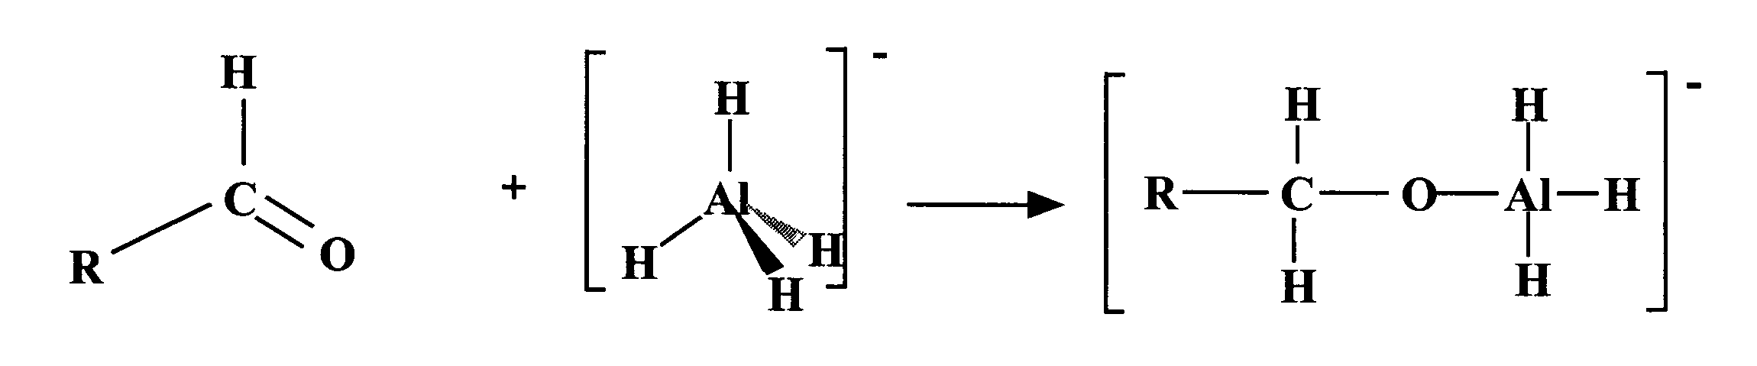

This step is repeated with three more aldehyde molecules and the resultant complex ion is then hydrolysed to produce the desired alcohol:

(R–CH₂–O)₄ Al⁻ + 4H₂O 4RCH₂OH + Al³⁺ + 4OH⁻

It should be obvious that the reduction of aldehydes produces primary alcohols whereas the reduction of ketones gives rise to secondary alcohols (Figure 49).

Figure 49

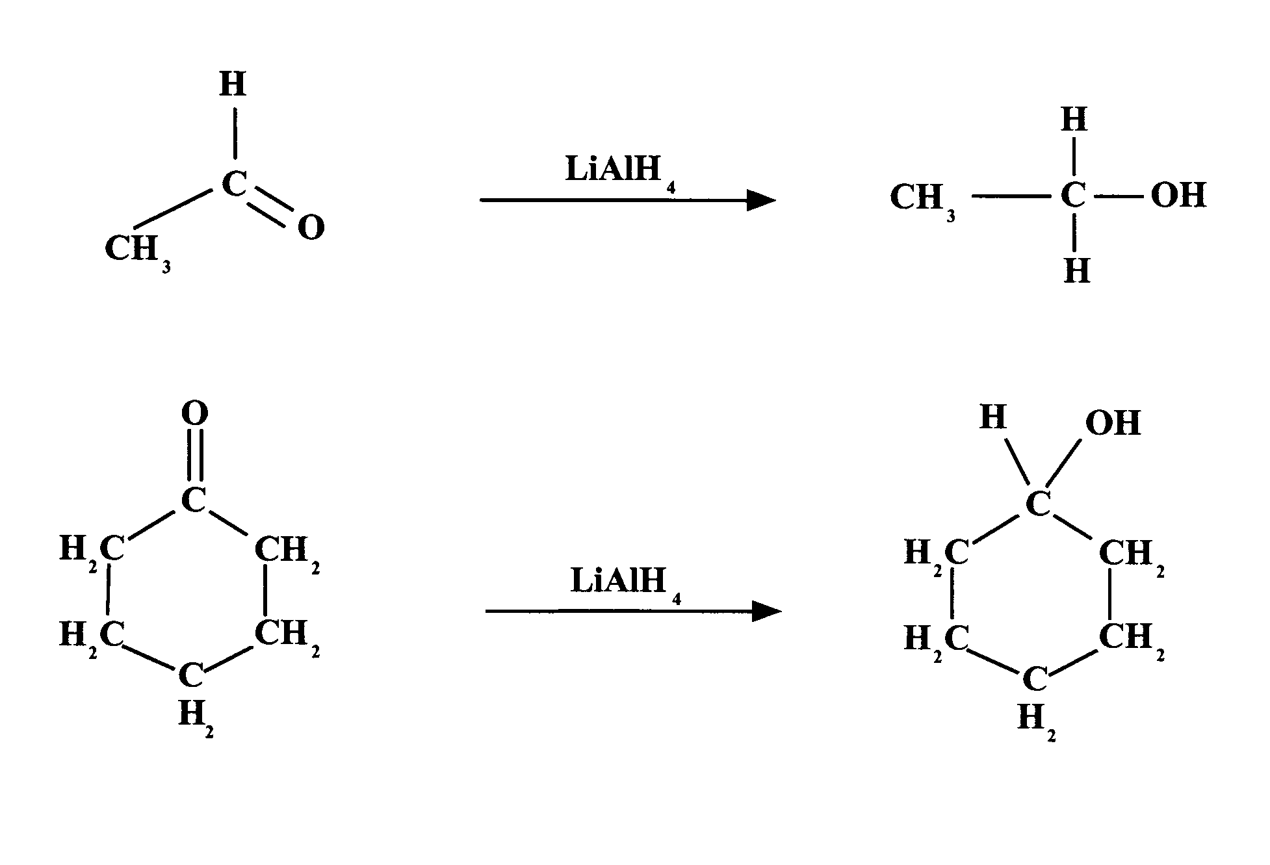
cyclohexanone
cyclohexanol
ethanol
ethanal

Reactions of alcohols

Given the similarities in the structures of the molecules (Figure 50), it is not surprising that some of the reactions of the simple alcohols are analogous to some reactions of water.

Figure 50

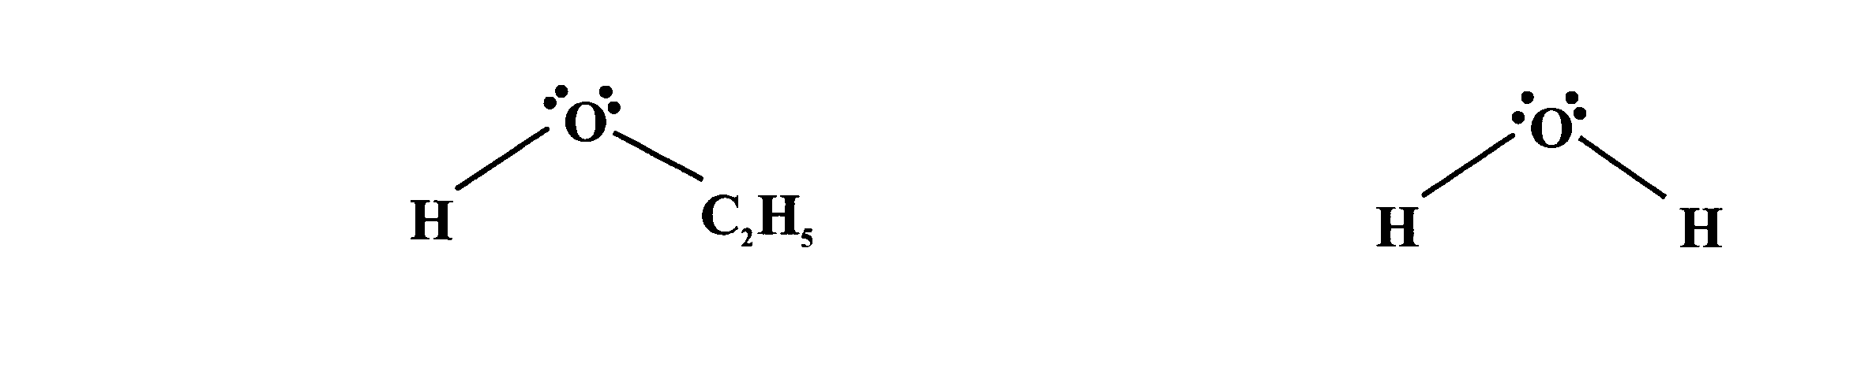
ethanol water

(a) Phosphorus(V) chloride is easily hydrolysed by water, producing white fumes of hydrogen chloride according to the equation:

PCl₅(s) + H₂O (l) POCl₃(l) + 2HCl(g)

If ethanol is used instead of water, a similar reaction occurs with the production of chloroethane:

PCl₅ (s) + C₂H₅OH(l) POCl₃ (l) + HCl(g) + C₂H₅Cl

This method can be used to prepare specific haloalkanes from the corresponding alcohols.

(b) As we saw earlier (see page 32), sodium metal will react with dry ethanol to give hydrogen gas. This reaction is analogous to the reaction of sodium with water:

2Na + 2 H₂O 2NaOH + H₂

In this reaction, water behaves as an acid by losing hydrogen ions.
When ethanol is used, the reaction is:

2Na + 2 C₂H₅OH 2NaOC₂H₅ + H₂

Although the mechanism is probably different, the outcome is similar. Ethanol molecules lose hydrogen ions to produce ethoxide ions and hydrogen gas is formed. The resultant solution of sodium ethoxide in ethanol is very useful as an organic base (-OC₂H₅) in situations where the absence of water is essential.

- As we saw earlier, an important method for the synthesis of alkenes is the dehydration of a suitable alcohol. This reaction involves the elimination of water and is generally catalysed by acids such as concentrated sulfuric acid or phosphoric acid. The mechanism for this elimination reaction, which is favoured by high temperatures and high acid concentrations, is shown in Figure 51 using ethanol as an example.

Figure 51

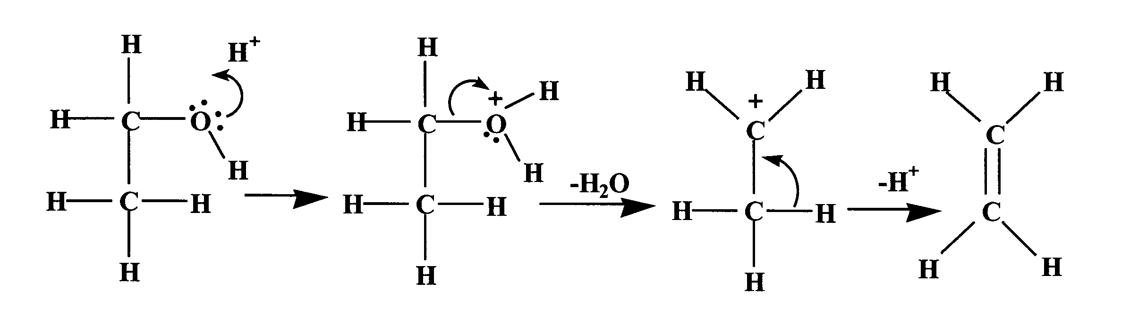

After initial rapid protonation of the alcohol molecule, loss of a water molecule occurs to form the carbocation intermediate, which in turn loses a hydrogen ion to form the alkene. This mechanism is the exact opposite of that proposed for the acid-catalysed hydration of alkenes on page 37.

- Another reaction of alcohols that was considered at Higher was the condensation reaction with carboxylic acids to form esters (Figure 52). This reaction is reversible and slowly reaches a state of equilibrium. Use of concentrated sulfuric acid as a dehydrating agent removes water and pushes the equilibrium towards the ester side. It also serves as an acid catalyst for the reaction.

Figure 52

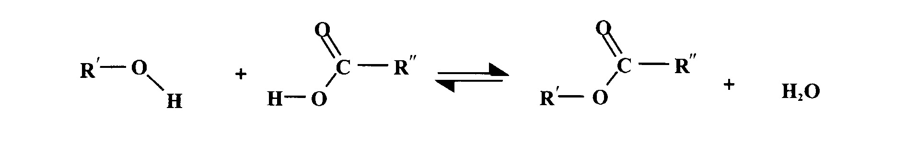

The reaction between alcohols and carboxylic acids is relatively slow. Consequently, esters are more often prepared by a standard two-stage process. The first stage involves the conversion of the acid into an acid chloride by reaction with thionyl chloride (SOCl₂), phosphorus(III) chloride or phosphorus(V) chloride (Figure 53).

Figure 53

acid chloride
SOCl₂ or PCl₃ or PCl₅
In the second stage, the acid chloride reacts rapidly with the alcohol to form the ester (Figure 54).

Figure 54

Both these stages are essentially irreversible and occur faster than the direct reaction between the carboxylic acid and the alcohol. The presence of a chlorine atom bonded to the carbon atom of the carbonyl group makes this carbon even more susceptible to nucleophilic attack by the alcohol.

Ethers

Ethers are compounds with the general formula R′–O–R″ where R′ and R″ are alkyl groups. If both groups are the same, the ether is described as symmetrical. If they are different, the ether is unsymmetrical (or asymmetrical).

As with other organic compounds, ethers are named according to IUPAC rules. Basically, they are described as alkoxy substituted alkanes. If the ether is unsymmetrical, the larger alkyl group is used to provide the base name and the smaller group is used as the alkoxy substituent (Figure 55).

Figure 55
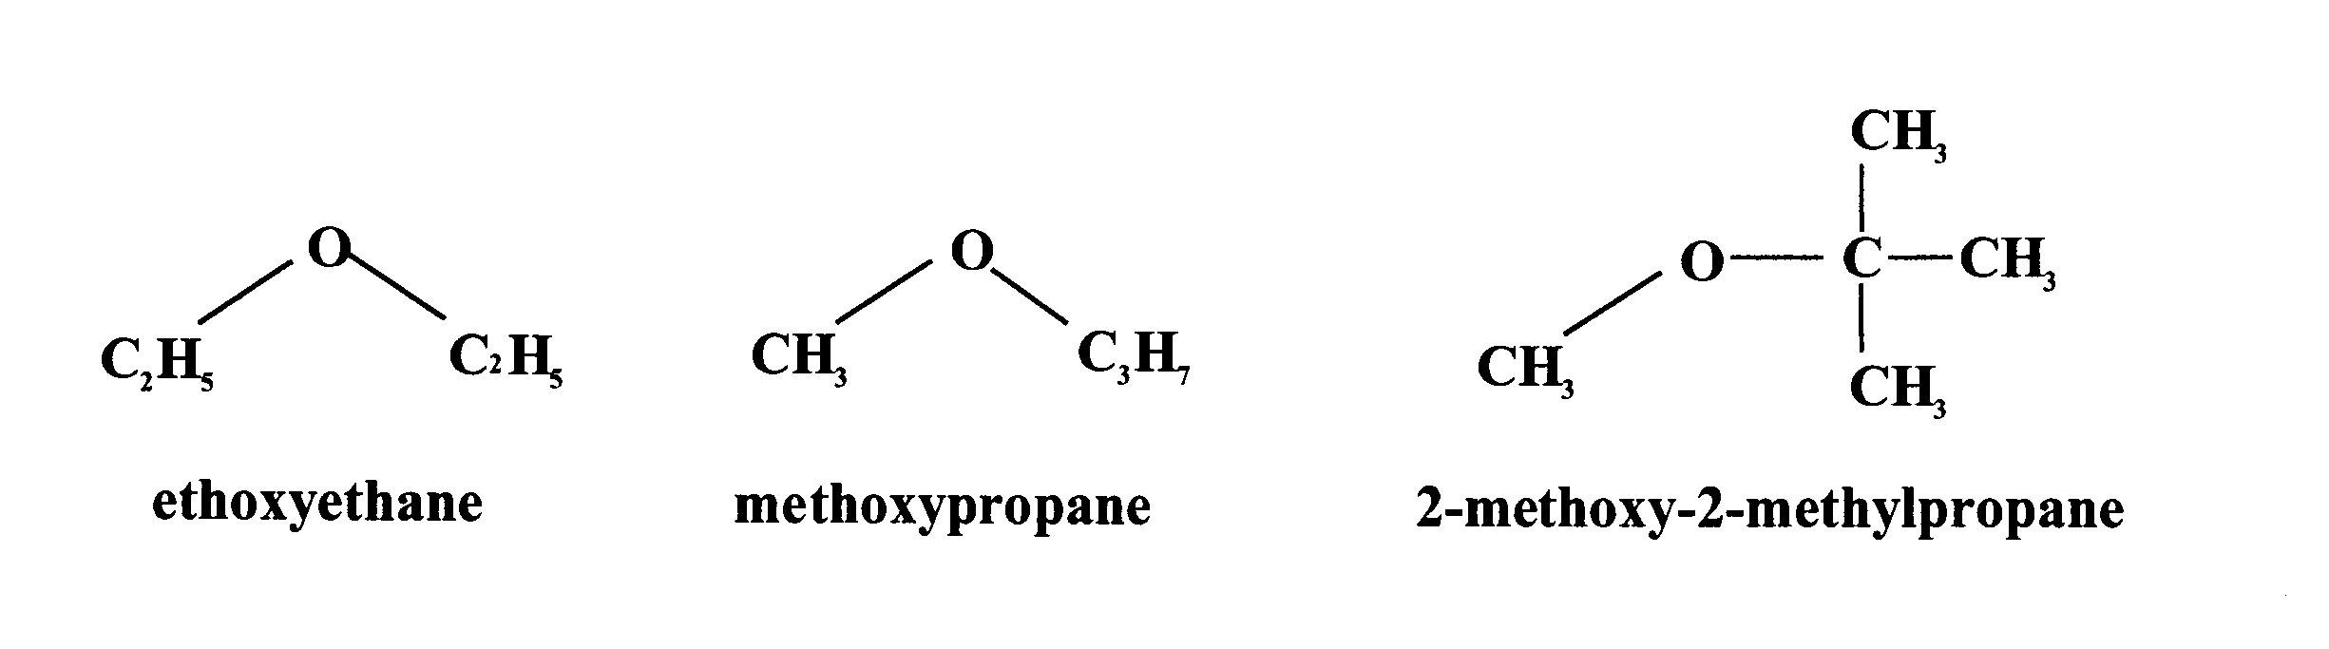
ethoxyethane methoxypropane 2-methoxy-2-methylpropane

Ethoxyethane is the most common ether and is frequently called simply ‘ether’.

Figure 56

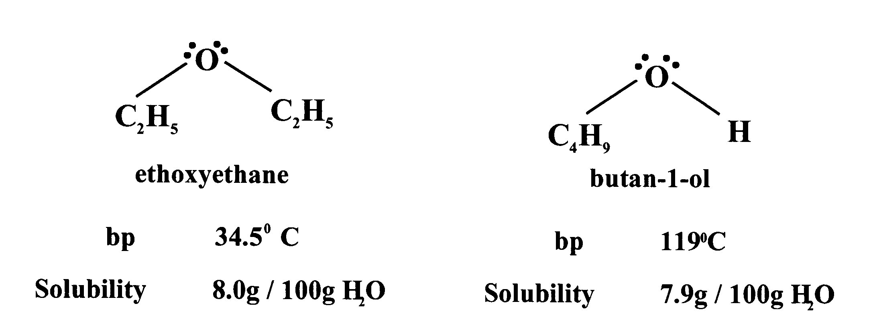

Ethoxyethane buten-1-ol

bp = 34.5ºC bp = 119ºC

Solubility = 8.0g/100g H₂O Solubility = 7.9g/100g H₂O
=
=
=
=

A comparison of the structural formulae of ethoxyethane and butan-1-ol (Figure 56) with their molecular formulae shows that they are isomeric. It also shows that the ether lacks a hydroxyl group. Consequently, there is no possibility of hydrogen bonding between ether molecules, unlike the isomeric alcohol. This accounts for the much lower boiling point of the ether. In general, ethers have lower boiling points than isomeric alcohols.

However, the structural formula of ethoxyethane also shows that the
C–O–C bonds are non-linear. The molecule is effectively a water molecule in
which both hydrogen atoms have been replaced by alkyl groups. The C–O bonds are polar, making the whole ether molecule polar. The polarity of the molecule makes little difference to the boiling point. Consequently, the boiling points of ethers are not much different from those of alkanes of similar relative formula mass.

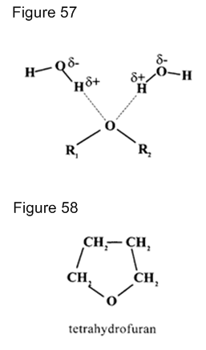

Note that the polarity does have an effect on the solubility in water.

This is because there is the possibility of hydrogen bonding between ether and water molecules, as shown in Figure 57.

As a result, some ethers with low relative formula masses are soluble to some extent in water.

For example, ethoxyethane and butan-1-ol have very similar solubility in water, about 8 g per 100 g of water.

Indeed tetrahydrofuran, Figure 58, which is a small cyclic ether, is completely soluble in water.

Preparation

In the laboratory, the most common method used to prepare ethers is the reaction of haloalkanes with sodium alkoxides (see page 32). This has the advantage over other methods in that it is possible to synthesise both symmetrical and unsymmetrical ethers with equal ease.

Ethoxyethane is famous as one of the early general anaesthetics but nowadays it has been largely superseded by safer alternatives. By far the major use for ethers is as solvents. There are a number of reasons for this:
• ethers are polar molecules and can dissolve a wide variety of organic compounds
• ethers are relatively unreactive: although polar, they are not polar enough to be susceptible to attack by electrophiles or nucleophiles and they are resistant to oxidation and reduction.
• ethers of low formula mass are volatile and so are easily removed by distillation.

However, one of the major problems in using simple ethers is their high volatility coupled with a high flammability. Also, if exposed to air and sunlight, they have a tendency to slowly produce unstable peroxides (R–O–O–R) which can be explosive, especially towards the end of distillations following solvent extractions.
The dangers involved in using ethoxyethane, in particular, as a solvent cannot be over-emphasised. It evaporates very easily and the vapour formed is much denser than air. It can therefore gather unseen in pockets such as sinks and troughs. A naked flame or even a small spark is enough to cause a fire or serious explosion even in the absence of peroxides. Strict safety precautions must be adopted whenever ethoxyethane is being used.

Alkenes

Preparation of alkenes

You will be aware from National 5 and Higher of the importance of alkenes, and in particular ethene, as feedstocks for the synthesis of a wide variety of essential chemicals from plastics to antifreeze to solvents. The main industrial source of alkenes is from the cracking of hydrocarbon sources such as ethane, natural gas liquids, naphtha and gas oils.

In the laboratory, two main routes are used to synthesise alkenes.

Acid-catalysed dehydration of the appropriate alcohol

This can be accomplished by mixing the alcohol with concentrated sulfuric acid or phosphoric acid and heating the mixture. Water is eliminated to form the appropriate alkene(s). An elimination reaction is one in which a small molecule (e.g. H2O or HBr) is removed (eliminated) from a larger molecule. This often results in the formation of a double bond, e.g.

CH3—CH2—CH CH2

OH but-1-ene

CH3—CH2—CH—CH3

butan-2-ol

CH3—CH CH—CH3

but-2-ene

Figure 59

This type of reaction and the mechanism(s) involved are discussed in more detail in the alcohols section (see pages 32–36).

From monohaloalkanes

If a monohaloalkane is reacted with potassium hydroxide in ethanolic solution, the hydrogen halide is eliminated to leave the appropriate alkene(s), e.g.

CH3—CH2—CH2Br CH3—CH CH2
1-bromopropane propene

This reaction is considered in more detail below (Figure 60)

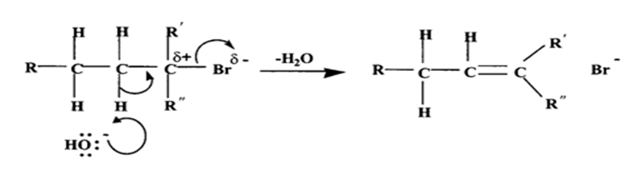
Figure 60

This mechanism is referred to as an E2 reaction (an elimination reaction, in which two particles are involved in the RDS).

In the second type of mechanism, there are two stages. In the first step, the C–X bond breaks heterolytically to form a carbocation. In the second step, a hydrogen ion is removed from an adjacent carbon atom forming the carbon-to-carbon double bond (Figure 61).

Figure 61
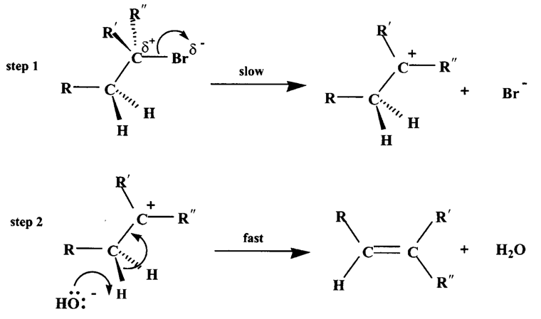
This mechanism is referred to as an E1 reaction (an elimination reaction, in which one particle is involved in the RDS). In any given situation, the mechanism involved will depend on a number of factors, including the strength of the base involved and the environment of the halogen atom.

Electrophilic Addition Reactions of alkenes

Almost all the important reactions of alkenes involve addition reactions in which molecules such as hydrogen, hydrogen halides and halogens add across the double bond to form saturated products.

Addition of hydrogen (hydrogenation)

The reaction between alkenes and hydrogen is slightly exothermic but so slow at room temperature as to be unobservable. However, the reaction can be carried out successfully at higher temperatures with a suitable catalyst. Nickel, platinum and palladium are commonly used as catalysts and act as heterogeneous catalysts by adsorbing hydrogen onto the surface of the catalyst (Figure 62). (For further explanation about how transition metals operate as catalysts, see Unit 1a.)

Figure 62

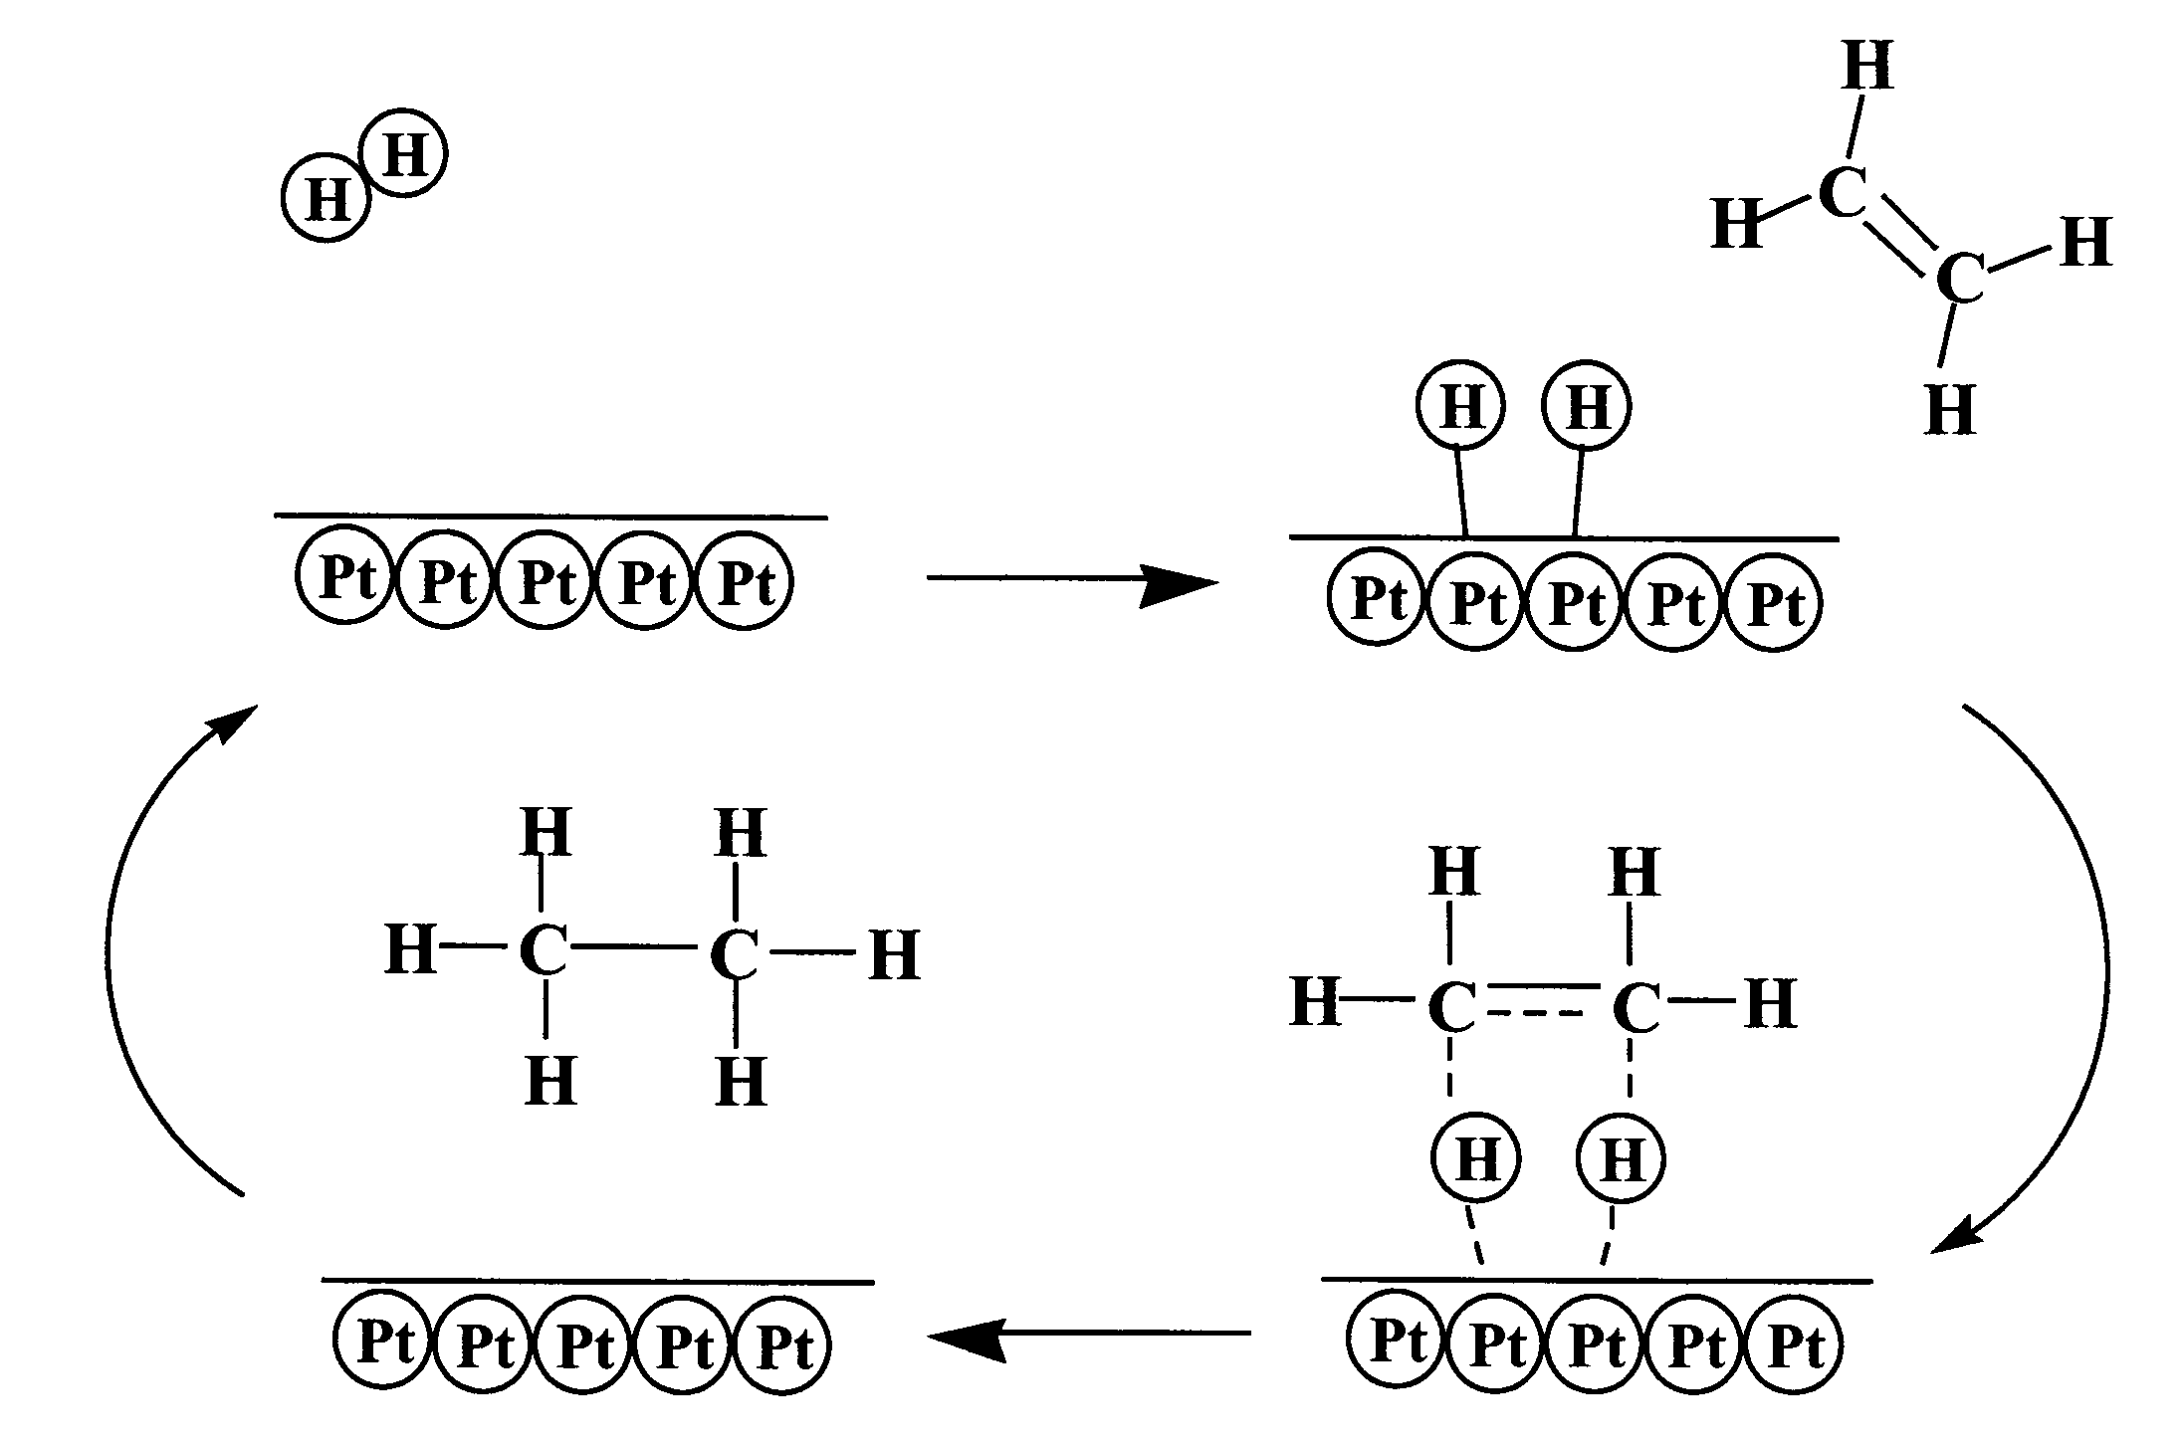

Addition of halogens

The rapid decolourisation of bromine even in the absence of light has been used in National 5 and Higher as a test to identify the presence of a carbon-to-carbon double bond. In fact, chlorine and iodine will also add across a double bond and, as you would expect, the reaction of chlorine is more vigorous than that of bromine and the reaction of iodine is less vigorous still. In each case, the corresponding dihaloalkane is the sole product.

The likely mechanism for the reaction of bromine with ethene is as follows.

The first stage involves attack by bromine on the electron-rich carbon-to-carbon double bond. The Br–Br bond is non-polar but, as it approaches the double bond, the electrons of the double bond repel the electrons of the bromine molecule, causing temporary polarisation and the creation of an electrophilic bromine atom. In organic chemistry, reaction mechanisms are frequently explained by using curly arrows to represent the direction of movement of pairs of electrons, as shown in Figure 63.

Figure 63
This arrow shows the Br-Br bond breaking heterolytically, both electrons of the bond going with the leaving bromide ion
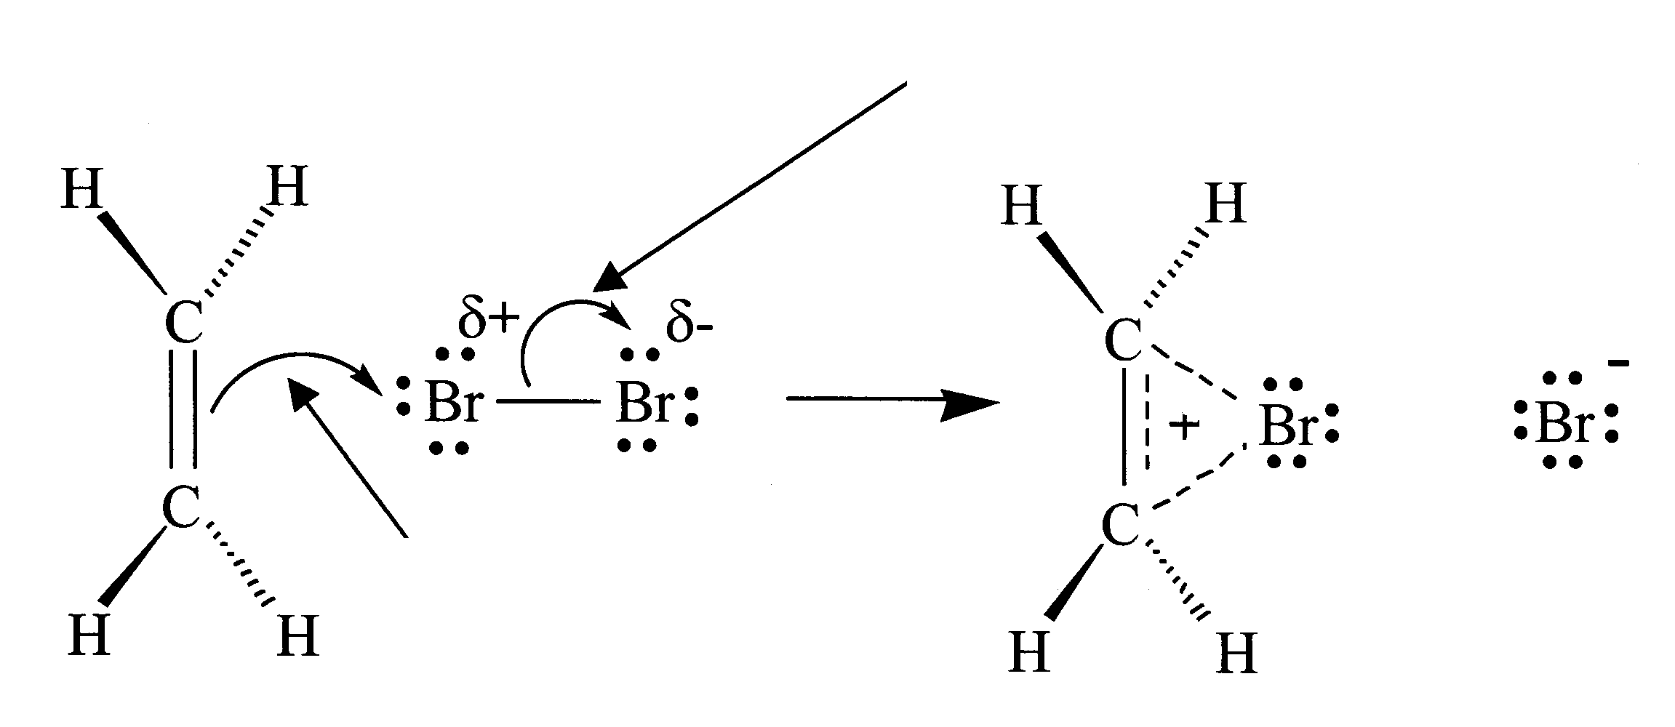
bromonium ion
This curly arrow shows that the pair of electrons from the π bond attacks electron-deficient bromide atom

There is evidence to suggest that the intermediate is the positive cyclic ion shown in Figure 63. This ion is called a bromonium ion, in which the positive charge is stabilised by delocalisation. The formation of the bromonium ion is the rate-determining step in the reaction.

The second stage of the reaction is the rapid nucleophilic attack of the bromide ion on one of the carbon atoms of the bromonium ion to give the final product, 1,2-dibromoethane (Figure 64).

Figure 64

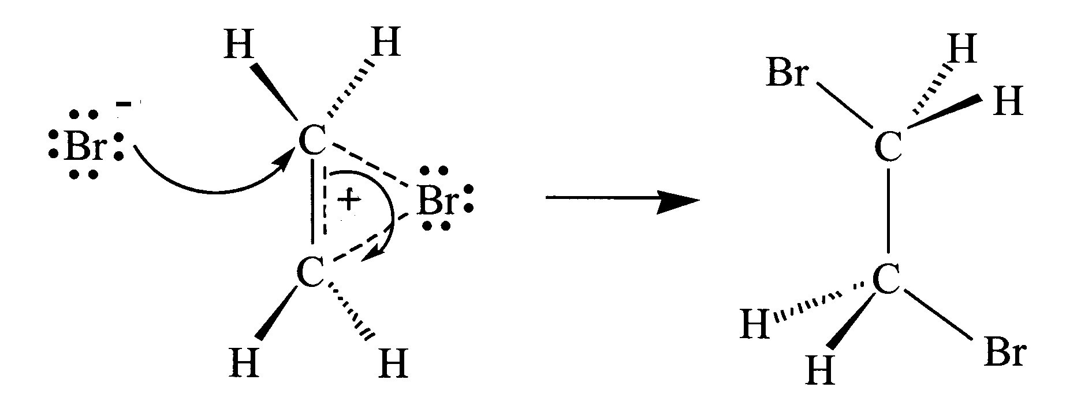

If the reaction is carried out in the presence of sodium chloride, some 1-bromo-2-chloroethane is formed, in addition to the usual product (Figure 65).

Figure 65

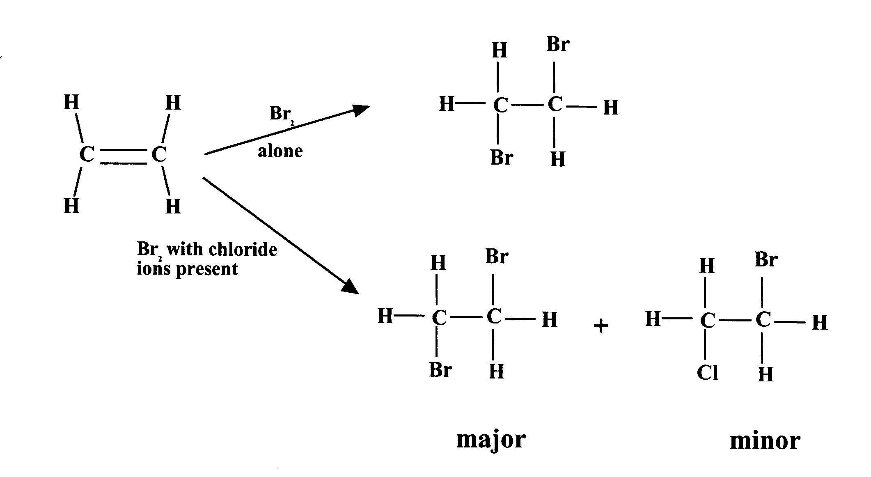

Presumably, the chloride ion can compete with the bromide ion as a nucleophile and intercept the cyclic ionic intermediate. This provides strong evidence for the existence of a positively charged ionic intermediate.

The addition of chlorine to a carbon-to-carbon double bond is likely to occur via a similar cyclic ionic intermediate.

Addition of hydrogen halides

The carbon-to-carbon double bond in alkenes is also readily attacked by the hydrogen halides (HCl, HBr and HI), forming the corresponding haloalkanes. These reactions are normally carried out in the gas state or in fairly non-polar solvents. For example, ethene reacts readily with hydrogen iodide to give iodoethane (Figure 66).

Figure 66

CH2 = CH2 + H—I CH3 — CH2I

However, if an unsymmetrical alkene is used, addition of a hydrogen halide can lead to two possible products. In practice, a mixture of the two products is obtained although one product is normally obtained in far greater yield than the other. For example, the reaction of propene with hydrogen bromide produces mainly 2-bromopropane with a much smaller amount of the isomeric 1-bromopropane (Figure 67).

Figure 67

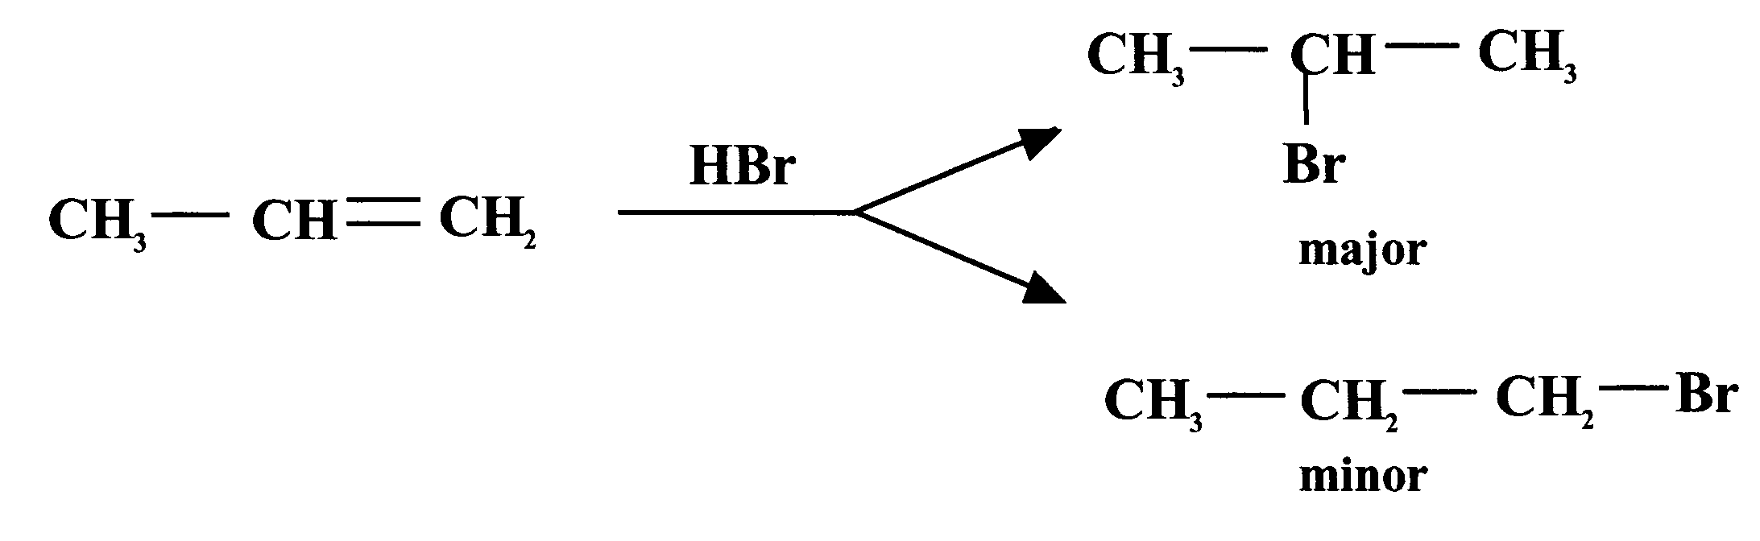

From a study of a large number of similar addition reactions, a general rule has been developed to enable the prediction of the most likely product.

Markovnikov’s rule states that:

‘When a compound HX is added across a carbon-to-carbon double bond, the hydrogen becomes attached to the carbon atom of the double bond that is already bonded to the greater number of hydrogen atoms.’

As with many simple rules, there are exceptions to Markovnikov’s rule but it is still a useful predictive tool.

The mechanism of this type of reaction is also thought to involve electrophilic attack on the electron-rich carbon-to-carbon double bond. In this case, the HX bond is permanently polarised (Figure 68).

Figure 68

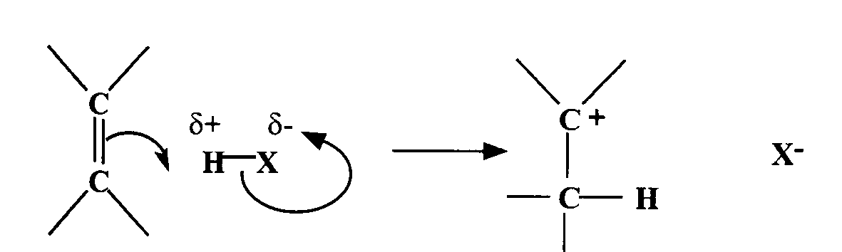

A bond forms between the hydrogen atom and one of the unsaturated carbon atoms using π electrons. At the same time, the HX bond breaks. This is the rate-determining step and it produces an X– ion and a carbocation (carbonium ion), which is susceptible to rapid nucleophilic attack by the X– ion, as shown in Figure 69.

Figure 69

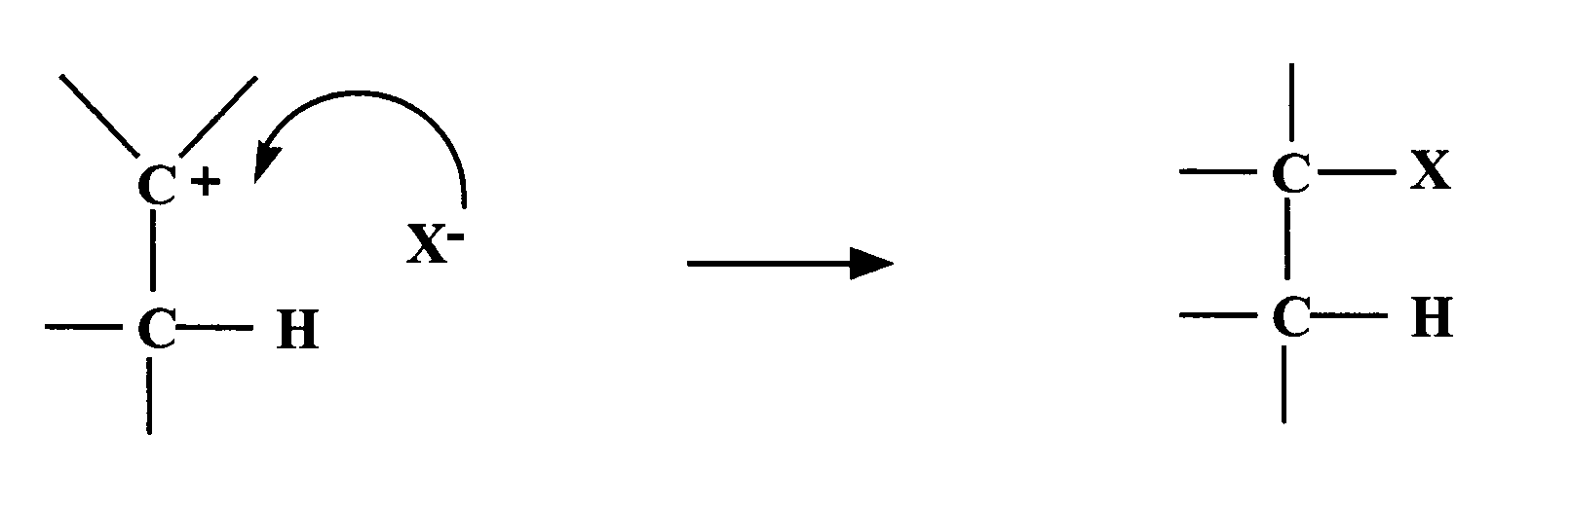

In the reaction between propene and hydrogen bromide, two carbocation intermediates are possible (Figure 70).

Figure 70
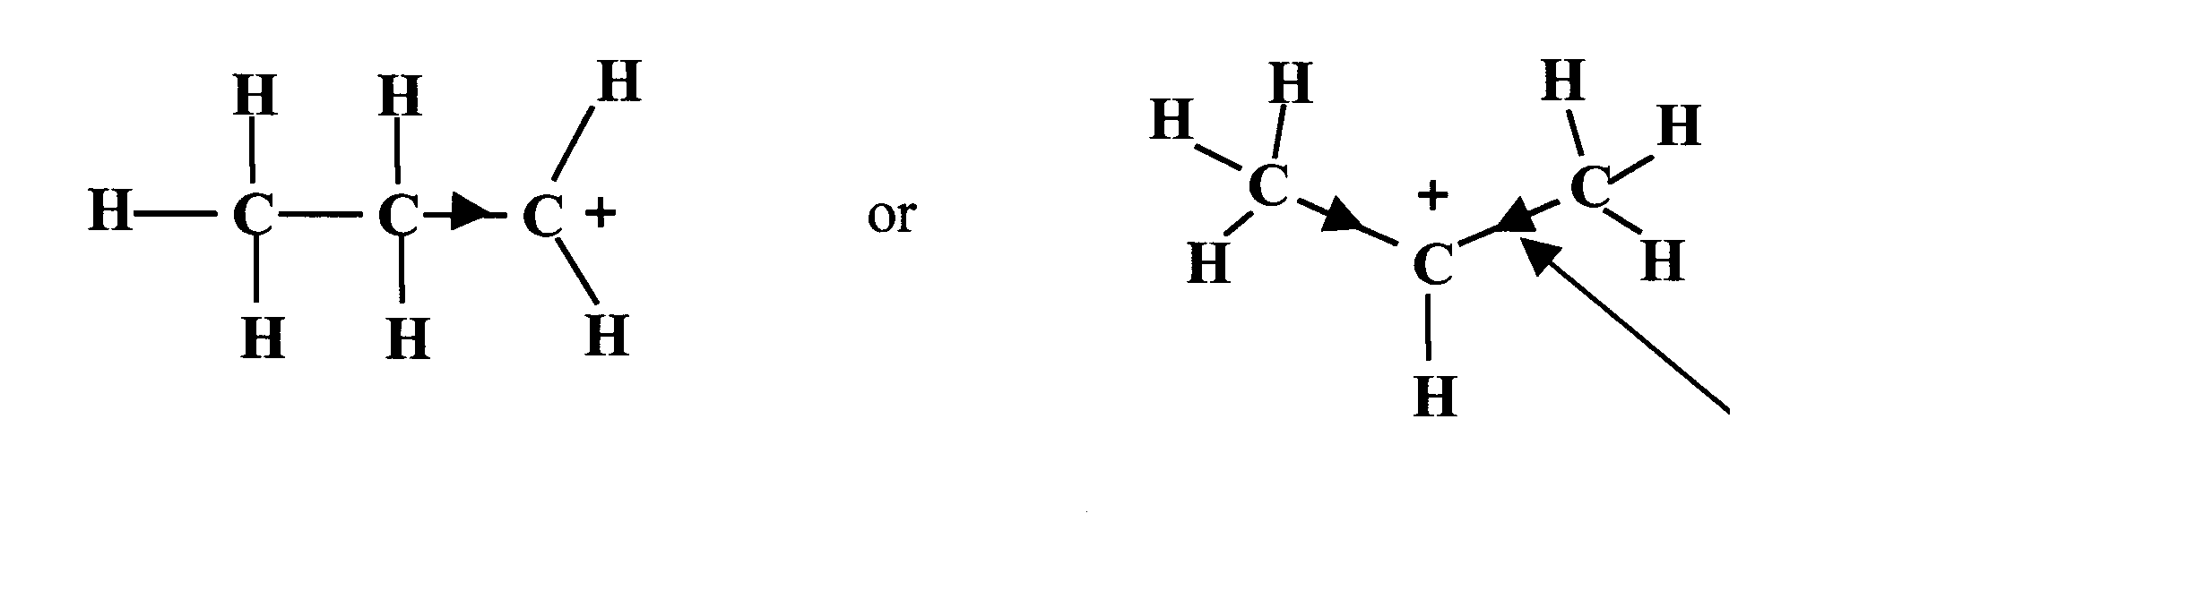
electron-donating effect
In the first carbocation, the positive carbon atom is attached to only one alkyl group, whereas in the second the positive carbon is attached to two alkyl groups. Alkyl groups are able to donate electrons to adjacent atoms and so can help to stabilise a positive charge. The second carbocation has two alkyl groups helping to stabilise the positive charge. It will be more stable than the first one and so will be formed in preference to it. Thus the more likely product of the reaction is 2-bromopropane, which is derived from the more stable carbocation.

Acid-catalysed addition of water

If the previous reaction of hydrogen iodide with ethene is carried out in an aqueous solution, the product can be different. A significant amount of ethanol is produced. In aqueous solution, hydrogen iodide is a typical strong acid and dissociates into hydrated hydrogen ions and iodide ions:

HI + H₂O H₃O + + I⁻

The hydrated hydrogen ion (H₃O⁺) is also known as the hydronium ion or oxonium ion. It is an electrophile and can attack the carbon-to-carbon double bond to form the same carbocation as was formed in the reaction mechanism shown in Figure 68. The concentration of water molecules in the aqueous solution is many times greater than that of the iodide ions and so the carbocation is much more likely to react with a water molecule than with an
iodide ion. This produces a protonated ethanol molecule, which readily loses a hydrogen ion to form ethanol, as shown in Figure 71.

Figure 71

This mechanism is exactly the reverse of that proposed for the dehydration of alcohols to form alkenes (see page 44).

The same result can be obtained in two steps using cold concentrated sulfuric acid. The sulfuric acid adds across the double bond to form ethyl hydrogensulfate. This can be hydrolysed by warming with water to regenerate the sulfuric acid and produce ethanol (Figure 72).

Figure 72

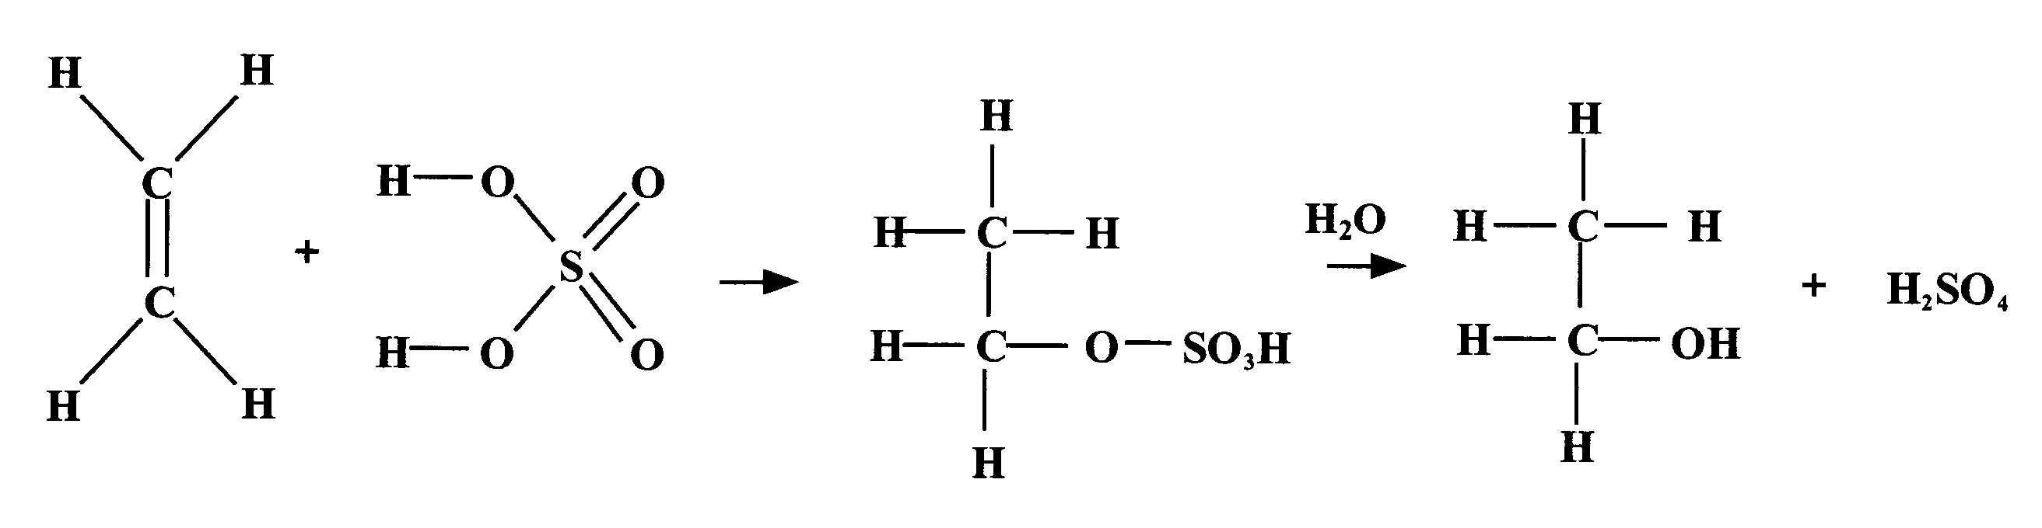

The addition of water to an alkene by either method follows Markovnikov’s rule and is an excellent method for synthesising appropriate alcohols. The concentrated sulfuric acid method can also be used to purify substances contaminated with alkenes. Alkanes and haloalkanes that are insoluble in concentrated sulfuric acid can be freed from alkene impurities by bubbling through or shaking with sulfuric acid. Any alkene present is converted to alcohol, which dissolves in the acid. The alkane or haloalkane is easily obtained in a pure state by distillation.

Questions

1. Propane was reacted with chlorine. The following products were obtained:
i) hydrogen chloride
ii) two compounds of formula C₃H₇Cl
iii) four compounds of formula C₃H₆Cl₂(labelled A, B, C and D).

(a) What type of reaction has taken place and what type of bond fission occurred?
(b) Draw full structural formulae for all the organic compounds.
(c) Each of the dichlorocompounds was further treated with chlorine. A gave one trichloro product. B gave two trichloro products and C and D both gave three trichloro products. The product obtained from A was also produced by C but not by D. Identify which of the dichloro structures are A, B, C and D.

2. Table 1 (page 7) shows that the CC bond is stronger than the C–C bond but not three times as strong. The ethyne molecule
(H–CC–H) is known to be linear. Describe in terms of hybridisation how the CC bond could be formed.

3. Ethene is reacted with a solution of bromine in methanol. As well as the expected product, some Br–CH₂–CH₂–OCH₃ is also obtained. By considering the mechanism of the reaction, account for the formation of the second product.

4. Name and draw structures for the products of the following reactions, in each case stating which product will be formed in the higher yield:
(a) the reaction of propene with hydrogen bromide
(b) the reaction of 2-methylbut-2-ene with hydrogen chloride
(c) the catalytic hydration of 2-methylbut-1-ene
(d) the addition of hydrogen bromide to 3-methylbut-1-ene.

Carboxylic acids

Carboxylic acids are compounds of the general
formula R–COOH (Figure 73) and are generally Figure 73
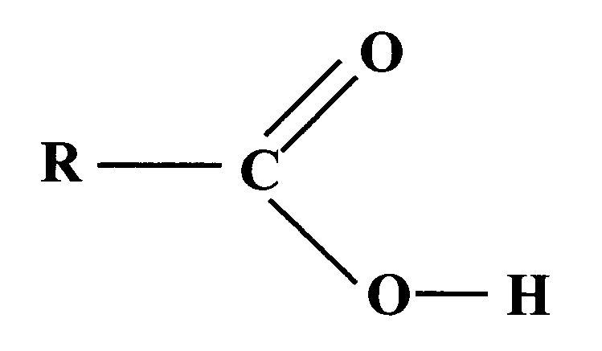
referred to as alkanoic acids when R is an alkyl group. The –COOH group is known as the carboxyl group and consists of a carbonyl group attached to a hydroxyl group. The presence of a carboxyl group in the molecules of a compound is shown in the name of the compound by the name ending -oic acid.

The carboxyl group is a polar group containing an acidic O–H bond. Consequently, carboxylic acid molecules are capable of forming hydrogen bonds with other carboxylic acid molecules and also with molecules containing other relevant functional groups. This has a marked effect on their physical properties.

Table 6

Acid | Relative formula mass | Boiling point (ºC) | Solubility (g/100g H₂O) | Alcohol | Relative Formula mass | Boiling point (ºC) | Solubility (g/100g H₂O)
Methanoic | 46 | 101 | ∞ | Ethanol | 46 | 79 | ∞
Ethanoic | 60 | 118 | ∞ | Propan-1-ol | 60 | 97 | ∞
Propanoic | 74 | 141 | ∞ | Butan-1-ol | 74 | 117 | 7.9
Butanoic | 88 | 164 | ∞ | Pentan-1-ol | 88 | 138 | 2.3

Carboxylic acids have higher boiling points than alcohols of similar relative formula mass, providing good evidence that even stronger intermolecular forces exist between the acid molecules than between the alcohol molecules. The presence of the electron-withdrawing carbonyl group adjacent to the hydroxyl group makes the O–H bond in the carboxyl group even more polar than the O–H bond in the alcohol. As a result, hydrogen bonding between carboxylic acid molecules is stronger than that between alcohol molecules. Also, the shape of the carboxyl group is such that two carboxylic acid molecules can pair up to form a dimer held together by two hydrogen bonds (Figure 74). Dimers exist in pure carboxylic acids in both the solid and liquid states and even in the gaseous state at temperatures just above the boiling point.
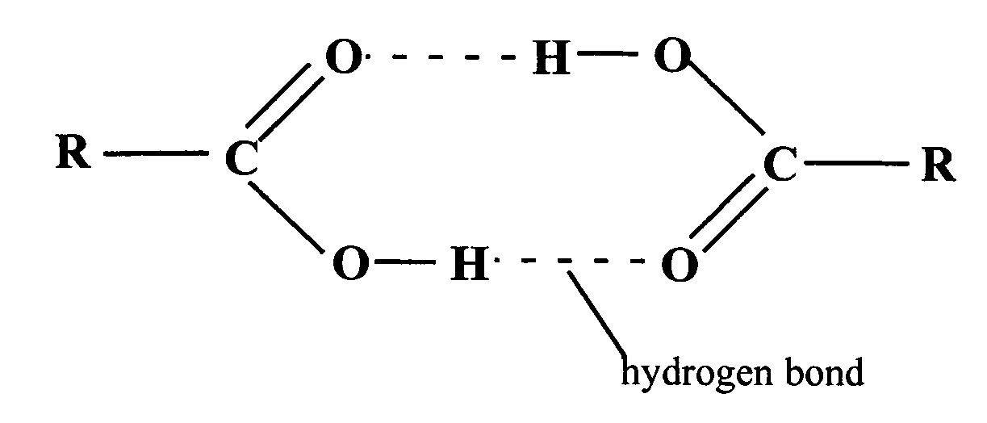

Figure 74

Early members of the alkanoic acids are more soluble in water than the corresponding alcohols due to their increased ability to form hydrogen bonds with water (see Figure 75).

Figure 75
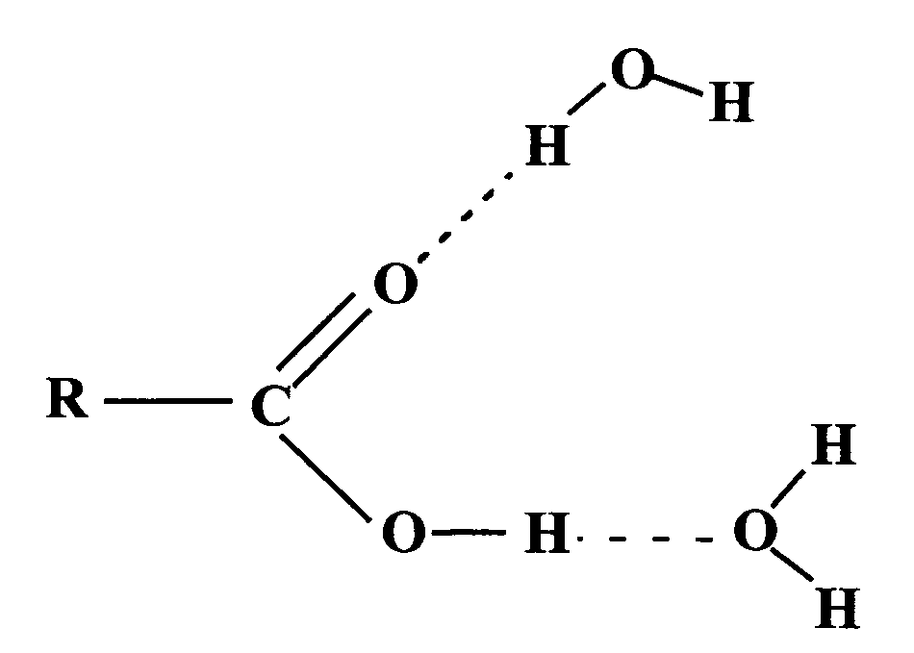
As with other homologous series, solubility decreases as chain length increases.

Carboxylic acids, alcohols and water all contain the hydroxyl group. The
O–H bond is polar and can be broken heterolytically to produce H+ ions. Molecules containing a hydroxyl group are thus potentially acidic. A measure of the strength of an acid is given by the dissociation constant, Ka (see Unit 1b). Since alcohols are much less likely to dissociate to produce hydrogen ions than water, K_{a} for ethanol is 10⁻¹⁸ and is lower than the value of K_{a} for water, 1.8 × 10⁻¹⁶. On the other hand, carboxylic acids dissociate much more readily (K_{a} for ethanoic acid is 1.7 × 10⁻⁵) but they are classed as weak acids because the dissociation to form hydrogen ions and carboxylate ions occurs to only a small extent (Figure 76).

Figure 76

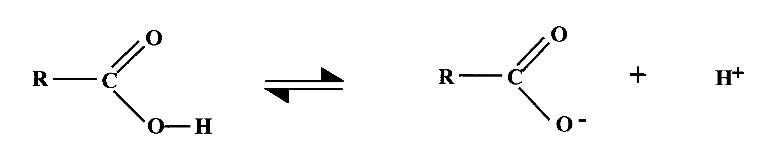

The presence in the carboxyl group of a carbonyl group adjacent to the OH group is responsible for this increased acidity. The carboxylate ion formed on dissociation is shown in Figure 76 as containing a double bond to one oxygen atom and a single bond to the other. In fact, X-ray diffraction studies show that the bond lengths of both carbon to oxygen bonds in the carboxylate ion are identical, suggesting that the two bonds are identical.

This can be explained by the delocalisation of the electrons over the whole carboxylate group (Figure 77). The spreading of the negative charge stabilises the carboxylate ion and means that it is less likely to combine with a hydrogen ion. As a result, the dissociation equilibrium (Figure 76) lies further to the right, making the acid stronger than it would be without this stabilisation.

Figure 77 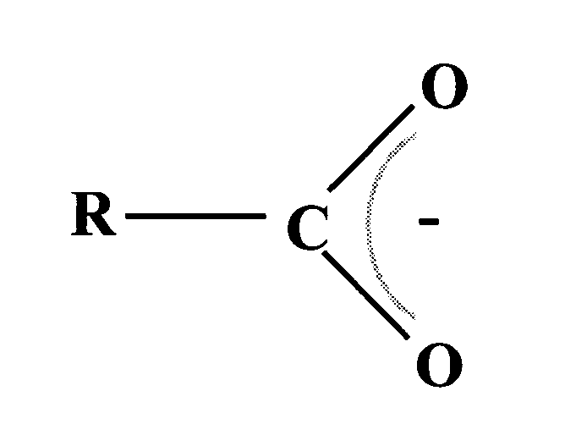
Preparation

Oxidation of primary alcohols and aldehydes

In the laboratory, carboxylic acids are generally produced by the oxidation of primary alcohols or aldehydes with oxidising agents such as Tollens’ reagent, acidified potassium dichromate(VI) solution or acidified manganate(VII) solution or hot copper(II) oxide (as described below).

The ease of oxidation of aldehydes to ketones provides a simple way of distinguishing between the two families. A number of mild oxidising agents can be used, including Tollens’ reagent, which is made by treating an aqueous silver(I) nitrate solution with ammonia. Initially, a black precipitate of silver(I) hydroxide is formed. On the addition of further ammonia solution, the precipitate dissolves and the complex diamminesilver(I) ion is produced, [Ag(NH₃)₂]⁺. On reaction with an aldehyde, the complex silver(I) ion is reduced to metallic silver and the aldehyde is oxidised to the corresponding carboxylic acid. Under suitable conditions, this oxidation produces a silver mirror on the inside of a test tube.

[Ag(NH₃)₂]⁺ (aq) + e⁻ Ag(s) + 2NH₃ (aq)

R–CHO + H₂O R–COOH + 2H⁺ (aq) + 2e⁻

Fehling’s solution can also be used as the oxidising agent. The deep-blue Fehling’s solution contains complexed copper(II) ions, which are reduced to copper(I) ions causing the precipitation of reddish copper(I) oxide. The aldehyde is again oxidised to the corresponding carboxylic acid while the copper(II) ions are reduced according to the following equation:

H₂O(l) + 2Cu²⁺ (aq) + 2e⁻ Cu₂O (s) + 2H⁺ (aq)

Hydrolysis of nitriles, esters and amides

Alternatively, they can be synthesised by the hydrolysis of nitriles with strong acids or bases (Figure 78).

Figure 78
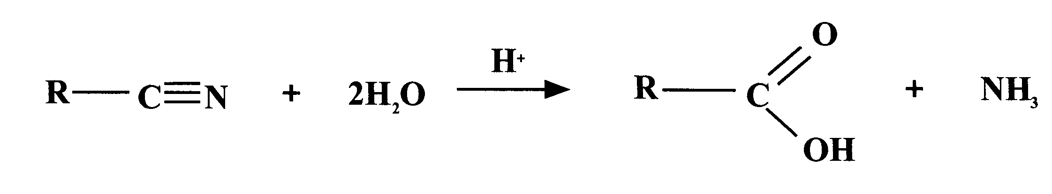

Similarly, hydrolysis of esters or amides can be used to produce carboxylic acids (Figure 79).

Figure 79

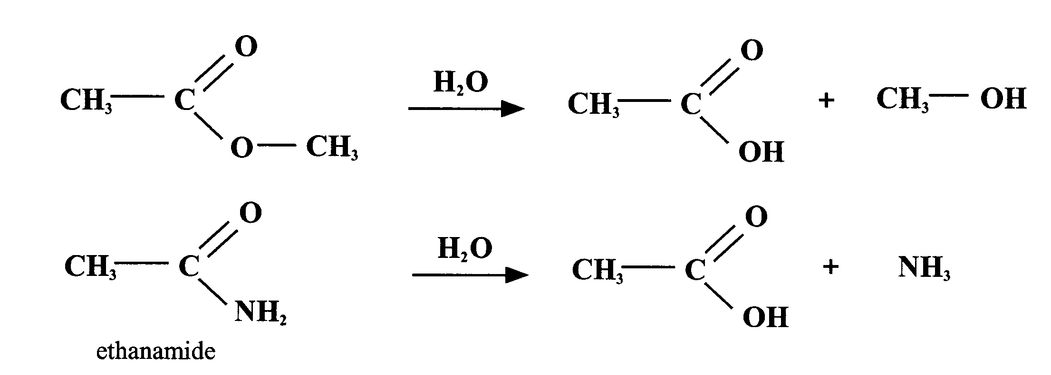

Reactions of Carboxylic Acids

Some of the reactions of carboxylic acids should already be familiar to you.

(a) They behave as typical acids by forming salts when neutralised in the following ways:
(i) with alkalis:
CH₃COOH(aq) + Na⁺OH⁻(aq) Na⁺CH₃COO⁻ (aq) + H₂O(l)

(ii) with metal carbonates:
2CH₃COOH(aq) + Na₂CO₃(aq) 2Na⁺CH₃COO⁻(aq) + H₂O(l) + CO₂(g)

(iii) with some metals:
2CH₃COOH(aq) + Mg(s) Mg²⁺(CH₃COOH)₂(aq) + H₂ (g)

(b) Condensation with alcohols to form esters (esterification) was discussed in the Alcohols section (see pages 35 -41).

Figure 80

(c) Carboxylic acids can also be reacted with ammonia or amines to form amides. Both ammonia and amines are basic (see pages 60) and, in the first step of the process, can be used to neutralise carboxylic acids to form the corresponding ammonium salts, which are then heated to drive off water and produce amides (Figure 81).

Figure 81

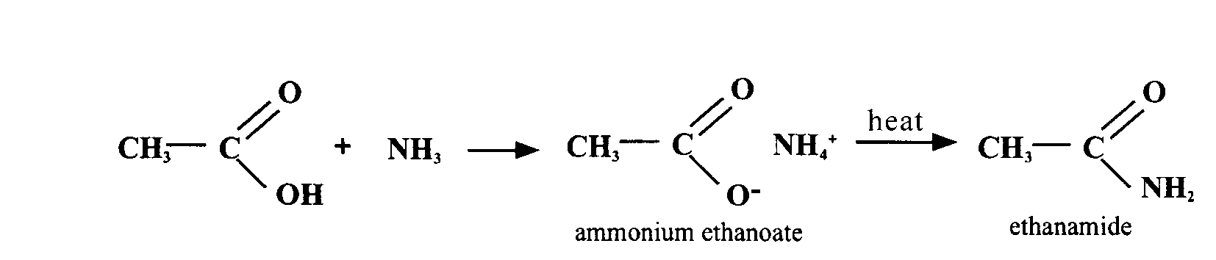

This type of reaction is used in the production of nylon, which is an example of a condensation polymer. During the polymerisation, the amino group, –NH₂, on one monomer molecule is condensed with a carboxyl group (or a derivative of a carboxyl group) on another monomer molecule to form a secondary amide (Figure 82). For this reason, nylon polymers are sometimes called polyamides.

Figure 82

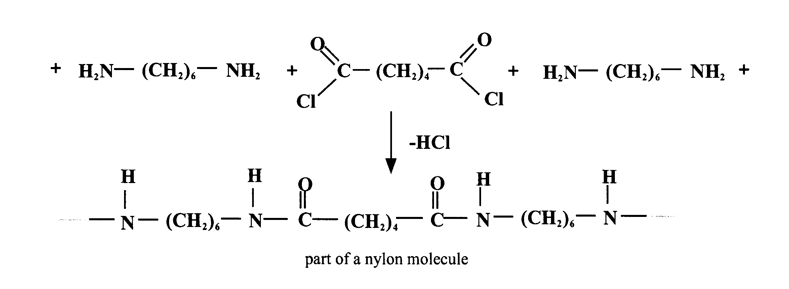
…
…

(d) One of the few reagents powerful enough to reduce a carboxylic acid is lithium aluminium hydride. The reaction proceeds in a similar manner to the reduction of aldehydes and ketones (see page 37) and produces primary alcohols in high yield (Figure 83).

Figure 83
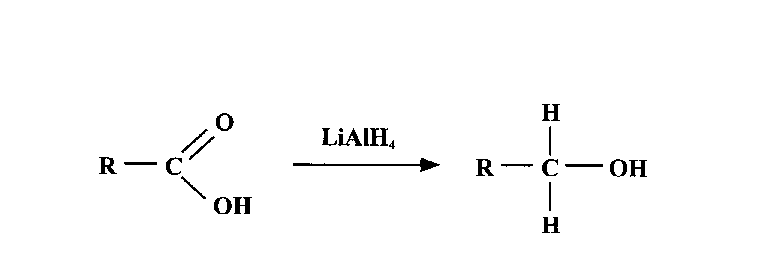

Amines
Figure 84

(a)
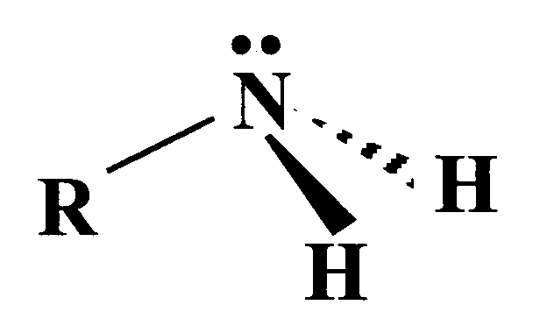
Amines can be regarded as organic compounds based on ammonia, NH₃, in which one or more of the hydrogen atoms are replaced by alkyl or aryl groups (an aryl group is one based on the aromatic hydrocarbon benzene). If only one of the hydrogen atoms is replaced, then the compound is a primary amine and the functional group, –NH₂, is known as the amino group (Figure 84a).

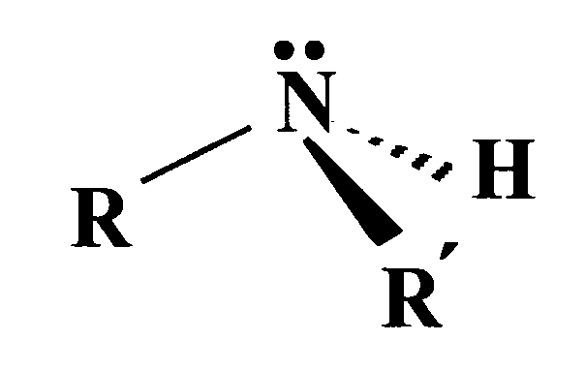
(b)
If two hydrogen atoms are replaced, the compound is a secondary amine. The two groups may be the same or different (Figure 84b).
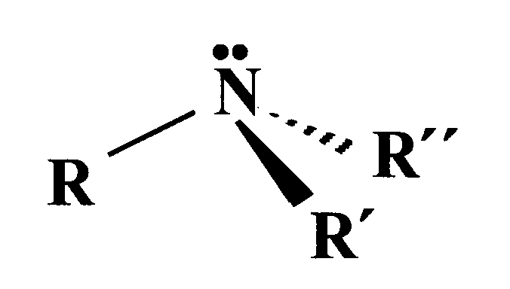
If all three hydrogen atoms are replaced, the compound is a tertiary amine. Again the groups may be all the same or different (Figure 84c).
(c)

The naming of the amines follows the rules laid down by IUPAC.

Primary amines may be named in two ways:
(a) by removing ‘e’ from the name of the parent hydrocarbon and adding the suffix ‘-amine’, e.g.

C₂H₅NH₂ ethanamine C₄H₉NH₂ butanamine

(b) by adding the suffix ‘-amine’ to the name for the substituent group R, e.g.

C₂H₅NH₂ ethylamine C₄H₉NH₂ butylamine

The second method is used commonly for simple amines and has the advantage that it makes the naming of secondary and tertiary amines and the corresponding salts much simpler (see pages 59–60). Note that if the
–NH₂ group is not the principal group in the compound, it is named by the prefix ‘amino’ (Figure 85).

Figure 85

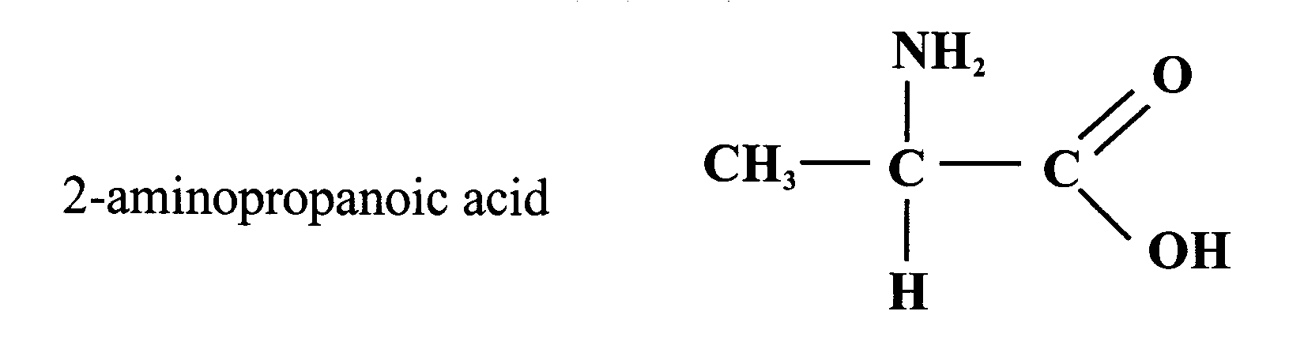
2-aminopropanoic acid

Secondary and tertiary amines are named by citing the substituent group R preceded by the prefix ‘di’ or ‘tri’ respectively, followed without a space by the name ‘amine’ (Figure 86).

Figure 86

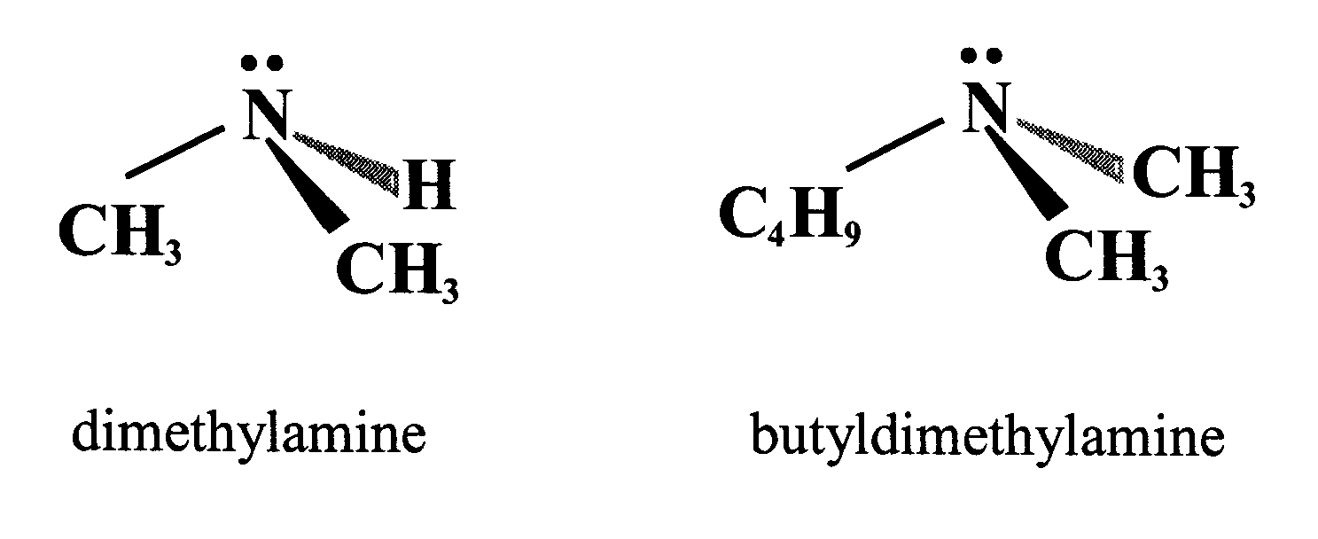

It is apparent from their structures that both primary and secondary amine molecules contain a polar N–H bond and are therefore capable of forming hydrogen bonds with other amine molecules (Figure 87). On the other hand, tertiary amine molecules have no hydrogen atoms directly attached to the nitrogen and so there can be no hydrogen bonds between such molecules. This difference is confirmed by studying the boiling points in Table 7.

Figure 87

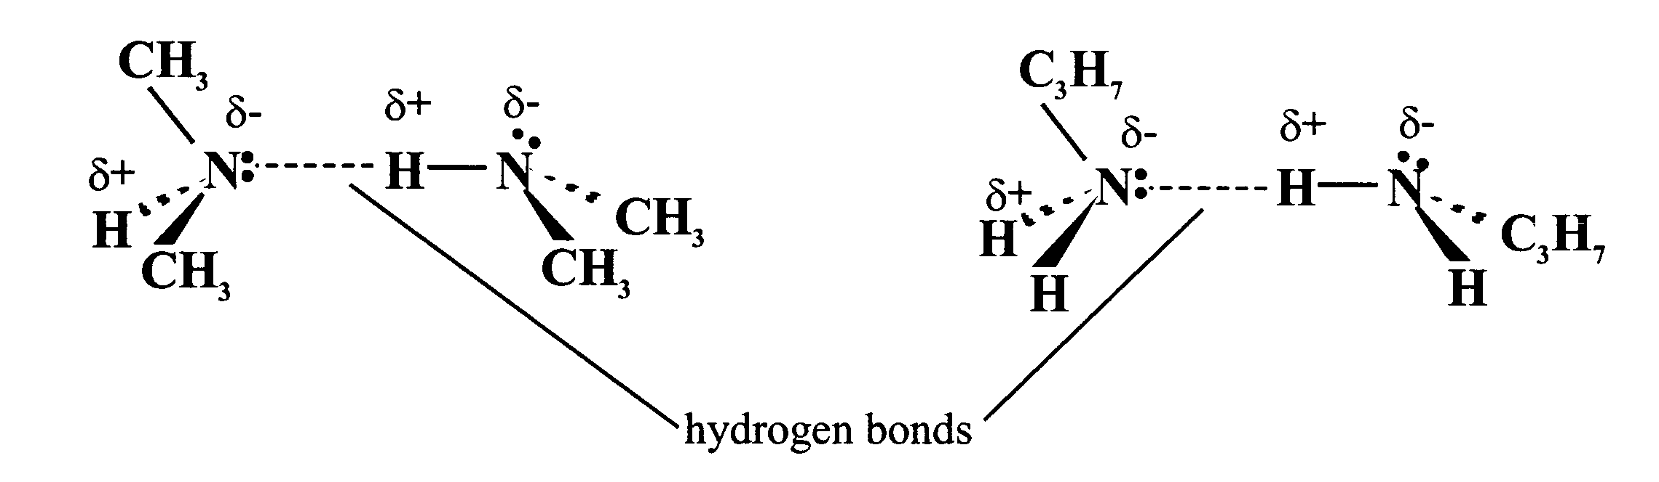

Table 7

Amine | Relative formula mass | Boiling point (ºC) | Alkane | Relative formula mass | Boiling point (ºC)
CH₃NH₂ | 31 | -7.5 | CH₃CH₃ | 30 | -89
(CH₃)₂NH | 45 | 7.5 | CH₃CH₂CH₃ | 44 | -42
(CH₃)₃N | 59 | 3 | CH₃CH₂CH₂CH₃ | 58 | 58
CH₃CH₂CH₂NH₂ | 59 | 49 | CH₃CH₂CH₂CH₃ | 58 | 58

It can be seen that dimethylamine has a higher boiling point than trimethylamine despite having a lower relative formula mass. This is because of the presence of hydrogen bonding between the dimethylamine molecules (Figure 87) but not between the trimethylamine molecules. For the same reason, the boiling point of propylamine is considerably higher than that of the isomeric trimethylamine.

In general, primary amines and secondary amines have much higher boiling points than alkanes of similar relative formula mass. By comparison, the tertiary amine trimethylamine has a boiling point only slightly higher than that of butane, which has almost the same relative formula mass.

Water, however, can form hydrogen bonds with all amines, including tertiary amines (Figure 88). Thus the lower amines are readily soluble in water but, as with other homologous series, the solubility decreases as the number of carbon atoms increases.

Figure 88

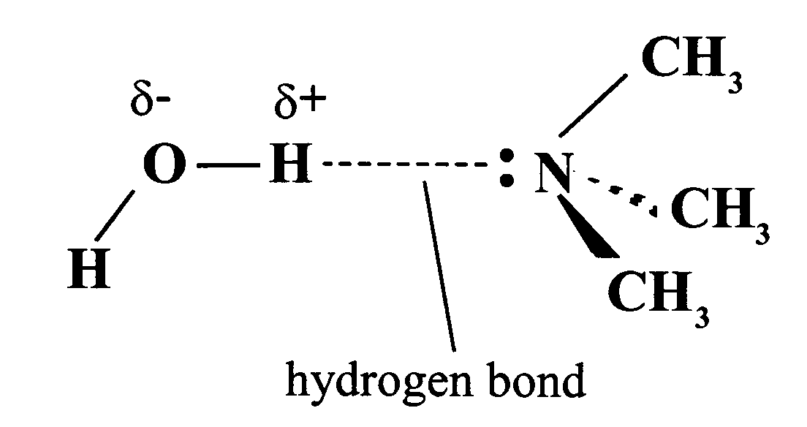

The orientation of the bonds attached to the nitrogen atom has an important bearing on the chemistry of amines. The ammonia molecule is pyramidal in shape with a lone pair of electrons on the nitrogen atom (see Unit 1a). A similar arrangement of bonds will occur around the nitrogen atom in any amine molecule.

If a bottle of concentrated hydrochloric acid is opened near an open bottle of concentrated ammonia solution, dense white fumes of ammonium chloride are produced. The ammonia molecule is acting as a base (proton acceptor) by accepting a hydrogen ion (proton). The lone pair is used to form a dative covalent bond in which both shared electrons come from the same atom. The hydrogen chloride acts as a proton donor (an acid; Figure 89). A similar result is obtained if ethylamine solution is used instead of the ammonia.

Figure 89

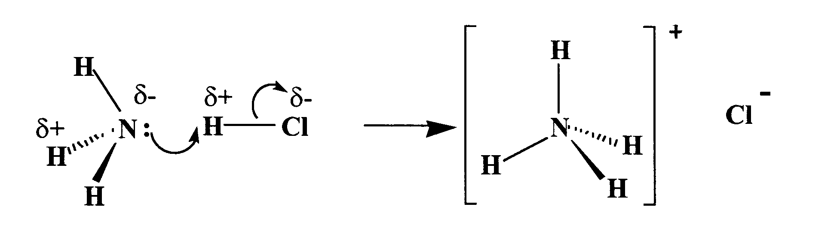

When an amine dissolves in water, the lone pair of electrons on nitrogen accepts a proton from a water molecule to form the appropriate ammonium ion and a hydroxide ion (Figure 90).

Figure 90

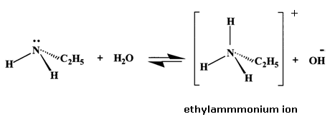

The reaction is reversible and the equilibrium generally lies well towards the left and so amines are weak bases and solutions of amines are weakly alkaline. Accordingly, amines react with aqueous mineral acids and carboxylic acids to form salts:

C₂H₅NH₂(aq) + H⁺Cl⁻(aq) C₂H₅NH₃⁺Cl⁻(aq)
ethylamine ethylammonium chloride

This reaction is useful for isolating amines from mixtures with other organic compounds. Only those compounds that are basic will react with the acid to form water-soluble salts. If the mixture is then shaken with a relatively non-polar solvent such as ethoxyethane or dichloromethane, the non-basic compounds will dissolve in the organic solvent while any amine will remain in the aqueous solution as the ammonium salt. After separating off the organic solvent, the aqueous layer can be warmed with a strong alkali such as sodium hydroxide to regenerate the original amine in gaseous form:

C₂H₅NH₃⁺Cl⁻(aq) + Na⁺OH⁻ (aq) Na⁺Cl⁻(aq) + H₂O(l) + C₂H₅NH₂ (g)

The formation of salts by the reaction of amines with carboxylic acids is often the first stage in the production of amides (see page 56).

Questions

1. Describe and explain the shape of the ammonia molecule.

2. Ethylamine reacts with hydrogen chloride producing dense white fumes:

C₂H₅NH₂ (g) + HCl(g) C₂H₅NH₃⁺Cl⁻(s)

(a) What type of bond breaking occurs?
(b) What type of bond is formed?
(c) Identify the electrophilic centre and the nucleophilic centre.
(d) What other term can be used to describe the role of the amino group in this reaction?

Aromatics

The term ‘aromatic’ was first used to describe a group of natural oils, many of which were pleasant smelling. As more and more similar compounds were discovered, it became apparent that many had an unpleasant smell. Indeed, some are toxic and smelling the vapours can be very dangerous. The common link between these compounds was not a similarity in their smells but a similarity in their structures. The term ‘aromatic’ is still retained to indicate a particular structure and characteristic chemical behaviour. The systematic name for the family of aromatic hydrocarbons is the ‘arenes’. The simplest and most important aromatic compound is benzene, which was first isolated from whale oil in 1825 by Michael Faraday. The molecular formula of benzene was first established as C₆H₆ in 1834 but its structure remained a source of controversy for many years.

Bonding and structure of benzene Figure 91
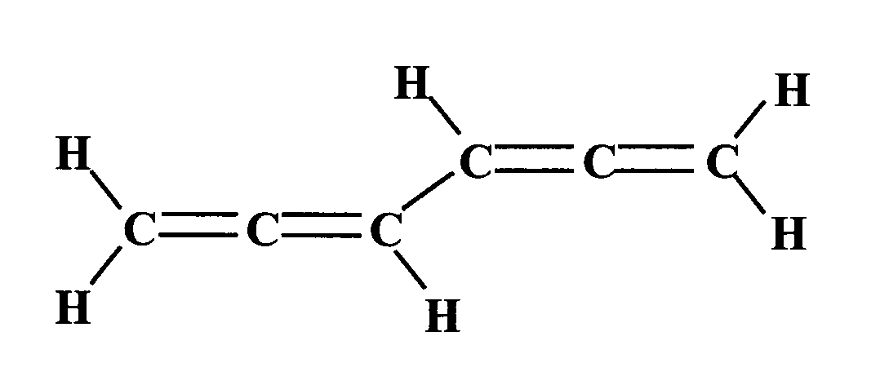
A variety of highly unsaturated structures were initially suggested for benezene, including the hexatetraene shown in Figure 91.

Monosubstitution by chlorine can occur either on the end carbon atoms or on the middle carbon atoms, giving rise to two possible isomers. However, chlorobenzene, C₆H₅Cl, does not exhibit isomerism. The problem was partly solved by Kekulé in 1865 when he proposed a ring structure with alternating single and double bonds (Figure 92).

Figure 92
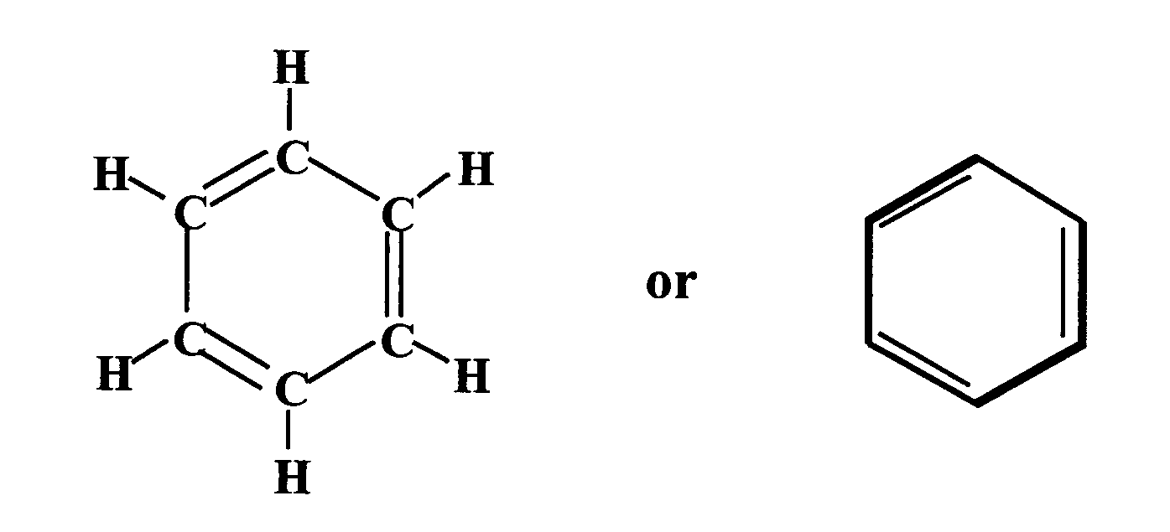
In this structure all the hydrogen atoms are identical and so there can be only one form of chlorobenzene. However, Kekulé’s structure was unable to explain other subsequent observations and measurements:

(a) X-ray diffraction shows that the carbon-to-carbon bond lengths are all the same (139 pm), shorter than the carbon-to-carbon single bond length (154 pm) but longer than the carbon-to-carbon double bond length (133 pm). In sharp contrast, Kekulé’s structure predicts alternating short and long bonds.

(b) Benzene is more thermodynamically stable than Kekulé’s structure suggests. The standard enthalpy of formation of gaseous benzene is +82 kJ mol⁻¹, based on measured enthalpies of combustion:

6C(s) + 3H₂(g) C₆H₆(g)

(c) Benzene is resistant to the addition of bromine. If the ring contained three carbon-to-carbon double bonds, bromine would be expected to add easily, as is the case with alkenes.

Question

Using the bond enthalpy information on page 10 of the Data Booklet, calculate the theoretical enthalpy of formation of gaseous benzene using the Kekulé structure. Compare your answer to the measured value.

One proposal to explain these observations was to describe the structure of benzene in terms of two different ‘resonance structures’ (Figure 93).

Figure 93
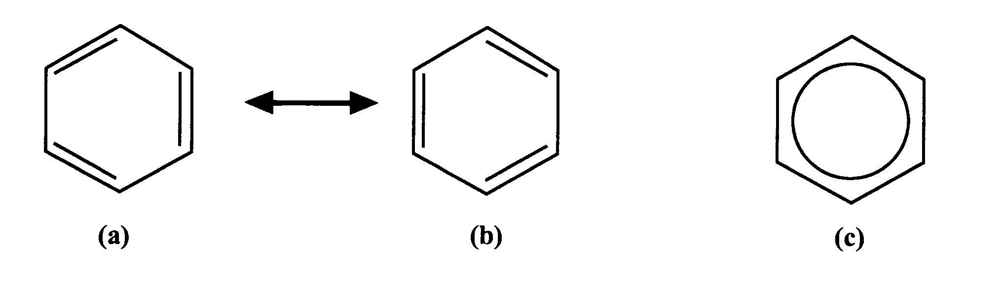
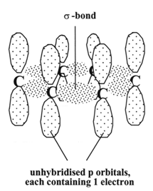
The structures (a) and (b) in Figure 93 are energetically equivalent and differ only in the arrangement of the electrons. The real structure of benzene is neither (a) nor (b) but some intermediate between these two structures and is best represented by structure (c). It must be emphasised that the double-headed arrow that denotes resonance does not mean that there is a dynamic equilibrium between structures (a) and (b). Neither structure (a) nor structure (b) actually exists.

Figure 94
σ bonds

A more satisfactory explanation of the structure involves sp² hybridisation (see pages 13–14). In ethene, a planar σ framework with 120º bond angles was proposed, with the remaining two electrons shared between the two carbon atoms as a Π-bonding pair. For benzene a similar σ framework can be envisaged, as in Figure 94. Note that the hydrogen atoms have been omitted for simplicity. They lie in the plane of the ring, pointing away from the ring.
Unhybridised orbitals each containing 1 electrons

The six carbon atoms form a regular planar hexagonal ring. Each
p orbital contains one electron. Sideways overlap is possible with each adjacent p orbital. The result is that the six electrons become delocalised and occupy two continuous doughnut-shaped electron clouds, one above and one below the planar σ framework (Figure 95).

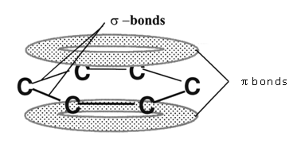
σ bonds

Figure 95

The delocalisation of the electrons helps to bond the atoms more tightly together. The result is a completely symmetrical molecule, with considerable stability. This type of delocalised structure is the common feature shared by aromatic hydrocarbons. Indeed, the term ‘aromatic’ can be redefined to describe any system that contains a ring of atoms stabilised by delocalized π electrons. Compounds that contain molecules with straight- or branched-chain carbon skeletons are described as aliphatic.

Reactions of benzene

Because the electrons in the π-electron cloud are less tightly held than the σ electrons they are more readily available to react with a reagent that is seeking electrons (an electrophile). Such reactions, because of the extra stability of the delocalised π system, lead to substitution rather than addition. The typical reaction of benzene is therefore electrophilic substitution. Since benzene itself is carcinogenic, methylbenzene (toluene) is often used as a safer alternative.

Reaction with bromine or chlorine

Benzene only reacts with bromine in the presence of a suitable catalyst, such as aluminium(III) chloride, iron(III) chloride or iron(III) bromide. Compare this to the electrophilic addition of bromine to an alkene (see pages 16–18).

In the first step in the bromination of an alkene, the alkene is sufficiently reactive to polarise the Br–Br bond in the attacking bromine molecule, resulting in the formation of the bromonium ion intermediate, which subsequently captures the bromide ion to form the addition product. There are parallels in the catalysed reaction of bromine with benzene. Since benzene is less reactive than the alkene, the catalyst is needed to polarise the bromine molecule and generate an electrophilic centre (Figure 96).
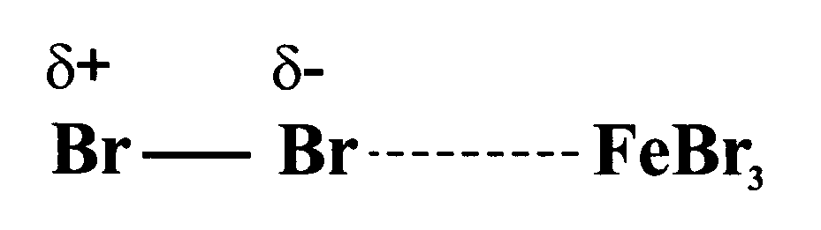
Figure 96

This partially positive bromine atom can then attack the benzene ring. Heterolytic fission of the Br–Br bond occurs to form a carbocation, just as happens in the bromination of an alkene (Figure 97).

Figure 97

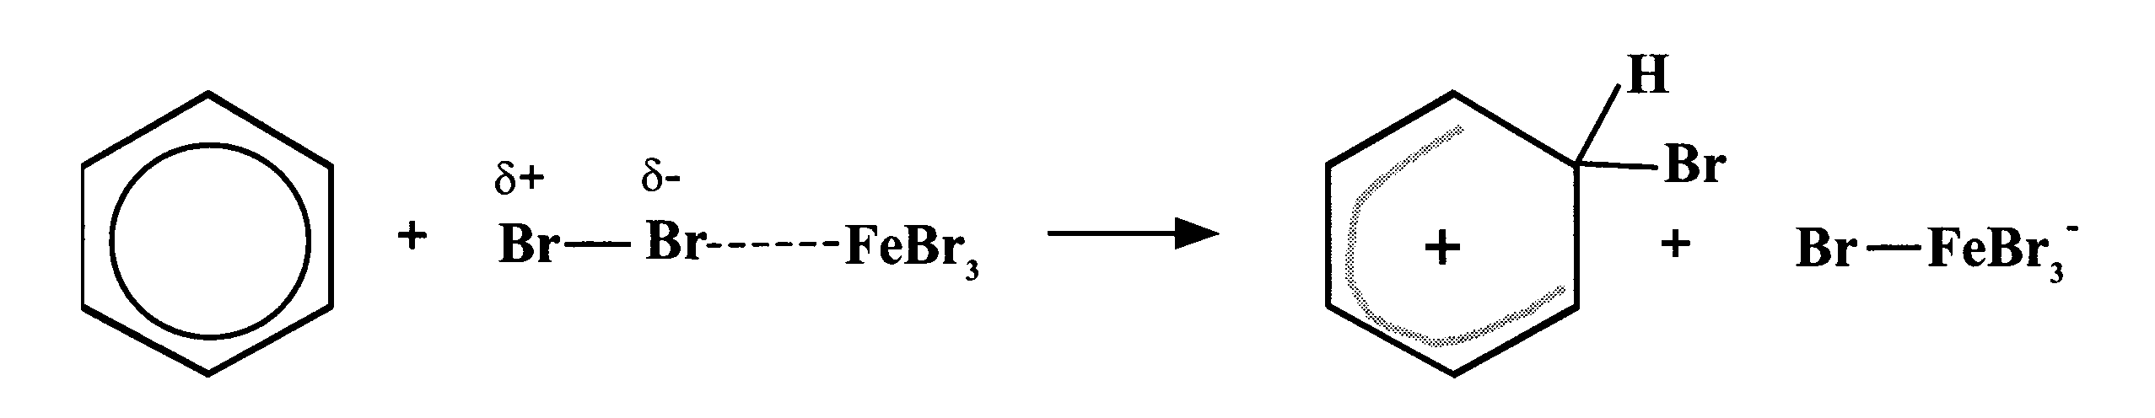

However, the similarity ends here and, by losing a hydrogen ion in the final step, the stable aromatic system is restored and the catalyst is regenerated (Figure 98).

Figure 98
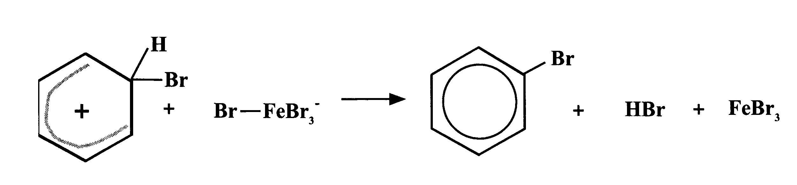

The overall effect is that one of the hydrogen atoms of the benzene molecule has been replaced by a bromine atom, i.e. an electrophilic substitution reaction has taken place (Figure 99).

Figure 99
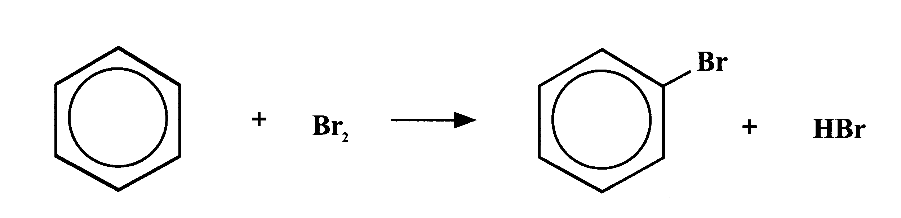

In the dark, chlorine undergoes a similar reaction with benzene to form chlorobenzene.

(Note that, in the presence of light, chlorine adds to benzene by a different mechanism to form 1,2,3,4,5,6-hexachlorocyclohexane – one of very few examples of addition to a benzene ring.)
Nitration

Benzene reacts with a mixture of concentrated nitric acid and concentrated sulfuric acid to form nitrobenzene (Figure 100).

Figure 100
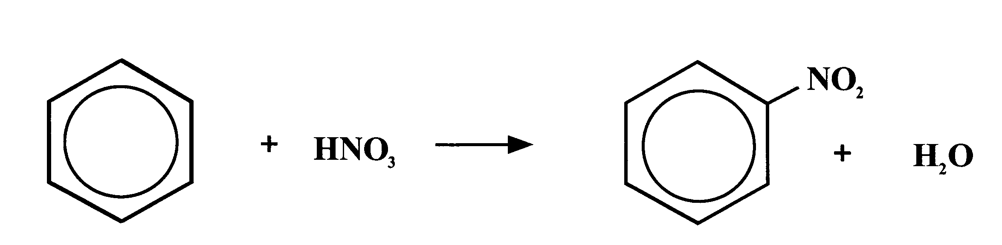
concentrated
H₂SO₄

This reaction is of great importance to industry since the nitrobenzene produced can be reduced to produce phenylamine, C₆H₅NH₂, also called aniline, which is an important intermediate in the manufacture of dyes.
The mechanism for nitration involves electrophilic attack by the very reactive nitronium cation NO₂⁺, which is generated from nitric acid by reaction with concentrated sulfuric acid:

HNO₃ + 2H₂SO₄ H₃O⁺ + 2HSO₄⁻ + NO₂⁺

The nitronium cation is a powerful electrophile and attacks the benzene molecule as shown in Figure 101.

Figure 101

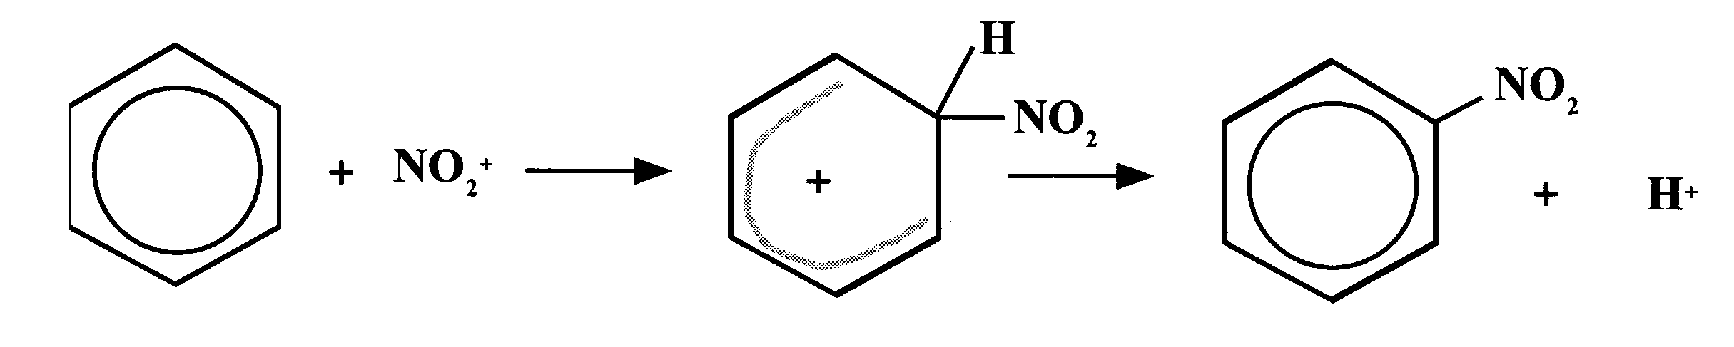

Sulfonation

Benzenesulfonic acid is formed if benzene is heated under reflux for several hours with concentrated sulfuric acid (Figure 102). This process is known as sulfonation.

Figure 102

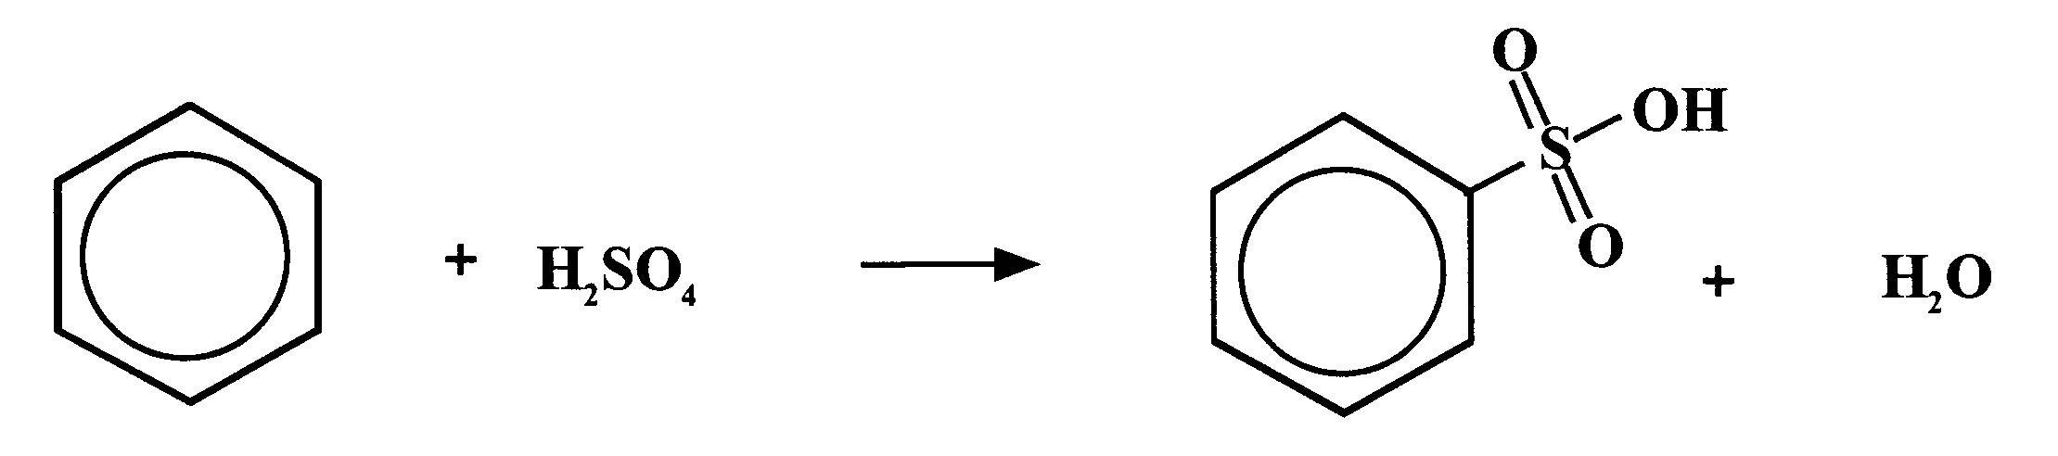

The same product is formed in the cold when Figure 103
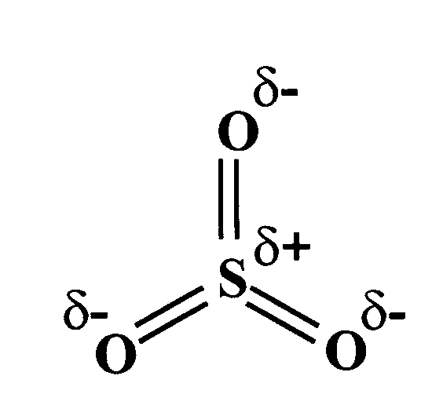
using fuming sulfuric acid, which is a solution of sulfur trioxide in concentrated sulfuric acid (Figure 103). The electrophile in sulfonation is believed to be the SO₃ molecule, either free or in combination with acid which helps to turn it into a strong enough electrophile to attack the benzene molecule. The SO₃ molecule is electron deficient and carries a partial positive charge on the sulfur atom. The mechanism is similar to that for nitration. This reaction is important in the production of synthetic detergents.

Alkylation

It was seen earlier (page 60) that aluminium(III) chloride was useful as a catalyst in the halogenation of benzene by promoting polarisation of the bond in the halogen molecule. This compound is also used, for similar reasons, as a catalyst in the reaction between benzene and haloalkanes (Figure 104).

Figure 104

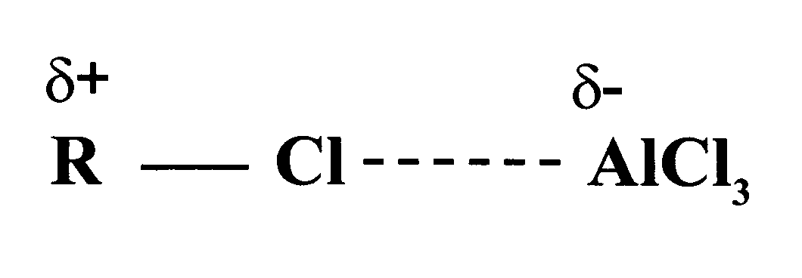
In this case, the C–Cl bond is already polar. The AlCl₃ catalyst increases the polarity and may even, with certain haloalkanes, cause the bond to break heterolytically to form a carbocation. In either case, the power of the electrophile is increased sufficiently to allow it to attack the benzene ring to form a monoalkylbenzene (Figure 105).

Figure 105

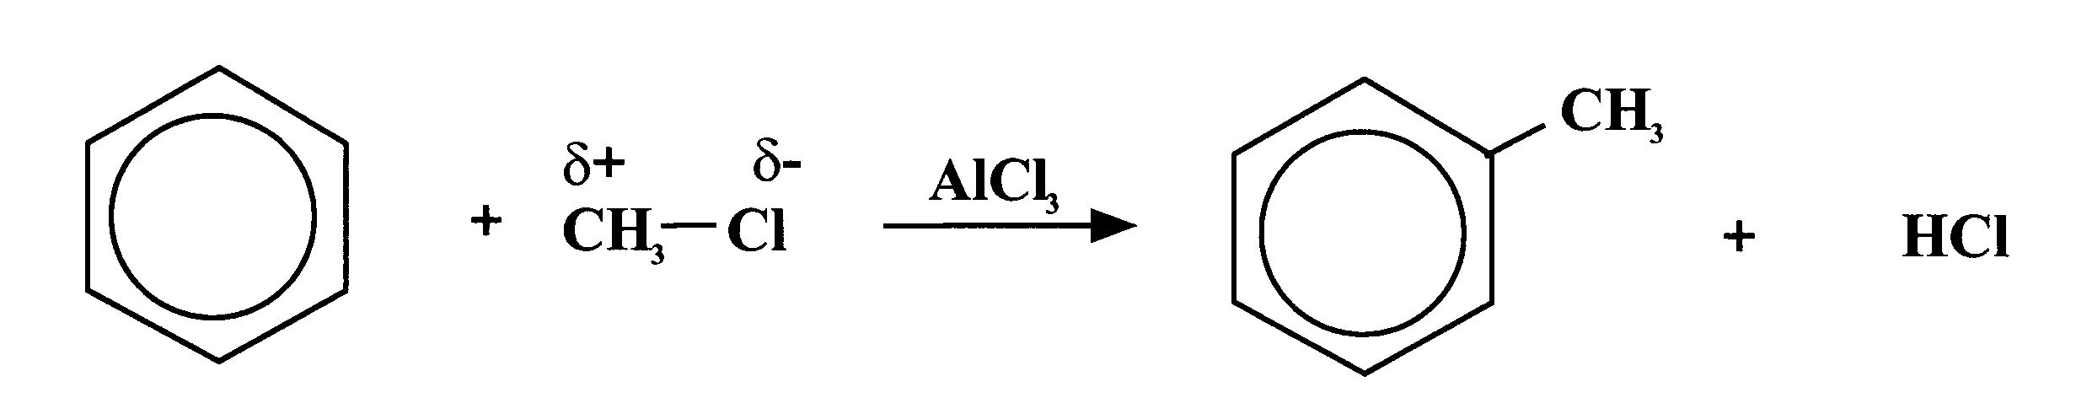

This reaction is used industrially in a variety of processes, including the manufacture of synthetic detergents, the production of phenol and propanone, and in the manufacture of nylon.

Electrophilic substitution is the typical reaction of the benzene ring. The presence of substituents on the ring has an influence on the outcome of this reaction. Some substituents increase the susceptibility to electrophilic attack while others decrease it. However, this aspect is beyond the scope of Advanced Higher. On the other hand, the benzene ring also has an influence on the behaviour of such substituents.

Question

Study the reaction scheme below, which is based on methylbenzene, and answer the following questions.

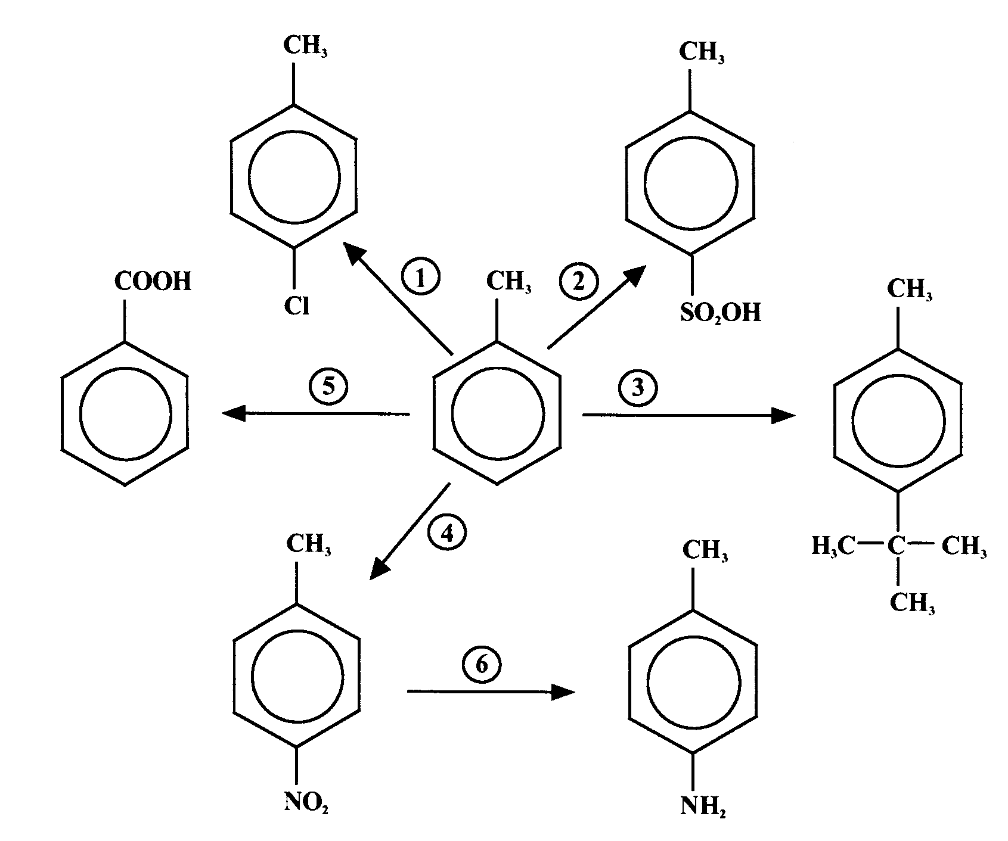

(a) What type of reaction is involved in reactions 1 to 4?

(b) For reactions 1 to 4, state the conditions required and in each case identify the electrophile.

(c) Identify the type of reaction involved in:
(i) reaction 5
(ii) reaction 6.

(d) Methylbenzene undergoes a free radical substitution with chlorine to give an isomer of the product of reaction 1. What conditions would be required for this reaction and what would be the product?

Section 5: Experimental Determination of Structure

Elemental microanalysis

Elemental analysis (or combustion analysis) is used to determine the masses of the elements in a sample of an organic compound in order to calculate its empirical formula.

The carbon, hydrogen and nitrogen contents are measured using an instrument known as a CHN analyser. For analysis approximately 2 mg of the solid sample is placed in a small tin capsule and weighed to ± 0.0001 g. This sample is then sealed before being put into a furnace where it is combusted in an atmosphere of oxygen at almost 1000oC. At this temperature, the carbon, hydrogen and nitrogen react with oxygen to form CO₂, H₂O and N_{X}O_{Y} respectively. These gases are carried via a stream of helium gas through a chromatography column to a detector. The detector sends data to a computer that compares it with that of a known value of a standard. Acetanilide is generally used as the standard since it conveniently contains the elements carbon, hydrogen and nitrogen.

Samples are usually analysed in duplicate to give more reliable results. The results are then given as a percentage, by mass, of each of the three elements.

If the sample is a liquid it is aspirated through a capillary glass tube before being weighed and put into the furnace.

To measure the sulfur content of a sample, a similar instrument with slight modifications needs to be used.

Compounds containing chlorine, bromine and iodine are titrated to determine the halide concentration. The sample is combusted and the gases passed through a halide-absorbing solution, which is then placed in an auto-titrator where a computer calculates the percentage of each halide. All three of these halides can be analysed simultaneously. Another method must be used to detect and measure the fluorine content of a sample.

Elemental analysis

It is often necessary to determine the mass of each of the elements in an organic compound in order to calculate the compounds empirical formula.

The ideas behind the technique is basically to use an analysis which determines the mass of each element by incinerating the compound at high temperatures i.e. 1000ºC and then allowing the elements to react with Oxygen. The products formed when C, H and N react with O₂ are CO₂, H₂O and NO (Nitrogen Oxides). Then they are compared with a standard (containing the elements required) and the mass and % composition can be determined.

Working out the mass of each element can be determined and a ratio derived by the following technique.

Q1 MASS OF COMPOUND = 1.224g
MASS OF OXYGEN = ?
MASS OF CARBON DIOXIDE = 2.340g
MASS OF WATER = 1.433g

STEP 1: Determine the mass of C in CO₂ + H₂ in H₂O

Mass of C in CO₂ = gfm C x Mass of CO₂
gfm CO₂ in sample

= 12 x 2.340
44

Mass of C in CO₂ = 0.638g

% composition = 0.638 x 100 = 52%
1.224 1

Mass of H₂ in H₂O = gfm H x mass of H₂O
gfm H₂O in sample

= 2 x 1.433
18

Mass of H₂ in H₂O = 0. 159g

% composition H₂ = 0.159 x 100 = 13%
1.224 1

STEP 2: To work out the oxygen used: take mass of C + H₂ and deduct from the mass of the whole compound.

Mass O₂ = mass of total sample - (mass C + mass H₂)
= 1.224 - (0.638 + 0.159)
= 1.224 - 0.797
Mass O₂ = 0.427g

% composition = 0.427 x 100 = 35%
1.224 1

STEP 3: Calculate the no. moles of C, H₂ + O₂ in sample by taking the mass of each and dividing by gfm.

No. moles of C = 0.638 = 0.053mol
12

No. moles of H = 0.159 = 0.159mol
1

No. moles of O = 0.427 = 0.0267mol
16

STEP 4: Calculate ratio. Take the smallest number and call it one. Then see how many times it goes into this other no.

i.e. smallest no: 0.0267 = 1 i.e. O = 1

0.053 = 2 i.e. C = 2
0.0267

0.159 = 6 i.e. H = 6
0.0267

STEP 5: Write empirical formula C₂ H₆ O

These ratios could also be calculated from the % compositions.

Questions

1. A sample of an organic compound with a mass of 1.224 g was completely burned in oxygen and found to produce 2.340 g of CO₂ and 1.433 g of water only. Calculate the empirical formula of the organic compound. (Note, this is the worked example shown above).

2. Oxalic acid is found in rhubarb and contains only the elements carbon, hydrogen and oxygen. When 1.540 g of oxalic acid was burned in oxygen, 1.504 g of CO₂ and 0.310 g of water were formed. Calculate the empirical formula for oxalic acid. If the molecular mass of oxalic acid is 90.0, what is its molecular formula?

3. An organometallic compound known as ferrocene contains only the elements Fe, C and H. When 1.672 g of ferrocene was combusted in oxygen, 3.962 g of CO₂ and 0.810 g of water were formed. Calculate the empirical formula of ferrocene.

Spectroscopy

MASS SPECTROMETRY

Introduction

Mass spectrometry can be used to determine the structure of organic molecules.

Figure 106 shows a diagram of a simple mass spectrometer.

Figure 106
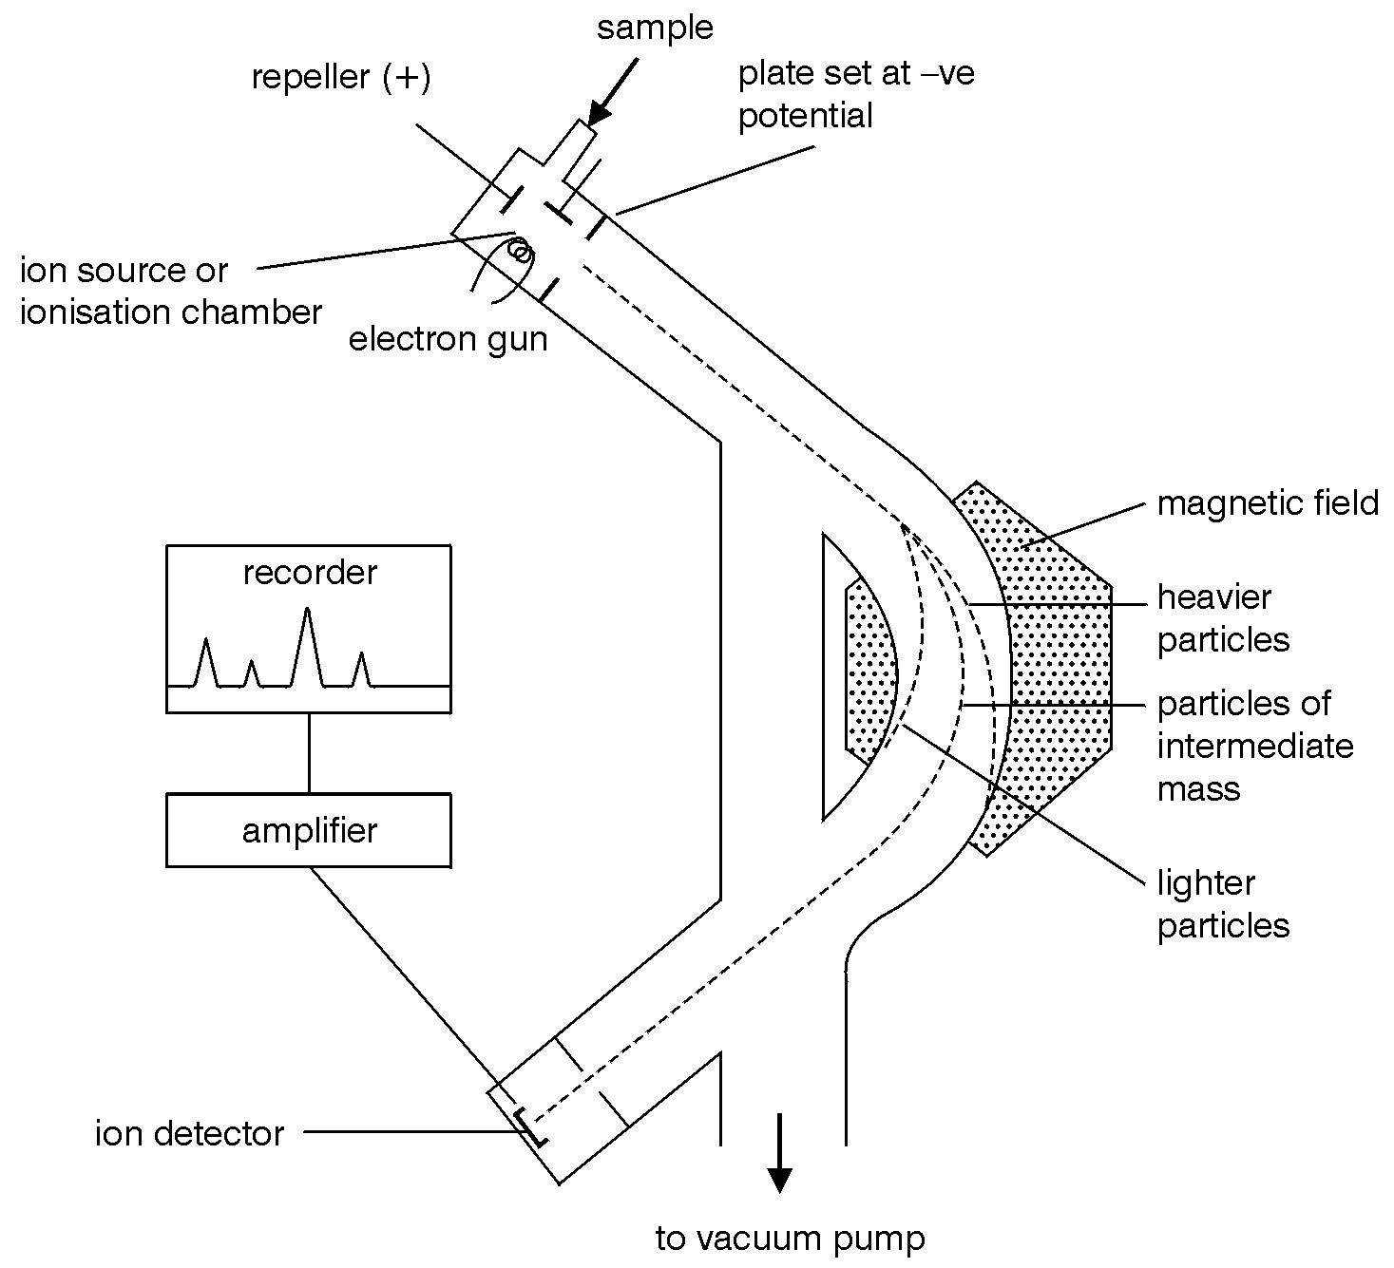

This type of mass spectrometer functions in the following manner:
1. The vacuum pump is switched on to reduce the pressure in the spectrometer.
2. A sample is introduced into the spectrometer and vaporised.
3. The vaporised sample is then bombarded with an electron beam in the ionisation chamber. These electrons ‘knock off’ some of the outer electrons from the molecules in the sample and positive ions are formed.
4. Fragmentation of the molecules can also occur when the energy available is greater than the molecular ionisation energy. Some of these different fragments are also positive ions.
5. The parent ion and ion fragments are accelerated by an electric field until they have similar kinetic energy and form an ion beam.
6. The ions are deviated by a magnetic field in such a way that ions of one particular mass/charge ratio continue along the spectrometer and hit the detector.
7. The strength of the magnetic field is varied to enable the ions of all different mass/charge ratios to be detected in turn.
8. The mass spectrum is plotted automatically by the instrument. The mass/charge ratio is labelled as m/z. Doubly charged ions can be formed in the mass spectrometer and they are detected at half their mass value on the mass spectrum.

In some respects molecules behave in a similar way to atoms in a mass spectrometer, but there are important differences:

When a molecule is ionised, one electron is removed. As molecules generally contain paired electrons only, the result is the formation of a species with an unpaired electron, or a free radical.

e.g. ethane: C₂H₆ [C₂H₆] ^{• +} + e

The resulting species is thus a positively charged ion and also a free radical. It is known as the molecular ion (or parent ion).

Two possible things can happen to a molecular ion when it is formed:

- it can pass intact through the mass spectrometer and onto the detector, being detected as having an m/z ratio of which z = 1 and m = relative mass of molecular ion.

- it can break up into two smaller, more stable species, one of which is a positively charged ion and one is a free radical. This is known as fragmentation. This will result in the detection of species with m/z ratios which are less than that of the molecular ion.

The result is that a number of different peaks are seen in the mass spectrum of an organic molecule:

- the peak with the largest m/z ratio corresponds to the molecular ion, and this m/z ratio corresponds to the relative molecular mass of the molecule.

- the peaks with smaller m/z ratios result from fragmentation of the molecular ion. These peaks can be used to deduce more information regarding the structure of the molecule, because different molecules fragment in different ways and some fragments are more stable than others.

e.g. mass spectrum of ethanol:

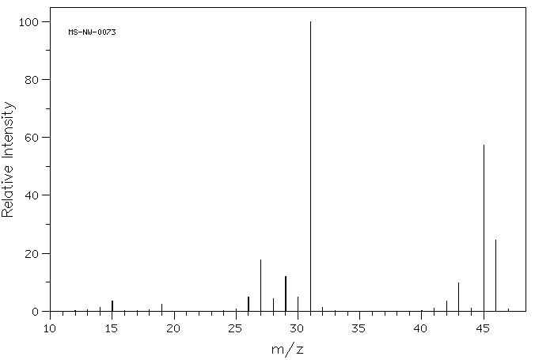
Figure 107

The mass spectrum of ethanol (Figure 107) contains several peaks:

- the largest m/z ratio in the mass spectrum is 46. This is therefore the molecular ion peak which means that the molecule has a relative molecular mass of 46.
- the other peaks with smaller m/z ratios result from fragmentation of the ethanol molecule. The most abundant fragment ions appear to have relative masses of 45 and 31, and there are less abundant fragment ions with masses of 27 and 29

Fragmentation

When a molecular ion fragments, it forms other ions and neutral molecules. This gives rise to a number of peaks in the mass spectrum. The arrangement and sizes of the peaks formed when the molecular ion of an organic compound breaks down in the mass spectrometer is known as the fragmentation pattern.

In some compounds the molecular ion forms a large peak in the mass spectrum, e.g. the peak at m/z 122 in the mass spectrum of benzoic acid (Figure 109). In other compounds the molecular ion fragments so easily that it produces an insignificant peak in the mass spectrum, e.g. butyl ethanoate (Figure 108). The molecular ion of butyl ethanoate fragments as follows:

CH₃COOCH₂CH₂CH₂CH₃⁺ CH₃O+ + C₄H₉O

and

CH₃COOCH₂CH₂CH₂CH₃⁺ C₄H₈⁺ CH₃COOH

The remaining ions fragment further to give the mass spectrum shown in Figure 108.

Figure 108: Mass spectrum of butyl ethanoate

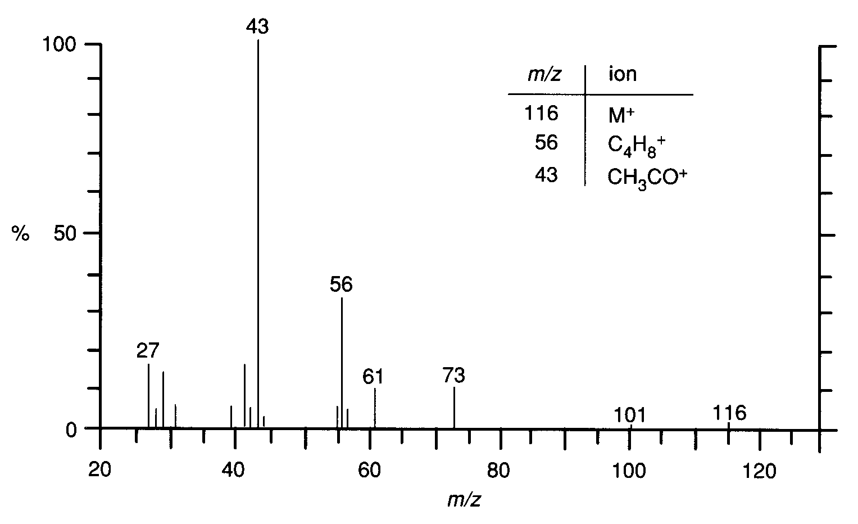

The fragmentation pattern of an organic compound can be used to help identify the type of organic compound present.

Question

Look at the mass spectra of benzoic acid and methyl benzoate and identify the ions responsible for the major peaks in each case.

Figure 109: Mass spectrum of benzoic acid

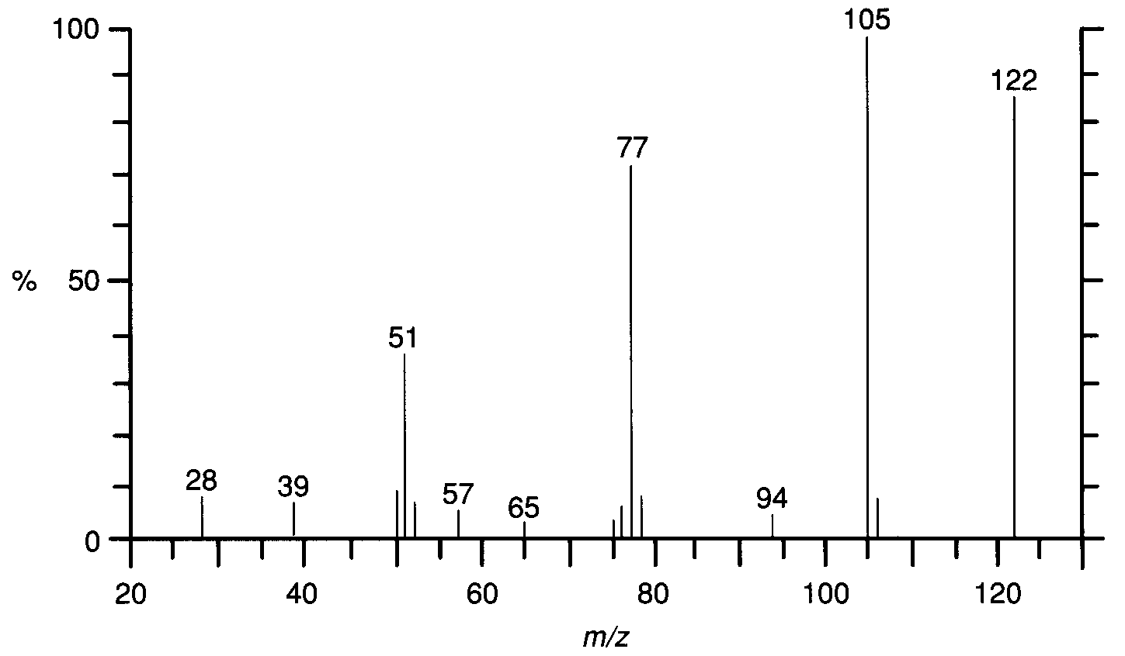

Figure 110: Mass spectrum of methyl benzoate

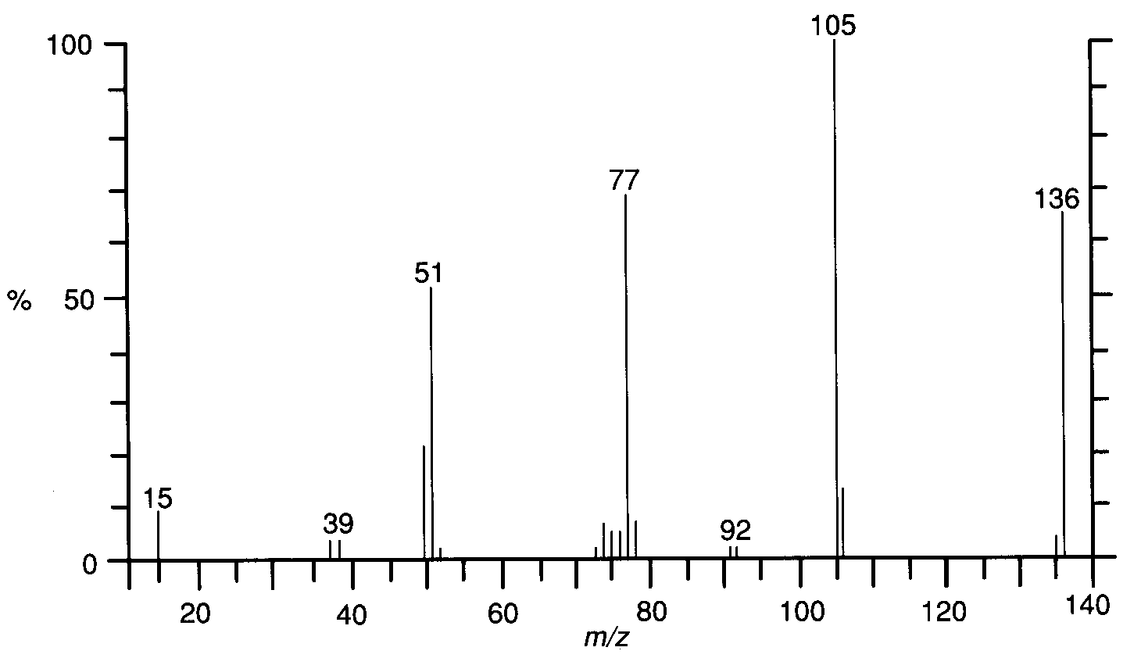

A range of resources to help in your understanding of the principles and practice of spectroscopy and spectroscopic methods are available on the RSC website at: http://spectraschool.rsc.org/ [Last accessed January 2016]
Infra-red spectroscopy

Infra-red spectroscopy can be used to identify certain functional groups in an organic compound. The atoms in molecules vibrate even in the solid state. Each atom vibrates with a frequency that depends on its mass and the length and strength of its bonds. The natural vibrational frequency of chemical bonds lies within the infra-red region of the electromagnetic spectrum and so molecular vibrations are stimulated by bonds absorbing infra-red radiation. In simpler terms it can be stated that infra-red radiation causes parts of a molecule to vibrate. The wavelengths that are absorbed and cause these vibrations depend on the nature of the chemical bonds and the groups or atoms at the ends of the bonds.

Examples of different types of vibration are shown in Figure 111.

Figure 111
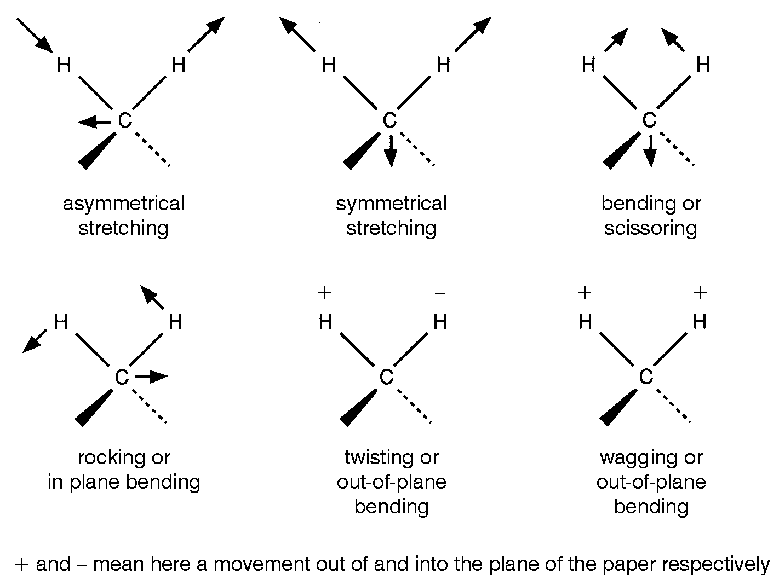

These different vibrations absorb different frequencies of infra-red radiation. The absorption is usually given in wavenumbers, units cm⁻¹. The relationship between frequency, wavelength, wavenumber and energy dealt with in Unit 1a is repeated here. The relationship between wavelength, frequency and velocity is:

velocity = wavelength × frequency
(ms⁻¹) (m) (s⁻¹)
c = and hence
Wavenumber is the reciprocal of wavelength and is given the symbol :
and hence
or or E= Lhc x wavenumber
where L is Avogadro’s constant (see data booklet page 22).

These relationships are summarised in Table 8.

Quantity | Symbol | Units | Description
Wavelength | λ | Metres (m) | Distance between adjacent wave crests
Velocity | c | m s^{–1} | Rate of advance of any one wave crest
Frequency | f | Hertz (Hz) | The number of wavelengths or cycles passing a point in 1 second
Wavenumber |  | Waves per metre (m⁻¹) or more commonly cm⁻¹ | Number of waves in one metre or one centimetre of radiation. Often used in place of frequency

Table 8

Compared to visible light, infra-red radiation has lower frequency and thus longer wavelength and lower energy. A typical infra-red spectrometer measures absorbance in the range 650–4000 cm⁻¹.

Conventional infra-red spectrometers have two beams of radiation: one passes through the sample and the other passes through a reference cell. When a particular frequency is absorbed by the sample, less radiation is transmitted and the detector compares the intensity passing through the sample with that passing through the reference.

Only vibrations resulting in a change in the dipole moment absorb infra-red radiation. In simple molecules such as SO₂, it is relatively easy to assign each absorption to a particular vibration. With more complex molecules each absorption can be assigned to the vibrations of particular functional groups within the molecule. Since particular types of vibration always occur at a similar frequency it is possible to build up a table of characteristic absorption frequencies (see page 14 of the Data Booklet). This means that a study of the infra-red spectrum of a compound will enable the functional groups present in that compound to be identified.

The infra-red spectrum of propanal is shown in Figure 112. Note that the major absorption peak at around 1730 cm⁻¹ is due to the carbonyl group.

Figure 112

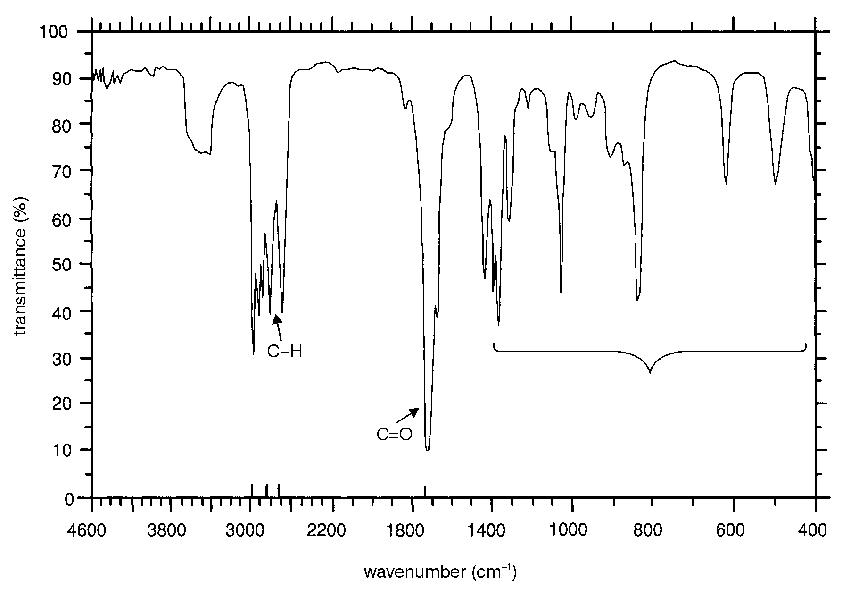
fingerprint

The pattern of absorptions below 1400 cm⁻¹ is characteristic of a particular organic compound and can be used in its identification. This region is often called the ‘fingerprint’ region.

Question

The spectra below (Figures 113 and 114) are of ethanoic acid, CH3COOH, and ethanoic anhydride, (CH₃CO)₂O. Draw the full structural formula for both compounds and then determine, giving reasons, which spectrum is due to which compound.

Figure 113

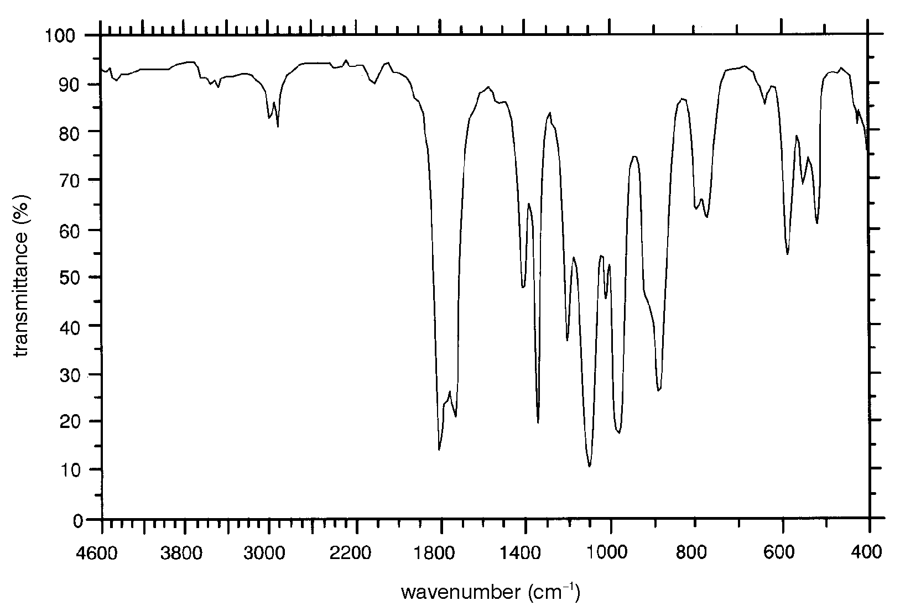

Figure 114

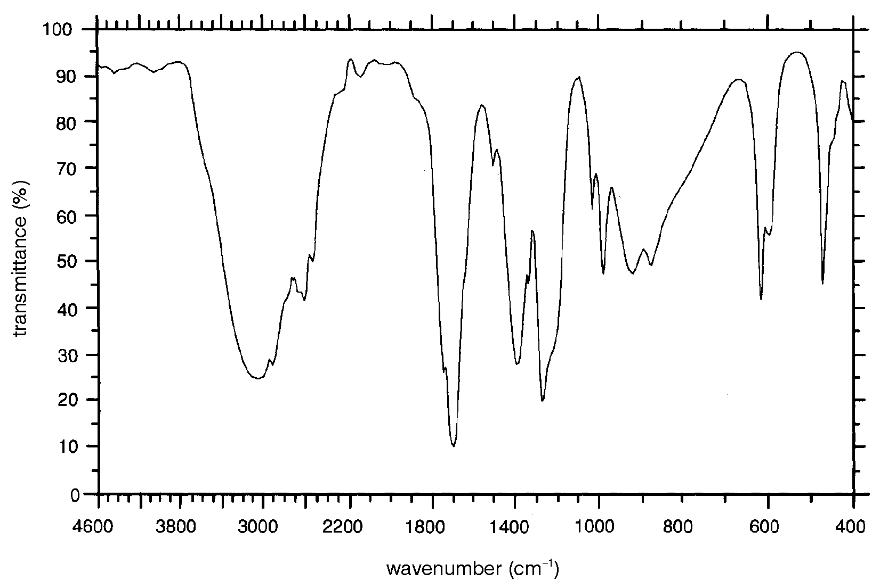
Nuclear magnetic resonance spectroscopy

Nuclear magnetic resonance (NMR) spectroscopy is one of the most useful analytical tools available to the modern organic chemist. It is possible to derive a huge amount of information concerning the environment of the carbon and hydrogen atoms in an organic molecule from a single NMR spectrum.

Theory

It has been discovered that many nuclei behave as if they were spinning about an axis. For organic chemists, the most important of these nuclei are ¹H and ¹³C. We will only consider ¹H at Advanced Higher level. Since the nucleus of an ¹H atom is simply a proton, the technique is often described as proton NMR spectroscopy.

Any spinning charged particle produces a magnetic field. In other words it will behave like a tiny magnet. Any ¹H nucleus will have either of two possible spin states (Figure 115). Compare this with the similar situation that arises with electrons (see Unit 1a).

Figure 115

In the absence of a magnetic field, the spin states have the same energy. However, if the nuclei are placed in an external magnetic field (e.g. between the poles of a powerful magnet), the nuclei become orientated in much the same way as a compass needle orientates itself in the earth’s magnetic field. The nuclei with one spin state will align themselves in the same direction as the magnetic field (parallel to the field) while the nuclei with the other spin state will oppose the magnetic field (Figure 116).

Figure 116
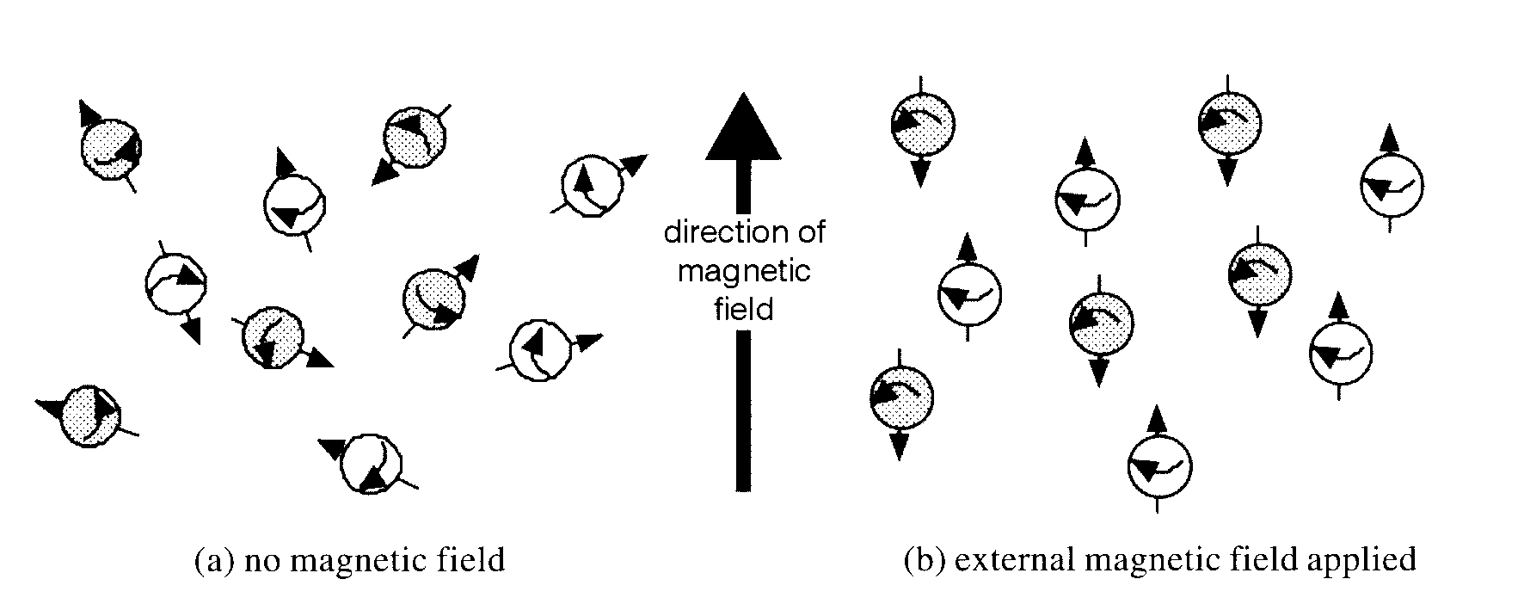
Those nuclei that are parallel to the magnetic field will have lower energy than those that oppose the field (Figure 117).

Figure 117

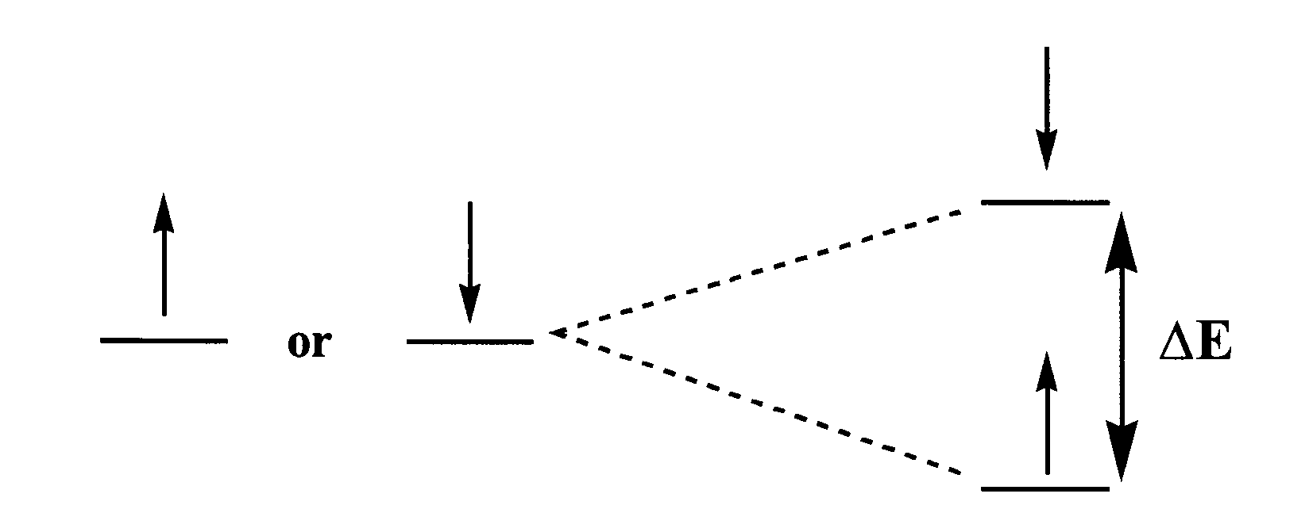
(a) no magnetic field (b) external magnetic field applied

The stronger the applied magnetic field, the greater will be the energy difference (ΔE) between the two states. If nuclei that are parallel to the field absorb sufficient energy, the spin can be ‘flipped’ to the higher energy state. The energy difference between the two states corresponds to the radio frequency region of the electromagnetic spectrum, typically in the VHF region, 60–1000 MHz. When the nuclei fall back to the lower state, the energy emitted can be detected.

Electrons also have the property of spin (see Unit 1a). The electron cloud around a nucleus will therefore generate its own magnetic field. When an external magnetic field is applied, the ¹H nucleus does not experience its full effect. Instead it will experience a different field because it is ‘shielded’ by the magnetic field of the electron cloud. In any organic molecule, the density of the electron cloud will vary from one part of the molecule to another. Different hydrogen nuclei will experience slightly different magnetic fields and will therefore have slightly different energy gaps (ΔE) between their spin states. The radiation absorbed or emitted by an ¹H nucleus as it changes from one state to another therefore depends on its local environment in the molecule. This variation of absorption frequency with chemical environment is called chemical shift.

Producing an ¹H NMR spectrum

The sample to be analysed is dissolved in a solvent that contains no hydrogen atoms, e.g. CDCl₃ or CD₃COCD₃. D is deuterium (²H), which has an NMR frequency that is a long way from ¹H. The applied magnetic field is kept constant and a pulse of radio frequency is supplied which promotes some nuclei to the higher energy state. Immediately after the pulse, some nuclei will drop back and emit radiation of a frequency corresponding to ΔE. This radiation can be detected but it is very weak. The process is repeated many times and the data is repetitively added up and stored and then analysed by computer.

When producing an ¹H NMR spectrum, an internal reference standard is included in the solution. Tetramethylsilane [Si(CH₃)₄, normally called TMS] is chosen because it produces a sharp signal in a region well away from the signals produced by almost all other organic hydrogen atoms. TMS is assigned a chemical shift of zero. For any ¹H atom, the chemical shift is expressed as the difference between its signal and that of TMS and is denoted by the symbol δ (delta). Notice that the units of δ are parts per million, emphasising how small the effect is.

Interpreting low resolution NMR spectra

In an organic molecule, different hydrogen atoms will be in different environments and have different chemical shifts. Each different environment will give rise to a different signal, e.g.
• in benzene, C₆H₆, all the hydrogen atoms are identical and only one peak appears in the spectrum.
• in ethanal, CH₃CHO, there are two different kinds of environment for the hydrogen atoms (the methyl group and the aldehyde group) and two peaks are produced.

Figure 118 shows the low-resolution NMR spectrum for ethanol.

Figure 118

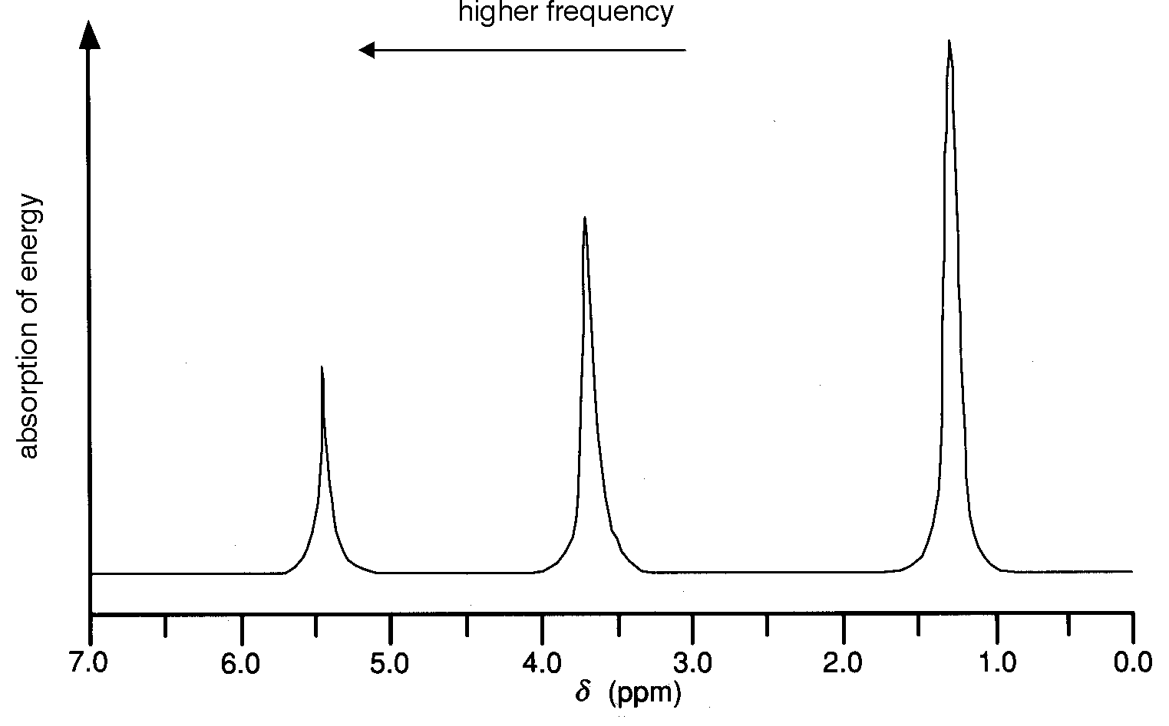

There are three peaks because there are three different environments for the ¹H atoms in ethanol. The peak at about 1.2 δ is caused by the ¹H atoms in the methyl group (CH₃). The peak at about 3.7 δ is caused by the hydrogen atoms in the CH₂ group. The smallest peak at about 5.4 δ is caused by the ¹H atom of the hydroxyl group (OH).

Tables are available which show the chemical shifts of ¹H atoms in different environments, e.g. page 15 of the Data Booklet. If the NMR spectrum of an unknown substance is produced, the chemical shifts of the peaks can be compared with the values in the tables to predict the different environments for the ¹H atoms in the sample.

However, the spectrum can provide yet more information. Look again at the spectrum for ethanol (Figure 118). The peaks are clearly different in size. In fact, the area under each peak is proportional to the number of ¹H atoms causing the absorption. In an ethanol molecule, there are three identical hydrogen atoms in the methyl group but only one hydrogen atom in the hydroxyl group. Consequently, the area under the methyl peak (1.2 δ) is three times the area under the hydroxyl peak (5.4 δ). Estimating areas is not easy so in practice an integration curve is plotted on the NMR spectrum (see Figure 119).

Figure 119

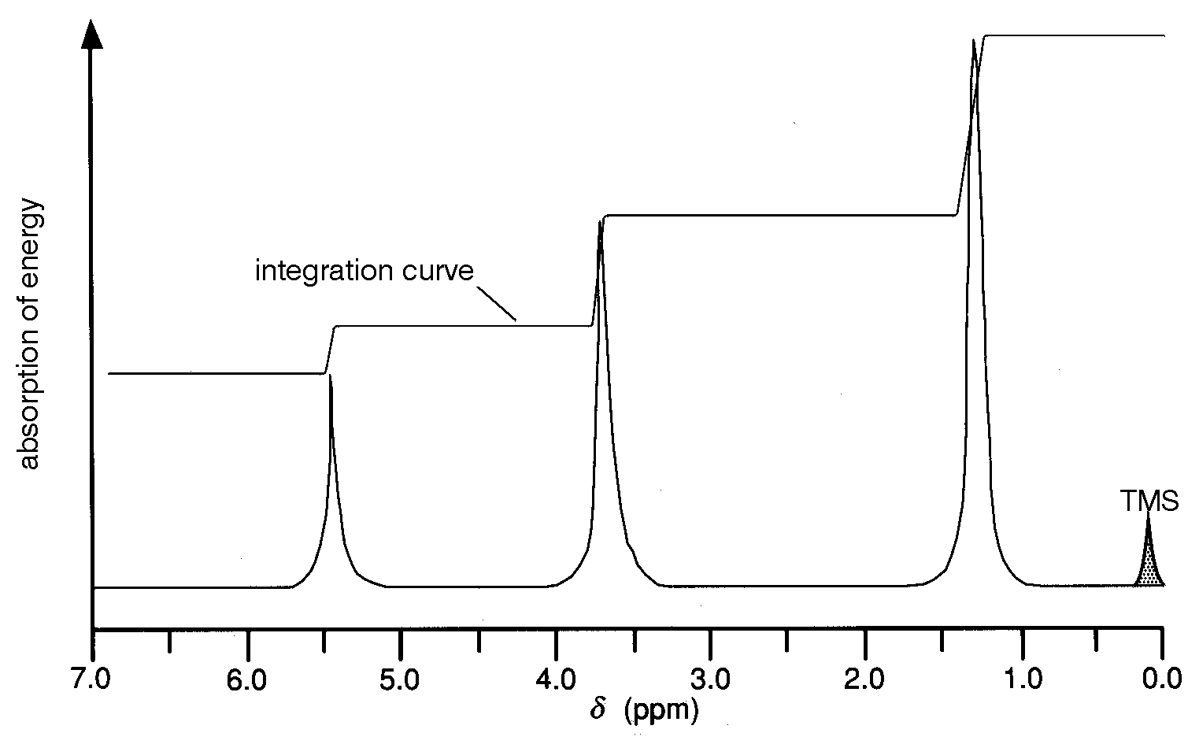

By measuring the height of the step in the integration curve for each signal, the ratio of ¹H atoms can be determined. Usually the spectrometer’s computer will give a numerical printout of the area under each peak. As well as giving information about the number of different environments for the ¹H atoms in a molecule, an NMR spectrum therefore gives information about the ratio of the number of hydrogen atoms in each environment.

Questions

From the following low-resolution NMR spectra and the other information given, suggest a possible structure for each substance.

1. Figure 120 is the spectrum for a hydrocarbon.

Figure 120

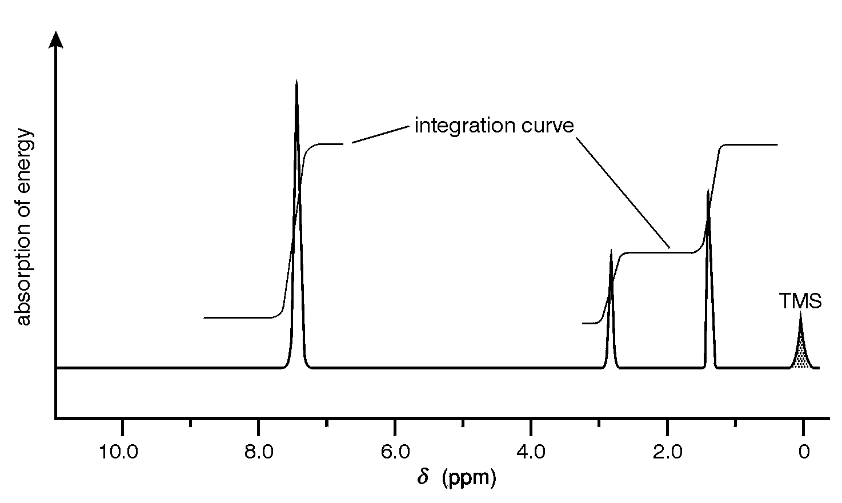

2. Figure 121 is the spectrum produced by a compound of molecular formula, C₂H₄O

Figure 121
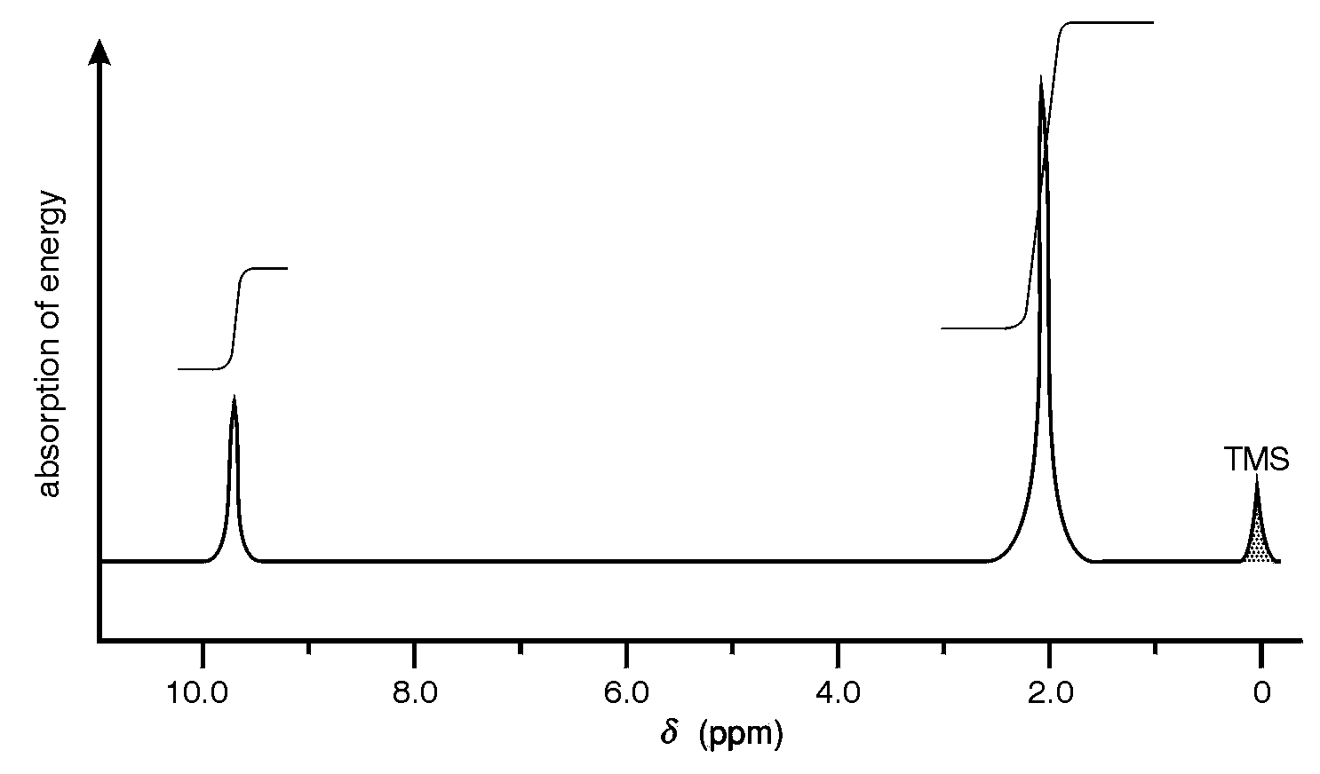

3. Analysis of a sweet-smelling, neutral compound of carbon, hydrogen and oxygen produced the following results: %C = 54.5; %H = 9.1.
From its mass spectrum, the molecular ion had a mass/charge ratio of 88.
Its infra-red spectrum showed a prominent peak at 1735 cm⁻¹.
Figure 122 shows the NMR spectrum of the compound.

Figure 122

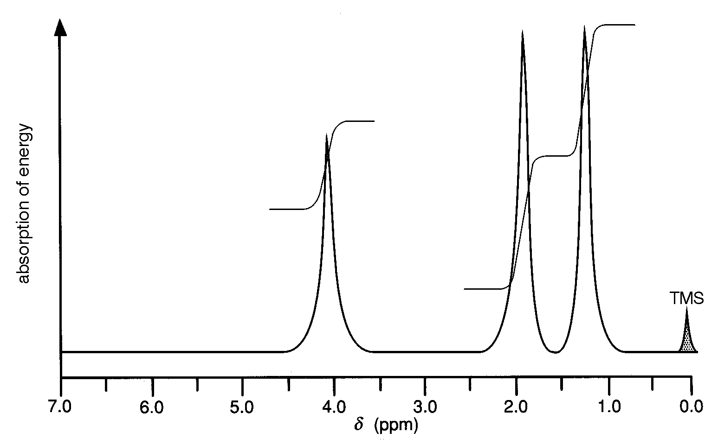

The difference between high and low resolution spectra

What a low resolution NMR spectrum tells you:
- The number of peaks tells you the number of different environments the hydrogen atoms are in.
- The ratio of the areas under the peaks tells you the ratio of the numbers of hydrogen atoms in each of these environments.
- The chemical shifts give you important information about the sort of environment the hydrogen atoms are in.

High resolution NMR spectra

In a high resolution spectrum, you find that many of what looked like single peaks in the low resolution spectrum are split into clusters of peaks.

1 peak a singlet
2 peaks in the cluster a doublet
3 peaks in the cluster a triplet
4 peaks in the cluster a quartet

You can get exactly the same information from a high resolution spectrum as from a low resolution one - you simply treat each cluster of peaks as if it were a single one in a low resolution spectrum. But in addition, the amount of splitting of the peaks gives you important extra information.

Interpreting a high resolution spectrum

The n+1 rule

The amount of splitting tells you about the number of hydrogens attached to the carbon atom or atoms next door to the one you are currently interested in.

The number of sub-peaks in a cluster is one more than the number of hydrogens attached to the next door carbon(s). So - on the assumption that there is only one carbon atom with hydrogens on next door to the carbon we're interested in.

singlet next door to carbon with no hydrogens attached
doublet next door to a CH group
triplet next door to a CH₂ group
quartet next door to a CH₃ group

Using the n+1 rule

What information can you get from this NMR spectrum (Figure 123)?

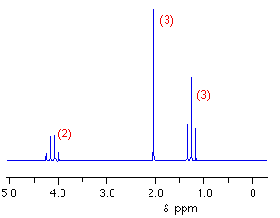
Figure 123

Assume that you know that the compound above has the molecular formula C₄H₈O₂.

Treating this as a low resolution spectrum to start with, there are three clusters of peaks and so three different environments for the hydrogens. The hydrogens in those three environments are in the ratio 2:3:3. Since there are 8 hydrogens altogether, this represents a CH₂ group and two CH₃ groups. What about the splitting?

The CH₂ group at about 4.1 ppm is a quartet. That tells you that it is next door to a carbon with three hydrogens attached - a CH₃ group.
The CH₃ group at about 1.3 ppm is a triplet. That must be next door to a CH₂ group.​ This combination of these two clusters of peaks - one a quartet and the other a triplet - is typical of an ethyl group, CH₃CH₂. It is very common.
Finally, the CH₃ group at about 2.0 ppm is a singlet. That means that the carbon next door doesn't have any hydrogens attached.

So what is this compound? You would also use chemical shift data to help to identify the environment each group was in, and eventually you would come up with:

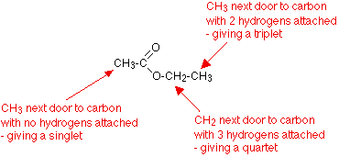

You should now complete the questions in the NMR Workbook
Section 6: Pharmaceutical Chemistry

Effect of drugs on the body

Most, if not all, of us will have taken medicines or drugs at some time or another during our lives. These might have been antibiotics prescribed by our doctor to counteract infection, simple painkillers bought from the local pharmacy or supermarket to cure a headache or toothache, inhalers to treat asthma or drugs to prevent heart disease.

Pharmaceutical companies invest huge sums of money in research in order to produce, profitably, the wide variety of medicinal compounds used daily by millions of people worldwide to relieve suffering, cure illnesses and save lives. Whatever our own personal experience may be, the pharmaceutical industry is very big business.

Before continuing, it is useful to clarify the distinction between medicines and drugs. Any substance that alters the biochemical processes of the body is known as a drug. Drugs are said to be pharmacologically active (pharmacology involves the study of how drugs affect living organisms). Substances that have a beneficial effect are invariably called medicines. A medicine usually contains the drug plus other ingredients.

Classification of drugs

Drugs can be split into two types: agonists and antagonists.

An agonist will produce a response similar to the body’s natural active compound.

An antagonist produces no response because it prevents the action of the body’s natural active compound.

How drugs work

To understand how medicines work, it is first necessary to understand:
• what is meant by a receptor
• how enzymes work.

A receptor is a part of a very large protein molecule that has evolved naturally to interact with a specific small, biologically active molecule. The shape, size and structure of the receptor site are such that the biologically active molecule can bind reversibly with the receptor. Such binding, between functional groups in the active molecule and functional groups in the complex protein, involves weak forces such as hydrogen bonding and weak electrostatic interactions.

Many different kinds of cell in the body have receptors on the surface of the cell. If the correct natural molecule binds to the receptor site, it activates the cell and triggers a biological response within the cell. The active molecule then leaves the site without itself being chemically changed (Figure 124).

Figure 124

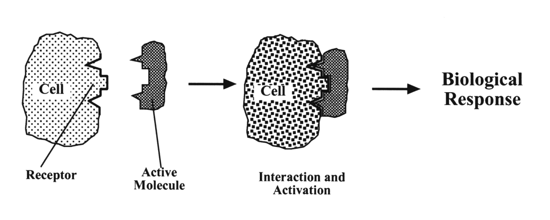

For example, if the cell is a muscle cell, the muscle cell will contract. If a nerve cell (neurone) receives the correct chemical messenger, a nerve impulse is sent on to the next nerve cell. Certain cells throughout the body respond by producing secretions. For example, in the stomach some cells secrete acid to aid the digestion of food while other cells secrete mucus, which forms a coating over the stomach wall to help prevent the stomach wall from being damaged by the acid.

This situation can be compared to a car engine and its ignition key. The car engine represents the cell. The ignition lock represents the receptor and the key represents the biologically active molecule. When the correct key (i.e. a small molecule) is fitted into the lock (i.e. the receptor), it can be turned to
switch on the ignition (i.e. activate the cell) and start the car engine (i.e. produce a biological response). Clearly the shape of the key is critical. If it does not fit the lock, the car cannot be started. Similarly, if the shape of the small molecule is such that it does not fit the receptor site, the cell will not be activated and there will be no response.

As mentioned earlier in the optical isomerism section (page 73), naturally occurring human proteins are polymers made from chiral α-amino acids (Figure 28). It follows that proteins themselves will be chiral and that the receptor sites will also be chiral. Consequently, only the correct optical isomer (or enantiomer, see page 72) of the chemical messenger will be biologically active.

Enzymes operate in a very similar way. Enzymes are large complex protein molecules which act as effective catalysts for biological processes. Protein molecules consist of a large number of -amino acids joined together by peptide (amide) links. Proteins are often referred to as polypeptides. The polypeptide chain naturally forms itself into a helical shape held together by internal hydrogen bonding. This helix in turn is folded into a three-dimensional structure, part of which forms a pocket known as the active site (Figure 125). This is also known as a catalytic receptor. The shape of this active site determines the function of the enzyme. A natural molecule (or part of a molecule) will fit into this site. This molecule is generally known as the substrate molecule. Once in position, the substrate molecule is changed chemically by the enzyme. This chemical change may involve cleavage of the substrate molecule (e.g. hydrolysis of sugars or proteins) or may involve the substrate molecule linking to other molecules (e.g. protein synthesis).

Figure 125
(Note that this diagram is flat. In practice, the active site is three-dimensional.)

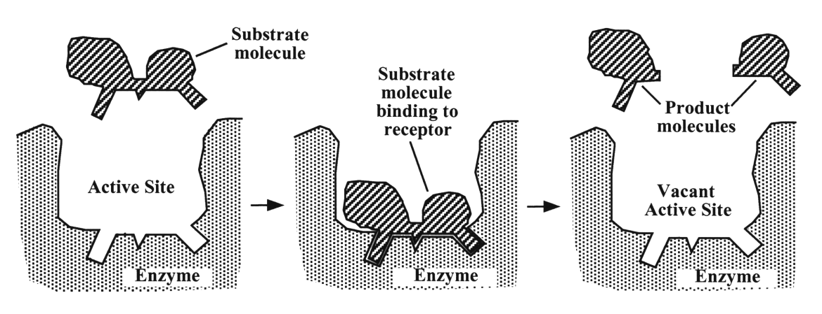

In Figure 125, it may be that groups within the active site bind to the substrate molecule in such a way that some bonds within the substrate molecule are weakened, causing the substrate molecule to split into two fragments. Alternatively, bonds within the substrate molecule may become more polarised and so more susceptible to attack by water, making hydrolysis much easier.

The product molecules are then released and the site is available to perform the same reaction on more substrate molecules.

Medicines work by acting on a receptor site either to mimic the response of the natural active compound or to block the effect of the natural compound. Medicines can be classified as agonists or antagonists according to the way in which they operate.

An agonist interacts with a receptor to produce a response similar to the body’s natural active compound.

An antagonist interacts with a receptor to produce no response because it prevents the action of the body’s natural active compound.

Using the car key analogy again, an agonist molecule is like a good copy of the original ignition key. It will fit into the lock and will still turn to switch on the engine. The agonist molecule will be sufficiently similar in structure and shape to the natural molecule that it binds to the receptor and activates the cell.

An antagonist molecule is like a badly copied key that fits into the lock but will not turn and so is unable to switch on the engine. It may also stick in the lock, preventing any other key from starting the engine. The antagonist molecule will be similar enough to the natural molecule to allow it to bind to the receptor but sufficiently different in some way so that it is prevented from activating the cell. For example, the natural molecule may contain four functional groups that are essential for binding to the receptor and for activating the cell. The antagonist molecule may contain only three of these groups. It will be able to bind to the receptor but the lack of the fourth functional group prevents it from activating the cell. If the binding between the receptor and the antagonist molecule is stronger than the binding with the natural molecule, the antagonist molecule will remain attached and block the receptor. This prevents the natural molecule from activating the cell and producing the biological response.

Most medicines and drugs are complex molecules containing a variety of functional groups. Some of these groups may not be essential for binding to the receptor. For chemists trying to design new, more effective medicines, it would be useful to know the minimum structural requirements for a molecule to be pharmacologically active.

The structural fragment of the molecule that confers pharmacological activity on it is called the pharmacophore. The shape of the pharmacophore complements that of the receptor site, allowing it to fit into the receptor. The functional groups on both structures are correctly positioned to interact and bind the medicine molecule to the receptor.

Figure 126

- (b) (c)
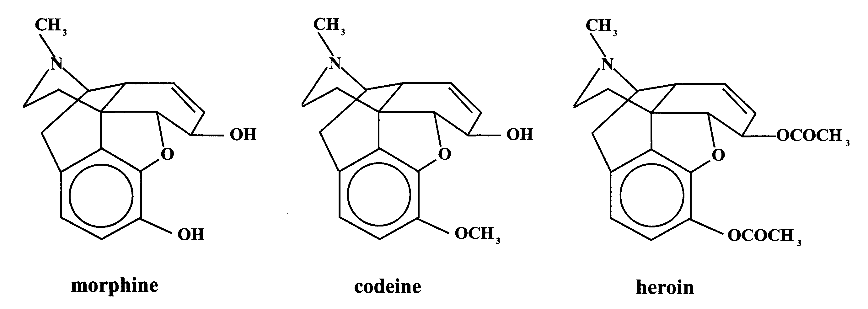

Figure 126a shows a structural representation of a molecule of morphine, a highly addictive analgesic. For simplicity, the carbon-to-carbon bonds are shown by lines and the symbols for most of the carbon and hydrogen atoms are not shown. Consequently, each corner or line junction represents a carbon atom. The structures for codeine (Figure 126b) and heroin (Figure 126c) are obviously very similar. Both of these compounds are also highly addictive and powerful analgesics. By comparing the structures of a number of medicines with similar pharmacological activity, the pharmacophore can be identified.

Figure 127 Figure 128

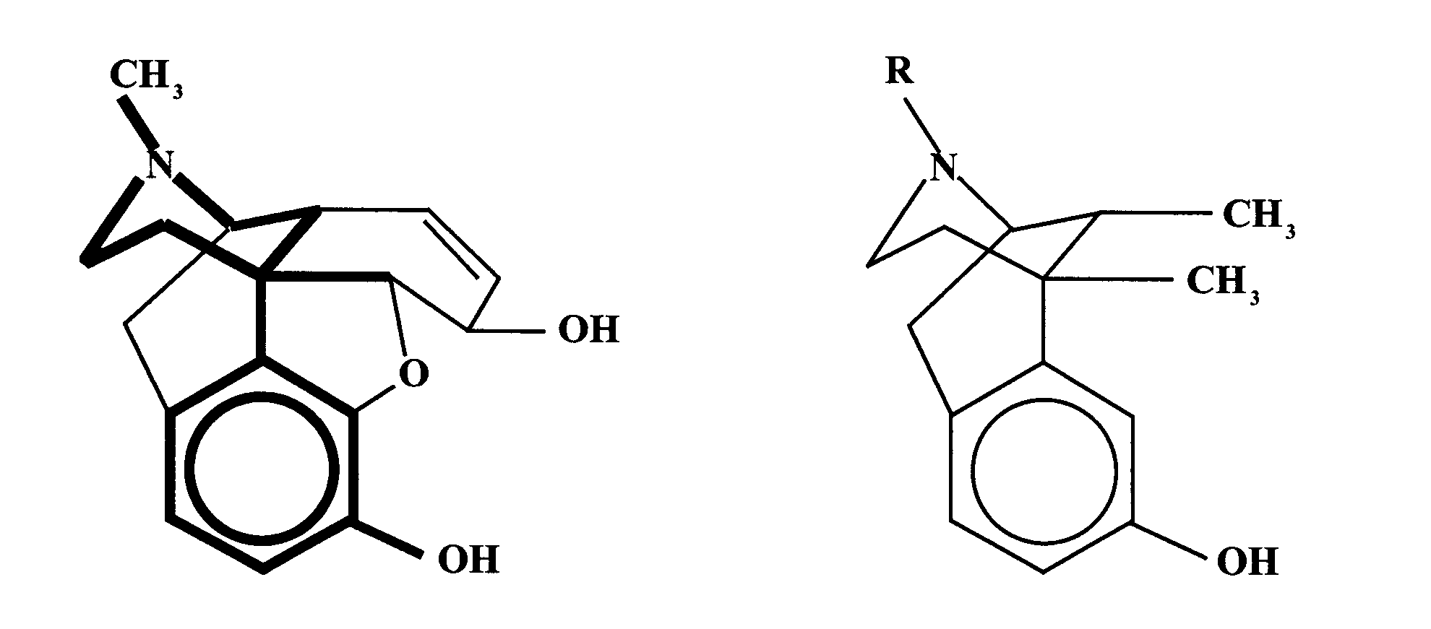
For example, in Figure 127 the structure of morphine, the pharmacophore for all these molecules, is shown by the darker line. Once the pharmacophore has been identified, chemists can design and synthesise potential medicines with a greater likelihood of success. By selectively changing parts of the molecule but still retaining the pharmacophore, it is possible to produce compounds like those shown in Figure 126, which have reduced addictive properties while still retaining their analgesic properties (Figure 128).

More recently, modern analytical techniques coupled with computer-aided molecular modelling have enabled biochemists to work out the precise structure of some enzymes and receptor sites. Computer-generated models of possible active compounds can then be matched with the active site. From this, a list of target molecules can be drawn up and chemists can devise methods to synthesise these molecules in the laboratory so that they can be tested for pharmacological activity.

Parts per million
The expression "1 ppm" means a given solute exists at a concentration of one part per million parts of the solution. There are two common ways to think about what the concentration "1 ppm" means:
a) it is one-millionth of a gram per gram of sample solution.
b) it is one gram of solute per million grams of sample solution.
Notice that the more general word 'part' is used above, but 'gram' is used in (a) and (b) just above. This is because 'gram' is used almost exclusively when parts per million is used.
For example:
Problem 1: Sea water contains 3.90 x 10⁻⁶ ppm of dissolved gold. What volume of this sea water would contain 1.00 g of gold?
Solution:
1) 3.90 x 10⁻⁶ ppm means this:
3.90 x 10⁻⁶ g of Au per 1.00 gram of seawater

2) We use a ratio and proportion:
3.90 x 10⁻⁶ g of Au 1.00 gram of seawater
1.00 g of Au X

3) Cross multiply and divide yields our answer:

2.56 x 10⁵ g of sea water contains 1.00 g of gold

Percentage concentration
Percent concentration is calculated using the following formula:
Notice that there are no units for the amounts of solute and solution. That is because you can either calculate weight per weight (w/w) percent concentration or volume per volume (v/v) percent concentration. Since these two methods can give you different answers, you should always note which method you used.
How does percent concentration relate to concentration in ppm? In order to figure out the answer, let's consider the solution below:
An aqueous solution contains 0.011 g of sulfuric acid and 2,000 grams of water. The concentration was found to be 5.5 ppm.
The percent concentration can be calculated as follows:
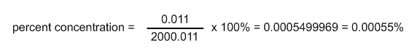
The w/w percent concentration is 0.00055%. Notice that this is the same as the ppm concentration divided by 10,000. W/w concentrations always show this relationship to ppm concentrations since the calculations are identical except for multiplying by one hundred in percent concentration and by one million in ppm concentration.
A concentration of 0.00055% is less understandable than a concentration of 5.5 ppm. As a result, percent concentration is usually used in situations more like that in which molarity is used, when the solute makes up a larger percentage of the solution.
Converting Between Types of Concentration
It is necessary to understand how to convert between different types of concentration. For example, if you had a 35.7 ppm solution, what would this be in percent concentration? If you had a 0.2 M solution, could you convert this to mg/L?
In aqueous solutions, the following conversion factors apply:
1 mg/L = 1 ppm
1,000,000 ppm = 100%
1,000,000 mg/L = 100%
Converting to molarity is a little more complicated. You must use the following formula to convert from mg/L (or ppm) to molarity in an aqueous solution:

