ABERDEEN GRAMMAR SCHOOL 2016

ABERDEEN GRAMMAR SCHOOL

Welcome to Aberdeen Grammar School

Dear Parent/Carer

A warm to Aberdeen Grammar School. I am pleased to have the opportunity to tell you about our school and look forward to having the pleasure of welcoming your son or daughter to the school.

Starting a new school is an exciting experience and we, along with our associated primary schools, have a programme to help pupils settle into their new school. We aim to build on each pupil’s previous experience to progress their achievement and provide educational excellence.

In the prospectus we have tried to give a brief profile of Aberdeen Grammar School. It is written for an adult audience and I hope you find it interesting and useful. New pupils are provided with information at appropriate times prior to and after joining the school.

I look forward to meeting you and your son/daughter and wish them much success as they progress their school career.

Alison Murison
Head Teacher

Aberdeen Grammar School
Skene Street
Aberdeen
AB10 1HT

Telephone No: 01224 642299
Fax No.: 01224 627413
Email: AberdeenGrammarSchool@aberdeencity.gov.uk
Web: www.grammar.org.uk

ABERDEEN GRAMMAR SCHOOL

SENIOR MANAGEMENT TEAM

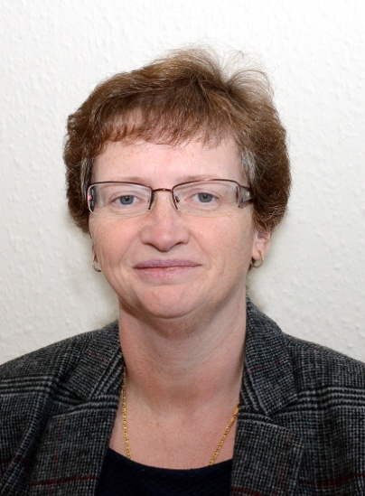

Head Teacher
Alison Murison
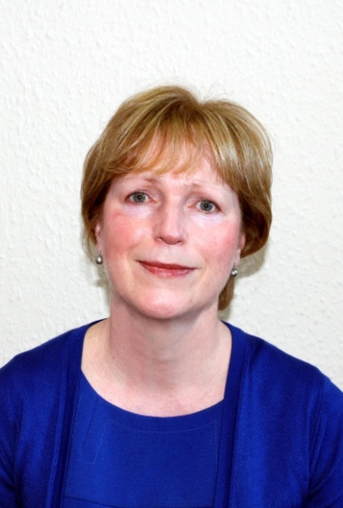
Depute Head Teacher Depute Head Teacher
Janet Adams Anne Bell

Depute Head Teacher Depute Head Teacher- (Acting) Alan Martin Ryan Robertson

I am Daniel Hume, this year’s Head Boy of Aberdeen Grammar School. In my sixth year I am studying Advanced Higher Biology, Advanced Higher Physics and Advanced Higher Chemistry, with the intention of studying Biological Chemistry and Drug Discovery at University. Last year I worked very hard, sitting Higher exams in Biology, Chemistry, French, Maths and Physics. Previous to Aberdeen Grammar School I attended St Joseph’s Primary School.
ABERDEEN GRAMMAR SCHOOL

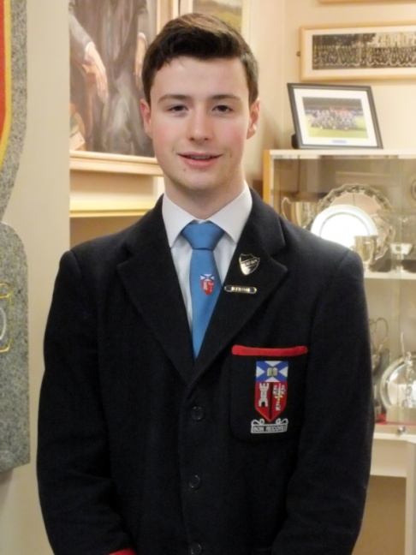
There is an extensive range of activities running within the school and so many opportunities to achieve and excel. Aside from my academic achievements, I also participate in a number of extra-curricular activities.

I have been a member of the school’s award winning concert band for the past 4 years. During this time, as well as achieving Gold Plus and Platinum award consistently in both the Scottish and National Concert Band Festivals, I played in four concerts to the public during our six day trip to Belgium. Additionally, I am also a member of two Percussion Ensembles. I have taken percussion lessons in school for the past four years and am currently working towards my Grade 8 exam. As well as percussion, I also play piano and guitar in my spare time.

This year, along with four of my classmates, I became a senior member of Charities Group. This has involved planning many fundraising events with the aim of raising around £3000 this year for the ARCHIE Foundation. So far we have raised just under £2000. I also volunteer at the ARCHIE Foundation in my spare time, doing everything from administrative tasks and counting money, to collecting donations at events.

I am so grateful for all the opportunities I have been offered at Aberdeen Grammar School. Participating in such activities has not only helped me to achieve within those particular fields, but it has also helped me develop many skills making me more mature, confident and a well-rounded individual. I would advise any new students to get involved in the wider life of the school and reap the rewards in doing so.

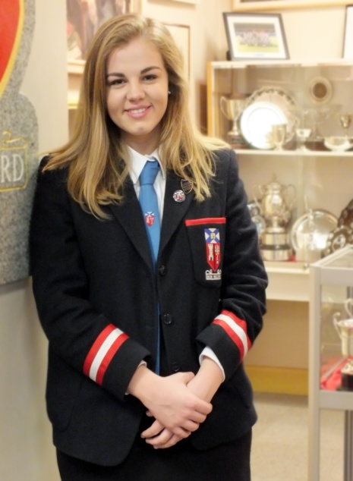
My name is Kate Riddoch, this year’s Head Girl of Aberdeen Grammar School. In my sixth year am studying Advanced Higher English, Advanced Higher Modern Studies, Higher Business Management and Higher Drama. I would like to go to university to study Politics with Quantitative Methods.

Academic achievement is highly recognised at the school and I have been awarded several Certificates of Merit. At the end of fifth year, I received the Masson Bain Prize for English and the Former Pupils’ Club Prize for Modern Studies. As well as working on my academic attainment, I am also very involved with the wider life of the school.

We are lucky to enjoy an extensive range of extra-curricular activities and clubs at Aberdeen Grammar School. I have played hockey since S1 and I am now the goalkeeper for the 1st XI Senior Team. I have recently been awarded half colours for my achievements in the sport. School hockey has given me the opportunity to trial for the North District Hockey Team and led me

to being selected to play in a national tournament in Edinburgh. Following this, I was invited to play for the North District performance development squad and the Grammar FP team.

I am also a member of Choir and Show Choir and have received half colours for participating in these clubs. I have performed as part of the school’s musical theatre group, ‘Face the Music’, taking part in four shows, I played a principal role in the last three productions: ‘Back to the 80’s,’RENT’ and ‘Zombie Prom’. For my achievements in this activity, I have been awarded junior, half and full colours. I am a Literacy Ambassador within the school and have been part of a team organising Literacy Weeks and Book Days, as well as mini games to challenge pupils during tutor time in the morning.
These extra-curricular commitments, in particular ‘Face the Music’ and hockey, have allowed me to make friends in different year groups. This has definitely made my Senior Phase more enjoyable as year groups are mixed in Higher classes.

I can easily say that if I had not been a part of the wider school life, my experience at Aberdeen Grammar would not have been nearly as enjoyable or fulfilling as these six years have been.

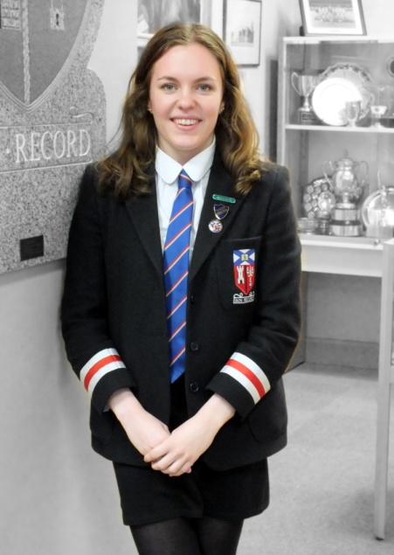
I am Catriona Stewart and I am one of the Depute Head Girls this year at Aberdeen Grammar School. For my final year at school I decided to study three Advanced Highers: Biology, Chemistry and French. My ultimate goal is to study medicine at University and I feel that the wide range of extra-curricular activities and inter-house events at the school have given me an insight into valuable team-work and communication skills.

My main commitment outside of school studies has always been swimming and I have been lucky enough to represent the school for this at Scottish Schools Swimming competitions. One of the most exciting opportunities been made available to me is the chance to participate in a World Challenge expedition to Vietnam and Cambodia for a month next summer. Some of the things which I am most looking forward to include trekking through the jungle and staying in the homes of locals; in order to get first-hand experience of their culture.

To sum up, Aberdeen Grammar School has allowed me to gain a range of skills and it is for this reason that I feel so prepared to move on to the next phase of my life.

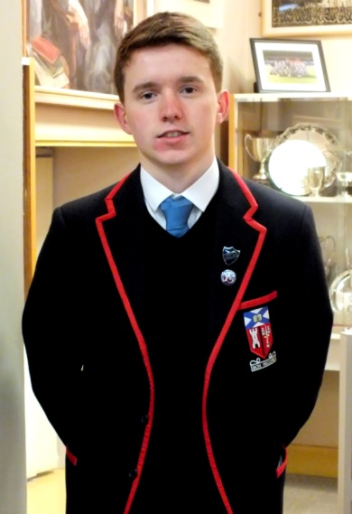
My name is Gavin Elliot. I am one of the Depute Head Boys this year. In my last year at Aberdeen Grammar School I am currently studying Higher Maths, Higher English, Higher Physics and Advanced Higher Chemistry. I have a real passion for sport and hope to study Physical Education when I leave school.

Aberdeen Grammar School has offered me many great opportunities and experiences, all for which I am very grateful of. The school Table Tennis Club has allowed me to train far more and this year I won my first cap for Scotland, playing at the UK Schools Championships in June. I feel this achievement could not have been done without the school’s assistance, such as giving me practice facilities, physical training and general feedback.
ABERDEEN GRAMMAR SCHOOL

Additionally, I am part of the 2016 World Challenge trip to Vietnam and Cambodia. I am very excited to be part of this fantastic

AMMARSOL
ABERDEEN GRAMMAR SCHOOL
experience and believe it will be a great success. My fundraising is going very well and I have participated in many events. My favourite event was an OAP Table Tennis competition, which I organised myself.

As I near the end of my years at Aberdeen Grammar, I continue to accept and relish all opportunities the school gives me.

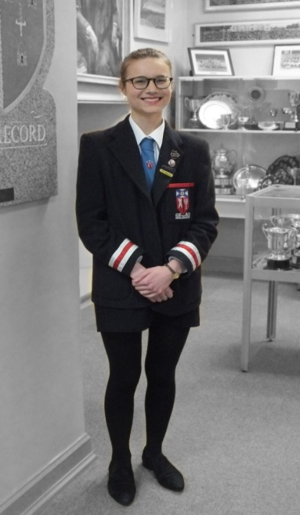
I am Libby Taylor and I am one of the Depute Head Girls at Aberdeen Grammar School. I am currently studying Advanced Higher Modern Studies, Advanced Higher French and Advanced Higher History. Following my school career I hope to go on to study Law with French at University.
Extra-curricular activities have played a key role in my time at secondary school. I have greatly enjoyed participating in several shows over the years through the S1 Drama club, Face the Music musicals and Pied Piper productions. The school choir and show choir have been exciting, giving me the opportunity to perform both on the HMT stage and in the Children in Need National Choir. Participating in various inter-house events, including those of netball and debating, has added to what I’ve gained from attending this school.
As I’ve been fortunate to experience, there is a wide selection of activities that develop multiple key skills, along with what is learnt in lessons, which make time spent at Aberdeen Grammar School very enjoyable and greatly beneficial.

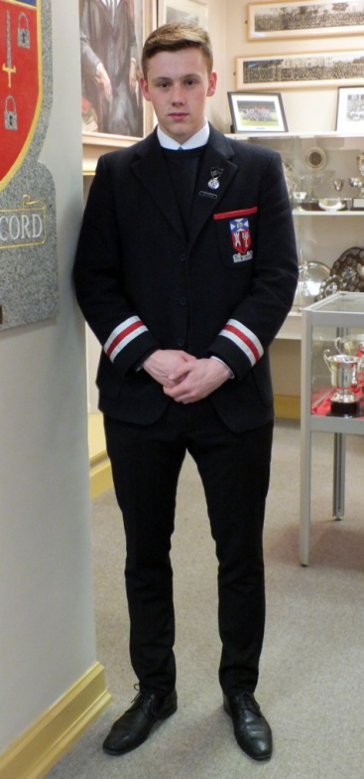
My name is Lachie MacLeod and I am one of the Depute Head Boys at Aberdeen Grammar School. I am studying Business Management, Geography and Psychology at Higher level. Throughout my time at Grammar I have received nothing but encouragement from my teachers to achieve my potential. Sport is my passion and since S2 I have been a member of the rugby team. As I am now one of the senior rugby players, I have had the opportunity to help the coaches to train the younger players, which is extremely rewarding. However, my main sport is football, having played in the school team every year and in the boys club since I was 8. I have represented the school in the city select squad in S3, S5 and S6 and am currently in trials for the Scottish Secondary Schools Football Association team for 2015/16. Being part of a team is a great way of meeting people and making new friends from all year groups. I feel the football team has enhanced my enjoyment of school life at AGS.

After I finish my school career at Aberdeen Grammar School I am participating in a month long World Challenge expedition to Vietnam and Cambodia, primarily to undertake voluntary work but also to trek through the jungle. I hope to take a gap year to get some hands on work experience with a ski season in Canada before attending University to study for a degree in Business Management.

Finally, I would like to say how happy I have been at Aberdeen Grammar School, thanks to all the staff and fellow pupils - I will be very sad to leave.

CONTENTS
Section | 1 | AN INTRODUCTION TO THE SCHOOL – past and present
 | 1.1 | School History and Development
 | 1.2 | The School’s Catchment Area
 | 1.3 | The School Roll
 | 1.4 | School Uniform
 | 1.5 | School Holiday Pattern
 | 1.6 | School Day
 | 1.7 | Present Accommodation
 | 1.8 | Statement of Values
Section | 2 | THE STAFF – who we are and what we do
 | 2.1 | Staff list
 | 2.2 | Staffing Policies and Brief Job Descriptions
 | 2.3 | Child Protection
 | 2.4 | Pupil Support
Section | 3 | THE CURRICULUM
 | 3.1 | Curriculum Model for S1 – S6
 | 3.2 | Religious, Social, Health and Careers Education, EMAs
 | 3.3 | Instrumental Instructions
 | 3.4 | Extra-Curricular Activities
 | 3.5 | Sport and Sporting Activities
 | 3.6 | Studying at Home and Homework
Section | 4 | ASSESSMENT AND REPORTING – how we assess and report pupil progress
 | 4.1 | Assessment and Reports
Section | 5 | ETHOS – procedures to maintain good relationships and high standards
 | 5.1 | Positive Behaviour
 | 5.2 | School Rules for Pupils
 | 5.3 | Attendance and Absence
 | 5.4 | Personal Property
Section | 6 | ADMINISTRATION – details of organisation
 | 6.1 | Administration
 | 6.2 | School Lunches and Morning Snacks, Accord Card
 | 6.3 | Information for New Arrivals and Pupils Leaving
 | 6.4 | Transport to School
 | 6.5 | School Pupils’ Insurance
Section | 7 | CONTACT AND LIAISON – links with groups and organisations
 | 7.1 | Parental Information
 | 7.2 | Parent Council
 | 7.3 | School Chaplains
 | 7.4 | Former Pupils’ Club
 | 7.5 | Communication

The information in this booklet is accurate at the time of printing, but is liable to change thereafter, during the session or in subsequent years.
1. THE SCHOOL

1.1 School History and Development

The date of Aberdeen Grammar School’s foundation is unknown, but the school has existed for around 750 years as reference to a school to teach grammar in the town exists from 1256. The first documentary reference to the town Grammar School occurs in the Burgh Records for the year 1418, when the Provost and the Council nominated John Homyll as ‘Master of the Schools’, in place of Andrew of Chivas, deceased, and the Chancellors of the Cathedral confirmed his appointment. The succession of Rectors since 1479 is known.

Until 1863, the School was situated in Schoolhill and the curriculum latterly consisted of Latin, Greek and Ancient Geography. Supported by the public spirit of local citizens, the Town Council erected the present handsome building which was opened on the 23rd October 1863 and which allowed expansion of the curriculum to include English, Mathematics, Modern Languages, Drawing and Gymnastics. Aberdeen Grammar School was one of the eleven schools in Scotland scheduled in the Education Act of 1872 as Public Secondary Schools. Its management was thus vested in the School Board of the Burgh. Since 1882, substantial additions and alterations have been carried out, culminating in a large-scale programme of expansion and modernisation in 1964.

As a result of a decision by the former City of Aberdeen Education Committee on the naming of
comprehensive schools in the City, the School had its title officially changed to Rubislaw Academy (Aberdeen Grammar School) at the start of session 1970/71. The title of Aberdeen Grammar School was restored as a result of a decision by Grampian Regional Council taken on 31 March 1977. Girls were admitted to the School for the first time at the beginning of session 1973/74 and Aberdeen Grammar School is now a six-year comprehensive school serving the central west-end area of Aberdeen.

1.2 School's Catchment Area

The majority of the pupils are drawn from the associated primary schools in the catchment area. They are Ashley Road, Gilcomstoun, Mile-End, Skene Square and St Joseph’s. Under the ‘Parents Charter’, parents living outwith the official catchment area may make application to Aberdeen City for admission of their children to Aberdeen Grammar School, but the Education Committee has placed specific limits on the number of pupils in each year group. Transport arrangements for such pupils are the responsibility of the parents. Applications for places are processed in accordance with a list of priorities published by Aberdeen City Council and available to all parents seeking to enrol their children.

The Education Authority continually reviews school zones and from time to time amendments are made.

1.3 The School Roll
December 2015 | GIRLS | BOYS | TOTAL
S1 | 95 | 79 | 175
S2 | 115 | 95 | 210
S3 | 89 | 91 | 180
S4 | 103 | 74 | 178
S5 | 72 | 94 | 166
S6 | 81 | 75 | 156

1. THE SCHOOL

1.4 School Uniform

The School is proud of its uniform and all pupils are expected to wear it (as detailed below), when attending school or representing it elsewhere. All our pupils wear the uniform and the co-operation of parents in this matter is greatly appreciated. Most of the items of school uniform can be obtained in most of the main clothing stores in the city. The blazer with school badge, school tie and pullover with school badge are available only from John Lewis and Aitken & Niven.

School blazer with badge
School tie
Shirt or blouse, white/grey/light blue
Pullover, navy or black v-neck with or without badge
Trousers, black or navy, not black denim or black jeans
Skirt, black or navy
Shoes, black (training shoes are not permitted)
Headscarf, black or navy if worn for reasons of religious belief.
Extremes of fashion should be avoided when purchasing trousers or skirts.
Outside jackets should be removed when inside the school building.

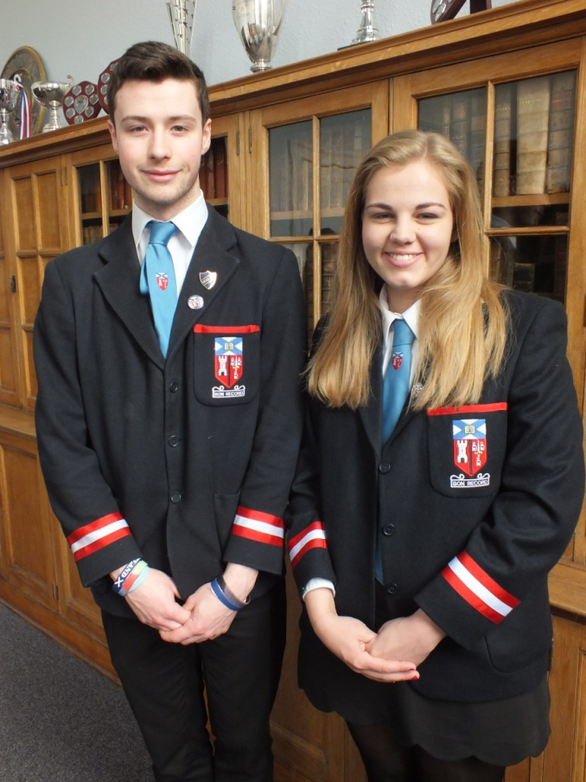

1. THE SCHOOL
1.5 School Holiday Pattern for Session 2016-2017

The pattern for the session 2016/2017 is shown below.

In-Service Day (staff only) | Monday 15 August 2016
Term begins for pupils | Tuesday 16 August 2016
September Holiday | Friday 23 September and Monday 26 September 2016
Term ends | Friday 07 October 2016
October holidays | Monday 10 October to Friday 21 October 2016
Term starts | Monday 24 October 2016
Term ends | Friday 23 December 2016
Christmas holidays | Monday 26 December 2016 to Friday 06 January 2017
Term starts | Monday 09 January 2017
Mid Term | Monday 13 February 2017
Term ends | Friday 31 March 2017
Easter Holidays | Monday 03 April to Friday 14 April 2017
Term starts | Monday 17 April 2017
May Day Holiday | Monday 01 May 2017
Term ends | Friday 30 June 2017

1.6 The School Day

Period | Start | Finish | Duration (mins)
Tutor time | 8.45 am | 8.55 am | 10
1 | 8.55 am | 9.50 am | 55
2 | 9.50 am | 10.40 am | 50
Interval | 10.40 am | 11.00 am | 20
3 | 11.00 am | 11.55 am | 55
4 | 11.55 am | 12.50 pm | 55
Lunch | 12.50 pm | 1.50 pm | 60
5 | 1.50 pm | 2.45 pm | 55
6 | 2.45 pm | 3.35 pm | 50

1. THE SCHOOL
1. THE SCHOOL
1.7 Present Accommodation

On July 1986, the central area of the School, including the Library, was severely damaged by fire. On 2 July 1987, Grampian Regional Council confirmed that the School would be rebuilt as a single-site secondary school providing for an ultimate roll of 1000 pupils. This has provided an opportunity to create modern facilities within the environment of a listed building. The rebuilt part of the School was formally opened on 4 March 1992 and has provided attractive new facilities for Art & Design, Business Studies, Computing, Drama, Home Economics and Support for Learning as well as a new Library, a Lecture Theatre, Technicians Area, Guidance Accommodation and a Main Staffroom. In addition, co-ordinated refurbishment programmes have allowed upgrading of classrooms in English, Geography, Religious Education and then Modern Languages, History and Modern Studies. A new Games Hall was opened in October 2007.

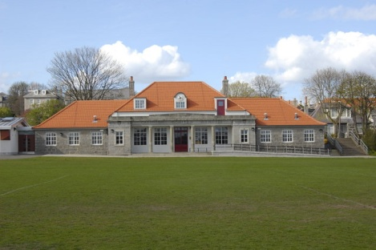
The school's sport fields, 18 acres in extent and situated less than a mile from the School, are at Rubislaw. A new All Weather pitch was opened in October 2004. A new pavilion was built in 2010.

MAIN BUILDING
3 Art Areas | 6 ICT Areas | Careers Base
5 Design & Technology Rooms | 7 English Classrooms | Pupil Support Base
2 Drama Studios, Drama Classroom | Games Hall | 3 Home Economics Areas
Special Education Needs Base | Assembly Hall | Kitchen & Dining Hall
7 Mathematics Classrooms | 14 Laboratories | Lecture Theatre
Large Swimming Pool | Medical Suite | 3 Music Rooms
Library Resource Centre | Sports Hall
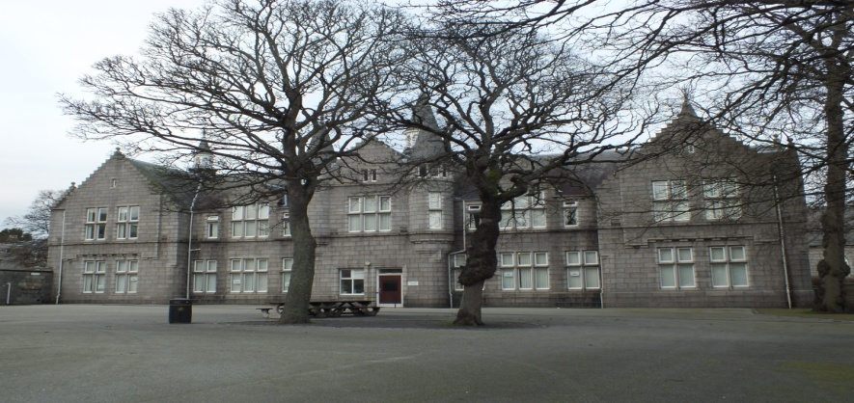
BENNUM BUILDING

3 History Classrooms | 2 Geography Classrooms | 5 Languages Classroom
3 Modern Studies Classrooms | 2 RME Classrooms
. TH

1. THE SCHOOL
1.2
1.8 Statement of Values

Aberdeen Grammar School Motto

“Bon Record”

Mission Statement and Aims

Our Mission Statement

To provide educational excellence so that pupils are equipped to be successful learners, confident individuals, effective contributors and responsible citizens.

Our aims are to:

1. recognise, maximise and value attainment, achievement and the participation of all pupils

2. provide an appropriate and progressive curriculum with learning and teaching approaches which develop knowledge, skills and positive attitudes to meet the needs of each individual pupil within society

3. provide effective support for each pupil in a safe and caring environment

4. foster an ethos which values equality, fairness, good relationships, achievement and a sense of identity and pride in the school and wider community

2. THE STAFF

2.1 Staff List as of January 2016

HEAD TEACHER
Ms Alison Murison

DEPUTE RECTORS
Miss Janet Adams
Mrs Anne Bell
Mr Alan Martin
Mr Ryan Robertson (Acting)

PRINCIPAL TEACHERS PUPIL SUPPORT
Mr Ross Allan
Mrs Linda Gibson
Mr Colin Gillespie (Acting)
Miss Charlotte Henderson (Acting)
Mrs Mary O’Brien
Mrs Mary Thom

FACULTY OF ART, DESIGN & TECHNOLOGY
Miss Elaine Forrest Faculty Head

ART & DESIGN
Mr Robert Donald
Ms Jo McIntosh
Miss Ashleigh Norrie

CRAFT & DESIGN
Mr Alasdair Brooks
Mr George Davidson
Mr Matthew Foster

FACULTY OF BUSINESS, ICT & ENTERPRISE
Miss Gillian Nicol Faculty Head

BUSINESS STUDIES
Miss Merlin Cook
Mrs Kristine Donohoe
Mr Alan Martin, DHT

COMPUTING
Miss Barbara MacEwan
Mrs Tracy Rennie

FACULTY OF ENGLISH & LITERACY
Mrs Emma Williams Faculty Head
Mrs Kathleen Duncan
Miss Caroline Fraser
Mrs Karen Fraser
Miss Claire Hercher

Mrs Laura Simpson
Miss Rona Sinclair
Mrs Rachel Williams

FACULTY OF HUMANITIES
Ms Jean Irvine Faculty Head

GEOGRAPHY
Mr Graham Kerr
Ms Sara Wilson

HISTORY
Miss Sinde Astraea
Miss Lauren Bruce

MODERN STUDIES
Mr Laurence Bews
Mrs Karen Matheson

RMPS
Mrs Lianne Smith

FACULTY OF PERFORMING ARTS
Mrs Tina Mackay Faculty Head

DRAMA
Miss Janet Adams, DHT
Mr Ryan Peacock

MUSIC
Miss Charlotte Henderson, PTPS (Acting)
Miss Rhona Johnstone
Miss Laura Pike

FACULTY OF HEALTH & WELLBEING
Mr Iain Stanger Faculty Head

HOME ECONOMICS
Mrs Jacqueline Barclay
Mrs Yvonne Matheson

PHYSICAL EDUCATION
Mr Ross Alan PTPS
Mrs Kathryn Barrett
Miss Hazel Croft
Mr Keith Milne
Miss Hannah Taylor
Mrs Mary Thom, PTPS

2. THE STAFF
FACULTY OF MATHEMATICS & NUMERACY
Mrs Jenny Smith Faculty Head
Mrs Emma Boyd (Maternity Leave)
Mr Stephen Cregg
Mrs Gwen Johnston
Mr Rory Kerr
Mr Joseph McLean
Miss Bronagh McKeown
Mrs Aileen Philip
Mr Ryan Robertson, DHT (Acting)
Mss Margaret Ruddy
Miss Helen Wood

FACULTY OF MODERN LANGUAGES
Mrs Joyce Tease Faculty Head

Mrs Anne Bell, DHT
Mr Mark Combredet
Mrs Fiona Durden
Mrs Linda Gibson, PTPS
Mrs Jacqueline Laundon
Mrs Mary O’Brien, PTPS

FACULTY OF SCIENCE
Mr Mark Stage Faculty Head

BIOLOGY
Ms Jennifer Cawdron
Mrs Lorraine Morrison
Miss Helen Murdoch

CHEMISTRY
Mrs Susan Davis
Dr Michael Gibson
Dr Mary McPhail
Ms Julie Tumelty

PHYSICS
Mr Alan Begg
Mr Adam Douglas
Mr Barry Gibson
Mr Colin Gillespie. PTPS (Acting)
Miss Morag McConnell
Mr Mark Stage

SUPPORT FOR LEARNING
Mrs Fiona Cumming
Mrs Claire Murray
Ms Tanith Rowberry

MUSIC INSTRUCTORS
Mr Andrew Brown
Ms Hilary Cromar
Miss Amy Dow
Ms Rhoda Duguid
Mr Ewing Lauder
Mr Ian Lovegrove
Mr Alan MacDonald
Ms Sarah Neil
Mrs Elaine Renwick

SUPPORT STAFF

OFFICE
Mrs Lesley Shearer School Administrator
Ms Norma Hunter
Mrs Tracy Harper
Miss Amanda Killin
Miss Jane Low
Mrs Irmina Majewska-Scott (Maternity Leave)
Mrs Gillian McLeod
Mrs Jennifer Nicolson

TECHNICIANS
Mr Martin Cowie Supervisory Technician
Ms Sheila Bruce
Mrs Alice Bye
Mr Robert Rennie
Mr Graeme Smith
Mr Christopher Walker
Mrs Fiona Wallace

LIBRARY
Ms Mary Allard

PUPIL SUPPORT
Mrs Michele Anderson
Mrs Debbie Cassie
Mrs Fiona McBride
Mrs Donna Reid
Mrs Jill Stallard

JANITORS
Mr Zander Dalgarno
Mr Rod Lawrence

CAREERS ADVISOR
Mrs Morag Evans

HOME LIAISON OFFICER
Mr Darren Rae

ACTIVE SCHOOLS CO-ORDINATOR
Peter McDougal (Acting)
2. THE STAFF

STAFF

2.2 Staffing Policies and Brief Job Descriptions

We seek to manage well qualified personnel and all available resources, to maximise the range of learning opportunities on offer, and to promote pupil success at every stage and level. Staffing provision is calculated annually on a formula related to the pupil roll. The staff allocation to departments is based on curriculum policy guidelines and by pupil choices. All Teachers are qualified by subject(s) and by registration with the General Teaching Council of Scotland. Teachers have direct responsibility for the teaching environment and the encouragement of learning, integrated with assessment, profiling and reporting. They also have a commitment to professional development as well as the formulation and implementation of departmental and whole-school policies and procedures.

The Senior Management Team consisting of the Rector and four Depute Rectors meets regularly to discuss matters of policy; evaluate the school's work; and implement school improvement plans.

Each Faculty Principal Teacher is responsible for the preparation of courses, organisation of resources and management of staff in a department, to achieve efficient and effective pupil learning in that subject or grouping of subjects. Assessment, evaluation and record-keeping are all integral parts of subject responsibility.

Principal Teachers of Pupil Support (PTPS) have skills, experience and an allocation of non-teaching time to help individual pupils in the group for whom the PTPS are responsible for providing pastoral support. This usually takes the form of advice about subjects and career intentions or support with a problem and the PTPS is usually the first point of contact for parents. Contact between PTPS and parents is always welcome and normally helps everyone involved. Each pupil should know his/her PTPS, who is allocated for the whole of the individual pupil’s school career. Group guidance through Social Education can also contribute to personal development.

In several ways Pupil Support staff enhance achievement in the learning process for individual pupils. This support can take the form of presence in class, working co-operatively with subject teachers to assist children with learning difficulties, and co-ordination of specialist help, when appropriate. Pupil Support staff also provide advice to teachers about learning difficulties and are consulted about the design and production of learning materials.

The Library Resource Centre Co-ordinator, Technicians, Office, Medical, and Janitorial staff are all qualified in accordance with national and regional agreements covering their detailed job descriptions. They all contribute substantially to the supportive network for education.

2.3 Child Protection

Given on-going public concern on the subject of child abuse, and changes in the law, schools are now required to report if we think that any child has come to harm as a consequence of possible abuse. Each school now has a Designated Officer appointed to be responsible for Child Protection matters and specially trained for this task. The nominated personnel within Aberdeen Grammar School for Child Protection are the Rector and Depute Rector, Miss Innes.

Should you wish to seek further advice about Child Protection and the safety of children please feel free to contact the Rector or Miss Innes.

Where there is a possibility that a child could be at risk of abuse or neglect, the school is required to refer the child to Social Work, the Police or the Children’s Reporter and under these circumstances, the parent would not normally be consulted first.
2. THE STAFF
2. THE STAFF

2.4 Pupil Support

Upon entry to Aberdeen Grammar School, each S1 pupil will be allocated to a House and remain there throughout their time at school. The house system of pupil support is made up in the following way:

 | Byron House | Keith & Dun House | Melvin House
House Head | Anne Bell | Alan Martin | Ryan Robertson  (Acting)
PTPS | Ross Allan  Mary Thom | Linda Gibson  Charlotte Henderson  (Acting) | Colin Gillespie (Acting)  Mary O’Brien
SfL | Fiona Cumming | Claire Murray | Tanith Rowberry

The aim of Pupil Support is to support the needs of individual pupils, regardless of their academic ability. Assistance may be provided on a short-term basis, for example if the pupil has had a lengthy absence, or may be provided throughout the pupil’s school career to answer specific learning requirements, or in response to emotional vulnerability that may hinder the learning process.

Our Pupil Support team has developed a range of expertise in supporting pupils’ learning needs and many have undergone specialist training. We liaise with agencies such as the Educational Psychology Service, Speech and Language Therapy, Occupational Therapy, Physiotherapy and the Social Work Department. There are other school based support services such as TASSCC and the Careers Service. The support of external agencies is requested only after discussion and agreement with the pupil, parents or carers.

Additional Support Needs
Relevant information about pupils is shared with subject teachers so that effective teaching and learning strategies can be developed to meet each pupil’s need.

Pupil progress is regularly monitored through informal discussions with subject teachers, with Principal Teacher of Pupil Support through the House System and through the formal system of reviews. Pupils who require significant levels of support through an Individualised Educational Programme and pupils who have a Co-ordinated Support Plan will have their rates of progress and levels of achievement reviewed termly in relation to personal targets.

Parents of pupils with significant additional support needs are invited to an annual review to consider their son or daughter’s progress over the previous year and consider their targets for the coming year.

Pupil Support teachers also identify and manage the special arrangements required for pupils sitting SQA examinations.

2. THE STAFF
Inclusion
All pupils are included into the academic and social life of the school. Pupils are allocated to classes after transfer information is received from the previous school. Where required, support may include team teaching, in-class support or provision of suitable learning materials. Pupil Support teachers and assistants are concerned with the well-being of the whole child so a Paired Reading Scheme as well as a Lunchtime Club for vulnerable young people are available.

Primary / Secondary Transition
We work in close partnership with primary school staff, external agencies and parents of pupils with additional support needs in order to ensure a smooth transition from primary to secondary
school. Support for pupils at this key stage is provided by an extended transition programme agreed through forward planning with parents, primary and support staff.

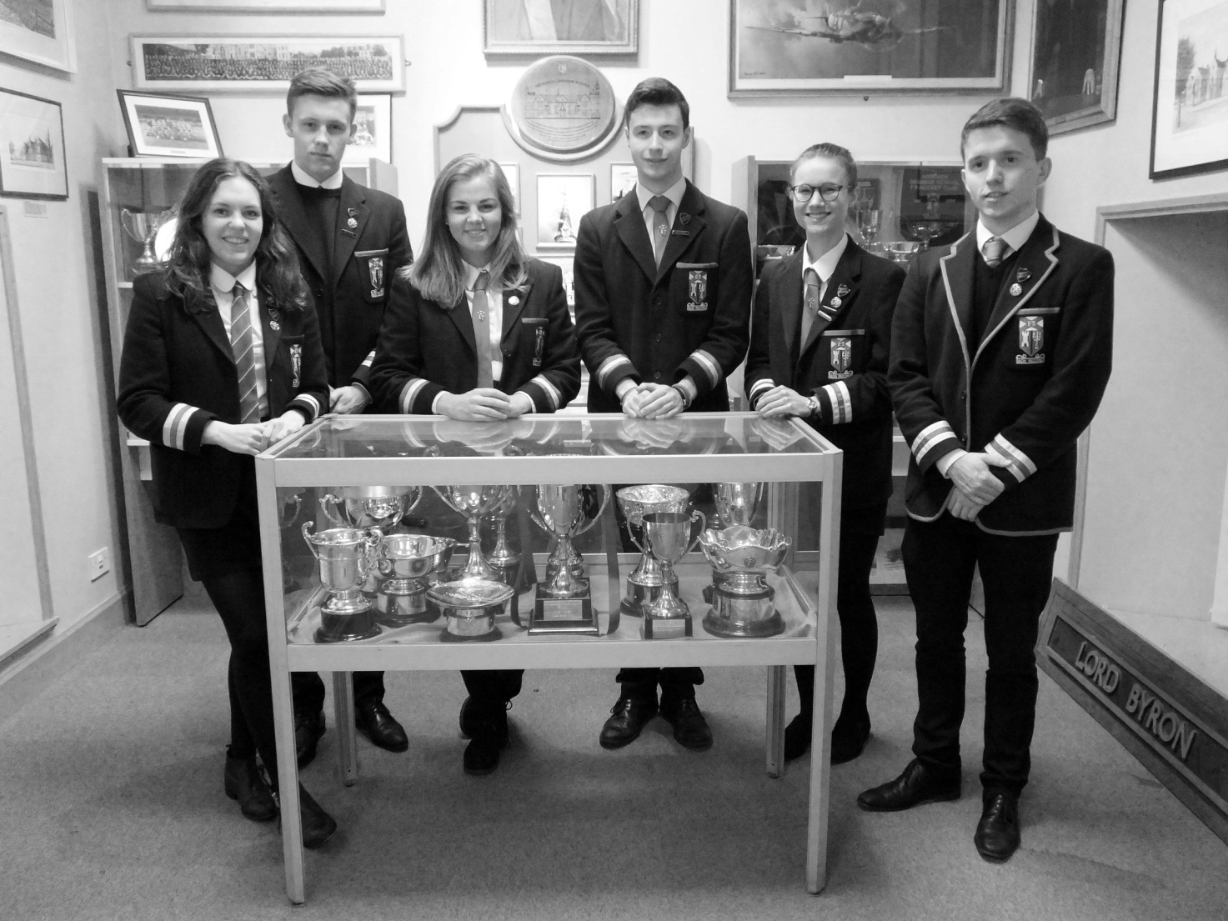
3. THE CURRICULUM

3.1 Curriculum Model for S1-S6

Aberdeen Grammar School’s curriculum model for S1-S6 is designed to deliver the Curriculum for Excellence entitlements and is based upon the CfE Principles of Curriculum Design. Through the curriculum design the school will develop the four capacities of CfE.

- Successful learners
- Confident individuals
- Responsible citizens
- Effective contributors

The curriculum is the totality of experiences which are planned for pupils. It includes the four contexts for learning.

- Ethos and life of the school as a community
- Curriculum areas and subjects
- Interdisciplinary Learning
- Opportunities for personal achievement

The six years of secondary school have been planned as a coherent and progressive experience for all pupils. Transitions from primary to secondary school, and from secondary to post school destinations have been planned to ensure continuity.

In Aberdeen Grammar School the experience is divided into 2 “phases”

(1) The “Junior Phase” is S1, S2 and S3
(2) The “Senior Phase” is S4, S5 and S6

The Junior Phase Curriculum Design
The Junior Phase curriculum is designed to provide a broad general education which increasingly builds upon pupils’ experience in primary school. It is also designed to provide a smooth transition into the Senior Phase.

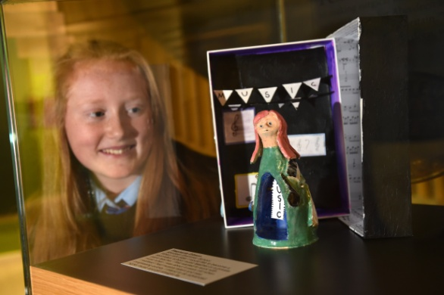
S1 Curriculum
In S1 all young people experience a broad general education involving well planned courses in all 8 curriculum areas. They receive their entitlement to the range of Experiences and Outcomes across all aspects of the 8 curricular areas up to and including the Third Level of CfE as is consistent with their learning needs. By focusing on the standards and expectations in the experiences and outcomes staff plan opportunities for progression and ensure learners build progressively on their prior learning.

The S1 timetabled courses are:-

English and Literacy
Mathematics and Numeracy
French
Science
Social Studies
Religious and Moral Education
Drama
Music
Art
Craft, Design and Technology
Home Economics
ICT and Enterprise
Physical Education
Personal and Social Education

All 8 curriculum areas are included in the curriculum which is delivered in a 30 period week

Exemplar
3. THE CURRICULUM
3. THE CURRICULUM
Languages | Mathematics | Science | Social Studies | Religious and Moral Education | Expressive Arts | Technologies | Health and Wellbeing
English and Literacy (4)  French (3) | Mathematics and Numeracy(4) | Science (3)  (taught by 1 teacher) | Social Studies (3)  (taught by 1 teacher) | RME (1) | Drama (1)  Music (2)  Art (1)  Performing Arts (1) | CDT (1)  HE (2)  HE also links to PSE, PE for Health and Wellbeing  Enterprise and ICT (2) | Physical Education (2)  Personal and Social Education (1)

English and Mathematics have each been allocated 4 periods per week to ensure time for the teaching, development and assessment of literacy and numeracy. However it is the responsibility of all teachers to develop these skills across pupils’ learning. Each faculty enhances specific literacy and numeracy skills as part of their S1 course.

All S1 pupils are taught French for three periods per week, building on their experience of this language in the associated primary schools.

The Science and Social studies curriculum areas are each taught by one teacher who teaches all elements of the courses. This arrangement helps to reduce the number of teachers experienced by each pupil in S1.

All pupils study Religious and Moral Education for one period per week. Those pupils whose parents wish their son/daughter to be taught Roman Catholic Religious Education can choose this option, which is delivered by a visiting specialist teacher.

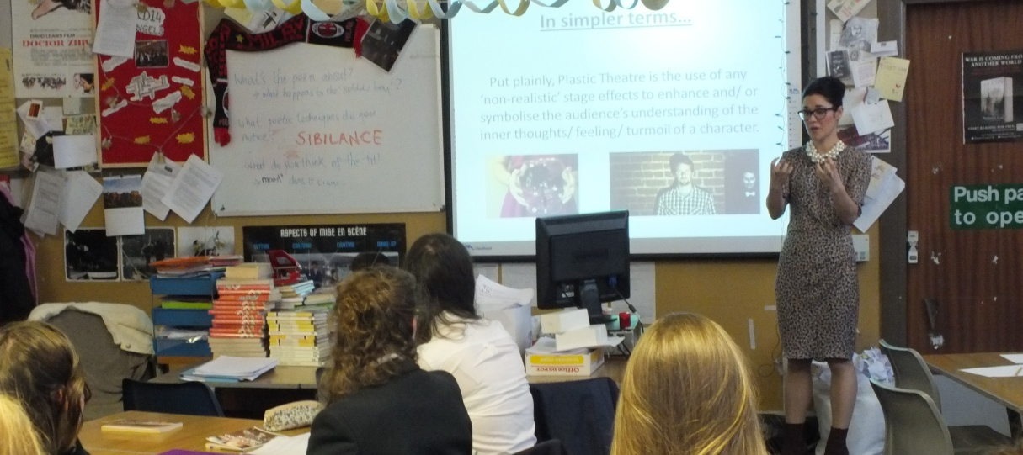

Drama, Music and Art are taught by specialist teachers in these subjects.

The technologies Experiences and Outcomes are delivered through courses in Craft, Design and Technology, Home Economics and ICT and Enterprise. The Home Economics course also delivers some of the Health and Wellbeing Experiences and Outcomes.

The Health and Wellbeing Experiences and Outcomes are being delivered through courses in Physical Education, Personal and Social Education, in addition to Home Economics. The ethos and wider life of the school also support the development of Health and Wellbeing. The extensive programme of extra-curricular activities enhances Health and Wellbeing.
3. THE CURRICULUM

Interdisciplinary Learning is delivered via two themed weeks (delivered through various subjects within the normal timetable) and a small number of events when the normal timetable is suspended. Individual subject courses have planned links.

S2 and S3 Curriculum
S2 and S3 of the Junior Phase are critical years for our learners.

It is a period when our pupils experience

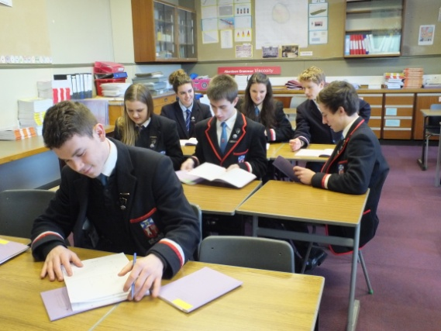
• an appropriate breadth to their curriculum.

• greater personalisation, choice and specialisation in their curriculum. Personalisation through a degree of course choice improves motivation, enthusiasm and attainment.

• greater depth, pace and challenge in order to develop their learning through for some Fourth curriculum level Experiences and Outcomes, National 4 outcomes and for some National 5 outcomes. This will ensure there is no ceiling to the level at which pupils can learn in S2/S3.

• learning in S3 which covers CfE Fourth Level Es and Os and some of the requirements for qualifications. This will pave the way into qualifications and allow the school to pursue its goal of raising attainment through Curriculum for Excellence.

• a transition into qualifications which can be taken at a time informed directly by learners’ needs, interests, abilities and future aspirations

All pupils in S2 and S3 will continue to study 5 of the 8 Curriculum for Excellence curricular areas:
English and Literacy
Mathematics and Numeracy
Health and Wellbeing – Physical Education, Social Education
Religious and Moral Education
Science

All pupils will have a breadth to their S2/S3 curriculum and will study 11 courses which is a reduction from 15 in S1. The programmes of study for almost all pupils will include study in all, or nearly all, 8 curriculum areas. An example of a personalisation, choice and specialisation sheet is shown on the next page. The choice sheet is reviewed regularly.

Exemplar
3. THE CURRICULUM
3. THE CURRICULUM
PERSONALISATION, CHOICE AND SPECIALISATION  (each choice = 3 periods per week) |  |  |  |  |  | CURRICULUM FOR ALL
1 | 2 | 3 | 4 | 5 | 6 | 7 | 8 | 9 | 10
3 Sciences | 3 Sciences | Drama | French | Modern Studies | French | English and Literacy (4 periods) | Mathematics and Numeracy (4 periods) | Health & Wellbeing:  Personal and Social Education (1 period)  Physical Education  (2 periods) | Religious and Moral Education  (1 period)
Biology | Food Technology and Health | Music | Spanish | History | History
Physics | Business & Enterprise | Art & Design | Geography | Business & Enterprise | Geography
Chemistry | Computing and Information Science | Practical Craft Skills | Administration & IT | Art & Design | Physics
 | Design & Manufacture | PE and Sports Studies | Drama | Practical Electronics | Biology
 | Music | Food Technology and Health | Computing and Information Science | Computing and Information Science | Graphic Communication
 | French | Computing and Information Science

Curriculum for All
In S2 and S3 all pupils will study English and Literacy (4 periods) and Mathematics and Numeracy (4 periods). However, all teachers will continue to have a responsibility for developing literacy and numeracy within their S2/S3 courses. All pupils will continue to study English and Literacy, Mathematics and Numeracy to the end of S4. This will ensure all pupils receive their full entitlement to literacy and numeracy and can achieve their highest level of attainment.

In order to deliver significant elements of the health and wellbeing curriculum area, all pupils will have 1 period of Personal and Social Education and 2 periods (110 minutes) of Physical Education. The Religious and Moral Education curriculum area will be delivered in a course of 1 period per week. Through this provision the school is ensuring pupils receive a significant part of their entitlement to health and wellbeing and Religious and Moral Education.

Personalising the Curriculum through Course Choice
All pupils will choose a further 5 courses, each of three periods per week.

All pupils will continue to study science. Pupils can choose to study one or two single science courses namely biology, chemistry, physics each for three periods. Historically a relatively high number of pupils choose to study three sciences and continue to study these in the Senior Phase. To meet this need, pupils are able to study three sciences over six periods, i.e. in two curriculum choice columns. This arrangement meets the pupils’ desire to study three sciences and also maintains curriculum breadth through the study of other curriculum areas.

The six “Personalisation, Choice and Specialisation” columns have been constructed to ensure pupils have a breadth of study. The Principal Teachers Pupil Support, through discussions with pupils and parents, guide pupils towards a broad curriculum. It is possible for pupils to follow a particular interest, for example, study two foreign languages or two social subjects. Some non-traditional courses are on offer for example Practical Electronics or Social and Vocational Skills. These meet the needs of some pupils who benefit from a more practical and vocational element to their experience.
3. THE CURRICULUM

In S2 and S3 pupils study subjects in greater depth to consolidate CfE third level and progress to CfE fourth level and National 4 and 5 outcomes as appropriate. The greater depth of study in the subjects taken in S2/S3 provides a secure foundation on which to build as pupils’ progress into the Senior Phase. Six of the eleven courses in S2/S3 are studied for 3 periods of 50/55 minutes per week, giving a total of 150 plus hours of study. English and Mathematics are studied for 4 periods per week. With such a time allocation, pupils experience the breadth, depth and challenge in each subject to facilitate a transition to National 3, National 4, National 5 or Higher qualification courses in S4.

All S1 and S2 pupils participate in the school’s annual Activities Week which involves a very wide range of cultural and sporting excursions and activities. This ensures all have 5 days devoted to developing broader achievements. At the end of S3 all pupils undertake a week long Work Experience. This assists with the development of skills for life, learning and work.

The creation of the S3 Profile ensures a meaningful and valued culmination to learning in the Junior Phase. The profiling process in the Junior Phase gives full account of, and recognises, what has been achieved.

Senior Phase Curriculum

Introduction
The curriculum design for the Senior Phase within Aberdeen Grammar School takes cognisance of the key principles of Curriculum for Excellence and the entitlements for pupils. The “Junior Phase” of the S1-S3 curriculum and the “Senior Phase” of S4-S6 have both been designed to take account of these principles.

The Senior Phase curriculum design will operate from session 2013-14 onwards.

Senior phase Curriculum design principles
The school’s Senior Phase curriculum design has a number of objectives:

- to provide opportunities to study for appropriate qualifications

- to provide a curriculum framework for pupils in S4, S5 and S6

- to provide flexibility to meet the needs of the individual learner rather than planning for an entire cohort or year group

- to provide opportunities for a range of pathways to positive and sustained destinations as part of the Scottish Government’s commitment to allow all young people to continue their learning up to and beyond to the age of 18

- to provide clear articulation between the Junior Phase (S1-S3) and the Senior Phase (S4-S6)

3. THE CURRICULUM
- to provide opportunities for the delivery of the education in the Senior Phase with partners: Aberdeen City Campus, Aberdeen College, Angus College, Aberdeen University, Open University, Neighbourhood Consortium School Group, Community Learning and Development and local employers

- to provide for the four contexts of the curriculum:

- curriculum areas and subjects
- interdisciplinary learning
- opportunities for personal achievement
- ethos and life of the school

- to provide universal support for learners

Senior Phase Curriculum Design
At the end of the Junior Phase (S1-S3), pupils move into S4 of the Senior Phase. They are able to enter courses at the most appropriate level based upon their previous attainment in a subject. In the Senior Phase courses are available at various levels:
- National 3
- National 4
- National 5
- Higher
- Advanced Higher
- University Courses
- Vocational Courses

There may be pupils from S4, S5 and S6 studying the same course in the same class at the same level. The Senior Phase curriculum and timetabling arrangements provides several benefits for pupils:

- a wider range of National 3, National 4 and National 5 courses is available to all pupils S4 to S6

- S4 pupils are able to study Higher courses if appropriate

- S5 pupils are able to study Advanced Higher courses, if appropriate

In the Senior Phase, there is less emphasis on curriculum breadth than in the Junior Phase as pupils are choosing courses to prepare for future destinations. Personalisation and choice is generally the main guiding principle.

The flexible structure of the Senior Phase curriculum provision facilitates the appropriate depth and challenge required by individuals. In addition, the curriculum provision allows for partnership delivery to provide greater personalisation and choice to meet the needs of individual learners. Vocational courses delivered by NESCOL are also available. Pupils may choose a package of courses based upon part-time in school and college.

The curriculum structure of the Senior Phase allows for vertical progression through SCQF levels but also opportunities for lateral progression to broaden the range of qualifications at a particular level. The curriculum followed by pupils in the Senior Phase with additional support needs is planned on an individual basis.

S4 of the Senior Phase
On entering S4 of the Senior Phase, all pupils study 6 courses leading to SQA qualifications at National 3, National 4 or National 5 or Higher levels. For all learners, English and Mathematics continue to be studied to the end of S4 for 5 periods per week. This provides time to deliver and assess literacy and numeracy skills and supports pupils to achieve their attainment potential.

Pupils have 2 periods of Physical Education per week in accordance with national guidance. There is also a weekly period of Social Education. This ensures the continuing development of Health and Wellbeing. Pupils will also study Religious and Moral Education for one period per week thus ensuring pupils continue to develop their knowledge, understanding and attributes in this valuable curriculum area.

In exceptional circumstances it is possible for a pupil in S4 to study one or more Higher level courses if this provides the best progression route from S3. Some pupils, therefore, may have a mixture of National and Higher courses in S4.

A small number of S4 pupils participate in a “Life and Employability Skills Course” delivered by
Community Learning and Development.

S5 of the Senior Phase
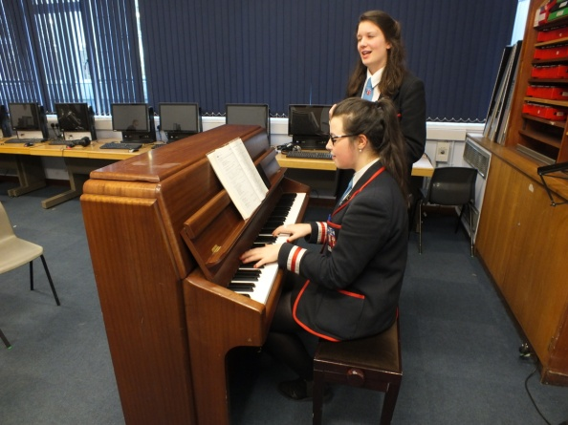
In S5, all pupils in the Senior Phase study at least 5 courses leading to SQA qualifications. All courses are available to pupils with the appropriate prior attainment for the course. A variety of combinations of course levels is possible:

5 or 6 courses at National 3, National 4 or National 5
5 courses at National 4, National 5 or Higher
5 courses at Higher
5 courses at Higher or Advanced Higher

All S5 pupils have 2 periods of Physical Education and 1 period of Social Education each week.

A small number of S5 pupils participate in a “Life and Employability Skills Course” delivered by Community Learning and Development.

S6 of the Senior Phase
Pupils in S6 have a wide variety of needs from their final year in school education. For many this is a transition year between school and employment, Further Education College or University. All pupils study a minimum 4 courses, many at Higher or Advanced Higher. However, where a pupil studies only Advanced Higher courses they need only study 3 courses .

Pupils also have access to various university courses:

a) Aberdeen University Flexible and Distance Learning Science courses
b) Aberdeen University Law Faculty courses
c) Open University Young Applicants in School Scheme (OUYASS)
3. THE CURRICULUM

S6 also have the opportunity to study courses delivered by Aberdeen and Angus Colleges. These currently include Higher Psychology, Higher Sociology and some vocational courses.
The Aberdeen City Campus provision of Advanced Higher courses, ESOL, Dance and Mandarin courses are also available.
M

3. THE CURRICULUM

3.2 Religious, Social, Health and Careers Education

Religious Education
As required by law, Religious Education is provided for all pupils in S1 - S4.

Assemblies and Religious Observance
Assemblies will be organised during tutor time, and delivered by senior staff and school chaplains. They cover the main religious events from a variety of religions as well as moral issues such as concern for others.

At religious assemblies, there will be no emphasis on any particular creed or denomination. These events are likely to involve the School Chaplains.

Parents who feel that their children should not attend these religious assemblies are entitled to request withdrawal. In this event, a letter to the Rector is required and arrangements will be made to allow supervised private study instead of attending religious assembly.

Parents of children of ethnic or religious background may require that their children be permitted to be absent from school in order to celebrate recognised religious events. Appropriate requests will be granted. The pupil will be noted as an authorised absence in the school register.

Social Education
Social Education is an important aspect of the school curriculum focusing, as it does, on a number of critical areas of personal development. While all staff see themselves as contributing significantly to pupil welfare, and are positively encouraged to do so, the Social Education programme is a structured curriculum taught by the Pupil Support staff, and other trained staff, to all pupils in S1-6.

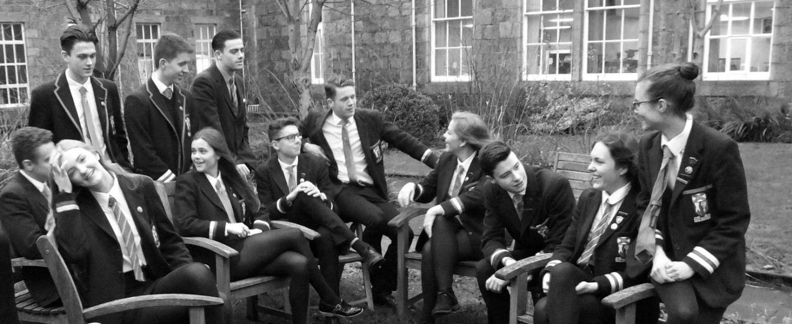

The programme is designed to develop personal and inter-personal skills so that pupils gain self-confidence in asserting themselves, in expressing opinions and beliefs and doing so in a way which helps them relate to others in a wide variety of contexts. The courses contain a number of developmental threads which are covered in a way that is felt to be appropriate to the pupils’ stages of development and which builds on the work of previous years. These threads include Sex Education, Drugs Education, Citizenship and Careers Education. The planned teaching programme covers such topics as skills required for coping with adolescence, individual self- awareness, career choices and decisions, priorities for a healthy lifestyle and study techniques. From S1, pupils are also involved in the process of self-assessment, review and target setting to

enable them to produce a Personal Statement as part of their S3 profile (Record of Achievement) and in preparation for College/University/job application.

Health Education
3. THE CURRICULUM
The school recognises that it is the right of every individual to expect a healthy environment and that Health Education has a major part to play in establishing this. We are committed to the promotion of positive attitudes towards health among pupils and staff, and to facilitate a healthy lifestyle for all.

Through a whole-school Health Education programme, we aim to encourage positive health behaviour in the following ways:-

To raise staff awareness regarding the broad nature of Health Education and their involvement in the physical, social and emotional development of pupils. Departments such as Home
Economics, Physical Education, Science, and Social Education all make direct curricular contributions towards this holistic approach.

To liaise with the school’s associated primaries re the input of Health Education into the curriculum, with the objective of giving coherence and continuity to the pupils’ learning experience from P7 to S1 and S2.

To encourage positive self-esteem and, by assisting pupils to develop decision-making skills to help them to make informed choices. The school aims to provide opportunities for pupils to develop attitudes and values concerning health, relevant to their needs and stages of development through a comprehensive Health and Social Education programme.

To enable all pupils to become aware of their present level of fitness and the desirability of developing a fitness scheme, which will help them to increase their standards, and to maintain this now and in later life.

To encourage healthy eating habits by raising pupils’ awareness of nutritional guidelines and promoting the provision of healthy food choices in all areas of the school.

To support the school health service in its contribution to the monitoring of the health of pupils and staff.

Drug Education
As school is such a significant focal point in the lives of young people, teaching and non-teaching staff in school have to be aware of the influences on pupils’ experiences and values. Currently, this awareness has to include recognition that the problem of drug abuse is widespread in our society, affecting almost every community large or small, urban or rural.

If there are any drug-related incidents in or around school, Police may be involved and exclusion from school will be an almost inevitable result, particularly in any case of supplying substances to others.

Our approach to this insidious and very real danger to our young people will be built on group teaching, particularly at several stages of the Social Education programme, alongside opportunities for individual advice through relationships established with Principal Teachers Pupil Support and other members of staff. We maintain sensitivity towards inclusion of material or information which may glamorise the drug scene to relatively innocent young people.
3. THE CURRICULUM

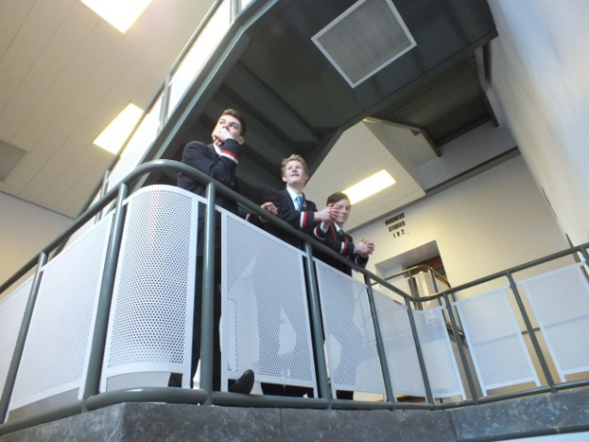
Careers
The Careers Adviser concentrates her services mainly upon S4/5/6 pupils. She will visit the pupils in their SE classes to raise awareness of her service, introduce Skills Development Scotland's website www. myworldofwork.co.uk and encourage pupils to begin looking at themselves, their options for the future and their career management skills.

During the year the Careers Adviser may issue a questionnaire to pupils asking for their thoughts on when they will leave school and where they hope to move on to. The Careers Adviser works closely with the Principal Teachers Pupil Support and School Management Team throughout the year to identify pupils who need to see her for individual appointments or inputs via small groups.
3. THE CURRICULUM

There is a drop in Quick Careers Queries Clinic for all pupils on Monday, Tuesday and Wednesday during lunchtime.

Education Maintenance Allowance
Senior Pupils who remain at school beyond the statutory leaving age of 16 may apply for an Education Maintenance Allowance (EMA). EMA is a weekly payment of £30 paid directly into the pupil’s bank account every two weeks. Pupils must meet all terms of their EMA Learning Agreement before payment is made.

EMA entitlement is based on an assessment of household income in the previous financial year.
Application forms are available from the school office or from Aberdeen City Council

3.3 Instrumental Instruction

Instruction on an individual or group basis is available in the school and covers the following instruments - Woodwind, Brass, Strings, Piano, Percussion, Guitar and Voice. Fees are payable for tuition. For more information, contact the Faculty Head of Performing Arts.

3.4 Extra Curricular Activities

We strongly believe in the value of extra-curricular activities as a means of enriching the education of our pupils and there are many opportunities for our pupils to be involved in activities outwith the timetabled school day. These may occur at lunchtime, or at the end of the school day, or they may involve day visits or residential visits either at home or abroad. These activities are organised on a voluntary basis by staff. Listed below, are some of the activities currently on offer.

Art Club | Duke of Edinburgh | Modern Languages Club
Badminton | Face the Music | Netball
Basketball (boys & girls) | Football (boys & girls) | Percussion Group
Charities Group | Funk Band | Photography Club
Chess | Golf | Programming club
Choir | Guitar Group | Reading Club
Christian Union | Gymnastics | Rowing
Concert Band | Hockey (boys & girls) | Rugby (boys & girls)
Craft Club | Jazz Band | Show Choir
Dance | Keyboard Club | String Orchestra
Debating | Lunch time Club | Table Tennis
Drama Club | Model United Nations (MUN) | Volleyball (boys & girls)

By tradition, one of the features of the festive season is the annual Carol Service in St Machar Cathedral provided by the musical groups of the School.

In addition, a number of residential excursions in the UK and overseas are organised each session which can provide groups of pupils with linguistic, cultural and often recreational
opportunities. Many of these events are now concentrated in a range of options available to all S1/S2 pupils during an Activities week in the summer term each year.
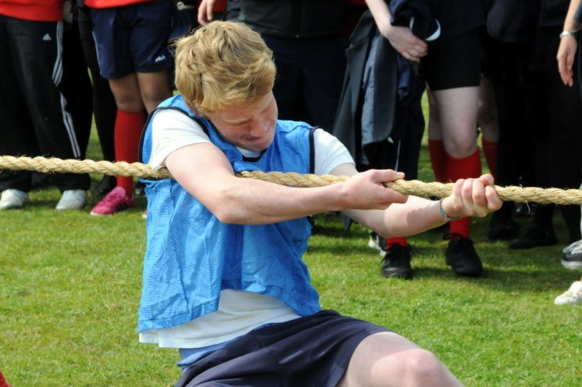
3. THE CURRICULUM
3. THE CURRICULUM
3.5 Physical Education and Sporting Activities

Aberdeen Grammar School has a long tradition of active and successful participation in a wide variety of Physical Education and Extra Curricular sporting activities.

Physical Education
Physical Education (PE) is delivered in the school facilities at Rubislaw Playing Fields, the games hall, the gymnasium and the swimming pool. The S1- S5 year groups are allocated a double period per week for PE. The S1-S3 classes follow a broad programme which incorporates a blend of traditional activities that includes rugby, hockey, football, swimming and an introduction to new activities.
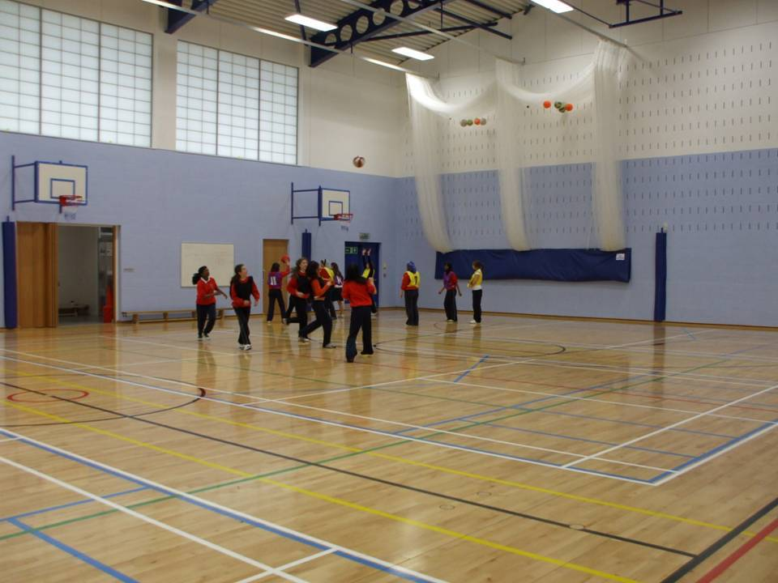
Pupils in S4 and S5 will have opportunities to select some of the activities they follow as part of their PE course. This may include going off site to utilise facilities in the wider community for example Aberdeen Sports Village, the Beach Leisure facilities and the ice rink.

Our aim is to provide the pupils at Aberdeen Grammar School with a broad experience that has some scope for personalisation and choice. We want to equip our pupils with the skills, enthusiasm and aptitudes that promote a healthier lifestyle, open the door to sporting participation and hopefully lead the pupils to engage in life-long physical activity.

Physical Education Kit
The following are the items of clothing and equipment required for Physical Education on the grounds of appearance, safety and general hygiene. These items are an integral part of the school uniform and all the tops are branded with the school badge.

NOTE: Most of the items below are available from Aitken & Niven and Thistle Sports

BOYS
Indoor Activities
Navy shorts, Boys Kukri T-shirt, navy sport socks or white socks and indoor training shoes.

Outdoor Activities
Kukri Rugby top or Kukri Hooded top, Boys Kukri T-shirt, navy blue shorts, navy blue socks, either rugby or football boots or sturdy outdoor trainers (training shoes for Astroturf). In cold weather blue tracksuit bottoms (no fashion labels) can be taken in addition to shorts.

We strongly recommend the use of shin pads and gum shields.

Swimming
Blue swimming trunks/shorts

GIRLS
Indoor Activities
Navy shorts, Girls Kukri T-shirt, navy sport socks or white socks and indoor training shoes.

Outdoor Activities
Girls Kukri T-shirt, Kukri Hooded top, navy blue shorts, navy blue socks, football boots or sturdy outdoor trainers (training shoes for Astroturf). In cold weather plain blue tracksuit bottoms (no fashion labels) can be taken in addition to shorts
3. THE CURRICULUM
We strongly recommend the use of shin pads and gum shields.

Swimming
Blue swimming costume. No bikinis

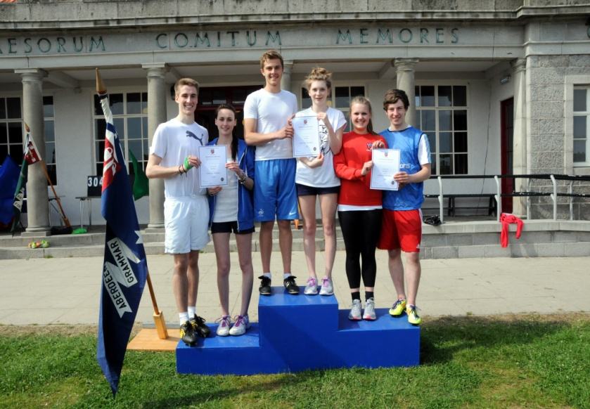
Extra Curricular Sporting Activities and Teams
As part of the whole school extra-curricular programme we offer the pupils further scope for personalisation and choice and the opportunity develop their performance in activities of their choice.

The programme of activities runs in partnership with Active Schools and a range of teachers and volunteers across the school and the wider community. We also have strong well developed links with a number of the clubs that form part of the Aberdeen Grammar School Former Pupils Club sport sections.

Currently pupils have the opportunity to become involved in the following activities: Rugby, Hockey, Football, Basketball, Netball, Badminton, Table Tennis, Cricket, Golf and Gymnastics.
Within these activities the school enters an extensive range of local and national competitions. In addition to this the school also enters pupils in Athletics, Tennis and Swimming competitions.

The list of activities is further supplemented by Active Schools who run a number of taster sessions and events throughout the year.

3.6 Studying at Home and Homework
3. THE CURRICULUM

Studying at home plays an important role in the education of young people. At all stages in their school career pupils are expected to support their class work by working at home. Homework is
used to encourage the development of good study habits and promote pupils responsibility for their own learning.
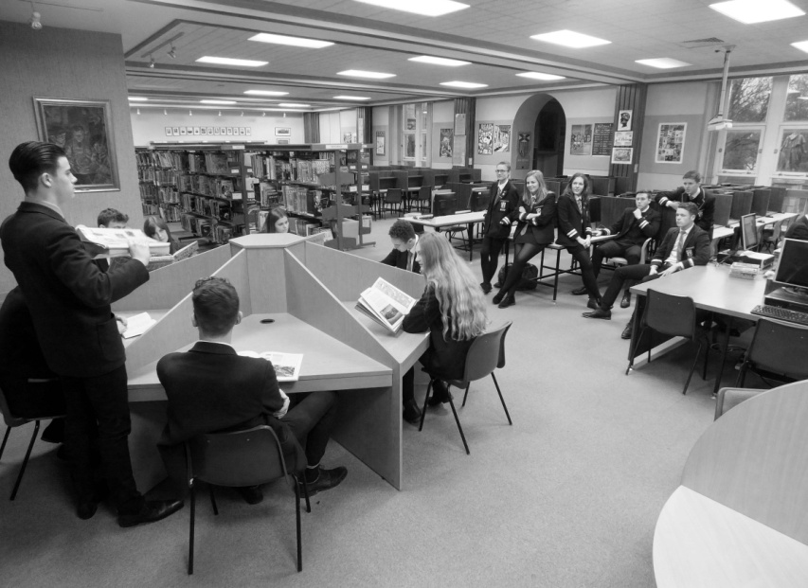
Homework can take many forms; set written exercises, research for project work or folios, independent study, reviewing class work. The nature, amount and duration of homework will vary from subject to subject and pupil to pupil. As a general guide the time a pupil spends on homework will increase as they progress through the school.

Parents have an important role in encouraging their children to see studying at home as an important and helpful part of their education. It will be beneficial if parents can provide a table or desk in a quiet area away from distractions. Time should be set aside for homework.

All pupils are provided with a homework diary/planner free of charge. Pupils are encouraged to use these to record homework on the date due which allows them to plan and prioritise. As the homework diary is an expensive investment pupils must take good care of them and bring them
to school each day. Parents are invited to check their child's homework planner on a regular basis.

4. ASSESSMENT & REPORTING

4.1 Assessment and Reports

Informal “assessment” of pupils’ work is carried out continuously as part of the normal learning and teaching process in each classroom. Using their judgement of individual pupils’ progress teachers then plan the “next steps” of learning.

Teachers supplement their ongoing informal assessment with tests at the end of topics or units of
work. A variety of methods of assessment are used in the school depending on the subject matter in each course; written, oral, aural or practical assessments.

S4, S5 and S6 pupils experience a formal diet of “estimate” examinations. S5/6 estimates in January/February. The senior pupils (S4 to S6) take end of course examinations set by the Scottish Qualifications Authority in May/June.

Reports are issued to parents during the session, the dates for issuing these are included in the parents’ diary issued annually. As the new Curriculum for Excellence courses are implemented the dates of reports to parents is reviewed annually.

Reports are issued for each of the subjects studied and contain attainment grades and information on attitude and effort. Written comments highlighting strengths and next steps or actions for improvement in learning are also provided by teachers. The attainment grading system used in each set of reports is explained within the reports. In S4-S6 the grades used are based on the grading system used by the Scottish Qualifications Authority. In S1, 2 & 3 the levels are based on the new Curriculum for Excellence Assessment curriculum levels.

Parents’ Interview Meetings
We report to parents on pupils’ progress at appropriate times of the session and a number of parents’ evenings are organised so parents can discuss progress with teachers. An appointment system is used to allow parents to plan suitable appointments. Parents' Interview Meetings are from 4.30pm - 7.00pm.

In January Primary 7 parents are invited to an Information Evening where the topic is P7 – S1 transfer arrangements. During the summer term in June they have a further opportunity to attend an Information Evening at the time of the primary 7 link visits to Aberdeen Grammar School.

Parents of S1 pupils are invited to attend an Information Evening at the time pupils choose subjects for S2/S3. Similar events are held for parents of S3, S4 and S5 as they choose courses for the following session. In November S3 parents are briefed on Work Experience.

PORTING

5. ETHOS
5.1 Positive Behaviour

In line with national and regional policy, the discipline structure relies on a partnership between pupils, teachers and parents to ensure good relationships, mutual respect and agreed objectives.

Good discipline is vital to the success of any school and the staff appreciate the understanding, co-operation and support of parents in their efforts to maintain acceptable standards among our pupils, in and out of school. Thereby, we seek to sustain a secure and happy environment in which young people can learn, with encouragement and without distraction.

The aims are to:

1. Recognise, maximise and value attainment, achievement and the participation of all pupils

2. Provide an appropriate and progressive curriculum with learning and teaching approaches which develop knowledge, skills and positive attitudes to meet the needs of each individual pupil within society

3. Provide effective support for each pupil in a safe and caring environment

4. Foster an ethos which values equality, fairness, good relationships, achievement and a sense of identity and pride in the school and wider community

The policy is based on the Rights and Responsibilities of all who attend Aberdeen Grammar School. These Rights and Responsibilities are outlined below and they indicate clearly the expectations placed on all those who attend the school. The Policy is designed to develop a working relationship between pupils and staff based on self-discipline, courtesy and respect.

On entering First Year each pupil has the school’s Discipline policy explained to them and receives a copy of the ‘Discipline Policy Document’ to take home. This document explains, in some detail, the expectations of pupil behaviour at Aberdeen Grammar School and the systems used when concerns start to emerge. Parents are involved in this process from an early stage and the system focuses on working constructively with the pupil in an attempt to raise standards quickly and effectively. Additional copies of the policy document are available from the school on request.

As a particular and important aspect of discipline, a discrete but compatible policy on bullying has been developed so that channels for communication and action are clear to all.

Each member of staff is responsible for the discipline in his/her classroom. Serious disciplinary problems are referred by teachers to their Principal Teacher, who may deal with the problem or may refer it to the Depute Rector responsible for that pupil, who in turn may involve the Senior Depute Rector. Principal Teachers Pupil Support are generally informed at every stage of such procedures, so that the pupil can be counselled and home contact co-ordinated.

The main form of sanction for breaches of discipline (misbehaviour, truancy, etc) is detention after normal school hours. Subject departments can, and do, operate their own schemes of detention for lack of co-operation or bad behaviour and, in such cases, parents are notified by letter of the detention and the reason for it.

Instances of lateness by a pupil are recorded by the office who then decides when an absence
5. ETHOS
‘problem situation’ is developing. At that point, parents are informed and thereafter some form of sanction may be invoked.

In cases involving breaches of the general school rules, detention is given and supervised by members of the Senior Management Team after school. Each case is considered separately and arrangements are made in the light of all relevant circumstances as to when and for how long detention will be done by the pupil concerned.

The ultimate sanction is, of course, exclusion from school. This is invoked by the Rector or Depute only in extremely serious cases and when all other strategies, as outlined in the ‘Discipline Policy Document’ have proven ineffective. In cases of exclusion, parents are automatically contacted and the City Education Officer informed. In its most serious form a pupil may be excluded and his/her name removed from the register here.

Grounds for Exclusion
“The Education Authority consider that in all the circumstances to allow the pupil to continue attendance at the school would be likely to be seriously detrimental to order and discipline in the school or the educational well-being of the pupils there”.

Anti-Bullying Policy
We have a policy document which describes our approach and procedures to prevent the deep and negative effects which bullying can create. Anyone suffering from any form of bullying should know of the channels available to tell us about the problem and should have confidence that their concerns will be addressed. This policy document is distributed to all pupils, staff and parents.

Supervision of Pupils at Interval and Lunchtime
Parents should be aware that the agreement on Conditions of Service for teachers employed in Scottish secondary schools does not make it any part of a teacher’s duties to supervise pupils during intervals or lunchtimes. Generally, prefects maintain supervisory duties and adults are available within the school premises to whom accidents or incidents can be referred.

5.2 School rules for pupils

It is the firm belief of the School that life is much easier for pupils when there is a simple and clear statement of what is expected and required of them as pupils of this School.

To this end, a list of simple, general rules has been drawn up and is distributed to all parents and pupils through this prospectus. Copies of the rules are also posted on notice boards in the School. Pupils are expected to have read the rules and to observe them, so that all in school can enjoy an orderly and relaxed atmosphere and environment.

The list of School Rules is included below.

Attendance
1. All pupils must report to school punctually each day. Failure to do so will lead to detention.

2. All pupils returning after absence must bring a note signed by a parent or guardian. This note must be presented to the House Tutor on the day of return. A confirmation slip will then be issued by the House Tutor and this, in turn, should be shown to all class teachers.

3. Pupils in S1 to S5 may not leave the school precincts during school hours without a permission slip signed by his/her Principal Teacher Pupil Support, or by the appropriate
Depute Rector. Pupils in S6 must attend all timetabled classes and registration classes and must remain in school until 9.50 each day if no classes are timetabled.
5. ETHOS
4. Parents are strongly discouraged from taking pupils out of school for family holidays during term time.

Conduct and Behaviour
5. All pupils are reminded that the good name of the school is in their keeping at all times,
especially when they are in school uniform.

6. On their way to and from school, and throughout the school day, pupils must conduct themselves in a disciplined, courteous and considerate manner.

7. It is a serious offence to damage or deface in any way, the buildings, furnishings, books or other equipment of the school.

8. Care and consideration must be shown at all times towards other pupils and their property.

9. Smoking and mischievous loitering are strictly forbidden anywhere within the school grounds and precincts.

10. Before school, and at intervals, pupils may not enter classrooms except when a member of staff is present.

11. When school has been dismissed, pupils must not remain within the buildings, without proper reason.

12. During intervals and lunchtimes, pupils should not be in any area above the ground floor unless attending a club or meeting.

13. Pupils must obey instructions given by Prefects.

14. It is the duty of all pupils to ensure that they keep themselves informed through the school News Sheet and information boards. In particular they should make themselves familiar with the Fire Drill procedures posted in each classroom.

Movement
15. As a general rule, pupils should keep to the left when moving along corridors and when using staircases.

16. Between periods, pupils must move smartly to their next class.

17. Pupils are forbidden to cycle within the school grounds.

18. All shops are out of bounds during school hours.

Property
19. Pupils must have their names on all books, clothing and personal belongings.

20. The care of money and valuables brought to school is the responsibility of the pupils. Pupils are advised not to bring valuable articles to school.

21. Bicycles are brought to school at the pupils’ own risk.
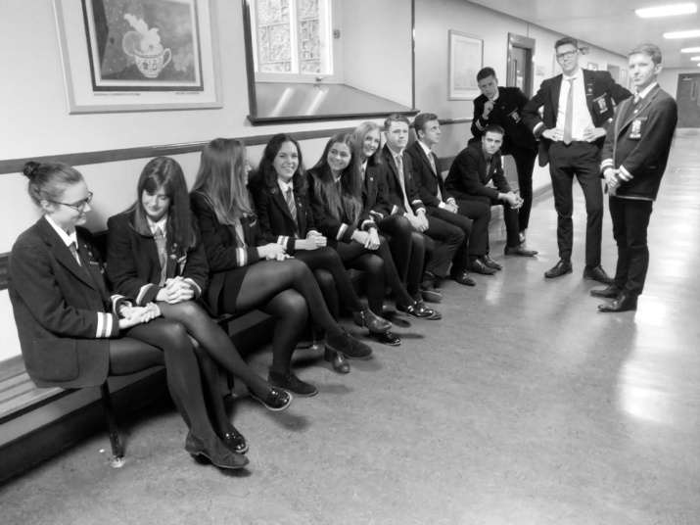

School Environment
5. ETHOS
22. Pupils are expected to take a pride in the appearance of their school and to help keep the area tidy by placing litter in the bins provided.

5.3 Attendance and Absence

All pupils under the age of 16 are required by law to attend school and it is the responsibility of parents/carers to ensure that their child attends school regularly and punctually. House Teams
monitor each pupil’s attendance and work closely with parents and the Home School Liaison Officer to ensure high attendance rates.

On each day of absence, parents/carers must inform the school office of their child’s absence by
telephoning (01224 655898) before 8.30am. Parents must also confirm, in writing, the reason for and length of the absence, on their child’s return to school. A note should be handed in to the House Tutor during registration on the pupil’s first day back at school. If such a note is not handed in, the Home-School Liaison Officer may be asked to conduct a home visit in order to confirm the reason for absence.

Holiday absence
Parents are strongly discouraged from taking pupils out of school for family holidays during term time. Holidays taken during term time are classified as ‘unauthorised absence’ unless exceptional family circumstances apply. If parents wish to take their child out of school during term time, they should make a written request, in advance, to the relevant Head of House, stating the reasons.

Appointments
Parents are requested to keep appointments during the school day to a minimum. Pupils leaving school for an appointment, or arriving late at school following an appointment, must show the appointment card / parental letter to office staff as they sign out / in at the school office.

Punctuality
All pupils are expected to arrive in good time for school and classes. Pupils who arrive in school late for registration must report to the Senior Depute’s office. Lates are monitored daily and detention issued. Pupils who arrive in school after registration must sign in at the school office. The parents/carers of pupils whose lateness is causing concern will be contacted in order to find an early resolution to the problem.

5. ETHOS

5.4 Personal Property

As any large comprehensive school is a busy place, all personal belongings, such as articles of clothing, books, school equipment, etc should be clearly marked with the owner’s name.

Pupils should not leave money or valuables unattended in desks, in their school bags or in items of clothing. Such articles should be carried on the pupil’s person or handed for safe-keeping to a teacher when they are PE.

Pupils are advised not to leave their bags unattended anywhere in school.

Lockers are available to pupils in S1-6 but parents are advised to ensure that their children carry the minimum of money and valuables to school with them.

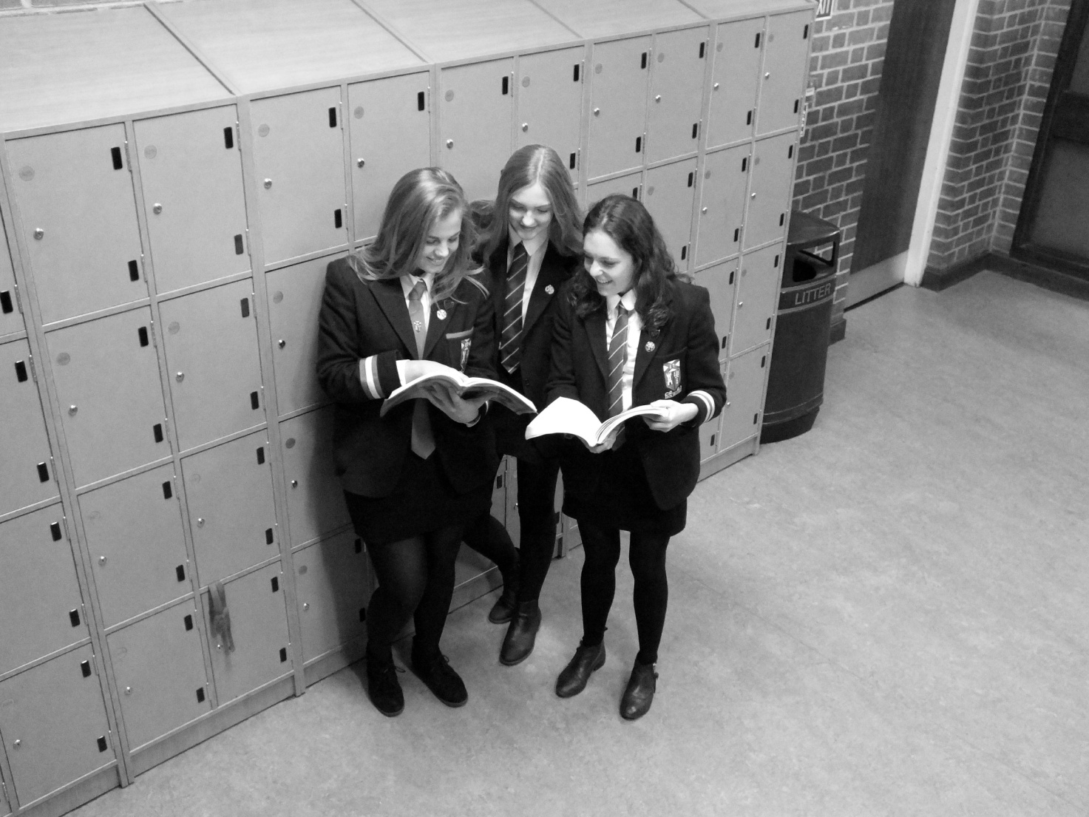

6. ADMINISTRATION
6.1 Administration

Medical Arrangements
We do not have a full time nurse though we do have trained First Aiders.

When a pupil becomes ill or requires first-aid during the school day, help is usually available from
First Aiders. If the pupil is unable to return to his/her studies, arrangements are made to contact the parents who take the pupil taken home. Where necessary, pupils may be conveyed home, or in the case of accidents, to the Casualty Department by taxi or parents.

In an emergency, your emergency-contact will be telephoned if there is no-one in the pupil’s home. Parents are asked, in the interest of the children, to ensure that the School has a realistic emergency contact.

It is in the interests of pupils that we ask parents to inform us of any medical problem or condition
affecting their children. Such information is helpful, for example of teachers of physical education,
and enables us to take prompt and appropriate action if a pupil is suddenly taken ill. Details of this nature are of course handled with sensitivity and in confidence.

Routine medical examinations are carried out from time to time by the school doctor and nursing
staff. Parents are informed when these examinations are to take place. Pupils with medical/dental appointments during the school day should bring the appointment card to
their House Tutor teacher to be recorded.

Fire Drill
Clear instructions as to what to do in case of fire are displayed beside the door in each classroom. Members of staff are instructed to make them known to pupils using their classroom and from time to time, pupils are reminded that they must be familiar with the drill to be carried out in case of an emergency.

Each term, a full-scale fire drill is carried out and the exercise evaluated.

Adverse Weather Arrangements
In the North of Scotland it is important that we carefully plan our arrangements for bad weather. In October each year Aberdeen Grammar School reviews its arrangements and reminds parents of the importance of adhering to guidelines.

Pupils living close to the school will not normally be sent home in snowy/icy weather. When there is a complete covering of snow persisting throughout the school day we will shorten the unchtime by 20 minutes and close 20 minutes earlier. This arrangement reduces the lunchtime and allows pupils and staff to travel home earlier in daylight.

Parents of children who travel some distance to the school by bus or car must be familiar with the
school’s arrangements for dealing with adverse weather. An information leaflet is issued to parents annually.

Parents of children who don’t live within reasonable walking distance of the school will be asked to provide the name and address of a relative or friend who lives near the school. In very bad weather conditions the pupil may need to stay overnight at this storm address.

6. ADMINISTRATION

If the weather has been severe overnight parents can access information on whether the school is open on the Aberdeen City Council’s Parents’ Information Line.

Telephone Number 0870 054 1999

Aberdeen Grammar School Pin Number 011000

Internet School Closures website: www.aberdeencity.gov.uk/closure

6.2 School Lunches and Morning Snacks

The dining hall operates a self-service system and uses a cashless card system named Accord. Money is loaded onto the Accord card via machines in the school, by cheque (made payable to Aberdeen City Council) or online. The maximum you can have on the card is £50. You then use the card to buy food as you would in a normal restaurant.

Pupils taking their own packed lunches are encouraged to eat them in the Dining Hall.

Free School Meals
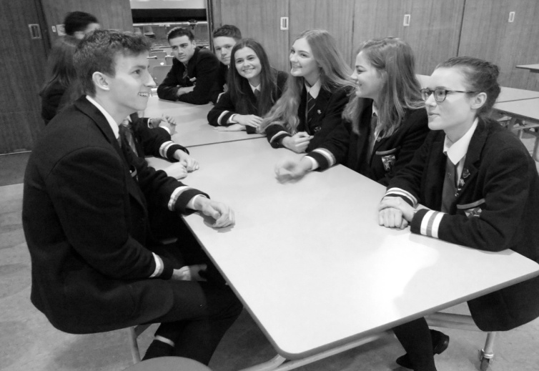
A free school meal is a school lunch to the value of a 2-course meal provided free of charge by Aberdeen Council.

Entitlement to Free School Meals is linked to the benefit/income a family receives and will be provided if parents/carers are in receipt of:

- Income Support or Pension Credit (Guarantee Credit)
- Job Seekers Allowance (income based), or income-related Employment Support Allowance
- Child Tax Credit but not Working Tax Credit and their annual income is less than £15,860
- Child tax Credit and Working Tax Credit and their annual income is less than £6420
- Support under Part VI of the Immigration and Asylum Act 1999.

Any person aged 16-18 years old in receipt of any of the benefits listed above is eligible to claim free school meals in their own right.

Application forms for Free School Meals are available on request from the school office or by calling the Benefits Section on 08456 08 01 49

Please note that if you are claiming for Housing or Council Tax benefit, the application form will also be used as a claim for free school meals – parents are not required to complete a separate form in this case.

6. ADMINISTRATION
6. ADMINISTRATION

6.3 Information for new arrivals and pupils leaving

Admission to School
The majority of pupils enrolling at Aberdeen Grammar School come from our associated primary
schools – Ashley Road Primary School, Gilcomstoun Primary School, Mile End Primary School, St Joseph’s Primary School and Skene Square Primary School.

A transition calendar for P7 pupils and parents/carers outlines a comprehensive programme
of activities which aim to facilitate the move from primary to secondary school. P7 Parents’
Information Evenings are held in January and June. During P7 Link Week in June, P7 pupils follow their S1 timetable.

The Depute Head Teacher co-ordinates the enrolment of new pupils who join Aberdeen Grammar School during the school year. All new pupils and their parents/carers attend an admissions and induction meeting prior to the agreed start date.

If parents living outwith the catchment area wish to make a placing request for their child to
attend Aberdeen Grammar School, they should contact School Placements at Aberdeen City
Council on 01224 522753.

Leaving School
There are two leaving dates:

- 31 May for pupils who reach the age of 16 between 1 March and 30 September that year
- Last school day in December for pupils who reach the age of 16 between 1 October and 29 February

The law does not permit any exceptions to this.

Parents are requested to inform the school and particularly the Principal Teacher Pupil Support, as soon as possible, if and when their children are transferring to another school.

All pupils leaving this School must ensure that all their text books are returned to departments and that a Leavers’ Form is completed. These forms are available the School Office.

6.4 Transport to School

Pupils are not permitted to park cars in the school grounds and cars bringing or collecting pupils are not allowed into the school grounds, unless they are conveying incapacitated pupils.

Bicycles are brought to school at the owner’s risk and should be locked securely when left unattended. Cycle racks are provided in a reasonably sheltered, central area. As bicycles cannot be supervised throughout the school day parents are advised to make certain that bicycles are
insured. In the interest of safety to others, pupils should dismount at the school gates and walk with the bicycles to the cycle rack.

These rules are strictly enforced in the interest of safety.

6. ADMINISTRATION

6.5 School Pupils’ Insurance

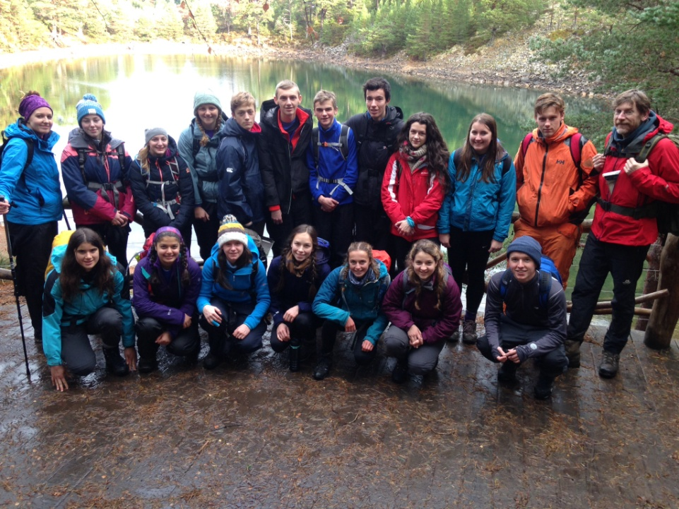
Parents should be aware that no insurance cover is held by the Aberdeen City Council to provide automatic compensation to pupils in the event of a personal accident or death. It is your responsibility as a parent to insure your child for personal accident or death if you feel this is appropriate.

Aberdeen City Council does hold third party liability insurance which indemnifies the Council for claims from third parties (e.g. parents of pupils) who have suffered injury, illness, loss or damage arising from the negligence of the Council or its employees. However, if there is no negligence, no claim would be accepted by the Council.

This information is brought to your attention in order that you may take whatever action you feel
appropriate. We are also particularly anxious to avoid the potentially distressing situation of parents only becoming aware of the insurance position after an accident has occurred however remote this possibility.

7. CONTACT & LIAISON
7.1 Parental Information

As our young people are a focus of common interest, very considerable importance is placed by the School on close liaison with parents. Parents are encouraged to consult staff initially through the relevant Principal Teacher Pupil Support or Depute Rector on any matter concerning their children.

The School has a policy of informing parents and consulting with them on specific matters of mutual concern such as behaviour, unexplained absence and school performance, so that appropriate action can be taken quickly.

Information of a general nature from the school to parents is usually conveyed home by letters from the Rector. These letters include such items as alterations in normal school hours, examination arrangements and ‘upcoming events’ on the school calendar. Parents should encourage their children to ensure that these communications are delivered to them. Details can also be found in our website www.grammar.org.uk

7.2 Parent Council

The Scottish Schools (Parental Involvement) Act 2006 makes provision for all parents of pupils in the school to be members of the Parent Forum. Aberdeen Grammar Parent Council meets regularly and is made up of volunteer members from the parent forum. The group is actively supported by the school and local councillors regularly attend Parent Council meetings to join in discussions on a range of issues connected with the school itself and with wider educational concerns. Its main functions are:

- To support the school in its work with pupils and parents.
- To represent the views of parents.
- To promote contact and communication between the school, parents, pupils, the community and other providers.
- To report to the parent forum.

The Parent Council has a role in the appointment of the Headteacher and Depute
Headteachers for the school.

Any parent forum member can volunteer to become a member of the Parent Council and all parent forum and staff members are welcome to attend its meetings. The Parent Council can be contacted by email at PCGrammar@aberdeencity.gov.uk

A sub-section of the Parent Council is the PTA whose main function is to raise funds for the school. They also provide a valuable contribution to Parents' Evenings, School Shows and Music Concerts by providing refreshments to staff and parents. The Fundraising Committee can be contacted by email AberdeenGrammarPTA@outlook.com

7.3 School Chaplains
7. CONTACT & LIAISON

The School has five officially appointed School Chaplains. They are drawn from those who have parochial involvement in our catchment area but are available to help any pupil who wishes their counsel and advice. They occasionally meet the pupils in groups arranged by the Religious Education teachers of this school as part of the Religious Education programme. They also contribute to Acts of Worship held in the school at different times of the year, within the framework of our policy on Religious Observance.

The School Chaplains are:

Rev. Diane Hobson, St Marks Church
Rev. Sarah Nicol, Midstocket Church
Rev. Dr Robert Smith, Rubislaw Church
Rev. Scott Rennie, Queens Cross Church
Fr. Gabor Czako, St. Peter’s Church
Rev. Duncan Eddie, Holburn West Church

7. CONTACT & LIAISON

7.4 Former Pupil Organisation

The School enjoys a very happy relationship with the local FP Club and its several active centres throughout the country. Their support contributes an intangible but real sense of stability and belonging, which is transmitted to many of the present pupil population. They, in turn, obviously qualify for membership which can foster a life-long attachment to the School.
Website www.agsfp.com

7.5 Communication

In addition to the statutory Prospectus, News Sheets and Newsletters are produced regularly to ensure the flow of information to pupils (Daily News Sheet) and parents (Termly Newsletter)

