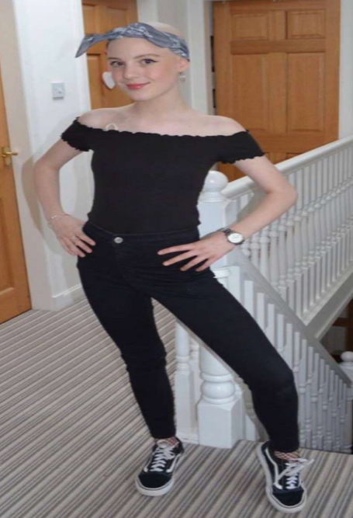
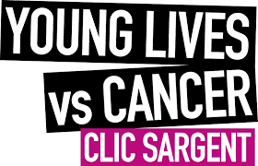

This year, Aberdeen Grammar School has chosen to partner with Clic Sargent, a charity which supports young people and their families during their fight against cancer.
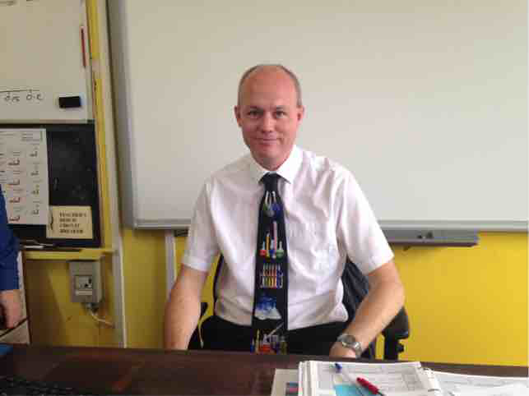
Their vision is that “everyone under 25 with cancer and their families, will get the support and help they need during their cancer treatment and beyond, including bereaved families living with emotional pain”.
Clic Sargent is our chosen charity this year as they are supporting one of our pupils Molly, a brave young girl fighting a strong battle against cancer. Clic Sargent is helping her and her family with accommodation when she travels for treatment, funding and if required, counselling and financial support.
Last year, as a school, we raised over £7000 pounds for Charlie House and this year we hope to build on this for Clic Sargent. In October 2017, we began our fundraising campaign at the annual ‘Autumn Concert’ where an awareness table was set up to spread the word about Clic Sargent. On the last day of term, our ‘Tights and Ties day’, the school came together to raise money and spread awareness, bringing our total to over £1000 raised with one week while displaying an impressive array of tights and ties as displayed below.
