Types of Organisational Structure
Type | Basic Drawing / Diagram | Definition | Benefit | Limitation
Flat | 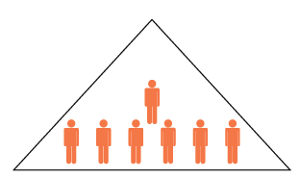
Extended / Hierarchical | 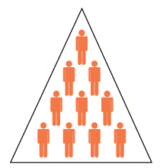
Matrix | 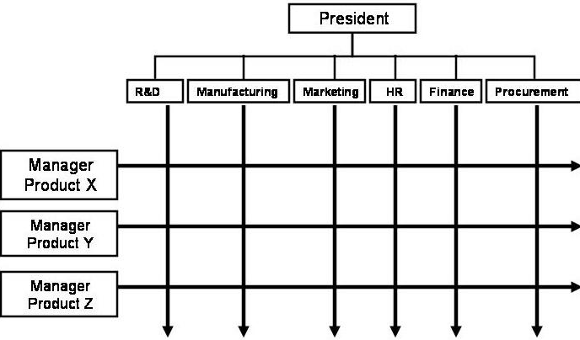
Circular | 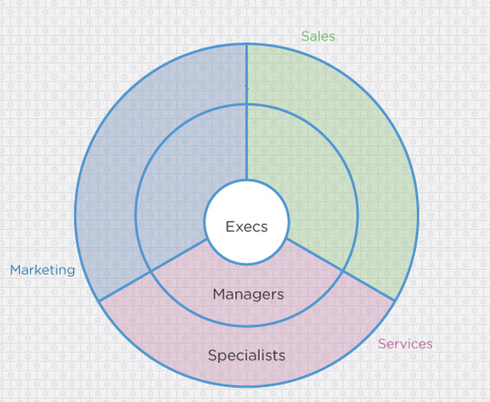
By Function | 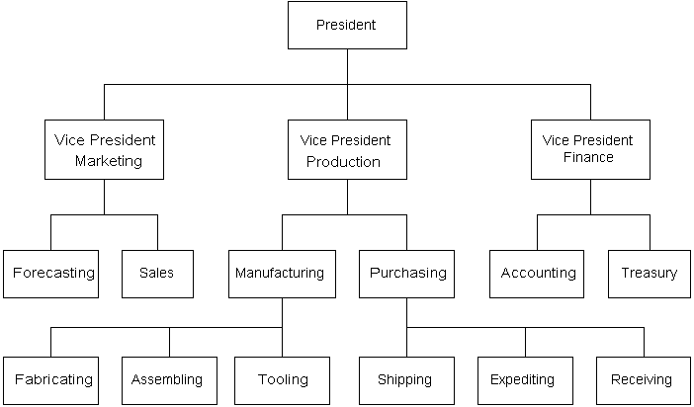
By Geography | 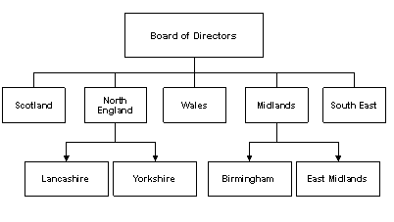
By product | 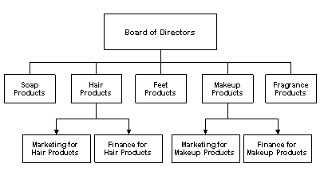

What is meant by the term ‘Span of Control’? Use an example above to illustrate your answer.

What is meant by the term ‘Chain of Command? Use an example above to illustrate your answer.

