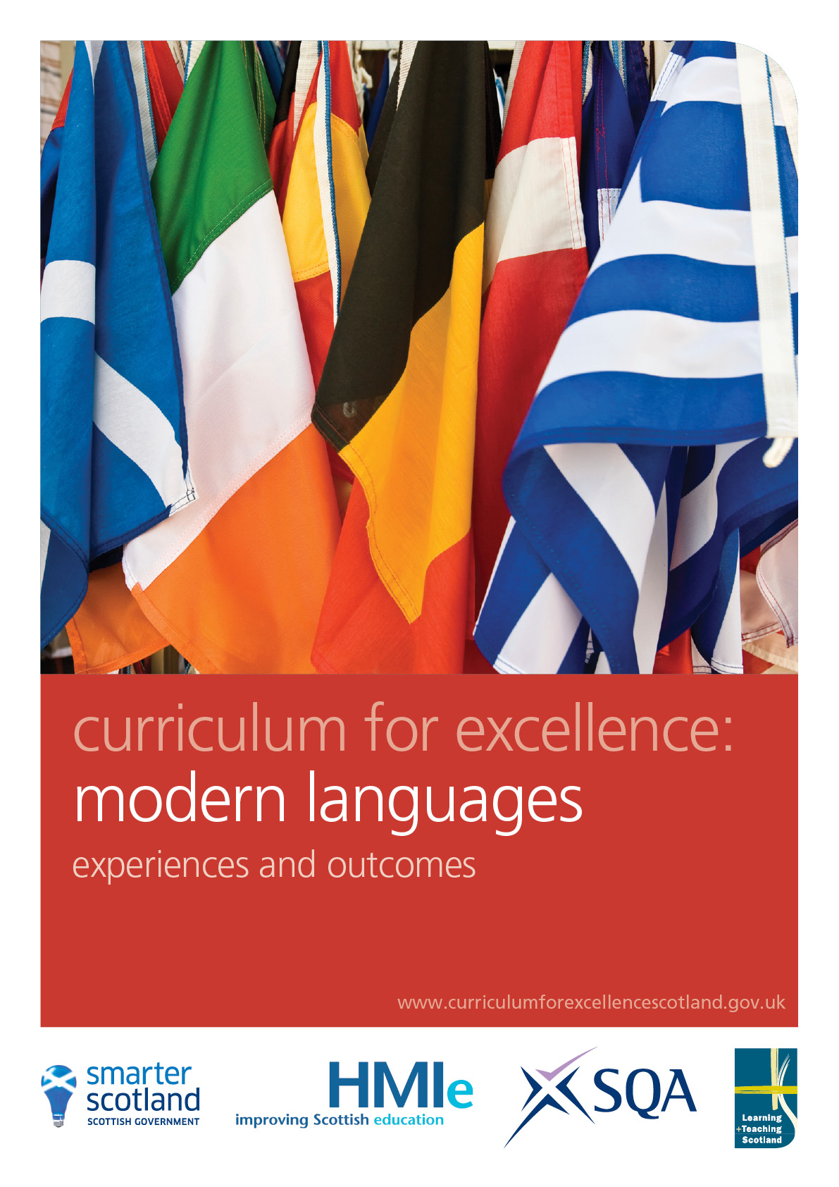

Modern languages

Experiences and outcomes

Learning a new language encourages children and young people to broaden their horizons as they explore the language and its associated culture.

Through my learning of a new language:

- I gain a deeper understanding of my first language and appreciate the richness and interconnected nature of languages
- I enhance my understanding and enjoyment of other cultures and of my own and gain insights into other ways of thinking and other views of the world
- I develop skills that I can use and enjoy in work and leisure throughout my life.

The study of language plays an important role in all language learning and the development of literacy skills.

I develop and extend my literacy skills when I have opportunities to:

- communicate, collaborate and build relationships
- reflect on and explain my literacy and thinking skills, using feedback to help me improve and sensitively provide useful feedback for others
- engage with and create a wide range of texts in different media, taking advantage of the opportunities offered by ICT
- develop my understanding of what is special, vibrant and valuable about my own and other cultures and their languages
- explore the richness and diversity of language, how it can affect me and the wide range of ways in which I and others can be creative
- extend and enrich my vocabulary through listening, talking, watching and reading.

Listening and talking

 | First | Second | Third | Fourth
Listening for information | I explore the patterns and sounds of language through songs and rhymes and show understanding verbally or non-verbally  MLAN 1-01a  I am learning to take an active part in daily routines, responding to simple instructions which are accompanied by gesture and expression.  MLAN 1-01b  I can listen to and show understanding of language from familiar voices and sources.  MLAN 1-01c | I explore the patterns and sounds of language through songs and rhymes and show understanding and enjoyment by listening, joining in and responding.  MLAN 2-01a  I take an active part in daily routines, responding to instructions which are accompanied by gesture and expression.  MLAN 2-01b  I can listen to and show understanding of familiar instructions and language from familiar voices and sources.  MLAN 2-01c | I can listen to and show understanding of mainly familiar language and instructions from a variety of sources, where the sentences are longer and where there may be more than one speaker.  MLAN 3-01a | I can listen to and show understanding of language from a variety of sources, including unfamiliar speakers, where the sentences are more complex, less predictable, and contain some unfamiliar language or known language used in unfamiliar contexts.  MLAN 4-01a
Listening and talking with others | I am beginning to identify key information from a short predictable conversation and react with words and/or gesture  MLAN 1-02a  I am beginning to share information about myself using familiar vocabulary and basic language structures.  MLAN 1-02b | I explore how gesture, expression and emphasis are used to help understanding. I can listen and respond to familiar voices in short, predictable conversations using straightforward language and non-verbal techniques as appropriate such as gesture and eye contact.  MLAN 2-02a | I can listen and respond to others in mainly predictable, more extended conversations using familiar language and non-verbal techniques as appropriate.  MLAN 3-02a | I can listen and respond to others, including sympathetic fluent speakers of the language, in extended conversations that are less predictable.  MLAN 4-02a

Listening and talking (continued)

 | First |  | Second | Third | Fourth
Listening and talking with others  (continued) |  | With support I am becoming an active listener and can understand, ask and answer simple questions to share information.  MLAN 1-03 | When listening and talking with others, I am developing an awareness of when to listen and when to talk. I am learning new words which I use to share information about myself and others.  MLAN 2-03a  I can take part effectively in prepared conversations by sharing information about myself and others or interests of my choice, using familiar vocabulary and basic language structures.  MLAN 2-03b | I can take part effectively in prepared conversations by using a variety of language structures to share information, experiences and opinions and by offering straightforward reasons for having these opinions.  MLAN 3-03a | I can take part effectively in more detailed conversations using an extended range of language structures to exchange information, experiences, feelings and opinions and by offering more detailed reasons for having these opinions.  MLAN 4-03a
 |  |  | I can ask for help confidently using learned phrases and familiar language.  MLAN 2-04a | I can support a conversation by asking for help, seeking repetition and asking simple questions.  MLAN 3-04a | I can start, support and sustain a conversation by, for example, asking relevant questions and by seeking help when necessary.  MLAN 4-04a
 |  | I enjoy listening to stories, songs, rhymes and poems in the language I am learning by joining in and responding to show my understanding.  MLAN 1-05a  I can participate in a range of collaborative activities.  MLAN 1-05b | I explore simple songs and rhymes and I enjoy learning with others as we talk and listen together.  MLAN 2-05a  I can participate in familiar collaborative activities including games, paired speaking and short role plays.  MLAN 2-05b | I can participate in a range of collaborative activities, including games, paired speaking and structured role plays, in a range of realistic contexts set mainly in a country where the language I am learning is spoken.  MLAN 3-05a | I can collaborate to prepare and present more open-ended role plays in a wide range of realistic contexts set both in my own country and in a country where the language I am learning is spoken.  MLAN 4-05a

Listening and talking (continued)

 | First | Second | Third | Fourth
Organising and using information | Through a variety of media, I am developing an awareness of social, cultural and geographical aspects of locations in a country where the language I am learning is spoken.  MLAN 1-06 | I can deliver a brief presentation on a familiar topic using familiar language and phrases.  MLAN 2-06a  I have worked with others, using a variety of media including ICT where appropriate, and can contribute successfully to a presentation in English, supported by use of the language I am learning, on an aspect of life in a country where the language I am learning is spoken.  MLAN 2-06b | I have contributed successfully to a group to plan and prepare short talks in the language I am learning on topics of personal interest or linked to an aspect of a country where the language I am studying is spoken.  MLAN 3-06a  I can deliver an individual presentation in the language I am learning, using a variety of media including ICT where appropriate.  MLAN 3-06b | I can, using a variety of media including ICT where appropriate, plan, prepare and deliver an individual presentation in the language I am learning on topics of personal interest or linked to an aspect of a country where the language I am studying is spoken.  MLAN 4-06a
Using knowledge about language | I am beginning to explore similarities and differences between sound patterns in different languages through play, rhymes, songs and discussion.  MLAN 1-07a  I can use my knowledge about language and pronunciation to ensure that others can understand me when I say familiar words and phrases.  MLAN 1-07b | I explore comparisons and connections between sound patterns in different languages through play, discussion and experimentation.  MLAN 2-07a  I can use my knowledge about language and pronunciation to ensure that others can understand me when I read aloud or say familiar words, phrases and short texts.  MLAN 2-07b | I can apply my knowledge about language, intonation and pronunciation to:  - ensure that others can understand me when I pronounce familiar words or phrases  - help me work out how to pronounce unfamiliar words  - read a short text aloud with accuracy and confidence.  MLAN 3-07a | I can apply my knowledge about language, intonation and pronunciation to:  - ensure that others can understand me when I pronounce familiar and unfamiliar words and phrases  - help me work out how to read aloud familiar and unfamiliar texts with accuracy and confidence.  MLAN 4-07a

Reading

 | First | Second | Third | Fourth
Finding and using information | I can recognise labels and environmental print. I am beginning to organise images and text. With support, I can sequence images and text to demonstrate my understanding.  MLAN 1-08a  I can work on my own or with others to demonstrate my understanding of words and phrases containing familiar language.  MLAN 1-08b | I work on my own and with others to understand text using appropriate resources, demonstrating my understanding by matching written words to pictures and by reconstructing the text in a logical sequence, for example.  MLAN 2-08a  I can read and demonstrate understanding of words, signs, phrases and simple texts containing mainly familiar language.  MLAN 2-08b | I work on my own and with others to understand text using appropriate resources. I can read and demonstrate understanding of more complex texts which contain familiar and unfamiliar language.  MLAN 3-08a | Using a variety of resources, I can independently read text which is more detailed and which contains complex language including a range of tenses, and demonstrate my understanding.  MLAN 4-08a

Reading (continued)

 | First | Second | Third | Fourth
Reading to appreciate other cultures | I am beginning to recognise similarities and differences between Scotland and a country where the language I am learning is spoken, using varied simple texts, visual prompts and media.  MLAN 1-09a | I work on my own and with others to read and discuss simple texts in the language I am learning. I can share simple facts about features of life in some of the countries where the language I am learning is spoken.  MLAN 2-09a | I work on my own and with others to read and explore texts in the language I am learning. I can demonstrate my knowledge about life and culture in some of the countries where the language I am learning is spoken.  MLAN 3-09a | I work on my own and with others to read and research texts in the language I am learning. I can demonstrate my understanding of different cultures and my appreciation of different ways of looking at the world in countries where the language I am learning is spoken.  MLAN 4-09a
Reading for interest and enjoyment | I have experienced a variety of simple texts, which may have been adapted for young learners.  MLAN 1-10a | I can choose and can read, on my own and with others, a variety of straightforward texts of different types, including non-fiction, short imaginative accounts, prose and poetry, which may have been adapted.  MLAN 2-10a | I can select and read for interest and enjoyment a range of texts, including longer imaginative texts in a variety of styles, both prose and poetry, which may have had some adaptation.  MLAN 3-10a | I can select and read for interest and enjoyment a range of more detailed texts containing complex language, including imaginative accounts, both prose and poetry, which use familiar and unfamiliar language and may have had some adaptation.  MLAN 4-10a

Reading (continued)

 | First | Second | Third | Fourth
Using knowledge about language | I am beginning to use illustrated word-banks, picture prompts, picture dictionaries and displays to support my understanding of simple texts.  MLAN 1-11a | I can understand how a bilingual dictionary works and use it with support.  MLAN 2-11a  I can make comparisons and explore connections between spelling patterns in English and the language I am learning.  MLAN 2-11b  I experiment with new language, working out the meaning of words and phrases using vocabulary I have learned so far.  MLAN 2-11c  I can recognise and comment on other features of my own language which help to make sense of words in the language I am learning.  MLAN 2-11d | I can use a bilingual dictionary independently to help me understand new language.  MLAN 3-11a  I can recognise features of words in the language I am learning and use them to make sense of vocabulary and of the connections between words.  MLAN 3-11b | I can use my knowledge about language and other strategies to help me to understand and analyse more detailed texts, containing some unfamiliar language and more complex structures.  MLAN 4-11a

Writing

 |  | Second | Third | Fourth
Organising and using information |  | I use the support of others and access appropriate reference materials of my choice to help me plan my writing in ways that engage my reader, using ICT when appropriate.  MLAN 2-12a / MLAN 3-12a / MLAN 4-12a
 | With support, I am beginning to experiment with writing in the language I am learning  MLAN 1-13 | I have opportunities to express myself in writing, exploring and experimenting with words and phrases using resources, to ensure my writing makes sense.  MLAN 2-13a  I can use familiar language to describe myself and to exchange straightforward information.  MLAN 2-13b | I can create, amend and present more extended information about myself and others, my experiences, or a topic of my choice for different purposes.  MLAN 3-13a  I can express opinions and can offer straightforward reasons for having those opinions.  MLAN 3-13b | I can write more extensively over a widening range of topics in a range of formats, using some variety of structures, tenses and linking words.  MLAN 4-13a  I can write about experiences, feelings and opinions and can offer reasons for having those opinions.  MLAN 4-13b
Using knowledge about language |  | I use my knowledge about language and success criteria to help me, and I can check that I have written familiar words and phrases accurately.  MLAN 2-14a | I can check the accuracy of my writing using my knowledge about language, the support of others and appropriate reference materials, including success criteria.  MLAN 3-14a | I can use my knowledge about language, including structure, spelling and punctuation, using success criteria to take responsibility for the accuracy of my writing.  MLAN 4-14a

