 **NATIONAL 4 AND NATIONAL 5 CHEMISTRY**

**Unit 1: Chemical Changes and Structure**

**Topic 1**

**RATES OF REACTION**



**Mass / g**

**Time / min**

**5**

**10**

**15**

**20**

**25**

**30**

**35**

**0**

**0**

**122.50**

**122.40**

**122.30**

**122.20**



|  |
| --- |
| **Name _____________________________________ Class _____** |

|  |
| --- |
| Unit 1: Chemical Changes and Structure |
| Topic 1: Rates Of Reaction |

|  |  |  |  |  |  |
| --- | --- | --- | --- | --- | --- |
| LEVEL N4 N5 | **AFTER COMPLETING THIS TOPIC YOU SHOULD BE ABLE TO:** | NOTES (Page) | **How well I have understood (✓)** | | |
| **☺** | **😐** | **☹** |
| N4 | State that the rate of a reaction is affected by changes, in concentration, particle size and temperature. | 8 - 9 |  |  |  |
| N4 | State the rate of a reaction can be followed by measuring changes in concentration, mass and volume of reactants and products. | 3 - 5 |  |  |  |
| N4 | Draw graphs from data from chemical reaction by measuring mass or volume of gas versus time and understand how the shape of the graph relates to the speed of the reaction at different times during the reaction. | 5 - 7 |  |  |  |
| N5 | Calculate the average rate of a reaction, or stage in a reaction, from initial and final quantities and the time interval. | 10 - 12 |  |  |  |
| N5 | Write the correct units for rate. | 12 |  |  |  |
|  |  |  |  |  |  |

|  |  |  |
| --- | --- | --- |
| **N4** | **FOLLOWING REACTIONS** | **N4** |

**REACTION RATES**

The speed the reactants change into products is called the **REACTION RATE**.

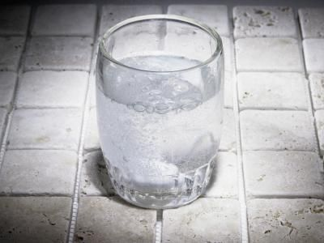

Rusting is a very slow reaction.

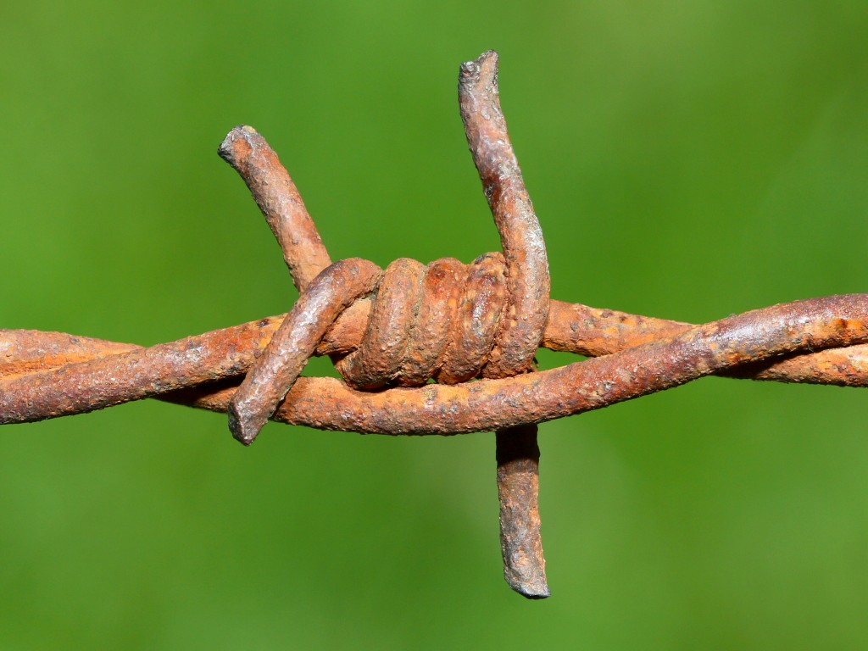

Extremely fast reactions are **EXPLOSIVE**.

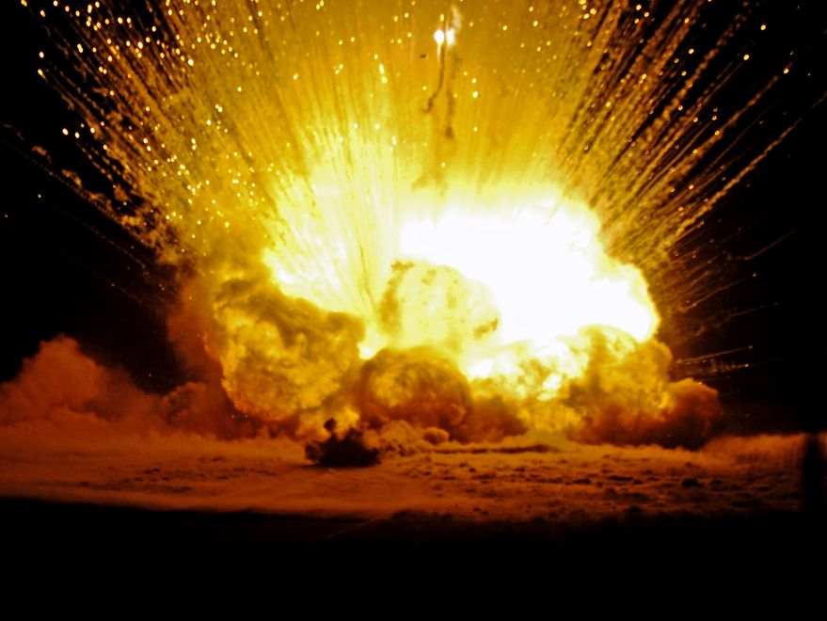

There are number of ways of measuring the rate of a reaction.

The rate of a reaction, which produces a gas, can be followed by:

* Measuring the mass of the reaction **OR,**
* Collecting the gas and measuring the volume.  
    
  **Over regular time intervals i.e. every 30 seconds.**

**FOLLOWING A REACTION: MEASURING MASS**

**Marble** (**calcium carbonate**) reacts with hydrochloric acid producing **calcium chloride**, **wate**r and **carbon dioxide gas**.



**hydrochloric acid**

Carbon dioxide molecules leave the reaction.

Therefore, the number of atoms in the beaker decreases.

**The mass of the beaker and its contents decreases during the reaction**.

The mass of the reaction can be followed, by placing the beaker on a balance.

**calcium carbonate (marble)**

The mass of the beaker and the reaction can be measured at regular intervals during the reaction.

This apparatus can be used to investigate the effect of:



**50 cm3  2 mol *l*-1 hydrochloric acid**

**calcium carbonate (marble)  
approximately 1 g**

**conical  
flask**

**balance**

**stopwatch**

**Start timing immediately after adding the marble.**

* The size of lump (particle size);
* The temperature of the

hydrochloric acid;

* The concentration of the

hydrochloric acid.

**On the rate of the reaction**.



**HYDROCHLORIC ACID  
2 mol *l*-1**



**50 cm3   
2 mol *l*-1 acid  
+  
50 cm3 water**

**HYDROCHLORIC ACID  
1 mol *l*-1**

**½**

**concentration**



**25 cm3   
2 mol *l*-1 acid  
+  
75 cm3 water**

**HYDROCHLORIC ACID  
0.5 mol *l*-1**

**¼**

**concentration**



**75 cm3   
2 mol *l*-1 acid  
+  
25 cm3 water**

**HYDROCHLORIC ACID  
1.5 mol *l*-1**

**¾**

**concentration**

**HOW TO CHANGE CONCENTRATION**

To change the concentration of a solution (hydrochloric acid), the solution has to be mixed with different volumes of water.

The following shows how to dilute **2 mol *l*-1** hydrochloric acid to make  
**100 cm3 of lower concentrations**.

**FOLLOWING A REACTION: MEASURING GAS VOLUME**

In a reaction where a gas is produced, the gas can be collected and measured at regular time intervals throughout the reaction.



**calcium carbonate  
(marble)  
maximum 1g**

**30 cm3 2 mol *l-*1 hydrochloric acid**

**delivery tube**

**measuring cylinder**

**water**



**stopwatch**

**FOLLOWING A REACTION: DRAWING & INTERPRETING GRAPHS**

The experimental data of either the **mass of the reaction OR** the **volume of carbon dioxide collected** measured at regular **time intervals** can be presented on a graph.



**0**

**0**

**5**

**10**

**15**

**20**

**25**

**30**

**35**

**Time / min**

**Mass / g**

**122.30**

**122.20**

**122.40**

**122.50**

**MASS vs TIME**

**2 mol *l-*1 hydrochloric acid**

**1 mol *l-*1 hydrochloric acid**

**4 mol *l-*1 hydrochloric acid**

**Reactants:  
0.56 g of marble**

**50 cm3 of hydrochloric acid**

**Variable:  
concentrationof hydrochloric acid**

**INTERPRETING GRAPHS: FOLLOWING MASS**

The shape of graph provides a lot of information about the rate and progress of a reaction.

The steepness, **the gradient**, of a line gives a measure of the rate.

The graph below shows the results of varying the concentration of hydrochloric acid in the reaction with calcium carbonate (marble).

To ensure the results were fair the following variables were kept the same:

* The mass of marble – (0.56 g in each experiment).
* The size of the lump of marble (surface area) – (medium lumps).
* The temperature of the hydrochloric acid – (room temperature).
* The volume of hydrochloric acid – (30 cm3 in each experiment).



**0**

**0**

**5**

**10**

**15**

**20**

**25**

**30**

**35**

**Time / min**

**Mass / g**

**122.30**

**122.20**

**122.40**

**122.50**

**MASS vs TIME**

**2 mol *l-*1 hydrochloric acid**

**1 mol *l-*1 hydrochloric acid**

**4 mol *l-*1 hydrochloric acid**

**The steeper the gradient of a line the greater the reaction rate,**

**i.e. the faster the reaction.**

**When the line levels off the reaction has stopped.**

**2 mol *l-*1 hydrochloric acid stops at 20 minutes.**

**4 mol *l-*1 hydrochloric acid stops at 9 minutes.**

**1 mol *l-*1 hydrochloric acid stops at 32 minutes.**

**INTERPRETING GRAPHS: FOLLOWING GAS VOLUME**

Measuring the gas volume produced by a reaction at regular time intervals throughout the reaction produces the following graphs.

The graph below shows the results of varying the size of the lump (surface area) of calcium carbonate (marble), in the reaction with hydrochloric acid.

To ensure the results were fair the following variables were kept the same:

* The mass of marble – (0.56 g in each experiment).
* The concentration of the hydrochloric acid – (2 mol *l*-1 in each experiment).
* The temperature of the hydrochloric acid – (room temperature).
* The volume of hydrochloric acid – (30 cm3 in each experiment).



**Time / min**

**5**

**10**

**15**

**20**

**25**

**30**

**35**

**0**

**0**

**175**

**125**

**75**

**25**

**50**

**100**

**150**

**Volume / cm3**

**medium lumps**

**small lumps**

**large lump**

**VOLUME vs TIME**

In all reactions the rate is fastest at the start, as the concentration of the reactants are at their highest.

As the reaction progresses, the rate slows down, as the reactants are used up and their concentration decreases.

**Small lumps reaction stops at 11 minutes.**

**Medium lumps reaction stops at 18 minutes.**

**Large lump reaction stops at  
30 minutes.**

**RATES OF REACTION - SUMMARY**

The rate of a reaction depends on the following variables:

* The **concentration** of a solution.
* The **temperature** at which the reaction is carried out.
* The **size of the lumps (particle size)** – this only affects reactions involving solids.

**COLLISIONS AND REACTIONS**



**hydrochloric acid particles**

**calcium carbonate  
(marble)**

For a reaction to occur the reactant particles must come into contact, or collide with each other.

The more collisions that occur per second, the faster the reaction.

A reaction occurs when the hydrochloric acid particles collide with the marble particles.

**CONCENTRATION**

The concentration of a solution is a measure of the number of particles of chemical in every drop of solution.

**hydrochloric acid particles**

**calcium carbonate  
(marble)**

**LOW CONCENTRATION**

**HIGH CONCENTRATION**

There are a small number of hydrochloric acid particles in the solution, resulting in very few collisions with the marble.

**The reaction is slow.**

There are a large number of hydrochloric acid particles in the solution, resulting in many collisions with the marble.

**The reaction is fast.**



**TEMPERATURE**

When a substance is heated up its particles move about faster as they have more energy.

**hydrochloric acid particles**

**calcium carbonate  
(marble)**

**LOW TEMPERATURE**

**HIGH TEMPERATURE**

The hydrochloric acid particles are moving slowly, resulting in very few collisions with the marble.

**The reaction is slow.**

The hydrochloric acid particles are moving quickly, resulting in many collisions with the marble.

**The reaction is fast.**



**SIZE OF LUMP – SURFACE AREA**

When a solid reacts, it is only the particles on the surface of the solid which come in contact with the other reactant.

**LARGE LUMP**

**SMALL LUMPS**

**Break up into small lumps.**

The large lump has few marble particles exposed to the hydrochloric acid. **It has a small surface area**.

Very few collisions take place between the marble and hydrochloric acid.

**The reaction is slow.**

The small lumps expose a large number of marble particles to the hydrochloric acid. **It has a large surface area**.

Many collisions take place between the marble and hydrochloric acid.

**The reaction is fast.**

|  |  |  |
| --- | --- | --- |
| **N5** | **CALCULATING RATE** | **N5** |

**HOW TO CALCULATE THE RATE OF A REACTION**

The rate of a reaction is a measure of how quickly a reactant is used up by a reaction, **OR**, how quickly a product is made by a reaction.

To calculate the **average rate of a reaction** requires:

* A measure of the **change in quantity** of either, a reactant used, or product made by a reaction.

**AND**

* The **time interval for the change in quantity**.

|  |  |  |
| --- | --- | --- |
| **Average reaction rate** | **=** | **Change in quantity of chemical**  **Time interval for the change** |

**EXAMPLE** At the start of a reaction between magnesium and hydrochloric acid, the concentration of hydrochloric acid was **2 mol *l* -1**. After **8 minutes** of reaction the concentration of the hydrochloric acid was found to be **0.4 mol *l* -1**.  
  
**Calculate the average rate of the reaction**.

|  |  |  |  |  |
| --- | --- | --- | --- | --- |
| **Change in concentration of hydrochloric acid = 2 - 0.4 = 1.6 mol *l* -1** .  **Time interval for the change = 8 minutes**. | | | | |
| **Average reaction rate** | **=** | **1.6**  **8** | **=** | **0.2 mol *l* -1 min-1** |

**UNITS OF RATE**

The unit for measuring reaction rate depends on the measurement of:

* The quantity of chemical – **mass (g)**, **volume of gas (cm3), or**  
  **concentration mol *l* -1.   
    
  AND**
* The unit of time – **seconds (s)**, **minutes (min),** or **hours (hr)**.

**EXAMPLES OF UNITS OF RATE**

|  |  |  |  |  |
| --- | --- | --- | --- | --- |
| **mol *l* -1 min -1**  **concentration change per minute** |  | **cm -3 s -1**  **gas volume change per second** |  | **g hr -1**  **mass change per hour** |

**CALCULATING RATE FROM A GRAPH**

A graph plotted from the data obtained by measuring the **mass**, **concentration** or **gas volume**, as they vary with time during a reaction, can be used to calculate the average rate.



**0**

**0**

**5**

**10**

**15**

**20**

**25**

**30**

**35**

**Time / min**

**Mass / g**

**122.30**

**122.20**

**122.40**

**122.50**

**MASS vs TIME**

The graph shows how the mass of a reaction between marble and hydrochloric acid varies with time.

**Calculate the average rate during the first 7 minutes**.

|  |
| --- |
| **Mass at start = 122.50 g**  **Mass after 7 minutes = 122.32 g**  **Change in mass:**  **122.50 - 122.32 = 0.18 g** |

|  |  |  |
| --- | --- | --- |
| **Average reaction rate** | **=** | **0.18**  **7** |
|  | **=** | **0.026 g min-1** |

**CALCULATING RATE FROM A GRAPH**

The graph shows how the volume of carbon dioxide gas produced in a reaction between marble and hydrochloric acid varies with time.



**Time / min**

**5**

**10**

**15**

**20**

**25**

**30**

**35**

**0**

**0**

**175**

**125**

**75**

**25**

**50**

**100**

**150**

**Volume / cm3**

**VOLUME vs TIME**

**Calculate the average rate during the between 10 and 15 minutes**.

|  |
| --- |
| **Volume at 10 min = 100 cm3**  **Volume at 15 min = 130 cm3**  **Change in volume:**  **130 - 100 = 30 cm3** |

|  |  |  |
| --- | --- | --- |
| **Average reaction rate** | **=** | **30**  **5** |
|  | **=** | **6 cm3 min-1** |

|  |  |
| --- | --- |
|  | To practise calculating the average rate of a reaction, do the **CALCULATING AVERAGE RATE** examples on **page 2** of the **Practice Examples Booklet**. |