 **NATIONAL 4 AND NATIONAL 5 CHEMISTRY**

**Unit 3: Chemistry In Society**

**Topic 2**

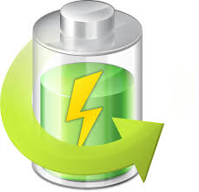**ELECTRICITY & CHEMISTRY**

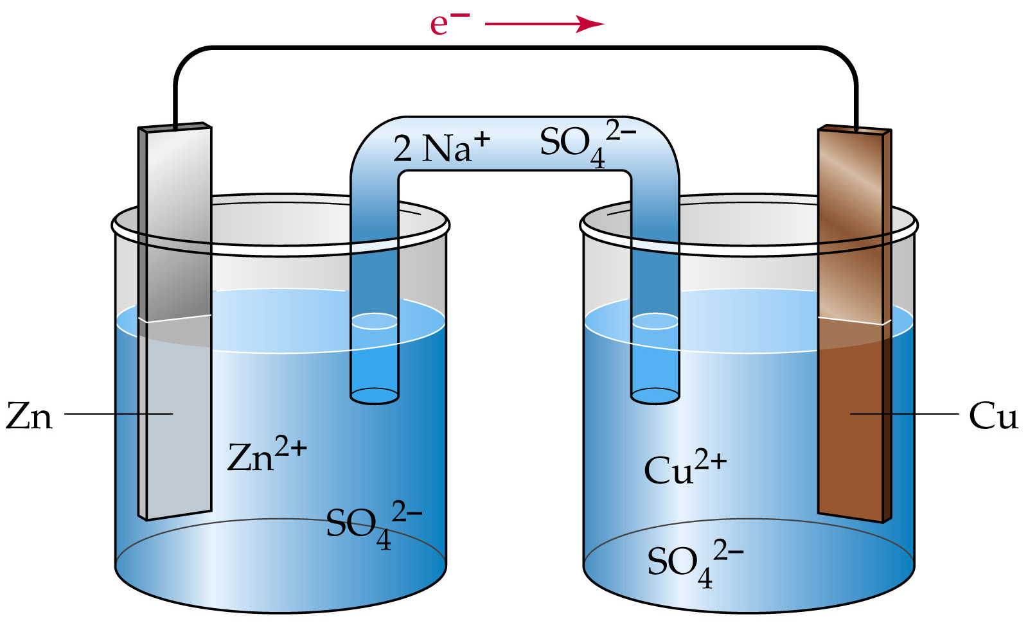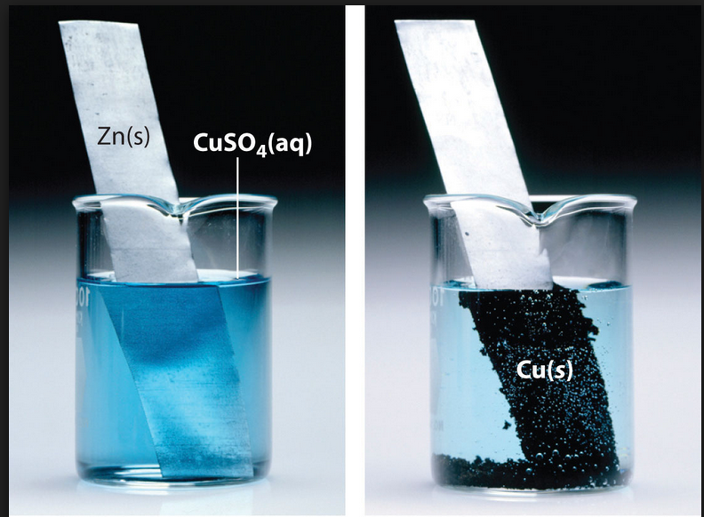

|  |
| --- |
| **Name __________________________________ Class _____** |

|  |
| --- |
| Unit 3: Chemistry In Society |
| Topic 2: Electricity & Chemistry |

|  |  |  |  |  |  |
| --- | --- | --- | --- | --- | --- |
| LEVEL N4 N5 | **AFTER COMPLETING THIS TOPIC YOU SHOULD BE ABLE TO:** | NOTES (Page) | **How well I have understood (✓)** | | |
| **☺** | **😐** | **☹** |
| N4 | State that, in a battery, electricity comes from a chemical reaction. | 3-4 |  |  |  |
| N4 | State that electricity passing along metal wires is a flow of electrons. | 4 |  |  |  |
| N4 | State electricity can be produced by connecting different metals together, with an electrolyte, to form a simple cell. | 5-6 |  |  |  |
| N4 | State the voltage between different pairs of metals varies and this leads to the electrochemical series. | 6 |  |  |  |
| N4 | State a displacement reaction occurs when a metal is added to a solution containing ions of a metal lower in the electrochemical series | 8-10 |  |  |  |
| N4 | State the reaction of metals with acids can establish the position of hydrogen in the electrochemical series. | 10-11 |  |  |  |
| N4 | Use the Electrochemical Series to make a prediction about a displacement reaction. | 10 |  |  |  |
| N5 | Identify the reactants, which undergo oxidation and reduction during a displacement reaction. | 11-12 |  |  |  |
| N5 | Combine oxidation and reduction reactions to give a redox reaction. | 12-13 |  |  |  |
| N5 | State electricity can be produced in a cell by connecting two different metals in solutions of their metal ions. | 14-15 |  |  |  |
| N5 | Electrons flow in the external circuit from the species higher in the electrochemical series to the one lower in the electrochemical series. | 17 |  |  |  |
| N5 | State the purpose of the ‘ion bridge’ (salt bridge) is to allow the movement of ions to complete the circuit. | 17 |  |  |  |
| N5 | Use the direction of electron flow in an electrochemical cell to describe where oxidation and reduction takes place. | 16-18 |  |  |  |
| N5 | Use the Electrochemical Series to produce a cell when at least one of the half-cells does not involve metal atoms. | 19-20 |  |  |  |
| N5 | State that some batteries are rechargeable, e.g. the lead-acid battery. | 21-22 |  |  |  |
| N5 | Describe the reactions, which take place in a hydrogen fuel cell. | 22-23 |  |  |  |
|  |  |  |  |  |  |

|  |  |  |
| --- | --- | --- |
| **N4** | **MAKING ELECTRICITY** | **N4** |

**CHEMICAL REACTIONS**

There are many everyday things that use batteries to provide the energy to work.

|  |  |  |
| --- | --- | --- |
| * a radio * a mobile phone * a personal music player |  |  |

There are many kinds of battery, but they all provide a portable source of electricity

|  |  |  |  |
| --- | --- | --- | --- |
|  |  |  |  |

The electricity from a battery is made as a result of a chemical reaction.

**LEAD - ACID BATTERY**

The first type of batteries invented was made from sulfuric acid and lead plates.

|  |  |
| --- | --- |
| **Sulfuric acid**  **Lead plates** | **(a) CHARGING**  During charging electrical energy is being fed into the battery.  Bubbles of gas are produced on the electrodes. **Hydrogen** is produced at the negative electrode and **oxygen** at the positive electrode.  During charging **ELECTRICAL ENERGY** is converted to **CHEMICAL ENERGY.** |

|  |  |
| --- | --- |
| **Bulb**  **Lead plates**  **Sulfuric acid** | **(b) DISCHARGING**  The bulb lights up for a short time.  During discharging **CHEMICAL ENERGY** is converted to **ELECTRICAL ENERGY.**  The lead-acid battery is an example of a **RECHARGEABLE** battery, as the chemicals, which produce the electricity, can be replaced again by **CHARGING** the battery. |

**ELECTRIC CURRENT**

When a metal conducts electricity, **electrons** move through the metal.

|  |  |
| --- | --- |
|  | In an electrical circuit involving a battery, electrons are made by a reaction at the negative terminal of the battery.  The electrons move around the circuit and are taken in by a reaction at the positive terminal of the battery |

|  |  |  |
| --- | --- | --- |
| **N4** | **SIMPLE CELLS** | **N4** |

**JOINING METALS**

A simple cell (or battery) can made by joining **zinc** to **copper**.



**Zinc electrode**

**Copper electrode**

**Salt solution (sodium chloride)**

An **electric current** flows from the **zinc electrode** to the **copper electrode**.

For **zinc atoms** to produce **electrons** they have to change into **zinc ions.**

|  |  |  |  |  |
| --- | --- | --- | --- | --- |
| **zinc atom** |  | **zinc ion** | **+** | **2 electrons** |
| **Zn** |  | **Zn2+** | **+** | **2 e-** |

The zinc atoms are **OXIDISED** as each atom **loses 2 electrons**.

The salt solution is an **electrolyte**. The ions in the salt solution completes the circuit

|  |
| --- |
| **DICTIONARY - ELECTROLYTE**  Compounds which conduct electricity when molten or in aqueous solution are called **ELECTROLYTES**.  All ionic compounds are electrolytes.  All cells (batteries) require electrolytes. |

A simple battery is called a **CELL**.

All metals change into their ions, giving off electrons when they react.

However, different metals are not equally good at changing into their ions.

The electrons, which come off the metal atoms, build up on the surface of the metal.

In the **zinc** – **copper** cell the **zinc** was better at giving off electrons than **copper**.

Measuring the **voltage** between two different metals gives a measure of the difference in their abilities to change into their ions and give off electrons.

**CELL VOLTAGE**

This experiment compares the ability of **different metals** with **copper** to change into their ions and give off electrons. The **voltage** of different metals with **copper** is measured.

**RESULTS**



**Copper**

**Filter paper soaked in salt solution.**

**Other metal**

|  |  |
| --- | --- |
| **METAL** | **VOLTAGE / V** |
|  |  |
|  |  |
|  |  |
|  |  |
|  |  |

This series of results is called an **ELECTROCHEMICAL SERIES**.

|  |  |  |  |
| --- | --- | --- | --- |
| The order of ability of the metals to give electrons to copper: | | | |
| **BEST** |  |  | **WORST** |
| **Mg** |  |  |  |

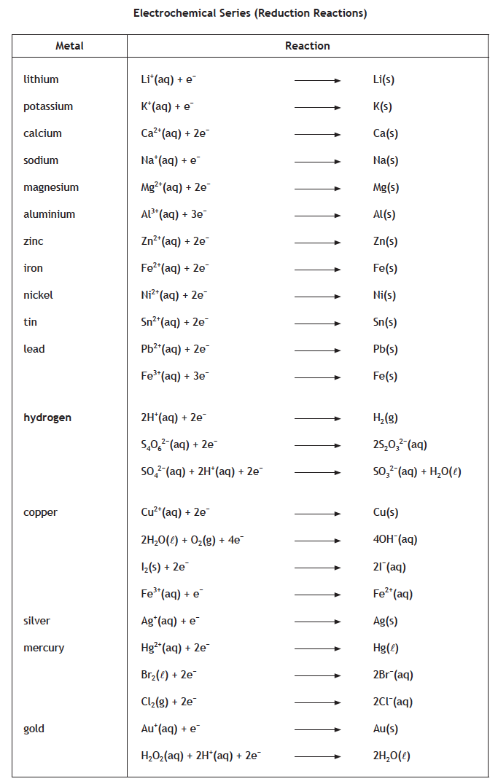**DATA BOOKLET**

The data booklet contains a table called **“ELECTROCHEMICAL SERIES (Reduction Reactions).”**

The table lists the metals in order of their ability to give away electrons.

**Lithium** is at the top – this means **lithium** atoms are **good at losing electrons**.

**Gold** is at the bottom showing **gold** is the **least able at losing electrons**.

|  |
| --- |
| **ELECTROCHEMICAL SERIES RULE 1**  The further the metals are apart in the Electrochemical Series the larger the voltage. |

|  |  |
| --- | --- |
|  | To practise applying the **ELECTROCHEMICAL SERIES RULE 1**, do the **ELECTROCHEMICAL SERIES RULE 1** examples on **page 3** of the **Practice Examples Booklet**. |

|  |  |  |
| --- | --- | --- |
| **N4** | **DISPLACEMENT** | **N5** |

**METALS AND SOLUTIONS**

**AIM: To find out what happens when a metal is placed in a solution containing a metal ion.**

Using a dimple tray, small pieces of **Mg**, **Zn** and **Cu** were placed into solutions containing different metal ions.



**Mg**

**Zn**

**Cu**

**Mg2+(aq)**

**Zn2+(aq)**

**Cu2+(aq)**

**Ag+(aq)**

If a reaction takes place the surface of the metal changes colour.

**RESULTS**

**AIM: To find out what happens when a metal is placed in a solution containing a metal ion.**

Using a dimple tray, small pieces of **Mg**, **Zn** and **Cu** were placed into solutions containing different metal ions.

|  |  |  |  |  |  |
| --- | --- | --- | --- | --- | --- |
| **SOLUTION** | | **METAL** | | |  |
| **FORMULA** | **METAL ION** | **Mg** | **Zn** | **Cu** |  |
| MgSO4(aq) | Mg2+(aq) |  |  |  | ✔  = reaction |
| ZnSO4(aq) | Zn2+(aq) |  |  |  | ✖  = no reaction |
| CuSO4(aq) | Cu2+(aq) |  |  |  |  |
| AgNO3(aq) | Ag+(aq) |  |  |  |  |

**Magnesium** (**Mg**) reacted with most of the metal ion solutions.

**Copper** (**Cu**) only reacted with the solution containing the **silver ion** (**Ag+**).

**DISPLACEMENT**

**Magnesium** reacted with every solution **EXCEPT magnesium sulfate**.



**Mg2+**

**Cu2+**

**SO42-**

**Cu**

**Mg**

The **magnesium** was pushing the metals in the solutions out and taking their place.

When **magnesium** was placed in **copper(II)  
sulfate** solution, **copper metal** was pushed out by the **magnesium** and **magnesium sulfate** solution formed.

**Magnesium** has displaced the **copper(II) ion** from the **copper(II) sulfate** solution to form **copper metal**.

|  |  |  |  |  |  |  |
| --- | --- | --- | --- | --- | --- | --- |
| **magnesium** | **+** | **copper(II)** sulfate |  | **magnesium** sulfate | **+** | **copper** |
|  |  |  |  |  |  |  |
| **Mg(s)** | **+** | **CuSO4(aq)** |  | **MgSO4(aq)** | **+** | **Cu(s)** |

|  |
| --- |
| **DICTIONARY - DISPLACEMENT REACTION**  When a metal **pushes another metal out of a solution** and **takes its place in the solution**, we call this a **DISPLACEMENT REACTION.** |

**ELECTROCHEMICAL SERIES**

The electrochemical series can be used to predict when a displacement reaction will take place.

|  |
| --- |
| **ELECTROCHEMICAL SERIES RULE 2**  A metal will displace another metal which is **LOWER DOWN** the **ELECTROCHEMICAL SERIES** from its solution. |

**Magnesium** is above **zinc**, **copper** and **silver** and therefore was able to **DISPLACE** these metals from their solutions.

**ACIDS AND METALS**

All acids contain the **hydrogen ion [H+(aq)]**. When a **metal** reacts with an acid the hydrogen ions in the acid are displaced out of the acid as **hydrogen gas [H2(g)]**.

|  |
| --- |
| All metals above **hydrogen** on the **ELECTROCHEMICAL SERIES** can displace **hydrogen ions [H+(aq)]** from an acid as **hydrogen gas [H2(g)]**. This means metals above **hydrogen** react with acids. |



**Mg2+**

**H+**

**SO42-**

**H2**

**H+**

**Mg**

When **magnesium** is placed in **sulfuric acid** the **magnesium** displaces the **hydrogen ions** as **hydrogen gas molecules**.

**Magnesium sulfate** also forms.

|  |  |  |  |  |  |  |
| --- | --- | --- | --- | --- | --- | --- |
| **magnesium** | **+** | sulfuric **acid** |  | **magnesium** sulfate | **+** | **hydrogen** |
|  |  |  |  |  |  |  |
| **Mg(s)** | **+** | **H2SO4(aq)** |  | **MgSO4(aq)** | **+** | **H2(g)** |

**N5**

**CHEMISTRY**

**DISPLACEMENT & REDOX**

A **DISPLACEMENT** **REACTION** is also a **REDOX** **REACTION** as electrons are transferred from one reactant to another.

**Zinc** displaces copper from **copper(II) sulfate** to produce a solution of **zinc** **sulfate**.



**Zn2+**

**Zn**

**Cu2+**

**SO42-**

**Cu**

**e-**

**e-**

The **zinc atoms** each lose **2 electrons** to form **zinc ions**.

|  |  |  |  |  |
| --- | --- | --- | --- | --- |
| **Zn(s)** |  | **Zn2+(aq)** | **+** | **2 e-** |

The **zinc atoms** are **OXIDISED**.

The **copper(II) ions** in the solution each gain **2 electrons** from the **zinc atoms** to form **copper atoms**.

|  |  |  |  |  |  |
| --- | --- | --- | --- | --- | --- |
| **Cu2+(aq)** | **+** | **2 e-** |  | **Cu(s)** | The **copper(II) ions** are **REDUCED.** |

In all **DISPLACEMENT REACTIONS** the metal that is added to a solution containing **metal ions** (or **hydrogen ions** in an acid) undergoes **OXIDATION**. The **metal ions** in solution (or **hydrogen ions** in an acid) undergo **REDUCTION**.



**Mg2+**

**H+**

**SO42-**

**H2**

**H+**

**Mg**

**e-**

**e-**

|  |  |  |  |  |
| --- | --- | --- | --- | --- |
| **Mg(s)** |  | **Mg2+(aq)** | **+** | **2 e-** |

The **magnesium atoms** are **OXIDISED**.

|  |  |  |  |  |
| --- | --- | --- | --- | --- |
| **2 H+(aq)** | **+** | **2 e-** |  | **H2(g)** |

|  |  |  |  |  |  |  |  |
| --- | --- | --- | --- | --- | --- | --- | --- |
|  |  | **Zn(s)** |  | **Zn2+(aq)** | **+** | **2 e-** | **OXIDATION** |
|  |  |  |  |  |  |  |  |
| **Cu2+(aq)** | **+** | **2 e-** |  | **Cu(s)** |  |  | **REDUCTION** |
|  |  |  |  |  |  |  |  |
| **Zn(s)** | **+** | **Cu2+(aq)** |  | **Zn2+(aq)** | **+** | **Cu(s)** | **REDOX** |
|  |  |  | Combining the **oxidation** and **reduction** reactions to give the **redox** reaction, results in the **2 electrons (2e-)** cancelling, as they will appear on opposite sides of each reaction. | | | | |
| **Zn is oxidised** |  | **Cu2+ is reduced.** |

The **hydrogen ions** **(H+)** are **REDUCED**.

**N5**

**CHEMISTRY**

**REDOX EQUATIONS**

A **REDOX** **EQUATION** can be written by combining the equations for the **oxidation** and **reduction** reactions.

**EXAMPLE: Zinc** displacing copper from **copper(II) sulfate** to produce a solution of **zinc** **sulfate**.

When combining **oxidation** and **reduction** reactions the **number of electrons lost** by the **oxidation** reaction must be the **SAME** as the **number of electrons** **gained** by the **reduction** reaction.

**EXAMPLE: Aluminium** displacing nickel from **nickel(II) nitrate** to produce a solution of **aluminium** **sulfate**.

|  |  |  |  |  |  |  |  |
| --- | --- | --- | --- | --- | --- | --- | --- |
| **× 2** |  | **Al(s)** |  | **Al3+(aq)** | **+** | **3 e-** | **OXIDATION** |
|  |  |  |  |  |  |  |  |
| **Ni2+(aq)** | **+** | **2 e-** |  | **Ni(s)** |  | **× 3** | **REDUCTION** |

The **oxidation** reaction is **multiplied by 2**, and the **reduction** reaction is **multiplied by 3**. This ensures both reactions have **6 electrons**.

|  |  |  |  |  |  |  |  |
| --- | --- | --- | --- | --- | --- | --- | --- |
| **× 2** |  | **Al(s)** |  | **Al3+(aq)** | **+** | **3 e-** | **OXIDATION** |
|  |  |  |  |  |  |  |  |
| **Ni2+(aq)** | **+** | **2 e-** |  | **Ni(s)** |  | **× 3** | **REDUCTION** |

|  |  |  |  |  |  |  |  |
| --- | --- | --- | --- | --- | --- | --- | --- |
|  |  | **2 Al(s)** |  | **2 Al3+(aq)** | **+** | **6 e-** | **OXIDATION** |
|  |  |  |  |  |  |  |  |
| **3 Ni2+(aq)** | **+** | **6 e-** |  | **3 Ni(s)** |  |  | **REDUCTION** |
|  |  |  |  |  |  |  |  |
| **2 Al(s)** | **+** | **3 Ni2+(aq)** |  | **2 Al3+(aq)** | **+** | **3 Ni(s)** | **REDOX** |
|  |  |  |  |  |  |  |  |
| **Al is oxidised.** |  | **Ni2+ is reduced.** |  |  |  |  |  |

|  |  |
| --- | --- |
|  | To practise combining reduction and oxidation reactions to write a redox reaction, do the **WRITING REDOX REACTIONS** examples on **page 5** of the **Practice Examples Booklet**. |

|  |  |  |
| --- | --- | --- |
| **N5** | **ELECTROCHEMICAL CELLS** | **N5** |

**METALS AND IONS**



**Zn2+**

**Zn**

**Cu2+**

**SO42-**

**Cu**

**e-**

**e-**

When **zinc** is placed into **copper(II) sulfate** solution, the **zinc** displaces the **copper**.

The **zinc atoms** transfer **electrons** to the **copper(II) ions**.

|  |  |  |  |  |
| --- | --- | --- | --- | --- |
| **Zn(s)** |  | **Zn2+(aq)** | **+** | **2 e-** |

The **zinc atoms** are **OXIDISED**.

The **copper(II) ions** in the solution each gain **2 electrons** from the **zinc atoms** to form **copper atoms**.

|  |  |  |  |  |  |
| --- | --- | --- | --- | --- | --- |
| **Cu2+(aq)** | **+** | **2 e-** |  | **Cu(s)** | The **copper(II) ions** are **REDUCED.** |

An **electrochemical cell** can be set up to show that **electrons transfer** and a **current** can be detected.

**ZINC – COPPER ELECTROCHEMICAL CELL**

Here is an **electrochemical cell** made using **zinc** and **copper**.



**Zn**

**ZnSO4(aq)**

**CuSO4(aq)**

**Cu**

**Zn2+**



**Cu2+**

**V**

**e-**

**e-**

**e-**

**e-**

**e-**

**e-**

Each metal is placed in a solution containing its own ions.

|  |
| --- |
| The **salt (or ion) bridge** completes the **electrochemical cell**.  This is filter paper soaked in a solution containing an ionic compound (an electrolyte). |

The **salt (or ion) bridge** **completes the** **circuit for ions**. It allows **ions** to **move between the solutions**.

The **electrochemical cell** produces a **voltage of about 1.0 V**. **Electrons** **(the current)** flows from the **zinc electrode** to the **copper electrode**

|  |
| --- |
| **DICTIONARY - ELECTROCHEMICAL CELL**  An **ELECTROCHEMICAL CELL** makes an electric current from chemicals.  This name is often shortened to a **CELL**. |

For **electrons** to flow from the **zinc electrode**, the **zinc** **atoms** have to change into **zinc** **ions**.



**Zn**

**ZnSO4(aq)**

**Zn2+**

**e-**

**e-**

**e-**

**Zn2+**

**Zn2+**

**Zn2+**

|  |  |  |  |  |
| --- | --- | --- | --- | --- |
| **Zn(s)** |  | **Zn2+(aq)** | **+** | **2 e-** |

The direction of the **current** (**electron** **flow**) shows **oxidation** occurs at the **zinc electrode**.

The **zinc ions** enter the solution of **zinc** **sulfate**.

The **mass** of the **zinc electrode decreases**.

At the **copper electrode**, **copper(II) ions**, **Cu2+(aq)** in the **copper(II) sulfate** solution are attracted to the **electrons** flowing in from the **zinc electrode**.

**CuSO4(aq)**

**Cu**



**Cu2+**

**e-**

**e-**

**e-**

**e-**

**e-**

**e-**

**e-**

**Cu2+**

**Cu2+**

When the **copper(II) ions** touch the **copper electrode**, they each gain **2 electrons**, and are changed into **copper atoms**.

The **copper(II) ions** are **REDUCED**.

|  |  |  |  |  |
| --- | --- | --- | --- | --- |
| **Cu2+(aq)** | **+** | **2 e-** |  | **Cu(s)** |

The **mass** of the **copper electrode increases** as **copper atoms** are deposited on the electrode.

**THE SALT (OR ION) BRIDGE**

The electrochemical cell does not work without a **salt bridge**. Another name for a **salt bridge** is an **ION BRIDGE**.

The **ion bridge** ensures the solutions are always electrically neutral by allowing **ions** to move between the solutions.

**-ve ions**

**+ve ions**

The number of **Zn2+(**aq) in solution increase as the **Zn**(s) give off electrons and changes into **Zn2+**(aq).

The solution needs **–ve ions** to remain electrically neutral.

The number of **Cu2+(aq)** decrease as they change into **Cu(s)**.

The solution needs **+ve ions** to remain electrically neutral.

**Cu**

**Cu2+**

**e-**

**e-**

**e-**

**e-**

**e-**

**e-**

**e-**

**Cu2+**

**Zn**

**Zn2+**

**e-**

**e-**

**e-**

**Zn2+**

**Zn2+**

The **salt (or ion) bridge** is made from **potassium nitrate** as it is **soluble**, and the **potassium** and **nitrate ions** do not form precipitates with any other ion.

**ELECTROCHEMICAL SERIES**

The **Electrochemical Series** can be used to work out:

* which pair of metals give the largest voltage;
* if a displacement reaction will happen;
* the direction of the current (electron flow) in an electrochemical cell.

|  |
| --- |
| **ELECTROCHEMICAL SERIES RULE 3**  In an electrochemical cell the electrons (the current) will flow from the metal higher in the Electrochemical Series to the metal lower down. |

Here are the zinc and copper equations as listed on the **Electrochemical Series**.

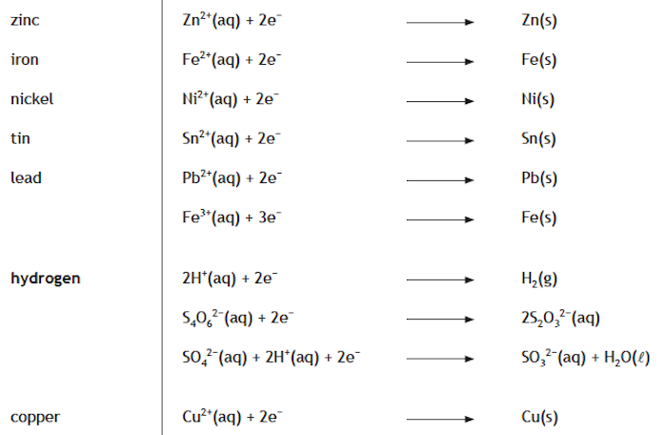

**Zn(s)**

**Zn2+(aq)**

**+**

**2 e-**

**e-**

**e-**

**Electrons** transfer from **Zn to Cu2+**.

The **Cu2+** is **reduced**. The equation is as written.

The **Zn** is **oxidised.** The equation is written in reverse.

**Cu2+(aq)**

**Cu(s)**

**+**

**2 e-**

The **electrons** flow from the **zinc electrode** to the **copper electrode**.

**CELLS WITHOUT METALS**

A **redox** reaction occurs when the reactants are located on the corners of the “**Z**” on the **Electrochemical Series**.

The **sulfite ion**, **SO32-(aq)**, can transfer electrons to **bromine, Br2(*l*)**.

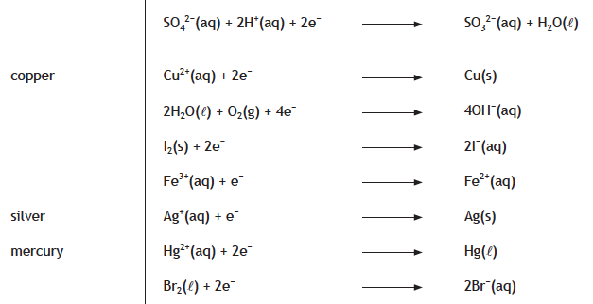

**e-**

**e-**

An **electrochemical cell** can be made using **sodium sulfite solution, Na2SO32-(aq)**, and **bromine solution, Br2(aq)**.

Here is **sulfite ion**, **SO32-(aq)** / **bromine molecule, Br2(aq)** **electrochemical cell**.



**Carbon rod**

**Na2SO3(aq)**

**Br2(aq)**

**Na+**

**V**

**e-**

**e-**

**e-**

**e-**

**e-**

**e-**

**Br2**

**SO32-**

**Na+**

**Carbon rod**

**Carbon electrodes** make the electrical connection with the solutions.

**Carbon** as **graphite** **conducts electricity**, and **does not react with the solutions**.

**Electrons** flow from the **sodium sulfite solution to the bromine molecule solution**

Here are the ion-electron equations from the **Electrochemical Series** for all the substances in the cell.

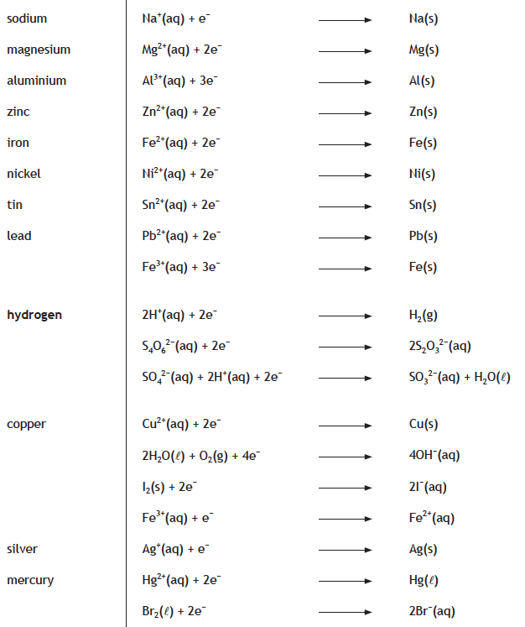

The **Na+** cannot react with the **Br2**, it is a spectator ion.

The **SO32-** is **oxidised.** The equation is written in reverse.

**Electrons** transfer from **SO32-** to **Br2**.

**e-**

**e-**

The **Br2** is reduced. The equation is as written.

**Br2(aq)**

**+**

**2 e-**

**2 Br-(aq)**

**SO32-(aq)**

**SO42-(aq)**

**+**

**2 e-**

**+**

**H2O(*l*)**

**2 H+(aq)**

**+**

Here are the **oxidation** and **reduction** reactions combined to give the **redox** reaction.

|  |  |  |  |  |  |  |  |  |  |  |  |  |  |  |
| --- | --- | --- | --- | --- | --- | --- | --- | --- | --- | --- | --- | --- | --- | --- |
| **SO32-(aq)** | **+** | **H2O(*l*)** |  | **SO42-(aq)** | | **+** | | **2 H+(aq)** | | **+** | | **2 e-** | | **OXIDATION** |
|  |  |  |  |  | |  | |  | |  | |  | |  |
| **Br2(aq)** | **+** | **2 e-** |  | **2 Br-(aq)** | |  | |  | |  | |  | | **REDUCTION** |
| **SO32-(aq)** | **+** | **H2O(*l*)** |  | | **SO42-(aq)** | **+** | **2 H+(aq)** | | | **+** | **2 Br-(aq)** | | | **REDOX** |
|  | **+** | **Br2(aq)** |  | |  |  | | |  |  | | |  |



|  |  |
| --- | --- |
|  | To practise applying the **ELECTROCHEMICAL SERIES RULE 3**, do the **ELECTROCHEMICAL SERIES RULE 3** examples on **page 6** of the **Practice Examples Booklet**. |

**RECHARGEABLE BATTERIES**

**Rechargeable batteries** are batteries which, when they go ‘flat’, can be charged and re-used. This means during **recharging** the chemicals used in the redox reactions are reformed.

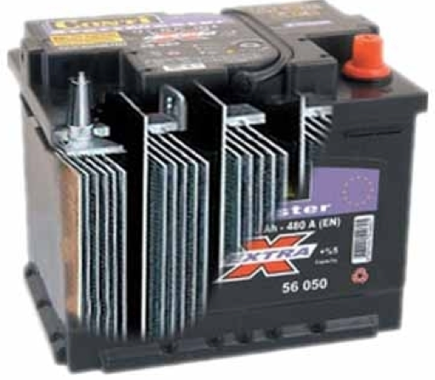The lead-acid battery is the oldest type of rechargeable battery. The battery is made from **lead** plates and **sulfuric acid**. A car battery is an example of this type of battery.

Some of the lead plates are covered in **lead(IV) oxide**, **PbO2**.

The following reactions occur at the electrodes when the battery is producing electricity, i.e. during **discharge**.

|  |  |  |  |  |  |  |  |  |  |  |  |
| --- | --- | --- | --- | --- | --- | --- | --- | --- | --- | --- | --- |
|  |  |  |  | **Pb(s)** | **+** | **SO42-(aq)** |  | **PbSO4(s)** | **+** | **2 e-** | **Oxidation** |
|  |  |  |  |  |  |  |  |  |  |  |  |
| **PbO2(s)** | **+** | **4 H+(aq)** | **+** | **SO42-(aq)** | **+** | **2 e-** |  | **PbSO4(s)** | **+** | **2 H2O(*l*)** | **Reduction** |
|  |  |  |  |  |  |  |  |  |  |  |  |
| **Pb(s)** | **+** | **PbO2(s)** | **+** | **4 H+(aq)** | **+** | **2 SO42-(aq)** |  | **2 PbSO4(s)** | **+** | **2 H2O(*l*)** | **Redox** |

In a battery:

* The **oxidation** reaction occurs on the **negative electrode** producing **electrons**.
* The **reduction** reaction occurs on the **positive electrode** taking in **electrons**.

During **charging** the chemical reactions are reversed. The following reactions occur at the electrodes when the battery is being **charged.**

|  |  |  |  |  |  |  |  |  |  |  |  |
| --- | --- | --- | --- | --- | --- | --- | --- | --- | --- | --- | --- |
| **PbSO4(s)** | **+** | **2 e-** |  | **Pb(s)** | **+** | **SO42-(aq)** |  |  |  |  | **Reduction** |
|  |  |  |  |  |  |  |  |  |  |  |  |
| **PbSO4(s)** | **+** | **2 H2O(*l*)** |  | **PbO2(s)** | **+** | **4 H+(aq)** | **+** | **SO42-(aq)** | **+** | **2 e-** | **Oxidation** |
|  |  |  |  |  |  |  |  |  |  |  |  |
| **2 PbSO4(s)** | **+** | **2 H2O(*l*)** |  | **Pb(s)** | **+** | **PbO2(s)** | **+** | **4 H+(aq)** | **+** | **2 SO42-(aq)** | **Redox** |

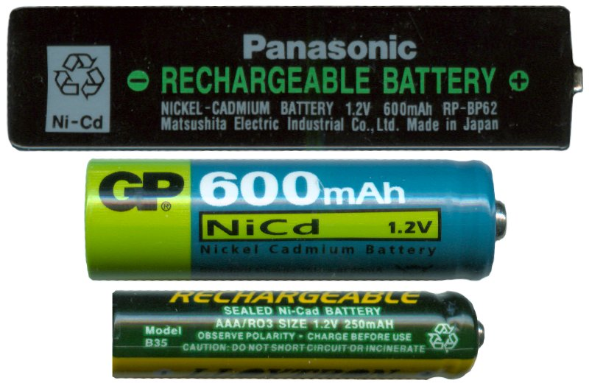The first small rechargeable battery produced for appliances, used a reaction between **cadmium** and a compound of **nickel (nickel oxyhydroxide NiOOH)** to produce a current.

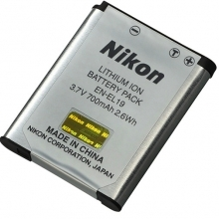

More advanced rechargeable batteries such as **lithium-ion** batteries have been developed. The main advantage of these batteries is they are much lighter.

**FUEL CELLS**

A **fuel cell** produces electricity by reacting **hydrogen** with **oxygen (from air)** in a **redox** reaction.

The **fuel cell** consists of 2 electrodes, which are separated by a special membrane, called a **PROTON EXCHANGE MEMBRANE** **(PEM).** This acts as an **electrolyte** in the cell.

|  |  |  |
| --- | --- | --- |
| At one electrode, **hydrogen gas** reacts with a catalyst producing **hydrogen ions (H+)** and **electrons**. **Hydrogen ions** are **protons**.  **H2(g)**  **2 H+(aq) + 2 e-**  **OXIDATION** | **H2O**  **H2O**  **PEM**  **H2**  **H2**  **H2**  **H2**  **H2**  **H+**  **H+**  **H+**  **H+**  **H+**  **O2**  **O2**  **O2**  **O2**  **O2**  **e-**  **e-**  **e-**  **e-**  **e-**  **e-**  **e-**  **e-**  **e-**  **e-**  **e-**  **e-**  **e-**  **e-**  **e-**  **e-**  **e-**  **e-**  **e-**  **e-** | At the other electrode the **H+** ions meet **oxygen** molecules from the **air** and **electrons** **from the external circuit**. These react to form **water**.  **O2(g) + 4 H+(aq) + 4 e-**  **2 H2O(*l*)**  **REDUCTION** |
|  | The **hydrogen ions (H+), protons**, move through the **(PEM)** to the other electrode. |  |

Here are the **oxidation** and **reduction** reactions combined to give the **redox** reaction.

|  |  |  |  |  |  |  |  |  |  |
| --- | --- | --- | --- | --- | --- | --- | --- | --- | --- |
| **× 2** |  | **H2(g)** |  |  |  | **2 H+(aq)** | **+** | **2 e-** | **Oxidation** |
|  |  |  |  |  |  |  |  |  |  |
| **O2 (g)** | **+** | **4 H+(aq)** | **+** | **4 e-** |  | **2 H2O(*l*)** |  |  | **Reduction** |

The **oxidation** reaction is **multiplied by 2**. This ensures both reactions have **4 electrons**.

The **4 e-**.and **4 H+(aq)** cancel.

|  |  |  |  |  |  |  |  |  |  |
| --- | --- | --- | --- | --- | --- | --- | --- | --- | --- |
|  |  | **2 H2(g)** |  |  |  | **4 H+(aq)** | **+** | **4 e-** | **Oxidation** |
|  |  |  |  |  |  |  |  |  |  |
| **O2 (g)** | **+** | **4 H+(aq)** | **+** | **4 e-** |  | **2 H2O(*l*)** |  |  | **Reduction** |
|  |  |  |  |  |  |  |  |  |  |
|  |  | **O2 (g)** | **+** | **2 H2(g)** |  | **2 H2O(*l*)** |  |  | **Redox** |

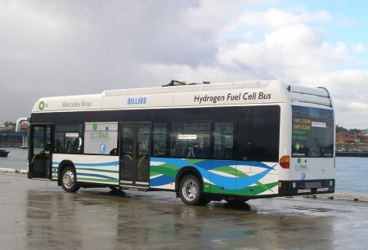

**Fuel cells** only produce **water** and therefore reduce emissions of **carbon dioxide**. **Hydrogen** can be made by electrolysis of **water**.

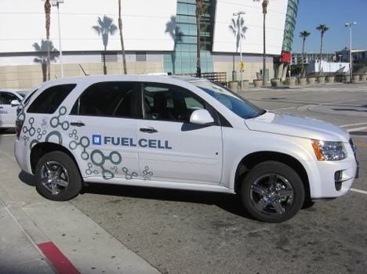

Electric vehicles, which are powered by fuel cells, are already being used.

The **hydrogen ions (H+), protons**, move through the **(PEM)** to the other electrode.