**NATIONAL 4 AND NATIONAL 5 CHEMISTRY**



**Unit 3: Chemistry In Society**

**Topic 4**

**PLASTICS, POLYMERS & CERAMICS**

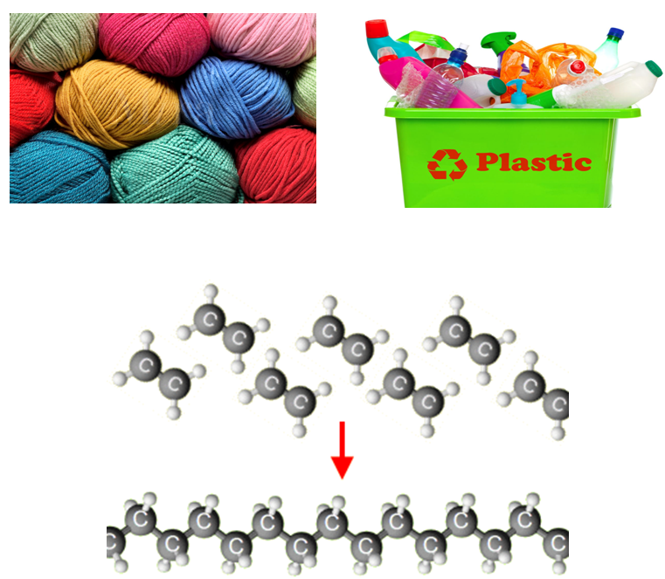

|  |
| --- |
| **Name __________________________________ Class _____** |

|  |
| --- |
| Unit 3: Chemistry In Society |
| Topic 4 : Plastics, Polymers & Ceramics |

|  |  |  |  |  |  |
| --- | --- | --- | --- | --- | --- |
| LEVEL N4 N5 | **AFTER COMPLETING THIS TOPIC YOU SHOULD BE ABLE TO:** | NOTES (Page) | **How well I have understood (✓)** | | |
| **☺** | **😐** | **☹** |
| N4 | State synthetic materials are made by the chemical industry. | 4 |  |  |  |
| N4 | State most plastics and synthetic fibres are made from chemicals derived from oil. | 6 |  |  |  |
| N4 | Name examples of plastics include polythene, polystyrene, perspex, PVC, and nylon. | 5 |  |  |  |
| N4 | Name examples of synthetic fibres include polyesters, e.g. Terylene, and nylon. | 4-5 |  |  |  |
| N4 | State what is meant by: monomer, polymer and polymerisation | 7-8 |  |  |  |
| N4 | Give examples of plastics formed from alkenes. | 9 |  |  |  |
| N4 | Explain, using full structural formulae, how ethene forms polythene. | 8 |  |  |  |
| N4 | State the name of the polymer made from an alkene, given the name of a monomer and vice-versa. | 9 |  |  |  |
| N5 | State addition polymers are made from small unsaturated molecules, produced by cracking, by a process called addition polymerisation. | 10 |  |  |  |
| N5 | Describe addition polymerisation as small unsaturated molecules joining together by the opening of the carbon to carbon double bond. | 10 |  |  |  |
| N5 | Draw the structure of an addition polymer given the monomer structure, or the repeating unit / monomer given the polymer structure. | 11-13 |  |  |  |
| N4 | State that a thermosoftening plastic is one, which can be melted or reshaped; and that a thermosetting plastic is one, which cannot be shaped in this way. | 14 |  |  |  |
| N4 | Give examples of how the properties of polymers, e.g. lightness, durability and insulation are related to their uses. | 14 |  |  |  |
| N4 | Give examples of uses of thermosetting plastics. | 14 |  |  |  |
| N4 | State some plastics burn or smoulder to give off toxic fumes, including carbon monoxide, hydrogen chloride and hydrogen cyanide. | 15-17 |  |  |  |
| N4 | Give examples of advantages and disadvantages of natural and synthetic materials. | 17 |  |  |  |
| N4 | State what is meant by biodegradable. | 15 |  |  |  |
| N4 | State that most plastics are not biodegradable and that their durability can cause environmental problems. | 15 |  |  |  |
| N4 | State ceramic materials made from compounds of 18-19a metal and non-metal and are made by the action of heat and followed by cooling | 18-19 |  |  |  |
| N4 | Give examples of everyday ceramic materials. | 18-19 |  |  |  |
| N4 | Give examples of new ceramic materials and their properties | 18-19 |  |  |  |
| N4 | Give examples of new polymers with special properties and their uses. | 20-21 |  |  |  |
| N5 | Condensation polymers are made from monomers with two functional groups per molecule. | 21-22 |  |  |  |
| N5 | Draw the structure of a polyester polymer given the monomer structures, or the repeating unit / monomers given the polymer structure. | 22-23 |  |  |  |
| N5 | Draw the structure of a polyamide polymer (nylon) given the monomer structures, or the repeating unit / monomers given the polymer structure. | 24-25 |  |  |  |

|  |
| --- |
| Unit 3: Chemistry In Society |
| Topic 4 : Plastics, Polymers & Ceramics |

|  |  |  |  |  |  |
| --- | --- | --- | --- | --- | --- |
| LEVEL N4 N5 | **AFTER COMPLETING THIS TOPIC YOU SHOULD BE ABLE TO:** | NOTES (Page) | **How well I have understood (✓)** | | |
| **☺** | **😐** | **☹** |
| N5 | State starch is a natural condensation polymer made of many glucose molecules linked together. | 26-27 |  |  |  |
| N5 | Understand the classifications mono-, di- and polysaccharides in relation to the terms monomer and polymer. | 26-27 |  |  |  |
| N5 | State proteins are natural condensation polymers made of many amino molecules linked together. | 28-29 |  |  |  |
| N5 | Draw the structure of a protein polymer given the amino acids (monomers) structures. | 29 |  |  |  |

|  |  |  |
| --- | --- | --- |
| **N4** | **FIBRES & PLASTICS** | **N4** |

**SYNTHETIC & NATURAL**

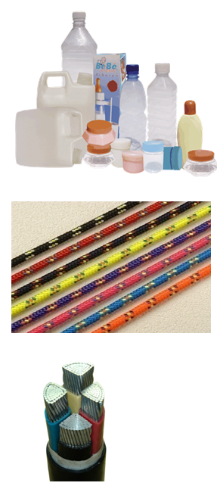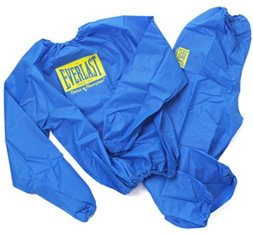

We use plastics and synthetic fibres everyday yet these have only been widely used in the past 50 years. Plastics and synthetic fibres are **man-made** materials, this is why they are called **SYNTHETIC**.

Plastics are generally **cheap** to produce, and have very useful properties such as: **lightness, strength** and **durability.** In addition, plastics are **easily moulded** into a variety of shapes and are **excellent insulators of both heat and electricity.**

|  |  |  |
| --- | --- | --- |
| **NATURAL & SYNTHETIC FIBRES** | | |
| **Name of Fibre** | **Natural / Synthetic** | **Description / Use** |
|  |  |  |
|  |  |  |
|  |  |  |

|  |  |  |
| --- | --- | --- |
| **Name of Fibre** | **Natural / Synthetic** | **Description / Use** |
|  |  |  |
|  |  |  |
|  |  |  |

|  |  |
| --- | --- |
| **PLASTICS & THEIR USES** | |
| **Name of Plastic** | **Description / Use** |
|  |  |
|  |  |
|  |  |
|  |  |
|  |  |
|  |  |
|  |  |

**SOURCE OF PLASTICS**

|  |  |  |
| --- | --- | --- |
|  |  |  |

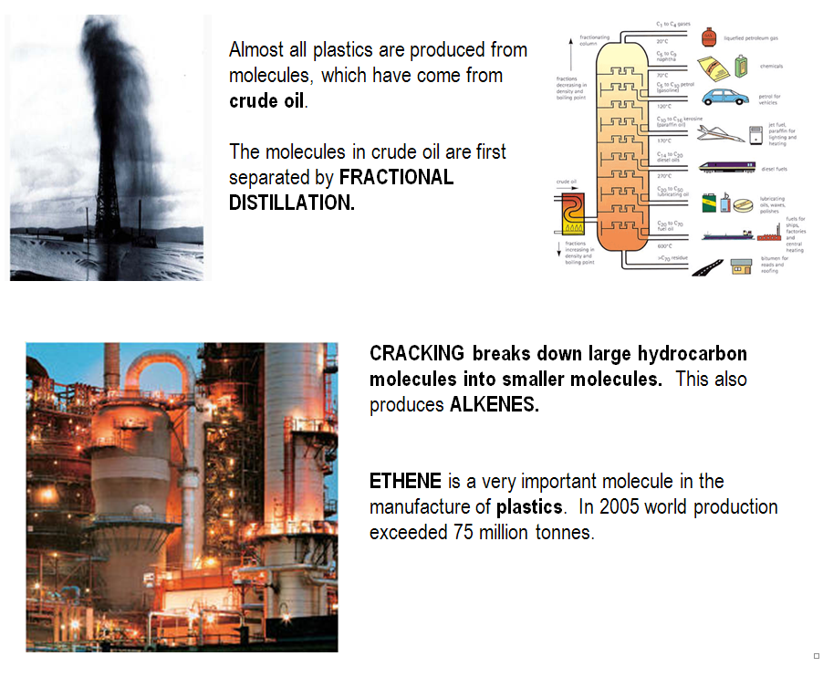

|  |  |  |
| --- | --- | --- |
| **N4** | **POLYMERISATION** | **N4** |

**MAKING POLYTHENE**

|  |  |
| --- | --- |
| **Monomer molecules**  **Small part of a polymer molecule.**  **join together** | Plastics and synthetic fibres are made from giant molecules.  Joining together many thousands of smaller molecules called **MONOMERS** makes these giant molecules**.**  The giant molecule is called a **POLYMER as** joining many small molecules together makes it. **POLY means many.** |

|  |  |
| --- | --- |
| The most common monomer is ethene, C2H4, used to make the plastic called **POLYETHENE**, known as **polythene**. |  |

|  |  |  |  |  |  |  |
| --- | --- | --- | --- | --- | --- | --- |
|  | **ETHENE** | | | | | |
| 3 ethene molecules **MONOMERS** |  | |  |  |  |  |
|  | The joining up reaction is called **POLYMERISATION** as a polymer is made. | |  |  |  | The **C=C** breaks open allowing the molecules to join. |
|  |  | |  |  |  |
| A section of the **POLYMER**. The **polymer** is named by placing **POLY** in front of the monomer name. | |  | | | | |
|  | | **POLYETHENE** | | | | |

|  |
| --- |
| **DICTIONARY - MONOMER, POLYMER AND POLYMERISATION**  **MONOMER** is the term used to describe the **small molecule**, which is the building block molecule of a **large molecule** called a **POLYMER**.  A **POLYMER** is the term used to describe the **large molecule** produced when several **small molecules (MONOMERS)** join.  These terms come the three Greek words **“mono”** meaning **“one”**, **“meros”** meaning **“part”**, and **“poly”** meaning **“many”**.  **POLYMERISATION** is the name given to a reaction, where many small molecules **(MONOMERS)** react and join, to produce a large molecule **(POLYMER)**. |

**NAMING POLYMERS**

|  |  |
| --- | --- |
| **MONOMER** | **POLYMER** |
| ethene |  |
| vinyl chloride |  |
| butene |  |
| stryrene |  |
| tetrafluoroethene |  |

**NAMING MONOMERS**

|  |  |
| --- | --- |
| **POLYMER** | **MONOMER** |
| polypropene |  |
| polybutadiene |  |
| polyphenylethene |  |
| polyurethane |  |
| polychloroethene |  |

|  |  |  |
| --- | --- | --- |
| **N5** | **ADDITION POLYMERISATION** | **N5** |

**ADDITION & POLYMERISATION REACTIONS**

|  |
| --- |
| **DICTIONARY - ADDITION POLYMERS**  When a polymer is made from monomers, which contain C=C, the **monomers** react and join by **addition** reactions. These **polymers** are classified as **ADDITION POLYMERS**.  The **polymerisation**, which takes place as the **monomers** join, is called **ADDITION POLYMERISATION**. |

|  |  |
| --- | --- |
|  | One of the covalent bonds of the **C=C** breaks open, allowing the **monomers** to “**ADD**” to each, other building up the **polymer** chain. |

|  |  |  |  |  |  |  |  |
| --- | --- | --- | --- | --- | --- | --- | --- |
|  | | **CHLOROETHENE** | | | | | |
| 3 chloroethene molecules **MONOMERS** | |  | |  |  |  |  |
|  | Since the **monomers** join by **addition reactions** this is called **ADDITION POLYMERISATION**. | | |  |  |  |  |
|  | |  | |  |  |  |
|  | | |  | | | | |
|  | | | **POLYCHLOROETHENE** | | | | |

All **addition** **polymers** have a chain of **C – C single bonds** forming the backbone of the **polymer** molecule

**MORE ADDITION POLYMERS**

|  |  |
| --- | --- |
| All **monomers**, which form **addition polymers**, are based on the **ethene molecule**. |  |
|  | **ethene C2H2** |

|  |  |  |  |  |
| --- | --- | --- | --- | --- |
| **MOMOMER: PROPENE** | | | | |
|  |  |  |  |  |
|  |  |  |  |  |
|  |  |  |  |
|  | | | | | |
| **POLYMER:** | | | | | |

|  |  |  |  |  |
| --- | --- | --- | --- | --- |
| **MOMOMER: PHENYLETHENE**  **This group of atoms is called the phenyl group** | | | | |
|  | | | | |
|  |  |  |  |  |
|  |  |  |  |  |
|  |  |  |  |
|  | | | | | |
| **POLYMER:** | | | | | |

|  |  |  |  |  |
| --- | --- | --- | --- | --- |
| **MOMOMER: TETRAFLUOROETHENE** | | | | |
|  |  |  |  |  |
|  |  |  |  |  |
|  |  |  |  |
|  | | | | | |
| **POLYMER:** | | | | | |

**REPEATING UNIT**

All **addition polymers** are based on a **monomer** containing a **C=C**. This means the **polymer** chain will **repeat every 2-carbon atoms**. This is called the **REPEATING UNIT**.



**POLYMER**

**repeating unit**

**repeating unit**

**repeating unit**

**MONOMER**

**REPEATING UNIT**

**Written as**

**n**



**POLYMER**

**REPEATING UNIT**

**n**

**MONOMER**

|  |  |  |
| --- | --- | --- |
| **N4** | **POLYMER PROPERTIES** | **N4** |

**HEAT & PLASTICS**

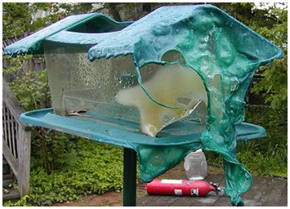Many polymers soften and melt when heated and become rigid again when cooled. These polymers are called **THERMOSOFTENING** (or **THERMOPLASTIC**) **POLYMERS**.

|  |
| --- |
| **Examples: polyethene; polypropene; polystyrene; PVC; nylon and polyester.** |

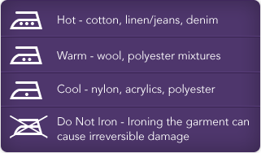

Many synthetic fibres are **thermosoftening** and must be ironed using a low temperature.

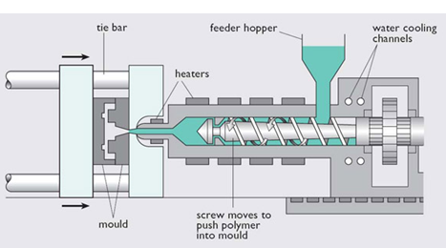

Plastic items are manufactured by **injecting molten plastic into a mould**.

When the plastic cools and solidifies the mould opens and the item is removed.

Some polymers are not affected by **heat**, these polymers are called **THERMOSETTING POLYMERS**.

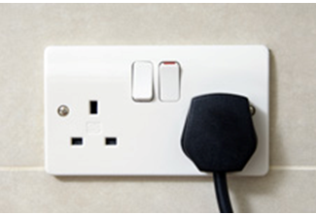

**Thermosetting polymers keep their shape when heated**.

|  |
| --- |
| **Examples: bakelite (phenol-formaldehyde), for pan handles, electrical plugs and sockets, plastic dishes.**  **Melamine resin used for work tops on kitchen units.** |

|  |  |  |
| --- | --- | --- |
|  |  |  |

**Thermosetting polymers can be melted only once**. This happens when they are moulded. The heating used in the moulding sets their shape.

**DISPOSAL OF PLASTICS**

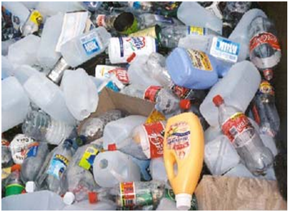An advantage of plastics is their **DURABILITY** and their **resistance to attack by corrosive chemicals.**

Plastics do not rot or decompose when dumped in the environment.

Natural materials, e.g. wood, decompose in time through the action of bacteria. Wood is said to be **“BIODEGRADABLE**.**”**

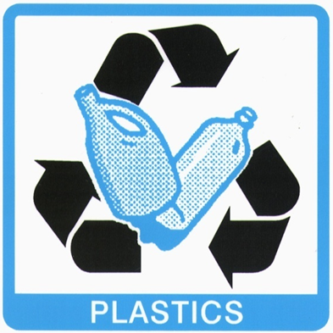

Plastics are **NON-BIODEGRADABLE**. This means dumping plastics in landfill is not a suitable way of disposing of waste plastics.

In addition dumping is a waste of a valuable resource. Plastics are now being **RECYCLED.**

New **BIODEGRADABLE PLASTICS** are being developed but there are limitations to their use.

**BURNING PLASTICS**

Many plastics and synthetic fibres are **flammable**. Apart from the danger of fire, these materials can produce **poisonous gases** when they burn.

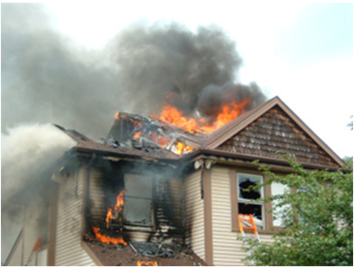

There are **three poisonous gases** produced when plastics burn.

* **CARBON MONOXIDE (CO)**
* **HYDROGEN CHLORIDE (HCl)**
* **HYDROGEN CYANIDE (HCN)**

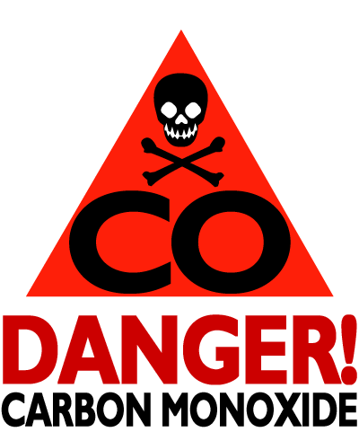**CARBON MONOXIDE (CO)**

All plastics contain **CARBON**. Most plastics are flammable and there is always the danger of producing **CARBON MONOXIDE** when there is **insufficient oxygen for complete combustion.**

Victims of house fire often die of **carbon** **monoxide** poisoning.

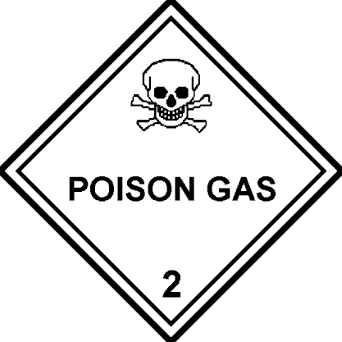

**HCl**



**HYDROGEN CHLORIDE (HCl)**

**Polychloroethene** (**polyvinyl chloride** – **PVC**) is widely used in our homes.



This polymer contains **CHLORINE** atoms. When **PVC** burns one of the products of combustion is **HYDROGEN CHLORIDE** (**HCl**)**.**

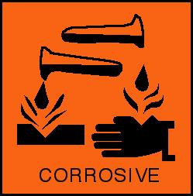

When hydrogen chloride gas is breathed in it dissolves in the moisture of the throat and lungs and forms **HYDROCHLORIC ACID,** which is **CORROSIVE**. This damages the respiratory organs.

**HYDROGEN CYANIDE (HCN)**

Soft furnishings like sofas and mattresses usually contain plastic foam. Until a few years ago a polymer called **POLYURETHANE** was used for this purpose.

|  |  |
| --- | --- |
| **cyanide group (CN)** | **POLYURETHANE** contains the **cyanide group (CN)**.  When polyurethane foam burns **HYDROGEN CYANIDE (HCN)** gas is produced. **Hydrogen cyanide is extremely poisonous.** |
| **polyurethane polymer** |  |

**Polyurethane** foam has been replaced in all soft furnishings with safer foam.

**ADVANTAGES & DISADVANTAGES OF POLYMERS**

The following table lists the advantages & disadvantages of polymers.

|  |  |
| --- | --- |
| **ADVANTAGES** | **DISADVANTAGES** |
| Cheap to make and makes lots of different structures. | Made from molecules from crude oil, which are non-renewable. |
| Very durable and don’t need maintenance. | Non-biodegradable is a problem when dumped. Discarded polymers kill animals. |
| Light weight and very strong. | Some polymers are very flammable and make very poisonous fumes when burned. |
| Good insulators of both heat and electricity. Some polymers do not melt on heating. | Mixed types of polymer waste can be difficult to recycle. |
| Large variety of properties, which allows them to be matched to their use. |  |

|  |  |  |
| --- | --- | --- |
| **N4** | **CERAMICS & NEW MATERIALS** | **N4** |

**HISTORY OF CERAMICS**

|  |  |
| --- | --- |
| **Clay** has been used for thousand of years to make bricks, pots and jars. Clay is moulded to manufacture the item, then left to dry. However, at this stage the clay is weak, porous and absorbs water. |  |
| The clay item is then heated to a high temperature (1000 oC) in a kiln. This stage is called **“firing the clay”**.  Firing the clay removes more water from the clay and alters the structure of the clay. Before firing, the unfired clay can be painted with a coating called a glaze. This gives a decorative finish to the clay. |  |

|  |  |  |
| --- | --- | --- |
|  |  |  |



**n**

**CERAMIC MATERIALS IN THE HOME**

|  |  |  |
| --- | --- | --- |
| Ceramic materials can be coated onto metals to make cookware. This makes an attractive non-stick surface, which is hardwearing. | | **Screen Shot 2014-01-12 at 21.16.52.png** |
|  |  | |



**Written as**

**repeating unit**

**repeating unit**

**repeating unit**

|  |
| --- |
| A **ceramic knife** is made out of a hard tough ceramic, **zirconium dioxide (ZrO2** this is also called **zirconia)**.  The blade is sharpened by grinding on a diamond-dust-coated grinding wheel.  The blade is harder than a steel blade and rarely needs sharpening. |

**CERAMIC MATERIALS IN THE CAR**

|  |  |  |
| --- | --- | --- |
| Ceramic materials can be found in cars.   * Catalytic converter to reduce pollution. * The spark plugs in the engine. * Materials of the brake pads, which give, better wear. * The clutch plate as part of the gearbox. |  |  |
|  |  |

Ceramic materials are lightweight, strong, hard-wearing and can withstand high temperatures.

**SPECIALISED POLYMERS**

There are number of polymers which have been developed which have properties which would not be expected.

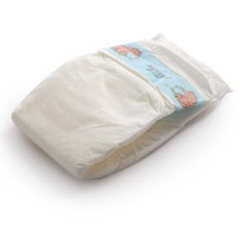

**(a) HYDROGELS**

A **hydrogel** is a polymer that can **absorb a large quantity of water**, but once absorbed it does not give the water back. A **hydrogel** polymer is used in disposable nappies.

**Plant storage crystals** are hydrogels. They absorb water and swell up. If put in plant tubs and hanging baskets, they slowly release water extending the time between watering's, for example when you go on holiday.

Soft contact lenses are **hydrogels**. Their ability to **absorb water** means they don’t dry out in use, and are compatible with tears, which lubricate the eye making them more comfortable to wear.

**(b) POLYVINYL ALCOHOL (PVA)**

|  |  |
| --- | --- |
| **Polyvinyl alcohol (PVA)** is a **water-soluble** polymer. It is used as an adhesive.  As a film it is used to make the packaging of **“liqui-tabs”**, which hold detergent for dishwashers and washing machines. |  |

**(c) BIOPLASTICS**

**Bioplastics** are polymers made from plant sources.

**Starch-based plastics** currently represent the mostly widely used **bioplastic**. Protective packaging is an example of this type of polymer.

**Polylactic acid (PLA)** is made from corn or sugar cane. It is used to make disposable cutlery, waste sacks and sutures used for internal stitches in the body during surgery.

**Bioplastics are biodegradable**

|  |  |  |
| --- | --- | --- |
| **N5** | **CONDENSATION POLYMERISATION** | **N5** |

**CONDENSATION REACTIONS**

In the topic on **esters** you learned that molecules can join by a **condensation reaction**.

|  |  |  |  |  |  |  |
| --- | --- | --- | --- | --- | --- | --- |
| **alcohol** | **+** | **carboxylic acid** |  | **ester** | **+** | **water** |
| **propan-1-ol** | **+** | **ethanoic acid** |  | **propyl ethanoate** | **+** | **water** |
|  | **+** |  |  |  | **+** |  |
| **water molecule eliminated** | | |  | **ester link (carboxylate group)** |  |  |
|  | **+** |  |  |  | **+** |  |
| **CH3CH2CH2OH** | **+** | **HOOCCH3** |  | **CH3CH2CH2OOCCH3** | **+** | **H2O** |

In making an **ester** the **condensation** **reaction** involves the **hydroxyl** **group** of the **alcohol** reacting with the **carboxyl** **group** of the **carboxylic acid**.

|  |  |  |  |  |  |  |
| --- | --- | --- | --- | --- | --- | --- |
| **molecules join** | **+** |  |  |  | **+** |  |
| **hydroxyl group** |  | **carboxyl group** |  | **water molecule** |  | **ester link (carboxylate group)** |

To build up a **polymer**, requires each **monomer** to have **TWO FUNCTIONAL GROUPS**. This allows repeated **condensation** **reactions** to take place.

A **POLYESTER** is made by reacting a:

|  |  |  |
| --- | --- | --- |
| **DIALCOHOL** |  | **DICARBOXYLIC ACID** |
|  | **MONOMERS of a POLYESTER** |  |
|  |  |  |

**MAKING A POLYESTER**



**H2O molecule forms**

**H2O molecule forms**

**H2O molecule forms**

|  |  |
| --- | --- |
| The **polymer** molecule contains many **ester** links, hence the name **POLYESTER.** | **Ester link**  **Ester link**  **Ester link** |

The structure of the **polyester** molecule repeats every **TWO MONOMERS.** This is called the **REPEATING UNIT.**



**REPEATING UNIT**

**MAKING TERYLENE - A POLYESTER**

One of the polyester molecules used in clothing is commonly called **TERYLENE**. It is made from the following monomer molecules.

|  |  |  |
| --- | --- | --- |
| **DIALCOHOL** |  | **DICARBOXYLIC ACID** |
|  |  |  |
| **ethane-1,2-diol** |  | **benzene-1,4-dicaboxylic acid (other name: terephthalic acid)** |



**H2O**

**H2O**

**H2O**



**POLYESTER**

**REPEATING UNIT**



**n**

**NYLON - A POLYAMIDE**

Nylon is a **condensation** **polymer** called a **POLYAMIDE**. Made from the following **monomers**.

|  |  |  |
| --- | --- | --- |
| **DIAMINE** |  | **DICARBOXYLIC ACID** |
|  | **MONOMERS of a POLYAMIDE** |  |
|  |  |  |

The **- NH2** group is called the amino group as it is derived from **ammonia**, **NH3.**

|  |  |  |  |  |
| --- | --- | --- | --- | --- |
|  | **N**  **H**  **H**  **H** |  |  | **N**  **H**  **H** |
| **Ammonia, NH3** | |  | **Amino group, - NH2** | |

**MAKING NYLON - A POLYAMIDE**



**H2O molecule forms**

**H2O molecule forms**

**H2O molecule forms**

The is called an **AMIDE LINK**.



|  |  |
| --- | --- |
| The **NYLON** **polymer** molecule contains many **amide** links, hence the name **POLYAMIDE.** | **Amide link molecule forms**  **Amide link molecule forms**  **Amide link molecule forms** |

The **repeating unit** consists of two monomers.



**REPEATING UNIT**

**MAKING NYLON 6, 6**

Nylon is a **condensation** **polymer** called a **POLYAMIDE**. Is made from the following **monomers**.

|  |  |  |
| --- | --- | --- |
| **DIAMINE** |  | **DICARBOXYLIC ACID** |
|  | Each **monomer** has **6 carbon atoms**, this is why the polymer is called **nylon** **6, 6**. |  |
| **1,6-diaminohexane** |  | **hexane-1,6-dioic acid** |



**H2O**

**H2O link**



**REPEATING UNIT**



**n**

**CARBOHYDRATES**

**Starch**, **cellulose** (**carbohydrates**) are **natural** **condensation** **polymers**.



A **monosaccharide** can be represented as:

**C6H12O6**

All **carbohydrates** are based on **glucose** or **fructose** **(C6H12O6)**.

**Glucose** and **fructose** are **monomers**.

These **carbohydrates** are classified as **MONOSACCHARIDES**.

When **2** **monosaccharides** join a **disaccharide** is produced and a **water molecule** is lost.



**+**

**H2O**

**C12H22O11**

**C6H12O6**

**C6H12O6**

**+**

**2** **monosaccharides**

**+**

**disaccharide**

When **many** **monosaccharides** join a **polysaccharide** is produced and **many** **water molecules** are lost.

**many** **monosaccharides**



**+**

**(C6H10O5)n**

**n = a large number**

**n C6H12O6**

**H2O molecule** is lost from each **C6H12O6** making the **polymer** chain made of many **C6H10O5 units**.

**Starch** and **cellulose** are **polysaccharides**.



**n H2O**

**many** **water molecules**

**polysaccharide**

**PROTEINS**

**Proteins** are **natural condensation polymers**. **Proteins** are found in both plants and animals. Proteins are found in structural material (skin, muscle, nails), and in enzymes, which maintain body processes.



**amino group**

**carboxyl (acid) group**

The **monomers** of **proteins** are **AMINO ACIDS**.

**Amino** **acids** have 2 functional groups.

There are **20** **amino** **acids** used to make **proteins**. The different **amino** **acids** have the same basic structure, with the **R group** being different. Here are three **amino** **acids**.

|  |  |  |
| --- | --- | --- |
|  |  |  |
| **glycine** | **alanine** | **serine** |

**MAKING PROTEINS**

When **amino acids** join to form a **protein** molecule, the **amino group** on one **amino acid**, reacts with the **carboxyl group** on another **amino acid**. A molecule of **water** is lost from each reaction.





**H2O molecule forms**

**H2O molecule forms**

In nylon the is called a **AMIDE LINK**. In a **protein** it is called a **PEPTIDE LINK**.





**peptide link**

Part of a **PROTEIN** molecule.

**peptide link**

Each **protein** has its own sequence of **amino** **acids** making up the polymer chain.