NATIONAL 4 AND NATIONAL 5 CHEMISTRY

Unit 1: Chemical Changes and Structure

Topic 6
ENERGY CHANGES
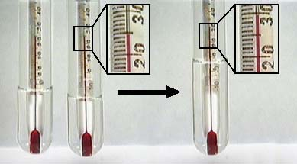
& REACTIONS

Name ____________________________ Class _____

Unit 1: Chemical Changes and Structure

Topic 6: Energy Changes & Reactions

LEVEL  N4 N5 | AFTER COMPLETING THIS TOPIC YOU SHOULD BE ABLE TO: | NOTES  (Page) | How well I have understood (✓)
LEVEL  N4 N5 | AFTER COMPLETING THIS TOPIC YOU SHOULD BE ABLE TO: | NOTES  (Page) | ☺ | 😐 | ☹
N4 | State an exothermic reaction releases energy to the surroundings and the products have less chemical energy than the reactants. | 3
N4 | Give some everyday examples of exothermic reactions and their uses. | 5
N4 | State an endothermic reaction takes in energy from the surroundings and the products have more chemical energy than the reactants. | 4
N4 | Give some everyday examples of endothermic reactions and their uses. | 5
N4 | Describe an experiment to find out if a reaction is exothermic or endothermic.

N4 | ENERGY CHANGES & REACTIONS | N4
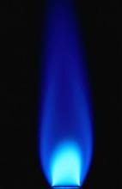
Methane burning is an exothermic reaction.
EXOTHERMIC REACTIONS

Reactions, which give out energy, usually in the form of heat, are called EXOTHERMIC REACTIONS.

Exothermic comes from the Greek words “exo,” which means “outside” and “thermasi” which means “to heat”.

Burning methane releases energy to cook food and heat our homes.

methane | + | oxygen |  | carbon dioxide | + | water

During the combustion reaction energy is lost from the methane and oxygen as it changes into carbon dioxide and water.

methane + oxygen

REACTANTS
ENERGY GIVEN OUT

ENERGY

carbon dioxide + water

PRODUCTS

In an exothermic reaction the reactants have more stored energy than the products.

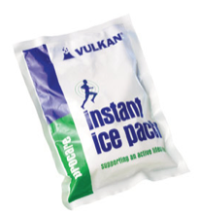
ENDOTHERMIC REACTIONS
The reaction, which takes place in a cool pack is an endothermic reaction.

Reactions, which take in (or absorb) energy, usually in the form of heat, are called ENDOTHERMIC REACTIONS.

Endothermic comes from the Greek words “endon,” which means “within” and “thermasi” which means “to heat”.

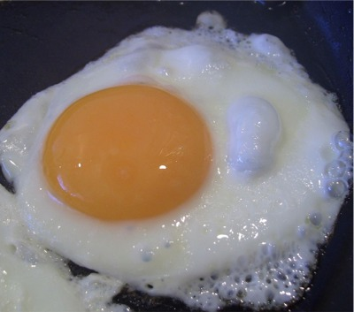

Cooking food, e.g. frying an egg, is an endothermic reaction.

During cooking, energy is absorbed by the food changing the molecules of the food.

ENERGY TAKEN IN
Cooked food
ENERGY

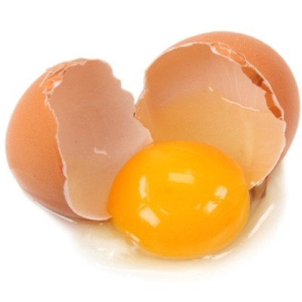
PRODUCTS

REACTANTS

Uncooked food

In an endothermic reaction the products have more stored energy than the reactants.

EVERYDAY EXO- & ENDOTHERMIC REACTIONS

EXOTHERMIC  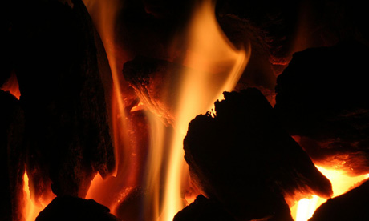  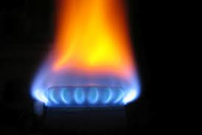  Combustion of fuels.  Releasing energy from food in our body during respiration.  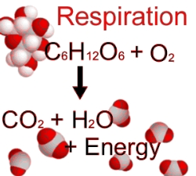  Hand warmers.  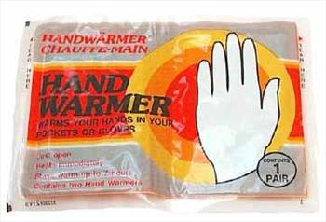 | ENDOTHERMIC  Cooking food.  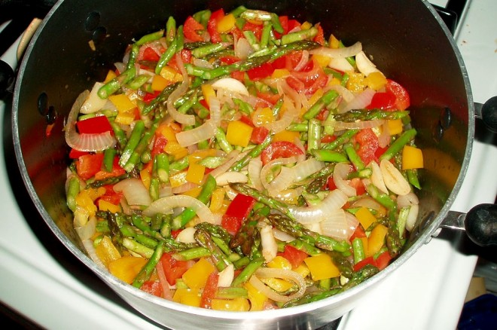  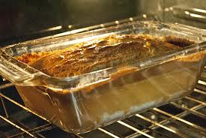  Plants absorbing light energy to make food during photosynthesis.  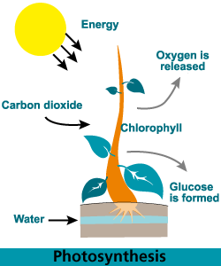  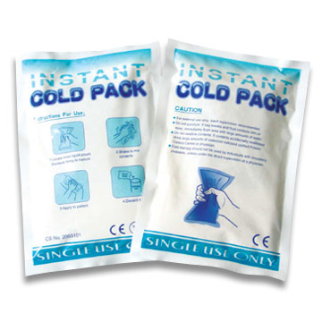  Cold packs

