 **NATIONAL 4 AND NATIONAL 5 CHEMISTRY**

**Unit 1: Chemical Changes and Structure**

**Topic 7**

**ACIDS and ALKALIS**

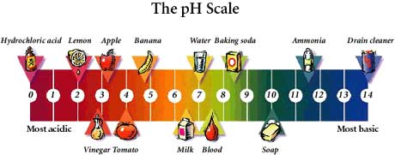

|  |
| --- |
| **Name ____________________________________ Class _____** |

|  |
| --- |
| Unit 1: Chemical Changes and Structure |
| Topic 7: Acids and Alkalis |

|  |  |  |  |  |  |
| --- | --- | --- | --- | --- | --- |
| LEVEL N4 N5 | **AFTER COMPLETING THIS TOPIC YOU SHOULD BE ABLE TO:** | NOTES (Page) | **How well I have understood (✓)** | | |
| **☺** | **😐** | **☹** |
| N4 | The pH scale is a continuous range from below 0 to above 14. | 3 - 4 |  |  |  |
| N4 | Acids have a pH of less than 7; alkalis have a pH of more than 7; pure water and neutral solutions have a pH equal to 7. | 3 |  |  |  |
| N4 | Non-metal oxides, which dissolve in water, produce acid solutions. | 6 |  |  |  |
| N4 | Write the formula of commonly used acids e.g. hydrochloric acid, nitric acid, sulfuric acid and phosphoric acid. | 7 |  |  |  |
| N4 | State solutions of acids and alkalis conduct electricity showing they have ionic bonding. | 6-7 |  |  |  |
| N4 | State that sulfur dioxide and nitrogen dioxide reacts with water in the atmosphere to produce acid rain. | 6 |  |  |  |
| N4 | Give examples of the damaging effects of acid rain on buildings, other structures, soils and plant and animal life. | 6 |  |  |  |
| N4 | Give examples of the use acids in food e.g. ascorbic acid (vitamin C), folic acid and drink and how they impact on health. | 8-9 |  |  |  |
| N4 | Metal oxides and hydroxides, which dissolve in water, produce alkaline solutions. | 5 |  |  |  |
| N5 | State that ions are present in an acid solution, an alkali solution and the concentration of ions in water is small. | 10-11 |  |  |  |
| N5 | State that the ion responsible for acidity is the hydrogen ion and the ion responsible for alkalinity is the hydroxide ion. | 10-11 |  |  |  |
| N5 | State that electrolysis of an acid results in hydrogen gas being produced at the negative electrode showing the positive ion in all acids is the hydrogen ion. | 10-11 |  |  |  |
| N5 | Write the ionic formula of the commonly used acids and alkalis. | 11 |  |  |  |
| N5 | Describe effect of dilution on the pH of an acid or alkali is explained in terms of the decreasing concentration of hydrogen and hydroxide ions. | 12-13 |  |  |  |
| N5 | Explain the low conduction in terms of dissociation of water molecules to form hydrogen and hydroxide ions. | 13 |  |  |  |
| N5 | State in water and neutral solutions, the concentration of hydrogen ions is equal to the concentration of hydroxide ions. | 14 |  |  |  |
| N5 | State an acidic solution contains more hydrogen ions than hydroxide ions and an alkaline solution contains more hydroxide ions than hydrogen ions. | 14 |  |  |  |

|  |  |  |
| --- | --- | --- |
| **N4** | **ACIDS and ALKALIS** | **N4** |

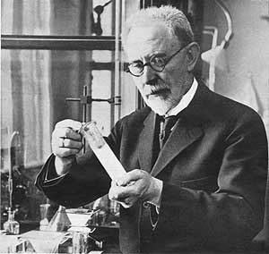

Søren Peder Lauritz Sørensen (1868 -1939)

**THE pH SCALE**

The pH scale was devised by the Danish chemist called **Søren Peder Lauritz Sørensen,** in 1909.

The pH scale is a number scale, which informs you if a substance is **ACIDIC, ALKALINE or NEUTRAL** (neither acidic or alkaline).

The pH of a substance can be measured using :

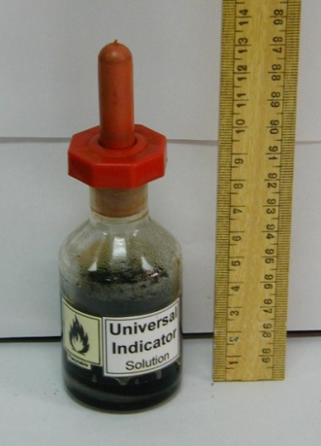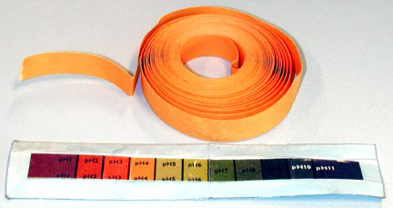

**pH PAPER;**

or an indicator liquid called **UNIVERSAL INDICATOR**.

Both pH paper and universal indicator require a **COLOUR CHART** to match the colour to a pH number.

**NEUTRAL substances have a pH of EXACTLY 7.**

**ACIDIC substances have a pH BELOW 7.**

**ALKALINE substances have a pH ABOVE 7.**

**1**

**2**

**3**

**4**

**5**

**6**

**7**

**8**

**9**

**10**

**11**

**12**

**13**

**14**

The further away from pH 7 the more acidic or alkaline a substance is.

**THE pH of DEVERYDAY SUBSTANCES**

The range of the pH scale is from just below 0 to just above 14.

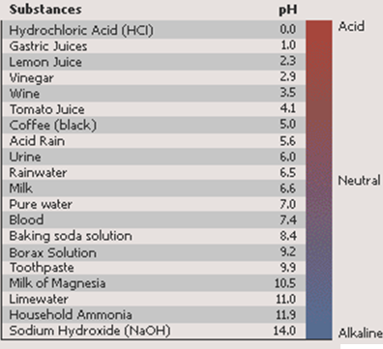

The word “acid” comes from the Latin ***acidus***, meaning **“sour”**.

All acids have a sour taste.

The word **“caustic”** comes from the Latin ***causticus***, meaning **“to burn”**.

Alkalis are corrosive.

pH is very important to life. In all biological systems the maintenance of a specific pH value is very important.

|  |  |  |
| --- | --- | --- |
| **N4** | **MAKING ACIDS and ALKALIS** | **N4** |

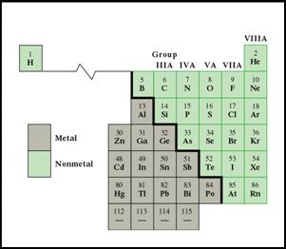

There are two types of element, metals and non-metals.

When elements react with **oxygen** they form an **oxide**.

**TESTING OXIDES**

The table below shows the results when the pH of solutions of oxides were tested.

|  |  |  |  |
| --- | --- | --- | --- |
| **TESTING OXIDES** | | | |
| **Name of Oxide** | **Formula** | **Type of Oxide (metal or non-metal oxide?)** | **pH (acidic / neutral / alkaline?)** |
| magnesium oxide | MgO | metal oxide | alkaline |
| calcium oxide | CaO | metal oxide | alkaline |
| sodium oxide | Na2O | metal oxide | alkaline |
| carbon dioxide | CO2 | non-metal oxide | acidic |
| sulfur dioxide | SO2 | non-metal oxide | acidic |
| nitrogen dioxide | NO2 | non-metal oxide | acidic |

**CONCLUSION**

Soluble **METAL OXIDES** produce **ALKALIS** in solution.

Soluble **NON-METAL OXIDES** produce **ACIDS** in solution.

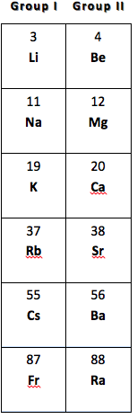

**METAL OXIDES**

**Only metal oxides** from **group I (alkali metals)** and **group II (alkaline earth metals)** are **soluble in water**.

Soluble metal oxides **REACT** with water to form a solution containing a **METAL HYDROXIDE**.

|  |  |  |  |  |
| --- | --- | --- | --- | --- |
| **metal oxide** | **+** | **water** |  | **metal hydroxide (alkali)** |
|  |  |  |  |  |
| **sodium oxide** | **+** | **water** |  | **sodium hydroxide (alkali)** |
|  |  |  |  |  |
| **Na2O(s)** | **+** | **H2O(*l*)** |  | **2 NaOH(aq)** |

Soluble **METAL HYDROXIDES** are **ALKALIS**.

**ALKALIS**

Alkalis are **soluble metal hydroxides**. Their solutions all conduct electricity showing they are all **IONIC** compounds.

|  |  |
| --- | --- |
| **ALKALI** | **FORMULA** |
| lithium hydroxide | LiOH |
| sodium hydroxide | NaOH |
| potassium hydroxide | KOH |
| calcium hydroxide | Ca(OH)2 |

The **HYDROXIDE ION (OH–)** is present in all the alkalis. The hydroxide ion is responsible for solutions being **ALKALINE**.

**ACIDS**

**Soluble non-metal oxides** **produce acids** when dissolved in water.

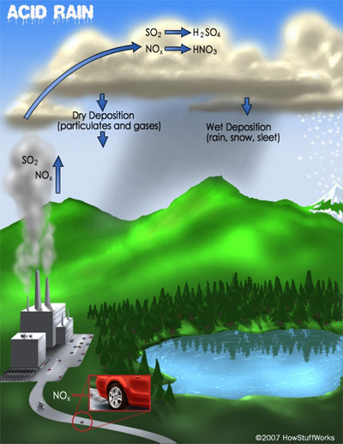**Sulfur dioxide gas (SO2)** and **nitrogen dioxide gas (NO2)** are pollutant gases, which are responsible for the formation of acid rain.

Acid rain is responsible for damaging:

* + Trees and plants in forests;
  + Killing fish and small animals which live in lakes which have become too acidic;
  + Causing metal structures to corrode more rapidly e.g. bridges;
  + Damaging buildings made from marble and limestone as they react with acids.

**ACID FORMULAE**

|  |  |  |
| --- | --- | --- |
| **ACID** | **CHEMICAL NAME** | **FORMULA OF ACID** |
| hydrochloric | hydrogen chloride solution | HCl(aq) |
| nitric | hydrogen nitrate solution | HNO3(aq) |
| sulfuric | hydrogen sulfate solution | H2SO4(aq) |
| phosphoric | hydrogen phosphate solution | H3­PO4(aq) |

|  |
| --- |
| **MEMORISE THE CHEMICAL NAMES AND FORMULAE OF THE ACIDS.** |

|  |
| --- |
| Hydrochloric acid does not contain oxygen in its formula showing that is not made by dissolving a non-metal oxide in water. It is made by dissolving hydrogen chloride gas in water. |

**BONDING IN ACIDS**

The formula of acids (only contain non-metals) indicates that they should have **covalent bonding**.

All **solutions of acids conduct electricity** showing they have **IONIC BONDING**.

|  |  |  |
| --- | --- | --- |
| **N4** | **ACIDS, FOOD & HEALTH** | **N4** |

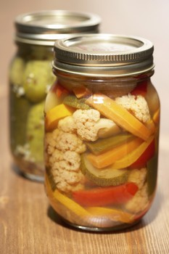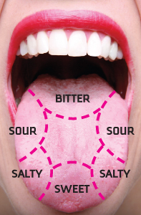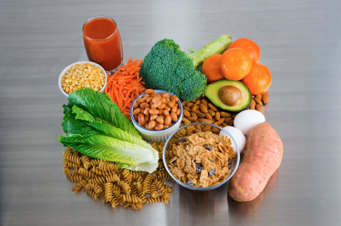

**FOLIC ACID**

**vegetables, grains and nuts, fruit**

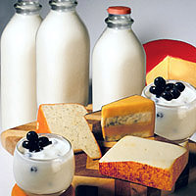

**LACTIC ACID**

**milk, cheese, cream sour cream, yogurt**

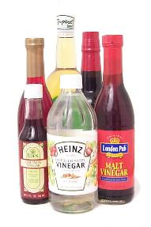

**ETHANOIC ACID  
(ACETIC ACID)**

**vinegar for flavouring and pickling**

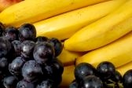

**TARTARIC ACID**

**bananas, grapes**

**CITRIC ACID**

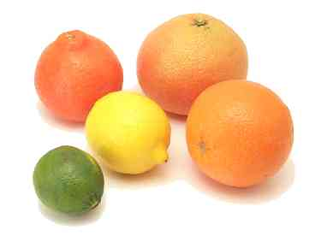

**oranges, lemons limes grapefruits.**

Acids are found in our food and drinks. Acids are important as they:

* Contribute to the taste of food.
* Preserve food preventing food rotting.
* Essential for providing important chemicals for our body.

**ACIDS in FOOD**

Acids have a sour taste. Foods, which have a sharp sour taste, will contain acids.

**ACIDS & HEALTH**



Acids in our food, are used by our body, to carry out important reactions.

|  |  |  |
| --- | --- | --- |
| **ACID** | **OTHER NAME** | **USE IN OUR BODY** |
| Ascorbic acid | Vitamin C | Prevents scurvy, an antioxidant, and preservative in food. |
|  | Vitamin B9 | Aids cell division. Helps produce red blood cells and prevents anaemia. |
| Amino acids |  | Used to make proteins e.g. skin, muscle, hair, nails. |
| Fatty acids |  | Obtained from fats and oils. Help regulate the immune response and liver and help blood clot. |

|  |  |  |
| --- | --- | --- |
| **N5** | **ACID and ALKALI FORMULAE** | **N5** |

**ALKALI IONIC FORMULAE**

Metal hydroxides have ionic bonding, which can be shown by writing an ionic formula.

|  |  |  |  |
| --- | --- | --- | --- |
| **ALKALI** | **FORMULA** | **IONIC FORMULA** | |
| **solid** | **solution** |
| lithium hydroxide | LiOH | Li+OH– (s) | Li+ (aq) + OH– (aq) |
| sodium hydroxide | NaOH | Na+OH– (s) | Na+ (aq) + OH– (aq) |
| potassium hydroxide | KOH | K+OH– (s) | K+ (aq) + OH– (aq) |
| calcium hydroxide | Ca(OH)2 | Ca2+(OH–)2(s) | Ca2+ (aq) + 2OH– (aq) |

When an ionic compound is a solid the ions are not free to move as they are held tightly in the ionic lattice.

|  |
| --- |
| **When an ionic compound is melted or in solution the ions are free to move the + is inserted between the ions in a formula to show they have moved apart.** |

**ELECTROLYSIS OF ACIDS**

**-ve electrode**

**acid**

**+**

**+**

Solutions of acids have ionic bonding; this means an ionic formula can be written to show the ions in the formula.

Normally **METALS** form **positive ions**, since acids only contain non-metals which element forms the positive ion?

Electrolysis can be used to identify the positive ion in acids by examining the product at the **NEGATIVE ELECTRODE**.

The product at the negative electrode was collected during the electrolysis of hydrochloric acid and sulfuric acid.

|  |  |  |  |  |  |  |  |  |  |  |  |  |  |  |  |  |  |  |  |  |  |
| --- | --- | --- | --- | --- | --- | --- | --- | --- | --- | --- | --- | --- | --- | --- | --- | --- | --- | --- | --- | --- | --- |
| **hydrogen gas**  **-ve electrode** | **RESULTS**  The gas, which collects, burns with a pop.  **CONCLUSION**  The gas produced at the negative electrode is hydrogen (H2).  The positive ion in all acids is the hydrogen ion and its formula is H+.   |  |  |  |  |  | | --- | --- | --- | --- | --- | | **The equation for the discharge of the hydrogen ion during electrolysis:** | | | | | | **2 H+(aq)** | **+** | **2 e-** |  | **H2(g)** | |  |  |  |  |  | | **From the acid.** |  | **From the -ve electrode** |  |  |   **This equation is listed in the ELECTROCHEMICAL SERIES.** |

**ACID IONIC FORMULAE**

All acids contain the **HYDROGEN ION** **(H+(aq))**. The hydrogen ion is responsible for acidity and causes indicator to turn red.

|  |  |  |  |
| --- | --- | --- | --- |
| **ACID** | **CHEMICAL NAME** | **FORMULA** | **IONIC FORMULA** |
| hydrochloric | hydrogen chloride solution | HCl(aq) | H+(aq) + Cl– (aq) |
| nitric | hydrogen nitrate solution | HNO3(aq) | H+(aq) + NO3– (aq) |
| sulfuric | hydrogen sulfate solution | H2SO4(aq) | 2 H+(aq) + SO42– (aq) |
| phosphoric | hydrogen phosphate solution | H3­PO4(aq) | 3 H+(aq) + PO43–(aq) |

|  |
| --- |
| **MEMORISE THE CHEMICAL NAMES AND FORMULAE OF THE ACIDS.** |

|  |  |  |
| --- | --- | --- |
| **N5** | **DILUTING ACIDS and ALKALIS** | **N5** |

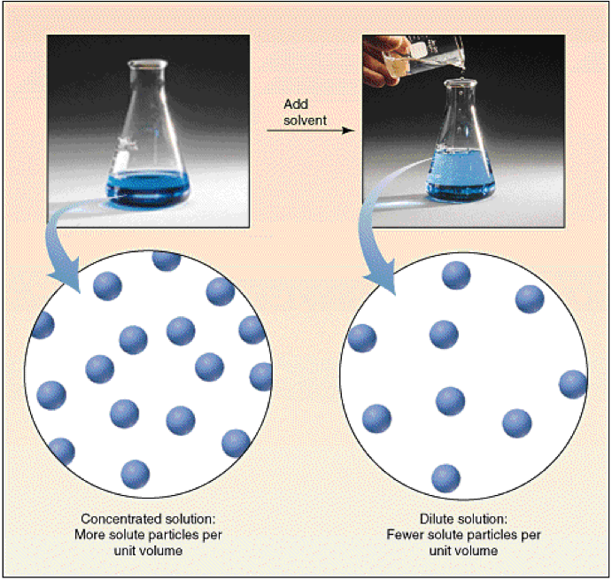**DILUTING A SOLUTION**

When a solution is mixed with water the concentration of the solution decreases.

During dilution of a solution the number of particles (ions or molecules) of solute in every cm3 decreases.

**How does diluting an acid or alkali affect the pH of the solution?**

**DILUTING AN ACID**

The pH of 0.1 mol *l*-1 hydrochloric acid was measured using a pH meter. The acid was then diluted by a factor of 10 by measuring 10 cm3 of acid and adding 90 cm3 of distilled water. The dilution was repeated several times.

After each dilution the pH was measured using a pH meter.

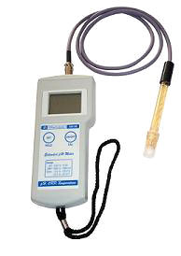

The table shows the results of the experiment.

|  |  |
| --- | --- |
| **Concentration of HCl (mol *l*-1)** | **pH** |
| 0.1 | 1 |
| 0.01 | 2 |
| 0.001 | 3 |
| 0.0001 | 4 |
| 0.00001 | 5 |
| 0.000001 | 6 |
| 0.0000001 | 7 |

**CONCLUSION**

Diluting an acid decreases the acidity and raises the pH towards 7.

**DILUTING AN ALKALI**

The table below shows the results when the pervious experiment was repeated using 0.1 mol *l*-1 sodium hydroxide.

|  |  |
| --- | --- |
| **Concentration of NaOH (mol *l*-1)** | **pH** |
| 0.1 | 13 |
| 0.01 | 12 |
| 0.001 | 11 |
| 0.0001 | 10 |
| 0.00001 | 9 |
| 0.000001 | 8 |
| 0.0000001 | 7 |

**CONCLUSION**

Diluting an alkali decreases the alkalinity and results in the pH falling towards 7.

**DILUTION AND WATER**

Pure water is a very poor conductor of electricity. This shows water contains ions.

The very low conductivity shows water contains a very small number of ions.

When an acid and alkali are diluted enough the pH eventually arrives at pH 7.

**7**

**1**

**H+**

**OH–**

**H+**

**OH–**

**14**

This shows that pure water contains a very small number of **H+** and **OH-** ions

**WATER**

Water forms ions from its molecules in the following reaction.

**H2O(*l*)**

**H+(aq)**

**OH–(aq)**

**+**

The low conductivity of water shows very few molecules break up to form ions. Pure water is neutral because there are equal numbers of **H+** and **OH–** ions.

The double arrow shows the reaction is **REVERSIBLE.**

This reaction is called the **DISSOCIATION OF WATER.** This means all solutions contain small numbers of **H+** and **OH–** ions.

Acids contain **MORE H+** ions than is present in pure water.

Alkalis contain **MORE OH–** ions than is present in pure water.

Diluting an acid or alkali decreases the concentration of **H+** or **OH–** to bring them down to the same concentration as present in pure water.