Faculty of Modern Languages – French
Purpose and Aims of the Course
Learning other languages enables children and young people to make connections with different people and their cultures and to play a fuller part as global citizens. The course aims to develop communicative competence so pupils are able to use language effectively in real situations and for a range of relevant purposes in work and leisure throughout their life. ICT enhances teaching and learning and provides real-life contexts that motivate learners to become enthusiastic and confident language learners. Learning through languages enhances pupils’ enjoyment and understanding of their own language and cultures as well as those of other people.
Course Description
The core text is Expo pour l’Écosse 1 and covers 6 different topics to develop the elements of reading, writing, listening and talking:
- Personal information *Home town
- Friends and Family * Daily Routine and School
- Home * Leisure and Holidays
Grammar is fully integrated into the teaching sequence so pupils gain knowledge about language structures to create new language and develop their competence in French.
Learning and Teaching Approaches
A variety of learning and teaching approaches that are enjoyable and relevant will be used including:
Active learning, individual work, paired work, collaborative learning, research work, project work, self and peer evaluation and the use of ICT to support learning.
Most activities take account of different starting points to language learning and are differentiated to allow for different rates of progression among pupils.
Development of Literacy and Numeracy
The Literacy Skills that the course develops are:
Listening and Talking | Writing | Reading
- Finding and using information  - Verbal Communication  - Talks/Role Play  - Listening for pleasure | - Creating texts  - Knowing about  language  - Organising and using information | - Finding and using information  - Understanding and analysing  - Reading for enjoyment  - Reading to appreciate other cultures
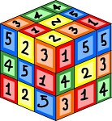
The Numeracy Skills that the course develops are:
- Numbers – ordinal – cardinal * Time
- Surveys and graphs * Money (Euro)
Assessment Methods
- Teacher questioning
- Formative assessment by teacher
- Summative assessment in the 4 elements of reading, writing, listening and talking
- Personal target setting

Homework and Home Learning Guide
Homework is set to consolidate the language covered in class. The main focus of homework is vocabulary learning. Pupils are expected to continually learn vocabulary and vocabulary tests are set regularly. It is essential that pupils also review the various grammar points which arise from the course work. Pupils complete a project jotter to develop
their appreciation of the culture surrounding the language
which they are learning.

Types of tasks issued
- Vocabulary learning
- Grammar revision
- Exercises from textbook
- Exercises from workbook
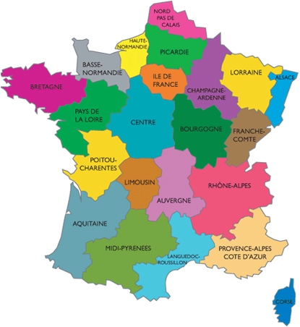
- Short written exercises
- Practice in talking (role plays, presentations, conversations)
- Revision for end of unit assessments
- Project work
- Research on cultural and topical themes

Pupil Perspective

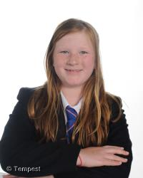
S1 – Véronique Gleghorn on homework in French
“It’s pretty easy. It’s the thing we have covered in class so it is easy if you listen in class”
A tip from Véronique:
“When doing homework make sure all electronic distractions are not on. You can do it faster and concentrate more. You can do it better. Normally I don’t get any corrections”

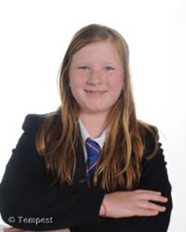

S6 - Libby Taylor on homework in French.
“Homework is an extension of classwork and if you use all the resources you will cope well”
A tip from Libby:
“Don’t rely on your dictionary and Google Translate. Use the language which the teachers have given you”

What can you do to help your son/daughter?
- Go over the vocabulary in the vocabulary booklet with your son/daughter regularly (15 – 20 minutes daily revision is more effective than one or two long sessions per week)
- Encourage your son/daughter to divide their time between studying new language and revising previous vocabulary
- Use the websites below to help with language practice
- Encourage your son/daughter to write sentences/short paragraphs using the vocabulary they have covered (current and previous topics)
- Encourage them to speak French at home
- Encourage them to read as much French as possible
- Encourage your son/daughter to copy the school listening files on to a pen drive so they can do extra listening work at home

Websites and resources available
Expo 1 Textbook and Workbook
Vocabulary booklets
www.linguascope.com
www.languagesonline.org.uk
https://quizlet.com/
www.jde.fr/

