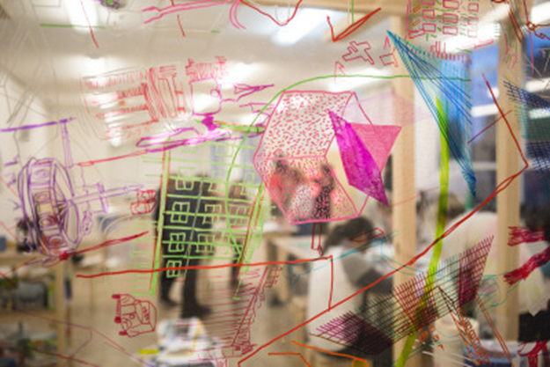
Photo taken by Grant Anderson
CAREERS in the Arts | Visual Art & Design Workshop
This contemporary sculpture workshop will be led by experienced artist Jason Nelson with support from young emerging artists’ part of STACK collective.
In this practical workshop, participants will work creatively to explore visual art & design with reference to architecture to build three dimensional forms using simplistic techniques and materials. The final artworks will be displayed and documented in fun and interesting ways within the STACK space. There will be the opportunity for individuals interested in a creative career to ask the artists about their creative journeys to date and find out how they sustain their artistic practice/career.
Workshop 1 – 12.00-1.00pm: Workshop 2 - 1.30-2.30pm: Workshop 3 – 3.00-4.00pm STACK studio space (Lemon Tree Lounge) – 10 Participants per workshop – length 1 hour
*Supporting info
Jason Nelson is an artist based in Dundee he has over 15 years’ experience as an artist and educator. Over the past several years the term that would best describe his practice would be ‘participatory’. Working directly within communities exploring notions of culture, co-production, collective ownership and stewardship. He is interested in how activity can empower and enable expression and action. This expression can manifest in many forms and range from engagement with local authority, permanent sculptural interventions to live events and activities. His work is often a response to context and exists as a result of direct engagement with people, their environments and their relationship to it. Regardless of the scale of project the underpinning concepts that drive his work are notions of learning, social structure and ideas of identity, community and ownership. http://www.jasonnelson.co.uk/look-and-learn.html
STACK Collective are a group of 6 young emerging artists/designers, who took part in a Mentoring project in September 2016 called LOOK & LEARN, Jason Nelson inspired and skilled the group up to create a studio space from scratch. Using the ‘art of building’ as the tool for conversation, Jason mentored and brought the group together to collaborate and discuss all aspects of their creative practice and deliver participatory art workshops. Since the mentoring programme the group have continued to work collaboratively and have been successful in receiving an exciting commission as part of this year’s SPECTRA. It’s an exciting time for the group of young artists! http://stackartistcollective.tumblr.com

