ABERDEEN GRAMMAR SCHOOL
SKENE STREET
ABERDEEN AB10 1HT
Telephone No. (01224) 642299
Fax No. (01224) 627413
Email AberdeenGrammarSchool@AberdeenCity.Gov.uk
Alison Murison, MA (hons), Head Teacher

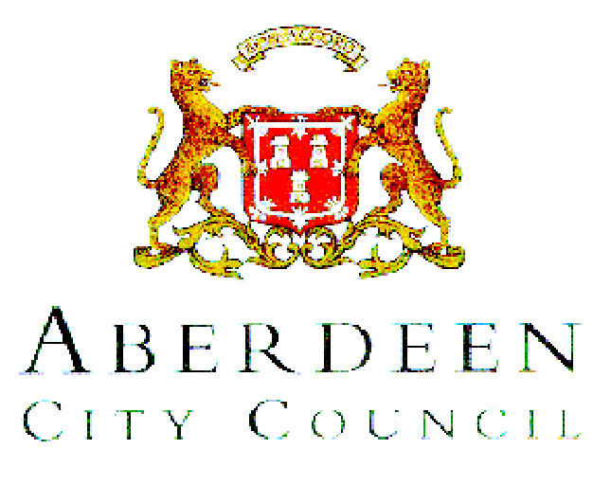

October 2017

Dear Parent/Carer

Changes to SQA National Qualifications

Last September, the Scottish Government announced changes were to be made to National Qualifications over a period of three years, starting from session 2017-18 with National 5 qualifications. Changes to Higher qualifications will be made from session 2018-19, and to Advanced Higher qualifications from session 2019-20. To date, the SQA has issued detailed information only about how National 5 will be affected.

National 5: What is changing?

The fundamental change being made to all qualifications is the removal of all unit assessments from course awards. This decision has been made to allow more time for learning and teaching, and to reduce the amount of assessment experienced by young people taking national qualifications. As a result of the removal of the unit assessments, however, course assessments have been strengthened to ensure the credibility and standards of the qualifications are maintained. This means for each National 5 course, one or more of the following changes has been made:

- Extension of the existing examination paper
- Extension or modification of the existing item of coursework
- Addition of a new examination paper
- Addition of a new item of coursework

This means that there will now be an examination in some subjects, which up to now had none: for example, there will now be an examination at the end of the course in Administration and IT, Engineering Science, Hospitality – both Cake Craft and Practical Cookery. In other subjects, the change will be seen in the coursework assignment that has to be completed, or pupils will have to sit a longer examination at the end of the course.

A further change announced by SQA is an extension to the grade boundary for a Grade D. Grade D will be awarded to a candidate who achieves 40%-49% in the examination. Previously, Grade D was given only to those with 45% or above.

How will this affect your child?

The Senior Phase, S4-S6, is designed to ensure that there is a variety of pathways open to pupils to help them gain a range of qualifications, at different levels, at a rate that best suits them. There are different routes to each of the qualifications, which allow pupils to pick up awards at different levels over the three years of this qualifications phase.

With the changes to qualifications, it is important that pupils are entered at the correct level to ensure they gain an award at the end of S4. Schools have to make decisions about course entries by early November: these decisions will be based on a range of assessment information, gathered over time. The aim will be to ensure that all pupils are entered at a level where they will be challenged, but can still achieve.

Decisions about entry for National 5 will be based on assessment evidence and pupil tracking information gathered over this session. Pupils will be entered for the National 5 if the school feels that they are capable of achieving the 40% needed to gain a course award. If pupils are not yet ready for presentation at National 5, they will be presented at National 4 in S4, and may also be able to cover some elements of the National 5 course. Thereafter they may progress to National 5 in S5, with a far greater likelihood of success. If pupils are not presented at the appropriate level, they are at risk of achieving no award at the end of S4.)

In session 2017-18, SQA has indicated that there may be an opportunity for a very small number of candidates to achieve a National 4 Award by using Recognising Positive Achievement arrangements. This is likely to require borderline candidates who are being presented for National 5, to have evidence that they have successfully overtaken the content of Level 4 or 5 units, and the Added Value Award for the corresponding National 4 Award. This could create a considerable amount of extra assessment over and above the assessment demands in the National 5 coursework and the examination.

Because of these demands, every effort will be made to ensure pupils are entered at the correct level when entries are made in November this year: this means pupils will, in the main, be presented for only the course award or for only freestanding units.

If you would like more information on the changes to National 5 qualifications, please refer to the SQA website: www.sqa.org.uk/nqchanges

Yours sincerely

A Murison
Head Teacher

