Aberdeen City Campus Course Choice 2018/19

19.12.17
LIST OF COURSES IN ALPHABETICAL ORDER
Note: For NESCol courses, CC = City Campus on the Gallowgate.
Course | SCQF Level | Qualification/Award | Providing Partner | Venue | Page
Accountancy | 6 | Foundation Apprent'ship | NESCol | CC | 52
Accounting | 6 | Higher | ACC | AGS | 8
Beauty Therapy | 4 | City & Guilds L1 | NESCol | CC | 36
Biology | 7 | Advanced Higher | ACC | AGS | 9
Business Management | 7 | Advanced Higher | ACC | Hazlehead | 10
Business skills (I year) | 6 | Foundation Apprent'ship | NESCol | CC | 53
Chemistry | 7 | Advanced Higher | ACC | St. Machar | 11
Chemistry | 6 | Higher | ACC | St. Machar | 12
Children & young people | 6 | Foundation Apprent'ship | NESCol | City Campus | 53
Civil engineering | 6 | Foundation Apprent'ship | NESCol | Altens & CC | 54
Computing Science | 7 | Advanced Higher | ACC | Harlaw | 13
Computing Science | 6 | Higher | ACC | AGS | 14
Computing Science | 5 | National 5 | NESCol | CC | 36
Computing Science | 6 | Higher | NESCol | CC | 37
Construction Crafts | 4 | Skills for Work N4 | NESCol | Altens | 37
Construction Crafts | 5 | Skills for Work N5 | NESCol | Altens | 38
Creative & digital media | 6 | Foundation Apprent'ship | NESCol | CC | 54
Creative Textiles | 5/6 | NPA L5/6 | NESCol | CC | 38
Dance | 6 | Higher | Citymoves | Citymoves Studio | 15
Digital media | 6 | NPA | NESCol | CC | 39
Drama | 7 | Advanced Higher | ACC | AGS | 16
Early education & childcare | 4 | Skills for Work N4 | NESCol | CC | 39
Early education & childcare | 5 | Skills for Work N5 | NESCol | CC | 40
Economics | 6 | Higher | ACC | AGS | 17
Electrical engineering | 6 | Foundation Apprent'ship | NESCol | Altens & CC | 55
Engineering | 5 | Skills for Work N5 | NESCol | Altens | 40
English | 7 | Advanced Higher | ACC | AGS | 18
ESOL (English for Speakers of Other Languages) | 5 | National 5 / Higher | ACC - EAL Service | Harlaw | 19
Exercise & fitness leadership | 6 | NPA | NESCol | CC | 41
Food & drink operations | 6 | Foundation Apprent'ship | NESCol | CC | 55
French | 6 | Higher | ACC | Hazlehead | 21
French | 7 | Advanced Higher | ACC | Hazlehead | 20
Gaelic | 4/5 | National 4/5 learners | ACC | Hazlehead | 22
Geography | 7 | Advanced Higher | ACC | Harlaw | 23
German | 6 | Higher | ACC | Hazlehead | 24
German | 5 | National 5 | ACC | Hazlehead | 25
Girls in Energy (Shell) | 5 | Skills for Work N5 | NESCol | Altens | 41
Graphic Communication | 6 | Higher | ACC | Harlaw | 26
Hairdressing | 4 | City & Guilds L1 | NESCol | CC | 42
Health Sector | 5 | Skills for Work N5 | NESCol | CC | 42
History | 7 | Advanced Higher | ACC | AGS | 27
Hospitality | 5 | Skills for Work N5 | NESCol | CC | 43
ICT - Hardware & system support | 6 | Foundation Apprent'ship | NESCol | CC | 56
Lab Science | 5 | Skills for Work N5 | NESCol | CC | 44
Mandarin | 7 | Advanced Higher | ACC | Oldmachar | 28
Mandarin | 6 | Higher | ACC | Oldmachar | 29
Mandarin | 4/5 | National 4/5 | ACC | Oldmachar | 30
Maritime | 5 | Skills for Work N5 | NESCol | Maritime Ac’y,  Peterhead | 44
Mathematics of Mechanics | 7 | Advanced Higher | ACC | Harlaw | 31
Mechanical engineering | 6 | Foundation Apprent'ship | NESCol | Altens & Cc | 56
Modern Studies | 7 | Advanced Higher | ACC | AGS | 32
Photography | 5 | NPA L5 | NESCol | CC | 45
Physics | 7 | Advanced Higher | ACC | AGS or Harlaw | 33
Physics | 6 | Higher | NESCol | CC | 45
Politics | 7 | Professional Development award | NESCol | CC | 46
Psychology | 6 | Higher | NESCol | CC | 46
Saks Hair Academy | 1 | Diploma | Saks | Union Square | 34
Scientific technologies (Lab skills) | 6 | Foundation Apprent'ship | NESCol | CC | 57
Service industries | 4 | College Certificate | NESCol | CC | 47
Social care & healthcare | 6 | Foundation Apprent'ship | NESCol | CC | 57
Sociology | 6 | Higher | NESCol | CC | 47
STEM | 4 | College Certificate | NESCol | Altens | 48
Supported learning links | 2/3 | College Certificate | NESCol | CC | 48
Travel & Tourism | 5 | National Cerificate | NESCol | CC | 50
Vehicle maintenance & repair | 4 | City & Guilds L1 | NESCol | Altens | 50

List of Courses (SCQF Level)
Course | SCQF Level | Qualification/Award | Providing Partner | Venue | Page
Biology | 7 | Advanced Higher | ACC | AGS | 9
Business Management | 7 | Advanced Higher | ACC | Hazlehead | 10
Chemistry | 7 | Advanced Higher | ACC | St. Machar | 11
Computing Science | 7 | Advanced Higher | ACC | Harlaw | 13
Drama | 7 | Advanced Higher | ACC | AGS | 16
English | 7 | Advanced Higher | ACC | AGS | 18
French | 7 | Advanced Higher | ACC | Hazlehead | 20
Geography | 7 | Advanced Higher | ACC | Harlaw | 23
History | 7 | Advanced Higher | ACC | AGS | 27
Mandarin | 7 | Advanced Higher | ACC | Oldmachar | 28
Mathematics of Mechanics | 7 | Advanced Higher | ACC | Harlaw | 31
Modern Studies | 7 | Advanced Higher | ACC | AGS | 32
Physics | 7 | Advanced Higher | ACC | AGS or Harlaw | 33
Politics | 7 | Professional Development award | NESCol | CC | 46
Accountancy | 6 | Foundation Apprent'ship | NESCol | CC | 52
Accounting | 6 | Higher | ACC | AGS | 8
Business skills (I year) | 6 | Foundation Apprent'ship | NESCol | CC | 53
Chemistry | 6 | Higher | ACC | St. Machar | 12
Children & young people | 6 | Foundation Apprent'ship | NESCol | CC | 53
Civil engineering | 6 | Foundation Apprent'ship | NESCol | Altens & CC | 54
Computing Science | 6 | Higher | ACC | AGS | 14
Computing Science | 6 | Higher | NESCol | City Campus | 37
Creative & digital media | 6 | Foundation Apprent'ship | NESCol | Altens | 54
Creative Textiles | 5/6 | NPA L5/6 | NESCol | CC | 38
Dance | 6 | Higher | Citymoves | Citymoves Studio | 15
Digital media | 6 | NPA | NESCol | CC | 39
Economics | 6 | Higher | ACC | AGS | 17
Electrical engineering | 6 | Foundation Apprent'ship | NESCol | Altens &CC | 55
ESOL (English for Speakers of Other Languages) | 5/6 | National 5 / Higher | ACC - EAL Service | Harlaw | 19
Exercise & fitness leadership | 6 | NPA | NESCol | CC | 41
Food & drink operations | 6 | Foundation Apprent'ship | NESCol | CC | 55
French | 6 | Higher | ACC | Hazlehead | 21
German | 6 | Higher | ACC | Hazlehead | 24
Graphic Communication | 6 | Higher | ACC | Harlaw | 26
ICT - Hardware & system support | 6 | Foundation Apprent'ship | NESCol | CC | 56
Mandarin | 6 | Higher | ACC | Oldmachar | 29
Mechanical engineering | 6 | Foundation Apprent'ship | NESCol | Altens & CC | 56
Physics | 6 | Higher | NESCol | CC | 45
Psychology | 6 | Higher | NESCol | CC | 46
Scientific technologies (Lab skills) | 6 | Foundation Apprent'ship | NESCol | CC | 57
Social care & healthcare | 6 | Foundation Apprent'ship | NESCol | CC | 57
Sociology | 6 | Higher | NESCol | CC | 47
Computing Science | 5 | National 5 | NESCol | CC | 36
Construction Crafts | 5 | Skills for Work N5 | NESCol | Altens | 38
Early education & childcare | 5 | Skills for Work N5 | NESCol | CC | 40
Engineering | 5 | Skills for Work N5 | NESCol | Altens | 40
German | 5 | National 5 | ACC | Hazlehead | 25
Girls in Energy (Shell) | 5 | Skills for Work N5 | NESCol | Altens | 41
Health Sector | 5 | Skills for Work N5 | NESCol | CC | 42
Lab Science | 5 | Skills for Work N5 | NESCol | CC | 44
Maritime | 5 | Skills for Work N5 | NESCol | Maritime Ac’y, Peterhead | 44
Photography | 5 | NPA L5 | NESCol | CC | 45
Travel & Tourism | 5 | National Cerificate | NESCol | CC | 50
Gaelic | 4/5 | National 4/5 learners | ACC | Hazlehead | 22
Mandarin | 4/5 | National 4/5 | ACC | Oldmachar | 30
Beauty Therapy | 4 | City & Guilds L1 | NESCol | CC | 36
Construction Crafts | 4 | Skills for Work N4 | NESCol | Altens | 37
Early education & childcare | 4 | Skills for Work N4 | NESCol | CC | 39
Hairdressing | 4 | City & Guilds L1 | NESCol | CC | 42
Service industries | 4 | College Certificate | NESCol | CC | 47
STEM | 4 | College Certificate | NESCol | Altens | 48
Vehicle maintenance & repair | 4 | City & Guilds L1 | NESCol | Altens | 50
Supported learning links | 2/3 | College Certificate | NESCol | CC | 48
Saks Hair Academy | 1 | Diploma | Saks | Union Square | 34

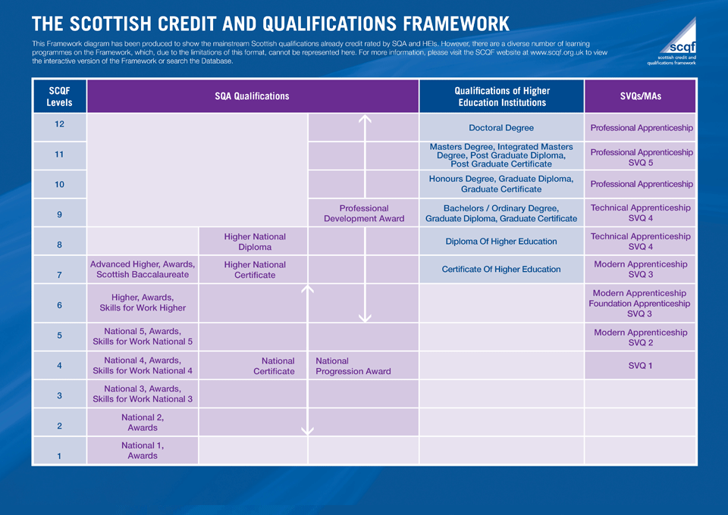

Aberdeen City Council Courses

ACCOUNTING HIGHER
SCQF 6
Days | Mon/Weds and Tue/Thurs 2-4pm (choose one)
Location | Aberdeen Grammar School
Starting Date | Wed 6th June / Thur 7th June
Entry Requirements | National 5 Maths or National 5 Accounting
Course Content | The Course has three mandatory Units:  Preparing Financial Information (Partnership and PLC accounts),  Preparing Management Information (Budgeting and Costing) and  Analysing Accounting Information (Ratios and Decision-making).
Career progression | Further Education or Higher Education e.g. HNC/D or degree courses in Accounting and Finance, Business or Management studies  A range of employment – Insurance, Banking, Accounting, Administration jobs
Materials Required | The school provides all materials for all courses, the pupils don’t need to bring anything apart from a ruler and a calculator.

BIOLOGY ADVANCED HIGHER
SCQF 7
Days | Mon/Wed 2-4pm
Location | Aberdeen Grammar School
Starting Date | Wed 6th June
Entry Requirements | A Higher Biology or Human Biology pass at A or B is desired. Entrance to the course is at the discretion of the department.
Course Content | This course is composed of the following 3 Units:  - Cells and Proteins: proteomics, protein structure, binding and conformational change; membrane proteins; detecting and amplifying a stimulus; communication within multicellular organism and protein control of cell division. The Unit includes important laboratory techniques for biologists.  - Organisms and Evolution: evolution; variation and sexual reproduction; sex and behaviour and parasitism. This Unit covers techniques for ecological field study.  Investigative Biology: This Unit builds on understanding of the scientific method from Higher Biology. Learners will develop knowledge and understanding of the principles and practice of investigative biology and its communication. The Unit covers scientific principles and processes, experimentation and critical evaluation of biological research.
Assessment | To gain the award of the Course, the learner must pass Course assessment. Course assessment will provide the basis for grading attainment in the Course award at levels A-D. The Course assessment is externally assessed and composed of the following two components:  - Component 1 — question paper 100 marks  - Component 2 — project 30 marks
Materials Required | Access to Scholar is expected and the Bright Red Advanced Higher book is recommended.

BUSINESS MANAGEMENT ADVANCED HIGHER
SCQF 7
Days | Tue/Thur 2-4pm
Location | Hazlehead Academy
Starting Date | Thur 7th June
Entry Requirements | A Higher Business Management pass at A or B is desired. Entrance to the course is at the discretion of the department.
Course Content | The aim of the course is to provide pupils with an opportunity to extend and enhance understanding developed at previous levels of study. Pupils are expected to assimilate new content but there is considerable emphasis on using ideas to which candidates have already been exposed, particularly in terms of problem solving and decision-making within organisations. Pupils are expected to apply these ideas in an extended context and, in this respect, the Course broadens and deepens the issues raised at Higher level, particularly with respect to international influences and the principles and practices of management. It will enable pupils to extend their problem solving skills in a way that will help them to assess their personal effectiveness as potential members of the business community and develop further their ability to communicate by means of written and spoken language.  The course content is organised in 3 units:  - The Internal Environment  - The External Environment  - Researching a business
Assessment | The course consists of:  - Three mandatory units with unit assessments  - Final Exam  - Component 1 – Question Paper (worth 80 marks)  - Component 2 – Business Report (worth 50 marks)
Materials Required

CHEMISTRY ADVANCED HIGHER
SCQF 7
Days | Tue/Thur
Location | St. Machar Academy
Starting Date | Thur 7th June
Entry Requirements | A Higher Chemistry pass at A or B is desired. Entrance to the course is at the discretion of the department.
Course Content | The course is comprised of three units:  - Inorganic and Physical Chemistry  - Organic Chemistry and Instrumental Analysis  - Researching Chemistry  Study at this level builds on previous knowledge and understanding of the physical and natural environments. Throughout the course, concepts which have been introduced in the Higher course are developed, leading to deeper and broader understanding. The range of practical skills is also developed with many new techniques being introduced. The course also develops the skills of independent study and thought – particularly during the individual research project. The course is particularly suitable for candidates who wish to progress to degree courses either in chemistry or in subjects in which chemistry is a major component such as medicine, chemical engineering, and the environmental and health sciences.
Assessment | The externally assessed parts of the course are a written paper, worth 100 marks and a project worth 30 marks.
Materials Required

CHEMISTRY HIGHER
SCQF 6
Days | Tue/Thur
Location | St. Machar Academy
Starting Date | Thur 7th June
Entry Requirements | A National 5 Chemistry pass at A or B is desired. Entrance to the course is at the discretion of the department.
Course Content | There are four units:  - Chemical changes and structure – controlling reaction rates & periodic trends; collision theory & the use of catalysts in reactions; electro-negativity and intra-molecular and intermolecular forces.  - Researching Chemistry – relevance of chemical theory to everyday life by exploring the chemistry behind a topical issue.  - Nature’s Chemistry – Organic chemistry within the context of the chemistry of food and the chemistry of everyday consumer products, soaps, detergents, fragrances and skincare.  - Chemistry in Society – the principles of physical chemistry which allows a chemical process to be taken from the researcher’s bench through to industrial production.
Assessment | The Course assessment will consist of two Components: a question paper and an assignment.  Component 1 — question paper.  The question paper will have 100 marks The question paper will have two Sections. Section 1 (Objective Test) will have 20 marks. Section 2 will contain restricted and extended response questions and will have 80 marks.  Component 2 — assignment  This assignment requires learners to apply skills, knowledge and understanding to investigate a relevant topic in chemistry. The topic should draw on one or more of the key areas of the Course, and should be chosen with guidance from the assessor. The assignment will have 20 marks.
Materials Required

COMPUTING SCIENCE ADVANCED HIGHER
SCQF 7
Days | Mon/Wed
Location | Harlaw Academy
Starting Date | Wed 6th June
Entry Requirements | A Higher Computing Science pass at A or B is desired. Entrance to the course is at the discretion of the department.
Course Content | This course develops & extends a range of skills related to the design & development of software & information systems, including skills in analysis & problem-solving, designing & modelling, developing, implementing & testing, and skills in evaluating systems and solutions across a range of contemporary contexts..  The Course consists of two mandatory Units and a Course assessment, which consists of a project and a question paper.  Software Design and Development (Advanced Higher)  This Unit explores a range of advanced concepts and processes relating to software design and development, including the use of standard algorithms, structured data types and a range of programming constructs. Learners will develop skills in, developing well-structured, complex modular programs through practical tasks, using appropriate programming languages. Through investigative and practical work, learners will gain an understanding of the similarities and differences in different contemporary programming paradigms.  Information System Design and Development (Advanced Higher)  This Unit explores a range of advanced concepts and processes relating to the design and development of complex information systems. Learners will develop skills in developing and implementing complex information systems through practical tasks using appropriate development tools. Learners will develop their independent learning skills by investigating a contemporary development, describing its purpose, features and applications, a related technical challenge or current area of development, examining its legal and/or ethical implications, and evaluating its environmental, economic and/or social impact.
Assessment | The Course assessment will consist of two Components: a project and a question paper.
Materials Required

COMPUTING SCIENCE HIGHER
SCQF 6
Days | Mon/Wed 2-4pm
Location | Aberdeen Grammar School
Starting Date | Wed 6th June
Entry Requirements | Pupils wishing to participate in this course should have achieved a pass at N5 Computing or evidence of an interest in computing and N5 pass in a related technology subject.
Course Content | The Course enables learners to develop an extended range of computing and computational thinking skills, including skills in analysis and problem-solving, design and modelling, developing, implementing, testing and evaluating digital solutions across a range of contemporary contexts.  The Course has two mandatory Units: Software Design and Development (Computational constructs, Data types and structures, Testing and documenting solutions, Algorithm specification) and Information System Design and Development (Database and Web based structures, Media types, Coding and testing).
Assessment | The learner will be assessed by a combination of a question paper worth 90 marks and an assignment worth 60 marks. Learners will apply knowledge and skills to solve an appropriately challenging computing science problem. The question paper introduces breadth to the assessment.
Materials Required

DANCE HIGHER
SCQF 6
Days | Mon/Wed
Location | Citymoves Studio, Schoolhill (Above the Triplekirks)
Starting Date | Wed 6th June
Entry Requirements | Higher Dance accepts all students from 5th and 6th year. Previous dance or drama experience is preferable.
Course Content | Technical Skills Unit  - Develop and apply skills in two contrasting techniques. These will be Contemporary and Jazz.  - Research key practitioners and historical context influencing these two distinct styles.  Choreography Unit  - Create a group piece of choreography that communicates their chosen theme.
Assessment | Component 1 — Performance (70 marks)  Candidates will perform two tutor-choreographed technical solos, each lasting between 1.5 and 2 minutes, and each worth 35 marks.  Component 2 — Practical Activity (70 marks)  This component has two Sections.  Section 1: Choreography will have 35 marks. In this Section, candidates create and present a choreography for a group of dancers (excluding self), lasting between 2 and 3 minutes.  Section 2: Choreography Review will have 35 marks. In this Section, candidates review their work as a choreographer by explaining the relationship between their research, theme and an initial motif, explaining the reasons for the choreographic choices made, and reflecting on their skills as a choreographer.

DRAMA ADVANCED HIGHER
SCQF 7
Days | Mon/Wed 2-4pm
Location | Aberdeen Grammar School
Starting Date | Wed 6th June
Entry Requirements | A Higher Drama and Higher English pass at A or B is desired. Entrance to the course is at the discretion of the department.
Course Content | This course consists of two core units as well as a practical examination and a written project. Although the unit titles are the same as Higher there is a focus on Theatre Practitioners and their impact on modern theatre. Students will be required to analyse the influences, theories and practice of these practitioners.  Drama Skills  In this Unit, learners will be required to provide evidence to demonstrate their knowledge and skills in devising, directing and performing through the exploration of a key practitioner. They will independently create a devised drama production, using their dramatic interpretation of complex texts. They will present it to an audience and evaluate their effectiveness as an actor or director.  Production Skills  In this Unit, learners will focus on a study of a key theatre practitioner, and explore in depth the influences on and the theory and practice of their chosen practitioner. They will explore and analyse key productions that reflect their acting or directing or design methodologies through both research and practical experimentation. They will also view and analyse a live theatrical event, considering performance concepts and effectiveness.
Assessment | Component 1 — Practical Exam  The practical exam will have 60 marks (60% of the total mark). The practical exam has two sections.  - Section 1 will have 50 marks. (For performance in the chosen role of acting, directing or design)  - Section 2 will have 10 marks. (These marks are awarded for a report based on their chosen role and production)  Component 2 — Project  The project will have 40 marks (40% of the total mark).  - The candidate will select a topic from relevant and current performance theories and practice. The project will consist of a written response consisting of a 3000 word dissertation which is marked externally.  Total 100 Marks
Materials Required | No materials are required.

ECONOMICS HIGHER
SCQF 6
Days | Mon/Wed 2-4pm
Location | Aberdeen Grammar School
Starting Date | Wed 6th June
Entry Requirements | Higher Business Management or Higher Modern Studies and Higher English.
Course Content | The Course gives learners an appreciation of how markets and governments work and how the decisions taken in these economic contexts affect our daily lives. Studying economics will enable learners to become better-informed, by developing an awareness of the importance of the economic dimension to our lives.  The Course has three mandatory Units:  Economics of the Market; supply and demand and an in-depth understanding of markets and how they operate.  UK Economic Activity; the role of public and private sectors in the economy, the effects of the Scottish economy on the UK economy and consider the implications of government actions and suggest solutions to relatively complex economic problems.  Global Economic Activity; explore global trade and the balance of payments and their importance in the UK economy, examine exchange rates, consider economic features of the European Union, developing countries and emerging economies and their social impact.
Assessment | The learner will be assessed by a combination of a question paper and an assignment. The question paper is worth 70 marks and the assignment is worth 30 marks.
Materials Required | Ruler, highlighters and coloured pens/pencils.

ENGLISH ADVANCED HIGHER
SCQF 7
Days | Tue/Thur 2-4pm
Location | Aberdeen Grammar School
Starting Date | Thur 7th June
Entry Requirements | A Higher English pass at A or B is desired. Entrance to the course is at the discretion of the department.
Course Content | The Advanced Higher English course is comprised of two units:  - English: Analysis and Evaluation  Learners will provide evidence of their ability to critically respond to previously studied complex and sophisticated texts, and of their ability to carry out an independent study into an aspect or aspects of literature.  - English: Creation and Production  Learners will provide evidence of their writing skills through the production of writing which demonstrates a range of skills necessary for the deployment of language to create effect.
Assessment | Internal assessments will be carried out under controlled conditions and assessed on a pass/ fail basis. If any internal unit is failed, pupils will be given an opportunity to revise their work, following feedback from their teacher.  The course will be graded A-D by the external assessment of:  - A two part portfolio – total 60%  Part A: Dissertation – 30%  Part B: Writing – 30%  (comprising two pieces of original writing)  - A two part question paper – total 40%  Part A: Literary study – 20%  Part B: Textual Analysis – 20%
Materials Required | Pen drive and selected texts may be required to be purchased.

ENGLISH FOR SPEAKERS OF OTHER LANGUAGES (ESOL) NATIONAL 5 & HIGHER
SCQF 5 & 6
Days | Tue/Thur 2-4pm
Location | EAL Service, held at Harlaw Academy
Starting Date | Thur 7th June
Entry Requirements | These qualifications are specifically for candidates whose first language is not English. Entry is by recommendation and/or initial assessment from the EAL Service. Individual circumstances will be taken into account.
Course Content | The courses develop and assess the four skills of reading, writing, speaking and listening in the following contexts:  - ESOL for everyday life  - ESOL in the context of work and study  The texts and themes covered are relevant to learners and help them progress to further study or the world of work.
Assessment | These qualifications are internally assessed and externally moderated. There are two mandatory Units (ESOL for Everyday Life and ESOL in Context) and an external exam which can be taken upon successful completion of the units. The units can also be taken individually in which case there is no exam and candidates will receive a SQA Unit award for each Unit passed.
Materials Required

FRENCH ADVANCED HIGHER
SCQF 7
Days | Tue 2 – 4pm/Thur 1-3pm
Location | Hazlehead Academy
Starting Date | Thur 7th June
Entry Requirements | A Higher French pass at A or B is desired. Entrance to the course is at the discretion of the department.
Course Content | The Advanced Higher French course consists of 3 units:  Understanding Language – within the contexts of Society, Learning, Employability and Culture students have the opportunity to develop and extend their reading and listening skills  Using Language – in the same four contexts students develop and extend their talking and writing skills  Specialist study – students develop and extend their planning, research and analytical skills to undertake an independent study based on literature or media.
Assessment | There will be one Unit assessment in each of the four skills (pass/fail)  The course assessment will comprise –  - A Reading and Translation paper worth 50 marks  - A Listening and Discursive writing paper worth 70 marks  - A Talking performance marked by a Visiting Examiner worth 50 marks (completed in February or March)  - A portfolio (the final product of the work done on a literary or media topic). This is worth 30 marks and is sent off to the SQA for assessment by them before the Easter break.
Materials Required | A French-English dictionary.

FRENCH HIGHER
SCQF 6
Days | Mon 2-4pm, /Wed 1-3pm
Location | Hazlehead Academy
Starting Date | Thur 7th June
Entry Requirements | National 5 French at Grade A or B.
Course Content | This course builds on previous language learning skills in the development of communicative competence in French.  The course consists of two units:  - Understanding Language - developing and extending reading and listening skills in French, and developing knowledge and understanding of detailed and complex language in the contexts of society, learning, employability, and culture.  - Using Language - developing and extending talking and writing skills in French, and developing knowledge and understanding of detailed and complex language covering the same four contexts.
Assessment | To gain the award for the course, learners must pass the Course assessments. There is likely to be an extra assessment at some point in the year. We are still waiting for the nature of this to be confirmed by the SQA.  The external assessment determines the final grade for the course (A-D) and will consist of 3 parts:  - a Reading and Writing question paper (2 hours 10 minutes, worth 40 marks);  - a Listening and Writing paper (1 hour 20 minutes, worth 30 marks);  - a Talking performance worth 30 marks.  The Reading, Writing and Listening papers will be externally set and marked by the SQA, the Talking performance will be conducted, recorded and marked internally in line with SQA marking instructions and quality assured.
Materials Required | A French-English dictionary.

GAELIC NATIONAL 4/5
(LEARNERS) SCQF 4/5
Days | Mon 2 – 4pm/Wed 1-3pm
Location | Hazlehead Academy
Starting Date | Wed 6th June
Entry Requirements | Pupils would be expected to be sitting or already gained a N5 pass in another Modern Language.
Course Content | This course builds on the language learning skills developed in the Broad General Education phase in the contexts of ‘Society’, ‘Learning’, ‘Employability’ and ‘Culture’. The course provides learners with the opportunities to develop more detailed skills in Reading, Listening, Talking and Writing; develop understanding of how language works; use different media effectively for learning and communication; use language to communicate ideas and information; enhance their understanding and enjoyment of their own and other cultures.  The course is made up of 2 mandatory Units:  - Understanding Language – developing the skills of Reading and Listening  - Using Language – developing the skills of Talking and Writing.  For N4, there is also an Added Value Unit: Assignment – the opportunity to apply language skills to investigate a chosen topic.
Assessment | To achieve the National 4 Modern Languages Course, learners must pass all of the required Units, including the Added Value Unit. National 4 Courses are not graded and all Units are internally assessed on a pass/fail basis in line with SQA marking instructions and quality assured.  To gain the award for the N5 course, learners must complete an assignment and pass the Course assessment (exam), which determines the final grade for the course (A-D) and will consist of 5 components  Component 1: question paper 1 Reading (2 hours, worth 30 marks)  Component 2: question paper 1 Writing (2 hours, worth 20 marks)  Component 3: question paper 2 Listening (30 minutes, worth 20 marks)  Component 4: Assignment (written in class, worth 20 marks)  Component 5: Performance–talking (a presentation and conversation, approximately 6–8 minutes, worth 30 marks)  The Reading, Writing and Listening papers will be externally set and marked by the SQA, the Speaking performance will be conducted, recorded and marked internally in line with SQA marking instructions and quality assured. The writing assignment will be produced in class under exam conditions and marked by the SQA
Materials Required | A Gaelic- English dictionary.

GEOGRAPHY ADVANCED HIGHER
SCQF 7
Days | Mon/Wed 2-4pm
Location | Harlaw Academy
Starting Date | Wed 6th June
Entry Requirements | A Higher Geography pass at A or B is desired. Entrance to the course is at the discretion of the department.
Course Content | The Advanced Higher qualification in Geography aims to give learners an in-depth understanding of complex ideas about how the world works. The course provides learners with the chance to carry out their own research on geographical issues of interest to themselves, with an emphasis on fieldwork.  The skills developed in Advanced Higher Geography provide an excellent preparation for degree courses in social subjects and science, HNCs in social subjects and science or related areas or a diverse range of careers including environmental consultant, land surveyor, seismic acquisition specialist.
Assessment | There will be 2 elements that are externally assessed:  - Exam 50 / 150.  - The exam comprises 3 topics looking at; Question 1 -Map Interpretation, Question 2 - Gathering and Processing Techniques and Question 3 - Geographical Data Handling  - Folio 100 / 150.  - Geographical Study  - Geographical Essay  There will be 2 internal unit assessments:  - Geographical Skills  - Developing a range of geographical methods and techniques. These include mapping skills, graphical techniques and a wide range of statistical techniques for gathering, analysing and interpreting geographical data.  - Geographical Issues  - Developing critical thinking and the ability to evaluate viewpoints using evidence from a wide range of sources on complex, current geographical issues.
Materials Required | Coloured pencils and notebooks.  Their school should equip them with a copy of a Phillips Modern Atlas ISBN 978-1-84907-194-9. The school makes use of google classroom to share information and update folio work, so students must bring their google login details.

GERMAN NATIONAL 5
SCQF 5
Days | Mon 2 – 4pm/Wed 1-3pm
Location | Hazlehead Academy
Starting Date | Wed 6th June
Entry Requirements | Pupils would be expected to be sitting, or to have already gained, a N5 pass in another Modern Language.
Course Content | This course builds on the language learning skills developed in the Broad General Education phase in the contexts of 'Society', 'Learning', 'Employability' and 'Culture' covering the themes of family, friends and social issues, leisure and healthy living, school and education, jobs and future plans, holidays, travel and tourism.  The course provides learners with the opportunities to: develop skills in Reading, Listening, Talking and Writing; develop understanding of how language works; use different media effectively for learning and communication; use language to communicate ideas and information; enhance their understanding and enjoyment of their own and other cultures.  The Course is made up of 2 mandatory Units:  1) Understanding Language - developing reading and listening skills;  2) Using Language - developing talking and writing skills.
Assessment | To gain the award for the N5 course, learners must complete an assignment and pass the Course assessment (exam), which determines the final grade for the course (A-D) and will consist of 5 components  Component 1: question paper 1 Reading (2 hours, worth 30 marks) Component 2: question paper 1 Writing (2 hours, worth 20 marks) Component 3: question paper 2 Listening (30 minutes, worth 20 marks) Component 4: Assignment (written in class, worth 20 marks)  Component 5: Performance–talking (a presentation and conversation, approximately 6–8 minutes, worth 30 marks)  The Reading, Writing and Listening papers will be externally set and marked by the SQA, the Speaking performance will be conducted, recorded and marked internally in line with SQA marking instructions and quality assured. The writing assignment will be produced in class under exam conditions and marked by the SQA
Materials Required | A German -English dictionary.

GERMAN HIGHER
SCQF 6
Days | Mon 2 – 4pm/Wed 1 -3pm
Location | Hazlehead Academy
Starting Date | Wed 6th June
Entry Requirements | National 5 German at Grade A or B.
Course Content | This course builds on previous language learning skills in the development of communicative competence in German.  The course consists of two units:  - Understanding Language - developing and extending reading and listening skills in German, and developing knowledge and understanding of detailed and complex language in the contexts of society, learning, employability, and culture.  - Using Language - developing and extending talking and writing skills in German, and developing knowledge and understanding of detailed and complex language covering the same four contexts.
Assessment | To gain the award for the course, learners must pass the Course assessments. There is likely to be an extra assessment at some point in the year. We are still waiting for this to be confirmed by the SQA.  The external assessment determines the final grade for the course (A-D) and will consist of 3 parts:  - a Reading and Writing question paper (2 hours 10 minutes, worth 40 marks);  - a Listening and Writing paper (1 hour 20 minutes, worth 30 marks);  - a Talking performance worth 30 marks.  The Reading, Writing and Listening papers will be externally set and marked by the SQA, the Talking performance will be conducted, recorded and marked internally in line with SQA marking instructions and quality assured.
Materials Required | A German -English dictionary.

GRAPHIC COMMUNICATION HIGHER
SCQF 6
Days | Tue/Thur
Location | Harlaw Academy
Starting Date | Thur 7th June
Entry Requirements | National 5 Grade A or B in Graphic Communication.  Or Higher Art and Design A or B based on teacher recommendation
Course Content | This course provides opportunities for learners to initiate and develop their own ideas graphically. It allows them to develop skills in reading and interpreting graphics produced by others.  The aims of the Course are to enable learners to develop:  - skills in graphic communication techniques, including the use of equipment, graphics materials and software  - creativity in the production of graphic communications to produce visual impact in  meeting a specified purpose  - skills in evaluating the effectiveness of graphics in communicating and meeting their purpose  - an understanding of graphic communication standards protocols and conventions, where these apply  - an understanding of the impact of graphic communication technologies on our environment and society  The course is made up of two units:  - 2D Graphic Communication  - 3D and Pictorial Graphic Communication
Assessment | Assignment – 50% of final grade (internally assessed)  Question Paper – 50% of final grade (set and marked by SQA)
Materials Required

HISTORY ADVANCED HIGHER
SCQF 7
Days | Mon/Wed and Tue/Thur 2-4pm
Location | Aberdeen Grammar School
Starting Date | Wed 6th June
Entry Requirements | A Higher History pass at A or B is desired. Entrance to the course is at the discretion of the department.
Course Content | 'The House Divided': USA 1850 - 65  A study of American society and the tensions within it, the causes and nature of conflict, the political, social and economic outcomes of that conflict, focusing on the themes of conflict, rights, identity and authority.  American society on the eve of war, including: political, economic and social questions arising out of the newly acquired territories; centralised Federation in conflict with States' rights; conflict between the Southern slave economy and Northern industrialism.  The coming of war, including: the civil rights questions; the failure of compromise; the outbreak of war.  The Civil War, including: military events and developments from Union and Confederate viewpoints; the role of foreign powers in the conflict; the experience of blacks during the war.  The effects of war, including: the political consequences; social and economic conditions in North and South.
Assessment | To gain an overall award for the course, students must achieve a pass in each of the two internal assessments, as well as the external exam.  External exam:  The dissertation: The dissertation will allow learners to apply research, analysis and evaluation skills as they investigate a complex historical issue. 50 marks.  The Question Paper (3 hours): The question paper is marked out of 90. It will be divided into two sections:  - Historical Issues will have 50 marks. This Section will be made up of extended response questions requiring the learner to draw on the knowledge and understanding and skills acquired during the Course.  - Historical Sources will have 40 marks. This Section will be made up of extended response questions requiring the learner to draw on the knowledge and understanding and skills acquired during the course and apply these to unseen historical sources.  Throughout the year, students will be prepared for the question paper through regular practice with source-handling and essay questions, both in class and for homework. For the dissertation, students will also have access to library facilities at the University of Aberdeen.
Materials Required | No specific materials are required.

MANDARIN NATIONAL 4/5
SCQF 4/5
Days | Tue/Thur 2-4pm
Location | Oldmachar Academy
Starting Date | Thur 7th June
Entry Requirements | Pupils would be expected to have achieved Third or Fourth Level Modern Languages Experiences and Outcomes or to have gained a pass at the SQA Mandarin Languages for Life and Work Award or N4 Mandarin.  This course is also suitable for learners who are sitting, or have already gained a Higher pass in another Modern Language but have little previous knowledge of Mandarin.
Course Content | This course builds on the language learning skills developed in the Broad General Education phase in the contexts of 'Society', 'Learning', 'Employability' and 'Culture'. The course provides learners with the opportunities to: develop skills in Reading, Listening, Talking and Writing; develop understanding of how language works; use different media effectively for learning and communication; use language to communicate ideas and information; enhance their understanding and enjoyment of their own and other cultures.  The Course is made up of 2 mandatory Units:  1) Understanding Language - developing reading and listening skills;  2) Using Language - developing talking and writing skills;  For National 4, there is also an Added Value Unit: Assignment - the opportunity to apply language skills to investigate a chosen topic.
Assessment | To achieve the National 4 Modern Languages Course, learners must pass all of the required Units, including the Added Value Unit. National 4 Courses are not graded and all Units are internally assessed on a pass/fail basis in line with SQA marking instructions and quality assured.  To gain the award for the N5 course, learners must complete an assignment and pass the Course assessment (exam), which determines the final grade for the course (A-D) and will consist of 5 components  Component 1: question paper 1 Reading (2 hours, worth 30 marks)  Component 2: question paper 1 Writing (2 hours, worth 20 marks) Component 3: question paper 2 Listening (30 minutes, worth 20 marks) Component 4: Assignment (written in class, worth 20 marks)  Component 5: Performance–talking (a presentation and conversation, approximately 6–8 minutes, worth 30 marks)  The Reading, Writing and Listening papers will be externally set and marked by the SQA, the Speaking performance will be conducted, recorded and marked internally in line with SQA marking instructions and quality assured. The writing assignment will be produced in class under exam conditions and marked by the SQA
Materials Required | A Mandarin-English dictionary.

MANDARIN HIGHER
SCQF 6
Days | Mon/Wed 2-4pm
Location | Oldmachar Academy
Starting Date | Wed 6th June
Entry Requirements | A pass at National 5 Mandarin at grade A or B. This course is also an option for pupils with a native Chinese speaking background and some Chinese reading and writing skills who may not have formally studied Mandarin in Scotland in the past.
Course Content | This course builds on previous language learning skills in the development of communicative competence in Mandarin.  The course consists of two units:  - Understanding Language - developing and extending reading and listening skills in Mandarin, and developing knowledge and understanding of detailed and complex language in the contexts of society, learning, employability, and culture.  - Using Language - developing and extending talking and writing skills in Mandarin, and developing knowledge and understanding of detailed and complex language covering the same four contexts.
Assessment | To gain the award for the course, learners must pass the Course assessments. There is likely to be an extra assessment at some point in the year. We are still waiting for this to be confirmed by the SQA.  The external assessment determines the final grade for the course (A-D) and will consist of 3 parts:  - a Reading and Writing question paper (2 hours 10 minutes, worth 40 marks);  - a Listening and Writing paper (1 hour 20 minutes, worth 30 marks);  - a Talking performance worth 30 marks.  The Reading, Writing and Listening papers will be externally set and marked by the SQA, the Talking performance will be conducted, recorded and marked internally in line with SQA marking instructions and quality assured.
Materials Required | A Mandarin-English Dictionary

MANDARIN ADVANCED HIGHER
SCQF 7
Days | Mon/Wed 2-4pm
Location | Oldmachar Academy
Starting Date | Wed 6th June
Entry Requirements | A Higher Mandarin pass at A or B is desired. Entrance to the course is at the discretion of the department.
Course Content | The Advanced Higher Mandarin course consists of 3 units:  Understanding Language – within the contexts of Society, Learning, Employability and Culture students have the opportunity to develop and extend their reading and listening skills  Using Language – in the same four contexts students develop and extend their talking and writing skills  Specialist study – students develop and extend their planning, research and analytical skills to undertake an independent study based on literature or media.
Assessment | There will be one Unit assessment in each of the four skills (pass/fail)  The course assessment will comprise -  - A Reading and Translation paper worth 50 marks  - A Listening and Discursive writing paper worth 70 marks  - A speaking performance marked by a Visiting Examiner worth 50 marks (completed in February or March)  - A portfolio (the final product of the work done on a literary or media topic). This is worth 30 marks and is sent off to the SQA for assessment by them before the Easter break.
Materials Required | A Mandarin-English dictionary.

MATHEMATICS OF MECHANICS ADVANCED HIGHER
SCQF 7
Days | Tue/Thur 2-4pm
Location | Harlaw Academy
Starting Date | Thur 7th June
Entry Requirements | Higher Maths and Higher Physics pass at A or B is desired. Entrance to the course is at the discretion of the department.  Pupils should also be studying Advanced Higher Mathematics.  Mathematics of Mechanics can be taken as a fourth Advanced Higher, if a pupil is also studying Maths and Physics at Advanced Higher.
Course Content | Learners study mechanics in a way that recognises problem solving as an essential skill. The focus within the course is placed firmly on applications of mathematics to real-life contexts and the formulation and interpretation of mathematical models. The course offers depth of applied mathematical experience and, thereby, achieves relevance to further study or employment in the areas of mathematical and physical sciences and engineering. When an Advanced Higher Mathematics of Mechanics course is taken in addition to the Advanced Higher Mathematics course, an opportunity is offered for the candidate to acquire exceptional breadth and depth of mathematical experiences.
Assessment | This course consists of three mandatory units with unit assessments, a prelim and a final exam.
Materials Required | Textbook ‘Understanding Mechanics’ by Sadler & Thorning.

MODERN STUDIES ADVANCED HIGHER
SCQF 7
Days | Mon/Wed 2-4pm
Location | Aberdeen Grammar School
Starting Date | Wed 6th June
Entry Requirements | A Higher Modern Studies pass at A or B is desired. Entrance to the course is at the discretion of the department.
Course Content | The overall theme of the course is ‘Law and Order and Research Methods’ and comprises two units, one of 80 hours and one of 40 hours as outlined below:  Unit 1: Social Issues: Law and Order and Research Methods  Context A: Understanding criminal behaviour  This includes; The nature and extent of criminal behaviour, evaluation of theories of criminal behaviour and the social and economic effects of criminal behaviour.  Context B: Responses by society to crime  This includes; Theories and explanations of responses to crime, current responses to crime and evaluation of responses to crime.  Unit 2 – Researching Contemporary Issues  This unit will allow the pupil to carry out independent research on the content of a unit studied at Higher or Advanced Higher in Modern Studies. The pupil will develop the investigative skills of planning, researching, analysing and presenting through the production of a 4500 word dissertation for which part of the research must involve a primary method.
Assessment | To gain a full award for the course, pupils must achieve all the component units of the course (internally assessed) as well as the external assessment. The external assessment comprises of an externally set and assessed question paper and the dissertation. In addition, pupils must pass internal assessments throughout the course relating to the content and research methods related to the main study theme (Unit 1) and practical research methods (Unit 2).
Materials Required | A ring binder, folder and A4 paper. Pupils need access to the internet as we use Google Classroom a lot and they also need to be able to print articles and handouts as there is a lot of reading.

PHYSICS ADVANCED HIGHER
SCQF 7
Days | Mon/Wed or Tue/Thur 2-4pm
Location | Harlaw Academy (M/W) Aberdeen Grammar School (T/Th)
Starting Date | Wed 6th June / Thur 7th June
Entry Requirements | A Higher Physics and Higher Maths pass at A or B is desired. Entrance to the course is at the discretion of the department.
Course Content | This course is composed of the following four Units:  - Rotational Motion and Astrophysics: develop and apply concepts and principles in a wide variety of situations involving angular motion, rotational dynamics and angular momentum. An astronomical perspective is developed through a study of gravitation; leading to work on general relativity and stellar physics.  - Quanta and Waves: develop and apply concepts and principles in a wide variety of situations involving quantum theory and waves. The Unit introduces non-classical physics and considers the origin and composition of cosmic radiation. Simple harmonic motion is introduced. Work on wave theory is developed including: Interference, Division of amplitude, Division of wavelength, and Polarisation.  - Electromagnetism (half-unit): develop and apply concepts and principles in a wide variety of situations involving electromagnetism. Electric and magnetic fields and capacitors and inductors used in d.c. and a.c. circuits.  - Investigating Physics (half-unit): the Unit offers opportunities for independent learning set within the context of experimental physics. Learners will identify, research, plan and carry out a physics investigation of their choice.
Assessment | Throughout the course, learners must:  - apply skills of scientific inquiry and draw on knowledge and understanding of the key areas to carry out an experiment  - draw on knowledge and understanding of the key areas and apply scientific skills, typically in an end of unit assessment.  - research, plan and carry out investigative practical work on a chosen physics topic  To gain the award of the Course, the learner must pass all of the Units as well as the Course assessment. Course assessment will provide the basis for grading attainment in the Course award at levels A-D. The Course assessment is externally assessed and composed of the following two components:  - Component 1 — question paper 100 marks  - Component 2 — project 30 marks
Materials Required

SAKS HAIR ACADEMY

SAKS HAIR ACADEMY SVQ Level 1
Diploma

Days | Mon/Wed afternoons
Location | SAKS salon in Union Square.
Starting Date | TBA
Entry Requirements | Strong interest in the Fashion Industry / Hairdressing.
Course Content | The course includes skills such as  - How to shampoo and condition the hair and scalp  - Consultation skills  - Customer care and health and safety  - Salon ready finish techniques  - Setting techniques, such as pin curls, rollers and spirals
Assessment | Ongoing throughout the course.
Materials Required

North East Scotland College (NESCol) Courses

NESCol courses are offered on three campuses:
- City is the main building on the Gallowgate
- Altens is on Hareness Road
- The Maritime Academy is in Peterhead.

NOTE: Where demand exceeds available places selection measures will be applied, and in case of pupils not securing a place on their chosen College course they should have an in school back up option for that column.

BEAUTY THERAPY CITY & GUILDS LEVEL 1/NATIONAL 4
SCQF 4
Days | Tue/Thur 2pm – 4.30pm
Location | NESCol (City)
Starting Date | 6th June 2017
Entry Requirements | Pupils interested in this course should have a clear understanding that course delivery will include classroom based theory work as well as the development of practical skills. Pupils should have a stated interest in this area of employment and should understand that there is a requirement to wear a specified uniform to be purchased by the pupil and make-up and piercings are to be removed during lessons.
Course Content | Study of units including Facial Skin Care, Nail Services, Day Make-Up, Salon Reception Duties, Health and Safety and Maintaining Salon Treatment areas.
Assessment | Assessment will be based on a range of practical activities during which you will be observed and questioned. You will also be required to sit written and online invigilated assessments.
Materials Required | You will be required to provide & wear a specified uniform tunic, black dress trousers and non-slip enclosed shoes. Information on how to purchase the tunic will be given at time of offer.
BUILT ENVIRONMENT SCQF 5/6
NC Units
Days | Tue/Thur 2pm – 4.30pm
Location | NESCol (City)
Starting Date | 6th June 2017
Entry Requirements | This course is suitable for pupils who have achieved or are working towards A or B passes at National 5 in English and Maths and who have achieved, or will be working towards one or two Highers from subjects including Graphic Communication, Physics and Engineering Science.
Course Content | This course will include 4 main units taken from the National Certificate. Pupils will get credit for individual units achieved and gain insight into possible career pathways such as Architecture, Civil Engineering, Quantity Surveying or Construction Management.
Assessment | Evidence for assessment will be collated through a range of classroom based activities and assessments. There is no final examination.
Materials Required | None

BUSINESS SKILLS SCQF 5
NATIONAL PROGRESSION AWARD – LEVEL 5
Days | Tue/Thur 2pm – 4.30pm
Location | NESCol (City)
Starting Date | 6th June 2017
Entry Requirements | There are no particular entry requirements for this course but pupils should be able to work at N5 level and have an interest in developing essential skills and knowledge for future employment in a business setting.
Course Content | This one year programme comprises a National Progression Award covering units in  •Skills for Customer Care  •Market Operations and the Scottish Economy  •PC Passport: IT Software – Word Processing and Presenting Information  •PC Passport: Internet and Online Communication  •PC Passport: IT Software – Spreadsheets and Database  •IT Solutions for Administrators
Assessment | To achieve the course award you must successfully complete all units and attain all the assessments.
Materials Required

COMPUTING SCIENCE SCQF 5
Days | Mon/Wed 2pm – 4.30pm
Location | NESCol (City)
Starting Date | 6th June 2017
Entry Requirements | There are no particular entry requirements for this course although having an interest in Computer Science is essential.
Course Content | This course will provide pupils with a qualification at Level 5 in Computing and will introduce pupils to areas including programming, software and hardware.
Assessment | Assessment will be by way of end of course assessment plus portfolio work and classroom based assessment throughout the year.
Materials Required | None

COMPUTING SCIENCE HIGHER
SCQF 6
Days | Tue/Thur 2pm – 4.30pm
Location | NESCol (City)
Starting Date | 6th June 2017
Entry Requirements | Pupils wishing to participate in this course should have achieved a pass at N5 Computing or evidence of an interest in computing and N5 pass in a related technology subject.
Course Content | The Course is made up of the following Units:  - Information Systems Design and Development  - Software Systems Design and Development  Both units will introduce you to a range of advanced computational processes and thinking. You will learn to apply a rigorous approach to the design and development process across a variety of contemporary contexts. Learners will also gain an awareness of the importance that computing professionals play in meeting the needs of society today and for the future, in fields which include science, education, business and industry.

CONSTRUCTION CRAFTS SKILLS FOR WORK NATIONAL 5
SCQF 5
Days | Mon/Wed 2pm – 4.30pm
Location | NESCol (Altens)
Starting Date | 5th June 2017
Entry Requirements | This course is a suitable progression for pupils who have already completed Skills for Work N4 Construction Crafts. It would also suit pupils who have taken D&T courses in school at N4 and N5 level.
Course Content | This course will include 4 main units and acts as an introduction to a range of Construction Sector trades. The units in One Brick Walling, Bench Joinery and Decorative Painting Techniques are mandatory, along with the Employability Skills unit. If time allows the optional Plumbing of Sanitary Appliances unit may be completed.
Assessment | Candidates will be assessed through observation of practical tasks being carried out within the workshop setting. Candidates will also have to complete a self-review and a folio.
Materials Required | You must wear the appropriate Personal Protective Equipment, including safety boots, boiler suit & safety glasses in order to be admitted into the workshop.

CONSTRUCTION CRAFTS SKILLS FOR WORK NATIONAL 4
(CONSTRUCTION ACADEMY) SCQF 4
Days | Tues/Thurs 2pm – 4.30pm and Optional Extended Work Experience Placement Mon/Wed pm’s.
Location | NESCol (Altens) and Industry placement where relevant
Starting Date | 6th June 2017
Entry Requirements | This course is a suitable for pupils interested in employment in the Construction Sector, with an understanding of the requirement to follow Health and Safety regulations in a workshop and industry setting. Pupils should have numeracy skills to N4 level.
Course Content | This course will include units in Half Brick Walling, Bench Joinery, Decorative Painting Techniques, Plumbing, Employability Skills, Practical Copper Pipework, and Carpentry and Joinery Techniques.
Assessment | Candidates will be assessed through observation of practical tasks being carried out within the workshop setting. Candidates will also have to complete a self-review and a folio.
Materials Required | You must wear the appropriate Personal Protective Equipment, including safety boots, boiler suit & safety glasses in order to be admitted into the workshop.

CREATIVE TEXTILES NATIONAL PROGRESSION AWARD LEVEL 5/6
& GARMENT MANUFACTURE SCQF 5/6
Days | Mon/Wed 2pm – 4.30pm
Location | NESCol (City)
Starting Date | 19th June 2017
Entry Requirements | Applicants should have a genuine interest in developing skills for working in the fashion and garment manufacture industry. You should have achieved or be aiming working towards achieving Nat 5 Art and Design. Prior experience with textiles would also be of benefit but not essential.
Course Content | This is a practical course aimed at pupils with an interest in fashion and garment manufacture. Development of creative and practical skills essential for working in the industry is the key focus through units including Garment Pattern Cutting, Industrial Sewing Skills, Develop and Manufacture Skirts, Colour, Sketchbook Development and Creative Textile Development.
Assessment | To achieve the course award you must attend regularly and successfully complete all the units. Assessment will be through ongoing assessment under open book conditions alongside with project work and creation of finished garments.
Materials Required | A selection of needles and pins; a selection of threads; fabric scissors; tape measure; chalk.

DIGITAL MEDIA NATIONAL PROGRESSION AWARD LEVEL 6
SCQF 6
Days | Tues/Thurs 2pm – 4.30pm
Location | NESCol (City)
Starting Date | 6th June 2017
Entry Requirements | There are no particular entry requirements for this course but pupils should be able to work at N5 level and have an interest in developing digital and IT skills.
Course Content | This one year programme comprises 2 National Progression Awards at Level 5 in Digital Passport (units in Social Media Literacy, Information Literacy and Network Literacy) and Digital Media Editing (units in Still Images Editing, Audio Editing and Video Editing)
Assessment | To achieve the course award you must successfully complete all units and attain all the assessments.

EARLY EDUCATION & CHILDCARE SKILLS FOR WORK NATIONAL 4
SCQF 4
Days | Tue/Thur 2pm – 4.30pm
Location | NESCol (City)
Starting Date | 6th June 2017
Entry Requirements | Candidates should have a genuine interest in working with children and understand that course delivery will include usual classroom based activities as well as practical skills development. Candidates should have achieved or be expecting to achieve passes at National 4 Level.
Course Content | The Course is made up of the following 4 units.  • Child Development  • Play in Early Education and Childcare  • Working in Early Education and Childcare  • Care of Children
Assessment | To achieve the Course award you must attend regularly and successfully complete the 4 units. Assessment will be continuous and based on internally marked tests and case studies along with project work and a folio.

EARLY EDUCATION & CHILDCARE SKILLS FOR WORK NATIONAL 5
SCQF 5
Days | Mon/Wed 2pm – 4.30pm
Location | NESCol (City)
Starting Date | 5th June 2017
Entry Requirements | This course is a suitable progression opportunity for pupils who have already achieved N4 SfW Early Education and Childcare, but having this qualification is not essential. Pupils should be working towards or have achieved N5 English to participate in this course.
Course Content | The Course is made up of the following 4 units.  • Child Development  • Play in Early Education and Childcare  • Working in Early Education and Childcare  • Parenting
Assessment | To achieve the Course award you must attend regularly and successfully complete the 4 units. Assessment will be continuous and based on internally marked tests and case studies along with project work and a folio.

ENGINEERING SKILLS FOR WORK NATIONAL 5
SCQF 5
Days | Tue/Thur 2pm – 4.30pm
Location | NESCol (Altens)
Starting Date | 6th June 2017
Entry Requirements | Candidates should have a genuine interest in engineering and should have some practical skills in D&T at N4 level. Working towards attainment of N5 Maths would also be of benefit.
Course Content | The Course is made up of the following 4 units.  • Mechanical and Fabrication  • Electrical and Electronic  • Maintenance  • Design and Manufacture
Assessment | To achieve the Course award you must attend regularly and successfully complete the 4 units. Assessment will be continuous and based on observation of practical tasks.

EXERCISE & FITNESS LEADERSHIP NATIONAL PROGRESSION AWARD LEVEL 6
SCQF 6
Days | Tue/Thur 2pm – 4.30pm
Location | NESCol (City)
Starting Date | 6th June 2017
Entry Requirements | This course is a suitable progression from N5 Physical Education. A pass in N5 Biology or working towards Higher Biology would also be of benefit.
Course Content | This course will include 3 main units – Cardiovascular Training, Fixed Weight Training and Circuit Training. During this course pupils will learn about the main physiological effects of different types of training on the body and how to individualise training for selected clients.
Assessment | Candidates will be assessed by way of a range of formative and summative approaches to assessment, including observation of practical performance, case study and closed book assessment. All assessment is continuous through the course.
Materials Required | Generic sports clothing and shoes.

FOOD MANUFACTURING NATIONAL PROGRESSION AWARD LEVEL 6 SCQF 6
Days | Mon/Wed 2pm – 4.30pm
Location | NESCol (City)
Starting Date | 5th June 2017
Entry Requirements | Pupils wishing to participate in this course should have a stated interest in the Food Manufacturing sector and should be working towards or have achieved a related N5 qualification in Engineering, Hospitality or Science.
Course Content | The Course is made up of the following Units:  - Fundamentals of Food Science  - Food Manufacturing: Food Production  - Commercial and Social Drivers  - Sustainability
Assessment | To achieve the course award you must successfully complete all units and attain all the assessments. There is a closed book assessment element to the Fundamentals of Food Science unit.

GIRLS IN ENERGY SKILLS FOR WORK - NATIONAL 5
(SPONSORED BY SHELL) SCQF 5
Days | Tues/Thurs 2pm – 4.30pm
Location | NOTE – this course will also be offered outwith travel afternoons in Hazlehead, NESCol at Altens, and either Bridge of Don Academy
Starting Date | 6th June 2017
Entry Requirements | This course sponsored by SHELL is suited to girls with an interest in progressing into careers in the Energy Sector. Pupils should be working towards, or have achieved N5 Maths, and ideally also N5 Physics.
Course Content | This one year Skills for Work N5 award includes study of the following units:  •Energy: An Introduction  •Domestic Wind Turbines Systems  •Domestic Solar Hot Water Systems  •Employability and Careers  •Oil/Gas Extraction
Assessment | To achieve the course award you must successfully complete all units and attain all the assessments.
Materials Required | You must wear the appropriate Personal Protective Equipment, including safety boots, boiler suit & safety glasses in order to be admitted into the workshop. As this is a sponsored course, PPE is provided by the Sponsoring company.

HEALTH SECTOR SKILLS FOR WORK NATIONAL 5
SCQF 5
Days | Mon/Wed 2pm – 4.30pm
Location | NESCol (City)
Starting Date | 5th June 2017
Entry Requirements | Applicants should have a genuine interest in developing skills for working in the Health and Social Services industries and understand that course delivery will include usual classroom based activities as well as practical skills development. Candidates should have achieved or be expecting to achieve passes at National 5 Level
Course Content | 4 Units – Working in the Health Sector, Life Sciences Industry and the Health Sector, Improving Health and wellbeing, Physiology of the Cardiovascular System.
Assessment | To achieve the course award you must attend regularly and successfully complete all the units. Assessment will be based on case studies along with project work and a folio.

INTRODUCTION TO HAIR & BEAUTY SECTOR CITY & GUILDS LEVEL 1/NATIONAL 4
(HAIR) SCQF 4
Days | Mon/Wed 2pm – 4.30pm
Location | NESCol (City)
Starting Date | 5th June 2017
Entry Requirements | Pupils interested in this course should have a clear understanding that course delivery will include classroom based theory work as well as the development of practical skills in the salon environment. Pupils should have achieved or be expected to achieve at least 3 awards at National 4. Pupils should have a stated interest in this area of employment and should understand that there is a requirement to wear a specified uniform to be purchased by the pupil.
Course Content | Course content will cover practical skills including shampooing, conditioning, styling and colouring, as well as essential skills for the workplace, including customer care, reception skills, health and safety and personal presentation.
Assessment | Assessment will be based on a range of practical activities during which you will be observed and questioned. You will also be required to sit written and online invigilated assessments.
Materials Required | You will be required to provide & wear a specified uniform tunic, black dress trousers and non-slip enclosed shoes. Information on how to purchase the tunic will be given at time of offer.

INTRODUCTION TO VEHICLE TECHNOLOGY
INSTITUTE OF THE MOTOR INDUSTRY (IMI) AWARD - NATIONAL 4
SCQF 4
Days | Mon/Wed 2pm – 4.30pm
Location | NESCol (Altens)
Starting Date | 5th June 2017
Entry Requirements | No particular entry requirements but candidates should have a stated interest in progressing to employment in the Automotive Industry and should be expecting to achieve National 4 in the core skills of Communication, Numeracy, IT, Problem Solving and Working with Others. Pupils are expected to understand the need to comply with Health and Safety standards, particularly in relation to the high standards of behaviour required in a workshop environment.
Course Content | Units at introductory level in Motor Vehicle Workshop Safety, Intro to the Automotive Retail and Repair Industry, Steering and Suspension, Braking System Checks, Cooling and Lubrication System Checks, Light Vehicle Construction, Fuel Systems.
Assessment | Achievement is through observation of successful completion of various practical tasks when working on the vehicles.
Materials Required | You must wear the appropriate Personal Protective Equipment, including safety boots, boiler suit & safety glasses in order to be admitted into the workshop.

INTRODUCTION TO WORKING IN THE COMMUNITY NATIONAL 5 UNITS SCQF 5
Days | Mon/Wed 2pm – 4.30pm
Location | NESCol (City)
Starting Date | 5th June 2017
Entry Requirements | In order to secure a place on this course you will be expected to have achieved, or working towards achievement of at least 4 theory based subjects at National 4.
Course Content | This course aims to prepare you for entering community based employment or progression to associated further studies. Through this course you will be introduced to subjects that will provide you with an understanding of your place in your community and what positive contributions you can make to your community. You will also have the opportunity to explore some of the key issues that can affect a community, such as, crime. During this course you will study a range of SQA units in sociology, criminology, leadership and personal development as well as a unit designed to prepare you to undertake volunteering in your community.
Assessment | Assessment will be diverse, mainly open book, with the aim of developing a broad range of essential and employability skills.

LABORATORY SCIENCE SKILLS FOR WORK - NATIONAL 5 SCQF 5
Days | Mon/Wed 2pm – 4.30pm
Location | NESCol (City)
Starting Date | 5th June 2017
Entry Requirements | This course would suit any learner working towards N5 or Higher Sciences with an interest in developing practical Laboratory Skills to prepare for Further or Higher Education, or future employment.
Course Content | This one year Skills for Work N5 award includes study of the following units:  - Laboratory Science: Careers using Laboratory Science  - Laboratory Science: Working in a Laboratory  - Laboratory Science: Practical Skills  - Laboratory Science: Practical Investigation
Assessment | To achieve the course award you must successfully complete all units and attain all the assessments.
Materials Required | This course will require use of a scientific calculator. A Lab Coat will have to be worn in Laboratories.

MARITIME SKILLS SKILLS FOR WORK NATIONAL 5
SCQF 5
Days | Friday 9.15am - 2.45pm
Location | Scottish Maritime Academy, Peterhead
Starting Date | 9th June 2017
Entry Requirements | No specific entry requirements, but a commitment to travel independently to Scottish Maritime Academy in Peterhead every Friday and a genuine interest in progressing to the related industries.
Course Content | Course will include study in following units: Introduction to Seamanship, Introduction to the Maritime Environment, Small Boat Engineering and Health and Safety in the Maritime Sector. Successful completion of this course will support progression to employment within the commercial Sea Fishing industry, the Royal Navy, the Merchant Navy and the supply/standby sector in the North Sea.
Assessment | Assessment will be based on observation of and completion of a range of classroom based activities and practical activities. There is no final exam but regular attendance is essential for success completion.
Materials Required | You must wear the appropriate Personal Protective Equipment, including safety boots & boiler suit.

PHOTOGRAPHY NATIONAL PROGRESSION AWARD LEVEL 5
SCQF 5
Days | Mon/Wed 2pm – 4.30pm
Location | NESCol (City)
Starting Date | 19th June 2017
Entry Requirements | No specific entry requirements although preference will be given to applicants with a clearly expressed interest in photography and/or progression to employment or further study in Creative Industries.
Course Content | Pupils will learn how to use simple automatic functions of a camera to produce images relevant to the units. Units to be delivered include Understanding Photography, Photographing People, Photographing Places and Working with Photographs. Through unit based project work and peer evaluation pupils will learn about composition, framing, colour, mood, use of natural and artificial lighting and how to edit and present images.
Assessment | Continuous ongoing assessment and unit assessments based on project work produced.
Materials Required | A3 layout or sketchpad; Coloured pens and pencils; 4GB memory stick.

PSYCHOLOGY HIGHER SCQF 6
Days | Mon 2pm – 5pm (Group 1)  Wednesday 2pm – 5pm (Group 2)  Thursday 2pm – 5pm (Group 3)
Location | NESCol (City)
Starting Date | 5th June 2017
Entry Requirements | Pupils wishing to participate in this course should have achieved a pass in Higher English and understand the requirement for a high level of commitment to self study.
Course Content | The Course is made up of the following Units:  • Understanding the Individual  • Investigating Behaviour  • The Individual in the Social Context
Assessment | To achieve the course award you must successfully complete all units and attain all the assessments. There will be an assessment for each Unit. In addition there will be an assignment (the assignment will require learners to plan, carry out and report on their psychological research investigation) and an external exam in June.

SOCIOLOGY HIGHER SCQF 6
Days | Tues 2pm – 5pm
Location | NESCol (City)
Starting Date | 6th June 2017
Entry Requirements | Pupils wishing to participate in this course should have achieved a pass in Higher English and understand the requirement for a high level of commitment to self study.
Course Content | The Course is made up of the following Units:  • Studying Human Society: The Sociological Approach  • Understanding Human Society 1  • Understanding Human Society 2
Assessment | To achieve the course award you must successfully complete all units and attain all the assessments. There will be an assessment for each Unit. In addition, there is an assignment (the assignment will require learners to use sociological skills, knowledge and understanding to carry out and report on a piece of secondary research) and a final external exam in June.

SUPPORTED LEARNING LINKS COURSE SCQF LEVEL 2/3

Days | Friday 9.30am – 3.30pm
Location | NESCol (City)
Starting Date | 9th June 2017
Entry Requirements | Pupils wishing to participate in this course should be in their final year of school, working towards National 2 or 3 Level qualifications and have an additional learning support need.
Course Content | There is a wide range of choices available which your school will go over with you and help you to choose. The College will try to make sure you get your favourites, as far as possible. You can do up to eight subjects.  Options include:  - Office Skills & Keyboarding  - Working with Craft Tools (Joinery)  - Information Technology  - Food Preparation for Healthy Eating  - Exploring Visual Images (Art)  - Car Maintenance  - Painting & Decorating  - Countryside Skills  - Drama  - Music  - Investigation into Care of the Elderly  - Computer Activity  - Local Investigation  - Personal Presentation (Hair & Beauty)  - Retail Skills (Working in our charity shop)  - Enterprise Coffee Shop (Bakery)
Assessment | Through completion of college certificates or SQA units, as appropriate.
Materials Required | Individual units may require particular equipment or clothing which will be communicated upon allocation of options.

Foundation Apprenticeships
at NESCol
Foundation Apprenticeships are a fundamental change in the approach to education in the senior phase and were developed to help young people gain valuable, real-world work experience and access work-based learning while they’re still at school.
They are a work-based learning opportunity for senior-phase secondary school pupils. Lasting two years, pupils typically begin their Foundation Apprenticeship in S5. Young people spend time out of school at college or with a local employer, and complete the Foundation Apprenticeship alongside their other subjects like National 5s and Highers.
A Foundation Apprenticeship can lead straight into a job, further study at college or university, or a fast-track Modern Apprenticeship.

BUSINESS SKILLS FOUNDATION APPRENTICESHIP LEVEL 6
SCQF 6
Days | Tues/Thurs 2pm – 5pm
Location | NESCol (City)
Starting Date | 6th June 2017
Entry Requirements | Pupils participating in this course should be committed to attending school until the end of S6. Depending on career aspirations it could be beneficial to study Higher English and Higher Business Management or Administration alongside this programme.  Pupils should be expecting to achieve an A or B pass in N5 English and Maths and would ideally also have N5 Business Management.
Course Content | This is a 2 year SQA Award comprising a National Progression Award at Level 6 in Business with Information Technology and SVQ Level 3 Units alongside extended Work Based Learning opportunities. Units of study will include Contemporary Business Issues, Word Processing and Presenting Information, How to manage own performance in a business Environment, Designing and producing documents in a business environment.
Assessment | To achieve the course award you must successfully complete all units and attain all the assessments. Skills development will be assessed through assessment in work based settings through observation of tasks and activities being completed successfully.

CREATIVE AND DIGITAL MEDIA FOUNDATION APPRENTICESHIP LEVEL 6
SCQF 6
Days | Mon/Wed 2pm – 5pm
Location | NESCol (City)
Starting Date | 5th June 2017
Entry Requirements | Pupils participating in this course should be committed to attending school until the end of S6. Depending on career aspirations it could be beneficial to study Higher English, Higher Art and Higher Computing Science alongside this programme.  Pupils should be expecting to achieve an A or B pass in N5 English and Maths and would ideally also have N5 Art or N5 Computing Science.
Course Content | This is a 2 year SQA Award comprising a National Progression Award at Level 6 and SVQ Units alongside extended Work Based Learning opportunities. During this course pupils will develop skills in creating and sharing content through a range of medium including audio, visual and digital. Pupils will consider how to market and promote materials to different audiences and learn about creative business processes. Pupils will also develop understanding of digital marketing and the use of social media in marketing campaigns

ICT – HARDWARE AND SYSTEM SUPPORT FOUNDATION APPRENTICESHIP LEVEL 6
SCQF 6
Days | Mon/Wed 2pm – 5pm
Location | NESCol (City)
Starting Date | 5th June 2017
Entry Requirements | Pupils participating in this course should be committed to attending school until the end of S6. Depending on career aspirations it could be beneficial to study Higher Physics, Higher Maths and/or Higher Computing alongside this programme.  Pupils should be expecting to achieve an A or B pass in N5 English and Maths and would ideally also have N5 Computer Science qualification.
Course Content | This is a 2 year SQA Award comprising a National Progression Award at Level 6 in Professional Computer Fundamentals and SVQ Level 2 Units alongside extended Work Based Learning opportunities. Units of study will include Security Fundamentals, Working with IT and Telecom Hardware, Network Fundamentals, Testing IT and Telecom Systems.
Assessment | To achieve the course award you must successfully complete all units and attain all the assessments. Skills development will be assessed through assessment in work based settings through observation of tasks and activities being completed successfully.

MECHANICAL ENGINEERING FOUNDATION APPRENTICESHIP LEVEL 6
SCQF 6
Days | Mon/Wed 1.30pm – 4.30pm
Location | NESCol (City) and NESCol (Altens)
Starting Date | 5th June 2017
Entry Requirements | Pupils participating in this course should be committed to attending school until the end of S6. They are also required to be studying Higher Maths in school.  Pupils should be expecting to achieve an A or B pass in N5 Maths and would ideally also have N5 Physics.
Course Content | This is a 2 year SQA Award comprising an NC in Mechanical Engineering at Level 6, Units of the Performing Engineering Operations Level 2 Qualification and extended Work Based Learning opportunities.
Assessment | To achieve the course award you must successfully complete all units and attain all the assessments. Skills will be assessed through assessment in work based settings or the College workshop through observation of tasks being completed successfully.

CHILDREN & YOUNG PEOPLE FOUNDATION APPRENTICESHIP LEVEL 6
SCQF 6
Days | Tues/Thurs 2pm – 5pm OR Wed 8.50am – 4pm
Location | NESCol (City) OR Fraserburgh Campus
Starting Date | 6th June 2017
Entry Requirements | Pupils participating in this course should be committed to attending school until the end of S6. Depending on career aspirations it would be beneficial to study Higher English and a Higher Science alongside the FA.  Pupils should be expecting to achieve an A or B pass in N5 English and would ideally also have N5 Science qualifications.
Course Content | This is a 2 year SQA Award comprising a National Progression Award at Level 6 and SVQ Level 2 Units alongside extended Work Based Learning opportunities. Units of study will include Development of Children and Young People, Promoting Wellbeing of Children and Young People, Safeguarding Children and Young People, Play for Children and Young People.
Assessment | To achieve the course award you must successfully complete all units and attain all the assessments. Skills development will be assessed through assessment in work based settings through observation of tasks and activities being completed successfully.

SOCIAL CARE AND HEALTHCARE FOUNDATION APPRENTICESHIP LEVEL 6
SCQF 6
Days | Mon/Wed 2pm – 5pm
Location | NESCol (City)
Starting Date | 5th June 2017
Entry Requirements | Pupils participating in this course should be committed to attending school until the end of S6. Depending on career aspirations it would be beneficial to study Higher English and a Higher Science alongside the FA.  Pupils should be expecting to achieve an A or B pass in N5 English and would ideally also have N5 Science qualifications.
Course Content | This is a 2 year SQA Award comprising a National Progression Award at Level 6 and SVQ Level 2 Units alongside extended Work Based Learning opportunities. Units of study will include Social Services in Scotland, Safeguarding people, Communication in Social Services and Human Development and Social Influences in Social Services.
Assessment | To achieve the course award you must successfully complete all units and attain all the assessments. Skills development will be assessed through assessment in work based settings through observation of tasks and activities being completed successfully.

Course Locations and Bus Routes

Aberdeen Grammar School

Address: Skene Street, Aberdeen, AB10 1HT

Bus Routes:
- Take any bus to Union Street. Get off at the west end then walk down Rose Street.
- Take the no.3 or 5 to South Mount Street then walk through Leadside Road.

Harlaw Academy

Address: 18 – 20 Albyn Place, Aberdeen, AB10 1RG
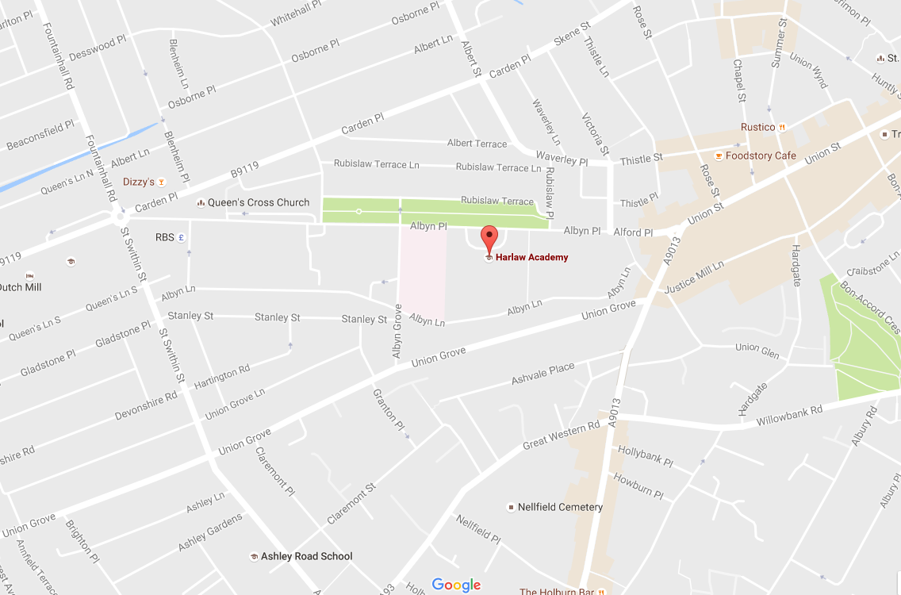

Bus Routes:
- Take any bus to Holburn Junction and walk up to Albyn Place.
- No. 11 and 13 go past the school.

Hazlehead Academy

Address: Groats Road (off Queen’s Road), Aberdeen, AB15 8BE
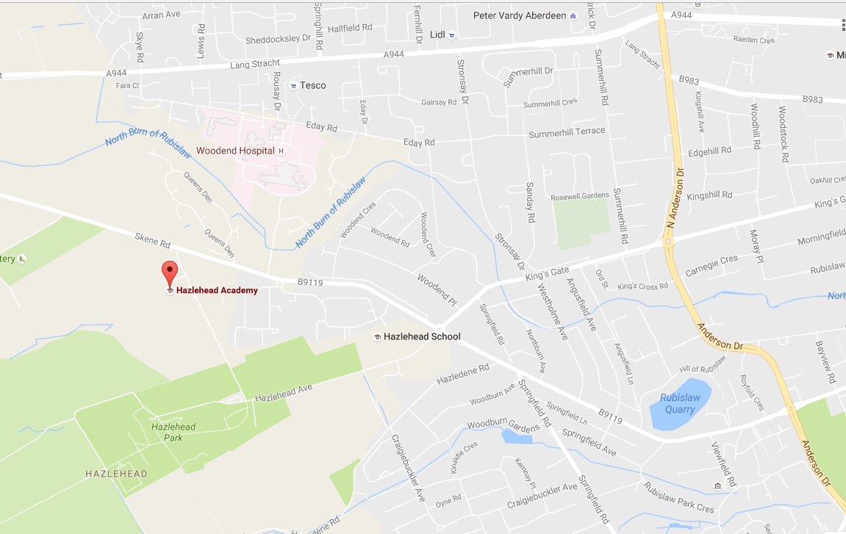

Bus routes:
- No.11 to the terminus opposite Woodend Hospital. Either walk up Queen’s Road a little further, then turn left onto Groats’ Road, or take the short cut over the (public) grassy area. (Which can be soggy!)

St. Machar Academy

Address: St. Machar Drive, Aberdeen, AB24 3YZ
Bus routes:
No. 1 or 2 to King Street – get off near the roundabout at Seaton, then walk up St. Machar Drive
No. 17 or 18 along Great Northern Road, get off at roundabout and walk down to school
No. 20 to Aberdeen University at St. Machar Drive, then walk up to the school.

North East Scotland College (NESCol) - City

Address: Gallowgate, Aberdeen, AB25 1BN
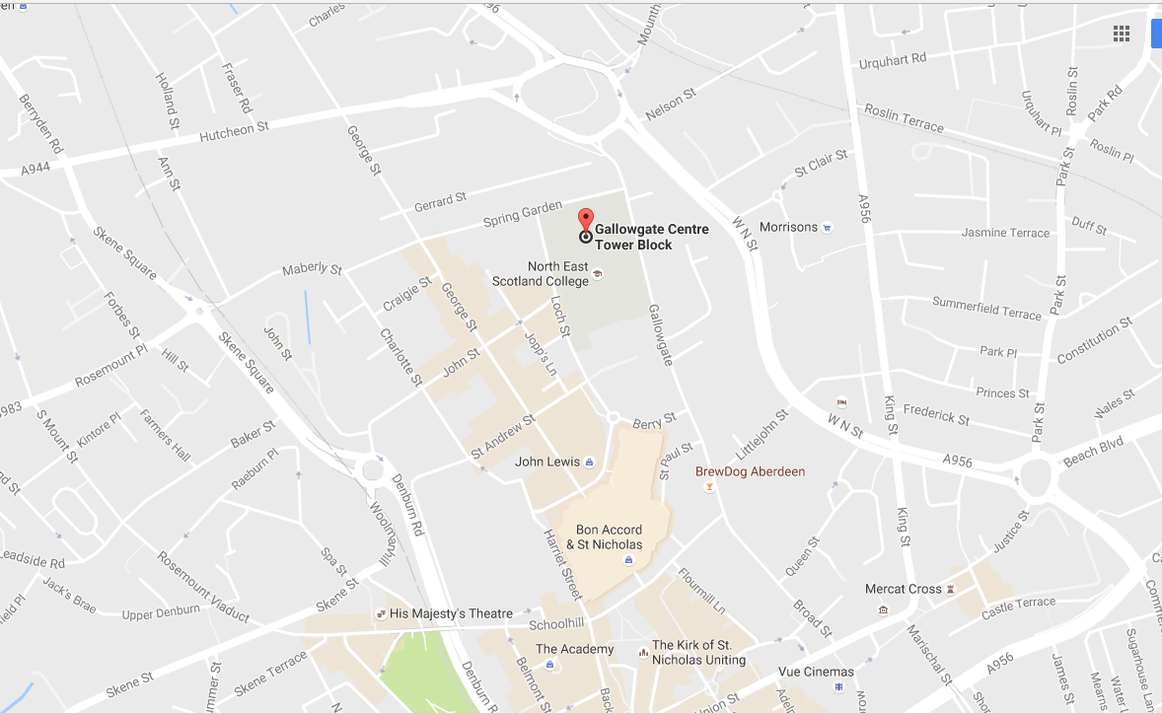

Bus routes:
- No. 11,17,18,19,20,25 all stop in Broad Street, outside Marischal College. NESCol is a short walk down The Gallowgate.
- The no. 11 continues down The Gallowgate.
- The no. 20 and 25, heading towards Union Street, stop in The Gallowgate
- The (new) no. 8 and 9 from Dubford/Bridge of Don stops on The Gallowgate
- The no. 23 from Heathryfold goes to Mounthooly – a short walk from The Gallowgate.

North East Scotland College (NESCol) - Altens

Address: Hareness Road, Altens Industrial Estate, Aberdeen AB12 3LE
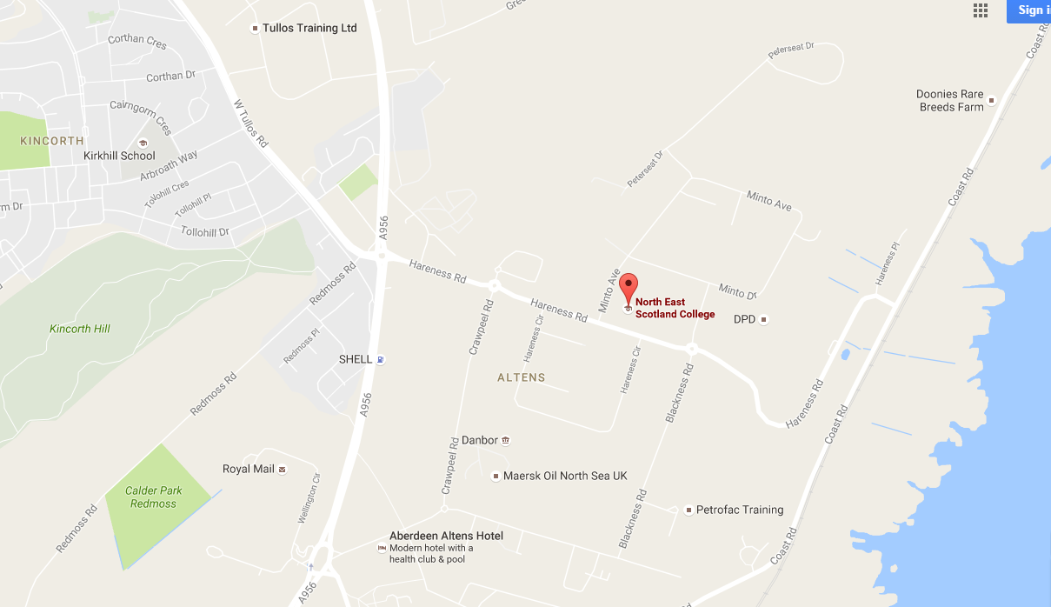

Bus routes
- College link, to and from Aberdeen city centre From 29 August 2016 until 16 June 2017 on weekdays – excluding College holiday periods.
- Pick up point | - Depart | - Arrive
- Union Street (outside Waterstones/ Trinity Centre) | - 8.00am | - 8.25am
- Aberdeen Altens Campus | - 4.35pm

- No. 18 bus – some go via the College. Otherwise, get off at Redmoss and walk along Hareness Road.
- No.3 bus – goes up Wellington Road. Get off at junction beside Hareness Road and walk along to college.

Saks Hair Academy at Northfield Academy.

Address: Granitehill Place, Aberdeen, AB16 7AU

Bus routes:
- The no. 5 and 11 go to Provost Fraser Drive, which Granitehill Place branches off.
- The 727 airport bus goes along North Anderson Drive and Northfield Academy is a short walk away.

Citymoves Dance Space

Address: Top floor, Triple Kirks, Schoolhill, Aberdeen, AB10 1FQ

Bus routes:
- Any bus to Union Street, then walk down Belmont Street. Citymoves is on the opposite corner from JD Wills. (Above the Triple Kirks bar)

