‘Some people dream of success while others wake up and work hard at it’

ADVICE FOR PARENTS
ABERDEEN GRAMMAR SCHOOL
Our Vision – working together, learning together, achieving together
Our Values – Ambition Growth Success

S1
Planning for Success
Contents

Ms Murison’s introduction and ‘Dates for your Diary’ | Page 2
Key to Success – How parents can support | Page 3
Homework and Revision | Page 4
Active Revision Techniques | Page 5-6
Developing Literacy Skills- How parents can support | Page 7-8
Recommended Reading for S1Pupils | Page 9-12
Numeracy and Mathematics | Page 13- 14
Research Skills | Page 15
Workshop notes | Page 16-18

Dear Parent /Carer

Parents and family members have a huge influence on how well young people progress in school. It is by working in partnership with you that we are best placed to deliver our school values of ambition and success for your child. Through our ‘Planning for Success’ programme, we wish to provide information, guidance and advice for you to support your child’s learning at home.

This booklet is designed to provide practical strategies for you to support the development of your child’s literacy, numeracy and study skills. It complements the series of workshops for parents at our S1 Planning for Success Evening.

We wish your child every success at Aberdeen Grammar School and look forward to working with you.

Alison Murison
Head Teacher

Dates for your diary
Wednesday 12 September 2018  7.00pm-8.30pm | S1 Planning for Success Workshops  ‘S1 Planning for Success’ Booklet | Support for S1 parents;  Literacy skills  Numeracy skills  Homework/Revision strategies
Week beginning 28 September 2018 | Settling-in Report | Feedback on:  Effort  Behaviour  Homework
Thursday 24 September 2018 (period 4 in Assembly Hall) | Workshop for S1 pupils | Hints and tips on homework and study
Week beginning 6 March 2019 | Report | Feedback on:  Level achieved in each subject  Strengths/ areas for development  Effort/behaviour/Homework
Thursday 14 March 2019  4.30pm-7.00pm | S1 Parents’ Evening | Parent appointments with subject teachers:  Strengths/ areas for development
Week beginning 20 May 2019 | Activities Week for S1 and S2 pupils
Week beginning 27 May 2019 | Start of S2 timetable

Key to success | How parents can support
Commitment and motivation to learn | Give positive messages – pupils need to believe to achieve!  Reinforce our high expectations of effort and behaviour in class.  Make the connection to longer term goals – a strong work ethic in S1 carries into S2/S3 subjects and into national examinations in S4-S6.  Acknowledge and reward effort for your child. Progress is individual - we want each child to be the best he/she can be.
High level of attendance in school | Ensure appointments are kept to a minimum.  No holidays during term time, please!  Contact PTPS, if extended absence.
Organisation | Copy your child’s timetable and display somewhere for easy reference.  Ensure notes/books are organised. A different coloured folder for each subject is a useful tip.  Take a regular look in your child’s school bag! You may need to plan for regular clear outs!!  Ensure your child is ready for school- develop the habit of your child packing his/her school bag the night before. A well -stocked pencil case is a must – pencils, pens, rubber and ruler.  Look at your child’s planner and plan homework / test preparation with him/her.
Healthy lifestyle | Encourage your child to get involved in an extracurricular activity. This session’s programme is on the website.  Monitor use of mobile technology:  - It is a good idea to remove mobile technology during homework/  study/ reading time  - A school day is tiring and our pupils are busy with activities after school. It’s a good idea to remove mobile technology an hour before bed time and during the night in order to ensure a full night’s sleep!  Ensure there is a good balance between school work, extracurricular activity, relaxation and family time.
Being in the know! | Know your child’s timetable, subjects and teachers. This will help you to check that your child is ready for school as well as to talk about school with your child. A general “How was school today?” will get little response. However, “What did you do in science this afternoon?” may elicit a fuller response.  Check your child’s planner and help him/her to plan homework and revision for tests.  If you change your mobile telephone number, you must let the school office know. A lot of communication with parents is by text.

Homework and Revision
Research shows that pupils who do homework, do better in school. As a parent/carer, it is not your ability or knowledge of a subject which counts but rather a positive and encouraging attitude. You can help and support in so many ways!

When
- Establish a routine for your child which takes account of their commitments outwith the school day. Your child should get into a routine of doing their homework at a specific time on identified days. eg. Monday – Thursday evening and Sunday evening.
- Check your child’s planner with them and ensure that all homework and preparation for tests is done in good time. You may have to adapt the set routine if there is a week with a number of tests, for example.
- Use your knowledge of your child to plan –is it best for them to do the subject they like least or best first? If your child is reluctant to get started, set a time (or so many questions at a time), with a treat at the end. Offer choices, break things down and set goals.
Where
- Identify a space where your child feels comfortable and able to concentrate.
- If possible, try to keep resources in this space, e.g. subject folders, calculator, English dictionary, thesaurus, notebooks. A pinboard can be a good idea with your child’s timetable/deadlines /feedback from teachers/ study advice/ motivational messages.
- Wherever your child does homework, ensure that there are no distractions (remove mobile phone for the time spent on homework!) and that you are available to provide encouragement and non-critical support, as required.
What
- There is always homework to do!! Encourage your child to get into the habit of reading over the classwork of that day (which has a significant impact on retention and test performance!). This may not be noted in their planner as homework but it is an important part of an effective homework and revision routine!
- Take an interest in homework and encourage your child to produce work to the best of their ability e.g. check presentation and accuracy, test factual knowledge.
- If your child is struggling or if the homework task seems too big, break down the task with your child and support them to complete one bit at a time.
- Ask your child to explain the homework / topic– this helps pupils to learn.

Encourage your child to:
- take account of feedback from teachers from previous work- look at jotters, previous tasks and essays.
Tip – do not file away reports. Keep looking at next steps for improvement.
- check over their work for technical and factual accuracy

Above all, acknowledge and reward effort!
Active Revision Techniques
Try out these techniques and find out what works best for your child.
LEARN IT! TEACH IT!

Teaching someone else gives 90% retention rate as you have to understand something fully before you can explain it to someone else. Teach your parent, brother, sister, pet or even your imaginary friend!

POST-ITS
- Write out key points and display them where you are most- in your bedroom/ on the stairs / around your mirror. Make it fun and keep reading them!
- Write out what you don’t know. Place post-its on your course notes and keep going back to them.
- The post-it notes can be used by someone else to quiz you.
- Improve a piece of work by re-doing an identified section on a post-it and place on top of the original section, rather than writing it all out again.

QUIZZES
Make up quizzes and get someone to test you.
Parents make great quizmasters!
Turn the tables - why not quiz your parents?
Active Revision Techniques
MINDMAPS
Visual signs and key words are easier for some people to remember than written notes. Mindmaps can summarise pages of notes and show links and associations. Information can be reviewed at a glance.
RECORD YOURSELF
Record key information and play it on repeat. Listen while walking, running, in the car…
Summarise your notes.
Copy out key information on paper/ card / magic paper for display OR copy into a new notebook. Use different coloured pens and add diagrams to break up text.

Reading over your notes is the least effective way of revising. You need to read your notes and do something!

FLASHCARDS
Turn your notes into portable revision tools that you can carry around with you. Test yourself or get someone to test you.
Use highlighters
- Read over your notes and highlight key information.
OR
- Highlight parts of your notes which you are unsure of – keep going back to the highlighted parts
FLASHCARDS (REVISION CARDS)
Front of card Back of card
‘chunk’ of information key words
question answer
specialist term definition
topic key facts
Hints and Tips for S1 pupils
NOTES
Keep your notes neat and organised, in folders for each subject. It helps to separate notes for each unit and topic. Don't throw away notes or hand-outs, you never know when you might need them.

You could traffic light your notes to help organise and prioritise your revision.
Green – I am confident about this
Orange – I need to go over this again
Red – I need to work on this NOW / I need to speak to my teacher
If you miss a class, speak to your teacher as soon as you can. It's your responsibility to catch up with the work you missed.
Don't just copy the notes from your teacher or your friend's jotter; make sure you understand what you're writing and what you're supposed to be learning.
If in doubt, speak to your teacher.
In class…
Concentrate during every lesson. Something being taught at the time you were dreaming could pop up in an assessment or test.
If you don’t understand something, ask your teacher!
It is a good idea to follow up on feedback/advice from your teacher right away. Re-do the piece of work or go over the topic when the feedback is fresh in your mind.
Do your homework!
Keep up to date with your homework and use your planner properly. Don't leave it until the last minute.
By completing your homework as soon as you get it, you can go and ask your teacher, in or out of class, about anything you're unsure of.
Consolidate your knowledge and understanding by reading over your notes regularly. It is really helpful to read over your notes after school every day.
FACT – Going over information x5 commits it to long-term memory!
And finally, take time to relax and get involved in extracurricular activities!
At home, when doing homework
- switch off all technology
- study for at least 25 minutes at a time.
- take regular short breaks
- have plenty of water and snacks to keep you going
ACTIVE REVISION techniques
Break down your notes into “chunks” to learn and use the techniques which work best for you.
- Use flash cards
- Use highlighters
- Use Post-it notes
- Make mind maps

Developing Literacy Skills- How parents can support

Encourage good reading habits
Pupils who read widely are more easily able to access texts in class. They also have a more sophisticated vocabulary and are able to adapt their writing style to suit a range of purposes.

Help choose a text to read:
- Be readers – students who see others read at home are more likely to be readers themselves
- Read widely and in a variety of ways – novels, articles, audio books, magazines, comics, kindles, tablets. go to the book shop or library together and discuss what is available
- Leave reading materials around the home so they are easy to pick up
- Create a quiet, comfortable space at home to encourage reading
- Look for books that are part of a series or try biographies about people they admire
- Link books and reading to the cinema releases or video games etc.
- Share what you have read – or what you have watched or heard – open up discussion and encourage questions

How to help your child get the most from their reading – some suggested strategies:
Make Predictions.
- Look at covers and blurbs and make predictions about the content of the text.
- Ask: What do you think this text is about? Does it reminds you of anything that you have seen, heard, read or watched before? What do you think the character will do next?

Ask Questions:
- This helps build UNDERSTANDING, ANALYSIS and EVALUATION. For example:
- Where and when do you think the story is set? Why does (character) act in this way at this particular time? What do you think is going through (character’s) mind here?

Make Comparisons:
- Ask your child if the text reminds them of anything they have read or experienced before. Would they have behaved in the same way as the characters or those involved? How does the text compare with a previous one?

Summarising:
- This is an essential skill and involves putting key ideas into own words and selecting key information
- You could ask your child to write down or tell you in 50 words or less about what they have read, watched or listened to.
- try asking them to write down the events in the order in which they happen
- Discuss what your child has read, or watched or listened to. News articles and non-fiction are good options. Ask them to summarise what they have read in their own words. You could ask for the three things they learned or found interesting.

Next Steps
Building Vocabulary

Reading widely will help to build vocabulary but there are some other things that you can do to help.

Create a Glossary:
- This is a strategy that can be used in all subjects
- ask your child to highlight words they are unsure of and look them up together
- sometimes using a dictionary can be challenging
- try to work out what a word might mean by thinking about its context – can you work out its meaning by looking at the language which surrounds it

Use Technology:
- Try crosswords, word searches, code words, word games… (online, apps or print) these encourage familiarity with word patterns and build vocabulary

Finally
Useful Links
- http://www.bbc.co.uk/skillswise/english
- http://www.channel4learning.com/support/websites/english.html
- http://www.vocabulary.co.il/
- http://www.bbc.co.uk/bitesize/ks2/english/spelling_grammar/
- http://www.lovereading.co.uk/
- http://www.goodreads.com/
- http://www.scottishbooktrust.com/

Useful Apps
Reading/vocabulary: Kindle, ibooks, online dictionary and thesaurus, The Guardian…

Games: Word Brain, Words with Friends, Scrabble, Letterpress…
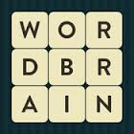

Apps to watch: useful for clips to discuss, research: You tube, TED talks, BBC …

Apps to help with planning and organising: iBrainstorm, Popplet…

Before you start reading, let us help you create the perfect reading vibe…
Recommended Reading for S1Pupils
- The perfect partner to a good book is a hot chocolate – try adding a relaxing reading break into your day
- Drown out the outside noise – put your headphones on to remove yourself from the outside world… and become immersed in your book!
- Reading for a short while before you go to bed is said to help you get a better quality of sleep, so remember to read a chapter (or two) before turning off the light

I’m new to reading/reluctant to read… where do I start?
RED/ORANGE
- Andy McNabb – The Nick Stone Missions series
https://www.goodreads.com/series/59246-nick-stone
- Jacqueline Wilson – A series of books
https://www.thebookpeople.co.uk/webapp/wcs/stores/servlet/CategoryDisplay?categoryId=147733&catalogId=10051
- Neil Gaiman ‘The Graveyard Book’
https://www.goodreads.com/book/show/2213661.The_Graveyard_Book
- Cassandra Clare – ‘The Shadowhunter Chronicles’
https://www.cassandraclare.com/shadowhunter-chronicles/
- Veronica Roth – ‘Divergent’ Trilogy
https://en.wikipedia.org/wiki/Divergent_(novel)

I’m growing in confidence… where do I go next?
YELLOW/GREEN
- J.K. Rowling – The Harry Potter Series http://www.thebookbag.co.uk/reviews/index.php?title=J_K_Rowling%27s_Harry_Potter_Books_in_Chronological_Order
- Philip Pullman – His Dark Materials
https://en.wikipedia.org/wiki/His_Dark_Materials
- Arthur Ransome – ‘Swallows and Amazons’
https://www.booktrust.org.uk/book/s/swallows-and-amazons/
- Paul Stewart – ‘Beyond the Deepwoods’ Saga
https://en.wikipedia.org/wiki/Beyond_the_Deepwoods
- Jamila Gavin – ‘Coram Boy’
https://www.theguardian.com/childrens-books-site/2015/mar/01/review-jamila-gavin-coram-boy
- Malorie Blackman – ‘Noughts and Crosses’
https://en.wikipedia.org/wiki/Noughts_%26_Crosses_(novel_series

Right, now I’m ready for a challenge!
BLUE/INDIGO/VIOLET
- J. R. R. Tolkien – ‘The Hobbit’ and ‘The Lord of the Rings’ Series
https://en.wikipedia.org/wiki/The_Hobbit
https://en.wikipedia.org/wiki/The_Lord_of_the_Rings

- William Nicholson - ‘The Wind Singer’ and the ‘Wind on Fire’ Trilogy
https://en.wikipedia.org/wiki/The_Wind_Singer

- Mark Haddon – ‘The Curious Incident of the Dog in the Night-Time’
https://en.wikipedia.org/wiki/The_Curious_Incident_of_the_Dog_in_the_Night-Time

- Louis Sachar – ‘Holes’ and ‘Small Steps’
https://www.amazon.co.uk/Holes-Louis-Sachar/dp/074754459X
https://www.amazon.co.uk/Small-Steps-Louis-Sachar/dp/0747583455/ref=sr_1_1?s=books&ie=UTF8&qid=1526391892&sr=1-1&keywords=small+steps

- Derek Landy – ‘Skulduggery Pleasant’ Series
https://en.wikipedia.org/wiki/Skulduggery_Pleasant

- Markus Zuzak – ‘The Book Thief’
https://en.wikipedia.org/wiki/The_Book_Thief

- Eoin Colfer – ‘Artemis Fowl’ Series
https://en.wikipedia.org/wiki/Artemis_Fowl

Looking for something local? Check out some Scots versions of our favourites translated by Matthew Fitt
- Roald Dahl’s classic ‘The Twits’ becomes ‘The Eejits’ http://blackandwhitepublishing.com/shop/the-eejits.html

- J.K Rowling’s famous introduction to Harry Potter gets the Scots treatment in ‘Harry Potter and the Philosopher’s Stane’
https://www.amazon.co.uk/Harry-Potter-Philosophers-Stane-Language/dp/1785301543

Don’t forget… it is not all about novels!
Poetry –
- Robert Macfarlane and Jackie Morris – ‘The Lost Words’
https://www.waterstones.com/book/the-lost-words/robert-macfarlane/jackie-morris/9780241253588
- Allie Esiri – ‘A Poem for Every Night of the Year’
https://www.waterstones.com/book/a-poem-for-every-night-of-the-year/allie-esiri/9781509813131

Spoken Word – Steve Camden aka Polar Bear (The Spoken Word Genius!)
- https://www.youtube.com/watch?v=JTAsDue9buY

Graphic Novels –
- Eoin Colfer and Andrew Donkin – ‘Illegal’
https://www.amazon.co.uk/Illegal-graphic-telling-journey-Europe/dp/1444934007
- Jim Ottaviani - ‘The Imitation Game – Alan Turing Decoded’
https://www.amazon.co.uk/Imitation-Game-Turing-Decoded-Graphic/dp/1419718932/ref=sr_1_1?s=books&ie=UTF8&qid=1526028400&sr=1-1&keywords=the+imitation+game+alan+turing+decoded

Give your eyes a rest and tune in!
Audio books –
https://www.audiobooks.com/
A whole world to explore… and you get your first book for free!
You can also download the app https://itunes.apple.com/app/apple-store/id521227008?mt=8 to keep your ears entertained when you are on the move.

Want a slice of real life?
Autobiographies:
- Mackenzie Ziegler – ‘Kenzie’s Rules for Life: How to be Happy, Healthy, and Dance to Your Own Beat’
https://www.amazon.com/Kenzies-Rules-Life-Happy-Healthy/dp/1501183575/ref=sr_1_1?s=books&ie=UTF8&qid=1526374656&sr=1-1&keywords=mackenzie+ziegler
- Anthony Kiedis and Larry Sloman – ‘Scar Tissue’
https://www.amazon.com/Scar-Tissue-Anthony-Kiedis/dp/1401307450/ref=sr_1_1?s=books&ie=UTF8&qid=1526374693&sr=1-1&keywords=scar+tissue
- Adeline Yen Mah – ‘Chinese Cinderella’
https://www.amazon.co.uk/Chinese-CinderellaThe-Secret-Unwanted-Daughter/dp/B0092FTM58/ref=pd_lpo_sbs_14_t_0?_encoding=UTF8&psc=1&refRID=G5WRRDVC9C3Y49FKF60A

Biographies:
- Rachel Ignotofsky – ‘Women in Science: 50 Fearless Pioneers Who Changed the World’
https://www.amazon.com/Women-Science-Fearless-Pioneers-Changed/dp/1607749769/ref=pd_bxgy_14_img_2?_encoding=UTF8&pd_rd_i=1607749769&pd_rd_r=GV8PXRPJ5SJKXDWWYHY0&pd_rd_w=tukRA&pd_rd_wg=2Ev1Z&psc=1&refRID=GV8PXRPJ5SJKXDWWYHY0
- Rachel Ignotofsky – ‘Women in Sports: 50 Fearless Athletes Who Played to Win’
https://www.amazon.com/Women-Sports-Fearless-Athletes-Played/dp/1607749785/ref=zg_bs_17418_17?_encoding=UTF8&psc=1&refRID=2EFC1Y26CA3GTW4QMQ9K

Try These for More Ideas….
www.scottishbooktrust.com
www.goodreads.com
https://www.thebookpeople.co.uk

Numeracy and Mathematics
“We are all surrounded by things which rely on maths in one way or another. It is no exaggeration to say that maths is the language of modern life.” Emeritus Professor Adam McBride. University of Strathclyde.

What is numeracy?
Confidence and accuracy in applying numeracy skills across a variety of real life contexts leads to us being numerate and being able to function responsibly, at school, in everyday life and the world of work.
Fluency and confidence in working with numbers and their relationships is vital to support your child’s progression and attainment in mathematics.

Top tips
- Be positive about maths, your attitude will be reflected through your children.
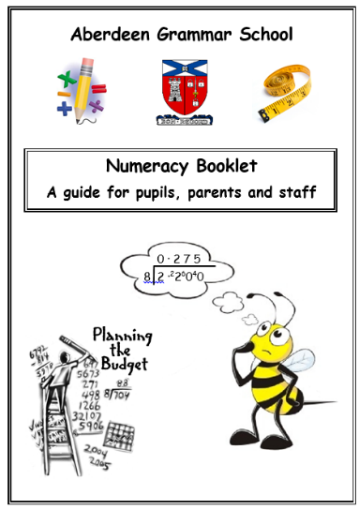
- Point out and talk about the maths in everyday life. Include your child in activities involving maths such as using money, cooking and travelling.

S1 Numeracy Booklet
Your child will have brought home the Aberdeen Grammar
School Numeracy Booklet which exemplifies good practice
and methodologies used by the Maths faculty.
This booklet covers many numeracy skills and we would encourage
parents/ guardians to support their children by regularly discussing
and asking questions to promote numeracy confidence and fluency.

In particular
- By S1 most children know their number bonds and are fluent in their times tables, however regular practice is still essential to increase accuracy and speed of recall.
- If your child has not yet mastered these skills their teacher will work on strategies to support their learning and understanding.

- Encourage your children to recognise number relationships and opposites and understand that:

- tells us that
- tells us that
- tells us that
Draw a picture
3 | 3 | 3 | 3

- tells that
- Draw a picture
4 | 4 | 4
Number Literacy
As your children move through the school they will meet more challenging problems requiring a wider knowledge of mathematical terms. The diagram below summarises some of the words related to the 4 rules of number.
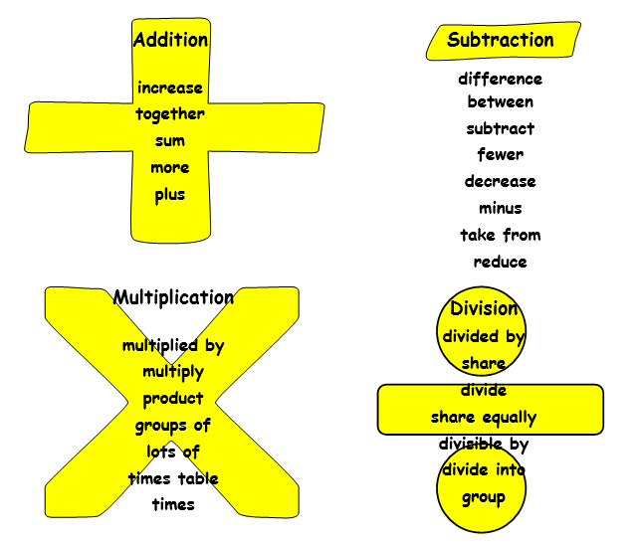

Useful Websites

Mathsworkout http://www.mathsworkout.co.uk/
Password: aberdeengrammar
Login: decimal11
Mathsbox http://www.mathsbox.org.uk/index1.php
Password : ags3
Login: maths
Supermathsworld http://www.supermathsworld.co.uk/
Select : LAUNCH DESKTOP SITE
Maths Games http://www.maths-games.org/
Select: Multiplication Games OR Addition Games OR Subtraction Games OR Division Games form Tab at the top.

Research Hints and Tips

If your child comes home with a research task that is for a fairly wide topic and you are unsure of where to start, simply follow these simple steps to help them narrow down their search and focus their notes towards reliable information.

STEP 1: What is the task?
What are they actually being asked to do?
For example:
- A diary entry: this will require looking at first-hand accounts, looking for personal experiences and information.
- A report: this will include facts and figures on the subject.
- A newspaper article: include bias and opinion therefore you should look for opinions on a topic as well as facts and figures.
- A fact file: this will include a variety of information about a certain subject.
- Answer a Question: Look for the key words: is it a cause or an impact of something they are looking for? Or simply facts on a topic? For Example:
    - Explain the reasons why Mary Queen of Scots was executed. (Causes)
    - Give details of what happened on the day of her Execution (Events)
    - What will happen to Scotland now that their Queen is gone? (Impact)
STEP 2: Narrowing the Search.
Now you know what you are being asked to do how do you narrow down what you are looking for?
- If the topic is quite wide, one strategy would be to ask your child to write out 10 questions about the topic that they want to find the answer to. When searching for information they then search for the specific answers to these questions. This should give them specifics.
- For example if they were researching Working conditions for Children in the industrial revolution they could maybe look at :
    - What were the average working hours for a child?
    - How many days a week did a child work in a factory?
    - What type of jobs did children do in a cotton mill?
- You can also break down a topic into subtopics. If looking at a play in English you could break it down into Characters, Themes and Main events.

STEP 3: Using search engines effectively.
Once you have looked at the task and what is being asked and you have narrowed down your topic slightly the next step is to find relevant information.
Here are some hints and tips to make using Google easier!
- If you are searching for something and put it in inverted commas you will get only results that has that exact phrase rather than searches containing all of the words individually.
- For example a search for ‘Execution of Mary Queen of Scots’ will only bring up sites that has this phrase whereas without the inverted commas you will get results for execution, Mary, Queen, Scots and this will make it more difficult to find relevant information.
- You should also make sure that what you are inputting into the search bar is specific. Try to include dates, names etc.
- For example a search on ‘ Working conditions in factories’ will bring up results from various countries, time periods, types of factories, whereas ‘Working Conditions in Cotton Mills in Britain between 1760 and 1830’ will target you towards the information you need.
STEP 4: Is the source Valid?
Before note taking from a website you should make sure that the source is valid.
- If something has come from a Wiki Site then you need to be aware that anyone can publish here. While things are checked, not everything is checked constantly and there can be mistakes.
- Stick to reliable websites, reputable news companies, BBC and teachers will give advice on Subject related sites or may post helpful links in the Google Classroom.
- Be aware of the author of any source as they can be bias. An article on the Aberdeen V Rangers game written by Derek McKinnes will have a different angle to one written by Steven Gerrard!
STEP 5 Recording the Information
There are several techniques to use to help you child record information when researching a topic. Here are a few suggestions:
- Look up the answers to the 10 questions that you have previously written down to focus your research.
- If your child is looking to create a fact file or they are to take notes from a video clip another strategy is to take down singular facts on post it notes. Once they think they have enough facts they should organise their notes into categories. For Example:
      - If they were researching an earthquake they could organise their post-it notes into causes, events and aftermath.
      - If they are looking at a specific person they could organise their individual notes into Early Life, Major Achievements, Successes and Failures.
      - Flow charts or timelines are particularly good for mapping events in a chronological order.
      - Mind maps on a topic can be useful when done correctly and colour coded.
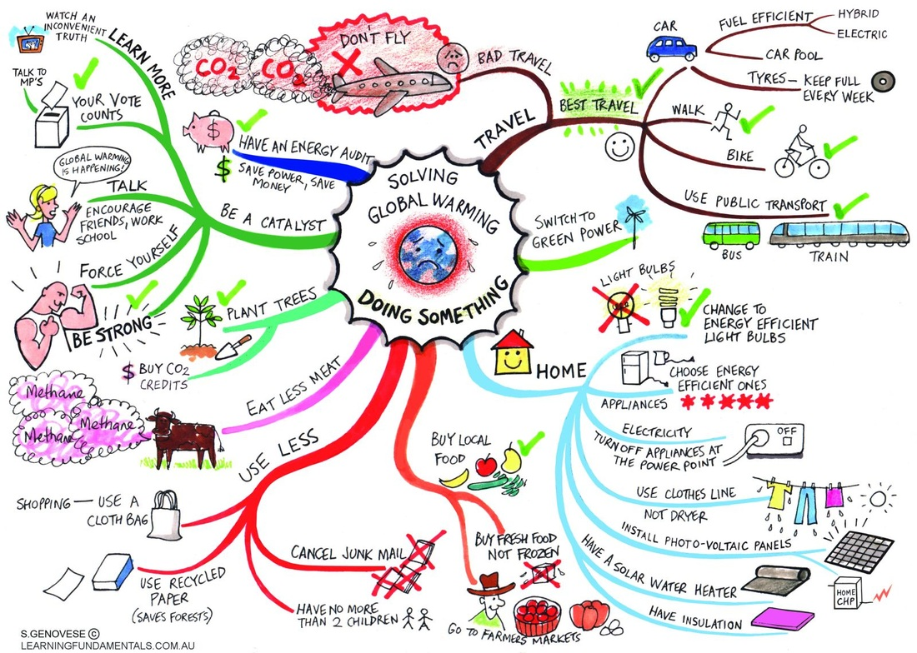

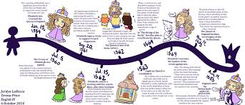

PARENT WORKSHOP NOTES

Workshop 1 – Literacy (Research Skills)

Workshop 2 – Numeracy (S1 Success Criteria)

Workshop 3 – How to support your child with homework/revision

Our Vision – working together, learning together, achieving together
Our Values – Ambition Growth Success

