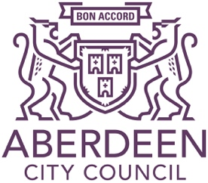

Scottish National Standardised Assessment (SNSA)

Scottish National Standardised Assessments (SNSA) were introduced in session 2017/18 for S3 pupils. Assessments will be carried out in all Aberdeen City schools and will contribute to teacher professional judgement of pupil progress and achievement of Curriculum for Excellence (CfE) levels for Literacy and Numeracy.

What is involved?

- S3 pupils will undertake national standardised assessments covering aspects of Reading, Writing and Numeracy.

- Assessments will be completed online and will be automatically marked by the online system, giving teachers immediate feedback to help children progress and plan next steps. There will be no pass or fail.

- The system is designed so that if a child is struggling with the questions, they will get easier. If a child is doing well, the questions will become more challenging.

- The standardised assessments are as short as possible and will be age and stage appropriate.

- Your child will not be expected to take assessments covering Reading, Writing and Numeracy in one sitting.

- The assessments will, as far as possible, accommodate the needs of children who require additional support.

When will the assessments take place?

This school year in Aberdeen, secondary assessments will be carried out in November and December.

What does this mean for my child?

Teachers will continue to judge if children have achieved CfE levels at the end of S3.

Your child will not have to revise or prepare for national standardised assessments. There will be no additional work for your child and the assessments will offer no distraction from daily learning.

What does this mean for me as a parent?

The SNSA is primarily for teachers. Teachers will use the results, alongside a range of other assessment information, to assess progress and achievement of CfE Levels.

SNSA assessment results will not be routinely shared with parents/carers. However, these will inform discussions with you about your child’s progress and achievement and their school report.

The sharing of data to allow SNSA assessments to be administered will be done under the strict control of Aberdeen City Council and Scottish Government. This will ensure that individuals’ data will not be made public and that data will not be used to take any actions in respect of an individual. At all times pupils’ rights under the Data Protection Act (2018), GDPR and other relevant legislation will be ensured.

Further information about SNSA is available here: https://standardisedassessment.gov.scot/

If you have questions or concerns regarding SNSA, please contact your child’s school in the first instance.

