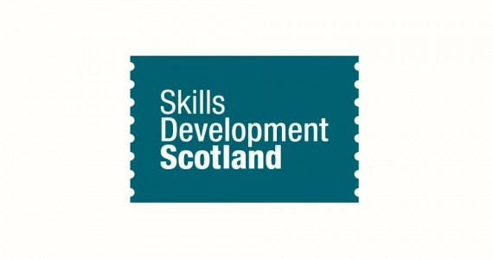

Skills Development Scotland is Scotland’s careers service.
Our qualified Careers Advisers are working in schools and careers centres across the whole of Scotland.
Your Careers Adviser is Morag Evans and you can get in touch with her through school on 01224642299 or morag.evans@sds.co.uk or come to the Careers Room next to the lecture theatre.
Your Careers Adviser will be there for you all through school, helping you get ready for whatever pathway you chose when you leave.
Some people think Careers Advisers are here to tell you what to do. Not true! And they won’t say ‘no’ or ‘you can’t’ either. They will help you to think about what’s best for your future.
One of the main things your Careers Adviser will help you do is develop your Career Management Skills, which are the skills you’ll need to make your career decisions a success.
You’ll take part in groupwork sessions via PSE, as well as having the chance of one-to-one time with your Careers Adviser. They’re also available for drop-in sessions.
Our work is supported by our websites My World of Work , https://mykidscareer.com/ & https://www.apprenticeships.scot/
You can use them to explore your careers, skills and learning opportunities right through school and working life. They will give you access to career interest generators, job profiles, advice on CV’s and interviews, information on college and university options, modern apprenticeships, information on work in the future, subject choice help, services for those who need help after leaving school, advice after exam results, etc.
Parents and carers
When it comes to making career decisions, you’re one of the first people your child will turn to for help.
My World of Work is also packed with information to help you explore the routes your child could take for their career and their Career Management Skills
You can find more information on how to support them in making important career decisions by using our website dedicated to parents https://mykidscareer.com/

