‘Some people dream of success while others wake up and work hard at it’

ADVICE FOR PARENTS
ABERDEEN GRAMMAR SCHOOL
Our Vision – working together, learning together, achieving together
Our Values – Ambition Growth Success

S3
Planning for Success
Home Learning

Contents

Ms Murison’s introduction and ‘Dates for your Diary’ | Page 2
Key to Success – How parents can support | Page 3
Home Learning – When? Where? What? | Page 4
Active Revision Techniques | Page 5-6
Developing Literacy Skills | Page 7
Research Skills Toolkit | Page 8
Developing Numeracy Skills | Page 9
S3 Home Learning Schedule | Pages 10-16

Dear Parent /Carer

Parents and family members have a huge influence on how well young people progress in school. It is by working in partnership with you that we are best placed to deliver our school values of ambition and success for your child. Through our ‘Planning for Success’ programme, we wish to provide information, guidance and advice for you to support your child’s learning at home.

This booklet is designed to provide practical strategies for you to support the development of your child’s literacy, numeracy and study skills. It complements the series of workshops for parents at our S1 Planning for Success Evening.

We wish your child every success at Aberdeen Grammar School and look forward to working with you.

Alison Murison
Head Teacher

Dates for your diary
Week beginning 16 December 2019 | Report | Feedback on:  Level achieved in each subject  Strengths/areas for development
Wednesday, 29 January 2020 | S3 Parents’ Meeting | Parent appointments with subject teachers:  Strengths/areas for development; Course choice
Friday, 13 March 2020 | Course Choice | Deadline: submission of Subject Choices for S4
Week beginning 27 April 2020 | Summary Report | Feedback on:  Effort, Behaviour, Homework, CfE Level Achieved
Week beginning 18 May 2020 | Skills Week for S3 pupils
Week beginning 25 May 2020 | Start of S4 timetable | All pupils study English and Maths plus 4 subjects of their choice.

Key to success | How parents can support
Commitment and motivation to learn | Give positive messages – pupils need to believe to achieve!  Reinforce the school’s high expectations of effort and behaviour in classes.  Make the connection to longer term goals – a strong work ethic in S1-S3 will have a positive impact in S4-S6 and national examinations.  Acknowledge and reward your child’s effort. Progress is individual - we want each young person to reach their own potential.
High level of attendance in classes | Ensure appointments are kept to a minimum.  No holidays during term time, please!  Contact PTPS to plan for an extended absence, if required.
Organisation | Copy your child’s timetable and display somewhere for easy reference.  Assist your child to organize their notes/books, if required. A different coloured folder for each subject is a useful tip.  Take a regular look in your child’s school bag! You may need to plan for regular clear outs!!  Ensure your child is ready for school - encourage them to pack their school bag the night before. A well-stocked pencil case is a must – pencils, pens, rubber and ruler.  Check your child’s planner regularly and help them to prepare a time plan for home learning and assessments.
Use of Technology | Research recommends the removal of:  - all technology at least one hour before bed time in order to ensure a good night’s sleep;  - mobile phones while home learning is taking place.
Being in the know! | Keep up to date with school news and your child’s learning. There is lots of useful information for parents/carers on the school website and we recommend that all parents/carers sign up to our School App.

HOME LEARNING

Research shows that pupils who do homework, do better in school. As a parent/carer, it is not your ability or knowledge of a subject which counts but rather a positive and encouraging attitude. You can help and support in so many ways!

When?
- Create a home learning timetable with your child which takes account of their extra curricular activity. This will support your child to establish a routine of home learning.
- Check your child’s planner with them and ensure that all homework and preparation for assessments is done in good time. You may have to adapt the home learning timetable if there is a week with a number of assessments, for example.
- Use your knowledge of your child – is it best for them to do the subject they like least first? Or is it best for them to do the subject they like best first? If your child is reluctant to get started, then it would be better to get them to do something they enjoy. Help them to break down the task, set a target (eg complete 5 questions), and offer an incentive.

Where?
- Identify an area where your child feels comfortable and able to concentrate.
- Try to keep resources required in this area, e.g. subject folders, calculator, English dictionary, thesaurus, notebooks. A notice board can be a good idea with your child’s timetable/deadlines /feedback from teachers/study advice/ motivational messages.
- Wherever your child does home learning, ensure that there are no distractions (remove mobile phones during this time). Make yourself available to provide encouragement and support, as required.
What?
- There is ALWAYS home learning to do. Encourage your child to get into the habit of reading over the classwork of that day - research shows that this has a significant impact on retention and performance. This may not be noted in your child’s planner as homework but it is an important part of an effective home learning routine.
- Take an interest in your child’s home learning and encourage them to produce work to the best of their ability e.g. check presentation and accuracy, test factual knowledge.
- If your child is struggling or if the homework task seems too big, break down the task with your child and support them to complete one bit at a time.

TIPS

Refer to feedback from teachers and act on advice given by looking at class jotters, previously marked work and reports.

Support, acknowledge and reward effort!
ACTIVE REVISION TECHNIQUES
Try out these techniques and find out what works best for your child.
LEARN IT! TEACH IT!

Teaching someone else gives 90% retention rate as you have to understand something fully before you can explain it to someone else. Teach your parent, brother, sister, pet or even your imaginary friend!

POST-ITS
- Write out key points and display them where you are most- in your bedroom/ on the stairs / around your mirror. Make it fun and keep reading them!
- Write out what you don’t know. Place post-its on your course notes and keep going back to them.
- The post-it notes can be used by someone else to quiz you.
- Improve a piece of work by re-doing an identified section on a post-it and place on top of the original section, rather than writing it all out again.

Reading over your notes is the least effective way of revising. You need to read your notes and do something!
QUIZZES
Make up quizzes and get someone to test you.
Parents make great quizmasters!
Turn the tables - why not quiz your parents?
MINDMAPS
Visual signs and key words are easier for some people to remember than written notes. Mindmaps can summarise pages of notes and show links and associations. Information can be reviewed at a glance.
RECORD YOURSELF
Record key information and play it on repeat. Listen while walking, running, in the car…
Summarise your notes.
Copy out key information on paper/ card / magic paper for display OR copy into a new notebook. Use different coloured pens and add diagrams to break up text.

FLASHCARDS
Turn your notes into portable revision tools that you can carry around with you. Test yourself or get someone to test you.
Use highlighters
- Read over your notes and highlight key information.
OR
- Highlight parts of your notes which you are unsure of – keep going back to the highlighted parts
FLASHCARDS (REVISION CARDS)
Front of card Back of card
‘chunk’ of information key words
question answer
specialist term definition
topic key facts
HINTS AND TIPS FROM OUR SENIOR PUPILS
NOTES
Keep your notes neat and organised, in folders for each subject. It helps to separate notes for each unit and topic. Don't throw away notes or hand-outs, you never know when you might need them.

You could traffic light your notes to help organise and prioritise your revision.
Green – I am confident about this
Orange – I need to go over this again
Red – I need to work on this NOW / I need to speak to my teacher
If you miss a class, speak to your teacher as soon as you can. It's your responsibility to catch up with the work you missed.
Don't just copy the notes from your teacher or your friend's jotter; make sure you understand what you're writing and what you're supposed to be learning.
If in doubt, speak to your teacher.
In class:
Concentrate during every lesson. Something being taught at the time you were dreaming could pop up in an assessment or test.
If you don’t understand something, ask your teacher!
It is a good idea to follow up on feedback/advice from your teacher right away. Re-do the piece of work or go over the topic when the feedback is fresh in your mind.
Consolidate your knowledge and understanding by reading over your notes regularly. It is really helpful to read over your notes after school every day.
FACT – Going over information x5 commits it to long-term memory!
Do your homework!
Keep up to date with your homework and use your planner properly. Don't leave it until the last minute.
By completing your homework as soon as you get it, you can go and ask your teacher, in or out of class, about anything you're unsure of.
And finally, take time to relax and get involved in extracurricular activities!
At home, when doing homework
- switch off all technology
- study for at least 25 minutes at a time.
- take regular short breaks
- have plenty of water and snacks to keep you going
ACTIVE REVISION techniques
Break down your notes into “chunks” to learn and use the techniques which work best for you.
- Use flash cards
- Use highlighters
- Use Post-it notes
- Make mind maps

DEVELOPING LITERACY SKILLS

Encourage good reading habits
Pupils who read widely are able to access written text more easily. They have a more sophisticated vocabulary and are able to adapt their writing style to suit a range of purposes.

- Be readers – young people who see others read at home are more likely to be readers themselves.
- Share what you have read – or what you have watched or heard – open up discussion and encourage questions.
- Encourage your child to read widely eg newspapers, biographies, novels.
- Look for books which are part of a series or try biographies about people they admire.
- Link books and reading to the cinema releases or video games etc.

Build literacy skills to support learning and examination technique

Make Predictions
- Discuss book covers and headlines to make predictions about the content of the text.
- Ask: What do you think this text is about? Does it reminds you of anything that you have seen, heard, read or watched before? What do you think the character will do next?

Ask Questions
- Where and when do you think the story is set? Why does (character) act in this way at this particular time? What do you think is going through (character’s) mind here?

Make Comparisons
- Ask your child if the text reminds them of anything they have read or experienced before. Would they have behaved in the same way as the characters or those involved? How does the text compare with a previous one?

Summarise Information
- Ask your child to select key information from a text and put it in their own words.
- Ask your child to write down or tell you in 50 words or less what they have read, watched or listened to.
- Ask your child to write down events in the order in which they happened.
- Ask for the 3 things they learned or found interesting.

Build Vocabulary
- Note new words which your child encounters and build a glossary of vocabulary.
- Make use of a dictionary and thesaurus.
- Encourage your child to work out what a new word might mean by its context – can your child work out the meaning from the language surrounding it.

Use Websites
- See list of recommended websites in English Home Learning section.

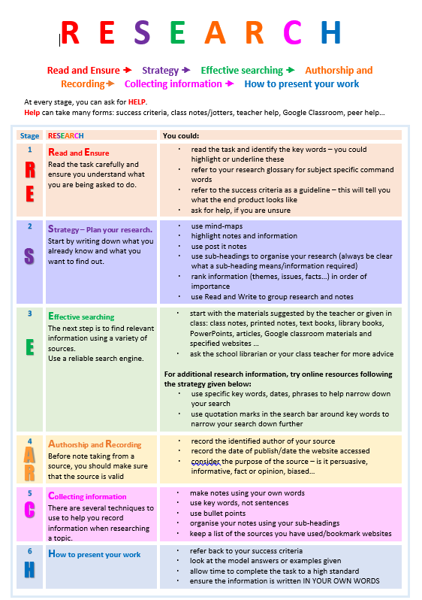

DEVELOPING NUMERACY SKILLS

Encourage an interest in numbers
- Be positive about maths - your attitude will influence your children.
- Point out and talk about the numeracy in everyday life.
- Include your child in activities involving numbers such as budgeting, cooking and time planning.

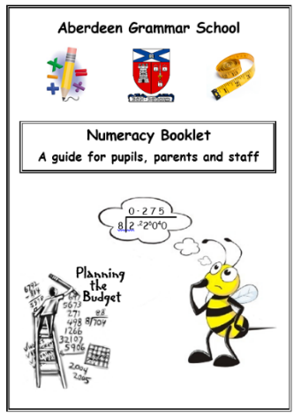

Numeracy Booklet
- This exemplifies methodologies used by the
Maths faculty which pupils should recognise,
recall and be confident in applying.

- This booklet should still be referenced
as a quick reminder when necessary.

Consolidate and extend Numeracy Skills
- Accuracy and speed of recall of times tables continues to be essential to all number processes.
- Substitutions and calculations with positive and negative numbers in a variety of contexts
- Familiarity with fractions, decimal and percentages and their equivalences allows the most efficient method of calculation to be chosen.
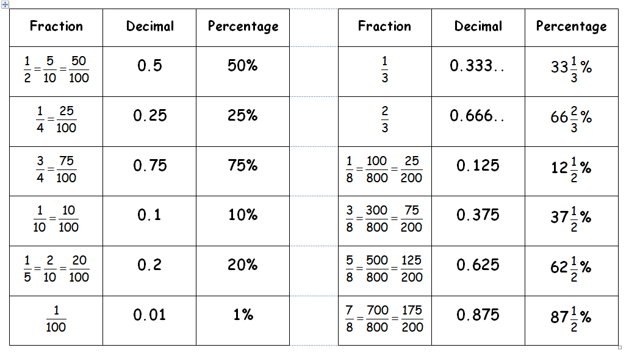
- Use websites to practise skills – see list of recommended websites in Maths Home Learning section.
FACULTY: ART, DESIGN AND TECHNOLOGY
SUBJECT | HOME LEARNING TASKS | FREQUENCY | TIME ALLOCATION | RECOMMENDED RESOURCES AND WEBSITES
ART AND DESIGN | Google Classroom Assignments - Research Tasks including collation of imagery to create digital moodboards, collecting research on Artists and Designers.  Pupils are welcomed in the department during lunch to complete practical work. | Fortnight/per project. | Each Task will take up to an hour - approx one task per fortnight. | All suggested websites will be embedded within the assignments.
ENGINEERING GRAPHICS | - Sketching practice  - General theory  - Rendering  - Questioning based on classwork | Monthly/per project | 20 - 25 minutes | Resources will be uploaded to google classroom.
PRACTICAL DESIGN | - General theory  - Questioning based on classwork | Monthly/per project | 20 - 25 minutes | Plan is to collate them on google classroom.

FACULTY: ENGLISH AND LITERACY

SUBJECT | HOME LEARNING TASKS | FREQUENCY | TIME ALLOCATION | RECOMMENDED RESOURCES AND WEBSITES
ENGLISH | Personal Reading (fiction or non-fiction)  Pupils may also be given Reading papers/pre-reading to be completed at home – move into National style work.  bbc.co.uk/news (non-fiction)  Tedtalks | Daily  As appropriate | 20-25 minutes per day  Dependent on the paper given | Planning for Success Booklet – P7/S1 Reading List  - www.scottishbooktrust.com  - www.goodreads.com  - https://www.lovereading4kids.co.uk/  Pupils may also be registered for READ theory(reading skills development)  https://readtheory.org/auth/login
 | Language Work (Spelling, punctuation, grammar) | As appropriate | As required | - http://www.bbc.co.uk/skillswise/english  - http://www.bbc.co.uk/bitesize/ks2/english/spelling_grammar/  Pupils may also be given appropriate resources to work from at home
 | Talk Preparation | Minimum once per year | Will be given at least a week to prepare | All resources will be issued and/or placed on Google website
 | Research Tasks  For example, WW1, Room 101, Discursive topic, AVU articles | Dependent on class plan | Will be given at least one week to prepare | All resources will be issued and/or placed on Google classroom

FACULTY: HEALTH AND WELLBEING

SUBJECT | HOME LEARNING TASKS | FREQUENCY | TIME ALLOCATION | RECOMMENDED RESOURCES AND WEBSITES
HOME ECONOMICS | - Product design tasks  - Research tasks, dietary targets, nutrients safe hygienic practices  - Practice practical skills (optional) Pupils are encouraged to practice: knife skills, food preparation skills and cooking processes on a weekly basis. This extra work will reinforce learning. | 1-2 per session  As required  Optional tasks | 1 week to complete  1-2 hours per task  30 minutes- 1 hour  10mins -1 hour | British Nutrition Foundation https://www.nutrition.org.uk/
PE | BGE reflection diary  Home workout challenge (optional) | Twice per term  Bi-weekly | 30 minutes  5-20minutes depending on challenge | - Resources on google classroom  - Online via goggle classroom and instagram

FACULTY: HUMANITIES

SUBJECT | HOME LEARNING TASKS | FREQUENCY | TIME ALLOCATION | RECOMMENDED RESOURCES AND WEBSITES
GEOGRAPHY | - Benchmark level-based option tasks (L3 and L4)  - Research within Health topic  - Research and newspaper article writing in Development and Globalisation topic  - Creative tasks e.g. coastal defence strategies  - Factfiles e.g. levels of development cards | - Average 1 per fortnight  - Reading over notes weekly  - Revision for end of unit assessments | Recommended an average of 45 minutes per task, and reading over notes in addition to this | All lesson material is available on Google Classroom  BBC Bitesize

FACULTY: HUMANITIES (contd)

SUBJECT | HOME LEARNING TASKS | FREQUENCY | TIME ALLOCATION | RECOMMENDED RESOURCES AND WEBSITES
HISTORY | - Research activities  - Report writing/ diary tasks/ newspaper article/ Poster/ Fact files  - Presentation preparation  - Completing and checking class notes  - Revision for end of unit assessments | - Once per fortnight  - Reading over class notes once per week | Recommended 1-2 hours per task | - All lesson materials are on Google Classroom  - Revision materials provided before class assessments  - BBC Bitesize
MODERN  STUDIES | - Research tasks  - Essays and opinion pieces  - Completion of assessments  - Recap and revision tasks. | One piece per fortnight plus revision for end of unit tests and reading over notes weekly. | Recommended. 1-2 hours per task | The best way to enhance knowledge is to regularly research the relevant issues that are currently in the news. Websites such as: The BBC, Guardian, Telegraph, Independent, Scotsman or any other quality newspaper will be of great use. Watching television programmes such as Question Time, Newsnight and Sunday Politics will also greatly help understanding of key issues in Modern Studies. https://www.parliament.scot/  https://www.parliament.uk/
RME | Additional research on pupil’s choice of topic for National 4 Added Value Unit | Preparation for N4 open book unit assessment and additional research for N4 AVU. | 1-2 hours per task

FACULTY: ICT, BUSINESS AND ENTERPRISE

SUBJECT | HOME LEARNING TASKS | FREQUENCY | TIME ALLOCATION | RECOMMENDED RESOURCES AND WEBSITES
BUSINESS MANAGEMENT | - Researching businesses  - Multiple Choice using Google Forms  - Topic related short-answer questions | Fortnightly | 20-30 minutes, depending on task | Google Classroom  BBC Bitesize  BBC News website
COMPUTING SCIENCE | All tasks are located on Google Classroom:  - Multiple Choice using Google Forms  - Short-answer questions  - Research | Fortnightly | 20-30 minutes, depending on task | Microsoft package  Google Classroom  Scratch website  Internet

FACULTY: MATHEMATICS AND NUMERACY

SUBJECT | HOME LEARNING TASKS | FREQUENCY | TIME ALLOCATION | RECOMMENDED RESOURCES AND WEBSITES
MATHS | Differentiated worksheets / booklets to support and allow further practice of the skills being developed in class. | Ongoing | As directed by the class teacher. | Maths Workout  Please see Maths  Department for log in details  BBC Bitesize  MathsRevision  IXL  nrich  Interactive Maths
 | Read over Learning Intentions and Success criteria booklet | Ongoing | Revisit regularly
 | Revision booklets to prepare for summative assessments. | Ongoing | Learners will complete these in class and at home.

FACULTY: MODERN FOREIGN LANGUAGES

SUBJECT | HOME LEARNING TASKS | FREQUENCY | TIME ALLOCATION | RECOMMENDED RESOURCES AND WEBSITES
FRENCH  SPANISH | Ongoing vocabulary test preparation  Short pieces of writing  Sentence building  Learning of extended writing and talks/conversations | At least once a week for written work | Varies, but at least 20 minutes a week/before a lesson (at least) of vocabulary and grammar revision | - Quizlet.com  - Languagesonline.org.uk  - BBC Bitesize (National 4)

FACULTY: PERFORMING ARTS

SUBJECT | HOME LEARNING TASKS | FREQUENCY | TIME ALLOCATION | RECOMMENDED RESOURCES AND WEBSITES
DRAMA | Preparation Tasks  - Learning Lines  - Research  - Script Writing  Workbook/Google Classroom Tasks  - Vocabulary Tests  - Character Card/Writing in Role  Evaluative Task  - Self and Peer Evaluations  - Live Production Analysis | 2-3 Pieces across a term.  At the end of a unit of work. Usually termly. | 10-60 Minutes (depending on the task)  1 Hour | Guide will be posted in the google classroom.
MUSIC | - Pupils should practice their instruments at home in preparation for end of term performance.  - Assessments | Daily  Termly | 30 Minutes  10-60 minutes (depending on task | nq music website

FACULTY: SCIENCE

SUBJECT | HOME LEARNING TASKS | FREQUENCY | TIME ALLOCATION | RECOMMENDED RESOURCES AND WEBSITES
BIOLOGY | - Creative type task  - Knowledge and understanding based task  - Problem solving based task  - Data handling activity  - Research based task  - Active Revision task | Minimum of 2 per topic with possible additional tasks | 20-30 minutes per activity | BBC Bitesize
CHEMISTRY | - Creative type task  - Knowledge & understanding based task  - Problem solving based task  - Data handling activity  - Research based task  - Active Revision task | Minimum of 2 per topic with possible additional tasks | 20-30 minutes per activity | List of URL’s updated regularly on Google Classroom (and S3 Revision Google Classroom)
PHYSICS | - Creative type task  - Knowledge & understanding based task  - Problem solving based task  - Data handling activity  - Research based task  - Active Revision task | Minimum of 2 per topic with possible additional tasks | 20-30 minutes per activity | BBC Bitesize  Summary Booklets

